Supp. Table 1. Variables retained in all the reduced datasets after removing highly correlated variables (low spatial resolution daily, weekly and monthly; and high spatial resolution daily, weekly and monthly): depth, slope, distance to the coast and seasonal Eddy Kinetic Energy for the Azores and São Miguel.

STATIC VARIABLES | RESOLUTION | DESCRIPTION (common for the 6 datasets)
DEPTH | 30 arc-seconds  (~1 km) | Depth (m) at the sighting location.
SLOPE | 30 arc-seconds  (~1 km) | Slope (degrees) at the sighting location.
DISTANCE TO THE COAST | High resolution coastline (Instituto Hidrográfico de Portugal) | Distance to the coast (m) from each sighting to the nearest land point.
DYNAMIC VARIABLES | RESOLUTION | DESCRIPTION (common for the 6 datasets)
AVISO MSLA U&V  “All sat” | 0.25º (~30km)  daily | EKE = 1/2((u-u_{mean})²+(v-v_{mean})²)
- São Miguel –  (37-38.5ºN, 26.5-24.5ºW) | 1. EKE monthly  2. EKE seasonal | Eddy Kinetic Energy. u_{mean} and v_{mean} are calculated over the 7 years as:  - monthly means (12 months).  - seasonal means (winter: Dec-Jan-Feb; spring: Mar-Apr-May; summer: Jun-Jul-Aug; autumn: Sep-Oct-Nov).
- Azores –  (35-42ºN, 33-23ºW) | 3. EKE monthly  4. EKE seasonal

Supp. Table 2. Variables in the low spatial resolution daily dataset: variables in bold were retained in the reduced dataset, variables in grey were removed because of high correlation with one or more retained variable.
DATASET 1 – LOW SPATIAL RESOLUTION DAILY
SST (OSTIA) - 0.05º grid (~6 km) [10-100 km effective] // daily // (ºC)
- São Miguel -  (37-38.5ºN, 26.5-24.5ºW) | - SST SM  - SST SD SM  - SST GRAD SM  - SST GRAD SD SM  - SST DAY SM  - SST ANOMALY SM | 1-4. Mean and standard deviation of SST and SST gradient for the sightings’ day.  5. Daily climatological SST mean calculated over the 7 years.  6. SST DAY SM – SST LOC (Dataset 1 - variable 7).
- sighting location - | - SST LOC  - SST GRAD LOC | 7-8. SST and SST gradient at the sighting location.
- thermal fronts - | - Distance to the front  - SST of the front  - Gradient of the front | 9. Distance from each sighting to the nearest daily front.  10-11. SST and SST gradient at the nearest front point.
WIND (ECMWF) - 0.5º (~50 km) // 6h // (m/s)
- sighting location - | - WS LOC  - U LOC  - V LOC | 12-14. Daily wind speed (ws), its horizontal component (u) and vertical component (v) at the sighting location at noon.
CHLOROPHYLL CONCENTRATION (GlobColour) - 1 km // daily, 8-day // (mg/m³)
- south of São Miguel-  (37-37.7ºN, 26-25ºW) | - CHL SOUTH SM  - CHL SD SOUTH SM | 15-16. Mean chlorophyll concentration and its standard deviation for the sightings’ day.
- São Miguel -  (37-38.5ºN, 26.5-24.5ºW) | - CHL SM  - CHL SD SM | 17-18. Mean chlorophyll concentration and its standard deviation for the sightings’ day.
- sighting location - | - CHL DAY LOC  - CHL WK LOC | 19-20. Daily and 8-day chlorophyll concentration at the sighting location.
- Chlorophyll Index - | - CHL INDEX1  - CHL INDEX2 | Mean of the 5% of the highest daily CHL values / Daily chlorophyll mean.  21. Coastal São Miguel (37.65-37.75ºN, 25.8-25.3ºW) / São Miguel (37-38.5ºN, 26.5-24.5ºW).  22. South São Miguel (37-38ºN, 26-25ºW) / bigger area south of São Miguel (30-38ºN, 32-22ºW)
- Chlorophyll delays- | 23 - 39. CHL WEEK 1 to 17  (Week 4, 8, 12, 16) | 23-29. Mean weekly chlorophyll concentration of 1 to 17 weeks before the sighting around São Miguel.

DATASET 2 – LOW SPATIAL RESOLUTION WEEKLY
SST (OSTIA) - 0.05º grid (~6 km) [10-100 km effective] // daily // (ºC)
- São Miguel -  (37-38.5ºN, 26.5-24.5ºW) | - SST SM  - SST SD SM  - SST GRAD SM  - SST GRAD SD SM  - SST WEEK SM  - SST ANOMALY SM | 1-4. Mean and standard deviation of SST and SST gradient for the sightings’ week (±3 days).  5. Weekly climatological SST mean calculated over the 7 years.  6. SST WEEK SM – SST LOC (Dataset 1-variable 7).
- Azores -  (35-42ºN, 33-23ºW) | - SST AZ  - SST SD AZ  - SST GRAD AZ  - SST GRAD SD AZ | 7-10. Mean and standard deviation of SST and SST gradient for the sightings’ week (±3 days).
- thermal fronts - | - Distance to the front  - SST of the front  - Gradient of the front | 11. Distance from each sighting to the nearest weekly front.  12-13. SST and SST gradient at the nearest front point.
CHLOROPHYLL CONCENTRATION (GlobColour) – 1 km // daily, 8-day // (mg/m³)
- south of São Miguel-  (37-37.7ºN, 26-25ºW) | - CHL SOUTH SM  - CHL SD SOUTH SM | 14-15. Mean chlorophyll concentration and its standard deviation for the corresponding 8-day period.
- São Miguel -  (37-38.5ºN, 26.5-24.5ºW) | - CHL SM  - CHL SD SM | 16-17. Mean chlorophyll concentration and its standard deviation for the corresponding 8-day period.
- Azores -  (35-42ºN, 33-23ºW) | - CHL AZ  - CHL SD AZ | 18-19. Mean chlorophyll concentration and its standard deviation for the corresponding 8-day period.
- Chlorophyll Index - | - CHL INDEX2 | 20. Mean of the 5% of the highest daily CHL values in the south of São Miguel (37-38ºN, 26-25ºW) / weekly chlorophyll mean in a bigger area south of São Miguel (30-38ºN, 32-22ºW).
- Chlorophyll delays- | 21 - 37. CHL WEEK 1 to 17  (Week 4, 12, 16) | 21-37. Mean weekly chlorophyll concentration of 1 to 17 weeks before the sighting around São Miguel.
Supp. Table 3. Variables in the low spatial resolution weekly dataset: variables in bold were retained in the reduced dataset, variables in grey were removed because of high correlation with one or more retained variable.

Supp. Table 4. Variables in the low spatial resolution monthly dataset: variables in bold were retained in the reduced dataset, variables in grey were removed because of high correlation with one or more retained variable.

DATASET 3 – LOW SPATIAL RESOLUTION MONTHLY
SST (OSTIA) - 0.05º grid (~6 km) [10-100 km effective] // daily // (ºC)
- São Miguel -  (37-38.5ºN, 26.5-24.5ºW) | - SST SM  - SST SD SM  - SST GRAD SM  - SST GRAD SD SM  - SST MONTH SM  - SST ANOMALY SM | 1-4. Mean and standard deviation of SST and SST gradient for the sightings’ month.  5. Monthly climatological SST mean calculated over the 7 years.  6. SST MONTH SM – SST LOC (Dataset 1- variable 7)
- Azores -  (35-42ºN, 33-23ºW) | - SST AZ  - SST SD AZ  - SST GRAD AZ  - SST GRAD SD AZ  - SST MONTH AZ  - SST ANOMALY AZ | 7-10. Mean and standard deviation of SST and SST gradient for the sightings’ month.  11. Monthly climatological SST mean calculated over the 7 years.  12. SST MONTH AZ – SST LOC (Dataset 1-variable 7).
- thermal fronts - | - Distance to the front  - SST of the front  - Gradient of the front | 13. Distance from each sighting to the nearest monthly front.  14-15. SST and gradient of the nearest front point.
CHLOROPHYLL CONCENTRATION (GlobColour) – 1 km // daily, 8-day // (mg/m³)
- south of São Miguel-  (37-37.7ºN, 26-25ºW) | - CHL SOUTH SM  - CHL SD SOUTH SM | Mean chlorophyll concentration and its standard deviation for the sightings’ month calculated from the 8-day composites.
- São Miguel -  (37-38.5ºN, 26.5-24.5ºW) | - CHL SM  - CHL SD SM | Mean chlorophyll concentration and its standard deviation for the sightings’ month calculated from the 8-day composites.
- Azores -  (35-42ºN, 33-23ºW) | - CHL AZ  - CHL SD AZ | Mean chlorophyll concentration and its standard deviation for the sightings’ month calculated from the 8-day composites
- Chlorophyll Index - | - CHL INDEX2  - CHL INDEX3 | Mean of the 5% of the highest daily CHL values / Monthly chlorophyll mean.  22. South of São Miguel (37-38ºN, 26-25ºW) / bigger area south of São Miguel (30-38ºN, 32-22ºW).  23. Azores (35-42ºN, 33-23ºW) / bigger surrounding area (30-48ºN, 38-15ºW).
- Chlorophyll delays- | - CHL MONTH 1  - CHL MONTH 2  - CHL MONTH 3  - CHL MONTH 4 | Mean monthly chlorophyll concentration of 1 to 4 months before the sighting around São Miguel, calculated from the 8-day composites.

DATASET 4 – HIGH SPATIAL RESOLUTION DAILY
SST (MetOp) - (1 km) // several images per day // (ºC) // QUALITY = 3, 4 or 5
(We discard “unprocessed”,” not useable” and “bad” data)
- São Miguel -  (37-38.5ºN, 26.5-24.5ºW) | - SST SM  - SST SD SM  - SST GRAD SM  - SST GRAD SD SM  - SST DAY SM  - SST ANOMALY SM | 1-4. Mean and standard deviation of SST and SST gradient for the sightings’ day.  5. Daily climatological SST mean calculated over the 7 years.  6. SST DAY SM – SST LOC (Dataset 4- variable 7)
- sighting location - | - SST LOC  - SST GRAD LOC  - SST QUALITY | 7-8. SST and SST gradient at the sighting location.  9. From 0 to 5.
- thermal fronts - | - Distance to the front  - SST of the front  - Gradient of the front | 9. Distance from each sighting to the nearest daily front.  10-11. SST and SST gradient at the nearest front point.
WIND (ECMWF) - 0.5º (~50 km) // 6h // (m/s)
- sighting location - | - WS LOC  - U LOC  - V LOC | 13-15. Daily wind speed (ws), its horizontal component (u) and vertical component (v) at the nearest point to the sighting location at noon.
CHLOROPHYLL CONCENTRATION (GlobColour) – 1 km // daily, 8-day // (mg/m³)
- south of São Miguel-  (37-37.7ºN, 26-25ºW) | - CHL SOUTH SM  - CHL SD SOUTH SM | 16-17. Mean chlorophyll concentration and its standard deviation for the sightings’ day.
- São Miguel -  (37-38.5ºN, 26.5-24.5ºW) | - CHL SM  - CHL SD SM | 18-19. Mean chlorophyll concentration and its standard deviation for the sightings’ day.
- sighting location - | - CHL DAY LOC  - CHL WK LOC | 20-21. Daily and 8-day (due to very high data loss) chlorophyll concentration at the sighting location.
- Chlorophyll Index - | - CHL INDEX1  - CHL INDEX2 | Mean of the 5% of the highest daily CHL values / Daily chlorophyll mean.  21. Coastal São Miguel (37.65-37.75ºN, 25.8-25.3ºW) / São Miguel (37-38.5ºN, 26.5-24.5ºW).  22. South of São Miguel (37-38ºN, 26-25ºW) / bigger area south of São Miguel (30-38ºN, 32-22ºW)
- Chlorophyll delays- | 24 - 40. CHL WEEK 1 to 17  (Week 4, 12) | 24-40. Mean 8-day chlorophyll concentration of 1 to 17 weeks before the sighting around São Miguel.
Supp. Table 5. Variables in the high spatial resolution daily dataset: variables in bold were retained in the reduced dataset, variables in grey were removed because of high correlation with one or more retained variable.

DATASET 5 – HIGH SPATIAL RESOLUTION WEEKLY
SST (MetOp) - (1 km) // several images per day // (ºC) // QUALITY = 3, 4 or 5
(We discard “unprocessed”,” not useable” and “bad” data)
- São Miguel -  (37-38.5ºN, 26.5-24.5ºW) | - SST SM  - SST SD SM  - SST GRAD SM  - SST GRAD SD SM  - SST WEEK SM  - SST ANOMALY SM | 1-4. Mean and standard deviation of SST and SST gradient for the sightings’ week (±3 days).  5. Weekly climatological SST mean around Azores calculated over the 7 years.  6. SST WEEK AZ – SST LOC (Dataset 4-variable 7).
- Azores -  (35-42ºN, 33-23ºW) | - SST AZ  - SST SD AZ  - SST GRAD AZ  - SST GRAD SD AZ | 7-10. Mean and standard deviation of SST and SST gradient for the sightings’ week (±3 days).
- sighting location - | - SST LOC  - SST GRAD LOC | 11-12. Weekly mean and gradient of the SST at the sighting location.
- thermal fronts - | - Distance to the front  - SST of the front  - Gradient of the front | 13. Distance from each sighting to the nearest weekly front.  14-15. SST and SST gradient at the nearest front point.
CHLOROPHYLL CONCENTRATION (GlobColour) – 1 km // daily, 8-day // (mg/m³)
- south of São Miguel-  (37-37.7ºN, 26-25ºW) | - CHL SOUTH SM  - CHL SD SOUTH SM | 16-17. Mean chlorophyll concentration and its standard deviation for the corresponding 8-day period.
- São Miguel -  (37-38.5ºN, 26.5-24.5ºW) | - CHL SM  - CHL SD SM | 18-19. Mean chlorophyll concentration and its standard deviation for the corresponding 8-day period.
- Azores -  (35-42ºN, 33-23ºW) | - CHL AZ  - CHL SD AZ | 20-21. Mean chlorophyll concentration and its standard deviation for the corresponding 8-day period.
- sighting location - | - CHL LOC | 22. 8-day chlorophyll concentration at the sighting location.
- Chlorophyll Index - | - CHL INDEX2 | 23. Mean of the 5% of the highest daily CHL values in south of São Miguel (37-38ºN, 26-25ºW) / weekly chlorophyll mean in a bigger area south of São Miguel (30-38ºN, 32-22ºW).
- Chlorophyll delays- | 24 - 40. CHL WEEK 1 to 17  (Week 4, 8, 12, 16) | 24-40. Mean weekly chlorophyll concentration of 1 to 17 weeks before the sighting around São Miguel.
Supp. Table 6. Variables in the high spatial resolution weekly dataset: variables in bold were retained in the reduced dataset, variables in grey were removed because of high correlation with one or more retained variable.

DATASET 6 – HIGH SPATIAL RESOLUTION MONTHLY
SST (MetOp) - (1 km) // several images per day // (ºC) // QUALITY = 3, 4 or 5
(We discard “unprocessed”,” not useable” and “bad” data)
- São Miguel -  (37-38.5ºN, 26.5-24.5ºW) | - SST SM  - SST SD SM  - SST GRAD SM  - SST GRAD SD SM  - SST MONTH SM  - SST ANOMALY SM | 1-4. Mean and standard deviation of SST and SST gradient for the sightings’ month.  5. Monthly climatological SST mean calculated over the 7 years.  6. SST MONTH SM – SST LOC (Dataset 4- variable 7)
- thermal fronts - | - Distance to the front  - SST of the front  - Gradient of the front | 7. Distance from each sighting to the nearest monthly front.  8-9. SST and SST gradient at the nearest front point.
CHLOROPHYLL CONCENTRATION (GlobColour) – 1 km // daily, 8-day // (mg/m³)
- south of São Miguel-  (37-37.7ºN, 26-25ºW) | - CHL SOUTH SM  - CHL SD SOUTH SM | 10-11. Mean chlorophyll concentration and its standard deviation for the sightings’ month calculated from the 8-day composites.
- São Miguel -  (37-38.5ºN, 26.5-24.5ºW) | - CHL SM  - CHL SD SM | 12-13. Mean chlorophyll concentration and its standard deviation for the sightings’ month calculated from the 8-day composites.
- Azores -  (35-42ºN, 33-23ºW) | - CHL AZ  - CHL SD AZ | 14-15. Mean chlorophyll concentration and its standard deviation for the sightings’ month calculated from the 8-day composites.
- Chlorophyll Index - | - CHL INDEX2  - CHL INDEX3 | Mean of the 5% of the highest daily CHL values / Monthly chlorophyll mean.  16. South of São Miguel (37-38ºN, 26-25ºW) / bigger area south of São Miguel (30-38ºN, 32-22ºW).  17. Azores (35-42ºN, 33-25ºW) / bigger surrounding area (30-48ºN, 38-15ºW).
- Chlorophyll delays- | - CHL MONTH 1  - CHL MONTH 2  - CHL MONTH 3  - CHL MONTH 4 | 18-21. Mean monthly chlorophyll concentration of 1 to 4 months before the sighting around São Miguel, calculated from the 8-day composites
Supp. Table 7. Variables in the high spatial resolution monthly dataset: variables in bold were retained in the reduced dataset, variables in grey were removed because of high correlation.

Supp. Table 8. Summary of the GAM results comparing the original GAMs (presented in the main manuscript) and the GAMs including “log(distance to Ponta Delgada)” as an offset. Abbreviations used are: HD, WH, HM: High spatial resolution daily, weekly and monthly respectively. LD, LH, LM: Low spatial resolution daily, weekly, and monthly respectively. AUC: Area Under the Curve of the Receiving Operating Characteristic plot. TSS: True Statistic Skill. DEV (%): Percentage of deviance explained in the model. n: total number of cetacean records (including presence and pseudo-absence) used in the model. SST: Sea Surface Temperature. EKE: seasonal Eddy Kinetic Energy. SM: São Miguel. AZ: Azores. Italic was used when all the selected variables were the same for both, original and offset final models.

FIN WHALE | HD |  |  | HW |  |  | HM
 | DEV | AUC | TSS | DEV | AUC | TSS | DEV | AUC | TSS
ORIGINAL | 22.9 | 0.724 | 0.326 | 31.5 | 0.785 | 0.55 | 29.3 | 0.795 | 0.55
OFFSET | 22.8 | 0.726 | 0.293 | 26.3 | 0.787 | 0.525 | 27.2 | 0.771 | 0.558
common variables | dist.coast, SST SM, EKE SM |  |  | depth, dist.coast, SST week, chl AZ, EKE SM, EKE AZ |  |  | dist.coast, SST front, chl SD SM, chl Index4, chl month 4, EKE SM, EKE AZ
FIN WHALE | LD |  |  | LW |  |  | LM
 | DEV | AUC | TSS | DEV | AUC | TSS | DEV | AUC | TSS
ORIGINAL | 29 | 0.805 | 0.572 | 34.3 | 0.799 | 0.6 | 32.2 | 0.756 | 0.534
OFFSET | 29.2 | 0.824 | 0.552 | 32.7 | 0.814 | 0.591 | 30.4 | 0.804 | 0.526
common variables | depth, dist.coast, gradient SM, SST DAY, SST anomaly, chl week 8, chl week 12, EKE SM, EKE AZ |  |  | depth, slope, dist.coast, SST grad SM, SST grad AZ, SST week SM, SST anom SM, chl southSM, chl AZ, chl week12, EKE SM |  |  | dist.coast, SST grad SM, SST grad AZ, SST grad SD AZ, SST anom SM, SST anom AZ, chl south SM, chl SD AZ, chl month 3
SEI WHALE | HD |  |  | HW |  |  | HM
 | DEV | AUC | TSS | DEV | AUC | TSS | DEV | AUC | TSS
ORIGINAL | 12.8 | 0.682 | 0.458 | 16.6 | 0.7 | 0.387 | 15.8 | 0.722 | 0.47
OFFSET | 11.3 | 0.714 | 0.348 | 16.1 | 0.736 | 0.343 | 14.9 | 0.74 | 0.399
common variables | chl SD south SM, chl week 12, EKE AZ |  |  | SST grad SM, SST grad SD SM, chl SD south SM, chl week 12, EKE AZ |  |  | SST grad SD SM, chl SD SM, SST front, chl month 4, EKE AZ
SEI WHALE | LD |  |  | LW |  |  | LM
 | DEV | AUC | TSS | DEV | AUC | TSS | DEV | AUC | TSS
ORIGINAL | 12.9 | 0.764 | 0.444 | 18.2 | 0.686 | 0.432 | 21.1 | 0.618 | 0.483
OFFSET | 13 | 0.763 | 0.393 | 17.4 | 0.763 | 0.428 | 17.4 | 0.769 | 0.39
common variables | SST grad SM, SST grad SD SM, chl week 12 |  |  | SST week, chl south SM, chl SD southSM, chl week 12 |  |  | depth, SST grad SM, SST grad SD SM, SST grad AZ, SST grad SD AZ, chl south SM, chl index 3, EKE AZ
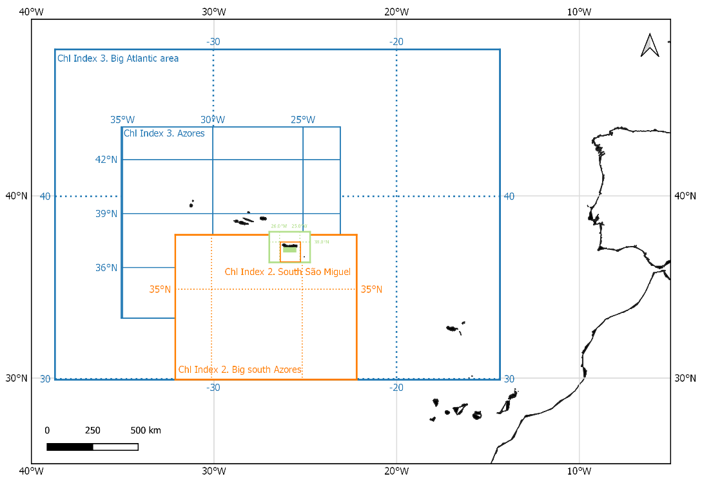
Supp. Fig. 1. Map highlighting the areas used to calculate the Chlorophyll Index. Chlorophyll Index were calculated as the mean of the highest 5% chlorophyll values in a small area divided by the chlorophyll mean in a larger area. For instance, Chlorophyll Index 1 (in green) was a ratio between the highest value in coastal São Miguel (37.65-37.75ºN, 25.8-25.3ºW) and the average for São Miguel (37-38.5ºN, 26.5-24.5ºW); Chlorophyll Index 2 (in orange) compared south São Miguel (37-38ºN, 26-25ºW) with a bigger area south of the Azores (30-38ºN, 32-22ºW); and Chlorophyll Index 3 (in blue) compared the Azores (35-42ºN, 33-25ºW) and a bigger Atlantic area (30-48ºN, 38-15ºW).
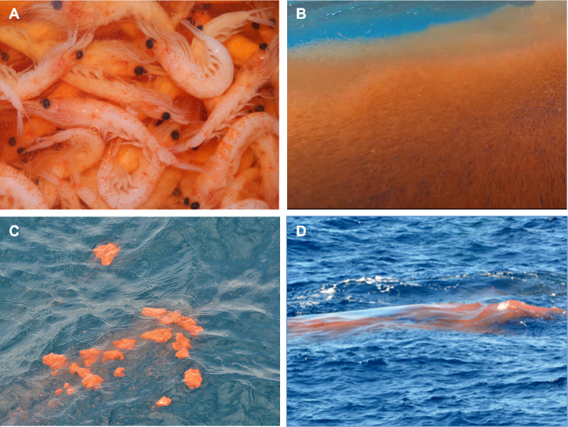
Supp. Fig. 2. Krill and whale faeces encountered during the study period. A) Krill found at the surface in May 2014, and B) in May 2013. C) Fin whale faeces in chunks (the biggest chunks reached approximately 15 cm in length, and easily broke into smaller pieces) and (D) faecal plume more liquid and dissolved. All photos were taken on whale watching trips by Futurismo Azores Adventures by (A) Wesley Zadelhoff, (B) Maite Goenaga, (C) Laura Otero and (D) Miranda van der Linde.
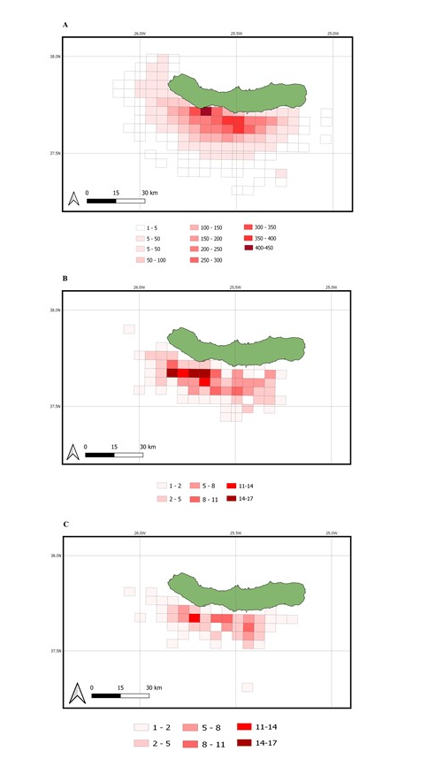
Supp. Fig. 3. Number of sightings per 5 km² sighted between May 2008 and December 2014 off São Miguel. A) Sightings of all species. B) Fin whale sightings. C) Sei whale sightings.
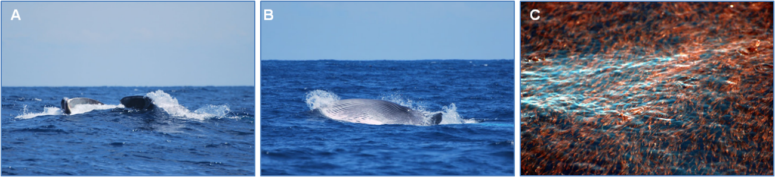
Supp. Fig. 4. A-B) Sei whales feeding during our sea surveys. Open mouth and lunge feeding behaviour on the 28th May 2011. C) Krill on the surface where the sei whale from the photos A and B was feeding.

