SUPPLEMENTARY MATERIAL

Comparative phylogeography in a marine biodiversity hotspot provides novel insights into evolutionary processes across the Atlantic-Indian Ocean transition
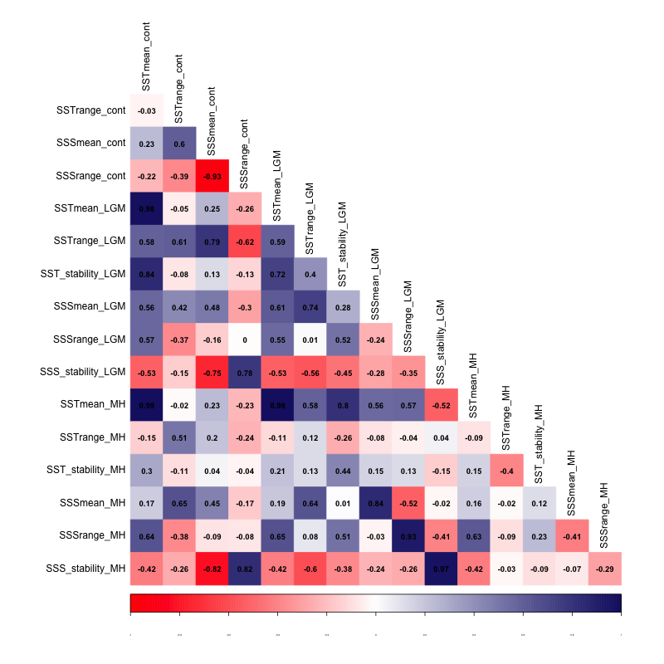
Figure S1 : Pearson’s correlation between environmental predictors, shown for Sea Surface Temperature (SST) and Sea Surface Salinity (SSS), for the present day (*_cont), Mid-Holocene (*_MH) and Last Glacial Maximum (*_LGM).
Table S1: List of species, with the number of sites and samples (individuals) taken in each bioregions, their distribution range, their preferred habitat and average values of haplotype and nucleotide diversity.
 | # of sites (# samples) |  |  |  |  | Western range limit | Eastern range limit | Habitat | Mean h | Mean π | References
 | CT | SW | WT | ST | Total
Acanthochiton garnoti (Aga) | 6 (105) | 4  (70) | 5  (51) | 1  (22) | 16  (248) | Port Nolloth | Port St Johns | Hard substrate | 0.947 | 0.008 | (Wright et al., 2015)
Afrolittorina africana (Aaf) | - | - | 3  (91) | 8  (96) | 11  (187) | False Bay | Southern Mozambique | Hard substrate | 0.360 | 0.001 | (Matumba et al., 2020)
Afrolittorina knysnaensis (Akn) | 7  (181) | 2  (17) | 7  (71) | 4  (43) | 20  (312) | Namibia | Port St Johns | Hard substrate | 0.299 | 0.001 | (Matumba et al., 2020)
Bullia rhodostoma (Brh) | 2  (39) | 2  (39) | 4  (59) | 2  (45) | 10  (182) | Cape Point | Port St Johns | Soft substrate | 0.828 | 0.076 | (Muteveri et al., 2015)
Caffrogobius caffer (Cca) | 3  (69) | 3  (69) | 6  (148) | 1  (21) | 13  (307) | Port Nolloth | Haga Haga | Hard substrate | 0.961 | 0.010 | (Neethling et al., 2008)
Chrysoblephus puniceus (Chu) | - | - | 6  (116) | 3  (112) | 9  (228) | Cape Point | East London | Hard substrate | 0.970 | 0.012 | (Duncan et al., 2015)
Cyclograpsus punctatus (Cpu) | 4  (57) | 3  (44) | 4  (61) | 2  (27) | 13  (189) | Jacobs Bay | Ponta de Ouro | Hard substrate | 0.758 | 0.009 | (Wright et al., 2015)
Jasus lalandii (Jla) | 6  (195) | 2  (67) | - | 1  (10) | 9  (272) | southern Namibia | Algoa Bay | Hard substrate | 0.603 | 0.002 | (Matthee et al., 2007)
Lithognathus lithognathus (Lli) | 2  (55) | 1  (55) | 4  (91) | 2  (65) | 9  (266) | northern Namibia | Mozambique | Soft substrate | 0.986 | 0.012 | (Bennett et al., 2017)
Nassarius kraussianus (Nkr) | 3  (29) | 1  (10) | 3  (30) | 4  (40) | 11  (109) | Namibia | Mozambique | Soft substrate | 0.685 | 0.002 | (Teske et al., 2007a)
Oxystele tigrina (Oti) | 10  (253) | 2  (39) | 6  (126) | 1  (24) | 19  (442) | Port Nolloth | Port St Johns | Hard substrate | 0.919 | 0.006 | (Wright et al., 2015; Mertens et al., 2018)
Oxystele antoni (Ova) | 4  (71) | 1  (9) | 4  (77) | 1  (15) | 10  (172) | Namibia | Port St Johns | Hard substrate | 0.675 | 0.003 | (Wright et al., 2015)
Palaemon peringueyi (Ppa) | 5  (52) | 2  (20) | 10  (76) | 3  (27) | 20  (175) | Walvis Bay (Namibia) | Kosi Bay | Soft substrate | 0.824 | 0.007 | (Teske et al. 2007)
Parechinus angulosus (Pan) | 10  (294) | 4  (126) | 5  (103) | 2  (62) | 21  (585) | Luderitz | Durban | Hard substrate | 0.909 | 0.008 | (Muller et al., 2012)
Perna perna (Ppe) | 2  (91) | 2  (91) | 4  (218) | 4  (110) | 12  (510) | Angola | Mozambique | Hard substrate | 0.770 | 0.004 | (Teske et al., 2013) + unpublished data
Siphonaria capensis (Sca) | - | - | 2  (83) | 3  (42) | 5  (125) | Namibia | Mozambique | Hard substrate | 0.810 | 0.004 | (Teske et al., 2011a, 2013)
Siphonaria serrata (Sse) | - | - | 2  (92) | 9  (205) | 11  (297) | Cape Point | Tongati | Hard substrate | 0.556 | 0.003 | (Teske et al., 2013)

Table S2. List of species in which within-bioregion Φ_{ST} values were calculated, with number (#) of sites used to calculate values, along with the significance of the values at p<0.05. The Φ_{ST} values are shown per species, per bioregion.

Species | Cool temperate (CT) | South-West (SW) | Warm Temperate (WT) | Subtropical (ST)
Acanthochiton garnoti
# sites |  | 4 | 5
within-region Φ_{ST} |  | 0.08169 | 0.04394
p-value |  | 0.00000+-0.00000 | 0.00489+-0.00203
Afrolittorina africana
# sites |  |  | 4 | 10
within-region Φ_{ST} |  |  | 0.12402 | 0.03524
p-value |  |  | 0.07625+-0.00842 | 0.04106+-0.00517
Afrolittorina knysnaensis
# sites | 5 |  | 8 | 4
within-region Φ_{ST} | 0 |  | 0 | 0.00637
p-value | 0.89932+-0.00988 |  | 0.53275+-0.01021 | 0.35386+-0.01358
Excirolana latipes
# sites | 4 | 4
within-region Φ_{ST} | 0.45979 | 0.31052
p-value | 0.00000+-0.00000 | 0.00098+-0.00098
Nassarius kraussianus
# sites |  |  | 3 | 4
within-region Φ_{ST} |  |  | 0.01645 | 0.13978
p-value |  |  | 0.33333+-0.01225 | 0.00391+-0.00185
Oxystele antoni
# sites | 3 | 4
within-region Φ_{ST} | 0.00309 | 0.00827
p-value | 0.48485+-0.01552 | 0.22385+-0.01095
Parechinus angulosus
# sites | 6 | 4 | 5
within-region Φ_{ST} | 0.28265 | 0.00597 | 0.08235
p-value | 0.00000+-0.00000 | 0.20528+-0.01538 | 0.00000+-0.00000
Tetraclita serrata
# sites | 4 | 4 | 7
within-region Φ_{ST} | 0.07692 | 0.16186 | 0.00219
p-value | 0.00000+-0.00000 | 0.00000+-0.00000 | 0.33333+-0.01419
Total sites | 22 | 20 | 32 | 18
Total species | 5 | 5 | 6 | 3

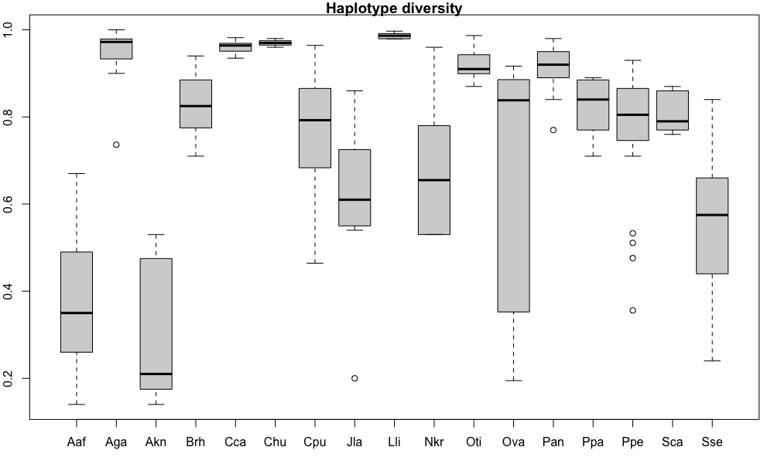
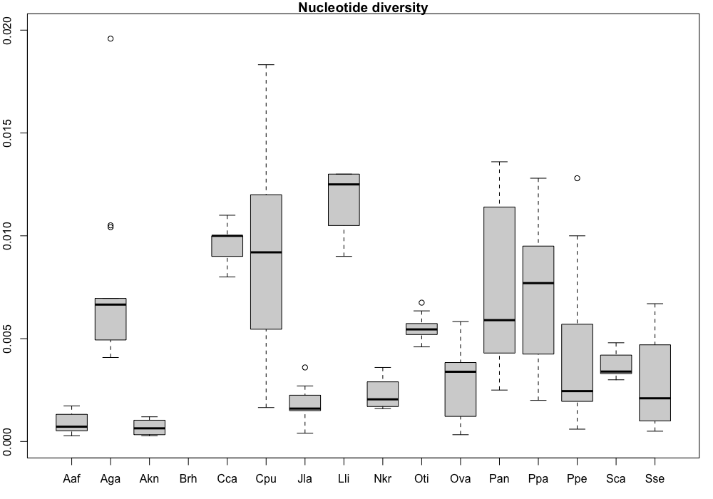
Figure S2 : boxplot of the haplotype and nucleotide diversity per species.

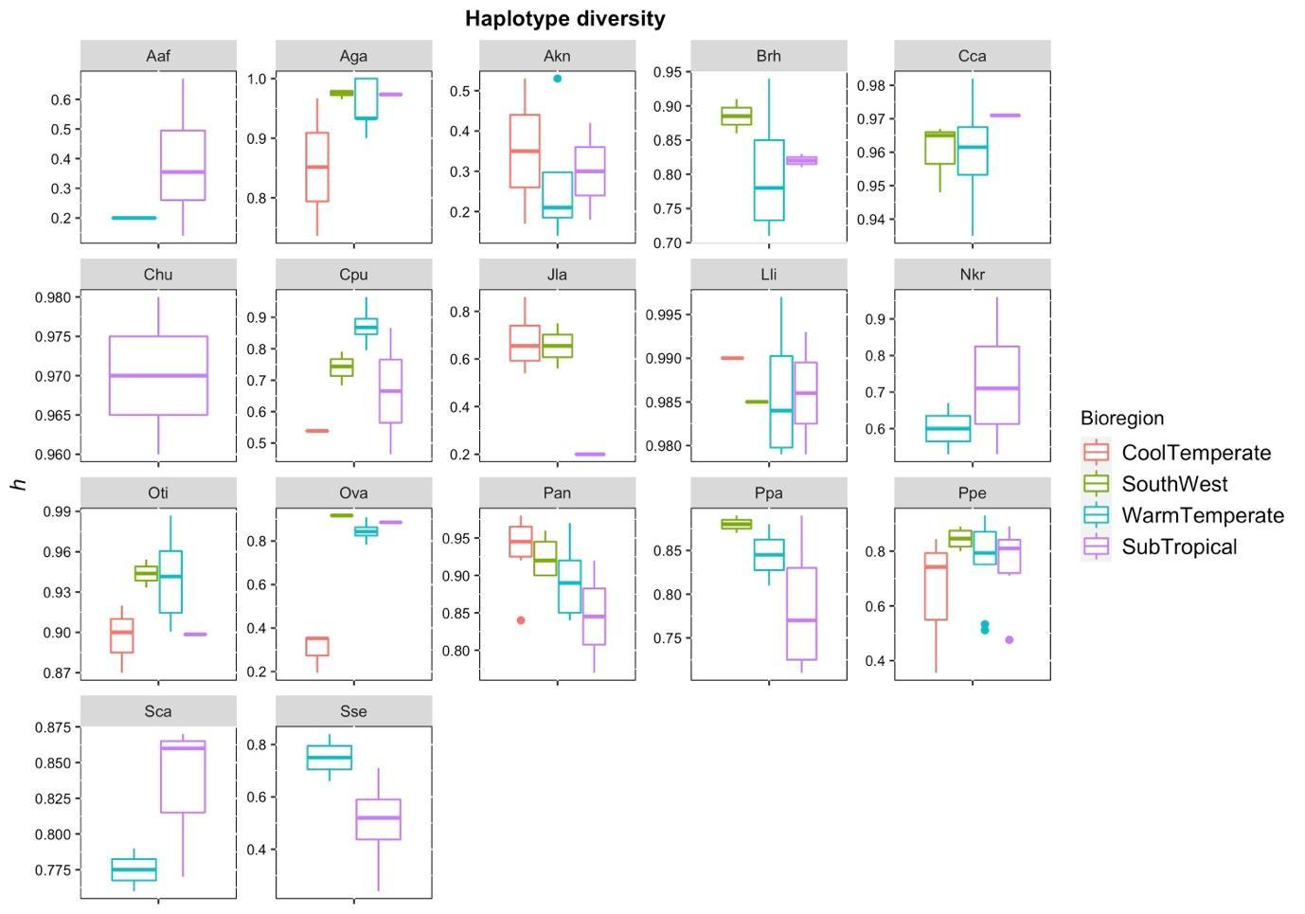
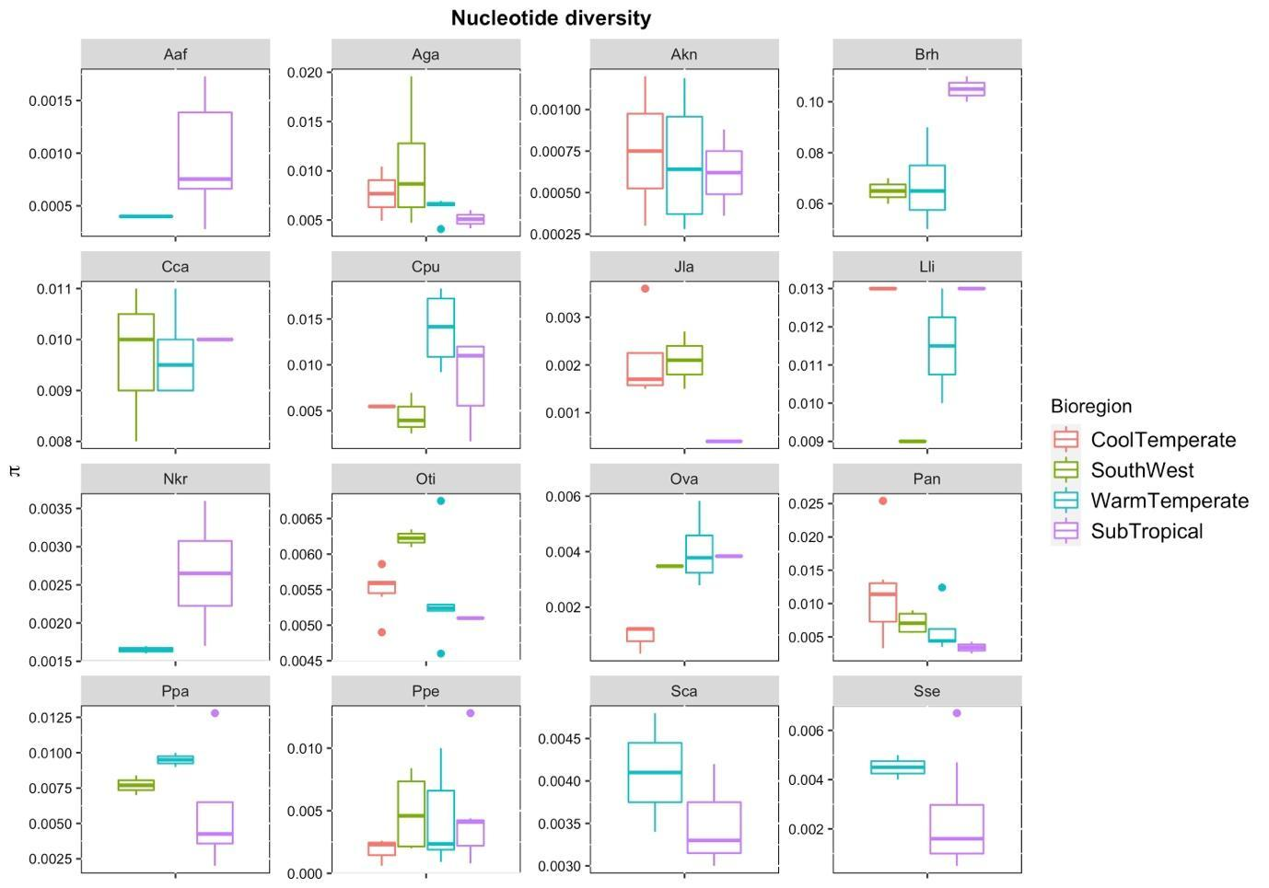
Figure S3 : boxplot of the haplotype and nucleotide diversity per species and bioregion.

