Disentangling the components of coastal fish biodiversity in southern Brittany by applying an environmental DNA approach.

Supplementary Material
Appendices
Appendix 1 - Sampling metadata table
Appendix 2 - Tables of the taxa composition for each of the 34 filters
Appendix 3 - Traits table for 81 species.
Appendix 4 - Overview of the seven functional traits used associated with different fish functions.
Appendix 5 - Overview of the functional indices computed.
Appendix 6 - Overview of the phylogenetic indices computed.
Appendix 7 - Correlation matrix between the 𝛼-diversity indices.
Appendix 8 - Barplot of the Jaccard dissimilarity between the two replicates collected on each of the 17 stations.
Appendix 9 - Map of the spatial distribution of three Standard Effect Size (SES) values of richness indices.
Appendix 10 - Overview of the observed values for the spatial distribution of richness, divergence and regularity indices for each biodiversity component in the study area.
Appendix 11- Barplots of the taxonomic, functional and phylogenetic β-diversity and their respective turnover and nestedness-resultant components.
Appendix 12 - Sensitivity analysis: Correlation and overview of the observed values for the spatial distribution of richness, divergence and regularity indices for each biodiversity component in the study area computed without Elasmobranch.

Appendix 13 - Sensitivity analysis: Correlation and overview of the observed values for the spatial distribution of richness, divergence and regularity indices for each biodiversity component in the study area computed with the random selection of filters per station.
Appendix 14 - Phylogenetic signal and correlation between functional traits and PCoA axes.

Appendix 1: Sampling metadata table.

 | Station | Code | Code  SPYGEN | Répl  1/ 2 | Sampling  Date | Station/  Transect | Start | End | Duration  (min) | Temp.  (°C) | Latitude  start | Longitude  start | Latitude  end | Longitude  end | Volume  (L) | Area  Depth  (m) | Sampling  Depth
North  stations  (Iroise Sea) | Chaussee_de_sein | CdS | SPY193095 | 1 | 08/09/20 | Station | 9h55 | 10h25 | 30 | 13.8 | 48°03.471 | 5°04.757 | - | - | 30 | 76 | surface
 | Chaussee_de_sein | CdS | SPY192828 | 2 | 08/09/20 | Station | 9h55 | 10h25 | 30 | 13.8 | 48°03.471 | 5°04.757 | - | - | 30 | 76 | surface
 | Chaussee_de_sein-2 | CdS-2 | SPY193099 | 1 | 08/09/20 | Station | 10h51 | 11h21 | 30 | 14.1 | 48°02.775 | 5°04.206 | - | - | 30 | 76 | surface
 | Chaussee_de_sein-2 | CdS-2 | SPY193089 | 2 | 08/09/20 | Station | 10h51 | 11h21 | 30 | 14.1 | 48°02.775 | 5°04.206 | - | - | 30 | 76 | surface
 | Raz_de_sein | RdS | SPY193078 | 1 | 09/09/20 | Transect | 6h06 | 6h36 | 30 | 15.5 | 48°00.581 | 4°43.615 | 48°02.294 | 4°47.032 | 30 | 28 | surface
 | Raz_de_sein | RdS | SPY193073 | 2 | 09/09/20 | Transect | 6h06 | 6h36 | 30 | 15.5 | 48°00.581 | 4°43.615 | 48°02.294 | 4°47.032 | 30 | 28 | surface
 | Raz_de_sein-2 | RdS-2 | SPY193080 | 1 | 09/09/20 | Transect | 6h54 | 7h24 | 30 | 14.64 | 48°02.900 | 4°46.850 | 48°04.200 | 5°50.100 | 30 | 38 | surface
 | Raz_de_sein-2 | RdS-2 | SPY193084 | 2 | 09/09/20 | Transect | 6h54 | 7h24 | 30 | 14.64 | 48°02.900 | 4°46.850 | 48°04.200 | 5°50.100 | 30 | 38 | surface
 | Tévennec | T | SPY193069 | 1 | 09/09/20 | Transect | 7h48 | 8h28 | 30 | 14.37 | 48°04.400 | 4°49.680 | 48°04.950 | 4°46.900 | 30 | 37 | surface
 | Tévennec | T | SPY192837 | 2 | 09/09/20 | Transect | 7h48 | 8h28 | 30 | 14.37 | 48°04.400 | 4°49.680 | 48°04.950 | 4°46.900 | 30 | 37 | surface
 | Nord_  Tévennec | NT | SPY193071 | 1 | 09/09/20 | Transect | 8h40 | 9h10 | 30 | 14.64 | 48°05.100 | 4°48.560 | 48°05.880 | 4°45.800 | 30 | 52 | surface
 | Nord_  Tévennec | NT | SPY193074 | 2 | 09/09/20 | Transect | 8h40 | 9h10 | 30 | 14.64 | 48°05.100 | 4°48.560 | 48°05.880 | 4°45.800 | 30 | 52 | surface
 | Baie_  douarnenez_Nord | BdN | SPY193077 | 1 | 09/09/20 | Transect | 9h32 | 10h02 | 30 | 15.00 | 48°05.700 | 4°45.500 | 48°07.200 | 4°43.200 | 30 | 48 | surface
 | Baie_  douarnenez_Nord | BdN | SPY193072 | 2 | 09/09/20 | Transect | 9h32 | 10h02 | 30 | 15.00 | 48°05.700 | 4°45.500 | 48°07.200 | 4°43.200 | 30 | 48 | surface
 | Pointe_du_  Raz | PdR | SPY193075 | 1 | 09/09/20 | Transect | 10h37 | 11h07 | 30 | 14.64 | 48°04.900 | 4°42.900 | 48°02.350 | 4°44.500 | 30 | 46.5 | surface
 | Pointe_du_  Raz | PdR | SPY193076 | 2 | 09/09/20 | Transect | 10h37 | 11h07 | 30 | 14.64 | 48°04.900 | 4°42.900 | 48°02.350 | 4°44.500 | 30 | 46.5 | surface
South stations | Baie_  Audierne_T1 | BA-1 | SPY193087 | 1 | 10/09/20 | Transect | 6h16 | 6h46 | 30 | 16.3 | 47°52.300 | 4°29.271 | 47°53.0885 | 4°29.271 | 30 | 55 | surface
 | Baie_  Audierne_T1 | BA-1 | SPY193088 | 2 | 10/09/20 | Transect | 6h16 | 6h46 | 30 | 16.3 | 47°52.300 | 4°29.271 | 47°53.0885 | 4°29.271 | 30 | 55 | surface
 | Baie_  Audierne_T2 | BA-2 | SPY193097 | 1 | 10/09/20 | Transect | 7h02 | 7h32 | 30 | 16.6 | 47°53.0885 | 4°32.2429 | 47°54.470 | 4°32.2429 | 30 | 58 | surface
 | Baie_  Audierne_T2 | BA-2 | SPY193092 | 2 | 10/09/20 | Transect | 7h02 | 7h32 | 30 | 16.6 | 47°53.0885 | 4°32.2429 | 47°54.470 | 4°32.2429 | 30 | 58 | surface
 | Baie_  Audierne_T3 | BA-3 | SPY193067 | 1 | 10/09/20 | Transect | 7h48 | 8h18 | 30 | 15.8 | 47°54.470 | 4°35.408 | 47°56.126 | 4°40.570 | 30 | 54 | surface
 | Baie_  Audierne_T3 | BA-3 | SPY193082 | 2 | 10/09/20 | Transect | 7h48 | 8h18 | 30 | 15.8 | 47°54.470 | 4°35.408 | 47°56.126 | 4°40.570 | 30 | 54 | surface
 | Baie_  Audierne_T4 | BA-4 | SPY193083 | 1 | 10/09/20 | Transect | 8h58 | 9h28 | 30 | 15.72 | 47°55.900 | 4°25.800 | 47°57.430 | 4°27.620 | 30 | 14.7 | surface
 | Baie_  Audierne_T4 | BA-4 | SPY193093 | 2 | 10/09/20 | Transect | 8h58 | 9h28 | 30 | 15.72 | 47°55.900 | 4°25.800 | 47°57.430 | 4°27.620 | 30 | 14.7 | surface
 | Baie_  Audierne_T5 | BA-5 | SPY193066 | 1 | 10/09/20 | Transect | 9h41 | 10h11 | 30 | 20.0 | 47°57.430 | 4°27.620 | 47°59.297 | 4°33.515 | 30 | 15.8 | surface
 | Baie_  Audierne_T5 | BA-5 | SPY193086 | 2 | 10/09/20 | Transect | 9h41 | 10h11 | 30 | 20.0 | 47°57.430 | 4°27.620 | 47°59.297 | 4°33.515 | 30 | 15.8 | surface
 | Baie_  Audierne_T6 | BA-6 | SPY193085 | 1 | 10/09/20 | Transect | 10h29 | 10h59 | 30 | 22.0 | 47°58.780 | 4°29.443 | 47°59.430 | 4°32.000 | 30 | 16 | surface
 | Baie_  Audierne_T6 | BA-6 | SPY193096 | 2 | 10/09/20 | Transect | 10h29 | 10h59 | 30 | 22.0 | 47°58.780 | 4°29.443 | 47°59.430 | 4°32.000 | 30 | 16 | surface
 | Baie_  Audierne_T7 | BA-7 | SPY193081 | 1 | 10/09/20 | Transect | 11h17 | 11h47 | 30 | 15.8 | 47°59.290 | 4°31.940 | 47°59.800 | 4°34.700 | 30 | 15.8 | surface
 | Baie_  Audierne_T7 | BA-7 | SPY193098 | 2 | 10/09/20 | Transect | 11h17 | 11h47 | 30 | 15.8 | 47°59.290 | 4°31.940 | 47°59.800 | 4°34.700 | 30 | 15.8 | surface
 | Sud_Armen | SA | SPY193091 | 1 | 08/09/20 | Station | 7h31 | 8h01 | 30 | 13.0 | 47°55.833 | 5°04.506 | - | - | 30 | 60 | surface
 | Sud_Armen | SA | SPY192815 | 2 | 08/09/20 | Station | 7h31 | 8h01 | 30 | 13.0 | 47°55.833 | 5°04.506 | - | - | 30 | 60 | surface
 | Sud_Sud_  Armen | SSA | SPY193094 | 1 | 08/09/20 | Station | 8h33 | 9h03 | 30 | 13.0 | 47°55.079 | 5°03.599 | - | - | 30 | 51 | surface
 | Sud_Sud_  Armen | SSA | SPY192842 | 2 | 08/09/20 | Station | 8h33 | 9h03 | 30 | 13.0 | 47°55.079 | 5°03.599 | - | - | 30 | 51 | surface
Appendix 2: Tables of the taxa composition for each of the 34 filters.
Table 1: Taxa composition for the filters in the southern stations. “1” corresponds to the taxa presence. The cells colored in yellow correspond to Elasmobranch taxa. The names in bold correspond to taxa that were not detected in any of the southern stations.
Taxon | SPY  192815  Sud_  Armen  (SA) | SPY  193091  Sud_  Armen  (SA) | SPY  192842  Sud_  Sud_  Armen (SSA) | SPY  193094  Sud_  Sud_  Armen (SSA) | SPY  193066  Baie_  Audierne_T5  (BA-5) | SPY  193086  Baie_  Audierne_T5  (BA-5) | SPY  193067  Baie_  Audierne_T3  (BA-3) | SPY  193082  Baie_  Audierne_T3  (BA-3) | SPY  193081  Baie_  Audierne_T7  (BA-7) | SPY  193098  Baie_  Audierne_T7  (BA-7) | SPY  193083  Baie_  Audierne_T4  (BA-4) | SPY  193093  Baie_  Audierne_T4  (BA-4) | SPY  193085  Baie_  Audierne_T6  (BA-6) | SPY  193096  Baie_  Audierne_T6  (BA-6) | SPY  193087  Baie_  Audierne_T1  (BA-1) | SPY  193088  Baie_  Audierne_T1  (BA-1) | SPY  193092  Baie_  Audierne_T2  (BA-2) | SPY  193097  Baie_  Audierne_T2  (BA-2)
Argentina |  |  |  |  |  |  | 1 |  |  |  | 1
Scomberesox saurus | 1 |  |  | 1
Tripterygion delaisi |  |  |  |  |  |  |  |  |  | 1
Capros aper
Trachurus | 1 | 1 | 1 | 1 |  | 1 |  | 1 | 1 | 1 | 1 | 1 | 1 | 1 | 1 | 1 | 1 | 1
Alosa |  |  |  |  |  |  |  |  |  |  |  | 1
Alosa fallax |  |  |  |  |  |  |  |  |  |  |  | 1
Sardina pilchardus | 1 | 1 |  | 1 | 1 | 1 |  | 1 | 1 | 1 | 1 | 1 | 1 | 1 | 1 | 1 | 1 | 1
Sprattus sprattus |  |  |  |  |  |  | 1 | 1 |  |  | 1 | 1 | 1 | 1 | 1 | 1 | 1 | 1
Engraulis encrasicolus | 1 | 1 | 1 | 1 |  | 1 | 1 | 1 | 1 | 1 | 1 | 1 | 1 | 1 | 1 | 1 | 1 | 1
Gadidae | 1 | 1 |  | 1 |  | 1 |  |  |  |  | 1 | 1
Merluccius merluccius | 1 | 1 |  |  |  |  |  |  | 1 |  |  |  |  |  |  | 1
Gobius paganellus |  |  |  |  |  | 1 |  |  |  | 1
Gobiusculus flavescens |  |  |  |  |  |  |  |  |  |  |  |  | 1
Lesueuri-  gobius  friesii |  |  |  |  |  |  |  |  |  |  |  |  |  |  | 1
Ctenolabrus rupestris |  | 1 |  | 1 |  |  |  |  |  | 1 | 1 | 1 | 1 |  | 1
Labrus |  | 1 |  | 1 | 1 | 1 |  |  | 1 | 1 | 1 | 1 | 1 | 1 | 1
Symphodus |  |  |  |  | 1 | 1 |  |  | 1 | 1 |  | 1 |  | 1 | 1 | 1
Symphodus melanocercus |  |  |  | 1 |  |  |  |  |  | 1 |  |  |  | 1
Chelon auratus |  |  |  |  |  | 1 |  |  |  | 1 |  |  | 1 | 1
Chelon labrosus |  |  |  |  |  |  |  |  | 1 |  |  | 1 | 1 | 1
Chelon ramada |  | 1 |  | 1 | 1 |  |  |  |  |  | 1 | 1 | 1 | 1 | 1
Gymno-  canthus |  |  |  |  |  |  |  |  |  |  |  | 1
Spinachia spinachia
Liparis
Helicolenus
Chirolo-
phis ascanii
Chelidoni-  chthys |  |  |  |  |  |  |  | 1
Scophthalmus maximus |  |  |  |  |  | 1
Salmo |  |  |  |  |  | 1
Salmo salar |  |  |  |  |  |  |  |  |  | 1
Scomber scombrus | 1 | 1 |  | 1 | 1 | 1 | 1 | 1 | 1 | 1 | 1 | 1 | 1 | 1 | 1 | 1 | 1 | 1
Thunnus |  |  |  |  |  |  |  |  | 1 | 1 |  |  | 1 | 1
Pagellus acarne
Pagellus bogaraveo | 1 | 1 |  |  |  |  |  |  |  |  |  |  | 1
Pagellus erythrinus |  |  |  |  |  |  |  |  |  |  | 1 | 1
Mola mola |  |  |  |  |  |  |  |  |  |  |  | 1 |  |  |  |  |  | 1
Ammodytes | 1 |  |  | 1 |  |  | 1 |  | 1 |  |  |  | 1 | 1 | 1
Zeus faber | 1
Dicentrarchus |  |  |  | 1 |  | 1 |  |  |  |  | 1 | 1 |  | 1 |  | 1
Dicentrarchus labrax | 1 | 1 | 1 | 1 | 1 | 1 |  | 1 | 1 | 1 | 1 | 1 | 1 | 1 | 1 | 1 |  | 1
Scyliorhinus
Scyliorhinus canicula
Mustelus asterias
Dipturus batis | 1
Leucoraja circularis | 1 |  |  |  |  |  |  |  |  |  |  |  |  |  |  | 1
Leucoraja fullonica | 1 | 1 |  |  |  |  |  |  |  |  |  |  |  |  |  | 1
Leucoraja naevus
Raja brachyura |  |  |  |  |  |  |  |  |  | 1
Raja microocellata |  |  |  |  |  |  |  |  |  |  |  |  |  | 1
Raja undulata |  |  |  |  |  | 1
Torpedo marmorata |  |  |  |  |  |  |  |  |  |  | 1 | 1 |  |  | 1
Table 2: Taxa composition for the filters in the northern stations (Iroise Sea). “1” corresponds to the taxa presence. The cells colored in yellow correspond to Elasmobranch taxa. The names in bold correspond to taxa that were not detected in any of the northern stations.
Taxon | SPY  192828  Chaussee  De_  Sein  (CdS) | SPY  193095  Chaussee  De_  Sein  (CdS) | SPY  192837  Tévennec  (T) | SPY  193069  Tévennec  (T) | SPY  193071  Nord_  Tévennec  (NT) | SPY  193074  Nord_  Tévennec  (NT) | SPY  193072  Baie_  Douarnenez  Nord  (BdN) | SPY  193077  Baie_  Douarnenez  Nord  (BdN) | SPY  193073  Raz_de  Sein  (RdS) | SPY  193078  Raz_de  Sein  (RdS) | SPY  193075  Pointe_  du_Raz  (PdR) | SPY  193076  Pointe_  du_Raz  (PdR) | SPY  193080  Raz_de_  Sein.2  (RdS-2) | SPY  193084  Raz_de_  Sein.2  (RdS-2) | SPY  193089  Chaussee  De_  Sein.2  (CdS-2) | SPY  193099  Chaussee  De_  Sein.2  (CdS-2)
Argentina |  |  |  |  |  |  |  |  |  |  |  |  |  | 1
Scomberesox saurus |  |  |  | 1
Tripterygion delaisi
Capros aper |  |  |  |  |  |  |  |  |  |  |  |  |  |  | 1
Trachurus | 1 | 1 | 1 | 1 | 1 | 1 | 1 | 1 | 1 | 1 | 1 | 1 |  | 1 | 1 | 1
Alosa
Alosa fallax
Sardina pilchardus | 1 | 1 | 1 | 1 | 1 | 1 | 1 | 1 | 1 | 1 | 1 | 1 | 1 | 1 | 1 | 1
Sprattus sprattus |  |  |  | 1 |  |  |  |  |  |  | 1
Engraulis encrasicolus | 1 | 1 | 1 |  | 1 | 1 | 1 | 1 | 1 | 1 | 1 | 1 |  | 1 | 1 | 1
Gadidae | 1 | 1 |  |  | 1 | 1 |  |  | 1 |  |  | 1 |  | 1 | 1 | 1
Merluccius merluccius |  |  | 1
Gobius paganellus |  |  |  |  |  |  |  |  |  |  | 1
Gobiusculus flavescens |  |  | 1 |  |  |  |  |  | 1 |  |  |  |  | 1 | 1 | 1
Lesueuri-
gobius
friesii
Ctenolabrus rupestris |  |  | 1 | 1 |  |  |  | 1 | 1 | 1 | 1 | 1 |  | 1 | 1 | 1
Labrus | 1 | 1 | 1 | 1 | 1 | 1 | 1 | 1 | 1 | 1 | 1 | 1 | 1 | 1 | 1 | 1
Symphodus |  |  | 1 |  |  |  |  |  | 1 | 1 | 1 | 1 | 1 | 1 |  | 1
Symphodus melanocercus |  |  | 1 |  |  |  |  |  | 1 | 1 |  |  |  |  | 1
Chelon auratus
Chelon labrosus
Chelon ramada |  |  |  |  |  |  |  |  |  | 1 | 1
Gymno-  canthus | 1 |  | 1 |  |  |  |  | 1 |  | 1 |  | 1 |  | 1 | 1 | 1
Spinachia spinachia |  |  | 1 |  |  |  |  |  |  |  |  |  |  | 1
Liparis | 1 | 1 | 1 |  | 1 |  |  |  |  | 1 | 1 | 1 |  | 1 | 1 | 1
Helicolenus | 1
Chirolophis ascanii |  |  |  |  |  |  |  | 1
Chelidoni-  chthys |  | 1 |  |  |  |  |  | 1 |  |  |  |  |  | 1
Scophthalmus maximus |  |  |  |  |  |  |  |  |  |  |  |  |  | 1
Salmo
Salmo salar
Scomber scombrus | 1 | 1 | 1 |  | 1 | 1 | 1 | 1 | 1 | 1 | 1 | 1 |  | 1 |  | 1
Thunnus |  |  |  |  | 1 |  |  |  |  |  | 1 |  |  | 1
Pagellus acarne | 1 |  | 1 | 1 | 1 |  |  | 1 | 1 | 1 |  |  |  | 1 |  | 1
Pagellus bogaraveo | 1 | 1 | 1 |  | 1 | 1 |  |  | 1 |  |  |  |  |  | 1 | 1
Pagellus erythrinus
Mola mola | 1 |  | 1
Ammody-  tes | 1 | 1 | 1 |  | 1 |  |  |  | 1 | 1 | 1 | 1 |  | 1 | 1 | 1
Zeus faber |  |  |  |  |  |  |  |  | 1
Dicentrar-  chus |  | 1 |  |  |  |  |  |  |  |  | 1 | 1 |  |  | 1
Dicentrarchus labrax | 1 | 1 | 1 |  | 1 | 1 | 1 | 1 | 1 | 1 | 1 | 1 |  | 1 | 1 | 1
Scyliorhinus |  | 1
Scyliorhinus canicula | 1 |  | 1 |  |  |  |  |  | 1 |  |  |  |  | 1
Mustelus asterias | 1 | 1 |  |  |  |  |  |  |  | 1 |  |  |  | 1 |  | 1
Dipturus batis |  |  | 1 |  |  |  |  |  |  | 1 |  |  |  | 1
Leucoraja circularis |  |  |  |  | 1 |  |  |  |  | 1 |  |  |  | 1
Leucoraja fullonica | 1 |  | 1 |  | 1 |  |  | 1 |  |  |  |  |  | 1
Leucoraja naevus |  |  |  |  |  |  |  |  |  |  |  |  |  |  |  | 1
Raja brachyura | 1 | 1 | 1 |  |  |  | 1 | 1 |  | 1 | 1 | 1 |  | 1 | 1 | 1
Raja microo-
cellata
Raja undulata |  |  |  |  |  |  | 1 |  |  |  |  | 1
Torpedo marmorata |  | 1 | 1 |  |  |  |  | 1 |  | 1 |  |  |  |  |  | 1

Appendix 3: Traits table for 81 species.
This table also includes the larger regional species list for the 15 taxa with taxonomic uncertainty that was used to randomly select one representative species for each of the 15 taxa.
Repro.Mode defines the mode of reproduction; Repro.Fertil defines the type of fertilization; Repro.ParentCare defines the type of parental care.

Species | Max  Length (cm) | Average  Depth (m) | Depth  Range (m) | Trophic  Level | Repro.Mode | Repro.Fertil | Repro.  ParentCare | Environment | Body shape
Alosa alosa | 69.0 | 155.0 | 290.0 | 3.0 | dioecism | external | none | pelagic | fusiform
Alosa fallax | 60 | 205 | 390 | 4.0 | dioecism | external | none | pelagic | fusiform
Ammodytes dubius | 25 | 54 | 94 | 3.2 | dioecism | external | none | demersal | elongated
Ammodytes marinus | 25 | 80 | 140 | 3.3 | dioecism | external | none | demersal | elongated
Ammodytes tobianus | 20 | 48.5 | 95 | 3.1 | dioecism | external | none | demersal | elongated
Argentina silus | 70.0 | 790 | 1300 | 3.3 | dioecism | external | none | bathypelagic | elongated
Argentina sphyraena | 35.0 | 375 | 650 | 3.5 | dioecism | external | none | bathydemersal | elongated
Capros aper | 30 | 370 | 660 | 3.1 | dioecism | external | none | demersal | short
Chelidonichthys cuculus | 70.0 | 207.5 | 385 | 3.8 | dioecism | external | none | demersal | fusiform
Chelidonichthys gurnardus | 60 | 175 | 330 | 3.9 | dioecism | external | none | demersal | elongated
Chelidonichthys lastoviza | 40 | 80 | 140 | 3.5 | dioecism | external | none | demersal | elongated
Chelidonichthys lucerna | 75.1 | 169 | 298 | 4.0 | dioecism | external | none | demersal | elongated
Chelidonichthys obscurus | 50.5 | 95 | 150 | 3.7 | dioecism | external | none | demersal | elongated
Chelon auratus | 59 | 15 | 10 | 2.8 | dioecism | external | none | pelagic | fusiform
Chelon labrosus | 75 | 7.5 | 15 | 2.6 | dioecism | external | none | demersal | elongated
Chelon ramada | 70 | 15 | 10 | 2.3 | dioecism | external | none | pelagic | fusiform
Chirolophis ascanii | 25 | 205 | 390 | 3.2 | dioecism | external | maternal | demersal | elongated
Ctenolabrus rupestris | 18 | 25.5 | 49 | 3.6 | dioecism | external | none | pelagic | fusiform
Dicentrarchus labrax | 103.0 | 55 | 90 | 3.5 | dioecism | external | none | demersal | fusiform
Dicentrarchus punctatus | 70.0 | 55 | 90 | 3.9 | dioecism | external | none | pelagic | fusiform
Dipturus batis | 285 | 550 | 900 | 3.5 | dioecism | internal (oviduct) | none | demersal | flat
Engraulis encrasicolus | 20 | 200 | 400 | 3.1 | dioecism | external | none | pelagic | elongated
Gadiculus argenteus | 15.3 | 550 | 900 | 3.6 | dioecism | external | none | pelagic | fusiform
Gadus morhua | 200.0 | 300 | 600 | 4.1 | dioecism | external | none | demersal | fusiform
Gobius paganellus | 13 | 7.5 | 15 | 3.3 | dioecism | external | paternal | demersal | fusiform
Gobiusculus flavescens | 6 | 10 | 20 | 3.2 | dioecism | external | paternal | bathydemersal | elongated
Gymnocanthus tricuspis | 30 | 278 | 556 | 3.3 | dioecism | external | none | demersal | elongated
Helicolenus dactylopterus | 50.0 | 575 | 1050 | 3.5 | dioecism | internal (oviduct) | none | bathydemersal | fusiform
Labrus merula | 45 | 25.5 | 49 | 3.6 | dioecism | external | paternal | demersal | fusiform
Labrus mixtus | 40.0 | 101 | 198 | 3.9 | protogyny | external | paternal | demersal | fusiform
Labrus viridis | 40 | 25.5 | 49 | 3.9 | dioecism | external | paternal | demersal | fusiform
Lesueurigobius friesii | 13 | 70 | 120 | 3.4 | dioecism | external | none | demersal | fusiform
Leucoraja circularis | 120 | 373 | 606 | 3.5 | dioecism | internal (oviduct) | none | demersal | flat
Leucoraja fullonica | 120 | 290 | 520 | 3.5 | dioecism | internal (oviduct) | none | bathydemersal | flat
Leucoraja naevus | 71 | 260 | 480 | 4.2 | dioecism | internal (oviduct) | none | demersal | flat
Liparis liparis | 15.0 | 150.5 | 299 | 3.6 | dioecism | external | none | demersal | elongated
Liparis montagui | 15.5 | 15 | 30 | 3.5 | dioecism | external | none | demersal | elongated
Melanogrammus aeglefinus | 112.0 | 230 | 440 | 4.0 | dioecism | external | none | demersal | fusiform
Merlangius merlangus | 91.5 | 105 | 190 | 4.4 | dioecism | external | none | demersal | fusiform
Merluccius merluccius | 140 | 552.5 | 1045 | 4.4 | dioecism | external | none | demersal | elongated
Micromesistius poutassou | 55.5 | 1575 | 2850 | 4.1 | dioecism | external | none | bathypelagic | elongated
Mola mola | 333 | 255 | 450 | 3.3 | dioecism | external | none | pelagic | short
Mustelus asterias | 140 | 175 | 350 | 3.6 | dioecism | internal (oviduct) | none | demersal | elongated
Pagellus acarne | 36 | 270 | 460 | 3.8 | protandry | external | none | demersal | fusiform
Pagellus bogaraveo | 70 | 425 | 550 | 4.2 | protandry | external | none | demersal | fusiform
Pagellus erythrinus | 60 | 160 | 280 | 3.5 | protogyny | external | none | demersal | fusiform
Pollachius pollachius | 130 | 120 | 160 | 4.3 | dioecism | external | none | demersal | fusiform
Pollachius virens | 130 | 200.5 | 327 | 4.3 | dioecism | external | none | demersal | fusiform
Raja brachyura | 120 | 195 | 370 | 3.8 | dioecism | internal (oviduct) | none | demersal | flat
Raja microocellata | 87 | 50 | 99 | 3.9 | dioecism | internal (oviduct) | none | demersal | flat
Raja undulata | 100 | 125 | 150 | 3.5 | dioecism | internal (oviduct) | none | demersal | flat
Salmo salar | 150 | 105 | 210 | 4.5 | dioecism | external | none | demersal | elongated
Salmo trutta | 140 | 14 | 28 | 3.4 | dioecism | external | none | pelagic | elongated
Sardina pilchardus | 27.5 | 55 | 90 | 3.1 | dioecism | external | none | pelagic | fusiform
Scomber scombrus | 60 | 500 | 1000 | 3.6 | dioecism | external | none | pelagic | fusiform
Scomberesox saurus | 50 | 15 | 30 | 3.9 | dioecism | external | none | pelagic | fusiform
Scophthalmus maximus | 100 | 45 | 50 | 4.4 | dioecism | external | none | demersal | flat
Scyliorhinus canicula | 100 | 395 | 770 | 3.8 | dioecism | internal (oviduct) | none | demersal | elongated
Scyliorhinus stellaris | 170 | 396 | 771 | 4.0 | dioecism | internal (oviduct) | none | demersal | elongated
Spinachia spinachia | 22 | 2.5 | 5 | 3.5 | dioecism | external | paternal | demersal | elongated
Sprattus sprattus | 16 | 80 | 140 | 3.0 | dioecism | external | none | pelagic | fusiform
Symphodus bailloni | 20.0 | 25.5 | 49 | 3.5 | dioecism | external | paternal | demersal | fusiform
Symphodus cinereus | 16 | 15.5 | 29 | 3.5 | dioecism | external | paternal | demersal | fusiform
Symphodus mediterraneus | 18 | 25.5 | 49 | 3.2 | dioecism | external | paternal | demersal | fusiform
Symphodus melanocercus | 14 | 13 | 24 | 3.2 | dioecism | external | paternal | demersal | fusiform
Symphodus melops | 28.0 | 15.5 | 29 | 3.4 | protogyny | external | paternal | demersal | fusiform
Symphodus ocellatus | 12 | 15.5 | 29 | 3.5 | protogyny | external | paternal | demersal | fusiform
Symphodus roissali | 17.0 | 15.5 | 29 | 3.5 | dioecism | external | paternal | demersal | fusiform
Thunnus alalunga | 140 | 300 | 600 | 4.3 | dioecism | external | none | pelagic | fusiform
Thunnus albacares | 239 | 125.5 | 249 | 4.4 | dioecism | external | none | pelagic | fusiform
Thunnus obesus | 250 | 750 | 1500 | 4.5 | dioecism | external | none | pelagic | fusiform
Thunnus thynnus | 458 | 492.5 | 985 | 4.5 | dioecism | external | none | pelagic | fusiform
Torpedo marmorata | 100 | 186 | 368 | 4.5 | dioecism | internal (oviduct) | none | demersal | flat
Trachurus mediterraneus | 60.0 | 250 | 500 | 3.8 | dioecism | external | none | demersal | fusiform
Trachurus picturatus | 60 | 185 | 370 | 3.3 | dioecism | external | none | demersal | fusiform
Trachurus trachurus | 70,0 | 525 | 1050 | 3.7 | dioecism | external | none | demersal | fusiform
Tripterygion delaisi | 8.9 | 20 | 40 | 3.4 | dioecism | external | paternal | demersal | elongated
Trisopterus esmarkii | 35.0 | 175 | 250 | 3.2 | dioecism | external | none | demersal | fusiform
Trisopterus luscus | 46.0 | 65 | 70 | 3.7 | dioecism | external | none | demersal | fusiform
Trisopterus minutus | 40.0 | 220.5 | 439 | 3.7 | dioecism | external | none | demersal | fusiform
Zeus faber | 90 | 202.5 | 395 | 4.5 | dioecism | external | none | demersal | short

Appendix 4: Overview of the seven functional traits used, associated to different fish functions in the ecosystem.

Function performed by fish | Continuous trait | Categorical trait | Ordinal trait
Food acquisition | - Trophic level |  | - Maximum length  - Position in the water column
Mobility |  | - Body shape | - Maximum length
Reproduction |  | - Reproduction mode  - Type of  fertilization  - Parental care
Defense against predation | - Trophic level | - Body shape | - Maximum length
Habitat | - Average depth  - Depth range |  | - Position in the water column

Appendix 5: Overview of all the functional indices computed .

 | Functional indice | Notation | Definition | Reference
alpha diversity | Functional richness | Fric | Volume of the convex hull shaping the species presents in the assemblage | Villéger et al., 2008
 | Functional Hill number of order 0 | HillF_q0 | number of species-pair distance unit (q= 0 means that abundances are not accounted for) | Chao et al.,  2014
 | Mean Pairwise Functional Distance | MPFD | The mean functional distance between all pairs of species | Weiher et al., 1998
 | Variance in Pairwise Functional Distance | VPFD | regularity of the functional distances among species | Myers et al., 2021
Beta  diversity | Functional Jaccard dissimilarity | 𝛽jac_Func | Total functional strategies unique to each community relative to the total functional strategies present in both communities | Villéger et al., 2013
 | Functional Jaccard turnover | 𝛽jtu_Func | Relative proportion of unique functional strategies between communities | Villéger et al., 2013
 | Functional Jaccard nestedness | 𝛽jne_Func | one of the community hosting a small subset of the diversified functional strategies presents in the other one | Villéger et al., 2013

Appendix 6: Overview of all the indices computed in the phylogenetic diversity pipeline

 | indice | Notation | Definition | Reference
alpha diversity | Phylogenetic Diversity  (Faith) | PD | Overall amount of evolutionary history in a sampled community. Sum of the branch lengths linking species through a phylogeny | Faith, 1992
 | Phylogenetic Hill number of order 0 | HillP_q0 | number of unit-branch length segments (q= 0 means that abundances are not accounted for) | Chao et al.,  2014
 | Mean Pairwise (phylogenetic)  Distance | MPD | Average phylogenetic distance among species | Tucker et al., 2017  Eme et al., 2020
 | Variance in Pairwise (phylogenetic)Distance | VPD | Variability in phylogenetic distances among species | Tucker et al., 2017  Eme et al., 2020
Beta  diversity | UniFrac dissimilarity index | UniFrac | Total branch length unique to each community relative to  the total branch length linking all species in both communities | Leprieur et al., 2012
 | Unifrac Turnover | UniFracTurn | Relative proportion of unique phylogenetic lineages between communities that is not attributable to their difference in PD | Leprieur et al., 2012
 | UniFrac Phylogenetic Diversity | UniFracPD | Amount of phylogenetic diversity caused by PD differences between phylogenetically nested communities (i.e. communities sharing at least one branch within a rooted phylogeny) | Leprieur et al., 2012

Appendix 7: Correlation matrix between the different Standardized Effect Size (SES) values of alpha-diversity metrics. The correlation is based on the Spearman method. The values correspond to the ⍴ correlation coefficient and range from -1 (red) indicating a strong negative correlation, to 1 (dark blue) indicating a strong positive correlation. The metrics names correspond to: SR = Species Richness, for the taxonomic component. MPFD = Mean Pairwise Functional Distance; VPFD = Variance in Pairwise Functional Distance; FRic = Functional Richness; HillF_q0 = Functional Hill numbers of order 0 (number of species-pair distance unit), for the functional component. MPD = Mean Pairwise (phylogenetic) Distance; VPD = Variance in Pairwise (phylogenetic) Distance; PD = Phylogenetic Diversity; HillP_q0 = Phylogenetic Hill numbers of order 0 (number of unit-branch length segments), for the phylogenetic component.

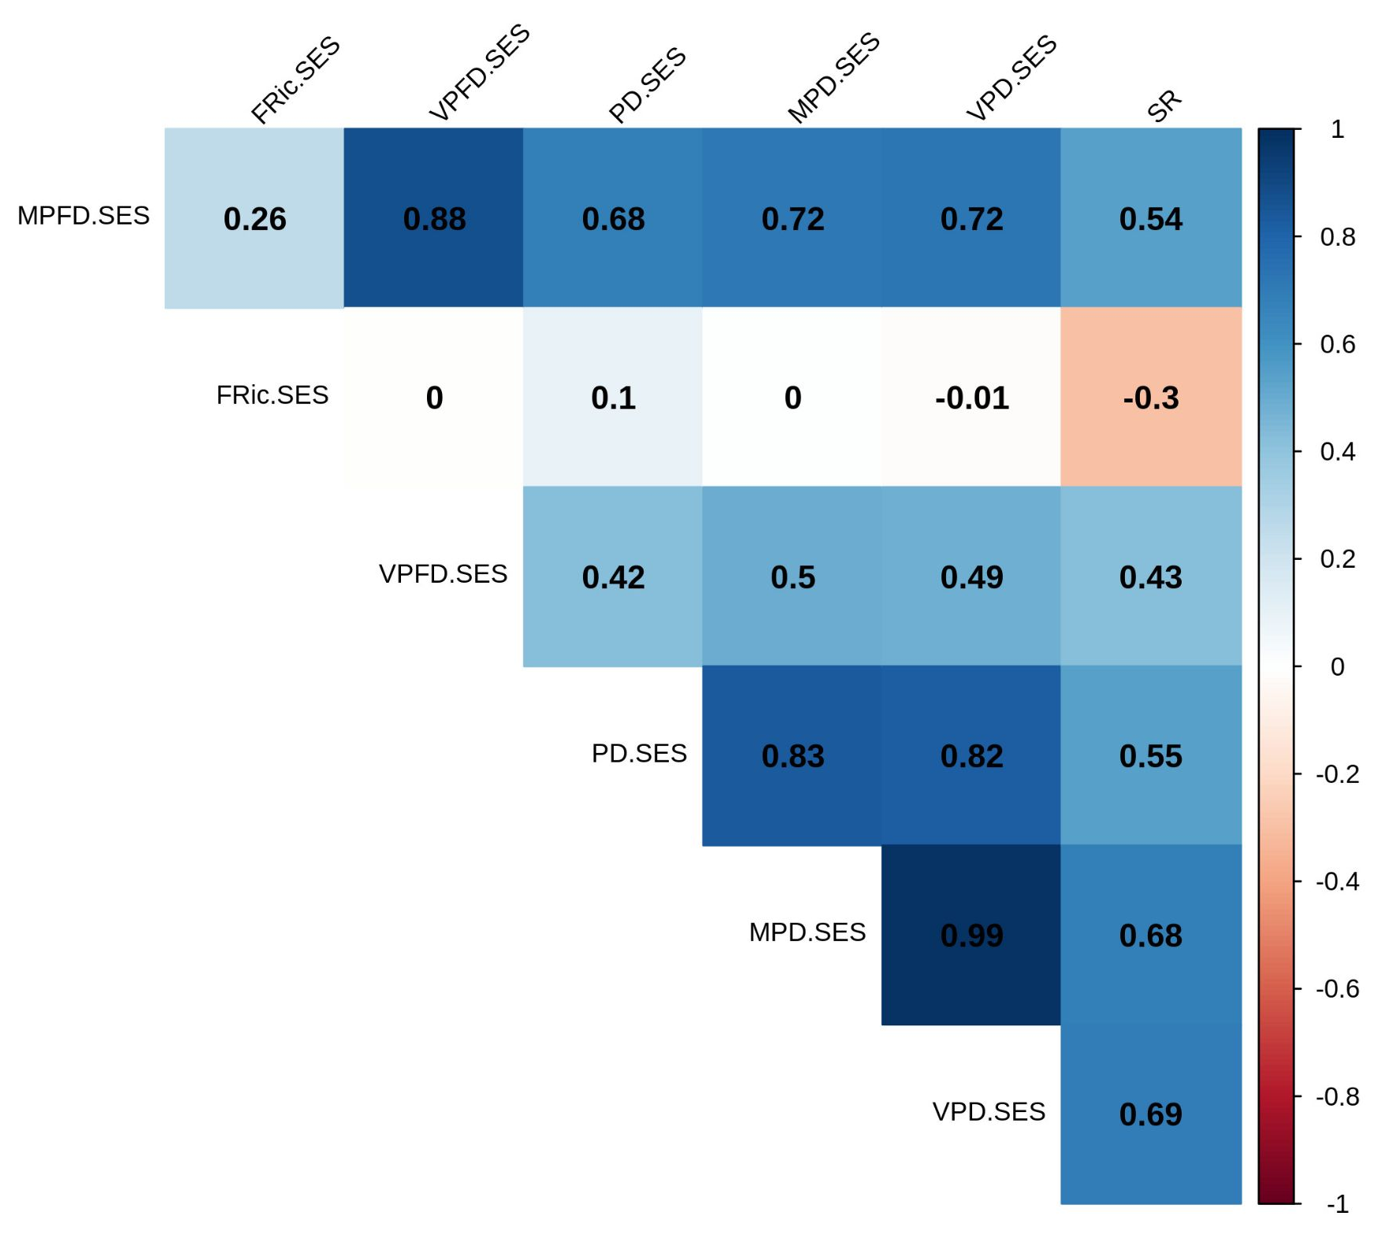

Appendix 8: Barplot of the taxonomic Jaccard dissimilarity between the two filters collected on each of the 17 stations ( 𝛽jac = 𝛽jtu + 𝛽jne). The abbreviations correspond to the names of the stations: BA-1 to 7: Baie Audierne 1 to 7/ BDN: Baie Douarnenez Nord/ CdS (-2): Chaussée de Sein/ NT: Nord Tévennec/ PdR: Pointe du Raz/ RdS(-2): Raz de Sein/ SA: Sud Armen/ SSA: Sud Sud Armen/ T: Tévennec. The maximum value is 𝛽jac = 0.42

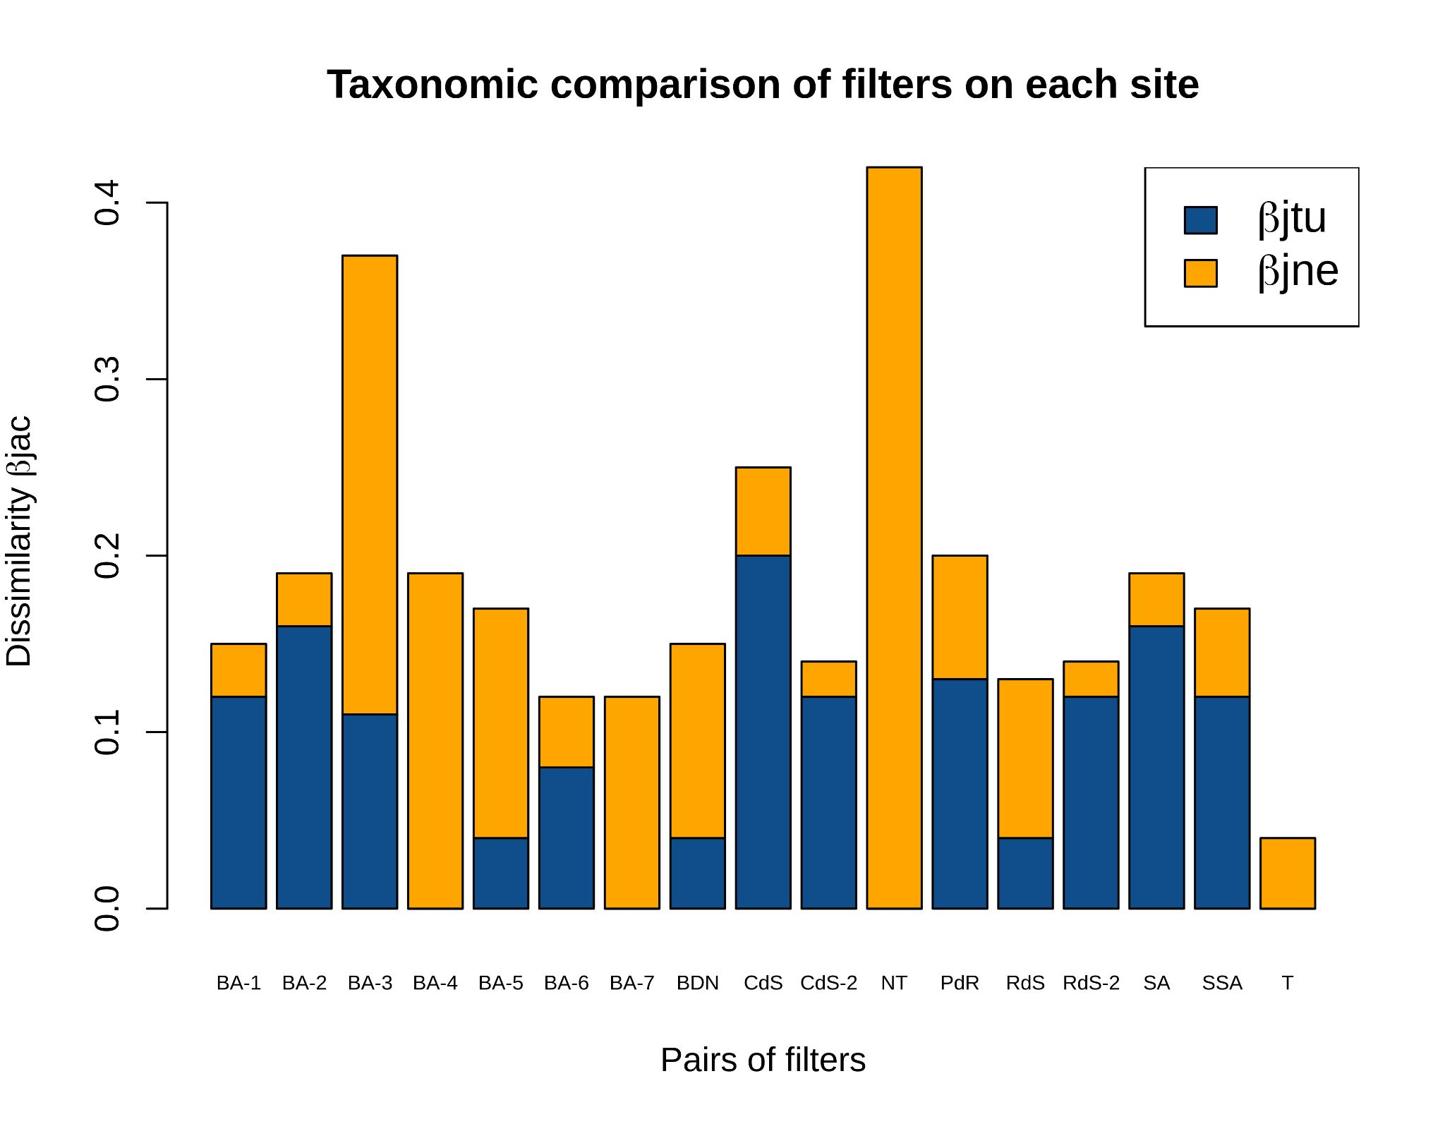

Appendix 9: Map of the spatial distribution of three Standardized Effect Size (SES) values of richness indices (normalized) in all the sampling stations. The abbreviations correspond to the names of the stations: BA-1 to 7: Baie Audierne 1 to 7, BDN: Baie Douarnenez Nord, CdS(-2): Chaussée de Sein, NT: Nord Tévennec), PdR: Pointe du Raz, RdS(-2): Raz de Sein, SA: Sud Armen, SSA: Sud Sud Armen, T: Tévennec. The radar plots range from 0 (center) to 1 (vertices).

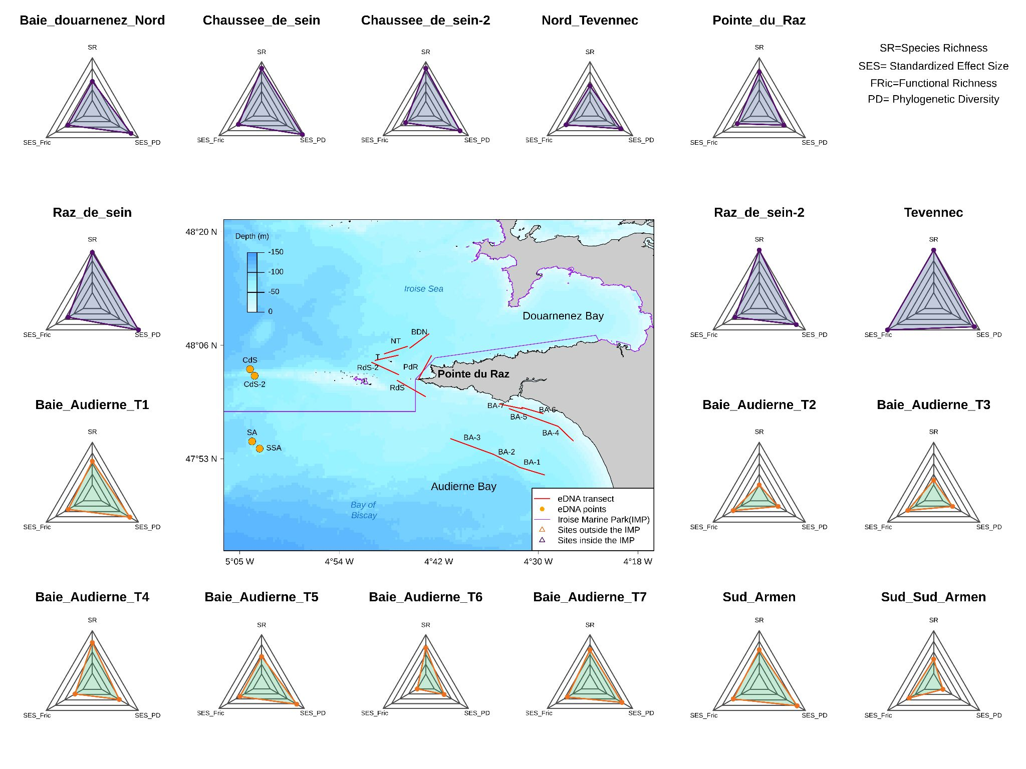

Appendix 10: Overview of the observed values for the spatial distribution of richness, divergence and regularity indices for each biodiversity component in the study area.

The abbreviations correspond to the names of the stations: BA-1 to 7: Baie Audierne 1 to 7/ BDN: Baie Douarnenez Nord/ CdS(-2): Chaussée de Sein/ NT: Nord Tévennec/ PdR: Pointe du Raz/ RdS(-2): Raz de Sein/ SA: Sud Armen/ SSA: Sud Sud Armen/ T: Tévennec. (a) - PCA of observed 𝛼-diversity indices. The color gradient represents the 𝛼-diversity indices range, from blue (minimization) to red (maximization). Arrows represent: functional richness (Fric), phylogenetic diversity (PD), Species Richness (SR), Mean Pairwise (phylogenetic) Distance (MPD), Mean Pairwise Functional Distance (MPFD), Variance in Pairwise (phylogenetic) Distance (VPD) and Variance in Pairwise Functional Distances (VPFD). (b) - Spatial distribution of the 𝛼-diversity gradient in the study area based on the PCA colors. (c) - Spatial distribution of the richness facet in the sampling stations for each component. The radarcharts range from 0 (center) to 1 (vertices).

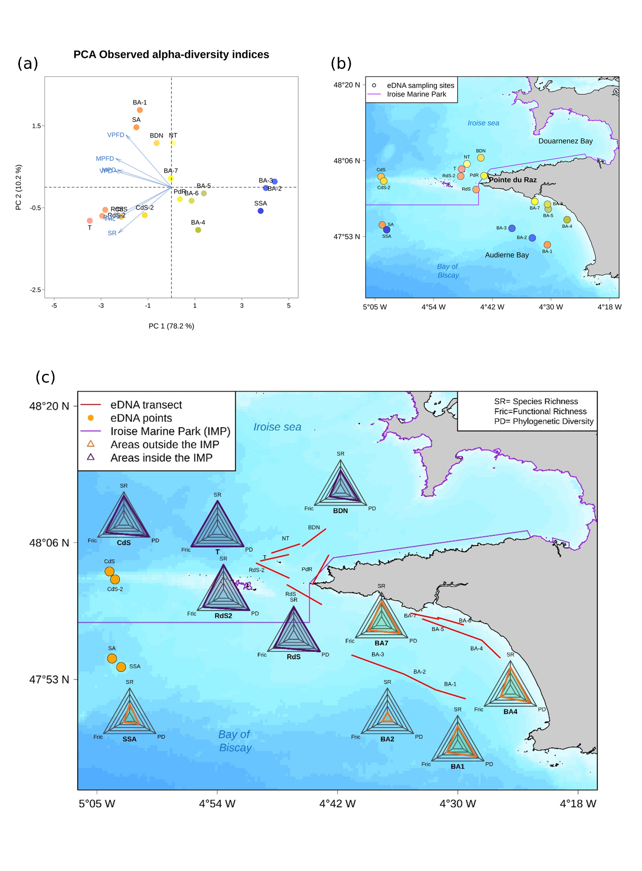

Appendix 11: Barplots of the taxonomic, functional and phylogenetic 𝛽-diversity and their respective turnover and nestedness-resultant components (𝛽jac = 𝛽jtu + 𝛽jne) for each of the 17 stations in southern Brittany. Index values for each station correspond to the average of the pairwise comparisons between that station and the 16 others weighted by the inverse of their geographical distances (Villéger et al., 2013).

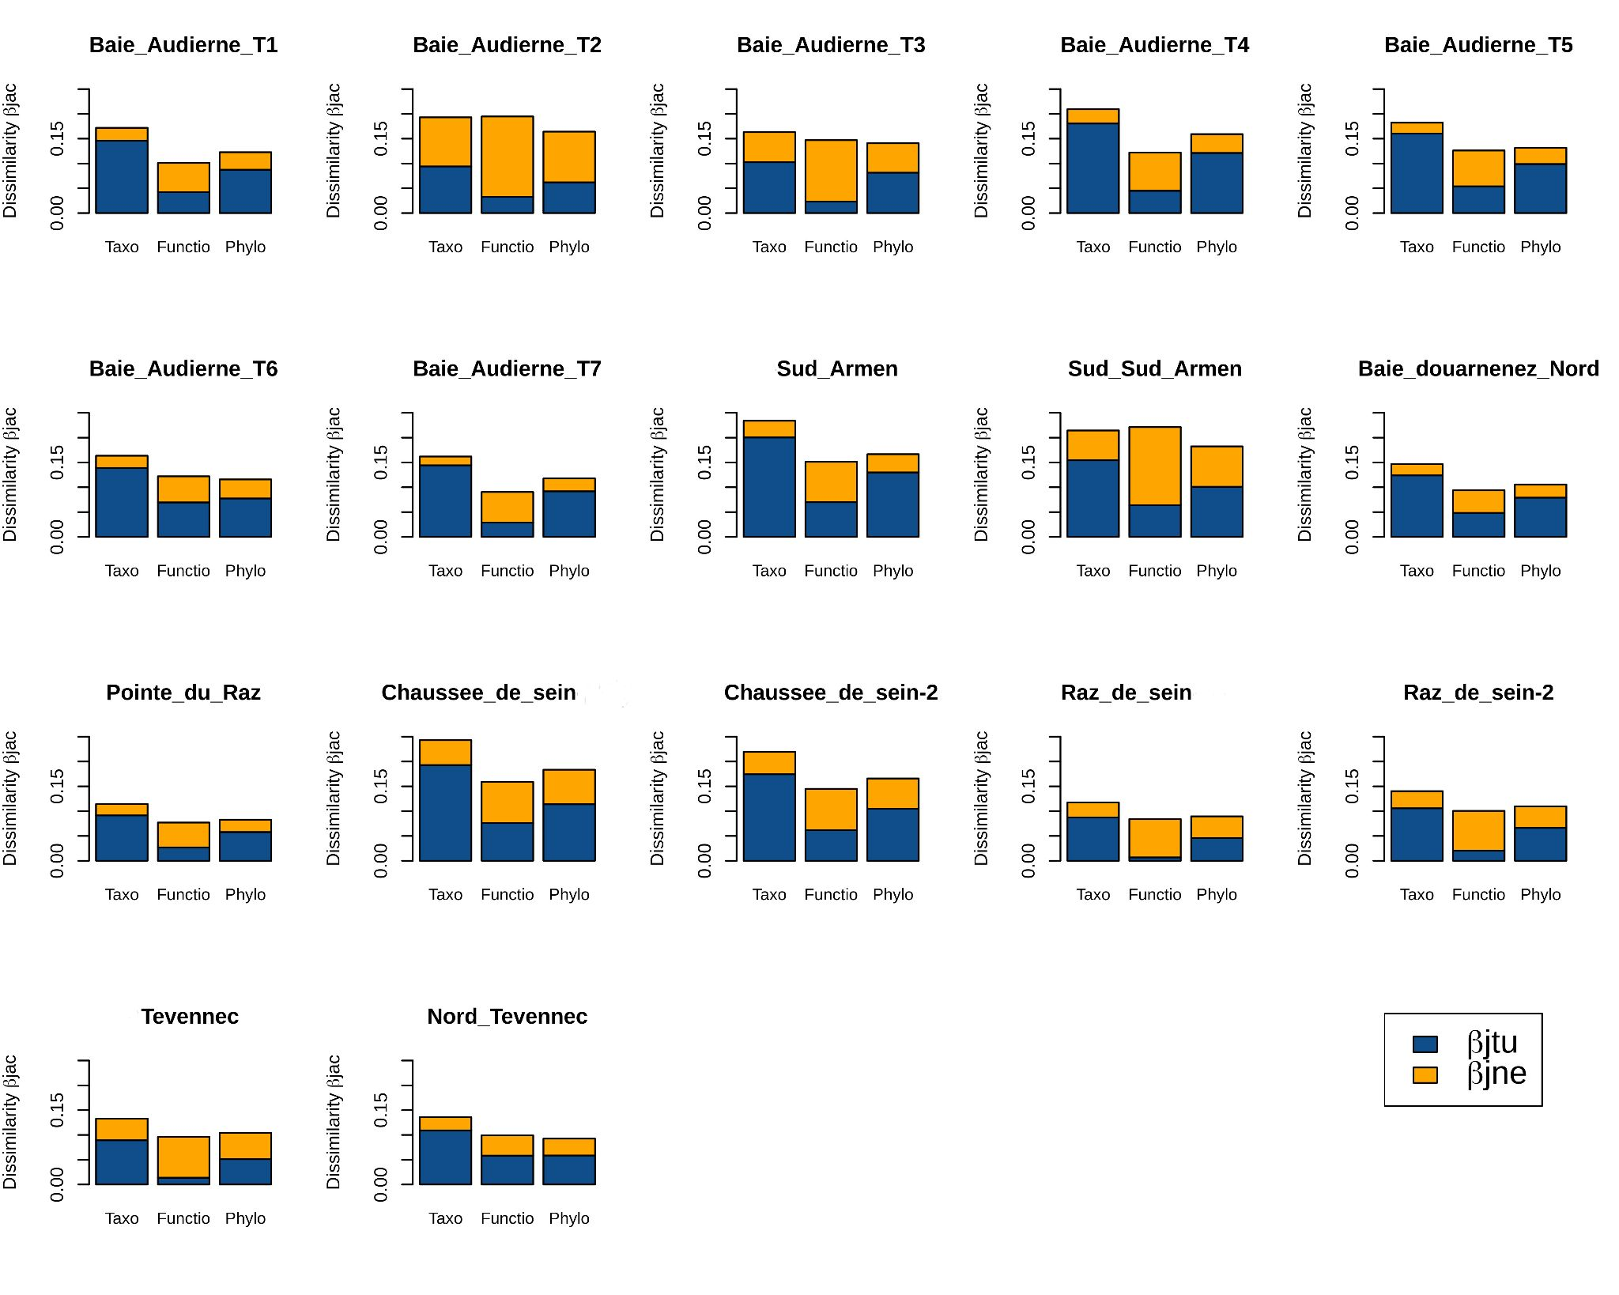

Appendix 12: Sensitivity analysis: Correlation and overview of the observed values for the spatial distribution of richness, divergence and regularity indices for each biodiversity component in the study area computed without Elasmobranch.

We computed the alpha-diversity indices without the 11 Elasmobranch taxa in order to analyze whether the North/South patterns obtained in our results were only driven by Elasmobranch. We also tested the correlation between the biodiversity values computed with and without Elasmobranch.

The strong correlation between almost all the biodiversity variables with and without Elasmobranch (See Table S12.1 below) and the similarity in the spatial gradient for the three component of biodiversity with and without Elasmobranch (See Figure S12.1 below) suggest that we observed a strong pattern already valid with Actinopterygii only, that was reinforced by the presence of Elasmobranch.

Table S12.1: Spearman’s correlation between indices computed with and without Elasmobranch
 | SR | Fric | MPFD | VPFD | PD | MPD | VPD
ρ  (Spearman) | 0.926 | 0.890 | 0.922 | 0.904 | 0.870 | -0.542 | -0.051
p-value | 9.4x10⁻⁸ | < 2.2x10⁻¹⁶ | < 2.2x10⁻¹⁶ | < 2.2x10⁻¹⁶ | < 2.2x10⁻¹⁶ | 0.03 | 0.85

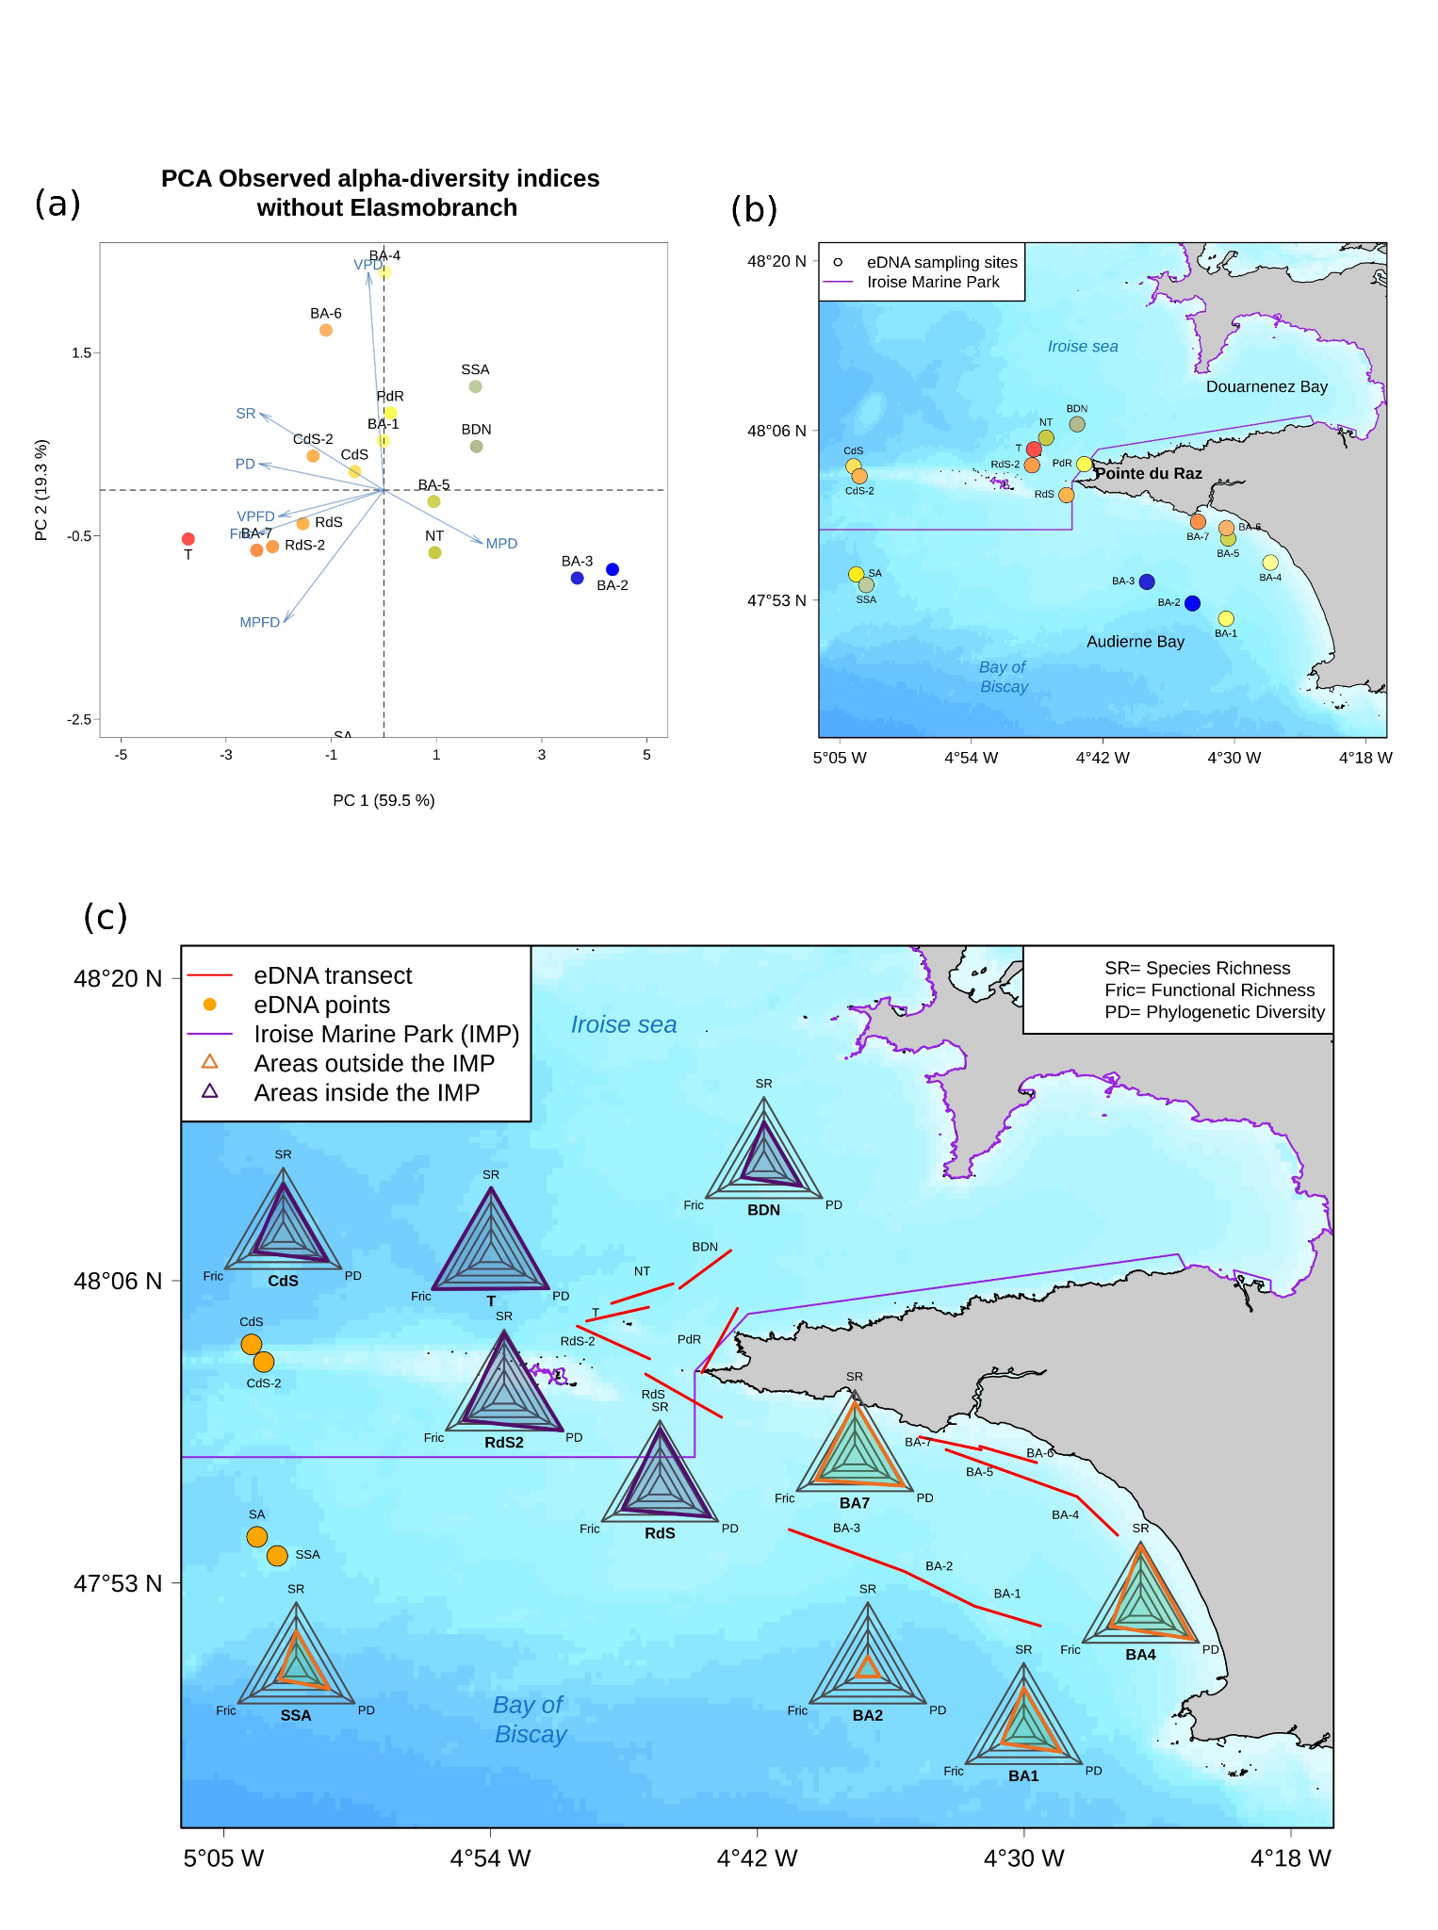
Figure S12.1: Overview of the spatial distribution of observed values of richness, divergence and regularity indices (previously normalized) for each biodiversity component in the study area including only Actinopterygii (the 11 taxa of Elasmobranch were removed). The abbreviations correspond to the names of the stations: BA-1 to 7: Baie Audierne 1 to 7/ BDN: Baie Douarnenez Nord/ CdS(-2): Chaussée de Sein/ NT: Nord Tévennec/ PdR: Pointe du Raz/ RdS(-2): Raz de Sein/ SA: Sud Armen/ SSA: Sud Sud Armen/ T: Tévennec. (a) - PCA of 𝛼-diversity indices without Elasmobranch. The color gradient represents the 𝛼-diversity indices range, from blue (minimization) to red (maximization). Arrows represent: functional richness (Fric), phylogenetic diversity (PD), Species Richness (SR), Mean Pairwise (phylogenetic) Distance (MPD), Mean Pairwise Functional Distance (MPFD), Variance in Pairwise (phylogenetic) Distance (VPD) and Variance in Pairwise Functional Distances (VPFD). (b) - Spatial distribution of the 𝛼-diversity gradient in the study area based on the PCA colors. (c) - Spatial distribution of the richness facet in the sampling stations for each component. The radarcharts range from 0 (center) to 1 (vertices).
Appendix 13: Sensitivity analysis: Correlation and overview of the observed values for the spatial distribution of richness, divergence and regularity indices for each biodiversity component in the study area computed with the random selection of filters per station.

We computed the alpha-diversity indices by using a randomisation of filters in order to analyze whether the North/South patterns obtained in our results was only due to pooling filters and thus potential variability in species detection rates between filters. Therefore, we selected one filter randomly for each of the 17 stations. We repeated this random choice 20 times and then computed the indices associated. We finally calculated the average value of each index across the 20 random draws. For the functional richness facet, we only used the functional Hill number of order 0 (Hill_Func) as not enough species were present in some filters which prevented the computation of the Fric index. We also tested the correlation between the biodiversity values based on pooling and based on the average across the 20 random draws.

The strong correlation between biodiversity variables computed with the pooled filters and the randomized filters (See Table S13.1 below) and the similarity in the spatial gradient for the three component of biodiversity with the pooled filters and the randomized filters (See Figure S13.1 below) suggest that we observed a strong pattern for both techniques ensuring that the biodiversity patterns using the pooling approach is robust.

Table S13.1: Spearman’s correlation between indices computed with the 2 filters pooled and the filter randomly chosen.
 | SR | Hill_Func | MPFD | VPFD | PD | MPD | VPD
ρ  (Spearman) | 0.898 | 0.767 | 0.721 | 0.821 | 0.760 | 0.299 | 0.292
p-value | 1.0x10⁻⁶ | 5.0x10⁻⁴ | 1.6x10⁻³ | 6.0x10⁻⁵ | 6.1x10⁻⁴ | 0.24 | 0.26

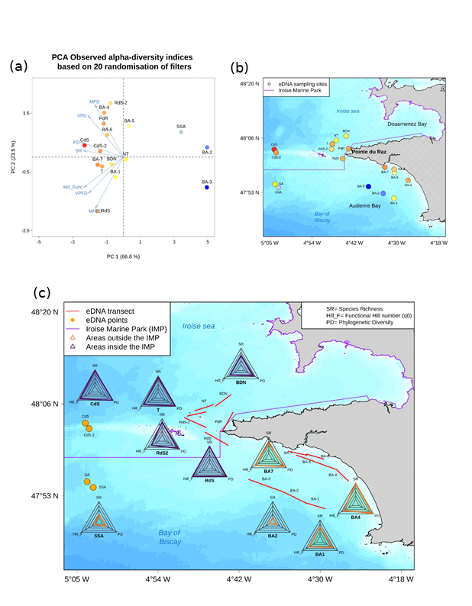
Figure S13.1: Overview of the spatial distribution of observed values of richness, divergence and regularity indices (previously normalized) for each biodiversity component in the study area based on the average value of a 20 randoms selection of one filter per station. The abbreviations correspond to the names of the stations: BA-1 to 7: Baie Audierne 1 to 7/ BDN: Baie Douarnenez Nord/ CdS(-2): Chaussée de Sein/ NT: Nord Tévennec/ PdR: Pointe du Raz/ RdS(-2): Raz de Sein/ SA: Sud Armen/ SSA: Sud Sud Armen/ T: Tévennec. (a) - PCA of 𝛼-diversity indices without Elasmobranch. The color gradient represents the 𝛼-diversity indices range, from blue (minimization) to red (maximization). Arrows represent: functional Hill number (Hill_Func), phylogenetic diversity (PD), Species Richness (SR), Mean Pairwise (phylogenetic) Distance (MPD), Mean Pairwise Functional Distance (MPFD), Variance in Pairwise (phylogenetic) Distance (VPD) and Variance in Pairwise Functional Distances (VPFD). (b) - Spatial distribution of the 𝛼-diversity gradient in the study area based on the PCA colors. (c) - Spatial distribution of the richness facet in the sampling stations for each component ((we displayed a subset of the most representative stations). The radarcharts range from 0 (center) to 1 (vertices).

Appendix 14: Phylogenetic signal and correlation between functional traits and axes.

We used a Pagel’s test (Pagel, 1999) to test for a potential phylogenetic signal in the considered functional traits, i.e. whether closely related species display more similar trait values than expected by a Brownian model of trait evolution (Pagel, 1999). Because we considered both continuous and categorical traits, we therefore used the first five PCOA axes as synthetic traits based on a mean Gower distance matrix calculated from the 100 matrices. We performed 100 tests with the 100 phylogenetic trees and then computed the mean and the standard deviation of the summary statistics of the Pagel’s test.
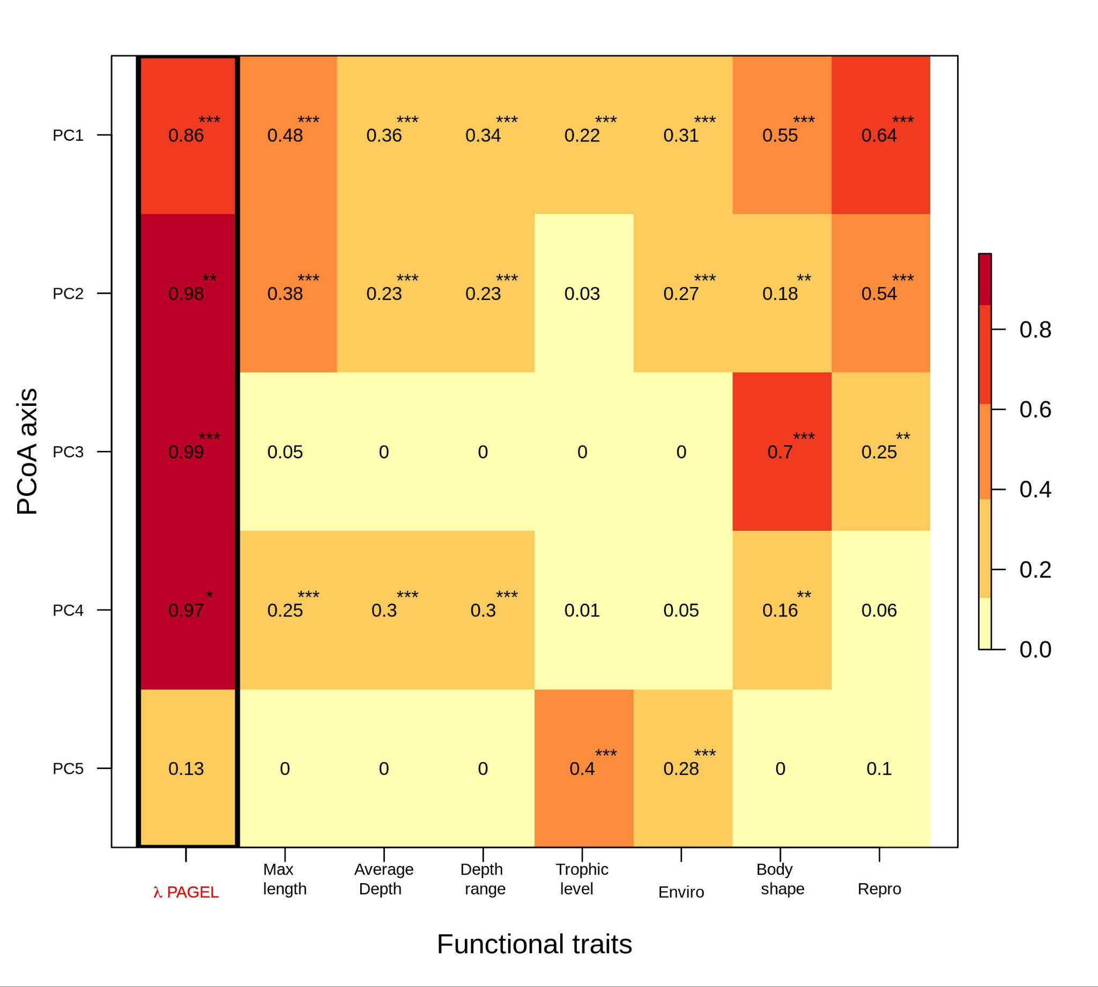
The first column corresponds to the Pagel test result for each PCoA axis (range from 0: no phylogenetic signal, to 1: strong phylogenetic signal). The other columns correspond to the coefficient of determination (R²) between each trait and axis, ranging from 0 (the trait does not explain the variance of the axis) to 1 (the trait explains all the variance of the axis). The stars indicate a significant p-value: * P < 0.1; ** P < 0.05; *** P < 0.01.

