Supporting Information for
Behavior of SRPLA (Self Reinforced PLA) in seawater

This file includes:
Identification of formed SRPLA microplastics
Details of µFTIR analysis
Recovery rate test of microplastic formation
Quality Criteria and Quality Control measures
References

Identification of formed SRPLA microplastics
To identify, characterise and quantify the microplastics formed from the SRPLA flakes we used a combination of fluorescent microscopy and image analysis [1]. All fluorescence microscopy was performed using a Leica DM1000 LED fluorescent microscope (10 x objective lens) connected with a separate beam path. Photo acquisition was performed using a Leica camera and the software LAS Core™ (Leica), and image analysis was done using ImageJ™ software [1]. Filter samples were scanned in the Blue light (BL) and Ultraviolet (UV) respectively to identify microplastic particles [2]. Preliminary tests indicated that PLA specimens showed similar colours (yellow / orange) in UV and BL filters (Figure S1). All SRPLA particles with a size over 50 µm were photographed. To confirm the polymer composition of particles, 10 % of the MP recovered at each filter were randomly selected for FTIR analysis. The amount of SRPLA particles (> 50 µm) in each filter were determined in ImageJ. Microplastic from PLA were easily distinguished from airborne fibre contamination, as natural-based fibres (cotton, paper, etc.) exhibit a blue fluorescence under UV [2].
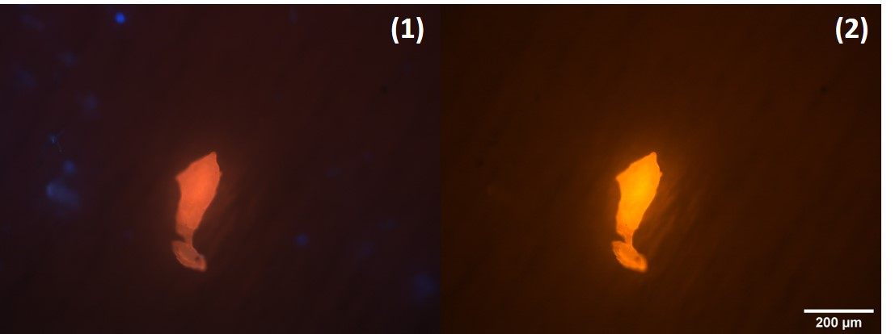
Figure S1. Fluorescence microscopy images of identified SRPLA particle under a UV filter (1), and under blue light filter (2). The SRPLA particle has a Feret’s diameter of 344 µm and looks orange/yellow under both filters. Some small-sized airborne contamination of natural fibers is detectable and has a blue color under UV filter (1), but is not detectable under the blue light filter of the fluorescent microscope (2).

Details of µFTIR analysis
A PerkinElmer FTIR spectrometer Frontier with μ-FTIR microscope Spotlight 200i (Zaventem, Belgium) was used to confirm the polymer characterisation of 10% of the visually-identified particle/fibre types. All particles were analysed with a magnification of 10x. The detector type was liquid nitrogen-cooled mercury cadmium telluride. Beam splitter OptKBr and mid-infrared (MIR) source set the infrared spectral range of 4000 - 600 cm⁻¹. All spectra were recorded in transmittance mode with a resolution of 4 cm⁻¹ with an average of 64 scans per particle. The aperture size changed relative to the size of the particle being measured (dimensions: maximum 100 x 100 µm, minimum 20 x 20 µm). Once a particle was scanned in transmission, a spectrum was produced, and a search was carried out on the spectrum for particle comparison from various commercial libraries such as POLIMERI and FIBERS3. From this, the polymer composition of the particle was determined when the percentage of certainty above 70%. The PTFE filters that supported the MP samples had high absorption in the range of 1250 – 1150 cm⁻¹, so this range was excluded when carrying out the library search.

Recovery rate test of microplastic formation
Ground SR-PLA debris (supplied by the SeaBioComp partner CENTXBEL, WP3) were pre-sieved through a 300 µm stainless steel sieve and then dispersed in glass vials by adding 0.1% Tween80 (Cospheric, USA), followed by five minutes vortexing, prior to exposure. Further dilution series were prepared in 0.2 µm pre-filtered artificial seawater (100 and 1000 particles / mL).
The recovery rate test was performed independently in triplicate with cryo-milled PLA particles at 10 and 100 particles / sample respectively. To do so the PLA particle suspensions were spiked onto clean glass slides to obtain a number of particles around 10 and 100 particles per slide. Each slide was incubated in a clean glass petri-dish overnight until dry and stained with 100 µL Nile Red. After 15 mins, the number of particles on each slide was counted on the fluorescent microscope. Then the particles on each slide were transferred to a clean quartz cuvette filled with 20 mL filtered artificial seawater. One hour later, each sample was processed and analysed the same way as in UV exposure experiments (described in 2.2 and 2.3).
The recovery rate of each sample was calculated as :
$$Recovery rate =\frac{N_{Af}}{N_{Be}}×100\% Eq.(S1)$$
Where the N_{Af} and N_{Be} is the count of MP particles on the final filter and on the glass slide, respectively.

Quality Criteria and Quality Control measures
Several Quality Criteria and Quality Control (QA/QC) measures were implemented during the experimental procedures to avoid contamination of the samples by airborne fibres and other particles. First, all solvents used were of analytical grade. All glassware was pre-cleaned using detergent, rinsed thoroughly with Milli-Q water and then heat-treated (> 170 ºC, 1 h) for sterilization. Potential sources of MP contamination were minimised by avoiding the use of any plastic equipment and using only prewashed glass and metal items. All filtration manipulations were performed in a clean flow cabinet. Finally, in the rare cases of airborne fibre contamination of PLA MP samples, natural fibres were distinguished from sample particles using fluorescence microscopy as stated above. Procedural blanks, observation of filtered water samples without plastic items to detect contamination, were carried out throughout the analysis.

References:
[1] J. Schindelin, I. Arganda-Carreras, E. Frise, V. Kaynig, M. Longair, T. Pietzsch, S. Preibisch, C. Rueden, S. Saalfeld, B. Schmid, J.-Y. Tinevez, D.J. White, V. Hartenstein, K. Eliceiri, P. Tomancak, A. Cardona, Fiji: an open-source platform for biological-image analysis, Nat. Methods. 9 (2012) 676–682. https://doi.org/10.1038/nmeth.2019.
[2] N. Meyers, A.I. Catarino, A.M. Declercq, A. Brenan, L. Devriese, M. Vandegehuchte, B. De Witte, C. Janssen, G. Everaert, Microplastic detection and identification by Nile red staining: Towards a semi-automated, cost- and time-effective technique, Sci. Total Environ. 823 (2022) 153441. https://doi.org/https://doi.org/10.1016/j.scitotenv.2022.153441.

