Exploring South African Pacific Oyster Mariculture Potential through combined Earth Observation and Bioenergetics Modelling
Corresponding author: Amalia Grace Krupandan (amalia.krupandan@stir.ac.uk)
Appendix A: Methods
Model Description (detail)
Food-derived energy is first converted to the Energy Reserves (E), and is expressed through the ingestion, digestion, and assimilation rates. The ingestion rate is dependent on surface area and temperature, as temperatures above 19 degrees have been shown to minimise the oyster’s clearance rate (Bourlès et al. 2009). Ingestion rate is also regulated by a functional response, which in turn is influenced by the food availability and the half-saturation coefficient (X_{k}). This coefficient is ecosystem-specific and must be ascertained through calibration of the model for each locality.
Energy in E is then diverted to 2 different paths. An invariable fraction of this energy (K) is allocated to structural growth and maintenance (V), while the remainder (1-K) is allocated to maturation/reproductive growth and maintenance (E_{R}). Based on the gamete mobilisation and allocation rates, some of this remainder is allocated to gonad construction (E_{GO}). When food-derived energy is insufficient to support maintenance costs, energy allocated to growth is diverted to maintenance, leading to shrinkage in volume. Growth energy is first diverted from E_{GO} (through gamete resorption), then ER (through gonad degeneration) and finally from V as structure deteriorates. All metabolic rates are influenced by temperature, with increases occurring at higher temperatures, as described by the Arrhenius equation (Bourlès et al. 2009).

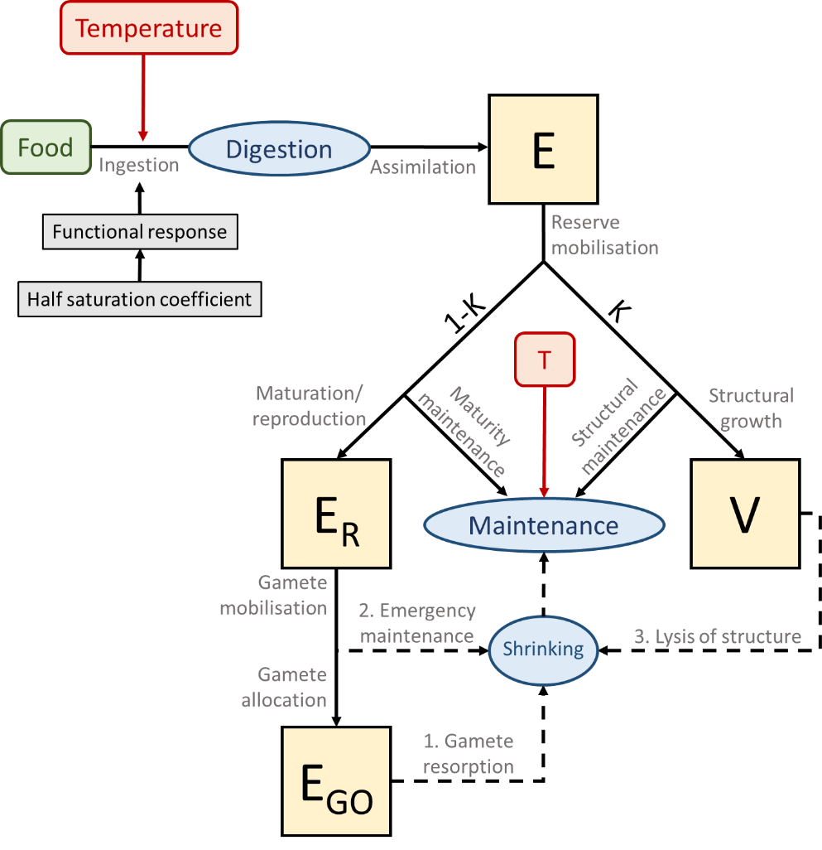
Figure A1: Schematic of the Pacific oyster DEB model, describing the transfer of energy through the state variables (E, V, E_{R} and E_{GO}). Forcing variables (Temperature and Food) are indicated in round-edged rectangles. Physiological processes are indicated in blue ovals. Rates are depicted in grey. Solid lines represent growth, and dashed lines shrinkage. Based on Thomas et al. (2016) and Bourlès et al. (2009).

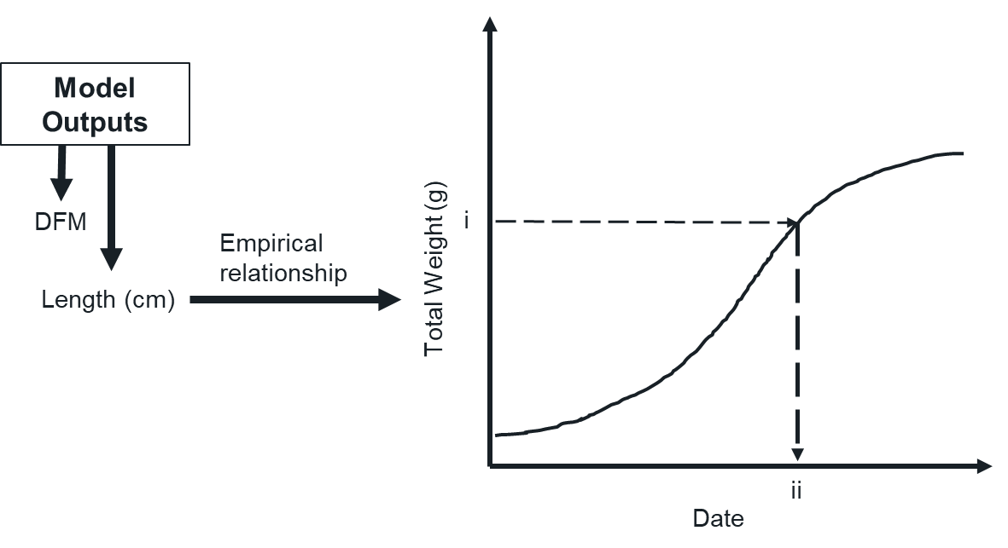
Figure A2: Conceptual representation of the transformation of model outputs (DFM and TW) to industry relevant outputs, such as “days to commercial weight”, first described by Palmer et al. (2020). TW can be represented as a growth curve for the culture period, with a desired commercial weight indicated by i, and a corresponding date to reach this weight (ii) which is then converted to the number of days since the start of the culture period.
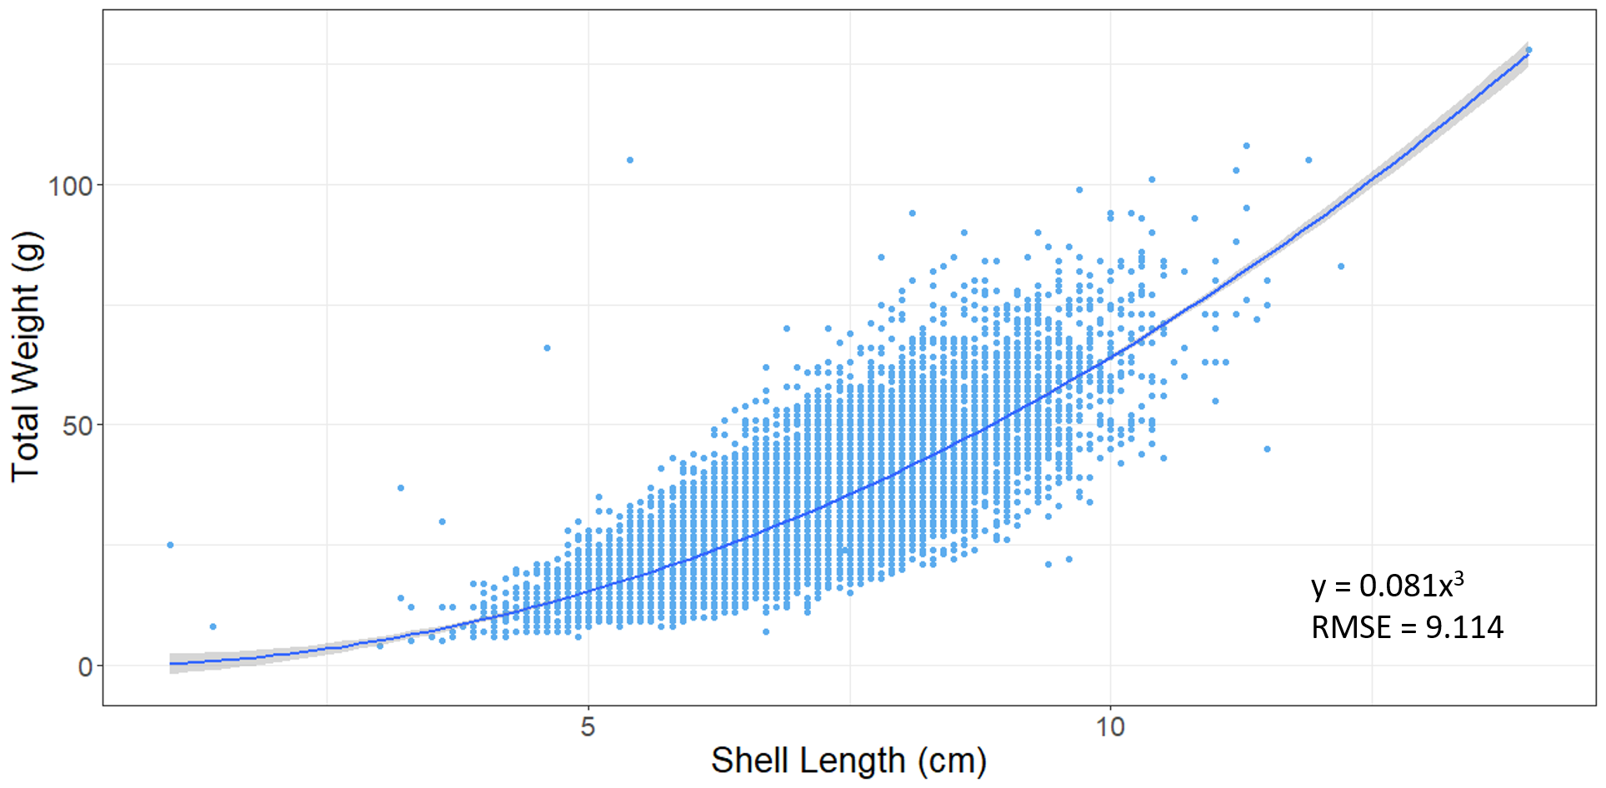
Figure A3: Non-linear regression of TW and L data from French localities with the aim of producing an equation in the format TW = x L³ to determine TW from Length. The resulting equation TW = 0.081 L³ was chosen for model post-application. Data source: RESCO REMORA database for 2010-2013 (Fleury et al. 2020).

Table A1: Oyster DEB Model parameters, based on previous studies by Thomas et al. 2016, Bernard et al. 2011, Bourlès et al. 2009, Pouvreau et al. 2006, and Van der Veer et al. 2006.
Parameter (symbol) | Value (units) | Reference
Main parameters
Maximum surface-specific ingestion rate (P_{xm}) | 1027 (J cm⁻² d⁻¹) | Thomas et al. 2016
Volume-specific maintenance cost (P_{m}) | 44 (J cm⁻³ d⁻¹) | Thomas et al. 2016; Bernard et al. 2011
Volume-specific structure cost (E_{g}) | 3900 (J cm⁻³) | Thomas et al. 2016
Maximum reserve density (E_{m}) | 4200 (J cm⁻³) | Thomas et al. 2016; Bernard et al. 2011
Allocation fraction to growth and maintenance (Κ) | 0.45 | Thomas et al. 2016; Van der Veer et al. 2006
Assimilation efficiency (Κ_{X}) | 0.75 | Thomas et al. 2016; Van der Veer et al. 2006
Reproduction efficiency (Κ_{R}) | 0.75 | Thomas et al. 2016
Auxiliary parameters
Ultimate length (L_{m}) | 45 (cm) | Thomas et al. 2016; Van der Veer et al. 2006
Energy content of reserves (µE) | 19600 (J g⁻¹) | Thomas et al. 2016
Dry mass ratio of structure (D_{y}) | 0.15 (gDW.gWW⁻¹) | Thomas et al. 2016; Bernard et al. 2011
Dry mass ratio of gonad (D_{go}) | 0.31 (gDW.gWW⁻¹) | Thomas et al. 2016; Bernard et al. 2011
Volume specific cost for gonad (E_{Ggo}) | 7500 (J cm⁻³) | Thomas et al. 2016; Bernard et al. 2011
Energy Conductance (v = K_{X} (P_{xm})/E_{m}) | 0.183 (cm d⁻¹) | Thomas et al. 2016; Bernard et al. 2011
Yield of gonadal tissue for maintenance (Y_{go}) | 0.25 | Thomas et al. 2016; Bernard et al. 2011
Structural volume at puberty (V_{p}) | 0.4 (cm³) | Thomas et al. 2016; Povreau et al. 2006
Gonado-Somatic ratio (GSR) | 0.4 | Thomas et al. 2016; Bourlès et al. 2009
Temperature-Metabolism parameters
Arrhenius temperature (T_{A}) | 5800 (°K) | Thomas et al. 2016; Van der Veer et al. 2006
Reference temperature for rates (T₁) | 293 (°K) | Thomas et al. 2016; Bernard et al. 2011
Lower boundary tolerance range (T_{L}) | 281 (°K) | Thomas et al. 2016; Van der Veer et al. 2006
Upper boundary tolerance range (T_{H}) | 300 (°K) | Thomas et al. 2016
Lower boundary Arrhenius temperature (T_{AL}) | 75000 (°K) | Thomas et al. 2016; Van der Veer et al. 2006
Upper boundary Arrhenius temperature (T_{AH}) | 30000 (°K) | Thomas et al. 2016; Van der Veer et al. 2006

Table A2: Randomised input measurements for the oyster DEB model
Cohort age | TWi (mean±SD) | DFMi (mean±SD) | TWi (mean±SD)
2 months | 0.5 ± 0.01 g | 0.01 ± 0.001 g | 1.9 ± 0. 1 g
4 months | 4 ± 0.1 | 0.5 ± 0. 1 g | 3.9 ± 0. 1 g
6 months | 19 ± 1 | 1 ± 0.1 g | 5.0 ± 0. 1 g

Table A3: Coordinates for sectors within the South Coast and West Coast study sites, chosen based on the presence of prominent coastal bays.
South Coast sectors  (Agulhas Ecoregion) | Coordinates
Infanta/Bree River Estuary (I-BR) | 34.4272°S, 20.8977°E
Mossel Bay (MB) | 34.1525°S, 22.1770°E
Plettenberg Bay (PB) | 34.0599°S, 23.4461°E
Jeffrey’s Bay/St Francis Bay (JB) | 34.0619°S, 25.0210°E
Algoa Bay (AB) | 33.8315°S, 25.7220°E
West Coast sectors
(Southern Benguela Ecoregion)
Alexander Bay (AXB) | 28.6555°S, 16.4590°E
Hondeklip Bay (HB) | 30.3338°S, 17.2493°E
Lambert’s Bay (LB) | 32.0820°S, 18.2906°E
St Helena Bay (SHB) | 32.7467°S, 18.0670°E
Saldanha Bay (SB) | 33.0679°S, 17.9327°E
Yzerfontein (Y) | 33.3550°S, 18.1327°E
False Bay (FB) | 34.1972°S, 18.6380°E

