Exploring South African Pacific Oyster Mariculture Potential through combined Earth Observation and Bioenergetics Modelling
Corresponding author: Amalia Grace Krupandan (amalia.krupandan@stir.ac.uk)
Appendix B: Supplementary Results

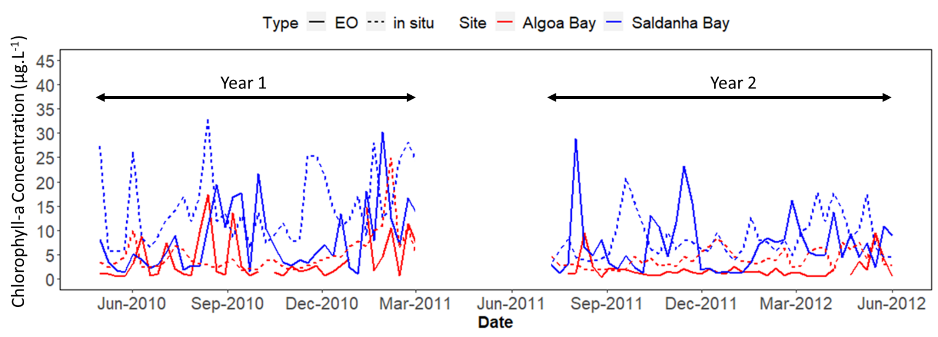
a)
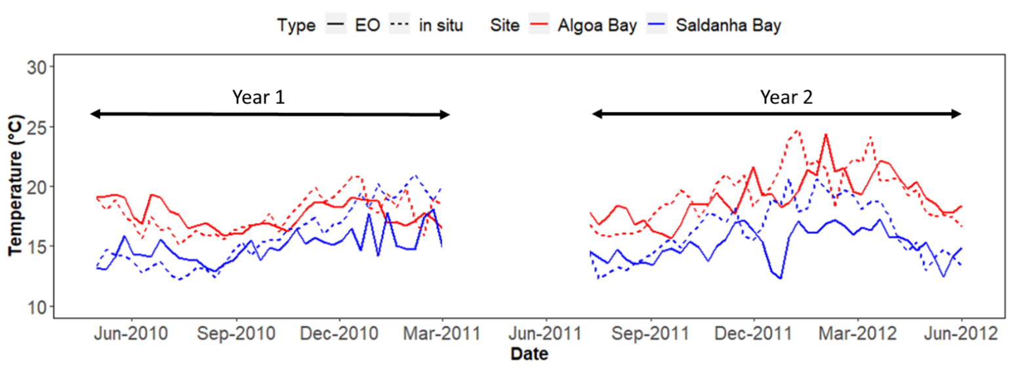
b)
Temperature (°C)
Figure B1: Comparison of in-situ and Earth-Observation (EO) a) chlorophyll-a and b) SST measurements in Algoa Bay (red) and Saldanha Bay (blue), from May 2010 to June 2012. Satellite-derived data are shown in solid lines and are sourced from MODIS 8-day chl-a/SST product. In-situ data are shown in dashed lines and are sourced from Pieterse et al. (2012) and Nel et al. (2014).

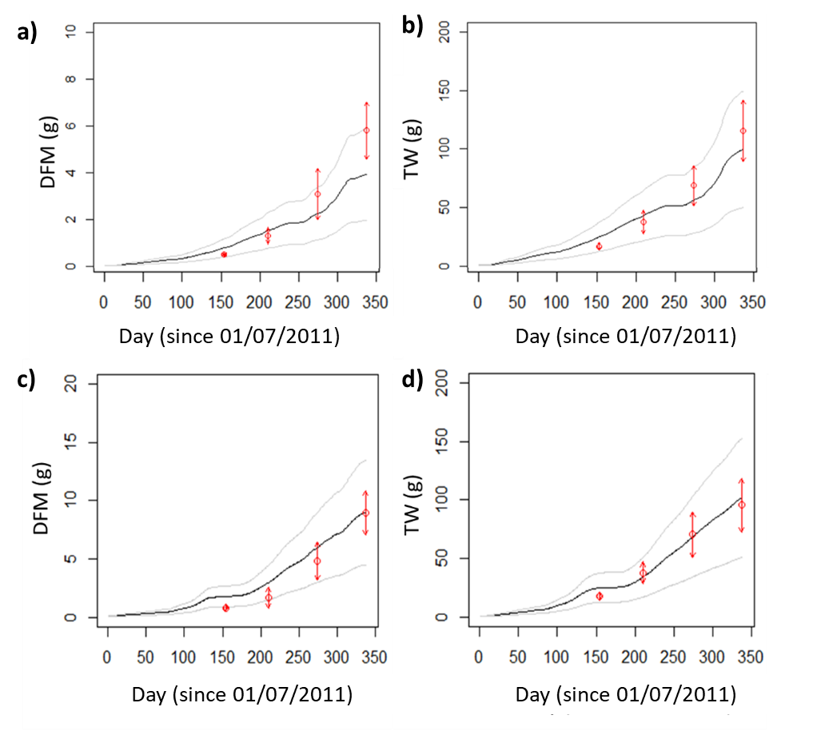
Saldanha Bay
Algoa Bay
Algoa Bay
Saldanha Bay
Figure B2: Calibration of the DEB parametrization for Algoa and Saldanha bays, comparing mean DEB oyster model simulations (black solid line) and mean in-situ measurements ± SD (red) for Algoa Bay (a, b) and Saldanha Bay (c, d), from 1st July 2011 to 1st June 2012 for model calibration. Measurements of the 2-month-old C. gigas cohort from Nel et al. 2014 were utilised (initial DFM: 0.5g, initial TW: 4g). Gray lines indicate the upper and lower boundary of model outputs over the 10 individual simulations.
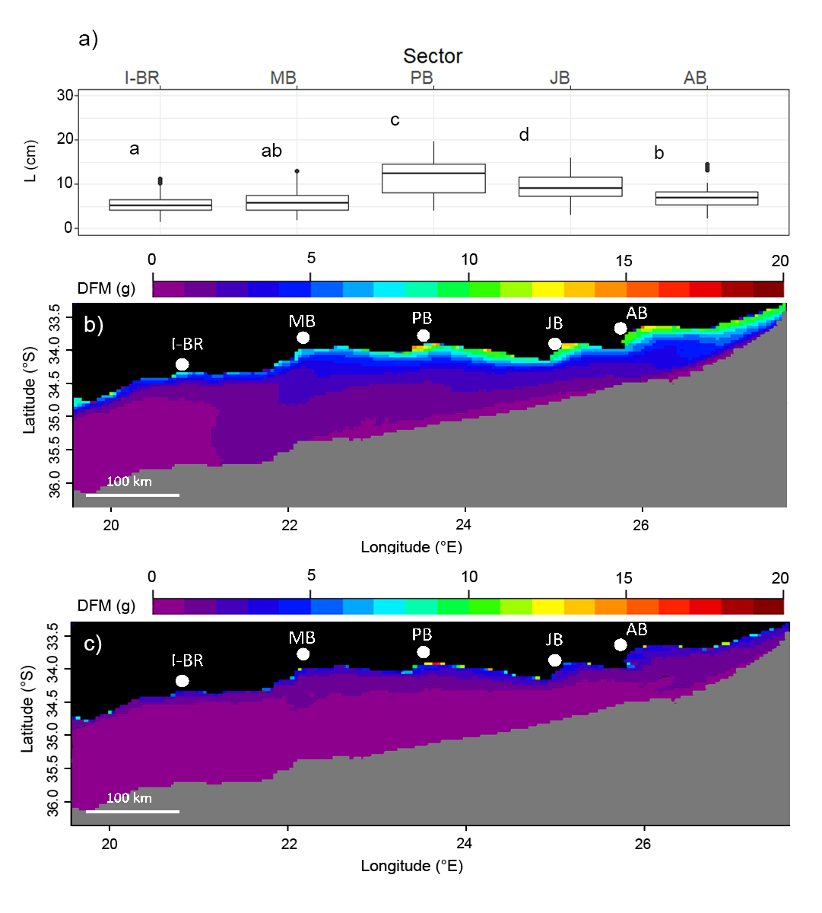
c)
b)
Figure B3: a) Agulhas Ecoregion intra- and inter-sector variability of simulated C. gigas Dry Flesh Mass (DFM) at the end of yearly culture period (1 July to 1 April) from 2002 to 2020, starting with a 4-month-old cohort (initial DFM: 0.5g). Letters indicate significant differences at a 99% level after a Welch’s One-Way ANOVA (p < 0.01). Spatial variability of b) mean and c) standard deviation of DFM at the end of yearly culture period. Areas further than 100 km from the shore and deeper than 200m are masked in grey. For full sector names refer to Table A3.

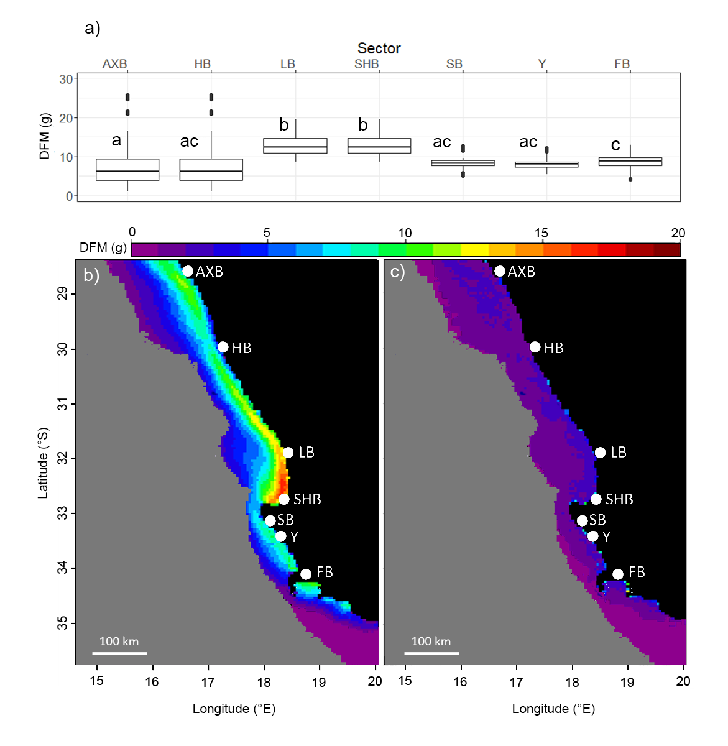
c)
b)
Figure B4: a) Benguela Ecoregion intra- and inter-sector variability of simulated C. gigas Dry Flesh Mass (DFM) at the end of yearly culture period (1 July to 1 April) from 2002 to 2020, starting with a 4-month-old cohort (initial DFM: 0.5g). Letters indicate significant differences at a 99% level after a Welch’s One-Way ANOVA (p < 0.01). Spatial variability of b) mean and c) standard deviation of DFM at the end of yearly culture period. Areas further than 100 km from the shore and deeper than 200m are masked in grey. For full sector names refer to Table A3.

b)
c)

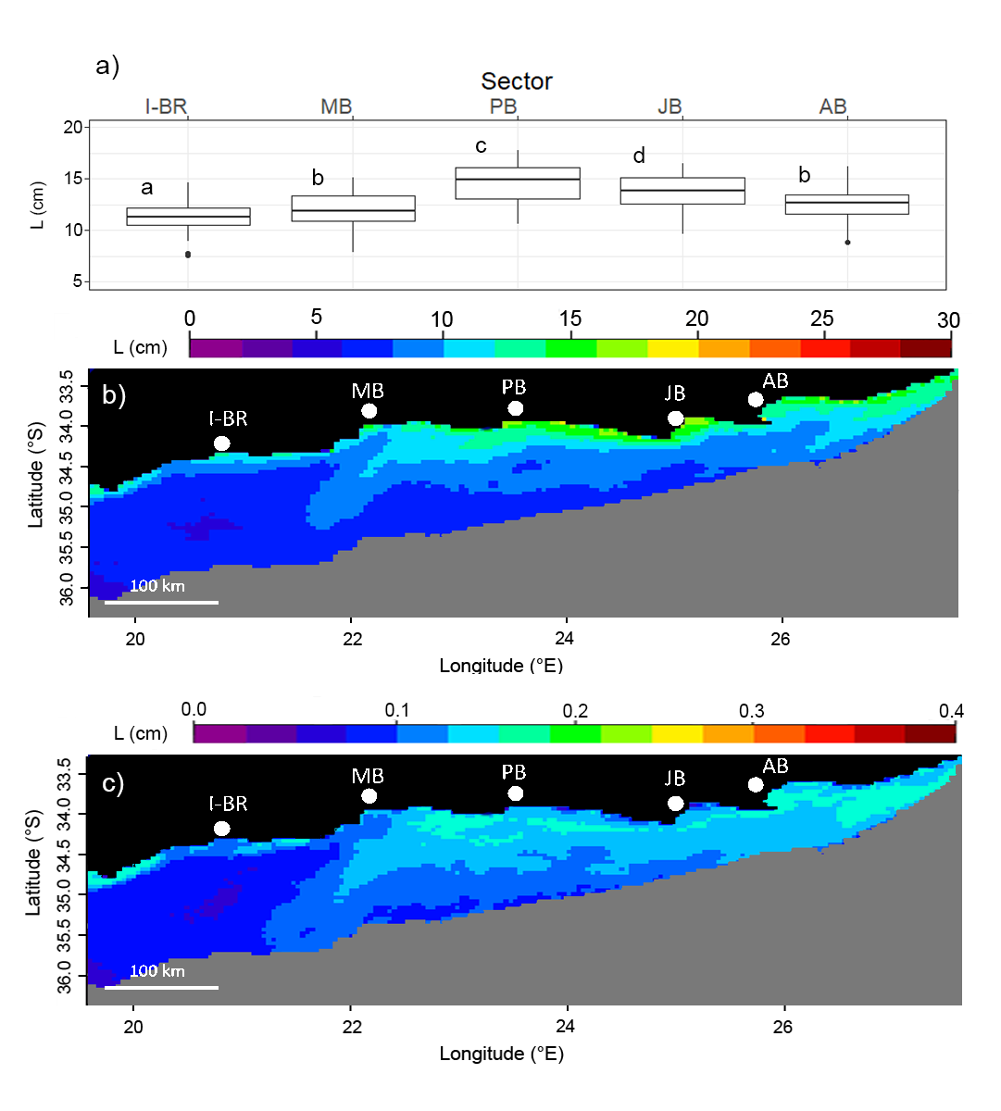
b)
c)
Figure B5: a) Agulhas Ecoregion intra- and inter-sector variability of simulated C. gigas Shell Length (L) at the end of yearly culture period (1 July to 1 April) from 2002 to 2020, starting with a 4-month-old cohort. Letters indicate significant differences at a 99% level after a Welch’s One-Way ANOVA (p < 0.01). Spatial variability of b) mean and c) standard deviation of L at the end of yearly culture period. Areas further than 50 km from the shore and deeper than 200m are masked in grey. For full sector names refer to Table A3.

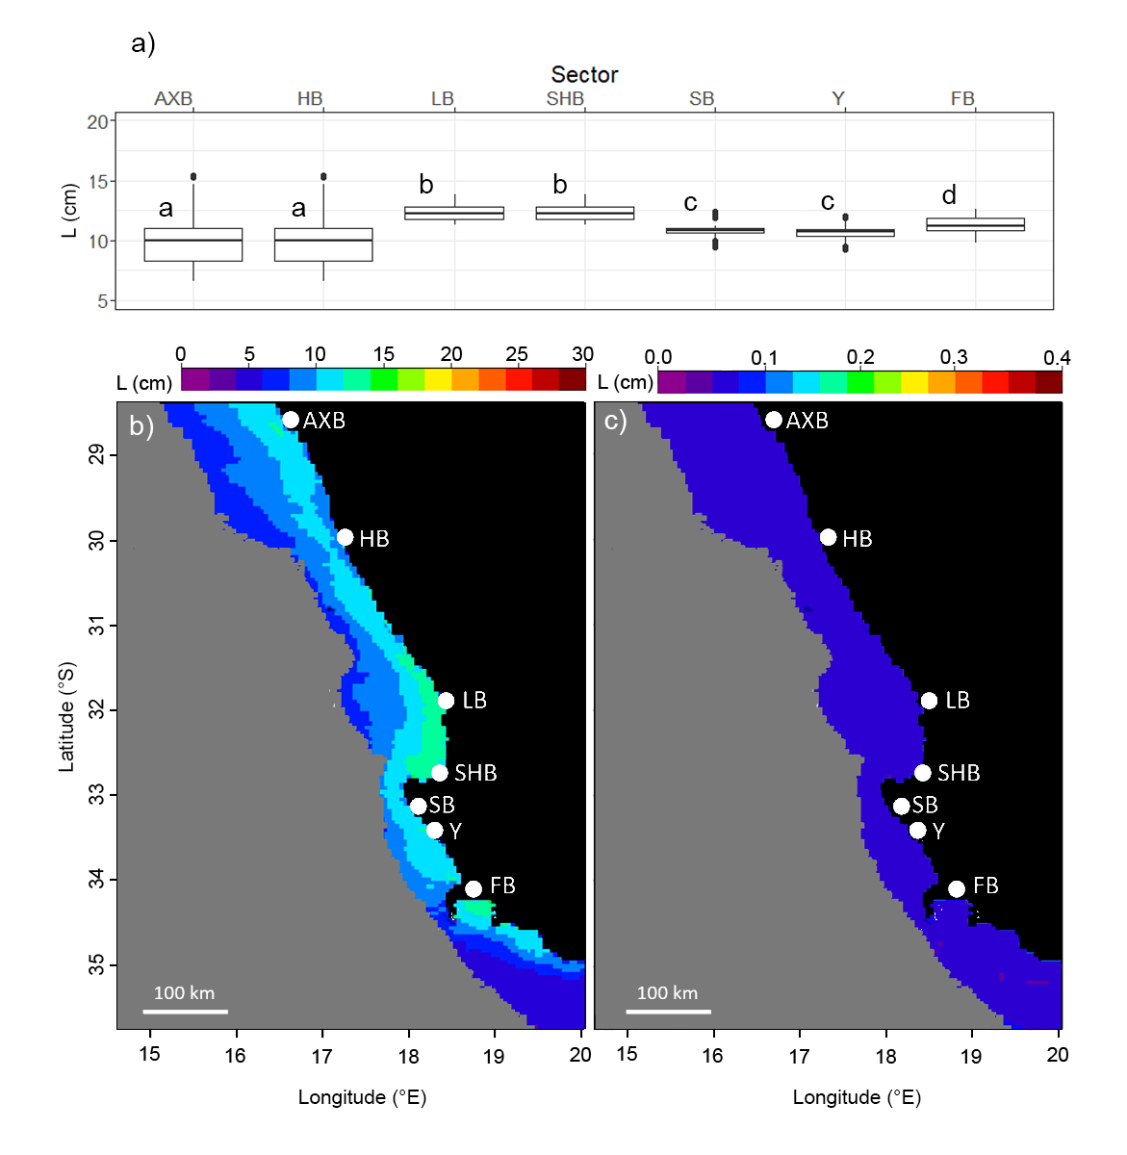
Figure B6: a) Benguela Ecoregion intra- and inter-sector variability of simulated C. gigas Shell Length (L) at the end of yearly culture period (1 July to 1 April) from 2002 to 2020, starting with a 4-month-old cohort. Letters indicate significant differences at a 99% level after a Welch’s One-Way ANOVA (p < 0.01). Spatial variability of b) mean and c) standard deviation of L at the end of yearly culture period. Areas further than 50 km from the shore and deeper than 200m are masked in grey. For full sector names refer to Table A3.

