Geophysical Research Letters
Supporting Information for
Warming-to-cooling reversal of overflow-derived water masses in the Irminger Sea during 2002-2021.

Damien G. Desbruyères¹, Eva Prieto Bravo¹, Virginie Thierry¹, Herlé Mercier¹, Pascale Lherminier¹, Cécile Cabanes¹, Tiago C. Biló², Nora Fried³, M. Femke De Jong³.

¹University of Brest, CNRS, Ifremer, IRD, Laboratoire d’Océanographie Physique et Spatiale (UMR 6523 LOPS), Plouzané, France

²Scripps Institution of Oceanography, University of Califonia San Diego.

³ Department of Ocean Systems, NIOZ, Royal Netherlands Institute for Sea Research, Texel, The Netherlands

Corresponding author: Damien Desbruyères (damien.desbruyeres@ifremer.fr)

Contents of this file

Figures S1

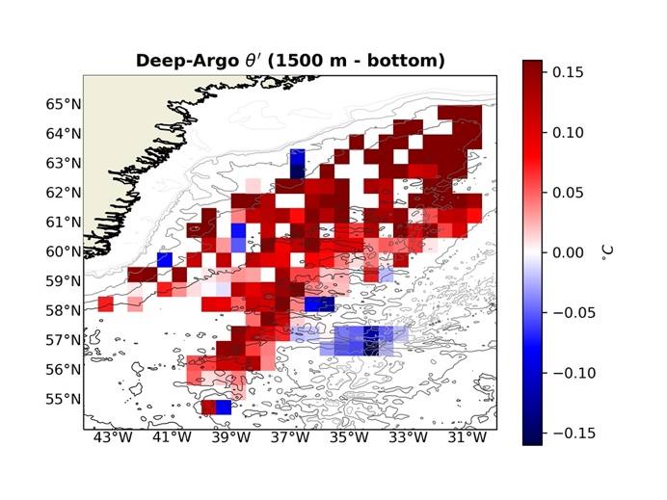  (a) | 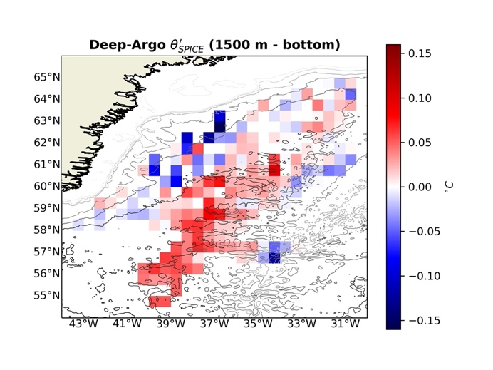  (c)
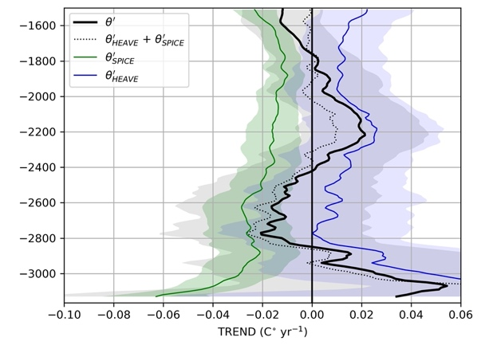  (b) | 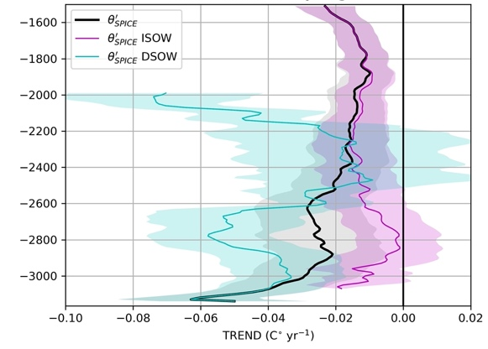  (d)
Figure S1. Same as Figure 4 (a, b, c, d) in the main manuscript but using the OV18 climatological product to obtain Deep-Argo-based temperature anomalies.

