SUPPLEMENTARY MATERIAL

Supplementary Material and methods

SMM1. Novel environment test and Ethovision analysis

In this behavioural challenge, we only used individuals not previously chronically stressed, to avoid any potential bias related to this previous experimental protocol.
The trials to monitor the group behavioural response to a novel environment and hypoxia were carried out according to the protocol described in Sadoul et al. (2021) [29]. Briefly, the day before the experiment, four groups of 8 fish (2 groups per behavioural phenotype) were isolated from the rearing tank and kept overnight in separated 300L tanks under the same water conditions. The next day, fish from one group were gently transferred to an Open field arena (75cm x 75 cm x 21.5 cm of water height, 120 L). A corner (15 cm x 15 cm) was isolated from the open field arena by a grid and contained a pump, oxygen and nitrogen aerators to maintain targeted oxygen concentration and an oxygen probe (Odéon, NEOTEK-PONSEL, Caudan, France) to record oxygen saturation over the experimental duration. After 1 hour in the novel environment, oxygen saturation was reduced over 20 minutes using nitrogen bubbling, in order to reach a saturation around 20%. This hypoxic period lasted 40 minutes. Fish behaviour was recorded over the whole duration of the test using a video camera DMK 31AU03 and IC Capture software (The imaging sources, Germany) at 25 frames.s⁻¹. This was performed successively on 4 groups (2 per behavioural phenotype) per day during 3 days, for a total of 12 trials. The open field arena was carefully rinsed between each trial. We made also sure to alternate groups of bold and shy individuals and, started each experimental day with a different behavioural type. Data extraction and analyses were performed using EthoVision XT 13.1 software (Noldus, The Netherlands).
Swaps between individuals were manually corrected using the track editor module. For behavioural analyses, the arena was virtually separated into two areas: the centre area composed of one half of the surface and the periphery area including the other half; time spent in periphery (s), indicative of thigmotaxis behaviour, was recorded. The velocity of each fish (cm.s⁻¹), indicative of individual fish activity, and the mean interindividual distances (MID; cm), indicative of group cohesion were also assessed. All variables were averaged over 1 minute every 10 minutes in order to record the kinetics of the behavioural responses. After the experiment, fish were gently caught and put back into their original tanks.

SMM2. RNA sequencing and analyses
All samples were mechanically disrupted (45 seconds at 30 rpm) in a 2 mL tube filled with 500 µL MR1 and 1 μL of TCEP from NucleoMag® RNA extraction kit (Macherey-Nagel) and 2 stainless steel beads. After a two minutes centrifugation at 13000 rpm, a sub-sample of 200 μL was transferred in a 96 deep-wells plate filled with 150 µL MR1. Automatic extraction was then performed using a KingFisher robot following manufacturer’s instructions for the NucleoMag® RNA kits. Finally, RNA integrity was confirmed (RIN above 8) on a 2100 bioanalyzer® (Agilent) following manufacturer’s instructions.

The Truseq stranded mRNA sample prep kit (Illumina, San Diego, CA, USA) was used to construct libraries according to manufacturer’s instructions. Briefly, poly-A RNAs were first purified using oligo-d (T) magnetic beads from 1 μg of total RNA. The poly-A RNAs were then fragmented in short sequences using divalent cations under elevated temperature and reverse transcribed using random hexamers, Super Script II (Thermo Fisher Scientific, Carlsbad, CA) and Actinomycin D. In order to prevent the second strand to be used as a matrix during the final PCR amplification, dUTP substituted dTTP during the second strand generation step. Before ligation was performed using Illumina's (dual) indexed adapters, double stranded cDNAs were adenylated at their 3′ends. Ligated cDNAs were then amplified by 15 cycles of PCR and products were purified using AMPure XP Beads (Beckman Coulter Genomics, Brea, CA, USA). Libraries were validated on a Fragment Analyzer (Agilent Technologies, Santa Clara, CA, USA) and quantified using the KAPA Library quantification kit (Roche, Bâle, CHE).
Libraries were pooled in equimolar amounts, denatured with NaOH, and diluted to 20 pM before clustering on a cBot system (Illumina, San Diego, CA, USA). Sequencing was performed on an HiSeq 2500 (Illumina, San Diego, CA, USA) using the single-end 1*50 nt protocol on 3 lanes of a flow cell V4. Sequencing produced between 6 and 36 million passed-filter clusters per library. Image analyses and base calling were performed using the Illumina HiSeq Control Software and the Real-Time Analysis component. Demultiplexing was performed using Illumina’s conversion software (bcl2fastq 2.20). The quality of the raw data was assessed using FastQC from the Babraham Institute and the Illumina software SAV (Sequencing Analysis Viewer). Potential contaminants were monitored with the FastQ Screen software from the Babraham Institute.
A splice junction mapper, TopHat 2.1.1 [1] (using Bowtie 2.2.9; [2]) was used to align the RNA-Seq reads to the Dicentrarchus labrax genome (NCBI, reference GCA_000689215.1) with a set of gene model annotations [3]. Final read alignments having more than 3 mismatches were discarded. Samtools (v.1.5) was used to sort alignment files and counting was performed with Featurecounts (v.1.6.2)[4]. As data comes from a strand-specific assay, the read has to be mapped to the opposite strand of the gene (-s 2 option). Before statistical analysis, genes with less than 25 reads (cumulating all the analyzed samples) were filtered out. Differentially expressed (DE) genes between bold and shy were identified within each organ using the R (v 3.4.2) Bioconductor [5] package DESeq2 v.1.26.0 [6], while the effect of sex was accounted for by the use of an additional factor in the statistical model. Data were normalized using the default method of DESeq2. Genes with adjusted p-value below 5% (according to the FDR method from Benjamini-Hochberg [7]) were considered differentially expressed.
The gene ontology (GO) enrichment was performed using the goseq package in R ran on gene symbols. The mouse, Mus musculus, genome (mm9) was used as reference genome because of the limited information available on other more related species regarding GO. Only biological processes of level 2 were evaluated after goseq. Raw p-values out of goseq were presented along with their adjusted value after applying the Benjamin and Hochberg method to control for the false discovery rate [7]. Heatmaps of standardized expressions (mean substraction followed standard deviation division) were created using the pheatmap package on some GOs chosen based on the GO enrichment results. Finally, raw expressions were illustrated using the ggplot2 package for biological processes of level 3. All statistical analyses were carried out using the R software 4.0.2.

Supplementary Table

Table S1. Overrepresentation of gene ontology per organ between bold and shy individuals, focusing on biological processes of level 2. Adjusted p-values, using Benjamin-Hochberg Procedure are provided in brackets.

Organ | GO ID | GO Name | Diff. Expr . in GO | Total in GO | p-value of over representation  (adjusted p-value)
Pituitary | GO:0007610 | behavior | 32 | 481 | 0,01 (0,37) | *
Pituitary | GO:0051703 | intraspecies interaction between organisms | 5 | 36 | 0,03 (0,37) | *
Headkidney | GO:0002376 | immune system process | 19 | 1256 | 0,001 (0,022) | **
Headkidney | GO:0044419 | interspecies interaction between organisms | 13 | 702 | 0,002 (0,022) | **
Headkidney | GO:0050896 | response to stimulus | 44 | 4217 | 0,003 (0,026) | **
Headkidney | GO:0023052 | signaling | 34 | 3001 | 0,005 (0,037) | **
Headkidney | GO:0048519 | negative regulation of biological process | 34 | 3165 | 0,009 (0,044) | *
Headkidney | GO:0048518 | positive regulation of biological process | 35 | 3450 | 0,009 (0,044) | *
Headkidney | GO:0008152 | metabolic process | 53 | 6240 | 0,03 (0,12) | *
Headkidney | GO:0050789 | regulation of biological process | 51 | 5799 | 0,043 (0,15) | *
Headkidney | GO:0065007 | biological regulation | 52 | 6084 | 0,046 (0,15) | *

Supplementary Figure

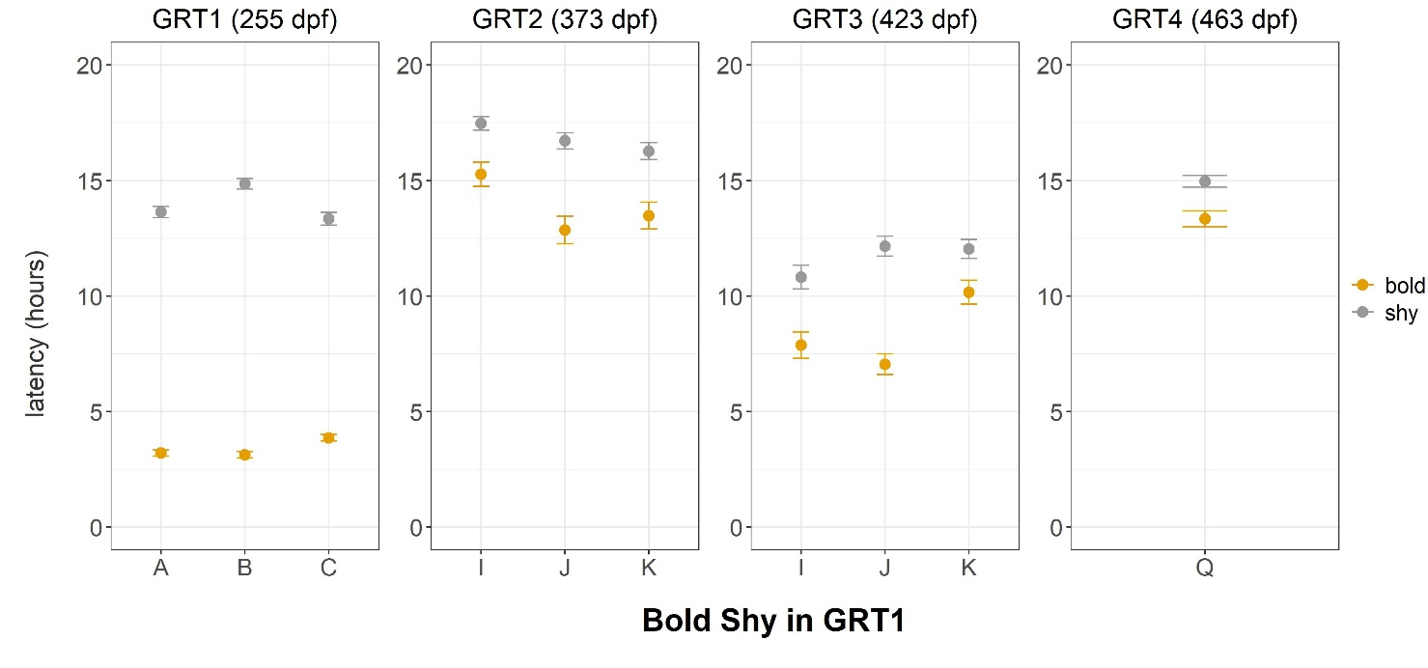
Figure S1. Latencies at the four GRTs for individuals categorized as bold and shy at 255dpf and across the different Tank replicate. Data are illustrated using the mean and standard error. Tanks A, B, and C are 1.5m³. Tanks I, J, and K are 1m³, while tank Q is a 5m³ tank.

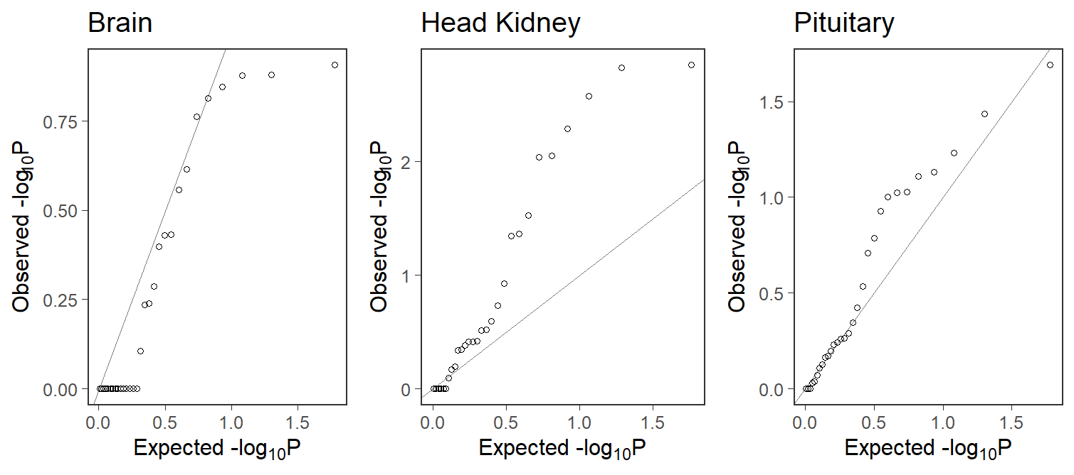

Figure S2. Quantile-quantile plots of p-values of enriched BP GO terms of level 2 tested on differentially expressed genes (adjusted p-value < 0.05) between bold and shy in the Brain, the Head kidney and the Pituitary. Each point represents the p-value (log-scale) from a test. The expected distribution under the null hypothesis is represented by the diagonal line. An excess of small p-values is observed compared to the null model represented by the line in the Head kidney and the Pituitary.

Supplementary References

1. Kim D, Pertea G, Trapnell C, Pimentel H, Kelley R, Salzberg SL. 2013 TopHat2: accurate alignment of transcriptomes in the presence of insertions, deletions and gene fusions. Genome Biol. 14, R36. (doi:10.1186/gb-2013-14-4-r36)
2. Langmead B, Salzberg SL. 2012 Fast gapped-read alignment with Bowtie 2. Nat. Methods 9, 357–359. (doi:10.1038/nmeth.1923)
3. Tine M et al. 2014 European sea bass genome and its variation provide insights into adaptation to euryhalinity and speciation. Nat. Commun. 5, 1–10. (doi:10.1038/ncomms6770)
4. Liao Y, Smyth GK, Shi W. 2014 featureCounts: an efficient general purpose program for assigning sequence reads to genomic features. Bioinformatics 30, 923–930. (doi:10.1093/bioinformatics/btt656)
5. Huber W et al. 2015 Orchestrating high-throughput genomic analysis with Bioconductor. Nat. Methods 12, 115–121. (doi:10.1038/nmeth.3252)
6. Love MI, Huber W, Anders S. 2014 Moderated estimation of fold change and dispersion for RNA-seq data with DESeq2. Genome Biol. 15, 550. (doi:10.1186/s13059-014-0550-8)
7. Benjamini Y, Hochberg Y. 1995 Controlling the False Discovery Rate: A Practical and Powerful Approach to Multiple Testing. J. R. Stat. Soc. Ser. B Methodol. 57, 289–300. (doi:10.1111/j.2517-6161.1995.tb02031.x)

