JGR
Supporting Information for
Geochemical characterization of the Oman Crust-Mantle transition zone, OmanDP Holes CM1A and CM2B.
F. Kourim^{1*}, M. Rospabé², N. Dygert³, S. Chatterjee⁴, E. Takazawa⁴, K-L. Wang^{1, 5}, M. Godard⁶, M. Benoit⁷, M. Giampouras⁸, K. Ishii⁴, D. A-H Teagle⁹, M-J. Cooper⁹, P. Kelemen¹⁰
¹ Institute of Earth Sciences, Academia Sinica, Academia Road, Nangang, Taipei 11529, Taiwan.
² Research Institute for Marine Geodynamics (IMG), Japan Agency for Marine-Earth Science and Technology (JAMSTEC), 2-15 Natsushima, Yokosuka, Kanagawa 237-0061, Japan.
³ Department of Earth & Planetary Sciences, University of Tennessee, 1621 Cumberland Ave., 602 Strong Hall, Knoxville, TN 37996, U.S.A.
⁴ Department of Geology, Faculty of Science, Niigata University, Niigata 950–2181, Japan
⁵ Department of Earth Sciences, National Taiwan University, No. 1, Section 4, Roosevelt Rd, Da’an District, Taipei City, 10617, Taiwan
⁶ Géosciences Montpellier, CNRS, Université Montpellier, Place E. Bataillon, 34095 Montpellier, France.
⁷ Géosciences Environnement Toulouse (GET), Observatoire Midi-Pyrénées, Université de Toulouse, CNRS, IRD, 14 avenue E. Belin, F-31400 Toulouse, France.
⁸ Instituto Andaluz de Ciencias de la Tierra (IACT), Consejo Superior de Investigaciones Científicas–Universidad de Granada, Avd. Palmeras 4, 18100 Armilla, Granada, Spain
⁹ School of Ocean & Earth Science, National Oceanography Centre Southampton, University of Southampton, European Way, Southampton SO14-3ZH, UK
¹⁰ Lamont–Doherty Earth Observatory, Columbia University, Palisades, New York, 10964, U.S.A.
* Corresponding author: Fatma Kourim (k.fatna@gmail.com)

Contents of this file

Text S1
Figures S1: Figure SD-1

Additional Supporting Information (Files uploaded separately)

Captions for Tables S1 to S3 (if larger than 1 page, upload as separate file)

Materials and methods
- Sample selection and preparation
The studied samples were selected from cores CM1A and CM2B following two strategies. First, a homogeneous sample was selected every 10 m downhole cores during the OmanDP Phase 2 drilling operations, onsite in Oman, in order to get a petrological and geochemical overview continuously along the cores. Second, additional samples have been selected during the daily ChikyuOman Leg 3 sampling meetings in consultation with the core description teams, to focus on more specific facies or levels. These samples are referred to as onsite samples and shipboard samples respectively in supplementary data table 1 and 2. Adjacent to each onsite and shipboard sample an oriented thin section billet was taken for mineralogical and lithological characterization. Geochemical data of onsite and shipboard samples were measured both aboard the D/V Chikyu during the ChikyuOman Phase 2 Leg 3 for major element and volatile contents for part of the samples, and at Institute of Earth Science, Academia Sinica, Taiwan (IES-AS), the University of Edinburgh, Scotland (EU), Université Toulouse III - Paul Sabatier, France (TU), and Niigata University, Japan (NU) for trace element contents and additional major element and volatile contents.

Sample collected onsite during OmanDP Phase 2 operations in Oman were selected every 10 m downhole, 5 cm long half cores were cut from the cores in the field, with blue-red double lines drawn on the working and archive halves to record the orientation. Thin section billets were cut from the half rounds, and most of the remainder core was crushed and ground into fine, homogeneous powder for whole rock geochemical analyses. Alteration surface or veins as well as pencil and saw marks were removed from the sample during the cutting and grinding. To remove dust and other particles samples were then put in an several successive ultrasonic baths with Milli-Q deionized water (18.2 MΩ.cm) until MilliQ water was clear. The clean samples were dried for 12 h at 60 °C before being stored in zip lock plastic bags and crushed to a <5 mm grit between plastic plates using a fly press. The resulting material was then ground in a RocklabsTM chrome-steel ring mill bench-top mill for ~3 minutes or until the powder was as fine as possible. After milling, sample powders were split into three portions: 10 g for major and trace element XRF analyses at University of Edinburgh, Scotland (EU), 10 g stored as archives in case of losses during transit, and the last portion transported to the D/V Chikyu for shipboard analyses and cross calibration, and personal sampling by the OmanDP Phase 2 Science Party.

Aboard D/V Chikyu and during the ChikyuOman 2018 Phase 2 Leg 3 core description, the samples were selected following an identical sampling practice to ChikyuOman 2017 Phase 1 (Kelemen et al., 2020a, 2020b, 2020c). Shipboard samples were 5 to 6 cm (HQ: 8 cm core diameter), or 8 to 10 cm (NQ: 5 cm core diameter) long quarter round core sections (HQ core: ~100 g; NQ core: 60 g). The samples were carefully cut from the working half of the core using a diamond impregnated continuous edged lapidary blade saw. During this step the alteration rinds due to drilling and sawing were removed. Afterwards, the samples were rinsed and ultrasonicated in Milli-Q deionized water (18.2 MΩ.cm) multiple times until the Milli-Q water was clean. The clean sample were dried for 12 h at 60 °C before they were cut into thin slices to facilitate crushing to a <1 mm grit. The sawed, clean samples were crushed following 4 steps, starting with a 14 mm jaw gap that was decreased in stages to 7 mm, 4 mm and 1 mm. The resulting <1 mm crushed sample was then powdered using the Fritsch Pulverisette 5 Planetary Mill. After milling, sample powders were then homogenized and stored.

- Analytical methods
Samples were analyzed for their whole rock major and trace element compositions and carbon and hydrogen contents. The analytical procedures, precision and accuracy of the methods are described in detail in Kelemen et al. (2020a, 2020b). Calculated mineral modes from XRF are reported in supplementary data table 1. Whole rock major and volatile element compositions are reported in supplementary data table 2. Whole rock trace element compositions are reported in supplementary data table 3.
Loss on ignition (LOI) of all onsite and shipboard samples were determined onboard the D/V Chikyu, using the OHTI (Ocean High Technology Institute, Inc., Tokyo, Japan) motion compensated balance system into a pre-weighed ceramic crucible using a spatula (that was never in contact with lithium metaborate flux). Duplicate LOI measurements were done on the onsite samples at EU, following the same steps and procedures. Major element abundances (wt.% oxides) in powdered rock samples were determined using the RIGAKU Supermini wavelength dispersive X-ray fluorescence spectrometer equipped with a 200 W Pd anode tube at 50 kV and 4 mA onboard DV Chikyu during OmanDP Phase 2 Leg 3. Major element analyses were determined to be acceptable if the sum of the anhydrous oxide concentrations totaled to between 99 and 101 wt.%. Precision and accuracy are better than 2.5 % for all oxides except for TiO₂ for reference materials DTS-2B and JP-1 (better than 11%) and Na₂O, P₂O5 and K₂O for JGb-2 (3.40, 17.60, and 7.49% respectively). Duplicates of onsite samples whole rock major element analyses were performed at EU, using the Panalytical PW2404 wavelength-dispersive sequential X-ray spectrometer. Gas chromatographic separation was undertaken on non-ignited powders to determine their volatile element contents (total carbon, C^{Total} and water recalculated from hydrogen) using the Thermo Finnigan™ FlashEA® 1112 elemental analyzers (EA) onboard D/V Chikyu.
Whole rock trace element analyses were measured by ICP-MS using acid digestion of powder samples after ChikyuOman 2018 Leg 3. Sample powders were divided into three batches. One batch was sent to each IES-AS, TU and NU laboratory for trace element measurements. The measurements were conducted at IES-AS using an Agilent 7500s inductively coupled plasma‐mass spectrometer (ICP‐MS) following the procedure described by Ionov et al. (1992) and adapted by Godard et al. (2000) for the analysis of ultra-depleted peridotites; at TU using a Thermo Scientific™ Element XR™ HR-ICP-MS following the procedures of Rospabé et al. (2018b) adapted from Yokoyama et al. (1999) and Barrat et al. (1996); and at NU using Yokogawa HP4500 ICP-MS following the procedure employed by Ionov et al. (1992). To compare the accuracy and the precision in the three different laboratories, trace element measurements were performed on a selection of duplicate samples, and on the same reference materials (DTS-2B and JP-1a).

Calculated mineral modes from XRF data

Peridotite mineral modes were calculated from shipboard X-ray fluorescence (XRF) bulk rock data obtained by the Leg 3 geochemistry team. Modes for CM1A and CM2B peridotites are presented in Supplementary Figure SD-1 and Supplementary Table 1.

1.1 Methods and results
Mineral modes were calculated on a spinel-free basis using a least squares regression algorithm assuming constant mineral compositions among all peridotites. Assumed mineral compositions are presented below, normalized to 100% to compensate for Cr, Mn, and K, for which XRF data are not available.

 | olivine | orthopyroxene | clinopyroxene | feldspar
SiO₂ | 39.96 | 56.61 | 52.94 | 43.59
TiO₂ | 0.00 | 0.01 | 0.21 | 0.00
Al₂O₃ | 0.03 | 1.80 | 3.01 | 36.24
FeO | 8.98 | 5.79 | 3.10 | 0.11
MgO | 50.57 | 33.27 | 18.55 | 0.00
CaO | 0.08 | 2.49 | 22.06 | 19.67
Na₂O | 0.38 | 0.03 | 0.11 | 0.39

Olivine, orthopyroxene, clinopyroxene and spinel are from samples collected in the upper part of the mantle section of the Wadi Tayin massif, southern Oman ophiolite (OM94-115; Hanghøj et al., 2010, OM94-114, Dygert et al., 2017), plagioclase is from the mantle section of the Othris ophiolite in Greece (Barth et al., 2003).

On average, mode residuals deviate 1% from a sum of 1 (Supplementary Table 1), and are typically negative, perhaps reflecting the absence of spinel in the calculation. All harzburgites and dunites are clinopyroxene-poor or clinopyroxene-free. Many rocks characterized as dunites by visual inspection have normative orthopyroxene modes >10%, many rocks characterized as harzburgites by visual inspection have normative orthopyroxene modes <10%. Below we present four possible explanations for the disagreement between visual lithological characterizations and mineral modes:

(1) Mineral compositions assumed in the mode regression are not representative of primary mineral compositions.
(2) Measured bulk compositions are not representative of the rocks. Measured subsamples are skewed toward anomalously high or low pyroxene fractions.
(3) Lithological classification was inaccurate owing to the difficulty of identifying primary phases in completely altered peridotites.
(4) Open system behavior (Mg loss or Si addition) increased the normative pyroxene content of the sample (see Figure 4a).

Relative mode distributions are shown in in histograms in Supplementary Figure SD-1. Mode distributions are similar between the two holes, but CM1A has a greater abundance of high olivine samples consistent with the core descriptions.

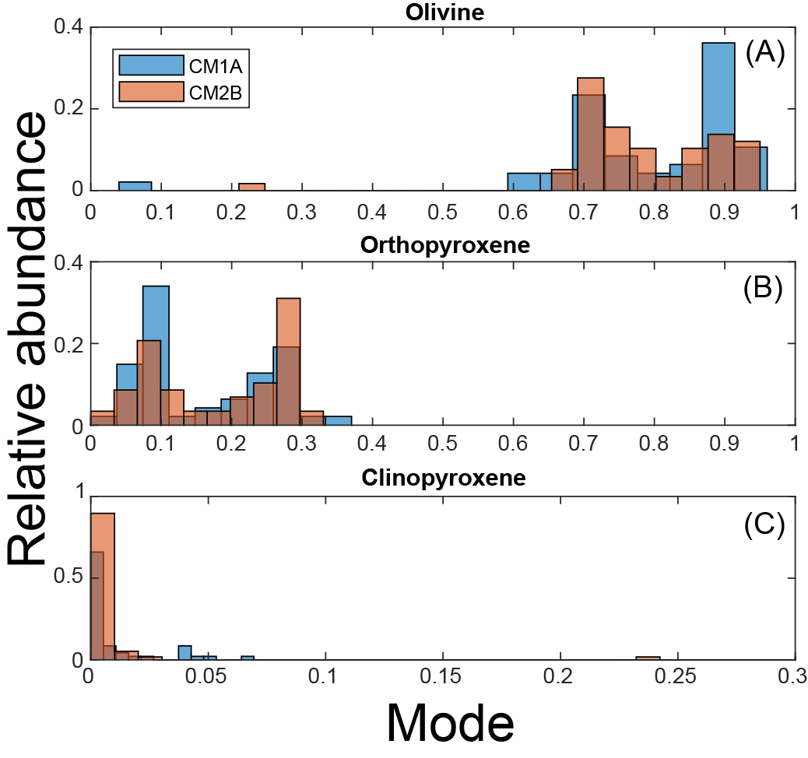
Figure SD-1 Olivine, orthopyroxene and clinopyroxene mode distributions in CM1A and CM2B peridotites (blue and brown bars, respectively) calculated on a spinel-free basis.

Table S1.Supplementary data table 1: Mineral modes, and mode residuals compositions, core (VCD) and thin section (TS) descriptions, and XRD compositions of samples recovered at Hole CM1A and CM2B.
Table S2. Supplementary data table 2: Whole rock LOI, major element, total carbon, calculated CaCO₃ and H₂O compositions of samples recovered at Hole CM1A and CM2B. Total carbon, hydrogen and sulfur compositions were measured by CHNS and inorganic carbon by coulometry on-board D/V Chikyu. Major element compositions were measured on-board D/V Chikyu by XRF using beads for all oxides excepting K₂O. Major compositions of onsite samples were additionally measured by XRF in Edinburg University. N.D. = note defined.
Table S3.Supplementary data table 3: Whole rock trace element compositions of samples recovered at Hole CM1A and CM2B, measured by ICP-MS using acid digestion of powder samples after ChikyuOman 2018 Leg 3 at Institute of Earth Science, Academia Sinica, Taiwan (IES-AS), Université Toulouse III - Paul Sabatier, France (TU), and Niigata University, Japan (NU). L.O.D=limit of detection.

