Supplementary Material
Table S1. Acronyms and definitions of the three biomass or abundance indices.
Acronym | Full name | Definition
TBI | Total Biomass Index | Survey-based total biomass per km² swept area
UAI | Undersized Abundance Index | Survey-based undersized abundance per km² swept area
URI | Undersized Rate Index | Survey-based proportion of undersized fish (numbers)

Table S2. Implementation of discard plans applicable to herring, horse mackerel, plaice and whiting caught by bottom trawlers in ICES Division 7d (2012-2019).
 |  | Herring | Horse mackerel | Plaice | Whiting | EU regulation
2012-2014 | Subject to LO? | No | No | No | No
 | Exemption?
2015 | Subject to LO? | No | No | No | No | 1393/2014
 | Exemption?
2016 | Subject to LO? | No | No | No | Yes | 1393/2014¹
 | Exemption? |  |  |  | de minimis | 2015/2438
2017 | Subject to LO? | No | No | No | Yes | 1393/2014¹
 | Exemption? |  |  |  | de minimis | 2016/2375
2018 | Subject to LO? | No | No | No | Yes | 2018/190
 | Exemption? |  |  |  | de minimis | 2018/46
2019 | Subject to LO? | Yes | Yes | Yes | Yes | 2018/190⁴
 | Exemption? |  | de minimis | survivability | de minimis | 2018/2034

Figure S1. Landings in tonnes (left panel) and as proportion (right panel) of the main species landed by French bottom trawlers operating in the EEC in October, over the period 2012-2019: seabass, cod, cuttlefish, herring, horse mackerel, mackerel, red mullet, plaice, thornback ray, squids, whiting and other species.

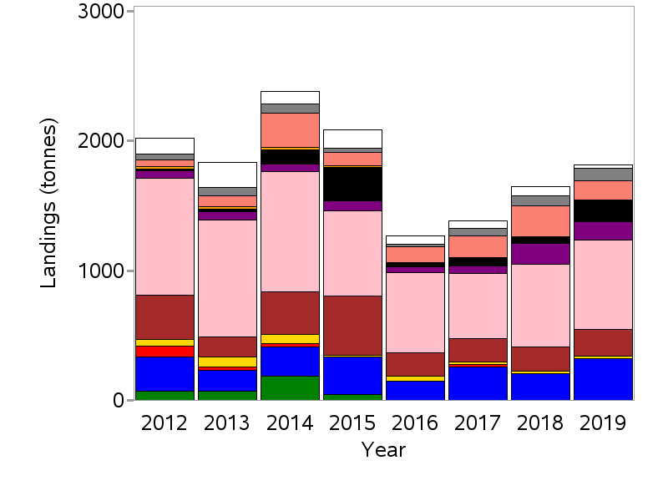 | 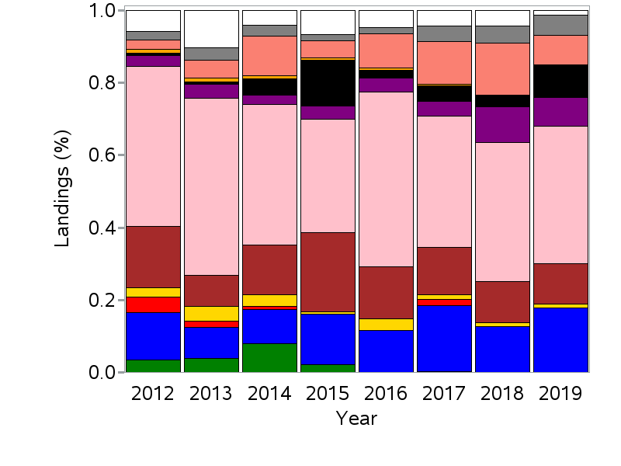

Figure S2. Latitude (left panels) and longitude (right panels) weighted by seabass, cod, mackerel, thornback ray TBIs (top panels), and by red mullet, cuttlefish, squids TBIs (bottom panels), over the period 1990-2019.

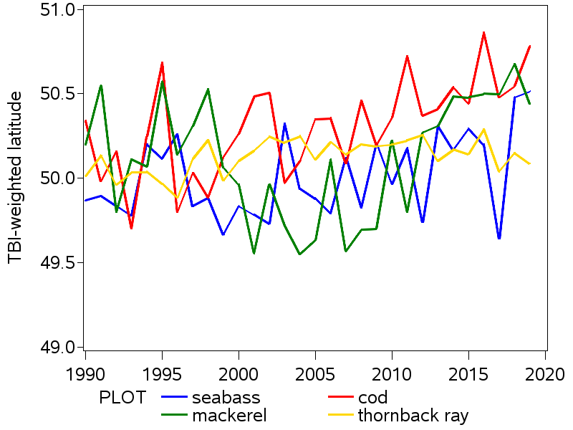 | 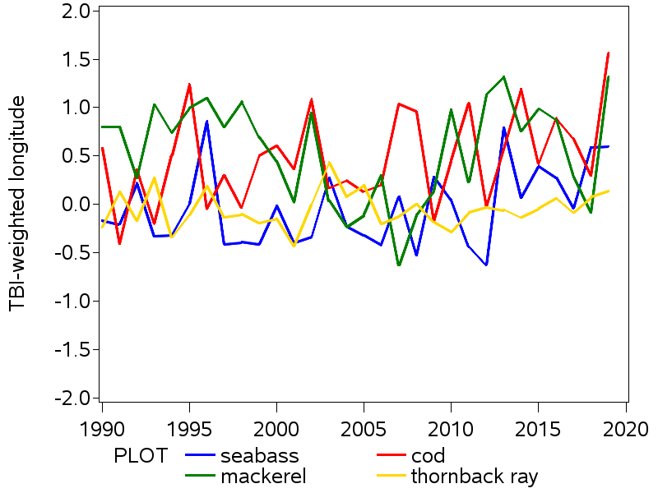
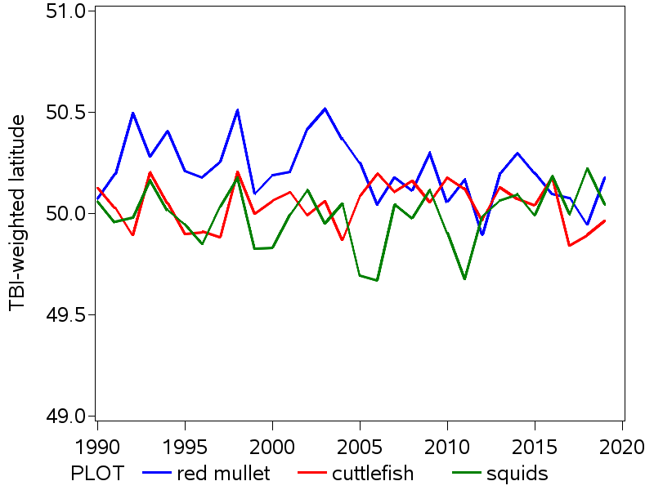 | 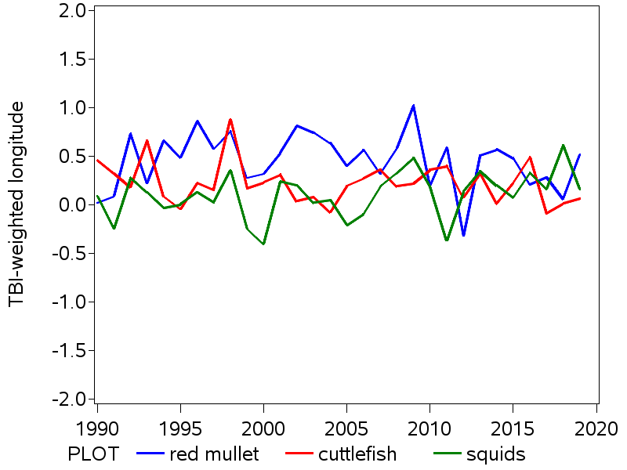

Figure S3. Latitude (left panels) and longitude (right panels) weighted by herring, horse mackerel, plaice, whiting TBIs (top panels), UAIs (middle panels) and URIs (bottom panels), over the period 1990-2019.

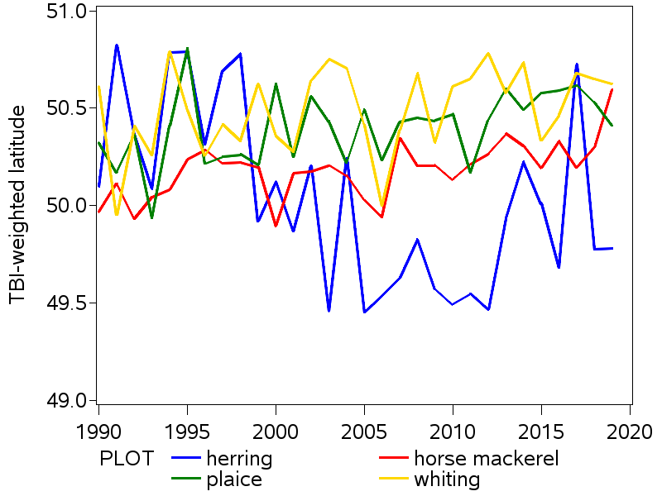 | 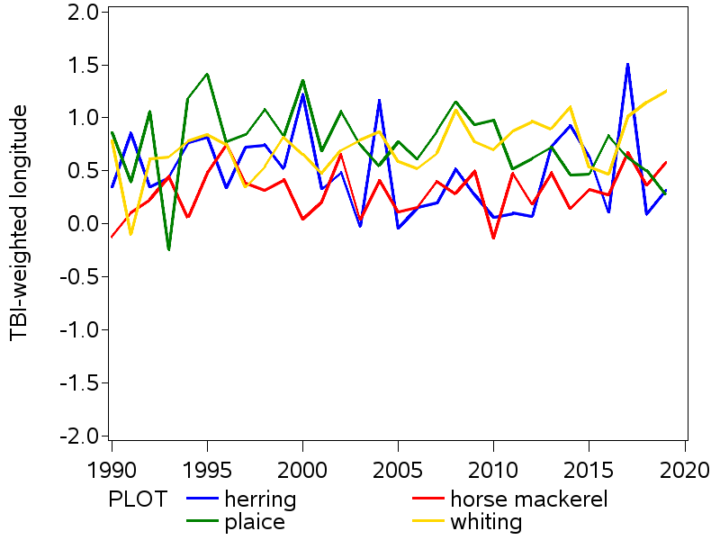
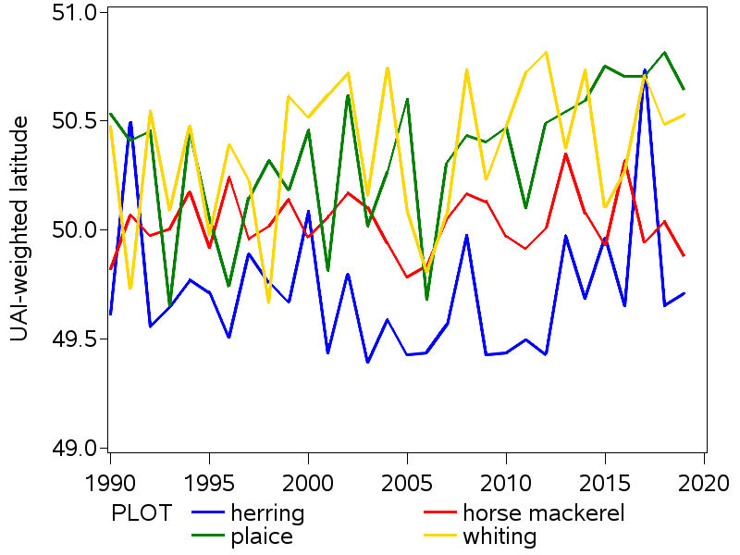 | 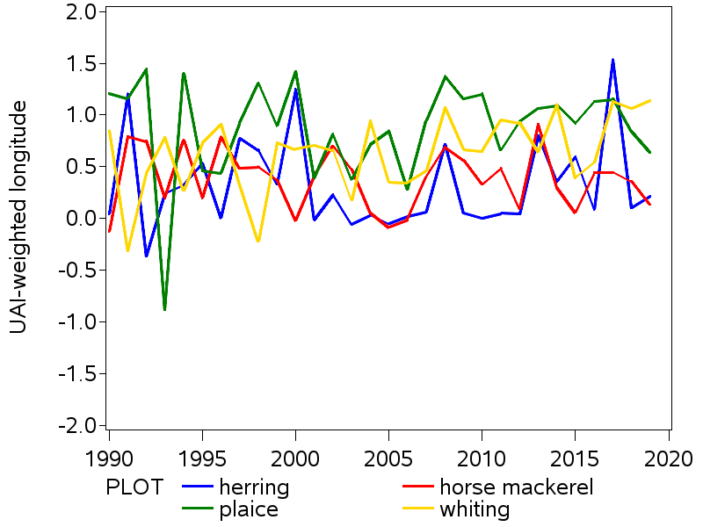
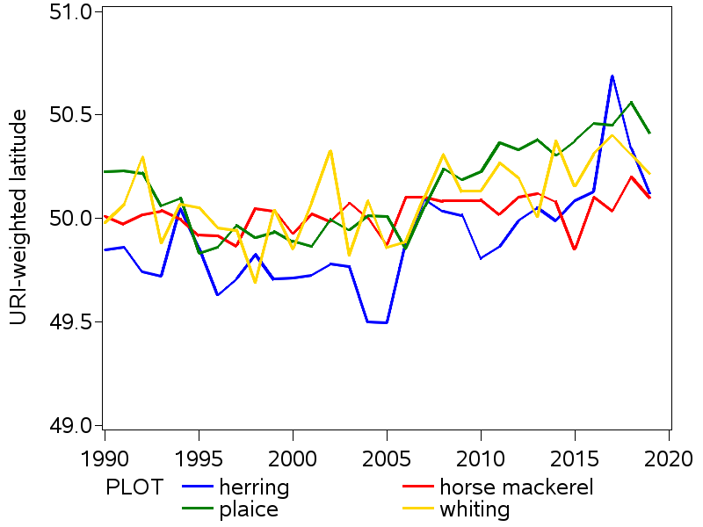 | 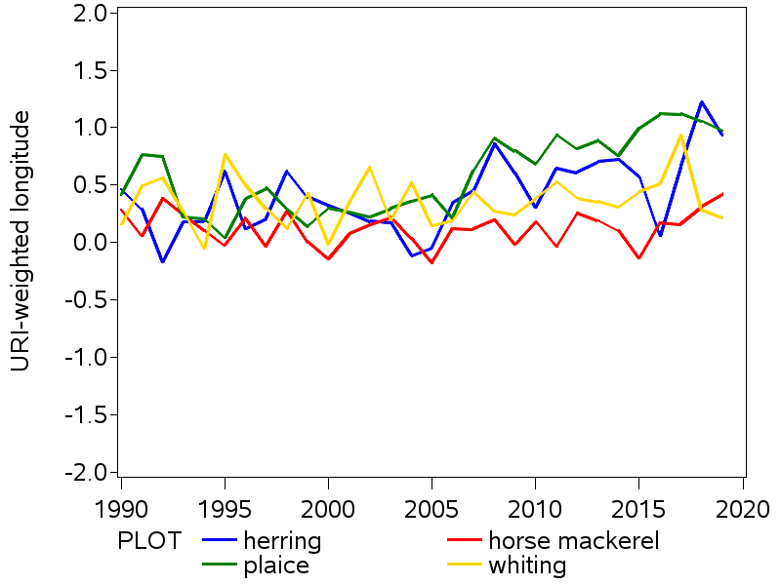

Figure S4. Spatial distribution of TBIs of seabass, cod, mackerel, thornback ray, red mullet, cuttlefish, squids, herring, horse mackerel, plaice and whiting derived from the CGFS survey, averaged over the period 1990-2019.
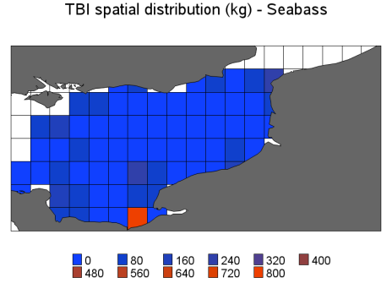 | 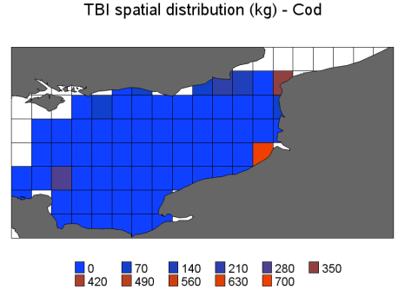 | 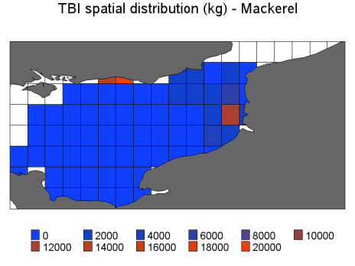 | 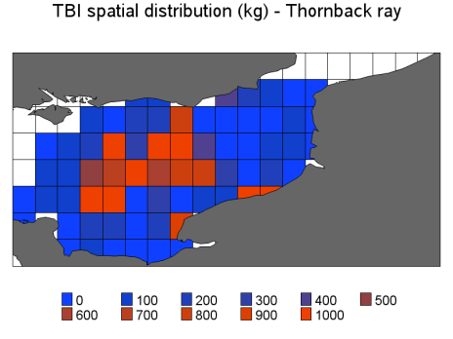
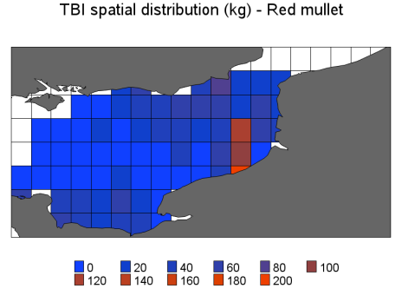 | 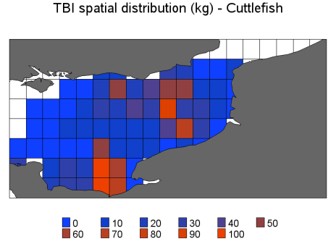 | 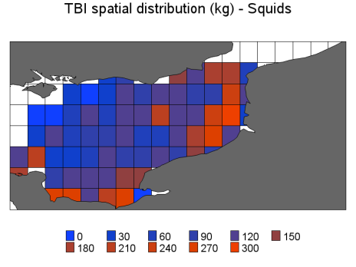
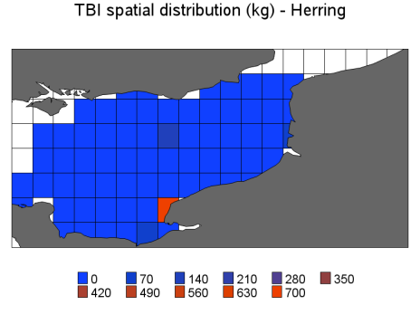 | 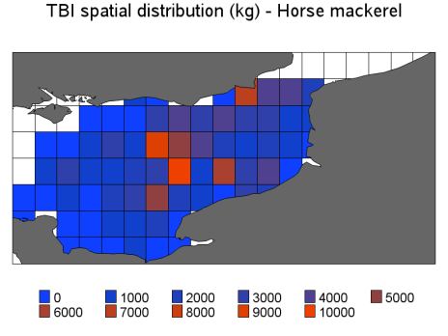 | 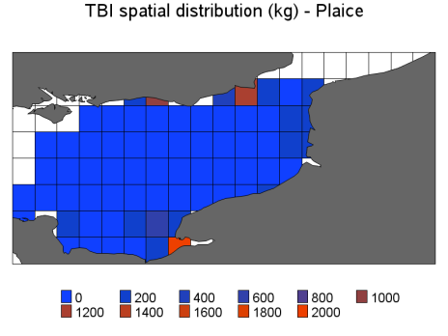 | 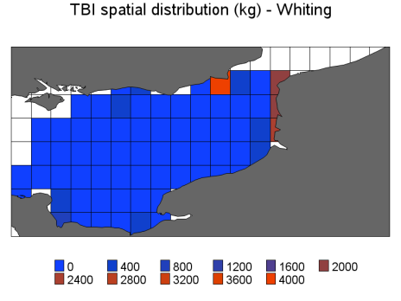

Figure S5. Spatial distribution of UAIs (top panels) and URIs (bottom panels) of herring, horse mackerel, plaice and whiting derived from the CGFS survey, averaged over the period 1990-2019.
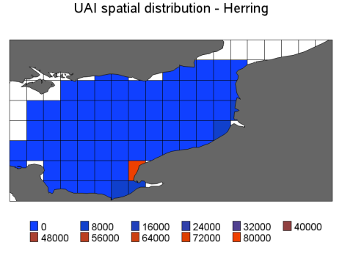 | 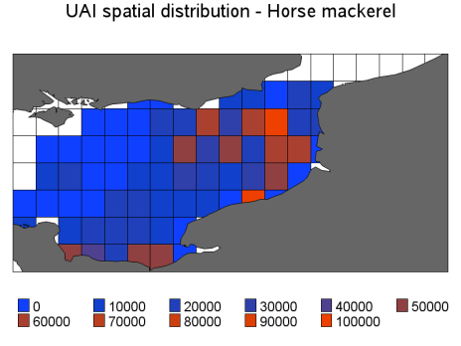 | 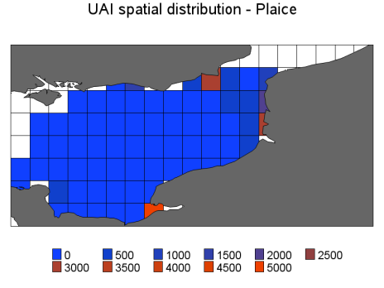 | 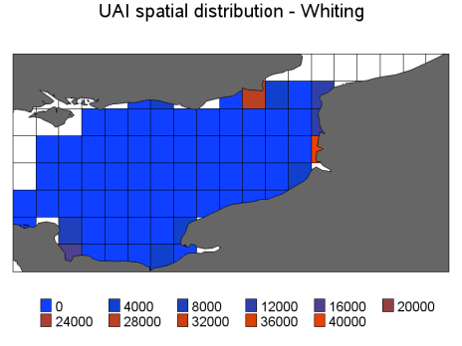
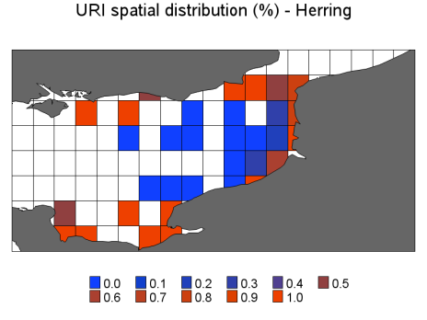 | 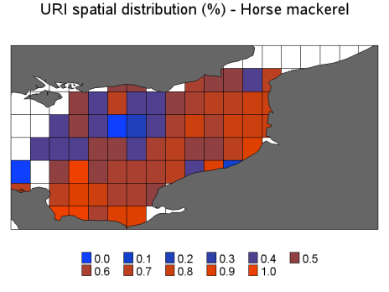 | 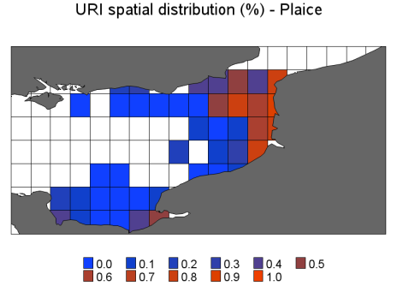 | 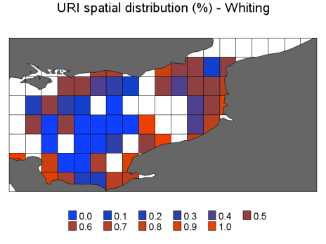

Figure S6. Latitude (top left panel) and longitude (top right panel) weighted by VMS effort (red curve) and the discard trip fishing effort (blue curve), per year and per quarter, over the period 2009-2019; relative spatial distribution of VMS effort, averaged over 2012-2019 (bottom left pannel).
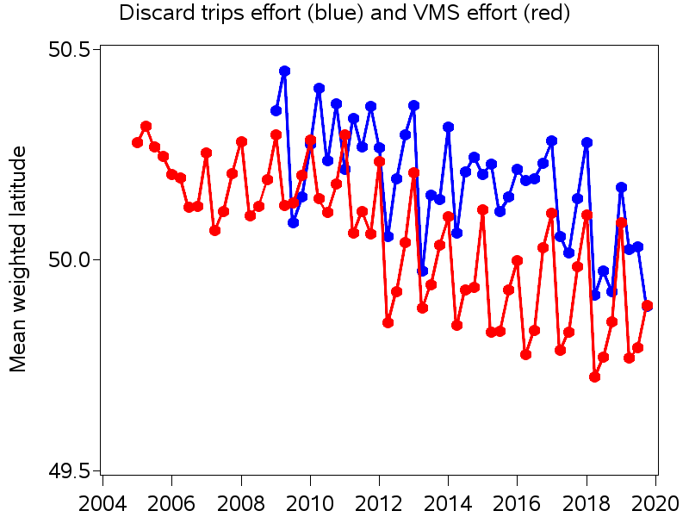 | 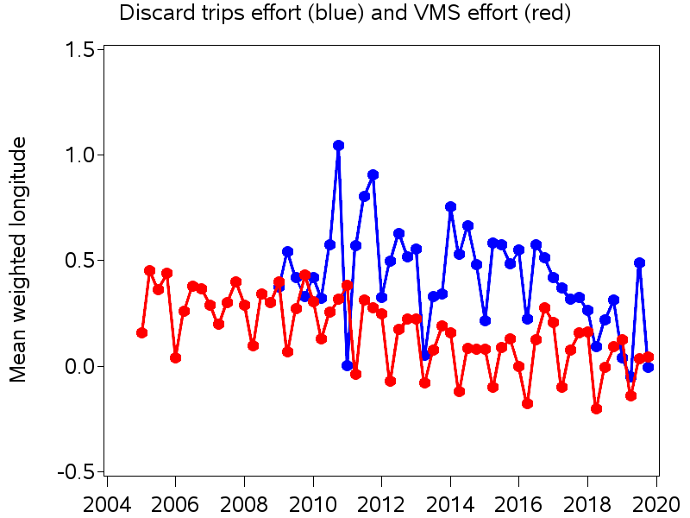
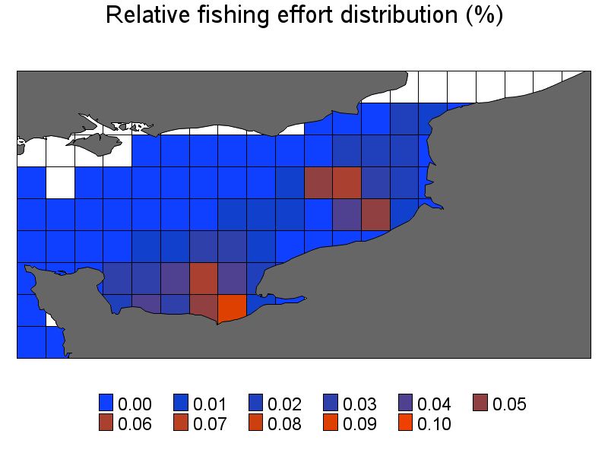

Figure S7. Spatial distribution of discard rates of herring (top left), horse mackerel (top right), plaice (bottom left) and whiting (bottom right) from bottom trawlers, averaged over 2009-2019.
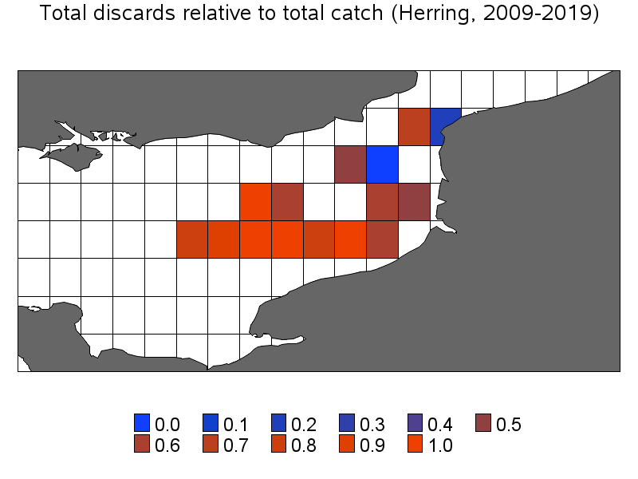 | 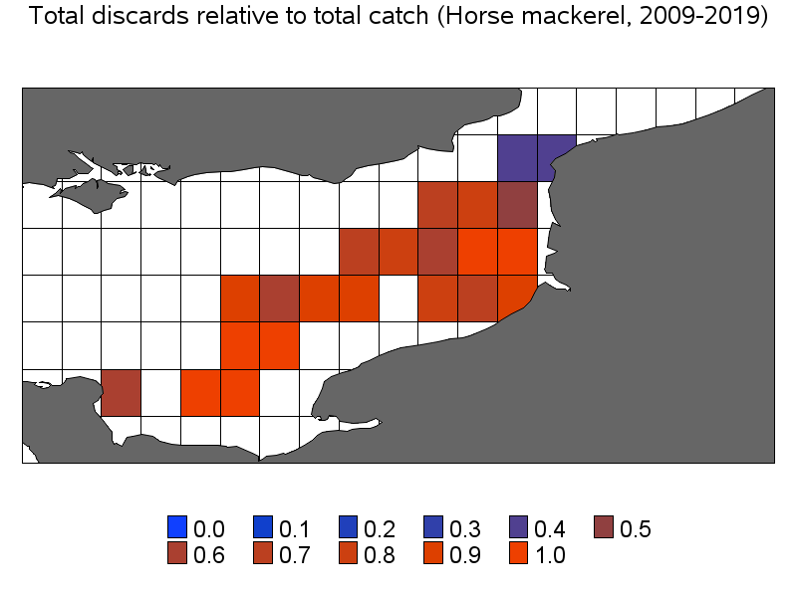
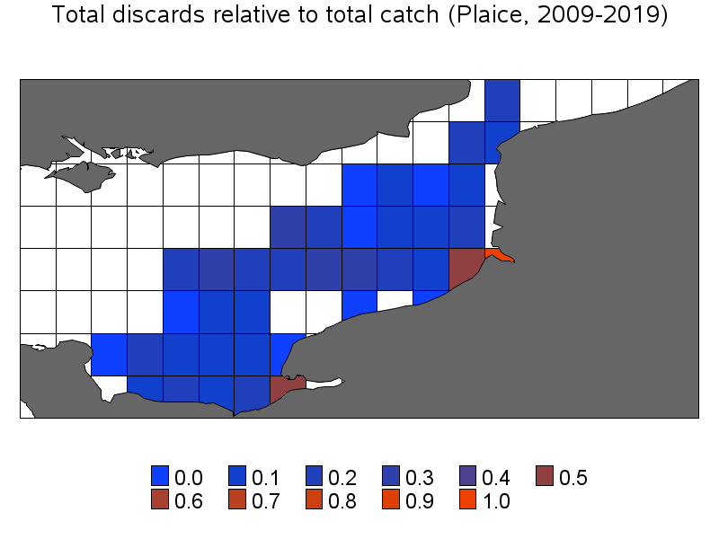 | 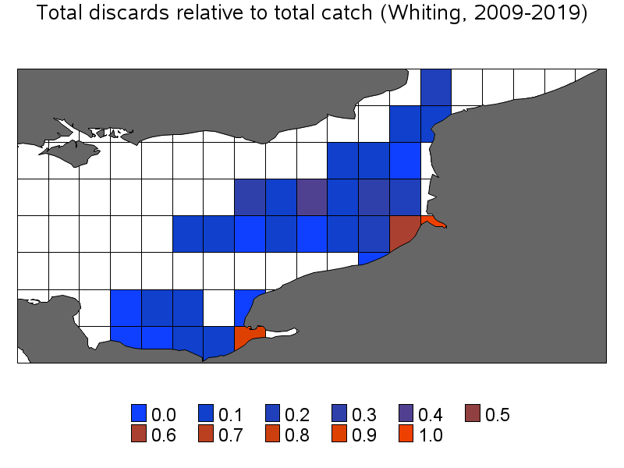

Figure S8. Spatial distribution of the undersized relative to total discards of horse mackerel (top right), plaice (bottom left) and whiting (bottom right) from bottom trawlers, averaged over 2009-20019.
 | 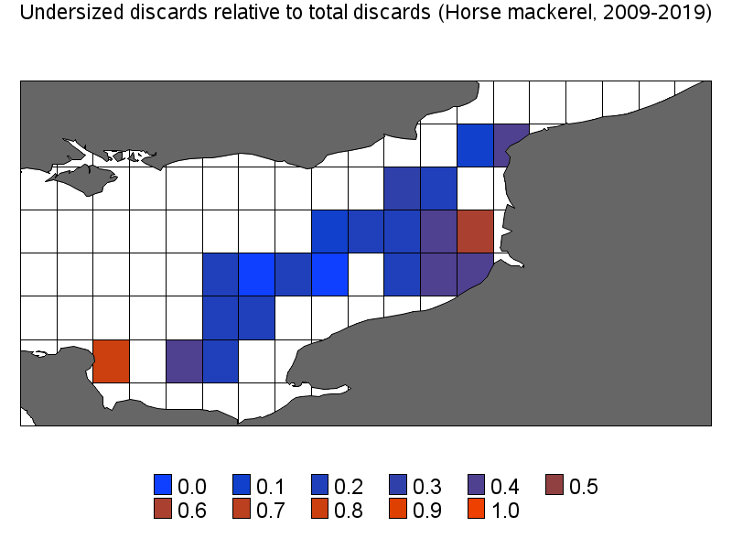
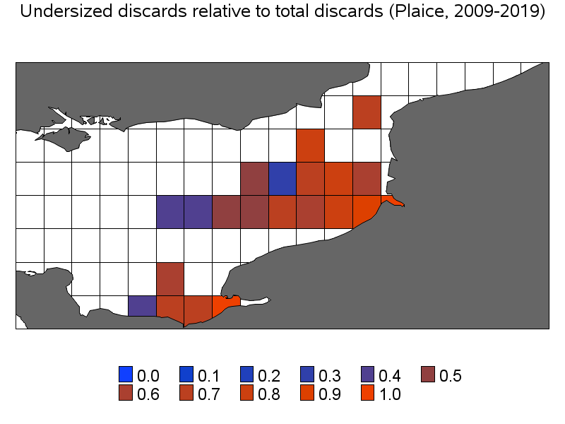 | 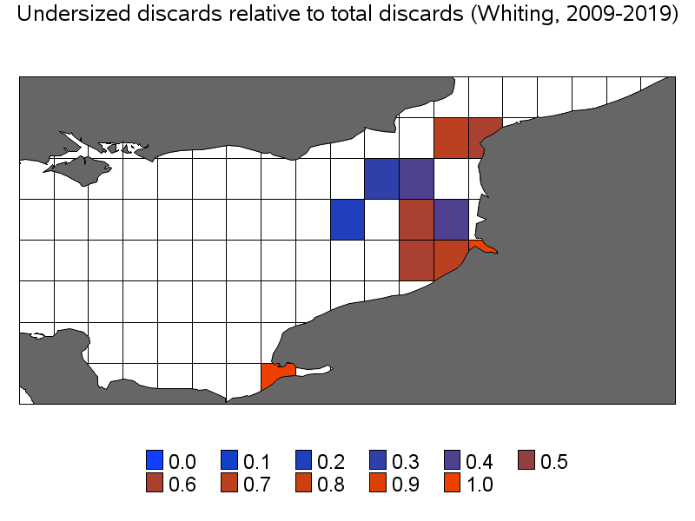

Figure S9. French quota uptake for the TAC stocks located within and/or beyond the EEC (ICES Division 7d). COD/07D.: cod in ICES Division 7d; PLE/7DE.: plaice in ICES Divisions 7d-e; WHG/7X7A-C: whiting in ICES Divisions 7b-k; HER/4CXB7D: herring in ICES Divisions 7d and 4c; MAC/2CX14-: mackerel in ICES Divisions/Subareas 6, 7, 8a-b, 8d-e, EU and international waters of ICES Division 5b, international waters of ICES Division/Subareas 2a, 12, 14; JAX/4BC7D: horse mackerel in ICES Divisions 4b-c, 7d.
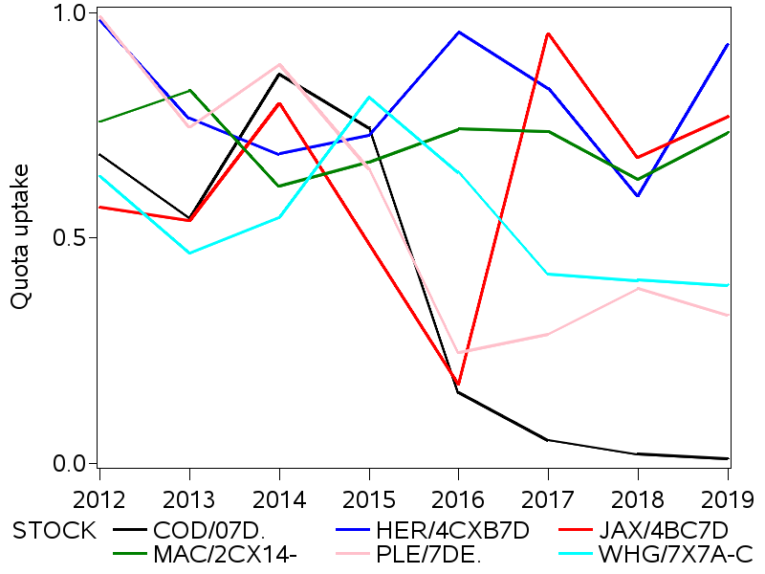

COMMISSION DELEGATED REGULATION (EU) No 1393/2014 of 20 October 2014 establishing a discard plan for certain pelagic fisheries in north-western waters
COMMISSION DELEGATED REGULATION (EU) 2015/2438 of 12 October 2015 establishing a discard plan for certain demersal fisheries in north-western waters
COMMISSION DELEGATED REGULATION (EU) 2016/2375 of 12 October 2016 establishing a discard plan for certain demersal fisheries in North-Western waters
COMMISSION DELEGATED REGULATION (EU) 2018/190 of 24 November 2017 amending Delegated Regulation (EU) No 1393/2014 establishing a discard plan for certain pelagic fisheries in North-Western waters
COMMISSION DELEGATED REGULATION (EU) 2018/46 of 20 October 2017 establishing a discard plan for certain demersal and deep sea fisheries in North-Western waters for the year 2018
COMMISSION DELEGATED REGULATION (EU) 2018/2034 of 18 October 2018 establishing a discard plan for certain demersal fisheries in North-Western waters for the period 2019-2021

