Supplementary Material
Supplementary Figure 1. Results of the three species delimitation methods based on the rbcL dataset. Bars represent results from the GMYC method using a single threshold (sGMYC), GMYC with multiple thresholds (mGMYC), and Bayesian poison tree processes method (bPTP). The green bar represents the consensus species delimitation using a conservative approach that matches at least 2 out of 3 species delimitation analyses. Posterior probability is indicated on the nodes.

Supplementary Figure 2. Latitudinal and longitudinal ranges of the 43 Pterocladiella species. Dot indicates geographical region of the species.

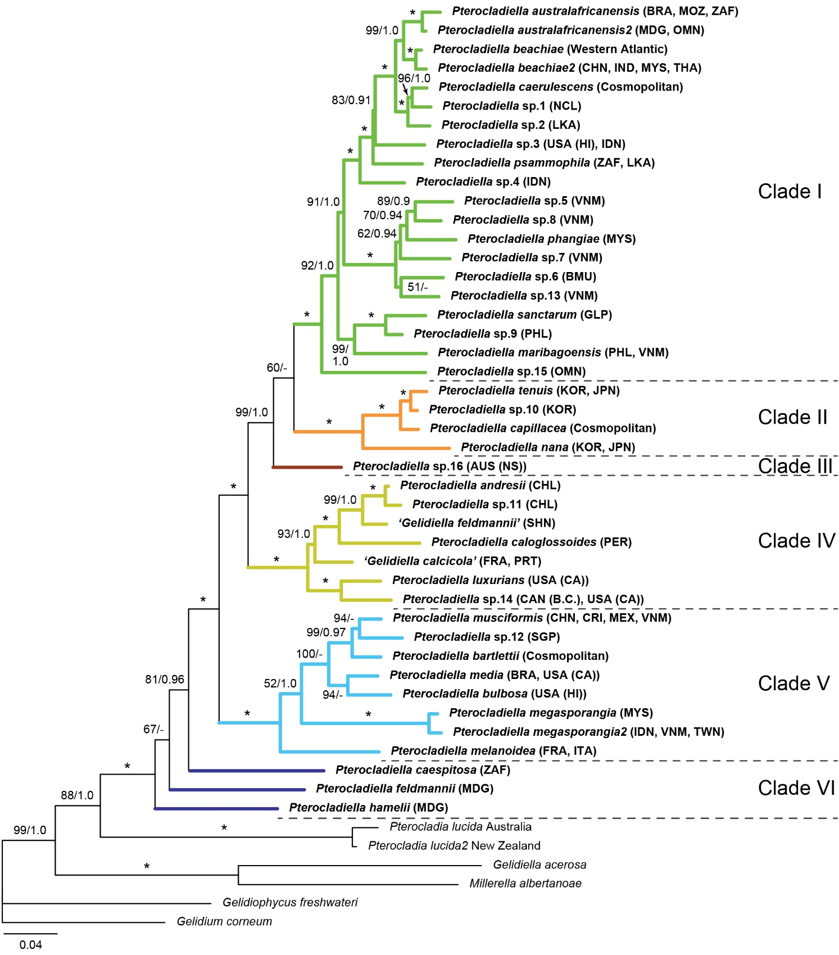
Supplementary Figure 3. Phylogenetic tree of Pterocladiella obtained by maximum-likelihood inference of the concatenated cox1 + cob + psaA + psbA + rbcL dataset (4,502 bp). ML and bootstrap values (≥50%) and Bayesian posterior probabilities (≥0.90) are indicated above and below branches, respectively. Asterisks indicate full support in both analyses.
Supplementary Figure 4. Maximum likelihood phylogeny of Pterocladiella for COI-5P (A), cob (B), psaA (C), psbA (D), and rbcL (E) sequences. Both ML bootstrap values (≥ 50%) and Bayesian posterior probabilities (≥ 0.9) are indicated at branches.

Supplementary Figure 5. Chronological dating of the order Gelidiales and crown node of Pterocladiella estimated using a Bayesian analysis concatenated data set of four-gene sequences (COI-5P, psaA, psbA, and rbcL). Mean divergence time estimates are presented near nodes and bars represent the highest posterior density (95%).
Supplementary Figure 6. Chronological dating of species in Pterocladiella estimated using a Bayesian analysis concatenated data set of five-gene sequences (COI-5P, cob, psaA, psbA, and rbcL). Mean divergence time estimates are presented near nodes and bars represent the highest posterior density (95%).

Supplementary Figure 7. Speciation rate (A) and Lineage-through-time (B) plot of Pterocladiella derived from the time calibrated phylogeny (Supplementary Fig. S4). The dashed straight line represents a constant rate of diversification with no extinction.
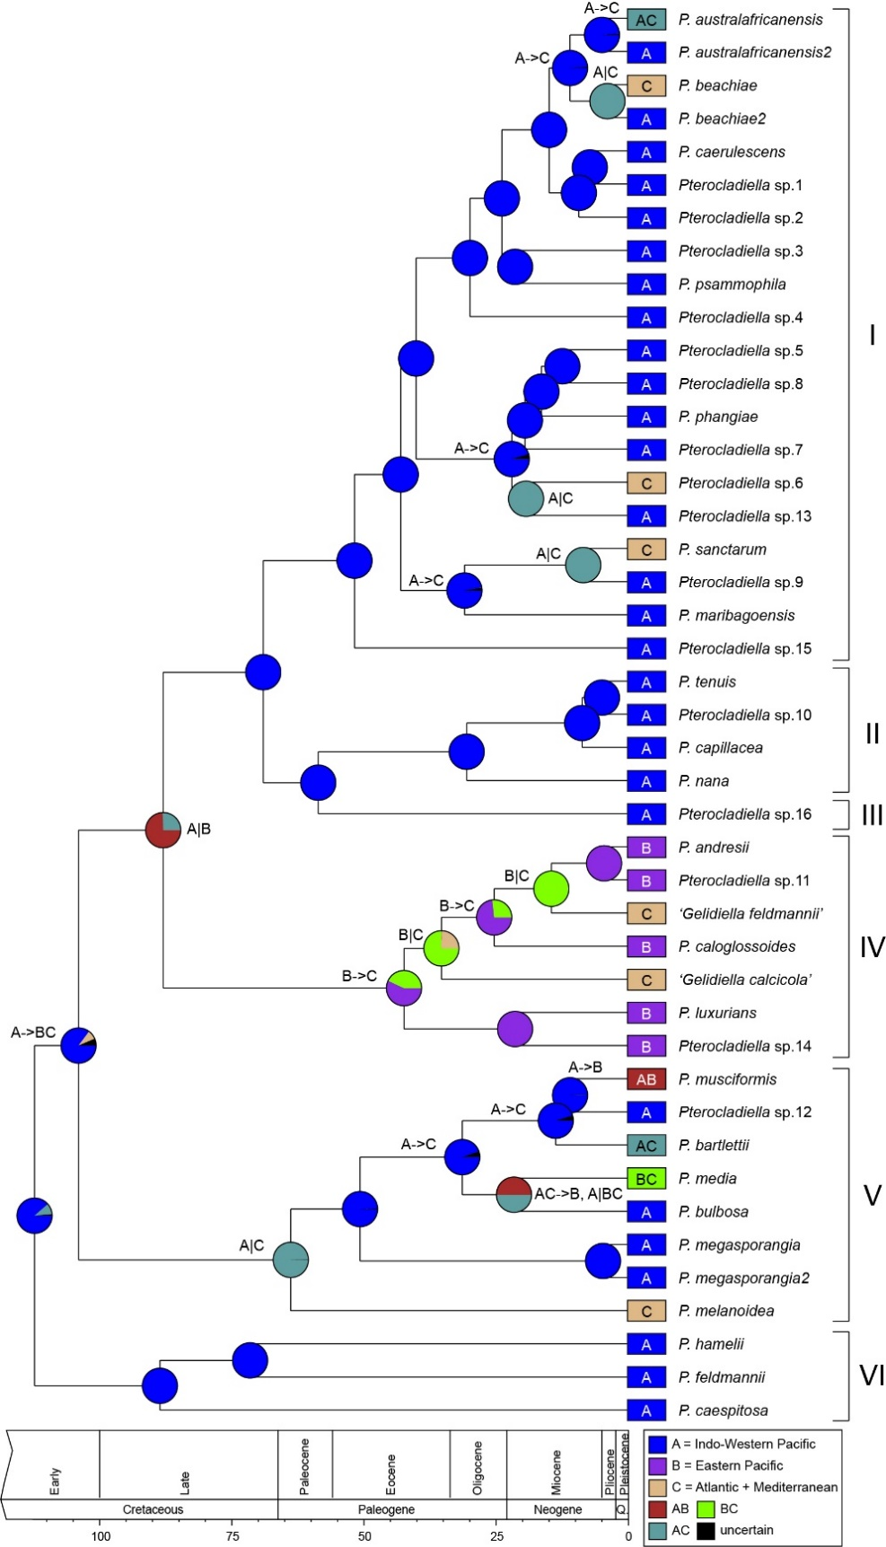
Supplementary Figure 8. Ancestral area reconstructions and biogeographical events in the genus Pterocladiella under DIVALIKE model considering three geographic regions. Boxes at the tips indicate geographical ranges of extant Pterocladiella species. Pie charts represent the probabilities for ancestral area of nodes. The map shows three regions used in the analysis. A color key is provided. The inferred biogeographic events are indicated at nodes and branches (e.g., A->B: dispersal and A|B: vicariance).

Supplementary Figure 9. Maps showing the three distribution patterns of nine pairs of sister species in Pterocladiella: peripatry (A–D), sympatry (E–G), allopatry (H). Detailed species’ geographic range is in Supplementary Table S1.

Supplementary Table 2. Information of primers used in the present study.
Gene | Primer name | Sequence (5’-3’) | References
cox1 | COXI43F | TCAACAAATCATAAAGATATTGGWACT | Geraldino et al., 2006
 | COXI1549R | AGGCATTTCTTCAAANGTATGATA | Geraldino et al., 2006
cob | CB44F | ATTTAATWGATTATCCWACDCC | Saunders and Moore, 2013
 | CB1006R | CAGGCATWCCRCCWATYCAKC | Saunders and Moore, 2013
psaA | psaA130F | AACWACWACTTGGATTTGGAA | Yoon et al., 2002
 | psaA971F | ACTACWTCATGGCAYGCWCAACT | Yang and Boo, 2004
 | psaA1110R | CCWATCCACATRTGATGTGT | Yang and Boo, 2004
 | psaA1760R | CCTCTWCCWGGWCCATCRCAWGG | Yoon et al., 2002
psbA | psbA-F | ATGACTGCTACTTTAGAAAGACG | Yoon et al., 2002
 | psbA-R2 | TCATGCATWACTTCCATACCTA | Yoon et al., 2002
rbcL | F7* | AACTCTGTAGAACGNACAAG | Gavio and Fredericq, 2002
 | F577** | GTATATGAAGGTCTAAAAGGTGG | Freshwater and Rueness, 1994
 | F645* | ATGCGTTGGAAAGAAAGATTCT | Lin et al., 2001
 | F753-Gelidium** | GGAAGATATGTATGAAAGAGC | Boo et al., 2015
 | F1237** | CCAGATGGTATTCAAGCAGGTGC | Freshwater and Rueness, 1994
 | R753*,** | GCTCTTTCATACATATCTTCC | Freshwater and Rueness, 1994
 | R900-Gelidium** | GCGAGAGTATGTTGAATTACC | Boo et al., 2015
 | R1381** | ATCTTTCCATAGATCTAAAGC | Freshwater and Rueness, 1994
 | RrbcS start* | GTTCTTTGTGTTAATCTCAC | Freshwater and Rueness, 1994
*rbcL primers for fresh materials, **rbcL primers for type and archival herbarium specimens.

Supplementary Table 3. Summary of results of the four species delimitation methods for mitochondrial COI-5P and plastid rbcL sequences.
Genes | Methods | Number of species (confidence interval) | Notes
Mitochondrial COI-5P | GMYC  singlfe threshold | 44 (38-49) | GMYC model significantly higher than that of the null model of uniform (coalescent) branching rates (L0 = 877.9, LGMYC = 888.0, LR = 20.1, p =4.2e-05***)
 | GMYC  multiple threshold | 42 (34-59) | GMYC model significantly higher than that of the null model of uniform (coalescent) branching rates (L0 = 877.9, LGMYC = 889.5, LR = 23.2, p =9.3e-06***)
 | bPTP | 38 | Most supported partition found by simple heuristic search
 | ABGD | 39 | Distance K2P with MinSlope = 1.3
Plastid rbcL | GMYC  single threshold | 33 (30-39) | GMYC model significantly higher than that of the null model of uniform (coalescent) branching rates (L0 = 541.8, LGMYC = 552.4, LR = 21.2, p =2.5e-05***)
 | GMYC  multiple threshold | 36 (36-39) | GMYC model significantly higher than that of the null model of uniform (coalescent) branching rates (L0 = 541.8, LGMYC = 553.7, LR = 23.8, p =6.8e-06***)
 | bPTP | 30 | Most supported partition found by simple heuristic search

Supplementary Table 4. List of species, type locality, sample used in molecular identification, and distribution pattern of Pterocladiella species.
Species name | Type locality | Sample used in molecular identification | Geographical range confirmed by DNA sequences | Distribution pattern: cosmopolitan, endemic, subcosmopolitan (including disjunct) | References on molecular and/or morphological studies
Pterocladiella andresii G.H.Boo, Calderón & S.M.Boo 2017 | Chungungo, Coquimbo, Chile | Holotype, CNU012838 (S.M. Boo), 27 Oct. 2011 | Chile | Endemic | Boo et al., 2017; This study
Pterocladiella australafricanensis E.M.Tronchin & D.W.Freshwater in Freshwater et al. 2010 | Four Buoy Reef, Sodwana Bay, KwaZulu-Natal, South Africa | Topotype, SA04-045 (W.D. Freshwater), 19 Apr. 2004 | Brazil, Mozambique, South Africa | Subcosmopolitan (Disjunct): Western Indo-Pacific and Western Atlantic | Tronchin and Freshwater, 2010; Iha et al., 2017
Pterocladiella australafricanensis2 | – | Specimens from Madagascar and Oman | Madagascar, Oman | Endemic (broad-range): Western Indo-Pacific | Boo et al., 2016; This study
Pterocladiella bartlettii (W.R.Taylor) Santelices 1998 | Saint Louis du Sud, Haiti | Many specimens from Caribbean Sea, where the type locality is located | Brazil, Costa Rica, Guadeloupe, Guyane Française, Madagascar, Malaysia, New Caledonia, Singapore, USA (Texas), Vietnam | Cosmopolitan: Western Atlantic, Central Indo-Pacific, and Western Indo-Pacific | Thomas and Freshwater, 2001; Sohrabipour et al., 2013; Boo et al., 2016; Iha et al., 2017; This study
Pterocladiella beachiae Freshwater in Thomas and Freshwater 2001 | Cahuita, Limón, Costa Rica | Holotype, MICH1306658 (D.W. Freshwater & D.T. Thomas), 24 Mar. 1999 | Brazil, Costa Rica, Guadeloupe, Martinique, Panama | Endemic (broad-range): Western Atlantic | Thomas and Freshwater, 2001;  Iha et al., 2017; This study
Pterocladiella beachiae2 | – | Specimens from Southeast Asia | China, India, Malaysia, Thailand | Subcosmopolitan: Central Indo-Pacific and Western Indo-Pacific | Sohrabipour et al., 2013; Boo et al., 2016; Wang et al., 2020; This study
Pterocladiella bulbosa (N.H.Loomis) Santelices 1997 | Waialau, Molokai, Hawaii, USA | Holotype, UC1884014 (M. Reed 338a), 19 Jul. 1905 | USA (Hawai’i) | Endemic | Loomis, 1960; Santelices, 1997; This study
Pterocladiella caerulescens (Kützing) Santelices & Hommersand 1997 | Wagap, New Caledonia | Holotype, L0056117 (L 941.11.91, Vieillard #2103), 1863; Isotype, L0056116 (L 941.11.98) | Australia (WA), China, Madagascar, Malaysia, New Caledonia, Philippines, Singapore, Sri Lanka, USA (Hawai’i), Vietnam | Cosmopolitan: Central, Western and Eastern Indo-Pacific | Santelices and Hommersand, 1997; Millar and Prud’homme van Reine, 2005; Sohrabipour et al., 2013; Boo et al., 2016; Wang et al., 2020; This study
Pterocladiella caespitosa (Kylin) Santelices 1998 | Isipingo Beach, near Durban, South Africa | Specimen from Treasure Beach, near type locality | South Africa | Endemic | Norris, 1987; Tronchin and Freshwater, 2007
Pterocladiella caloglossoides (M.Howe) Santelices 1998 | Isla San Lorenzo, Peru | Specimens from Yacila, Peru; Type lost | Peru | Endemic | Boo et al., 2017; This study
Pterocladiella capillacea  (S.G.Gmelin) Santelices & Hommersand 1997 | Mediterranean Sea | Specimens from Mediterranean Sea | Australia, Brazil, China, France, Indonesia, Japan, Korea, Galápagos Islands, Mexico, Taiwan, Tunisia, USA (Hawai’i) | Cosmopolitan: Pacific, Atlantic, and Mediterranean Sea | Shimada et al., 2000; Boo et al., 2010; Iha et al., 2017; Manghisi et al., 2019; Wang et al. 2020; This study
Pterocladiella feldmannii G.H.Boo, L.Le Gall, I.K.Hwang & S.M.Boo 2016 | Nord-Est du phare d’Evatra, Madagascar | Holotype, PC0166269 (MAD0302), 10 May 2010 | Madagascar | Endemic | Boo et al., 2016; This study
Pterocladiella hamelii G.H.Boo, L.Le Gall, I.K.Hwang & S.M.Boo 2016 | Lavanono, Madagascar | Holotype, PC0171542 (MAD1297), 8 Jun. 2010 | Madagascar | Endemic | Boo et al., 2016
Pterocladiella luxurians (Collins) Boo & Miller in Boo et al. 2016 | Pacific Beach, San Diego County, California, USA | Holotype, UC1878479 (M. Snyder), 8 Mar. 1899 | USA (California) | Endemic | Boo et al., 2016; This study
Pterocladiella maribagoensis G.H.Boo & P.J.L.Geraldino 2016 | Maribago, Cebu, Philippines | Holotype, CNU040562 (G.H.Boo & P.J.L. Geraldino), 23 Apr. 2013 | Philippines, Vietnam | Endemic | Boo et al., 2016; This study
Pterocladiella media (E.Y.Dawson) G.H.Boo & K.A.Miller in Boo et al. 2016 | Neptune Place, La Jolla, California, USA | Isotype, UC1884019 (Dawson 15609), 1 Dec. 1956 | Brazil, USA (California) | Subcosmopolitan (Disjunct): Eastern Pacific and Western Atlantic | Boo et al., 2016; Iha et al., 2017; This study
Pterocladiella megasporangia J.Sohrabipour, P.-E.Lim & C.A.Maggs in Sohrabipour et al. 2013 | Teluk Kemang, Port Dickson, Negri Sembilan, Malaysia | Holotype, KLU PSM12599-1 (J. Sohrabipour), 29 Aug. 2011 | Malaysia | Endemic | Sohrabipour et al., 2013
Pterocladiella megasporangia2 | – | Specimens from Southeast Asia | Indonesia, Taiwan, Vietnam | Endemic | This study, DNA only
Pterocladiella melanoidea  (Schousboe ex Bornet) Santelices & Hommersand 1997 | Tangier, Morocco | Specimens from Mediterranean Sea | Italy, Spain, southern France | Endemic | Freshwater et al., 1994; Boo et al., 2016; This study
Pterocladiella musciformis (W.R.Taylor) G.H.Boo & K.A.Miller in Boo et al. 2016 | Golfo Dulce, Costa Rica | Holotype, UC1884021 (W.R. Taylor 34-601), 7. Mar. 1934 | China, Costa Rica, Mexico, Vietnam | Subcosmopolitan (Disjunct): Central Indo-Pacific and Eastern Pacific | Boo et al., 2016; Wang et al., 2020; This study
Pterocladiella nana (Okamura) Shimada, Horiguchi & Masuda 2000 | Yura-jima, Shimo-Koshiki Island, Koshiki Islands, Kagoshima, Japan | Topotype (#83, Shimada et al. 2000) from Shimo-Koshiki Island, Kagoshima, Japan | Korea, Japan | Endemic | Shimada et al., 2000; Boo et al., 2010; This study
Pterocladiella phangiae  J.Sohrabipour, P.-E.Lim & C.A.Maggs in Sohrabipour et al. 2013 | Port Dickson, Negeri Sembilan, Malaysia | Holotype, KLU PSM12598-1 (J. Sohrabipour), 29 Aug. 2011 | Malaysia | Endemic | Sohrabipour et al., 2013
Pterocladiella psammophila Tronchin & Freshwater 2007 | Ribbon Reef, Sodwana, KwaZulu-Natal Province, South Africa | Holotype,BOL KZN2K4-70 (E. Tronchin), 19 Apr. 2004 | South Africa, Sri Lanka | Endemic (broad-range): Western Indo-Pacific | Tronchin and Freshwater, 2007; This study
Pterocladiella sanctarum (Feldmann & Hamel) Santelices 2007 | Îles des Saintes, Guadeloupe, West Indies | Specimens from Guadeloupe: FRA1753 (Sud Port Louis), FRA1926 (Canal des Saintes) | Caribbean Sea | Endemic | Santelices, 2007
Pterocladiella tenuis (Okamura) Shimada, Horiguchi & Masuda 2000 | Enoshima, Kanagawa Prefecture, Japan | Topotype (#320, Shimada et al. 2000) from Enoshima, Kanagawa, Japan | Korea, Japan | Endemic | Shimada et al., 2000; Boo et al. 2017; This study
‘Gelidiella calcicola Maggs & Guiry 1988’ | Carraroe, County Galway, Ireland | Specimens from northeastern Atlantic | Portugal, northern France | Endemic | Díaz-Tapia and Barbara, 2015; This study
‘Gelidiella feldmannii Baardseth 1941’ | Nightingale Island (St. 117) and the Settlement (St. 160), Tristan da Cunha | Topotype from shade pool at East Landing, Nightingale Islands, Tristan da Cunha | Tristan da Cunha | Endemic | Saunders et al., 2019
Pterocladiella sp1 | – | Specimens from New Caledonia | New Caledonia | Endemic | This study, DNA only
Pterocladiella sp2 | – | Specimen from Sri Lanka | Sri Lanka | Endemic (singleton) | This study, DNA only
Pterocladiella sp3 | – | Specimens from Hawai’i and Indonesia | USA (Hawai’i), Indonesia | Subcosmopolitan: Central Indo-Pacific and Eastern Indo-Pacific | This study, DNA only
Pterocladiella sp4 | – | Specimens from Indonesia | Indonesia | Endemic | This study, DNA only
Pterocladiella sp5 | – | Specimens from Vietnam | Vietnam | Endemic | This study, DNA only
Pterocladiella sp6 | – | Specimens from Bermuda | Bermuda | Endemic | This study, DNA only
Pterocladiella sp7 | – | Specimen from Vietnam | Vietnam | Endemic (singleton) | This study, DNA only
Pterocladiella sp8 | – | Specimens from Vietnam | Vietnam | Endemic | This study, DNA only
Pterocladiella sp9 | – | Specimen from the Philippines | Philippines | Endemic (singleton) | This study, DNA only
Pterocladiella sp10 | – | Specimens from Korea | Korea | Endemic | This study, DNA only
Pterocladiella sp11 | – | Specimens from Robinson Crusoe Island, Chile | Chile (Robinson Crusoe Island) | Endemic | This study, DNA only
Pterocladiella sp12 | – | Specimen from Singapore | Singapore | Endemic (singleton) | This study, DNA only
Pterocladiella sp13 | – | Specimens from Vietnam | Vietnam | Endemic | This study, DNA only
Pterocladiella sp14 | – | Specimens from British Columbia, Canada and California, USA, as P. caloglossoides | USA (California), Canada (British Columbia) | Endemic (broad-range); Eastern Pacific | Smith, 1944; Renfrew et al.1989; This study
Pterocladiella sp15 | – | Specimen from Oman | Oman | Endemic (singleton) | This study, DNA only
Pterocladiella sp16 (as P. caloglossoides) | – | Specimen from eastern Australia | Australia | Endemic (singleton) | Millar and Freshwater, 2005
Distribution patterns: cosmopolitan, occurring in multiple realms; endemic, occurring in a realm; subcosmopolitan occurring in two realms; disjunct, a species is considerably separated from each other geographically; singleton, a species based on a single specimen or a single sequence (Lim et al., 2011). Dash (–) indicates not applicable.

Supplementary Table 5. Latitudinal ranges of Pterocladiella species.
Species | Southern hemisphere |  |  | Northern hemisphere
 | 0-20°S | 21-40°S | 41-60°S | 0-20°N | 21-40°N | 41-60°N
P. andresii | - | O | - | - | - | -
P. australafricanensis | - | O | - | - | - | -
P. australafricanensis2 | - | - | - | O | O | -
P. bartlettii | - | - | - | O | O | -
P. beachiae | - | - | - | O | O | -
P. beachiae2 | - | - | - | O | - | -
P. bulbosa | - | - | - | - | O | -
P. caerulescens | O | O | - | O | O | -
P. caespitosa | - | O | - | - | - | -
P. caloglossoides | O | - | - | - | - | -
P. capillacea | O | O | - | O | O | -
P. feldmannii | - | O | - | - | - | -
P. hamelii | - | O | - | - | - | -
P. luxurians | - | - | - | - | O | -
P. maribagoensis | - | - | - | O | - | -
P. media | - | O | - | - | O | -
P. megasporangia | - | - | - | O | - | -
P. megasporangia2 | - | - | - | O | O | -
P. melanoidea | - | - | - | - | O | O
P. musciformis | - | - | - | O | O | -
P. nana | - | - | - | - | O | -
P. phangiae | - | - | - | O | - | -
P. psammophila | - | - | - | O | O | -
P. sanctarum | - | - | - | O | - | -
P. tenuis | - | - | - | - | O | -
‘Gelidiella calcicola’ | - | - | - | - | - | O
‘Gelidiella feldmannii’ | - | O | - | - | - | -
Pterocladiella sp1 | O | - | - | - | - | -
Pterocladiella sp2 | - | - | - | O | - | -
Pterocladiella sp3 | - | - | - | O | O | -
Pterocladiella sp4 | O | - | - | - | - | -
Pterocladiella sp5 | - | - | - | O | - | -
Pterocladiella sp6 | - | - | - | - | O | -
Pterocladiella sp7 | - | - | - | O | - | -
Pterocladiella sp8 | - | - | - | O | - | -
Pterocladiella sp9 | - | - | - | O | - | -
Pterocladiella sp10 | - | - | - | - | O | -
Pterocladiella sp11 | - | O | - | - | - | -
Pterocladiella sp12 | - | - | - | O | - | -
Pterocladiella sp13 | - | - | - | O | - | -
Pterocladiella sp14 | - | - | - | - | O | O
Pterocladiella sp15 | - | - | - | O | - | -
Pterocladiella sp16 | - | O | - | - | - | -
Total species: 43 | 5 | 11 | 0 | 22 | 18 | 3

Supplementary Table 6. Comparison of the ancestral area reconstruction models implemented in BioGeoBEARS using RASP: dispersal-extinction-cladogenesis (DEC), dispersal-vicariance analysis (DIVALIKE), and BAYAREALIKE. Bold indicate best fit models.
Model | 3 regions |  |  | 8 realms
 | LnL | AICc | AICc_wt | LnL | AICc | AICc_wt
DEC | -55.5 | 115.3 | 0.0012 | -116.2 | 236.6 | 4.99E-05
DIVALIKE | -52.5 | 109.3 | 0.024 | -115.7 | 235.8 | 6.00E-05
BAYAREALIKE | -72.4 | 149.1 | 5.40E-11 | -126.8 | 257.8 | 9.80E-10
LnL: log-likelihood of the model, AICc: corrected Akaike information criterion, AICc_wt: AICc weight.

References of the supplementary material
Freshwater, D. W., and Rueness, J. (1994). Phylogenetic relationships of some European Gelidium (Gelidiales, Rhodophyta) species, based on rbcL nucleotide sequence analysis. Phycologia 33, 187–194.
Gavio, B., and Fredericq, S. (2002). Grateloupia turuturu (Halymeniaceae, Rhodophyta) is the correct name of the non-native species in the Atlantic known as Grateloupia doryphora. Eur. J. Phycol. 37, 349–559.
Geraldino, P. J. L., Yang, E. C., and Boo, S. M. (2006). Morphology and molecular phylogeny of Hypnea flexicaulis (Gigartinales, Rhodophyta) from Korea. Algae 21, 417–423.
Lin, S. M., Fredericq, S., and Hommersand, M. H. (2001). Systematics of the Delesseriaceae (Ceramiales, Rhodophyta) based on large subunit rDNA and rbcL sequences, including the Phycodryoideae, subfam. nov. J. Phycol. 37, 881–899.
Saunders, G. W., and Moore, T. E. (2013). Refinements for the amplification and sequencing of red algal DNA barcode and RedToL phylogenetic markers: a summary of current primers, profiles and strategies. Algae 28, 31–43.
Yang, E. C., and Boo, S. M. (2004). Evidence for two independent lineages of Griffithsia (Ceramiaceae, Rhodophyta) based on plastid protein-coding psaA, psbA, and rbcL gene sequences. Mol. Phylogenet. Evol. 31, 680–688.
Yoon, H. S., Hackett, J. D., and Bhattacharya, D. (2002). A single origin of the peridinin- and fucoxanthin-containing plastids in dinoflagellates through tertiary endosymbiosis. Proc. Natl. Acad. Sci. U.S.A. 99, 11724–11729.

