Supplementary Information of the ms titled:
“Biogeography pattern of the marine angiosperm Cymodocea nodosa in the eastern Mediterranean Sea related to the quaternary climatic changes”

Table S1. The panel of the 18 microsatellite markers, along with genetic indices across the twelve geographical populations of the Cymodocea nodosa meadows in the study area. No: number of alleles; A: allelic richness. LEM: Lemnos, IME: Imeros, FAN: Fanari, VRA: Vrasidas, NKA: Nea Karvali; VIA: Viamyl; AGT: Ag. Triada; CHA: Chalkidiki; EPA: eastern Pagasitikos; WPA: western Pagasitikos; MAG: Maliakos Gulf; CYP: Cyprus

Locus | Genetic Indices | LEM | IME | FAN | VRA | NKA | VIA | AGT | CHA | EPA | EPA | MAG | CYP
Cn2-14 | H_{EXP} | 0.802 | 0.702 | 0.743 | 0.349 | 0.895 | 0.591 | 0.615 | 0.822 | 0.731 | 0.489 | 0.854 | 0.727
 | H_{OBS} | 0.714 | 0.531 | 0.839 | 0.219 | 1.000 | 0.222 | 0.189 | 1.000 | 0.667 | 0.448 | 0.938 | 0.546
 | A | 4.426 | 3.863 | 4.381 | 2.410 | 6.534 | 3.171 | 3.420 | 4.000 | 4.687 | 2.818 | 5.877 | 3.644
 | No | 5 | 7 | 9 | 5 | 12 | 5 | 7 | 4 | 9 | 4 | 11 | 4
 | F_{IS} | 0.118 | 0.247 | -0.131 | 0.377 | -0.121 | 0.630 | 0.695 | -0.250 | 0.088 | 0.085 | -0.099 | 0.259
Cn2-16 | H_{EXP} | 0.484 | 0.670 | 0.795 | 0.821 | 0.837 | 0.559 | 0.660 | 0.000 | 0.670 | 0.774 | 0.763 | 0.610
 | H_{OBS} | 0.286 | 0.656 | 0.516 | 0.594 | 1.000 | 0.444 | 0.351 | 0.000 | 0.689 | 0.862 | 0.844 | 0.818
 | A | 2.868 | 3.558 | 4.631 | 4.947 | 5.215 | 3.319 | 3.533 | 1.000 | 3.811 | 4.202 | 4.210 | 2.852
 | No | 3 | 5 | 6 | 7 | 7 | 5 | 6 | 1 | 7 | 5 | 6 | 3
 | F_{IS} | 0.429 | 0.020 | 0.354 | 0.280 | -0.202 | 0.209 | 0.471 | NA | -0.028 | -0.116 | -0.108 | -0.364
Cn2-18 | H_{EXP} | 0.769 | 0.793 | 0.846 | 0.833 | 0.615 | 0.478 | 0.666 | 0.533 | 0.591 | 0.750 | 0.800 | 0.697
 | H_{OBS} | 0.857 | 0.594 | 0.710 | 0.906 | 0.421 | 0.111 | 0.460 | 0.000 | 0.333 | 0.655 | 0.844 | 0.273
 | A | 4.407 | 4.607 | 5.636 | 5.316 | 3.382 | 2.710 | 3.178 | 2.000 | 3.870 | 4.460 | 4.549 | 3.722
 | No | 5 | 7 | 10 | 10 | 4 | 4 | 5 | 2 | 8 | 7 | 6 | 4
 | F_{IS} | -0.125 | 0.254 | 0.163 | -0.089 | 0.321 | 0.773 | 0.314 | 1.000 | 0.439 | 0.128 | -0.056 | 0.620
Cn2-45 | H_{EXP} | 0.571 | 0.809 | 0.850 | 0.821 | 0.835 | 0.848 | 0.795 | 0.733 | 0.817 | 0.843 | 0.887 | 0.844
 | H_{OBS} | 0.286 | 0.688 | 0.871 | 0.781 | 0.950 | 0.778 | 0.730 | 1.000 | 0.955 | 0.690 | 0.969 | 0.818
 | A | 3.418 | 4.916 | 5.658 | 5.174 | 5.429 | 5.585 | 4.818 | 4.000 | 5.019 | 5.693 | 6.263 | 5.176
 | No | 4 | 9 | 11 | 8 | 8 | 8 | 9 | 4 | 7 | 10 | 11 | 6
 | F_{IS} | 0.520 | 0.152 | -0.025 | 0.050 | -0.142 | 0.085 | 0.083 | -0.429 | -0.170 | 0.185 | -0.093 | 0.032
Cn2-86 | H_{EXP} | 0.791 | 0.726 | 0.551 | 0.586 | 0.470 | 0.572 | 0.621 | 0.689 | 0.664 | 0.635 | 0.602 | 0.723
 | H_{OBS} | 0.286 | 0.194 | 0.321 | 0.172 | 0.188 | 0.235 | 0.111 | 1.000 | 0.778 | 0.655 | 0.750 | 0.455
 | A | 3.931 | 3.953 | 3.711 | 3.641 | 3.119 | 3.094 | 3.326 | 3.000 | 3.636 | 3.005 | 3.063 | 3.642
 | No | 4 | 5 | 7 | 7 | 6 | 4 | 9 | 3 | 7 | 4 | 4 | 4
 | F_{IS} | 0.657 | 0.736 | 0.421 | 0.709 | 0.609 | 0.596 | 0.823 | -0.538 | -0.173 | -0.033 | -0.251 | 0.383
Cn4-27 | H_{EXP} | 0.909 | 0.897 | 0.882 | 0.907 | 0.892 | 0.879 | 0.876 | 0.822 | 0.932 | 0.890 | 0.899 | 0.714
 | H_{OBS} | 0.833 | 0.903 | 0.613 | 0.719 | 1.000 | 0.778 | 0.811 | 1.000 | 0.867 | 0.931 | 0.936 | 0.636
 | A | 6.455 | 6.604 | 6.490 | 6.851 | 6.343 | 6.271 | 6.224 | 5.000 | 7.440 | 6.411 | 6.696 | 4.218
 | No | 7 | 14 | 15 | 16 | 10 | 11 | 13 | 5 | 16 | 11 | 13 | 5
 | F_{IS} | 0.091 | -0.007 | 0.309 | 0.210 | -0.125 | 0.119 | 0.075 | -0.250 | 0.071 | -0.047 | -0.042 | 0.114
Cn4-29 | H_{EXP} | 0.264 | 0.645 | 0.875 | 0.823 | 0.800 | 0.457 | 0.802 | 0.000 | 0.558 | 0.557 | 0.092 | 0.312
 | H_{OBS} | 0.286 | 0.313 | 0.613 | 0.594 | 0.450 | 0.667 | 0.865 | 0.000 | 0.111 | 0.414 | 0.031 | 0.364
 | A | 1.934 | 3.275 | 5.951 | 5.228 | 4.792 | 1.992 | 5.040 | 1.000 | 2.964 | 3.281 | 1.446 | 1.932
 | No | 2 | 5 | 10 | 9 | 7 | 2 | 11 | 1 | 4 | 5 | 3 | 2
 | F_{IS} | -0.091 | 0.519 | 0.303 | 0.282 | 0.444 | -0.478 | -0.080 | NA | 0.803 | 0.261 | 0.663 | -0.176
Cn4-35 | H_{EXP} | 0.736 | 0.788 | 0.891 | 0.782 | 0.611 | 0.767 | 0.773 | 0.733 | 0.835 | 0.808 | 0.847 | 0.610
 | H_{OBS} | 0.857 | 0.677 | 0.621 | 0.586 | 0.714 | 0.722 | 0.595 | 1.000 | 0.556 | 0.690 | 0.781 | 0.818
 | A | 4.846 | 4.830 | 6.377 | 5.050 | 2.951 | 4.611 | 4.830 | 4.000 | 5.438 | 5.283 | 5.426 | 3.319
 | No | 6 | 8 | 12 | 8 | 4 | 7 | 10 | 4 | 10 | 9 | 8 | 4
 | F_{IS} | -0.180 | 0.142 | 0.307 | 0.253 | -0.176 | 0.060 | 0.233 | -0.429 | 0.337 | 0.148 | 0.078 | -0.364
Cn4-5 | H_{EXP} | 0.604 | 0.637 | 0.689 | 0.735 | 0.718 | 0.713 | 0.679 | 0.644 | 0.701 | 0.762 | 0.793 | 0.827
 | H_{OBS} | 0.286 | 0.313 | 0.742 | 0.625 | 0.600 | 0.833 | 0.838 | 1.000 | 0.711 | 0.655 | 0.969 | 0.818
 | A | 2.714 | 3.073 | 3.522 | 3.718 | 4.183 | 4.091 | 3.494 | 3.000 | 4.117 | 4.353 | 5.117 | 5.385
 | No | 3 | 5 | 4 | 4 | 6 | 7 | 5 | 3 | 8 | 7 | 9 | 7
 | F_{IS} | 0.547 | 0.514 | -0.078 | 0.151 | 0.168 | -0.175 | -0.238 | -0.667 | -0.015 | 0.142 | -0.227 | 0.011
Cn4-6 | H_{EXP} | 0.648 | 0.571 | 0.658 | 0.589 | 0.240 | 0.341 | 0.618 | 0.000 | 0.509 | 0.307 | 0.600 | 0.550
 | H_{OBS} | 0.286 | 0.313 | 0.452 | 0.156 | 0.053 | 0.389 | 0.378 | 0.000 | 0.500 | 0.103 | 0.719 | 0.455
 | A | 3.637 | 2.713 | 3.999 | 3.066 | 1.986 | 2.382 | 3.274 | 1.000 | 3.155 | 2.309 | 2.989 | 2.827
 | No | 4 | 5 | 7 | 5 | 3 | 3 | 5 | 1 | 5 | 4 | 4 | 3
 | F_{IS} | 0.579 | 0.457 | 0.317 | 0.738 | 0.786 | -0.144 | 0.391 | NA | 0.017 | 0.667 | -0.202 | 0.180
Cy1 | H_{EXP} | 0.736 | 0.820 | 0.806 | 0.819 | 0.831 | 0.470 | 0.781 | 0.644 | 0.747 | 0.737 | 0.255 | 0.749
 | H_{OBS} | 0.714 | 0.844 | 0.742 | 0.844 | 0.500 | 0.333 | 0.703 | 1.000 | 0.556 | 0.655 | 0.188 | 0.636
 | A | 3.702 | 5.101 | 4.790 | 5.071 | 5.256 | 3.199 | 4.298 | 3.000 | 4.140 | 3.998 | 2.060 | 4.361
 | No | 4 | 8 | 7 | 7 | 8 | 5 | 8 | 3 | 9 | 6 | 3 | 5
 | F_{IS} | 0.032 | -0.029 | 0.081 | -0.030 | 0.404 | 0.297 | 0.102 | -0.667 | 0.259 | 0.113 | 0.266 | 0.157
Cy16 | H_{EXP} | 0.000 | 0.733 | 0.509 | 0.497 | 0.723 | 0.332 | 0.501 | 0.644 | 0.429 | 0.716 | 0.354 | 0.710
 | H_{OBS} | 0.000 | 0.625 | 0.484 | 0.406 | 0.850 | 0.389 | 0.189 | 1.000 | 0.422 | 0.828 | 0.313 | 0.546
 | A | 1.000 | 3.893 | 3.543 | 3.490 | 4.038 | 2.160 | 2.500 | 3.000 | 2.869 | 3.979 | 2.530 | 3.634
 | No | 1 | 6 | 9 | 9 | 6 | 3 | 3 | 3 | 6 | 6 | 5 | 4
 | F_{IS} | NA | 0.149 | 0.051 | 0.185 | -0.181 | -0.178 | 0.626 | -0.667 | 0.016 | -0.160 | 0.119 | 0.241
Cy17 | H_{EXP} | 0.670 | 0.772 | 0.777 | 0.734 | 0.771 | 0.732 | 0.733 | 0.822 | 0.771 | 0.698 | 0.762 | 0.264
 | H_{OBS} | 0.429 | 0.438 | 0.807 | 0.750 | 0.895 | 0.611 | 0.811 | 1.000 | 0.614 | 0.828 | 0.656 | 0.286
 | A | 2.988 | 4.427 | 4.473 | 4.364 | 4.559 | 3.677 | 3.718 | 4.000 | 4.282 | 3.708 | 4.021 | 1.934
 | No | 3 | 6 | 7 | 8 | 8 | 4 | 5 | 4 | 7 | 5 | 5 | 2
 | F_{IS} | 0.379 | 0.437 | -0.038 | -0.023 | -0.166 | 0.169 | -0.108 | -0.250 | 0.206 | -0.189 | 0.141 | -0.091
Cy3 | H_{EXP} | 0.440 | 0.203 | 0.381 | 0.205 | 0.268 | 0.737 | 0.728 | 0.778 | 0.478 | 0.197 | 0.586 | 0.312
 | H_{OBS} | 0.571 | 0.188 | 0.194 | 0.125 | 0.300 | 0.667 | 0.568 | 1.000 | 0.000 | 0.103 | 0.344 | 0.364
 | A | 1.999 | 1.898 | 2.456 | 1.966 | 2.033 | 3.740 | 3.695 | 4.000 | 2.198 | 1.980 | 3.163 | 1.932
 | No | 2 | 4 | 3 | 4 | 3 | 4 | 4 | 4 | 3 | 5 | 4 | 2
 | F_{IS} | -0.333 | 0.079 | 0.497 | 0.395 | -0.123 | 0.097 | 0.223 | -0.333 | 1.000 | 0.478 | 0.417 | -0.176
Cy4 | H_{EXP} | 0.703 | 0.801 | 0.882 | 0.847 | 0.628 | 0.803 | 0.795 | 0.733 | 0.892 | 0.822 | 0.819 | 0.571
 | H_{OBS} | 1.000 | 0.625 | 0.968 | 0.903 | 0.765 | 0.722 | 0.703 | 1.000 | 0.600 | 0.586 | 0.844 | 0.727
 | A | 3.692 | 4.992 | 6.237 | 5.526 | 3.382 | 5.009 | 5.155 | 4.000 | 6.438 | 5.034 | 5.243 | 3.361
 | No | 4 | 8 | 10 | 9 | 6 | 7 | 10 | 4 | 12 | 9 | 10 | 4
 | F_{IS} | -0.474 | 0.222 | -0.100 | -0.068 | -0.227 | 0.103 | 0.117 | -0.429 | 0.330 | 0.290 | -0.031 | -0.290
Po-5 | H_{EXP} | 0.758 | 0.862 | 0.847 | 0.824 | 0.800 | 0.781 | 0.589 | 0.778 | 0.726 | 0.633 | 0.757 | 0.675
 | H_{OBS} | 1.000 | 0.688 | 0.871 | 0.688 | 0.700 | 0.500 | 0.703 | 1.000 | 0.600 | 0.310 | 0.813 | 0.818
 | A | 3.868 | 6.079 | 5.642 | 5.117 | 4.854 | 4.870 | 3.446 | 4.000 | 4.239 | 2.971 | 4.121 | 3.394
 | No | 4 | 12 | 10 | 9 | 8 | 8 | 6 | 4 | 7 | 4 | 5 | 4
 | F_{IS} | -0.355 | 0.205 | -0.029 | 0.168 | 0.128 | 0.366 | -0.197 | -0.333 | 0.175 | 0.514 | -0.074 | -0.224
RUMR25 | H_{EXP} | 0.000 | 0.768 | 0.781 | 0.789 | 0.797 | 0.652 | 0.740 | 0.689 | 0.670 | 0.823 | 0.683 | 0.688
 | H_{OBS} | 0.000 | 0.500 | 0.581 | 0.781 | 0.889 | 0.833 | 0.973 | 1.000 | 0.864 | 0.931 | 0.906 | 0.818
 | A | 1.000 | 4.653 | 4.749 | 4.612 | 4.565 | 2.935 | 4.445 | 3.000 | 3.225 | 4.912 | 3.369 | 3.617
 | No | 1 | 8 | 8 | 6 | 7 | 3 | 8 | 3 | 5 | 6 | 6 | 4
 | F_{IS} | NA | 0.353 | 0.259 | 0.010 | -0.119 | -0.288 | -0.320 | -0.538 | -0.293 | -0.134 | -0.334 | -0.200
RUMR4 | H_{EXP} | 0.363 | 0.686 | 0.717 | 0.691 | 0.695 | 0.541 | 0.531 | 0.644 | 0.541 | 0.482 | 0.572 | 0.247
 | H_{OBS} | 0.429 | 0.688 | 0.516 | 0.500 | 0.450 | 0.333 | 0.216 | 1.000 | 0.044 | 0.448 | 0.250 | 0.273
 | A | 1.989 | 3.753 | 4.075 | 3.565 | 3.621 | 2.623 | 2.628 | 3.000 | 2.517 | 2.163 | 3.057 | 1.857
 | No | 2 | 5 | 5 | 5 | 4 | 3 | 3 | 3 | 5 | 3 | 4 | 2
 | F_{IS} | -0.200 | -0.003 | 0.284 | 0.280 | 0.358 | 0.391 | 0.596 | -0.667 | 0.919 | 0.071 | 0.567 | -0.111
 | H_{EXP} | 0.569 | 0.716 | 0.749 | 0.703 | 0.690 | 0.625 | 0.695 | 0.595 | 0.681 | 0.662 | 0.662 | 0.602
 | H_{OBS} | 0.507 | 0.543 | 0.637 | 0.575 | 0.651 | 0.532 | 0.566 | 0.778 | 0.548 | 0.600 | 0.672 | 0.582
overall | A | 3.271 | 4.233 | 4.796 | 4.395 | 4.236 | 3.636 | 3.946 | 3.111 | 4.114 | 3.920 | 4.067 | 3.378
 | No | 3.56 | 7.06 | 8.33 | 7.56 | 6.50 | 5.17 | 7.06 | 3.11 | 7.50 | 6.11 | 6.50 | 3.83
 | F_{IS} | 0.100 | 0.247 | 0.164 | 0.215 | 0.091 | 0.146 | 0.211 | -0.363 | 0.221 | 0.134 | 0.041 | 0.000

Table S2. Direct and logistic regression of the 13 analyzed demographic scenarios. CI: confidence interval
A |  | S1 | S2 | S3 | S4 | S5 | S6 | S7 | S8 | S9 | S10 | S11 | S12 | S13
Direct Regression | Regression value | 0,018 | 0 | 0,782 | 0,124 | 0 | 0,014 | 0 | 0,002 | 0,008 | 0 | 0,052 | 0 | 0
 | 95% CI low | 0 | 0 | 0.420 | 0 | 0 | 0 | 0 | 0 | 0 | 0 | 0 | 0 | 0
 | 95% CI high | 0.135 | 0 | 1 | 0.413 | 0 | 0.117 | 0 | 0.041 | 0.086 | 0 | 0.246 | 0 | 0
Logistic Regression | Regression value | 0,002 | 0 | 0,863 | 0,128 | 0 | 0 | 0 | 0 | 0,002 | 0 | 0,004 | 0 | 0
 | 95% CI low | 0 | 0 | 0.848 | 0.113 | 0 | 0 | 0 | 0 | 0 | 0 | 0.001 | 0 | 0
 | 95% CI high | 0.004 | 0.002 | 0.879 | 0.144 | 0.002 | 0.002 | 0.002 | 0.002 | 0.004 | 0.002 | 0.006 | 0.002 | 0

Figure S1. 16 Demographic scenarios as implemented in the DYI-ABC software. Pop1: northeastern, Pop2: northern, Pop3: northwestern Pop4: central-western. t are the different tested generation times of divergence. Scenarios 14, 15 and 16 detect the presence of bottleneck events.

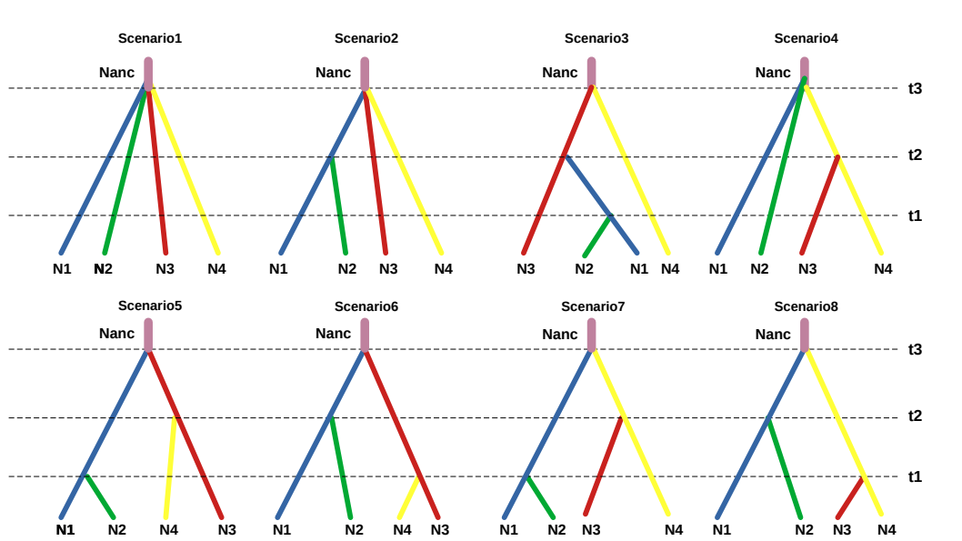
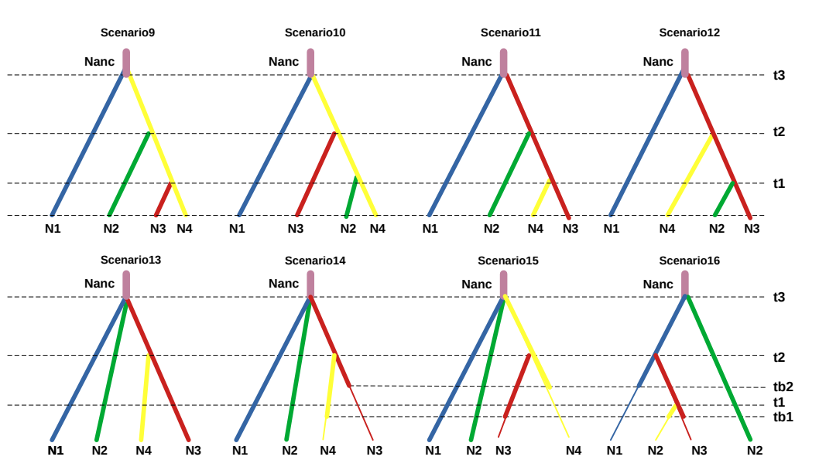

Figure S2. Delta K and Ln against K for Structure run given the reduction of Ln from K = 2 for all Cymodocea nodosa as implemented in HARVESTER software.

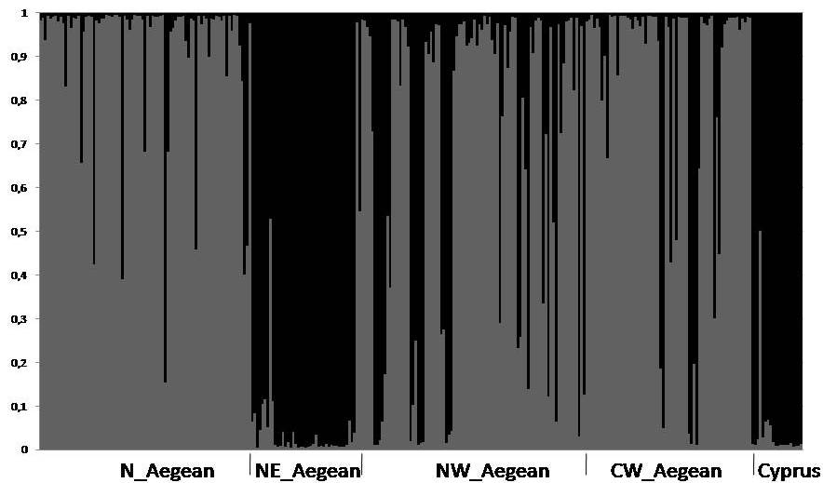
Figure S3. Estimated population structure plots based on genotypes of Cymodocea nodosa individuals. Each horizontal line represents a single individual divided into grey scale segments according to each station of membership (K = 2).

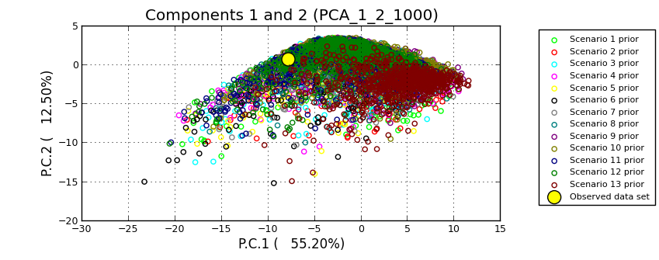
Figure S4: PCA plot displaying the fit between the 16scenarios simulated with uniform priors and the observed data. Plot made using DIY-ABC software.

A B
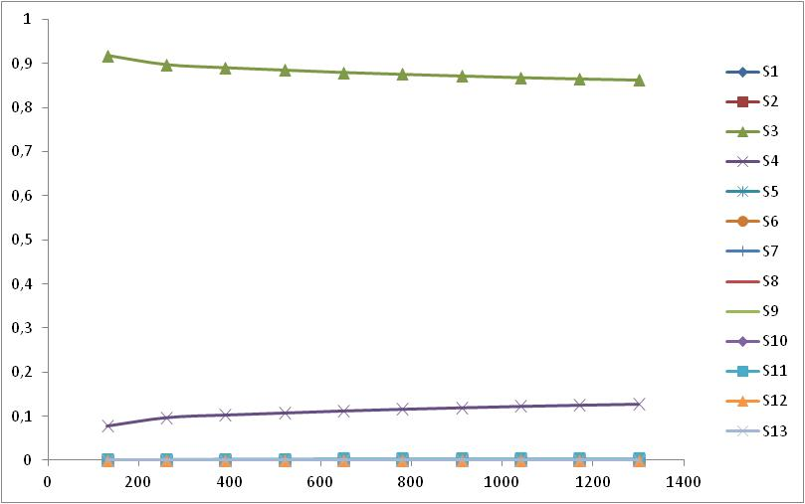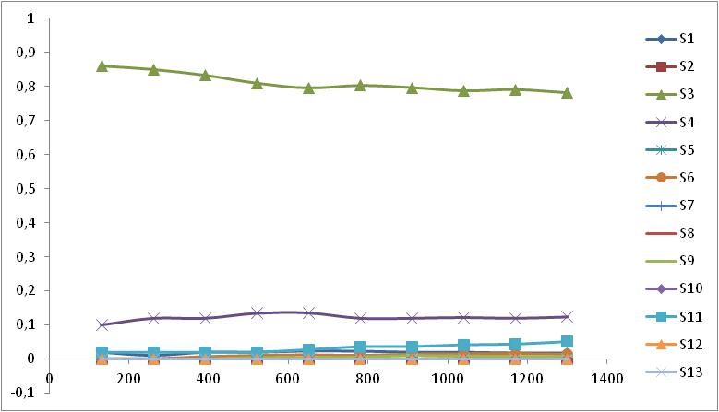
C D
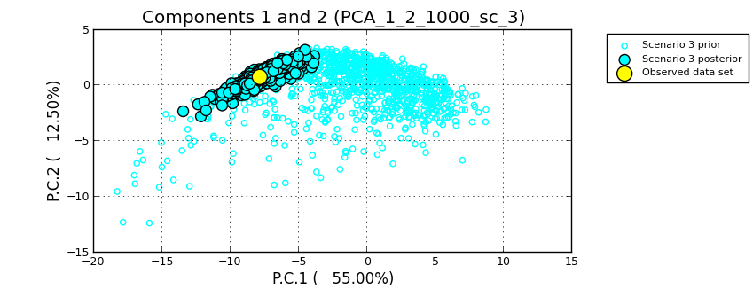

Figure S5. Logistic regression plot (A) and Direct regression plot (B) made in DIY-ABC to test which simulated scenarios better fit the observed data. Posterior probability in the y-axis represent the proportion of x datasets closest to the observed data that were simulated under different scenarios. (Top green line corresponds to Scenario 3). Model checking plot (D) displaying the fit of scenario 3 between prior and posterior simulated data. Plots constructed using DIYABC (Cornuet et al., 2008).

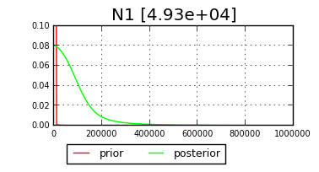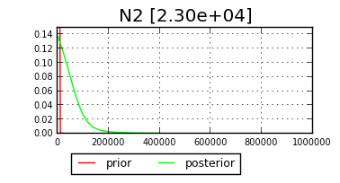
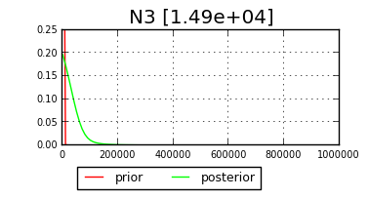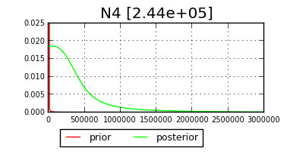
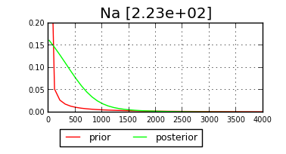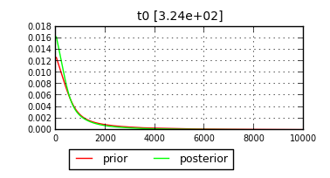

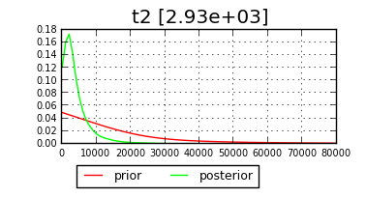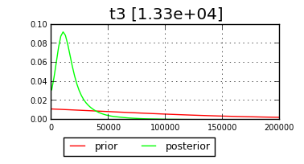
Figure S6: Posterior (green curve) and prior (red curve) distribution plots of ABC analysis based on 13x10⁶ simulated data sets of historical effective population sizes and time of divergence of the 3rd scenario; N₁: northern Aegean, N₂: north-eastern Aegean, N₃: north-western Aegean, N₄: central-western Aegean, N_{a}: ancestral population, t2: time of split within western Aegean Sea (north-western Aegean and central-western Aegean), t3: time of divergence of northern Aegean, north eastern Aegean and north-western Aegean Sea.

