Supplementary Information for
Phytoplanktonic Response to simulated Volcanic and Desert Dust Deposition Events in the South Indian and Southern Oceans
Carla Geisen¹, Céline Ridame¹, Emilie Journet², Pierre Delmelle³, Dominique Marie⁴, Claire Lo Monaco¹, Nicolas Metzl¹, Rawaa Ammar^{2,3}, Joelle Kombo¹, Damien Cardinal¹
¹Sorbonne Université, LOCEAN – IPSL Laboratoire d’Océanographie et du Climat: Expérimentations et Approches Numériques, UMR 7159, (SU CNRS MNHN IRD), 75252 Paris Cedex 05, France. ²LISA (Laboratoire Interuniversitaire des Systèmes Atmosphériques), UMR 7583, CNRS, Université Paris-Est Créteil et Université de Paris, Institut Pierre Simon Laplace (IPSL), Créteil, France. ³Earth and Life Institute, Environmental Sciences, UCLouvain, B-1348 Louvain-la-Neuve, Belgium. ⁴CNRS, Sorbonne Université, UMR 7144 Adaptation et Diversité en Milieu Marin, Station Biologique de Roscoff, 29680 Roscoff, France.
Corresponding author: Carla Geisen (carla.geisen@univ-littoral.fr)

Introduction
This supplementary information contains a detailed explanation about the negligible impact of possible iron contamination, as well as a calculation of aerosol sinking velocities in our experimental setup. Further, we detail the calculation steps to estimate the contribution of different phytoplankton size classes to the total biomass (using pigment analysis). Finally, we plot the response of heterotrophic bacteria and haptophytes to experimental nutrient and aerosol addition (assessed through flow cytometric cell count and 19’HF concentration, respectively).

Text S1. Possible iron contamination
The nutrient solution from the +Si treatment (assessed by ICP-AES and ICP-MS analyses) was contaminated with 0.23 nmol.L⁻¹ Fe. As no significant difference in PP response between +Fe and +Si was observed at any station, we discuss the risk that the biological response to the +Si treatment was due to Fe contamination instead of actual Si addition.
When comparing flow cytometry data, we observe that in opposition to the +Fe and +FeSi treatments, the addition of Si alone did not enhance picoeukaryote cell abundance at LNLC-2, indicating that the Fe contamination of the Si treatment was negligible for this phytoplankton group at this station. Moreover, at the Kerguelen plateau station A3, Fe addition increased both pico- and nanoeukaryote abundances (+120 % and +50 % respectively, Fig. 3i,j), while the potential Fe contamination of the Si treatment was insufficient to trigger a response. Finally, the unexpected Synechococcus development after Si or FeSi additions (~+70 %) were not observed after Fe addition, demonstrating that the Synechococcus response was not induced by Fe contamination, but in fact by Si addition.
Thus, we cannot definitely exclude the influence of 0.23 nmol.L⁻¹ Fe contamination within the Si treatment on PP at the western LNLC as well as the HN-LSi-LC and plateau stations. However, since the cell abundance response differs between nutrient treatments at several stations for several phytoplankton groups, we support the statement that this potential Fe contamination was negligible and should not impact the general conclusions of this study.

Text S2. Calculation of sinking velocities after representative aerosol deposition
In order to calculate the sinking velocity of aerosols in seawater, we applied the Stokes’ law, assuming that the dust and ash particles were spherical. This is a simplification of the reality, but it gives an estimate of the depth reached by aerosols after the experimental 48 h of incubation. The sinking velocity was calculated as follows (Equation S1):

$S_{v}=\frac{2}{9}×g×r^{2}×\frac{ρ_{particle}-ρ_{SW}}{η_{SW}}$ (S1)

where S_{v} is the sinking velocity, g is the Earth’s gravitational acceleration (9.81 m.s⁻²), r is the radius of the particle and ρ_{particle} is the density of dust or ash particles. Seawater density and viscosity of respectively ρ_{SW} = 1027 kg.m⁻³ and η_{SW} = 0.00141 kg.m⁻¹.s⁻¹ were calculated at 10 °C, according to the Engineering Tool Box (2005). The particle radius was calculated as half of the median diameter (6.4 and 22.1 µm for Pata and Eyja, respectively). Further, we used a mean estimated dust density of 2650 kg.m⁻³ (e.g., Langmann, 2013) and an Eyja density of 1400 kg.m⁻³ (Gudmundsson et al., 2012).
Applying Stokes’ law, we obtain the following sinking velocities for both aerosols:
S_{v}-Pata = 2.2 m.day⁻¹
S_{v}-Eyja = 6.1 m.day⁻¹

After 48 h of settling in seawater, the dust and ash particles would theoretically reach respectively 4.4 and 12.2 m depth. The mixed layer depth (MLD) ranks from 13 m to 50 m respectively in the LNLC and HNLC zones of the study area during austral summer (Hörstmann et al., 2021). Thus, the majority of dust/ash particles should theoretically not reach the MLD during the experimental time lapse. In this study, we used particle charges of 2 and 25 mg.L⁻¹ respectively in the dust and ash treatments, which correspond to an estimated deposition of 9 and 300 g.m⁻², assuming a mixing of aerosols within the 4.4 and 12.2 m upper layer. With a density of 1400 kg.m⁻³ (Gudmundsson et al., 2012), the Eyja deposition of 300 g.m⁻² corresponds to an ash layer of 0.2 mm over the sea surface.

Text S3. Contribution of phytoplankton size classes to the total biomass
The biomass fractions of micro-, nano- and picophytoplankton (Fig. S1) were calculated according to Uitz et al. (2006) depending on their individual pigment signature:
$﻿f_{micro}={(1.41 Fuco+1.41 Peri)}/{wDP}$ (S2a)
$f_{nano}=(1.27 19'HF+0.60 Allo+0.35 19'BF)/wDP$ (S2b)
$f_{pico}=(0.86 Zea+1.01 Tchlb)/wDP$ (S2c)
where wDP is the weighted sum of the concentrations of the seven diagnostic pigments:
$wDP= 1.41 Fuco+1.41 Peri+1.27 {19}^{'}HF+0.60 Allo+0.35 {19}^{'}BF+0.86 Zea+1.01 Tchlb$ (S3)

The concentration of total chlorophyll-a (Tchla) associated with each size class was calculated as follows, with x standing either for micro, nano or pico:
$﻿{Tchla}_{x}=f_{x}×Tchla$ (S4)

The diatom and dinoflagellate biomass were estimated using:
${Chla}_{diatom}={(1.41 Fuco*Tchla)}/{wDP}$ (S5a)
${Chla}_{dinoflagellate}={(1.41 Peri*Tchla)}/{wDP}$ (S5b)

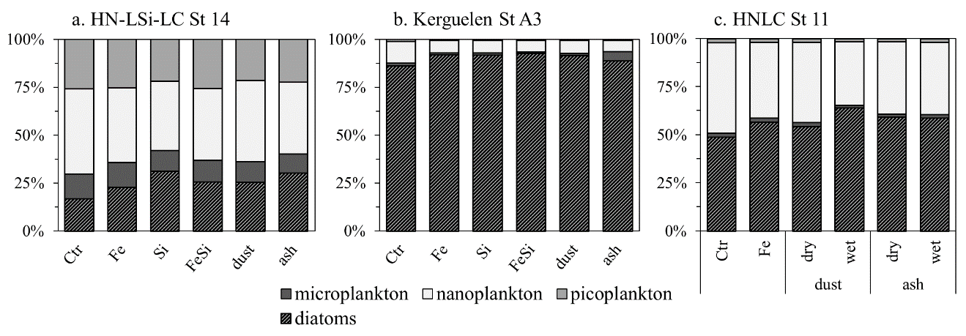Figure S1. Phytoplankton community composition (%) with relative abundances of micro- (dark), nano- (light) and pico-phytoplankton (median grey) calculated from pigment analysis, according to Equations S4 and S5. Diatom contribution within the micro-plankton size fraction is dashed.

S4. Response of heterotrophic bacteria and haptophytes

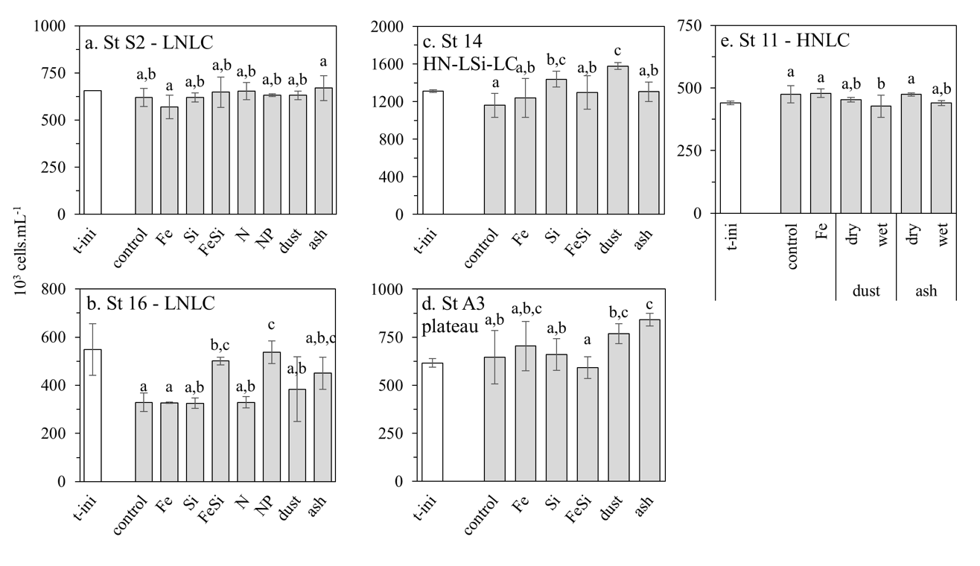

Figure S2. Cell abundance (cells.mL⁻¹) of heterotrophic bacteria at the beginning of the experiment (t-ini, white bar) and after 48 h of incubation for each treatment at the stations at LNLC Station 2 (a) and 16 (b), HN-LSi-LC Station 14 (c), plateau Station A3 (d) and HNLC Station 11 (e). Error bars indicate standard deviation of triplicates. Means that are not significantly different are labelled with the same letter (p > 0.05) within a station.

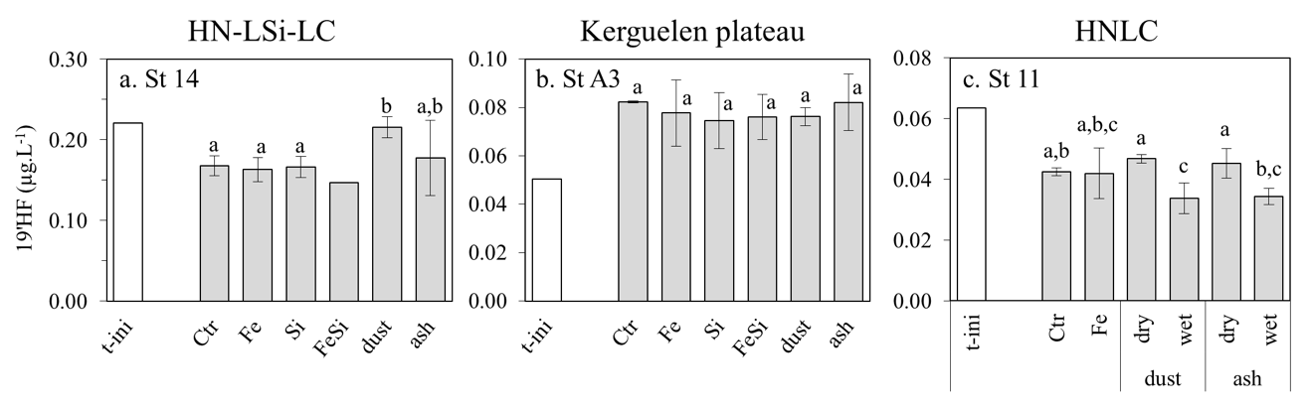

Figure S3. 19’Hexanoyloxyfucoxanthin concentration (19’HF, µg.L⁻¹) at the beginning of the experiment (t-ini, white bar) and after 48 h of incubation for each treatment at HN-LSi-LC Station 14 (a), plateau Station A3 (b) and HNLC Station 11 (c). Error bars indicate standard deviation of triplicates. FeSi treatment at Station 14 is not included in statistics, due to n = 1. Means that are not significantly different are labeled with the same letter (p > 0.05) within a station.

References
Engineering ToolBox, (2005). Seawater - Properties. [online] Available at: https://www.engineeringtoolbox.com/sea-water-properties-d_840.html [Accessed 15-06-2021]
Gudmundsson, M. T., Thordarson, T., Hoskuldsson, A., Larsen, G., Bjornsson, H., Prata, F. J., Oddsson, B., Magnusson, E., Hognadottir, T., Petersen, G. N., Hayward, C. L., Stevenson, J. A. and Jonsdottir, I.: Ash generation and distribution from the April-May 2010 eruption of Eyjafjallajökull, Iceland, Sci. Rep., 2, 1–12, doi:10.1038/srep00572, 2012.
Hörstmann, C., Raes, E. J., Buttigieg, P. L., Lo Monaco, C., John, U. and Waite, A. M.: Hydrographic fronts shape productivity, nitrogen fixation, and microbial community composition in the southern Indian Ocean and the Southern Ocean, Biogeosciences, 18(12), 3733–3749, doi:10.5194/bg-18-3733-2021, 2021.
Langmann, B.: Volcanic Ash versus Mineral Dust: Atmospheric Processing and Environmental and Climate Impacts, ISRN Atmos. Sci., 2013(ii), 1–17, doi:10.1155/2013/245076, 2013.
Uitz, J., Claustre, H., Morel, A. and Hooker, S. B.: Vertical distribution of phytoplankton communities in open ocean: An assessment based on surface chlorophyll, J. Geophys. Res., 111(C8), C08005, doi:10.1029/2005JC003207, 2006.

