Evidence for enhanced primary production driving significant CO₂ drawdown associated with the Atlantic ITCZ

J. Severino P. Ibánhez^{1,2*}, Manuel Flores³, Nathalie Lefèvre⁴

1. Instituto de Investigacións Mariñas, Consejo Superior de Investigaciones Científicas (IIM-CSIC), Eduardo Cabello 6, 36208 Vigo, Spain
2. Biogeochemistry Research Group, School of Natural Sciences, Trinity College Dublin, College Green, Dublin 2, Ireland.
3. Department of Oceanography – DOCEAN, Federal University of Pernambuco – UFPE, Av. Arquitetura, s/n, Cidade Universitária, 50740-550, Recife-PE, Brazil
4. IRD-LOCEAN, Sorbonne Universités (Université Pierre et Marie Curie-CNRS-MNHN), 4 place Jussieu, 75252 Paris Cedex 05, France

*Corresponding author: J.S.P. IBÁNHEZ
e-mail: jseverino@iim.csic.es

Introduction and supplementary text
During the collection of underway measurements used in this study, the atmospheric molar fraction of CO₂ (xCO_{2atm}) could not be recorded during March and April 2011 due to a problem with the atmospheric pumping. There, the monthly xCO_{2atm} recorded at the atmospheric stations of the NOAA/ESRL Global Monitoring Division were used to estimate underway atmospheric fCO₂ (fCO_{2atm}) and thus, to calculate underway sea-air CO₂ fluxes. To evaluate the reliability of this approximation, the same procedure is used to calculate fCO_{2atm} along the tracks of the voyages where underway fCO_{2atm} determinations are available. Comparison of both calculated and measured fCO_{2atm} gave very good results, with deviations (average 1.70 μatm, n=40925; Figure S1) within the precision range of the equipment (<2 μatm).
In this study, we use remote-sensed wind and rainfall fields to calculate sea-air CO₂ fluxes and to identify oceanic areas affected by recent rainfall. To evaluate the reliability of these data, we compared the daily wind and rainfall products with those measured in the in the Prediction and Research Moored Array in the Tropical Atlantic (PIRATA). Daily, remote-sensed properties were linearly interpolated at the location of the five PIRATA moorings closer to the study area framed in 5ºS to 15ºN, 18ºW to 36ºW. Furthermore, wind speed measured in the PIRATA array at 4m high was transformed to that at 10m high by using the parametrization of Smith (1985). Comparison of both datasets gave very good results; despite the relative coarse spatial resolution of the gridded, remote-sensed products used here (0.125º for the wind data and 0.25º for the rainfall data), both measured and remote-sensed data showed high correlation (p<10⁻⁷) with no significant differences in the median values (Mann-Whitney Rank Sum Test p>0.05; n>250; Figures S2 and S3) except for rainfall at the 0ºN 35ºW mooring. Interestingly, the newer wind product of the European Centre for Medium-Range Weather Forecasts (ECMWF) daily reanalysis data (ERA-5) gave poorer results than that used here (ERA-Interim). Based on these results, corrections of remote-sensed data used in this study is deemed unnecessary.
Further to these analyses, the monthly zonal component of surface currents in the tropical Atlantic, obtained from the Ocean Surface Current Analyses – Real time (OSCAR) data (1/3º resolution; JPL Physical Oceanography DAAC; developed by ESR) and used in this study, was compared with that measured in the PIRATA array. From the five selected moorings previously used, only two measured surface currents during the studied period (2008-2014). Rather than magnitude, we use direction to discern among the three main surface water currents in the study area. Thus, our comparison focuses on the agreement of direction between both data sets. 77% and 87% of the data agreed in direction when comparing the data at 0ºN 23ºW and 12ºN 23ºW, respectively (Figure S4). We interpret this agreement as reasonable considering the spatial resolution of the OSCAR data (1/3º).

Figure S1. Comparison of measured underway fCO_{2atm} with that calculated from the interpolation of monthly xCO_{2atm} recorded at the atmospheric stations of the NOAA/ESRL Global Monitoring Division. The solid line indicates a 1:1 relationship.

Figure S2. Comparison of daily wind speed measured at five of the moorings of the PIRATA during the period 2008-2014 with that obtained from the European Centre for Medium-Range Weather Forecasts (ECMWF) daily reanalysis data (ERA-interim). The gridded, daily wind speed data obtained from the ERA-interim was linearly interpolated at the location of each of the moorings used.

Figure S3. Comparison of daily rainfall measured at five of the moorings of the Prediction and Research Moored Array in the Tropical Atlantic (PIRATA) during the period 2008-2014 with that obtained from the Tropical Rainfall Measuring Mission (TRMM). The gridded, daily rainfall data obtained from the TRMM was linearly interpolated at the location of each of the moorings used. Spearman correlations between both datasets ranged from 0.59 at 8ºS 30ºW to 0.75 at 4ºN 23ºW.

Figure S4. Comparison of monthly zonal surface current speed (5 m depth) measured at two of the moorings of the PIRATA during the period 2008-2014 with that obtained from the Ocean Surface Current Analyses – Real time (OSCAR) data (1/3º resolution; JPL Physical Oceanography DAAC; developed by ESR). The gridded, monthly zonal current data obtained from the OSCAR was linearly interpolated at the location of each of the moorings used. Positive values denote eastward propagation.

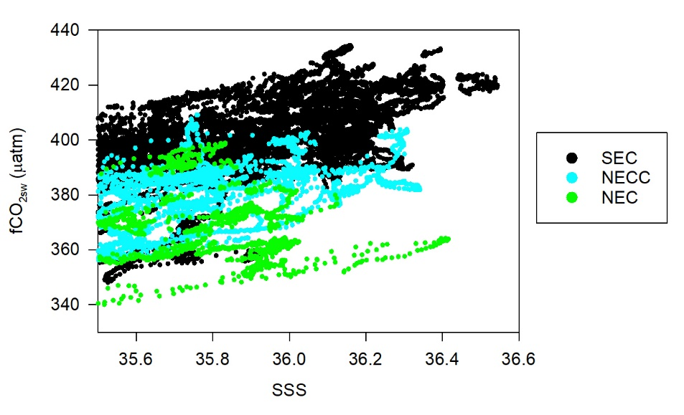

Figure S5. Surface seawater fCO₂ (fCO_{2sw}) associated to salinities higher than 35.5 in the areas where we found significant linear relationships of ln fCO_{2sw} vs ln SSS, organized by surface currents. Despite that the freshening caused by the ITCZ is still affecting the data used, the fCO_{2sw} showed significant (p<0.001) differences among surface currents.

References

Smith, S.V., 1985. Physical, chemical and biological characteristics of CO2 gas flux across the air-water interface. Plant Cell Environ. 8, 387–398.

