Supplementary Information

High coral recruitment despite coralline algal loss under extreme environmental conditions
Clément Tanvet^{1, 2,*}, Francesca Benzoni³, Christophe Peignon¹, Gérard Thouzeau² and Riccardo Rodolfo-Metalpa¹
¹ ENTROPIE – UMR 9220 (CNRS, IRD, UR, UNC, IFREMER), Institut de Recherche pour le Développement, 98848 Nouméa, New-Caledonia
² LEMAR – UMR 6539 (CNRS, IRD, UBO, IFREMER), Institut Universitaire Européen de la Mer, 29280 Plouzané, France ³ Red Sea Research Center (RSRC), King Abdullah University of Science and Technology (KAUST), Thuwal 23955-6900, Saudi Arabia
*Corresponding author: clement.tanvet@ird.fr

Supplementary Information: Figures

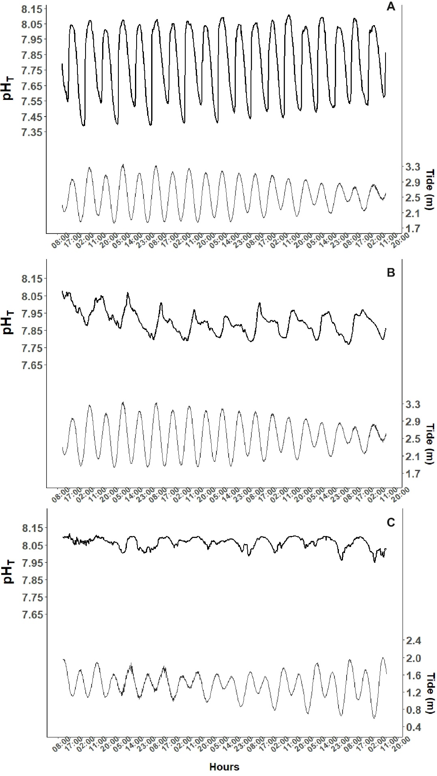
Figure S1| An example of the seawater pH_{T} coupled with the tidal variations, measured during 11 days at the end of March 2019 at St B3 and St R2 (A and B) and 11 days in January 2019 at St M1 (C).
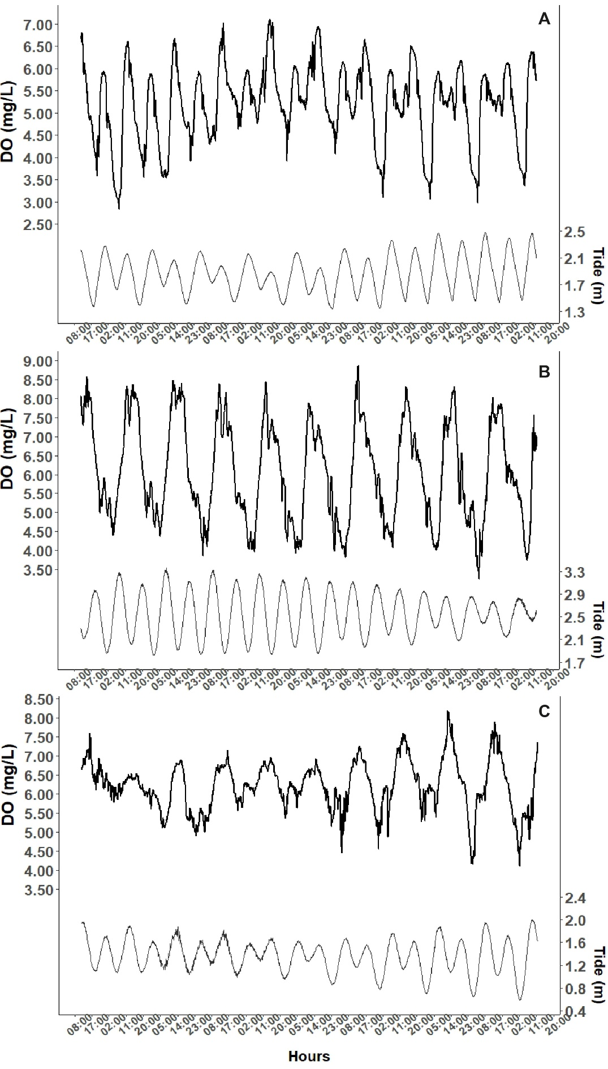
Figure S2| An example of the seawater dissolved oxygen concentrations, coupled with the tidal variations, measured during 11 days at the beginning of April 2019 at B3 (A), the end of March 2019 at St R2 (B) and at the end of January 2019 at St M1 (C).
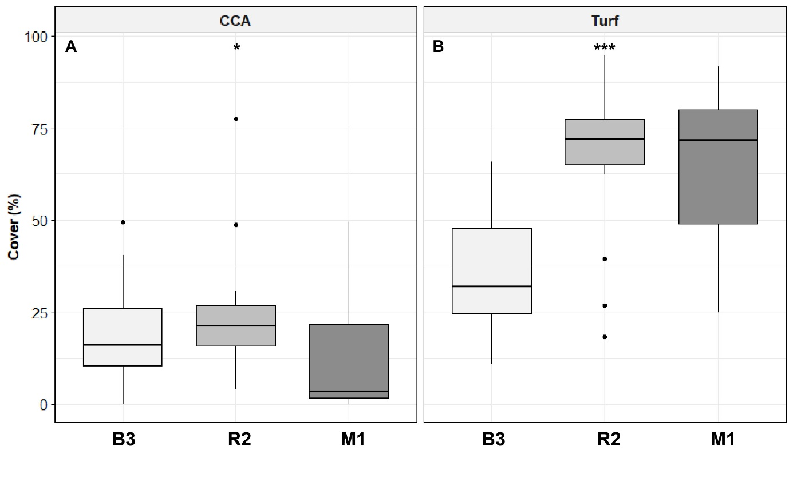Figure S3| CCA (A) and Turf percent cover (B) measured on the bottom sides of the tiles after ca. two years of tile immersion at stations B3, R2, and M1 (number of tiles n = 15, 20, and 19, respectively). Data are median values ± 25th and 75th percentiles (box), minimum and maximum values (whiskers), and outliers (dots). Stars represent statistical significance (see Table S3).

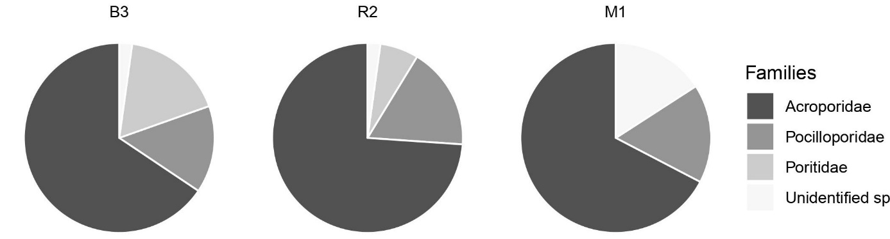
Figure S4| Mean relative abundances (%) of the coral families which settled on the tiles (all sides pooled) during the two years of tile immersion in Bouraké (B3) and stations R2 and M1.

Supplementary Information: Tables

Table S1| List of coral species identified in the Bouraké lagoon (B3) and at sites R2 and M1.
CORALS (Scleractinians)
Clade Complex
Family Genus Species Site
Acroporidae Acropora aculeus (Dana, 1846) B3-M1
Acroporidae Acropora cf. acuminata (Verrill, 1864) R2
Acroporidae Acropora aspera (Dana, 1846) B3-R2-M1
Acroporidae Acropora austera (Dana, 1846) R2
Acroporidae Acropora carduus (Dana, 1846) B3
Acroporidae Acropora cerealis (Dana, 1846) B3-M1
Acroporidae Acropora divaricata (Dana, 1846) B3-M1
Acroporidae Acropora echinata (Dana, 1846) B3
Acroporidae Acropora florida (Dana, 1846) R2-M1
Acroporidae Acropora gemmifera (Brook, 1892) R2
Acroporidae Acropora grandis (Brook, 1892) R2-M1
Acroporidae Acropora horrida (Dana, 1846) B3-R2-M1
Acroporidae Acropora humilis (Dana, 1846) B3-R2-M1
Acroporidae Acropora kirstyae Veron & Wallace, 1984 B3-R2-M1
Acroporidae Acropora latistella (Brook, 1892) R2
Acroporidae Acropora cf. longycyathus (Milne Edwards, 1860) R2
Acroporidae Acropora microphthalma (Verrill, 1869) B3-R2-M1
Acroporidae Acropora millepora (Ehrenberg, 1834) R2-M1
Acroporidae Acropora muricata (Linnaeus, 1758) B3-R2-M1
Acroporidae Acropora nana (Studer, 1879) B3
Acroporidae Acropora polystoma (Brook, 1891) R2
Acroporidae Acropora pulchra (Brook, 1891) B3-R2-M1
Acroporidae Acropora robusta (Dana, 1846) R2
Acroporidae Acropora retusa (Dana, 1846) R2
Acroporidae Acropora samoensis (Brook, 1891) B3-R2-M1
Acroporidae Acropora cf. secale (Studer, 1878) R2-M1
Acroporidae Acropora tenuis (Dana, 1846) B3-R2-M1
Acroporidae Acropora tortuosa (Dana, 1846) M1
Acroporidae Acropora valida (Dana, 1846) B3-R2-M1
Acroporidae Acropora vaughani Wells, 1954 B3-R2-M1
Acroporidae Anacropora forbesi Ridley, 1884 B3
Acroporidae Anacropora matthai Pillai, 1973 B3-R2
Acroporidae Anacropora puertogalerae Nemenzo, 1964 R2
Acroporidae Isopora palifera (Lamarck, 1816) R2-M1
Acroporidae Montipora aequituberculata Bernard, 1897 R2
Acroporidae Montipora angulata (Lamarck, 1816) M1
Acroporidae Montipora cactus Bernard, 1897 B3-M1
Acroporidae Montipora digitata (Dana, 1846) B3-R2-M1
Acroporidae Montipora efflorescens Bernard, 1897 R2
Acroporidae Montipora hispida (Dana, 1846) B3-R2-M1
Acroporidae Montipora mollis Bernard, 1897 R2
Acroporidae Montipora cf. nodosa (Dana, 1846) R2
Acroporidae Montipora stellata Bernard, 1897 B3-R2-M1

CORALS (Scleractinians) (continue Table S1)
Clade Complex
Family Genus Species Site
Agariciidae Pavona cactus (Forskål, 1775) B3-R2-M1
Agariciidae Pavona clavus Dana, 1846 R2
Agariciidae Pavona decussata (Dana, 1846) B3-R2-M1
Caryophylliidae Polycyathus fulvus Wijsman-Best, 1970 B3
Dendrophylliidae Turbinaria mesenterina (Lamarck, 1816) B3
Dendrophylliidae Turbinaria stellulata (Lamarck, 1816) R2
Dendrophylliidae Turbinaria reniformis (Bernard, 1896) M1
Dendrophylliidae Tubastraea coccinea Lesson, 1830 B3
Dendrophylliidae Tubastraea micranthus (Ehrenberg, 1834) B3
Euphylliidae Galaxea fascicularis (Linnaeus, 1767) B3-R2-M1
Incertae sedis Pachyseris rugosa Lamarck, 1801 B3-R2-M1
Incertae sedis Pachyseris speciosa Dana, 1846 B3-R2-M1
Poritidae Goniopora cf. minor Crossland, 1952 B3
Poritidae Porites sp. B3-M1
Poritidae Porites cf. annae Crossland, 1952 B3-M1
Poritidae Porites lutea Edwards & Haime, 1851 B3-R2-M1
Poritidae Porites lobata Dana, 1846 B3-R2-M1
Poritidae Porites cylindrica Dana, 1846 B3-R2-M1
Poritidae Porites rus (Forskål, 1775) R2
Siderastreidae Pseudosiderastrea tayamai Yabe & Sugiyama, 1935 B3

CORALS (Scleractinians)
Clade Robust
Family Genus Species Site
Fungiidae Heliofungia actiniformis (Quoy & Gaimard, 1833) B3
Fungiidae Halomitra pileus (Linnaeus, 1758) B3
Fungiidae Fungia fungites (Linnaeus, 1758) B3
Fungiidae Ctenactis echinata (Pallas, 1766) B3-M1
Fungiidae Cantharellus noumeae Hoeksema & Best, 1984 B3
Fungiidae Sandalolitha dentata Quelch, 1884 B3
Leptastreidae Leptastrea purpurea (Dana, 1846) B3-M1
Lobophylliidae Echinophyllia aspera (Ellis & Solander, 1786) B3
Lobophylliidae Lobophyllia cf. hemprichi (Ehrenberg, 1834) B3-M1
Lobophylliidae Lobophyllia corymbosa (Forskål, 1775) R2
Merulinidae Coelastrea aspera (Verrill, 1866) B3-R2
Merulinidae Cyphastrea serailia (Forskål, 1775) R2-M1
Merulinidae Cyphastrea sp. B3-M1
Merulinidae Dipsastrea pallida (Dana, 1846) B3-M1
Merulinidae Dipsastrea cf. lizardensis (Veron, Pichon, & B3
Wijsman-Best, 1977)
Merulinidae Echinopora lamellosa (Esper, 1795) B3-R2-M1
Merulinidae Echinopora horrida Dana, 1846 R2
Merulinidae Favites abdita (Ellis & Solander, 1786) B3-M1
Merulinidae Favites melicerum (Ehrenberg, 1834) B3-M1
Merulinidae Goniastrea favulus (Dana, 1846) B3-R2
Merulinidae Goniastrea pectinata (Ehrenberg, 1834) R2
Merulinidae Hydnophora rigida (Dana, 1846) B3
Merulinidae Merulina scabricula Dana, 1846 B3-M1
CORALS (Scleractinians) (continue Table S1)
Clade Robust
Family Genus Species Site
Merulinidae Merulina ampliata (Ellis & Solander, 1786) B3-M1
Merulinidae Pectinia lactuca (Pallas, 1766) R2-M1
Merulinidae Pectinia paeonia (Dana, 1846) B3-R2
Merulinidae Platygyra sinensis (Milne Edwards & B3-M1
Haime, 1849)
Merulinidae Platygyra daedalea (Ellis & Solander, 1786) B3-M1
Merulinidae Trachyphyllia geoffroyi (Audouin, 1826) B3
Pocilloporidae Pocillopora damicornis (Linnaeus, 1758) B3-R2-M1
Pocilloporidae Pocillopora verrucosa (Ellis & Solander, 1786) R2
Pocilloporidae Stylophora pistillata (Esper, 1797) R2
Psammocoridae Psammocora contigua (Esper, 1794) B3-R2-M1

CORALS (non-scleractinians)
Family Genus Species Site
Alcyioniidae Sinularia sp. B3

Table S2| Summary of cover percentages of each category (CCA, Turf and suspension feeders) per site (B3, R2 and M1) for top (A) and bottom side (B). Data are mean ± SE (n=15, 20 and 19 for B3, R2 and M1, respectively).
A)
Top sides, T₂ B3 R2 M1
Mean 46.94 ± 5.71 65.80 ± 5.30 70.89 ± 4.16
CCA Max 85.33 95.99 89.67
Min 20.55 21.89 32.32

Mean 19.64 ± 1.80 8.84 ± 1.57 10.11 ± 1.97
Turf Max 31.57 24.52 35.31
Min 8.50 1.03 0.20
Top sides, T_{24/26}
Mean 9.73 ± 1.27 50.23 ± 2.95 2.88 ± 1.00
CCA Max 17.85 77.53 18.97
Min 3.49 27.74 0.00

Mean 49.49 ± 6.97 20.37 ± 1.66 88.39 ± 2.40
Turf Max 92.80 32.73 97.17
Min 0.82 8.42 51.56
B)
Bottom sides, T_{24/26}
Mean 19.81 ± 3.45 23.99 ± 3.52 12.41 ± 3.25
CCA Max 49.54 77.46 49.39
Min 0.00 4.06 0.00

B)
Bottom sides, T_{24/26} (continue Table S2)
Mean 35.44 ± 4.48 67.00 ± 4.21 64.75 ± 4.65
Turf Max 65.82 94.42 91.69
Min 10.95 18.18 24.78

Susp. Mean 4.17 ± 1.05 0.45 ± 0.37 15.35 ± 4.77
feeders Max 12.09 7.32 70.75
Min 0.51 0.00 0.00

Table S3| Statistical data for each category of organisms settled on tile bottom sides after two years of tile deployment (T_{F}). Non-parametric Kruskal-Wallis tests, followed by Dunn’s multiple comparisons, were run between stations for each category of organisms settled A), for coral recruits between stations settled on the whole tiles (all sides pooled) B) and between sides per station C) (B refers to Bottom-sides ; L refers to Lateral-sides ; T refers to Top-sides).
A)
Bottom sides, T_{24/26} between stations df K-W p Dunn’s multiple comparison
CCA (2, 54) 7.530 0.020 M1 < R2 = B3 (p < 0.010)
Turf (2, 54) 18.135 <0.001 B3 < M1 = R2 (p < 0.001)
Susp. feeders (2, 54) 21.066 <0.001 B3 = M1 > R2 (p < 0.001)
Empty (2, 54) 27.090 <0.001 B3 > M1 = R2 (p < 0.001)
B)
Recruits, T_{24/26} between stations
Recruits 2 17.521 <0.001 B3 > R2 = M1 (p < 0.001)
C)
Recruits, T_{24/26} between sides
B3 2 23.676 <0.001 B > L > T (p < 0.020)
R2 2 30.161 <0.001 B > L = T (p < 0.001)
M1 2 26.729 <0.001 B > L = T (p < 0.001)

Table S4| Non-parametric Kruskal-Wallis test between the three stations on Shannon Index Diversity (i.e., H= 4.17, 4.02, and 3.97 for stations B3, R2 and M1, respectively.
Species diversity between stations df K-W p
Shannon Index Diversity 2 2 0.368

