SUPPLEMENTAL DATA

Supplemental materials and methods 2
Streptavidin-tagged proteins: cloning 2
Co-purification PAN with Streptavidin-tagged Q9UZY3 2
Unfolding assays 3
Expression and purification of P. abyssi 20S 3
Degradation assays by the proteasome complex 4
Production of Pyrococcus horikoshii proteins 4
Co-immunoprecipitation with P. horikoshii proteins 5
SAXS data collection and analysis 5
Electrophoretic mobility shift assays with linear substrates 6
Supplemental figures 7
Figure S1. Purification of P. abyssi PAN. 7
Figure S2. Purification of recombinant P. abyssi Q9UZY3 constructs. 8
Figure S3. Pull-down Q9UZY3-PAN. 9
Figure S4. Co-purification of PaPAN with Streptavidin-tagged Q9UZY3. 10
Figure S5. Q9UZY3 paralog (O58951) interacts with PhPAN. 11
Figure S6. PAN-20S enzymatic activities in presence of Q9UZY3. 12
Figure S7. Structural analysis of recombinant Q9UZY3 in solution. 14
Figure S8. Comparison of various OB-fold domains. 15
Figure S9. Electrophoretic mobility shift assays with tRNA. 16
Figure S10. Electrophoretic mobility shift assays with linear DNA or RNA substrates. 17
Figure S11. Sequence alignment of Haloferax volcanii Rqc2 homolog (A0A384LD57) and Pyrococcus abyssi Q9V0U1. 18
Supplemental tables 19
TABLE S1. Recombinant protein properties 19
TABLE S2. Primers and cloning strategies for expression in bacteria cells 20
TABLE S3. Data collection and refinement statistics for P. abyssi Q9UZY3 crystal structure. 21
Table S4. Parameters for SAXS data acquisition and analysis. 22
Table S5. Full list of PaQ9UZY3 partners identified by pull-down MS/MS. 23
Supplemental references 25

Supplemental materials and methods

Streptavidin-tagged proteins: cloning
N-terminal truncated Q9UZY3 constructs with a N-terminal Strep tag (for details on constructs, plasmids and primers, see tables S1 and S2) were amplified with primers to introduce restriction sites for directional cloning or overhangs for restriction-free cloning. Polymerase chain reaction (PCR) primers and restriction enzymes were purchased from Genecust and Thermo Fisher Scientific, respectively. PCR was performed using Phusion High Fidelity DNA polymerase (Thermo Fisher Scientific) according to the manufacturer’s instructions and following a standard optimization step by thermal gradient in each reaction. DNA was purified with the NucleoSpin Plasmid Kit (Macherey-Nagel) according to the manufacturer’s instructions, and all constructs were verified by Sanger sequencing (Genewiz).

Expression and purification of Streptavidin-tagged Q9UZY3

Two Streptavidin-tagged versions of P. abyssi Q9UZY3 (Q9UZY3-Ntag-Strep and Q9UZY3-ΔN-Ntag-Strep) were cloned as described in tables S1 and S2. Streptavidin-tagged Q9UZY3 proteins were overexpressed and purified following the same protocol described as for Q9UZY3, except for the dialysis step prior to the affinity chromatography column, against Strep buffer (100 mM Tris-HCl pH 8.0, 150 mM NaCl, 1 mM EDTA) and the affinity column used (1mL-StrepTrap HP column, Sigma-Aldrich). Strep-tagged proteins were washed using Strep buffer and eluted by Strep buffer supplemented with 2.5 mM desthiobiotin. After the affinity column, overnight dialysis, cation exchange and size exclusion chromatography purifications were performed following Q9UZY3 protocol.
The final Streptavidin-tagged Q9UZY3 protein concentrations were calculated by measuring absorbance at 280 nm using the predicted extinction coefficient of 13,980 M⁻¹.cm⁻¹ for both proteins and molecular weight of 15671.3 and 13368.6 Da for Q9UZY3-Ntag-Strep and Q9UZY3-ΔN-Ntag-Strep, respectively (ProtParam, ExPASy).

Co-purification PAN with Streptavidin-tagged Q9UZY3

To study the physical interaction between recombinant proteins, PAN and Q9UZY3, several pull-downs in Strep-Tactin XT Superflow resin (iba) were performed. In a final reaction volume of 1 mL of Strep buffer supplemented with 10 mM MgCl₂, a 300-μL sample of the prey protein (11 μM PaPAN) was incubated overnight at 4°C with 100-μL sample of the bait protein (40.8 μM Q9UZY3-Ntag-Strep or 30.6 μM and Q9UZY3-ΔN-Ntag-Strep). Then in the morning, 200 uL of dried Strep resin were added and incubated for 2-3h at 4°C. After this last incubation, the sample was added to the 2 mL-Econo-Pac chromatography column (Bio-RAD) and passed through by gravity. Resin was extensively washed by first, 10 CV (column bed volume) of Strep buffer supplemented by 0.05% Tween 20 (first wash) and then, 2 x 10 CV of regular Strep buffer (second and third washes). Strep-tagged proteins alone and in complex with PAN proteins were eluted by 3 x 3 CV of Strep buffer supplemented with 50 mM Biotin (first, second and third elutions). Same protocol for control of pull-down but buffer was added instead of Strep-tagged Q9UZY3 proteins. Co-elutions and controls were analyzed by 12% SDS-PAGE gel.

Unfolding assays
To confirm the unfolding activity of PaPAN, a modified GFP, named GFPssrA, was used as substrate as described by Mahieu and colleagues (Mahieu et al., 2020). Briefly, 10.8 µM GFPssrA were incubated with 0.94 µM PaPAN at 55°C for 60 min in 50 mM Tris-HCl, pH 8.0, 150 mM NaCl, 210 mM MgCl₂ and 100 mM ATP. For the assays in presence of Q9UZY3, the monomeric protein was added at 3.4 µM and 11.3 µM when indicated in the figure. GFPssrA unfolding was measured by following the fluorescence at 509 nm using the spectrofluorimeter BioTek Synergy H4 Hybrid Multi-Mode Microplate Reader.

Expression and purification of P. abyssi 20S

The P. abyssi 20S proteasome subunits were expressed and purified from E. coli: Q9V122, Q9V247 and Q9V0N9 for the α, β1 and β2 20S subunits, respectively. We used the mature β1 and β2 20S subunits truncated for its 6 and 10 first amino acids, where the original Gly^{6,10} were replaced by Met. A 6xHistidine tag was added at the C-terminal end of β1. Further information of the constructs is listed in the table S1. Overexpression of the P. abyssi 20S subunits was induced adding IPTG to a final concentration of 1 mM and the cells were further grown overnight at 20 °C. The cells were harvested by centrifugation at 3,000 x g for 15 min. The cell pellets of the 3 subunits was pooled and re-suspended into Buffer 3 (50 mM Tris-HCl pH 8.0, 300 mM NaCl, 10 mM MgCl₂, 5% Glycerol and 1 mM DTT), supplemented with 0.25 mg.mL⁻¹ lysozyme (Euromedex), 0.05 mg.mL-1 DNase I grade II (Roche), 0.2 mg.mL-1 RNase A (Roche), 1 mg.mL⁻¹ Pefabloc SC (Roche) and EDTA-free protease inhibitor (cOmpleteTM, Roche). The cell pellet was mixed and incubated for 30 min at 4ºC and then, was disrupted by using a Microfluidizer LM20 (Microfluidics) covered in ice at 18 KPsi. Then, the lysate was incubated at 85ºC for 20 min and centrifuged at 10,000 x g for 1 hour.
The soluble fraction was first, filtered with a 0.2 µm syringe filter and then, loaded onto an affinity column supplemented with 20 mM imidazole (5mL-HiTrap HP Chelating, GE Healthcare). Nonspecific binding to the column was washed with Buffer 3 supplemented with 40 mM Imidazole and specific binding was eluted by Buffer 3 supplemented with 300 mM Imidazole. Then the eluted protein was concentrated using a 100 MWCO Amicon Ultra-15 (Millipore) and loaded into a gel filtration column (Superose 6 I10/300 GL, GE Healthcare) to select the assembled 20S proteasome form. The size exclusion chromatography buffer was composed of 20 mM Tris-HCl pH 8.0, 150 mM NaCl and 10 mM MgCl₂. The final 20S concentration was calculated by measuring absorbance at 280 nm with a predicted extinction coefficient of 570,105 M⁻¹.cm⁻¹ and molecular weight of 722.5 kDa (for the assembled 20S) (ProtParam, ExPASy). Correct assembly of the Pa20S proteasome was validated by transmission electron microscopy (TEM).

Pa20S proteasome particles (stock at 1 mg/mL then, diluted 30 times) were negatively stained with uranyl acetate following negative Stain-Mica-carbon Flotation Technique. Samples were absorbed to the clean side of a carbon film on mica, stained and transferred to a 400-mesh copper grid. The images were taken under low dose conditions (<10 e-/Å2) with defocus values between 1.2 and 2.5 μm on a Tecnai 12 LaB6 electron microscope at 120 kV accelerating voltage using CCD Camera Gatan Orius 1000.

Degradation assays by the proteasome complex
Using the P. abyssi PAN:20S complex, proteasome activity assays were performed with 0.25 µM of the target protein (Q9UZY3 or GFPssrA) incubated with 1.25 µM PAN and 2.5 µM 20S at 60°C for 30 min in a buffer containing 20 mM Tris-HCl pH 8.0, 150 mM NaCl, 10 mM ATP and 10 mM MgCl₂. The target protein was revealed by western-blot with primary anti-Q9UZY3 antibody, anti-GFP antibody (GFPssrA) and secondary anti-rabbit antibody conjugated to HRP following the procedure described in the main manuscript.

Production of Pyrococcus horikoshii proteins
The truncated form of P. horikoshii PAN (O57940), starting at M³⁵, was synthesized and cloned into pET41c vector (Genecust). Constructs are detailed in Table S1. We also produced separately the N-terminal domain responsible for substrate recognition (PAN1, 35-135) and the ATPase-containing domain (PAN2, 136-399) (see sequence alignment Figure S3.A). PhPAN proteins were overexpressed in E. coli Rosetta pLysS cells. Then the production and expression steps were similar to those described for PaPAN.
Then for the purification, PhPAN was purified following the same as for PaPAN except that no affinity column was used. For PAN1, cell extract was treated by heating at 85 °C for 15 min and the lysate was clarified by centrifugation at 10,000 xg for 1 h. PAN1 was purified by using (i) a cation exchange column (Resource S, GE Healthcare) with a linear gradient of 50-500 mM NaCl and (iii) a size exclusion column (Superose 12, GE Healthcare). For PAN2, cell extract was treated by heating at 70 °C for 15 min and the lysate was clarified by centrifugation at 10,000 xg for 1 h. PAN2 was purified by using (i) an anion exchange column (Resource Q, GE Healthcare) with a linear gradient of 50-500 mM NaCl and (iii) a size exclusion column (Superose 12, GE Healthcare).
Final proteins were eluted in the Buffer 1: 20 mM Tris-HCl, pH 8.0, 150 mM NaCl, 10 mM MgCl₂. O58951 (Q9UZY3 ortholog) with a hexahistidine tag at the C-terminal end was purified following the same protocol than for Q9UZY3. Information about P. horikoshii protein properties and purification are listed in the Table S1.

Co-immunoprecipitation with P. horikoshii proteins
To study the physical interaction between purified proteins, PAN and Q9UZY3, 8.33 µg of anti-Pyrococcus abyssi Q9UZY3 polyclonal antibody (Proteogenix) was immobilized onto 1.5 mg of magnetic Dynabeads Protein A (ThermoFischer) in a final volume of 50 µL. Subsequently, antibodies were covalently anchored using 29 µg of BS₃ crosslinker (Thermo Scientific). In a 20 µl reaction volume, 1 µg O58951 was first incubated with 2 µg PhPAN, PhPAN1 or PhPAN2 for 15 min at 65 min and then at 4◦C for 45 min in the binding buffer: 20 mM Tris-HCl, pH 8.0, 300 mM NaCl, 10 mM MgCl₂. The resulting protein complexes were trapped by anti-O58951 Dynabeads over 15 min at 4°C. Beads were washed three times with PBS buffer. The mix bead-protein complexes were finally eluted in denaturing XT loading buffer (Bio-Rad) and incubated for 10 min at 95◦C.
Proteins were then separated on SDS-PAGE (4–20% Pierce) and stained with Coomassie Blue. As a negative control, PhPAN proteins were incubated with the anti-O58951 Dynabeads mix in absence of O58951. 1 µg for each protein was loaded as input control.

SAXS data collection and analysis
SAXS datasets were recorded at the European Synchrotron Radiation Facility (ESRF, Grenoble, France) on the BioSAXS beamline BM29 (Pernot et al., 2013) using a 2D Pilatus detector. Data on Q9UZY3 Ctag and Q9UZY3 (ΔN-Ctag) were collected at room temperature (20°C) using a standard set up (automated sample mounting to a capillary by a robot)(Round et al., 2015) for 1.3, 2.4, 5.6 and 9.5 mg.mL⁻¹. Buffer solution scattering curves were recorded before and after each protein sample. To evaluate radiation damage, each measurement was repeated 10 times with individual 1 s exposure frames and averaged, excluding frames displaying radiation damage.
Sample scattering curves were obtained after subtraction of the averaged buffer signals using standard protocols with PRIMUS (Konarev et al., 2003). The Rg and I(0) values were extracted using the Guinier approximation (Guinier, 1939). Theoretical SAXS curves of the Q9UZY3 (ΔN-Ctag) structure were back-calculated and fitted with the experimental SAXS datasets with the program CRYSOL (Svergun et al., 1995). SAXS parameters for data collection and analysis are reported in the Table S3.

Electrophoretic mobility shift assays with linear substrates
Synthetic oligonucleotides (listed below) were purchased from Eurogentec (Liege, Belgium). To generate substrates (S32/87), equal molar concentrations of oligonucleotides (32 nt, 87 nt) were mixed in buffer containing 10 mM HEPES, pH 7.5, 100 mM NaCl and heated at 95 °C for 5 min, then were gradually cooled down to 20 °C. The 5′Cy5 linear substrate (50 nM) was incubated with 0, 0.2, 0.6, 1.8, 5.4 µM Q9UZY3-Ctag in the similar conditions used for tRNA binding assays described in the main manuscript. Briefly, incubation was carried on ice for 15 min in binding buffer 20 mM Tris-HCl, pH 8.0, 50 µg.mL⁻¹ BSA, 2 mM DTT, 0.5% Triton and NaCl to a final concentration of 300 mM. Then samples were mixed with equal volume of 20% Ficoll and loaded onto a 0.8% (w/v) agarose gel. DNA and RNA products were then revealed by fluorescence using the Typhoon FLA 9500 (GE Healthcare).
Sequences (5’ to 3’):
Up32 DNA: Cy5 - TGC-CAA-GCT-TGC-ATG-CCT-GCA-GGT-CGA-CTC-TA
Up32 RNA: Cy5 - UGC-CAA-GCU-UGC-AUG-CCA-GCA-GGU-CGA-CUC-UA
Down87 DNA: CAG-GAA-ACA-GCT-ATG-ACC-ATG-ATT-ACG-AAT-TCG-AGC-TCG-GTA-CCC-GGG-GAT-CCT-CTA-GAG-TCG-ACC-TGC-AGG-CAT-GCA-AGC-TTG-GCA

Supplemental figures
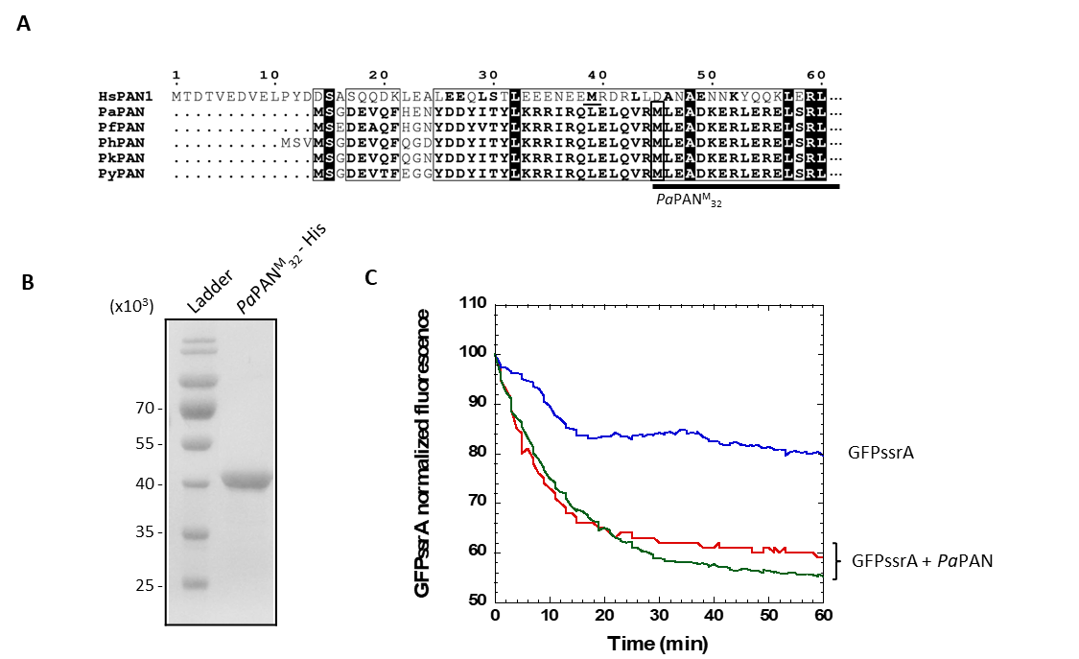

Figure S1. Purification of P. abyssi PAN.
(A) Sequence alignment of the N-terminal region of PAN for Halobacterium salinarum (Hs) (Q9HRW6), Pyrococcus abyssi (Pa) (Q9V287), Pyrococcus furiosus (Q8U4H3), Pyrococcus horikoshii (Ph) (O57940), Pyrococcus kukulkanii (0A127B6X7), Pyrococcus yayanosii (Py) (F8AH91). Alignment was done with T-coffee package(Di Tommaso et al., 2011; Notredame et al., 2000) and displayed with ESPript 3.0 (Robert & Gouet, 2014). (B) SDS-PAGE of the recombinant P. abyssi PAN produced using M³² as start codon. (C) Activity measurement of the purified PAN. GFPssrA, in control assay (blue curve), was incubated with PaPAN at 55°C (green and red curves). PAN activity was carried out in two independent reactions (green and red curves).

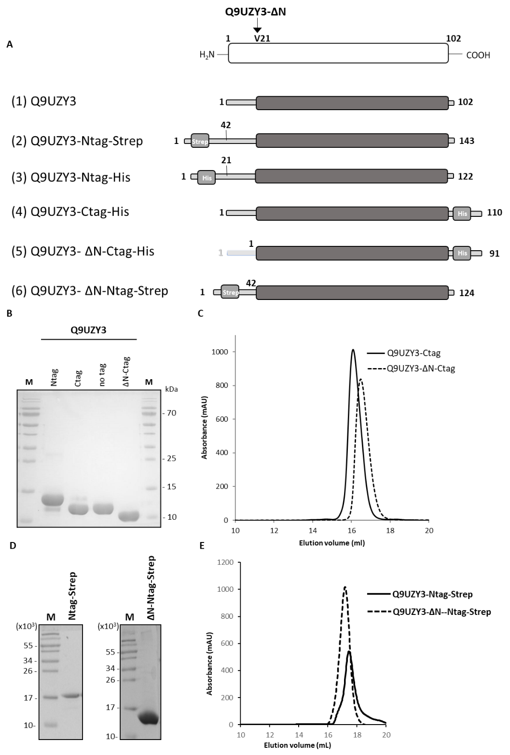

Figure S2. Purification of recombinant P. abyssi Q9UZY3 constructs.
(A) Schematic of Q9UZY3 constructions used for the production of recombinant proteins in E. coli. (B) SDS-PAGE gel of purified His-tagged Q9UZY3 constructs stained by Coomassie Blue. (C) His-tagged Q9UZY3 purification by size exclusion chromatography: elution profile with Superose 12 column (GE Healthcare). (D) SDS-PAGE gels stained by Coomassie Blue of purified Q9UZY3-Ntag-Strep and Q9UZY3-ΔN-Ntag-Strep in the left and right panels, respectively. (E) Size exclusion chromatography profiles of Q9UZY3-Ntag-Strep and Q9UZY3-ΔN-Ntag-Strep from left to right with a Superose 12 column (GE Heathcare). In the Table S1 are listed the characteristics of the different Q9UZY3 constructs.

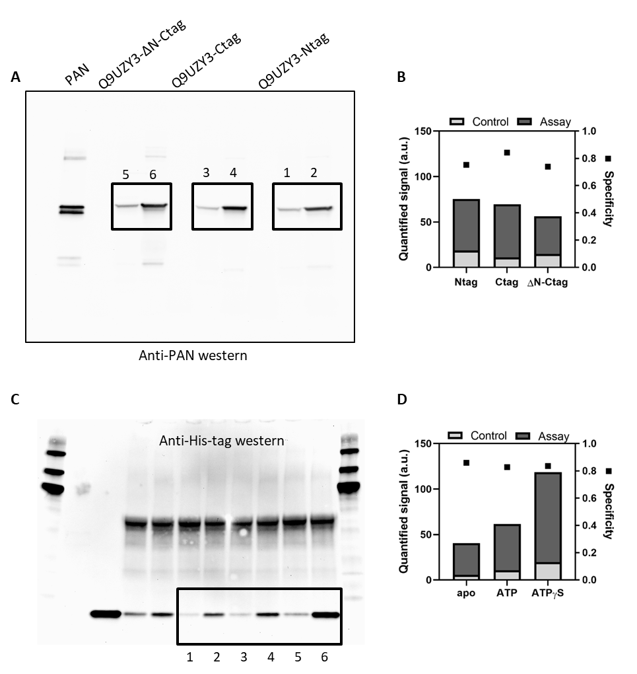

Figure S3. Pull-down Q9UZY3-PAN.
(A, B) Raw and calculated data from the Figure 1B. (C, D) Raw and calculated data from the Figure 1C. (B, C) Western signal quantification. “Control” refers to the experiment without immobilized protein. The specificity was quantified as the ratio of the assay and the control signal.

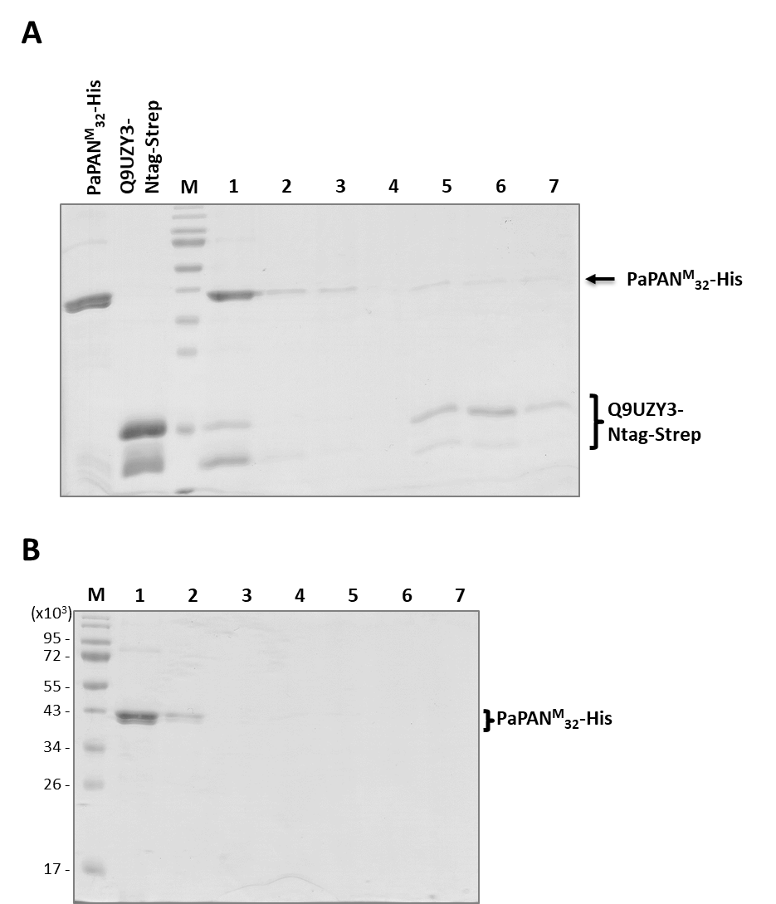

Figure S4. Co-purification of PaPAN with Streptavidin-tagged Q9UZY3.
(A) PaPAN^{M}₃₂-His was co-purified with immobilized Strep-tagged Q9UZY3. (B) Control condition without the Q9UZY3. Lane 1 corresponds to the flow-through; 2, 3 and 4 correspond to first, second and third washes; and 5, 6 and 7, to first, second and third elutions. SDS-PAGE gels stained by Coomassie Blue.

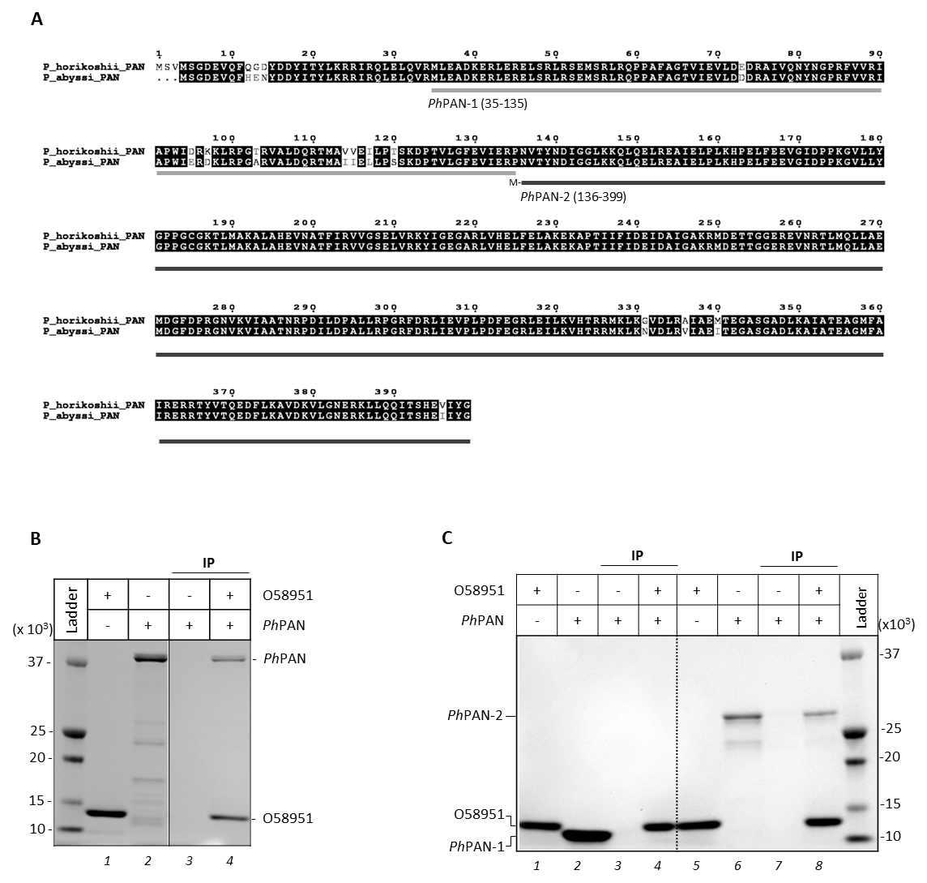

Figure S5. Q9UZY3 paralog (O58951) interacts with PhPAN.
The two domains of P. horikoshii PAN were produced for co-immunoprecipitation experiments with O58951 (Q9UZY3 ortholog). (A) PAN sequence alignment for P. abyssi and P. horikoshii proteins. The N-terminal domain of PhPAN starts at the M³⁵ and finishes at P¹³⁵ (PhPAN-1) while PhPAN-2 construct (136-399) includes the ATPase domain as well as the C-terminal domain within the motif for 20S opening. Alignment was done with T-coffee package (Di Tommaso et al., 2011; Notredame et al., 2000) and displayed with ESPript 3.0(Robert & Gouet, 2014). (B) The immunoprecipitation (IP) assay confirms that O58951 physically interacts with PhPAN. Co-IP experiment used immobilized O58951 and proteins were separated using SDS-PAGE gel and revealed by Blue Coomassie staining. Proteins alone were loaded as input controls in lane 1 and 2. Negative control (lane 3) corresponds to an assay without immobilized O58951. (C) O58951 only interacts with PhPAN-2 domain. Co-IP experiment used immobilized O58951 which was incubated either with PhPAN-1 (lane 4) or PhPAN-2 (lane 8). Individual proteins were loaded as input controls in lane 1-2 and 5-6. Negative controls without immobilized O58951 were performed (lane 3 and 7).

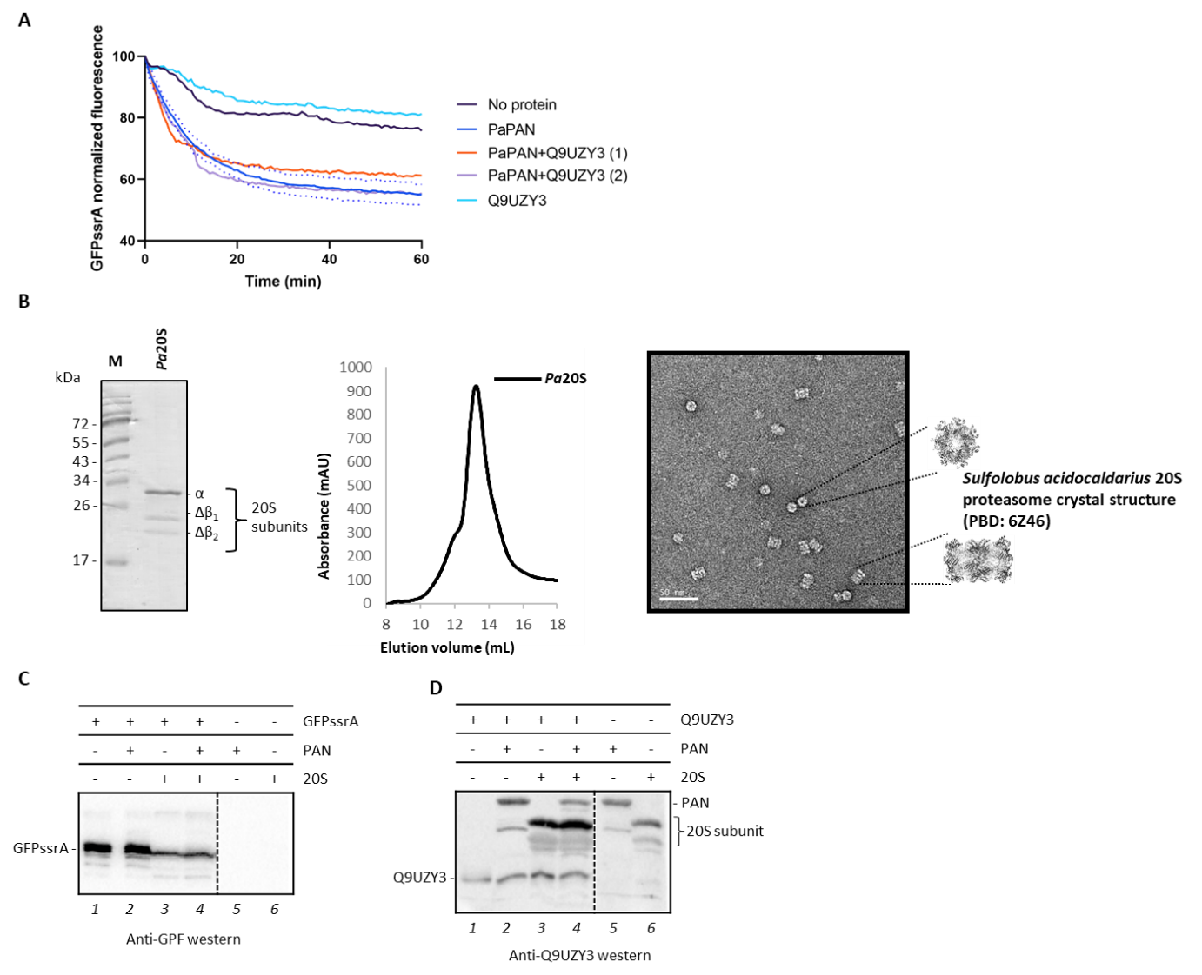

Figure S6. PAN-20S enzymatic activities in presence of Q9UZY3.
(A) PAN unfoldase activity. GFPssrA unfolding kinetics were not significantly modified by the addition of Q9UZY3. 10.8 µM GFPssrA were incubated, when indicated, with 0.94 µM hexameric PaPAN and 3.4 or 11.3 µM Q9UZY3 (“PaPAN+Q9UZY3” (1) and (2)). The dotted lines indicate the standard error for the blue curve “PaPAN” based on duplicate experiments. (B) In vitro reconstitution of the P. abyssi 20S proteasome. Left panel, SDS-PAGE gel of purified and assembled Pa20S proteasome stained by Coomassie Blue. Arrows correspond to the different 20S subunits used for the proteasome assembly. Middle panel, size exclusion chromatography profile of Pa20S proteasome. Right panel, transmission electron micrograph images of the Pa20S proteasome particles, negatively stained with uranyl acetate. Top and side views of the 20S particles were compared with the Sulfolobus acidocaldarius 20S proteasome crystal structure (PBD: 6Z46). (C-D) Degradation assays with P. abyssi proteasome complex. (C) GFPssrA was degraded by the P.abyssi 20S alone and in complex with P.abyssi PAN. The degradation of the target protein was revealed by western-blot using anti-GFP antibody. (D) No significant degradation of Q9UZY3 can be observed in the presence of 20S or PAN-20S. Proteins were revealed by western-blot using anti-Q9UZY3 antibody. The lack of specificity of this antibody also revealed all proteins from the gel.

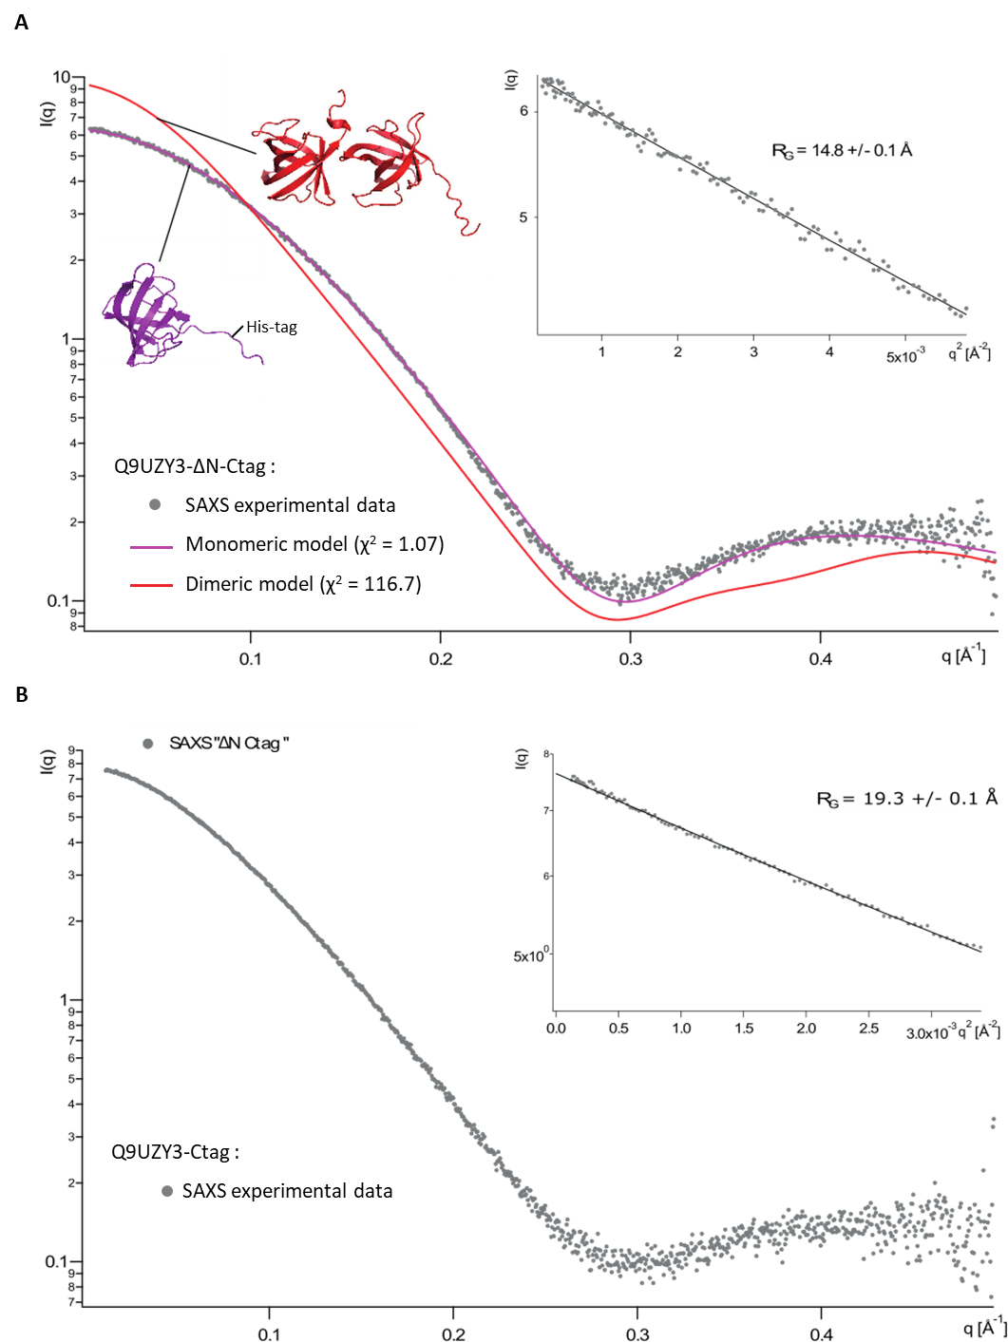

Figure S7. Structural analysis of recombinant Q9UZY3 in solution.
(A) Comparison between SAXS experimental data of Q9UZY3-ΔN-Ctag with theoretical curves calculated using CRYSOL (Franke et al., 2017). SAXS experimental data are represented by grey dots. SAXS theoretical data were calculated from a monomeric (green curve) or dimeric (red curve) atomic model of the crystallographic structure Q9UZY3-ΔN-Ctag, including hexahistidine C-terminal tag. (B) SAXS experimental data were recorded using the recombinant Q9UZY3-Ctag (grey dots). Logarithmic plot of the scattering intensity I(q) (in arbitrary units) vs. q (in Å⁻¹). Inset right panel: Guinier plot I(q) vs. q² (in Å⁻²).
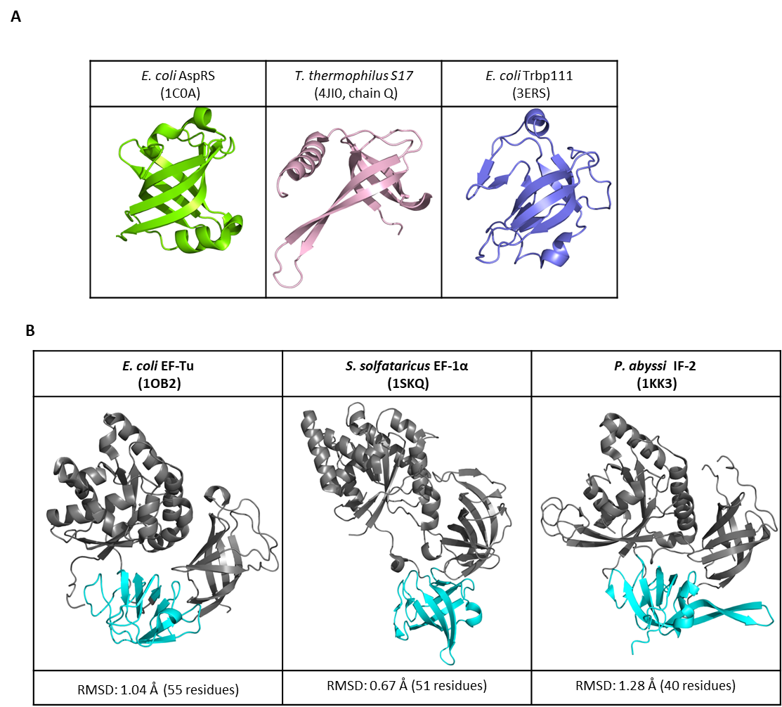

Figure S8. Comparison of various OB-fold domains.
(A) Escherichia coli aspartyl-tRNA synthetase (1COA) presents the canonical OB-fold domain. The two other small proteins presented are also described as containing OB-folds: the S17 subunit of 30S ribosomal subunit from Thermus thermophilus (4JI0, chain Q), and Escherichia coli Trbp111 (3ERS) a predicted tRNA binding protein. (B) The structure of Q9UZY3-ΔN was aligned with the domain II (in blue) of the following translational elongation factors: Escherichia coli EF-Tu (1OB2) and Sulfolobus solfataricus EF-1α (1SKQ) but also with the translational initiation factor from Pyrococcus abyssi, IF-2 (1KK3). The structural alignment was performed with PyMOL. The significant RMSD scores are indicated.

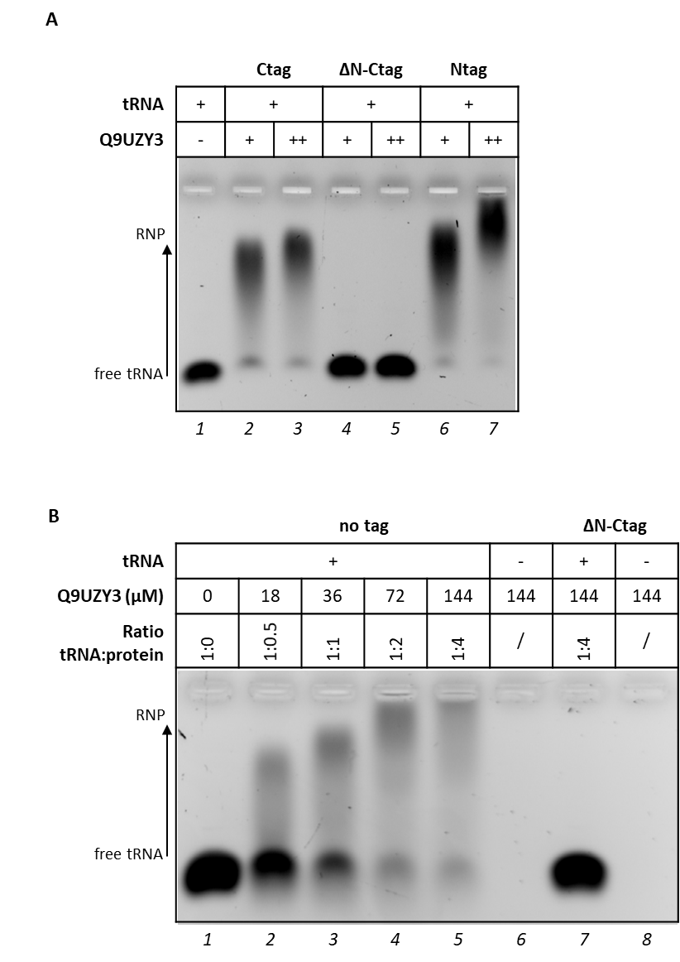

Figure S9. Electrophoretic mobility shift assays with tRNA.
(A) The N-terminal region of Q9UZY3 was required to bind tRNA. 36 and 72 µM of proteins were incubated with 36 µM of P. abyssi total tRNAs. (B) Increased concentrations of Q9UZY3 (without hexahistidine tag) were incubated with 36 µM of P. abyssi total tRNAs. Proteins were loaded alone (lane 6, 8) as control for the absence of nucleic-acid contamination. A negative control was performed using the truncated version of Q9UZY3 (lane 7). Samples were loaded into a 0.8 % agarose gel and ribonucleoprotein (RNP) complexes were revealed after staining with ethidium bromide.

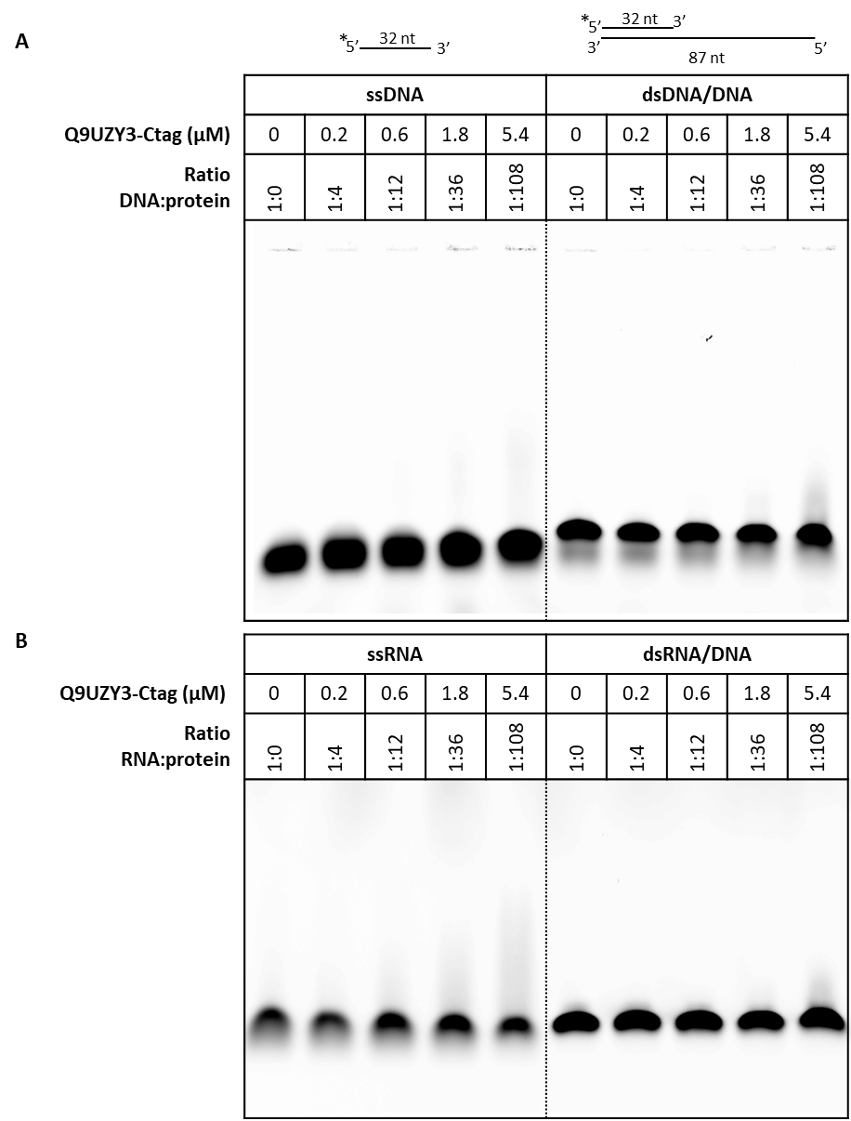

Figure S10. Electrophoretic mobility shift assays with linear DNA or RNA substrates.
Increased concentrations of Q9UZY3-Ctag (0, 0.2, 0.6, 1.8, 5.4 µM) were incubated with 50 nM of labelled linear single-strand (ss) or double-strand (ds) DNA (A) or RNA (B). Samples were loaded into a 0.8 % agarose gel and revealed by fluorescence.

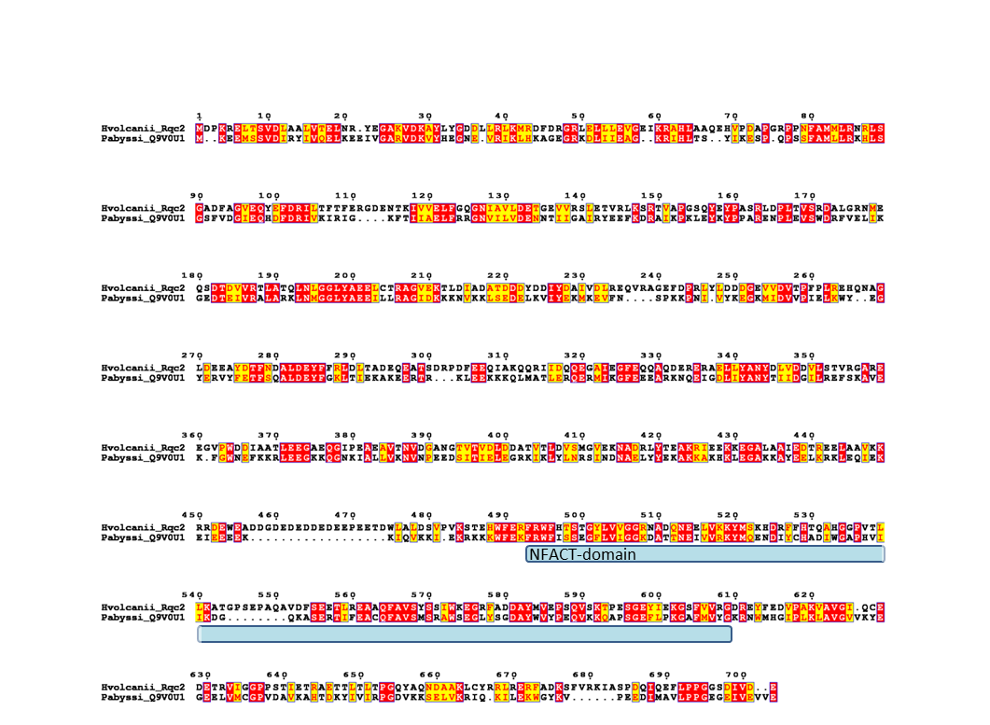

Figure S11. Sequence alignment of Haloferax volcanii Rqc2 homolog (A0A384LD57) and Pyrococcus abyssi Q9V0U1.
Alignment was done with T-coffee package (Di Tommaso et al., 2011; Notredame et al., 2000) and displayed with ESPript 3.0 (Robert & Gouet, 2014). The NFACT domain of H. volcanii Rqc2 (493-609) is highlighted in blue.

Supplemental tables

TABLE S1. Recombinant protein properties
Pyrococcus abyssi proteins

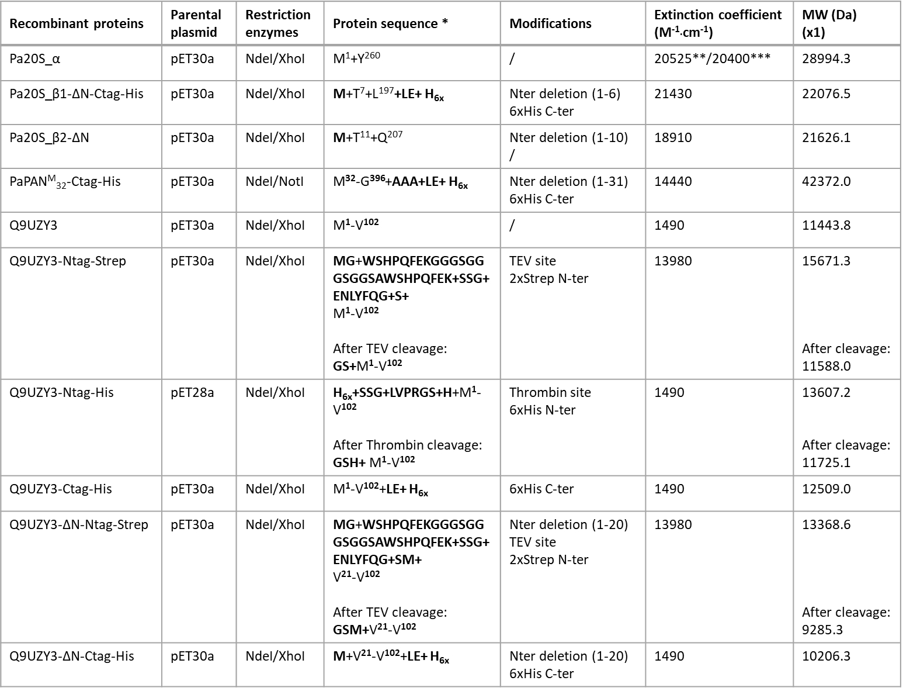
Pyrococcus horikoshii proteins
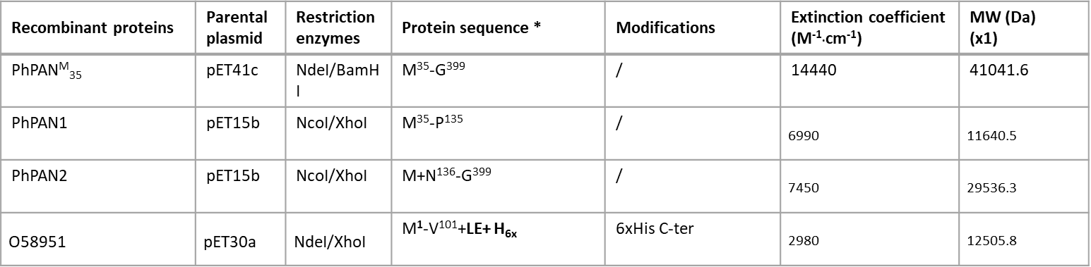
All constructs are for extracellular expression of the respective proteins.
* Peptide sequence of the expressed protein after fusion-tag removal. Amino acids derived from the construct are in bold.
**assuming all pairs of Cys residues form cystines
***assuming all Cys residues are reduced
TEV: tobacco-etch virus peptidase

TABLE S2. Primers and cloning strategies for expression in bacteria cells

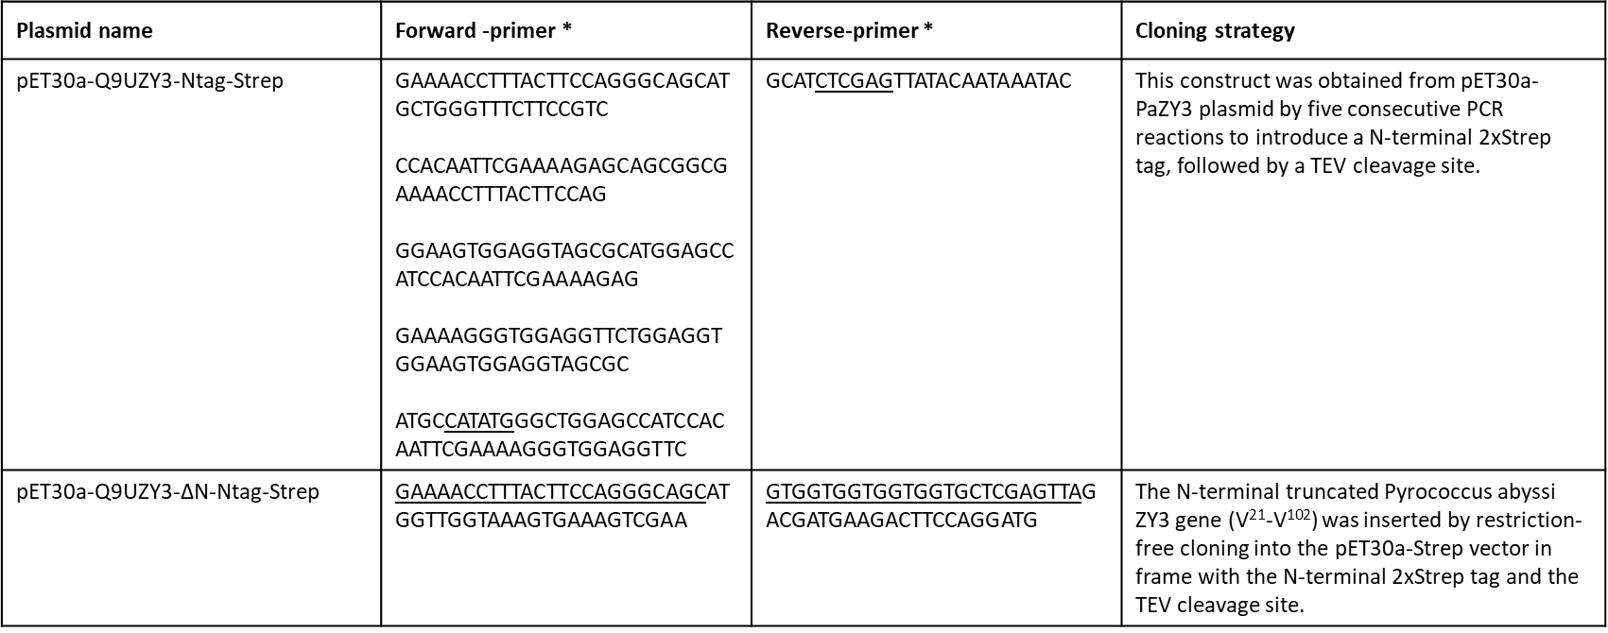
* Restriction-site sequences and overhangs for restriction-free cloning are underlined

TABLE S3. Data collection and refinement statistics for P. abyssi Q9UZY3 crystal structure.
 | P. abyssi Q9UZY3
DATA COLLECTION
Wavelength (Å) | 0.976
Resolution range (High resolution shell) (Å) | 42.42 – 1.64 (1.73 – 1.64)
Space group | I 1 2 1
Unit cell parameters | a= 53.58 Å, b= 54.16 Å, c= 52.55 Å  β= 95.06°
Total reflections | 120226 (16963)
Unique reflections | 21583 (3058)
Multiplicity | 5.6 (5.5)
Completeness (%) | 99.2 (97.3)
Mean I/sigma(I) | 10.4 (2.4)
Wilson B-factor | 21.98
R-merge | 0.076 (0.792)
R-pim | 0.038 (0.404)
CC1/2 | 0.998 (0.848
MOLECULAR REPLACEMENT
Template | 1XE1
Log-likelihood gain (LLG) | 283
Translation function Z score (TFS) | 20
REFINEMENT
Reflections used in refinement | 21519 (2047)
Reflections used for R-free | 1075 (103)
R-work | 0.1935 (0.3563)
R-free | 0.2214 (0.4187)
Number of non-hydrogen atoms | 1511
macromolecules | 1365
ligands | 44
solvent | 102
Protein residues | 177
RMS(bonds) | 0.037
RMS(angles) | 1.32
Ramachandran favored (%) | 97.63
Ramachandran allowed (%) | 2.37
Ramachandran outliers (%) | 0.00
Rotamer outliers (%) | 0.67
Clashscore | 2.39
Average B-factor | 32.33
macromolecules | 31.50
ligands | 45.48
solvent | 37.70

Table S4. Parameters for SAXS data acquisition and analysis.
Sample details
Name | Q9UZY3-ΔN-Ctag | Q9UZY3-Ctag
Organism | Pyrococcus abyssi | Pyrococcus abyssi
UniProt sequence ID | Q9UZY3 | Q9UZY3
Modification | N-ter : deletion (1-20)  C-ter : hexahistidine tag | C-ter : hexahistidine tag
M from chemical composition (Da) | 10,206.26 | 12,508.96
Average C in combined data frames (mg/ml) | 9.5 | 10.0
Concentration (range/values) measured and method | 7,950 - 9,950 Da (99.84% of credibility) - Bayesian inference(Hajizadeh et al., 2018) | 10,850 – 12,400 Da (96.09% of credibility) - Bayesian inference(Hajizadeh et al., 2018)
SAXS data-collection parameters
Instrument/data processing | ESRF BM29 beamline with Dectris PILATUS 1M detector
Wavelength (nm) | 0.992
Sample distance (m) | 2.867
q measurement range (nm⁻¹) | 0.036 to 4.94
Absolute scaling method | Water
Normalization | Direct beam
Exposure time | 10 times 1s frames
Sample configuration | Batch mode with robot sample changer
Sample temperature (°C) | 20
Software employed for SAXS data reduction, analysis and interpretation
SAXS data reduction and basic analyses | PRIMUSqt (ATSAS 3.0)
Atomic structure modelling | CRYSOL (v. 2.8.3)
Structural parameters
Guinier analysis
I(0) | 6.42 +/- 0.02 | 7.61 +/- 0.01
Rg (nm) | 1.48 +/- 0.01 | 1.93 +/- 0.01
qRg max | 1.22 | 1.03
Atomistic modelling
Crystal structure | Q9UZY3-ΔN-Ctag monomeric | -¹
q range for modelling (nm⁻¹) | 0.15 to 4.92 | -
CRYSOL (ATSAS 2.8.3)
𝛘² | 1.07 (monomer) | -
Predicted Rg (nm) | 1.46 | -
¹Due to the lack of structural data on the N-terminus (20 amino acids), no fitting with a single atomic model was attempted.

Table S5. Full list of PaQ9UZY3 partners identified by pull-down MS/MS.
Q9UZY3 partners were significantly captured using N-ter or C-ter hexahistidine Q9UZY3 constructs as described in materials and methods section. The presented data are the result of experimental duplicates for each His-tag Q9UZY3 constructs (Q9UZY3-Ctag and Q9UZY3-Ntag). The biological processes were manually annotated following Gene Ontology information retrieved from UniprotKB database and indicated with the corresponding colour used in Figure 3.
Data were combined between replicates and referenced versus negative control signal to calculate the final ‘Overall Signal’. The ‘Overall specificity’ is the result of the ‘Overall Signal’ ratio between the control and the corresponding assay. A maximum threshold of 1 was applied on the ‘Overall specificity’ to display proteins with twice as much signal in assay than in control. Here common partners between the two protein baits (Q9UZY3-Ntag and Q9UZY3-Ctag) were combined.
The two last columns correspond to the results obtained with pull-down assays: (i) using cell extract digested by nuclease (column ‘Resistant to nuclease’), performed in duplicates for each His-tag position (Q9UZY3-Ctag and Q9UZY3-Ntag) and (ii) using the truncated PaQ9UZY3 (column ‘Resistant to N-ter deletion’) performed in duplicates using the bait Q9UZY3-ΔN-Ctag.
* Q9V0E2 is homologous to P. furiosus PbaB described as a proteasome activator(Kumoi et al., 2013)
** Q9V2M1 was described and named ASH-Ski2 in P. abyssi (Phung et al., 2020)

ID | Gene | Name | Description | Biological process | Overall Signal | Overall Specificity | Resistant to nuclease | Resistant to N-ter deletion
Q9V122 | PAB0417 | PsmA | Proteasome subunit alpha | Protein catabolic process | 147.88 | 0.119 | + |  | +
Q9V0N9 | PAB1867 | PsmB2 | Proteasome subunit beta 2 | Protein catabolic process | 31.05 | 0 | + |  | +
Q9V247 | PAB2199 | PsmB1 | Proteasome subunit beta 1 | Protein catabolic process | 30.28 | 0.2 | + |  | +
Q9V287 | PAB2233 | PAN | Proteasome-activating nucleotidase | Protein catabolic process | 29 | 0.191 | + |  | +
G8ZHL8 | PAB1441 | G8ZHL8 | Pyruvate kinase | Other | 26.93 | 0 | - |  | -
Q9UZW0 | PAB1679 | Pgk | Phosphoglycerate kinase | Glycolytic process | 20.46 | 0.27 | + |  | +
Q9V0E2 | PAB0569 | Q9V0E2 | 3-isopropylmalate dehydratase* | Protein catabolic process | 19.12 | 0 | + |  | +
Q9V1P3 | PAB2092 | Trm1 | tRNA (guanine(26)-N(2))-dimethyltransferase | tRNA modification | 15.87 | 0.794 | - |  | -
Q9V076 | PAB1751 | aRNase J | Ribonuclease J | RNA catabolic process | 15.86 | 0.475 | - |  | -
Q9UZ60 | PAB0852 | Soj | minD/MRP superfamily | Other | 13.8 | 0 | - |  | -
Q9UZN0 | PAB0740 | TgtA | tRNA-guanine(15) transglycosylase | tRNA modification | 12.73 | 0 | - |  | -
Q9V1A5 | PAB0356 | TruB | Probable tRNA pseudouridine synthase B | tRNA modification | 10.87 | 0.693 | - |  | -
Q9V256 | PAB0150 | Q9V256 | Uncharacterized protein | Unknown | 10.16 | 0.197 | + |  | -
Q9V2M1 | PAB2313 | ASH-Ski2 | ATP-dependent RNA helicase, putative** | RNA catabolic process | 9.69 | 0.103 | - |  | -
Q9UYJ3 | PAB1363 | Q9UYJ3 | Uncharacterized protein | Unknown | 9.14 | 0.109 | + |  | +
Q9V0G8 | PAB1813 | Rps19e | 30S ribosomal protein S19e | Translation | 8.67 | 0.231 | - |  | -
Q9V0V6 | PAB0466 | Rps10 | 30S ribosomal protein S10 | Translation | 8.21 | 0.244 | - |  | -
Q9UXS5 | PAB1167 | Rpl10 | 50S ribosomal protein L10 | Translation | 8.09 | 0.124 | - |  | -
Q9UZS4 | PAB0713 | Q9UZS4 | Pyruvate formate-lyase activating enzyme | Other | 8.07 | 0 | + |  | -
G8ZHS3 | PAB0194 | G8ZHS3 | Fe-S oxidoreductase | Other | 7.16 | 0 | - |  | -
Q9V1T8 | PAB2122 | Rpl2 | 50S ribosomal protein L2 | Translation | 7.07 | 0.283 | - |  | -
Q9V118 | PAB0421 | Rrp42 | Exosome complex component Rrp42 | RNA catabolic process | 6.71 | 0.596 | - |  | -
Q9UYB7 | PAB1307 | MutS2 | DNA-binding protein MutS2 | DNA process | 6.66 | 0 | - |  | -
Q9V0U1 | PAB1903 | Q9V0U1 | NFACT-R_1 domain-containing protein | Unknown | 6.66 | 0 | - |  | -
Q9V0Z5 | PAB1942 | Q9V0Z5 | Uncharacterized protein | Unknown | 6.61 | 0 | + |  | -
P61994 | PAB0361 | Rps4 | 30S ribosomal protein S4 | Translation | 6.14 | 0.575 | - |  | -
Q9UXZ3 | PAB7435 | Rps27e | 30S ribosomal protein S27e | Translation | 6.11 | 0.164 | - |  | -
Q9V1T4 | PAB2119 | Q9V1T4 | Uncharacterized protein | Unknown | 6.09 | 0 | - |  | -
Q9V2M2 | PAB2314 | Csl4 | Exosome complex component Csl4 | RNA catabolic process | 5.64 | 0.625 | - |  | -
Q9V1Q0 | PAB2096 | TET1 | Aminopeptidase from family M42 | Protein catabolic process | 5.63 | 0.45 | + |  | -
Q9V1V6 | PAB2137 | Rpl30 | 50S ribosomal protein L30 | Translation | 5.17 | 0.58 | - |  | -
Q9UY85 | PAB1284 | Q9UY85 | RecJ-like phosphoesterase | Unknown | 5.16 | 0.878 | - |  | -
Q9UYI3 | PAB1357 | Q9UYI3 | GTP-binding protein | Unknown | 5.09 | 0.196 | - |  | -
Q9V1V2 | PAB2133 | Rpl32e | 50S ribosomal protein L32e | Translation | 4.62 | 0 | - |  | -
Q9UY31 | PAB1100 | HisS | Histidine--tRNA ligase | tRNA modification | 4.54 | 0 | - |  | -
P62006 | PAB7160 | Rpl37e | 50S ribosomal protein L37e | Translation | 4.12 | 0 | - |  | -
Q9V251 | PAB2203 | AsnS | Asparagine--tRNA ligase | tRNA modification | 4.07 | 0 | - |  | -
Q9V2F9 | PAB0071 | Fau-1 | Probable ribonuclease FAU-1 | RNA catabolic process | 4.05 | 0.247 | - |  | -
G8ZKN0 | PAB1561 | G8ZKN0 | DNA helicase, putative | Unknown | 3.54 | 0 | - |  | -
G8ZHS0 | PAB2163 | RPA41 | Replication factor A | DNA process | 3.52 | 0 | - |  | -
Q9V186 | PAB0373 | ArgB-like | Isopentenyl phosphate kinase | Other | 3.04 | 0 | - |  | -
Q9V022 | PAB1724 | ProS | Proline--tRNA ligase | tRNA modification | 3.04 | 0 | - |  | -
Q9UZ86 | PAB2423 | Rgy | Reverse gyrase | DNA process | 3.02 | 0 | - |  | -
Q9V2S3 | PAB2353 | Rpl11 | 50S ribosomal protein L11 | Translation | 2.52 | 0 | - |  | -
Q9V2P3 | PAB2354 | putP-3 | Proline or pantothenate permease | Transport | 2.02 | 0 | - |  | -

Supplemental references
Di Tommaso, P., Moretti, S., Xenarios, I., Orobitg, M., Montanyola, A., Chang, J.-M., Taly, J.-F., & Notredame, C. (2011). T-Coffee : A web server for the multiple sequence alignment of protein and RNA sequences using structural information and homology extension. Nucleic Acids Research, 39(suppl_2), W13‑W17. https://doi.org/10.1093/nar/gkr245
Franke, D., Petoukhov, M. V., Konarev, P. V., Panjkovich, A., Tuukkanen, A., Mertens, H. D. T., Kikhney, A. G., Hajizadeh, N. R., Franklin, J. M., Jeffries, C. M., & Svergun, D. I. (2017). ATSAS 2.8 : A comprehensive data analysis suite for small-angle scattering from macromolecular solutions. Journal of Applied Crystallography, 50(4), 1212‑1225. https://doi.org/10.1107/S1600576717007786
Guinier, A. (1939). La diffraction des rayons X aux très petits angles : Application à l’étude de phénomènes ultramicroscopiques. Annales de Physique, 11(12), 161‑237. https://doi.org/10.1051/anphys/193911120161
Hajizadeh, N. R., Franke, D., Jeffries, C. M., & Svergun, D. I. (2018). Consensus Bayesian assessment of protein molecular mass from solution X-ray scattering data. Scientific Reports, 8(1), 7204. https://doi.org/10.1038/s41598-018-25355-2
Ibrahim, Z., Martel, A., Moulin, M., Kim, H. S., Härtlein, M., Franzetti, B., & Gabel, F. (2017). Time-resolved neutron scattering provides new insight into protein substrate processing by a AAA+ unfoldase. Scientific Reports, 7, 40948. https://doi.org/10.1038/srep40948
Konarev, P. V., Volkov, V. V., Sokolova, A. V., Koch, M. H. J., & Svergun, D. I. (2003). PRIMUS : A Windows PC-based system for small-angle scattering data analysis. Journal of Applied Crystallography, 36(5), 1277‑1282. https://doi.org/10.1107/S0021889803012779
Kumoi, K., Satoh, T., Murata, K., Hiromoto, T., Mizushima, T., Kamiya, Y., Noda, M., Uchiyama, S., Yagi, H., & Kato, K. (2013). An archaeal homolog of proteasome assembly factor functions as a proteasome activator. PloS One, 8(3), e60294. https://doi.org/10.1371/journal.pone.0060294
Mahieu, E., Covès, J., Krüger, G., Martel, A., Moulin, M., Carl, N., Härtlein, M., Carlomagno, T., Franzetti, B., & Gabel, F. (2020). Observing Protein Degradation by the PAN-20S Proteasome by Time-Resolved Neutron Scattering. Biophysical Journal, 119(2), 375‑388. https://doi.org/10.1016/j.bpj.2020.06.015
Notredame, C., Higgins, D. G., & Heringa, J. (2000). T-Coffee : A novel method for fast and accurate multiple sequence alignment. Journal of Molecular Biology, 302(1), 205‑217. https://doi.org/10.1006/jmbi.2000.4042
Pernot, P., Round, A., Barrett, R., De Maria Antolinos, A., Gobbo, A., Gordon, E., Huet, J., Kieffer, J., Lentini, M., Mattenet, M., Morawe, C., Mueller-Dieckmann, C., Ohlsson, S., Schmid, W., Surr, J., Theveneau, P., Zerrad, L., & McSweeney, S. (2013). Upgraded ESRF BM29 beamline for SAXS on macromolecules in solution. Journal of Synchrotron Radiation, 20(Pt 4), 660‑664. https://doi.org/10.1107/S0909049513010431
Phung, D. K., Etienne, C., Batista, M., Langendijk-Genevaux, P., Moalic, Y., Laurent, S., Liuu, S., Morales, V., Jebbar, M., Fichant, G., Bouvier, M., Flament, D., & Clouet-d’Orval, B. (2020). RNA processing machineries in Archaea : The 5’-3’ exoribonuclease aRNase J of the β-CASP family is engaged specifically with the helicase ASH-Ski2 and the 3’-5’ exoribonucleolytic RNA exosome machinery. Nucleic Acids Research, 48(7), 3832‑3847. https://doi.org/10.1093/nar/gkaa052
Robert, X., & Gouet, P. (2014). Deciphering key features in protein structures with the new ENDscript server. Nucleic Acids Research, 42(W1), W320‑W324. https://doi.org/10.1093/nar/gku316
Round, A., Felisaz, F., Fodinger, L., Gobbo, A., Huet, J., Villard, C., Blanchet, C. E., Pernot, P., McSweeney, S., Roessle, M., Svergun, D. I., & Cipriani, F. (2015). BioSAXS Sample Changer : A robotic sample changer for rapid and reliable high-throughput X-ray solution scattering experiments. Acta Crystallographica. Section D, Biological Crystallography, 71(Pt 1), 67‑75. https://doi.org/10.1107/S1399004714026959
Svergun, D., Barberato, C., & Koch, M. H. J. (1995). CRYSOL– a Program to Evaluate X-ray Solution Scattering of Biological Macromolecules from Atomic Coordinates. Journal of Applied Crystallography, 28(6), 768‑773. https://doi.org/10.1107/S0021889895007047

