Appendix 1
Land-cover maps were derived from historical remotely sensed (Landsat 5, 7 or 8/Sentinel-2) images. Random forest classifications were applied to develop land-cover maps using in situ or photo-interpreted vegetation sampling points as training/validation points. Classifications from Landsat images were resampled at 10 m to maintain a resolution consistent with that of Sentinel-2 images. To avoid the salt-and-pepper effect of pixel-based classification, the dominant land-cover class was projected onto vector-based landscape features (e.g. agricultural fields; homogeneous topographical features such as areas with similar ranges of slope, exposure or elevation) available from freely available databases (i.e. EU Land Parcel Identification System (LPIS) dataset (Barbottin et al. 2018), SRTM elevation data). The dominant land cover was identified for each of these polygons, which were considered as homogeneous minimum areal units. Since remote sensing classifications are never 100% accurate, we corrected possible misclassifications by analyzing land-use and land-cover transitions over time. Inconsistent transitions were detected, and abnormal land-cover states were corrected. Using an independent validation dataset, built from an existing land dataset and/or photo-interpretation of aerial photographs for the corresponding year, overall accuracy exceeded 90% for the 1990, 2006 and 2018 land-cover maps.
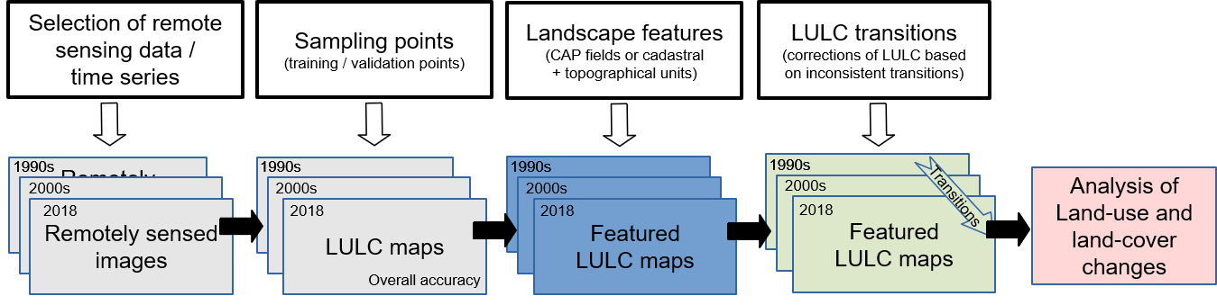
Figure 1 Appendix 1. The data-processing workflow to analyze land-use and land-cover (LULC) change. CAP: Common Agricultural Policy
Appendix 2
The FORESCEM model operates like many conventional land-use and land-cover (LUCC) models (Mas et al. 2014) by being calibrated with two historical land-cover maps. Moreover, it has the advantages and disadvantages of this kind of approach by incorporating flexible parametrization in order to simulate scenarios that break with the status quo (Houet al et. 2016). Future land demand can be defined automatically using transition matrices by default, but it can be also defined by predefined scenarios in which future land demand is determined by estimating population growth and mean land consumption per inhabitant (INSEE 2019-1, 2019-2; AUDIAR 2018). Future types of agricultural land cover were defined empirically by experts. The model was also calibrated to parameterize the weights of drivers that contribute to suitability maps for each type of land cover. Even though the calibration considers the weights of past drivers, existing drivers can be updated during the simulation, and new drivers can be included when their weight is empirically defined.
FORESCEM also considers land-management policies (limited or excluded areas) for each type of LULC. For instance, wheat crops have a lower probability of being grown in wet or potentially flooded areas. Urban sprawl cannot occur in natural (protected) areas or areas at risk (flooding or some industrial areas), as defined in local urban management plans. In this study, BGINs were considered in the modeling framework as a land-planning strategy defined using Graphab software (Foltête et al. 2012) and represented as a map of connectivity, whose values ranged from 0 (no connectivity) to 100 (maximum connectivity). In scenarios based on the “business-as-usual” territorial development assumption, BGIN with connectivity of 100 could not be urbanized during the simulation, while those based on the “ecological citizen” assumption did not expect urban sprawl in BGIN with connectivity greater than 50 (i.e. preserving larger and a greater number of corridors).
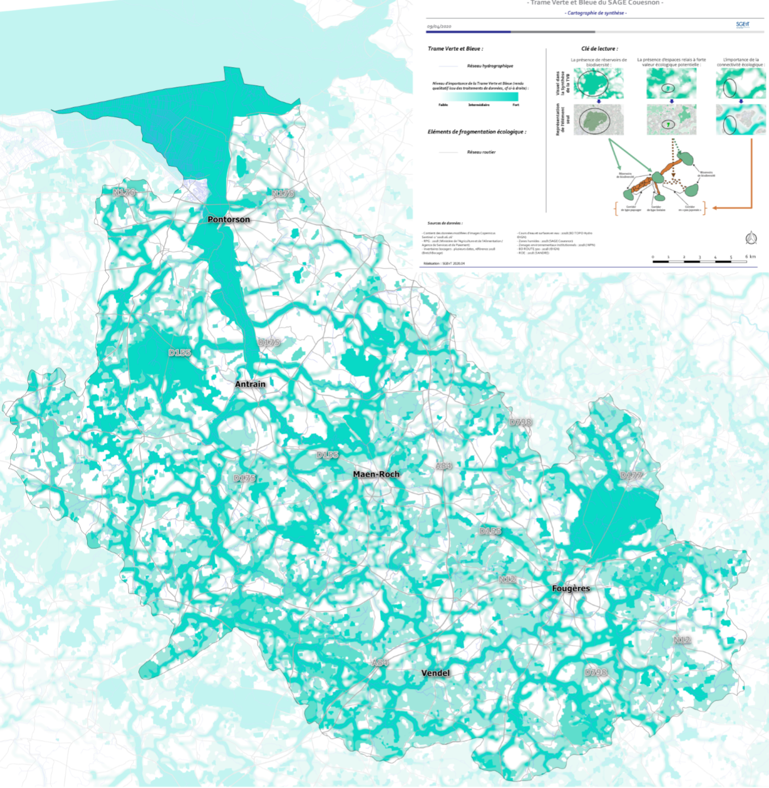
Figure 1 Appendix 2. Map of the blue and green infrastructure network of the Couesnon River watershed used in this study. This map was designed in the SCoT of the Fougères group of municipalities, generated using Graphab software (Foltête et al. 2012) and extended to the entire watershed.
Finally, FORESCEM generates annual land-use and land-cover maps with a 10 m resolution. Hedgerow extent in 2050 was estimated separately, since FORESCEM does not consider hedgerows. Hedgerows near roads and on farm boundaries (using the European Union LPIS database) were kept in all scenarios. Hedgerows in agricultural fields or islets of fields where crop occurrence exceeded 50% were kept, assuming that farm extents did not change over time. This assumption was false, but farm extents in the future cannot be predicted (Appendix 2). Finally, for restoration of riparian wetlands, the Green attractiveness scenario assumed that wetlands lost or drained over the past 50 years (based on historical aerial photographs) were restored. All maps were created using GIS and had the same resolution (10 m), bounding box and projection.
Table 1 Appendix 2. Mandatory (M) and optional (O) inputs for FORESCEM
Data | Type | M/O | Description
Land cover at time t-n | Map | M | Land-cover map used to calculate past transitions, past trends and the calibration
Land cover at time t | Map | M | Land-cover map used to calculate past transitions, past trends and the calibration. It also serves as the starting landscape of the simulation.
Land use at time t-n | Map | M | Land-use map used to calibrate the model
Land use at time t | Map | M | Land-use map as a starting landscape of the simulation
Set of drivers | Maps | M | Maps used for calibration and simulation. Driver maps at time t+x can be included if drivers change during the simulation.
Land-cover duration table | Table | M | Duration of each land cover that FORESCEM will try to match. In some situations, the land-cover duration can be exceeded to find a solution.
Land-cover type | Table | M | Table that defines, for each land cover, whether demand is a constraint or not. For instance, transition from shrublands to another cover is not constrained by demand, whereas change from Maize to another land cover (cereals, grassland) is constrained by age and demand.
Land-cover drivers | Table | M | Table that defines, for each land cover, which drivers of the set of drivers must be used to calculate the regression model.
Land-use drivers | Table | M | Table that defines, for each land use, which drivers of the set of drivers must be used to calculate the regression model.
Land-cover demand | Table | M | Table used during the simulation that summarizes annual demand for each land cover
Fields | Map | O | Map of fields; if this map is not provided, individual pixels are simulated
Land-cover age at time t | Map | O | Map of the age of land cover for each field; if this map is not provided, a random-age map that matches land-cover durations is simulated
Policy | Map | O | A “hard” (binary) or “soft” map used to consider land allocation. Policy (e.g. for urban sprawl) is used from the year it is defined. Several policy maps can be added for the same land cover/use in different years, with the last policy replacing the previous policy. Up to one policy per land cover/use can be added per year.
Event | Map | O | Map used to create unexpected changes, such as urban projects or hillside reservoirs. It is applied the year that the event is expected. Event maps can be added for land cover and use.

Table 2 Appendix 2. Mandatory inputs created by FORESCEM during data preparation
Data | Type | Description
Transitions | Tables | Binary matrix that lists possible land-cover transitions (value = 1). FORESCEM creates four matrices during data preparation:  - cover_to_cover: for each land cover, from which cover a field/pixel can be converted into that cover  - use_to_cover: for each land cover, from which use a field/pixel can be converted into that cover  - use_to_use: for each land use, from which use a field/pixel can be converted into that use  - cover_to_use: for each land use, from which cover a field/pixel can be converted into that use  FORESCEM asks users for a threshold to define which transitions are possible, which facilitates final validation by users for cover_to_cover and use_to_use matrices.
Appendix 3
Double performance
The population becomes aware of the need to change its lifestyles to address climate change. Territorial development favors proximity and quality of life. The search for a "green" living environment revitalizes rural villages. A victim of its success and faced with demand, urbanization in the countryside increases slightly and does not meet the zero urbanization goal in 2040 (+2 297 ha). This kind of territorial development with environmental considerations sometimes comes up against agricultural development, as in the Business-as-Usual scenario. Since the scenario focuses on dairy intensification and regional specialization, the area of maize increases while that of grasslands decreases, and hedgerow length decreases. In 2050, maize covers 42.2% of the UAA (vs. 30.2% in 2018, +13 764 ha), which highlights the intensification of dairy/livestock production, and some less productive farmland in valley bottoms has been abandoned (3 695 ha). Public policies use several mechanisms to support and harmonize these territorial and agricultural dynamics, such as investments to develop local sectors, aid for conversion to organic farming, compensatory measures to encourage compliance with environmental regulations based on sustainable farming practices, the use of wood from hedgerows and projects for small biogas plants to process livestock manure. The hope is that the next generation will be better trained and more aware: the money currently spent to raise awareness is allocated by the mid-2030s to finance environmental policing missions to punish environmental offenses. Agriculture remains connected to large food-processing companies, following the rationale of the global market.
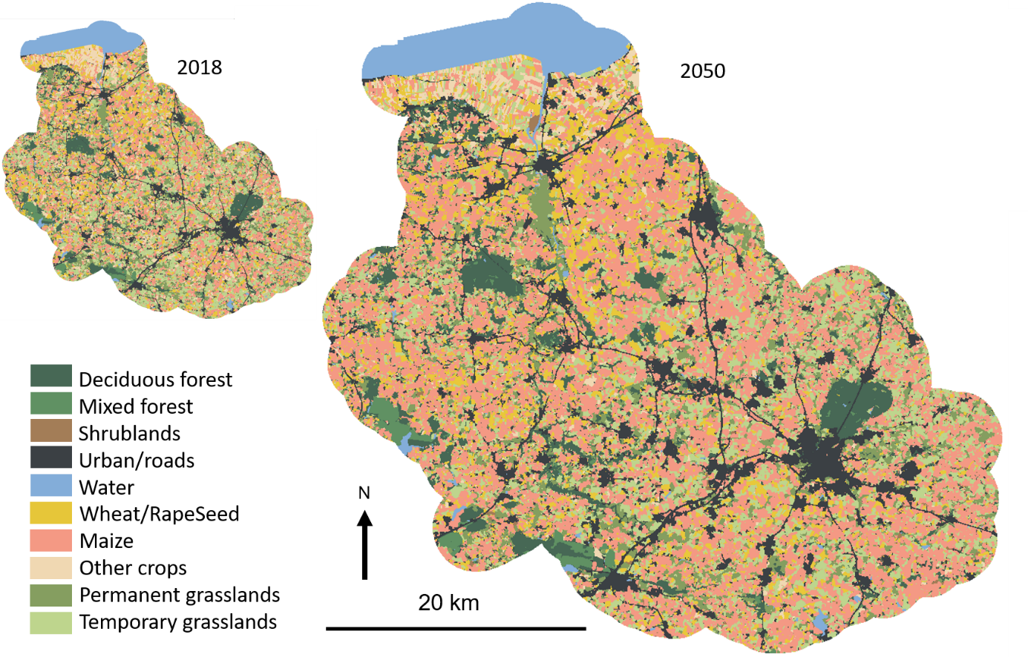Figure Appendix 3a – Approximately here
Desert of cereals
Territorial development continues the current rationale of competition between territories and urbanization of peri-urban areas, along with “cerealization” of the territory. Agricultural development breaks with the status quo but is based on seeds of change that are already present today (e.g. from 2014-2016, small conventional farms and large farms that were converting to organic farming disappeared or experienced major difficulties). Cereal crops (i.e. wheat, rapeseed, maize) develop massively throughout the watershed and cover more than 60% of the UAA in 2050, to feed biogas plants that are being installed there. Maize covers 25% of the UAA (8 808 ha less than in 2018) and grasslands 15% (35 884 ha less than in 2018). Meanwhile, hedgerow length has decreased by 22.5% (6 903 km in 2050), and abandonment of farmland has increased strongly (+5 995 ha). Hedgerows are now found only around the subdivisions built on the outskirts of villages and along farm boundaries. Similarly, a few isolated trees (i.e. small sections of fragmented hedgerows) are scattered over the plateaus. Livestock farming, which is now uncommon, is no longer visible in the landscape: only a few grasslands remain in valley bottoms and in protected sensitive natural areas. Regarding urbanization, towns expand due to construction of subdivisions for single-family houses. Urban renewal occurs but remains limited: only some agricultural buildings are converted to residential use. At the same time, industrial zones continue to develop along the A84 highway. The main change in the landscape is the creation of three major reservoirs and several small hillside reservoirs, as in the Business-as-usual scenario.
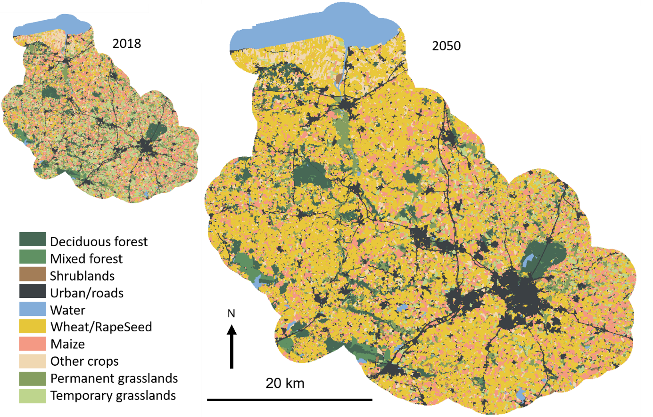Figure Appendix 3b – Approximately here
Appendix 4
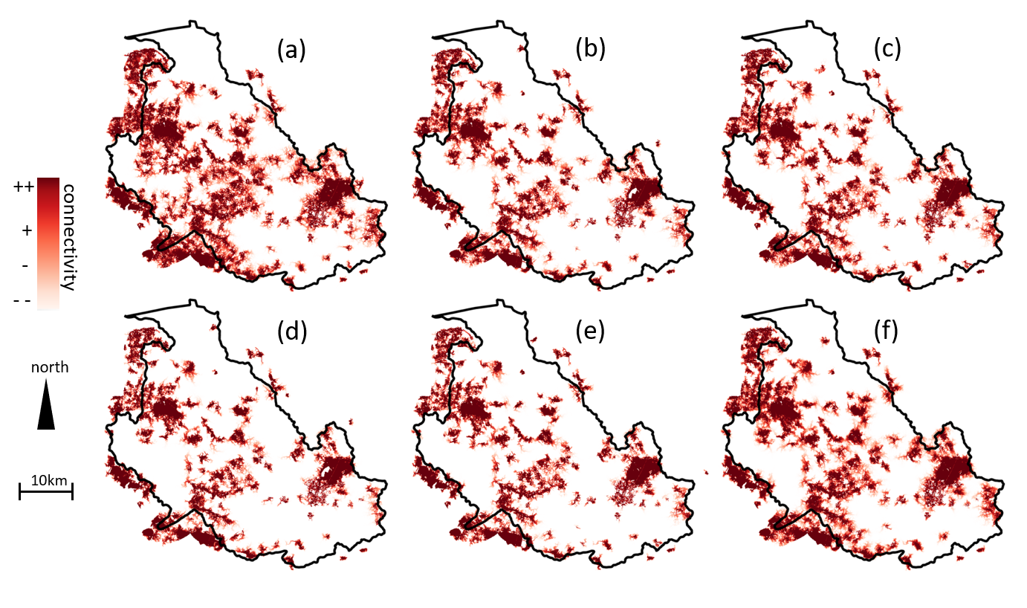
Appendix 4a. Woodland connectivity for the Couesnon watershed (a) in 2018 and for (b) the Business-as-usual, (c) Double performance, (d) Desert of cereals, (e) Energy performance and (f) Green attractiveness scenarios. It ranges from dark red (strong connectivity ++) to light red (weak connectivity --) and non-functional areas (no connectivity) are in white.

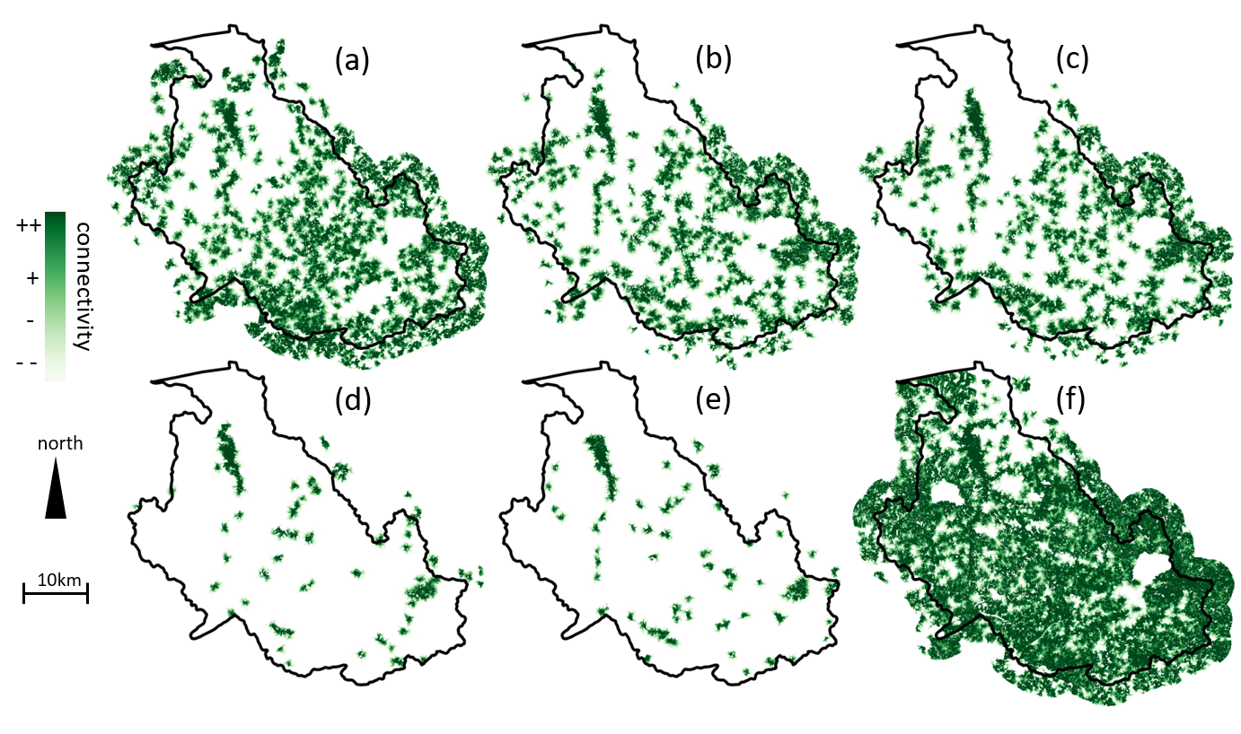
Appendix 4b. Grassland connectivity for the Couesnon watershed (a) in 2018 and for (b) the Business-as-usual, (c) Double performance, (d) Desert of cereals, (e) Energy performance and (f) Green attractiveness scenarios. It ranges from dark green (strong connectivity ++) to light green (weak connectivity --) and non-functional areas (no connectivity) are in white.

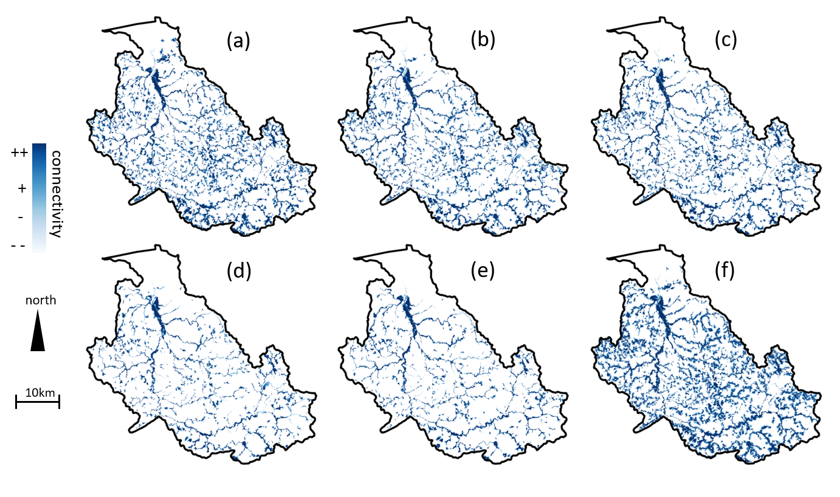
Appendix 4c. Wetland connectivity for the Couesnon watershed (a) in 2018 and for (b) the Business-as-usual, (c) Double performance, (d) Desert of cereals, (e) Energy performance and (f) Green attractiveness scenarios. It ranges from dark blue (strong connectivity ++) to light blue (weak connectivity --) and non-functional areas (no connectivity) are in white.
Appendix 5
Rules used to keep or remove hedgerows for each scenario. A given hedgerow is kept if it meets at least one condition. Durations are expressed in years.
Condition | Business-as-usual | Double performance | Green activity | Energy performance | Desert of cereals
on the edge of an islet | keep | keep | keep | keep | keep if not between two islets
on the edge of a field | keep | keep if crop duration < 12 | keep if crop duration < 6 and not on a plateau | keep if crop duration < 17 | keep if crop duration < 6 and not on a plateau
within a field | keep if grassland duration > 10 | keep if crop duration < 6 | remove | keep if crop duration < 6 | remove
within new urban area (u) | keep if u > 0 | keep if u > 0 | keep if u > 0 | keep if u > 0 and crop duration < 17 | keep if u > 0 and crop duration < 17
less than 50 m from a river (r) | keep if r > 0 | keep if r > 0 | keep if r > 0 and crop duration < 17 | keep if r > 0 | keep if r > 0 and crop duration < 17
abandonment duration (d) | keep if d > 0 | keep if d > 0 | keep if d > 0 and crop duration < 17 | keep if d > 0 | keep if d > 0 and crop duration < 17
permanent grassland duration (d) | keep if d > 0 | keep if d > 15 | keep if d > 15 | keep if d > 15 | keep if d > 15
BGIN connectivity value (v) | keep if v ≥ 75

References
Barbottin, A., Bouty, C., Martin, P., 2018. Using the French LPIS database to highlight farm area dynamics: The case study of the Niort Plain. Land Use Policy 73, 281–289. doi:10.1016/j.landusepol.2018.02.012.
Foltête, J.C., Clauzel, C., Vuidel, G., 2012. A software tool dedicated to the modelling of landscape networks. Environmental Modelling &amp; SoftwareEnviron. Model. Softw. 38, 316–327.
Houet, T., Aguejdad, R., Doukari, O., Battaia, G., Clarke, K., 2016. Description and validation of a ‘non path-dependent’ model for projecting contrasting urban growth futures. Cybergeo 759. http://cybergeo.revues.org/27397.
Mas, J.F., Kolb, M., Paegelow, M., Camacho Olmedo, M.T., Houet, T., 2014. Modelling Land use/cover changes: a comparison of conceptual approaches and softwares. Environ. Model. Softw. 51, 94–111. doi:10.1016/j.envsoft.2013.09.010.

