Determinants of haemosporidian single- and co-infection risks in western Palearctic birds
Romain Pigeault^{a,b,1,*}, Mathieu Chevalier^{a,c,1}, Camille-Sophie Cozzarolo^{a,d}, Molly Baurª, Mathilde Arlettazª, Alice Cibois^{e}, André Keiser^{f}, Antoine Guisanª, Philippe Christe^{a,2}, Olivier Glaizot^{a,f,2}
ª Department of Ecology and Evolution, CH-1015 Lausanne, Switzerland
^{b} Laboratoire EBI, Equipe EES, UMR CNRS 7267, 86000 Poitiers, France
^{c} Ifremer, Centre de Bretagne, DYNECO-LEBCO, CS 10070, 29280 Plouzané, France
^{d} Biogéosciences, UMR 6282 CNRS, université Bourgogne Franche-Comté, 6 boulevard Gabriel, 21000 Dijon, France
^{e} Natural History Museum of Geneva, C.P. 6434, CH-1211 Genève 6, Switzerland
^{f} Musée cantonal de zoologie, CH-1014 Lausanne, Switzerland
¹ These authors contributed equally to this work
²These authors share senior authorship
*Corresponding author. Romain Pigeault.
Tel.: +33 (0)5 49 45 37 30; Fax: +33 (0)5 49 45 40 15.
E-mail address: romain.pigeault@univ-poitiers.fr

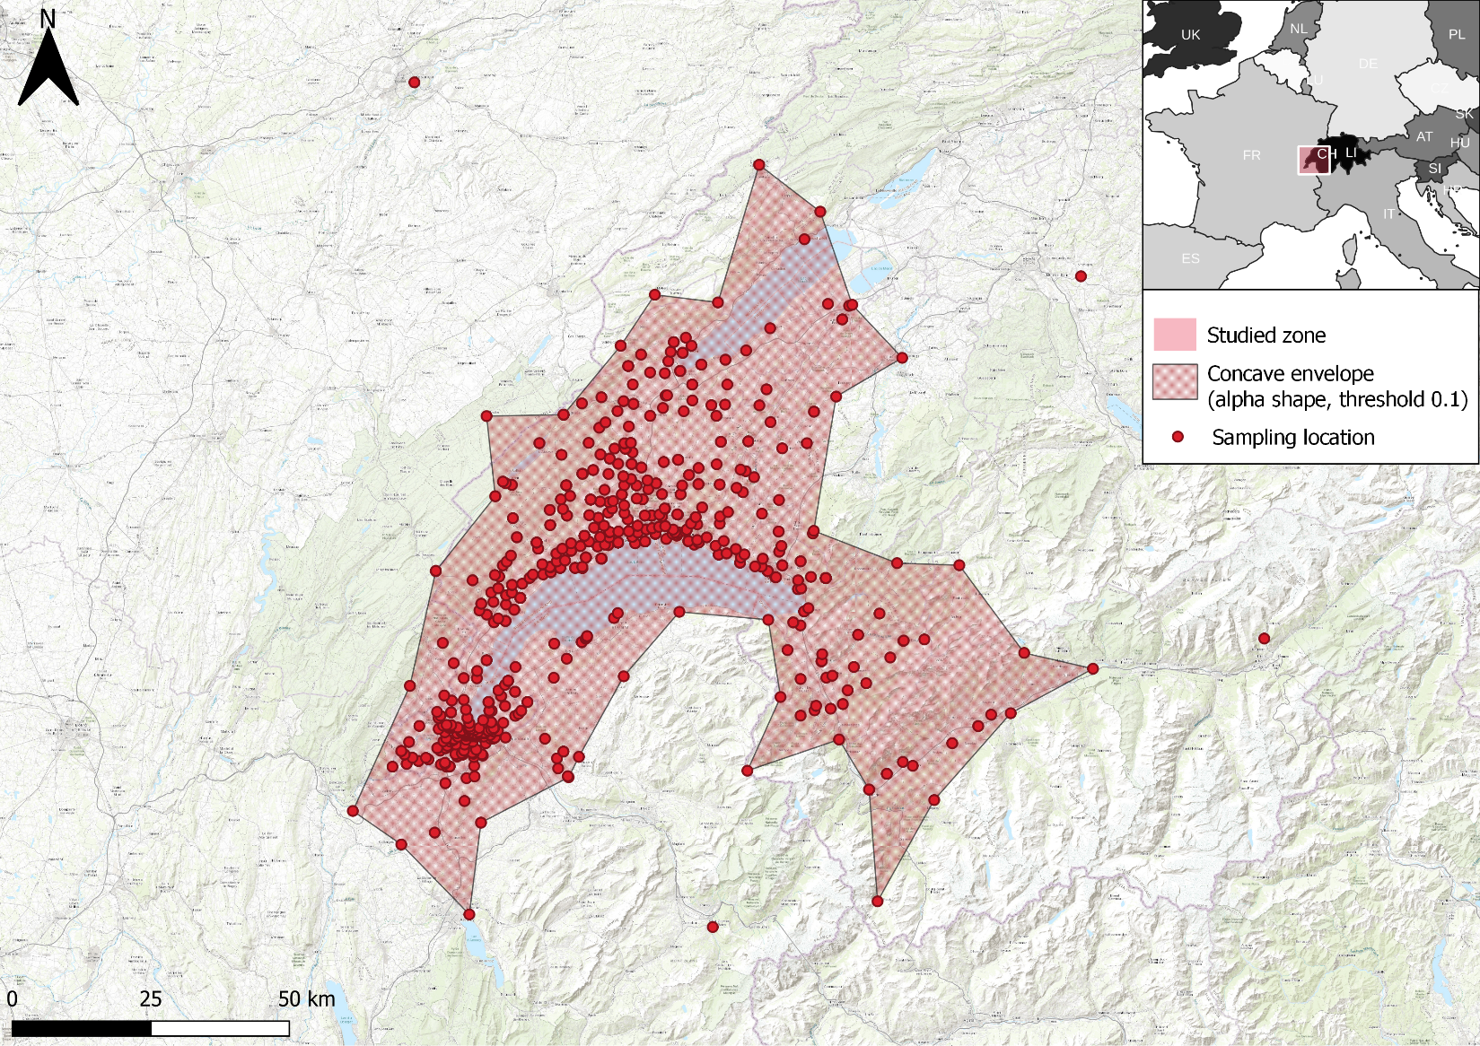
Supplementary Fig. S1. Map of the studied zone (i.e. Lake Geneva region). The concave envelope area (red hatched area) is 6642km². It includes the set of sampling points for which GPS coordinates were available in the museum databases (N=1289/1361). The concave envelope, calculated with an alpha shape model and a threshold of 0.1, excluded four points. The map and the estimation of the sampling envelope area were made using QGIS 3.20.2.
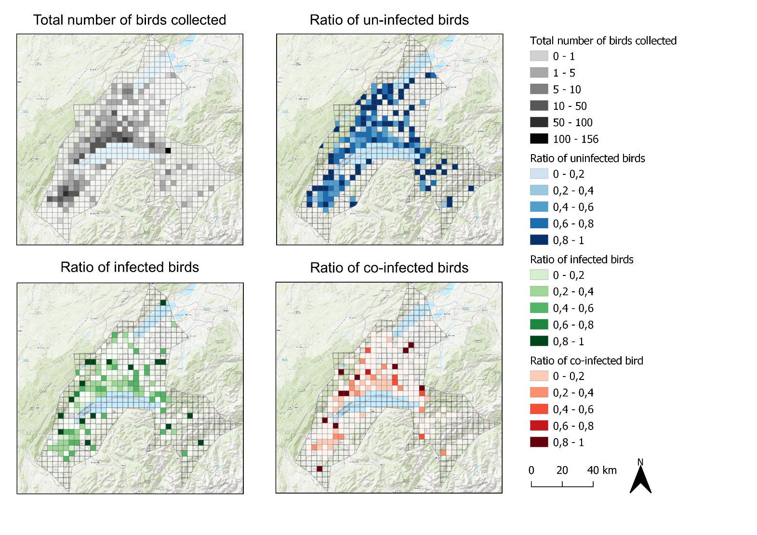
Supplementary Fig. S2. Geographic distribution of infection and co-infection patterns. The study area, characterized by a concave envelope, calculated with an alpha shape model and a threshold of 0.1, was divided into 5km square areas. Within each of these areas we calculated the number of birds collected and the ratios of uninfected, infected and co-infected birds.

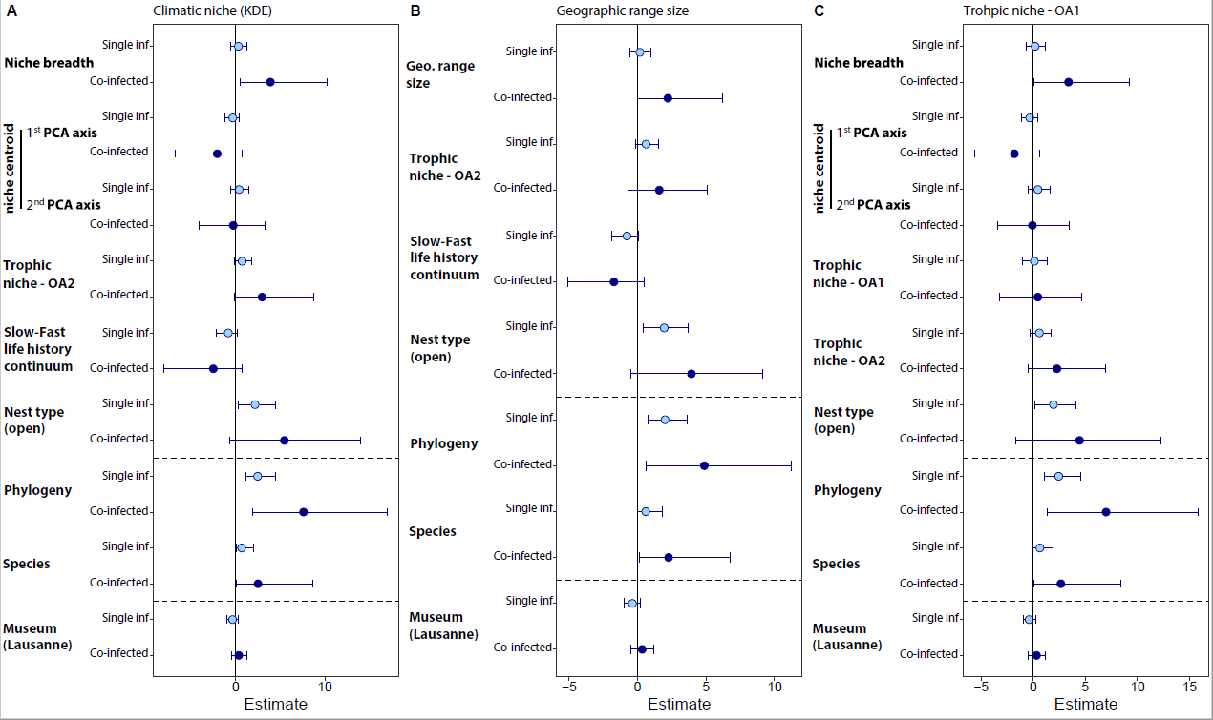
Supplementary Fig. S3. Sensitivity analyses of the removal of migratory species. Owing to the difficulty in characterizing the climatic niche of migratory species, the analyses presented in the main text (Fig. 3) were repeated with full and facultative migrant species excluded. Analyses were conducted on 401 individuals of 45 species. We here report the posterior mean and associated 95% credible intervals of predictors and random effects (i.e. phylogeny and host species) as estimated by multinomial phylogenetic brms models with infection status (i.e. uninfected, infected, co-infected) as the response variable. (A) Model with climatic niche breadth and climatic niche position estimated with a kernel density estimator (KDE) as predictors. (B) Model with geographic range size as predictor instead of niche breadth and niche position. (C) Model with trophic niche - OA1 (structure of the foraging environment) fitted as predictor instead of species position along the slow-fast life history continuum. For further details see Fig. 3 in the main text.
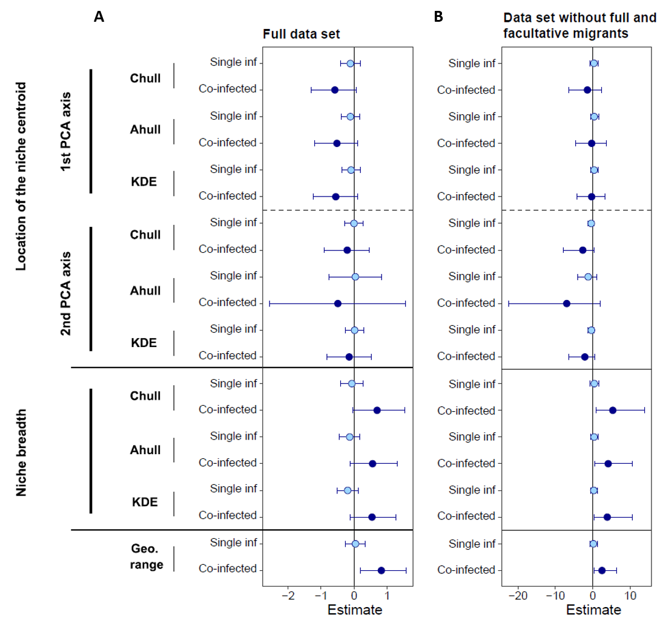

Supplementary Fig. S4. Sensitivity analyses of the effect of niche breadth and niche position on single- and co-infection rates according to the use of three different algorithms to quantify climatic niches. (A) Analyses carried out on the full data set and (B) on the data set where full and facultative migrant species were excluded. For each dataset, three models were run with climatic niche predictors (niche breadth and niche position along the two principal component analysis (PCA) axes) estimated using three different algorithms: kernel density estimators (KDE) presented in the main text, convex hull (Chull) and alpha hull (Ahull). Chull is defined as the smallest convex set that contains all samples. Ahull and KDE are extensions of Chull where non-convex and irregular shapes are allowed. While Chull are sensitive to outliers, Ahull and KDE are sensitive to the density of points in the environmental space. Chull is parameter-free whereas Ahull and KDE depend on a parameter that controls the shape of the envelope (the bandwidth; see Section 2.2.2 in the main text). For Ahull, we adopted an iterative procedure staring with an alpha value of one and then incrementing the value of the parameter by steps of 0.2 until 99% of points were included in the envelope. Posterior mean estimates of geographic (Geo.) range size on infection (inf) and co-infection status was also plotted on the figure.

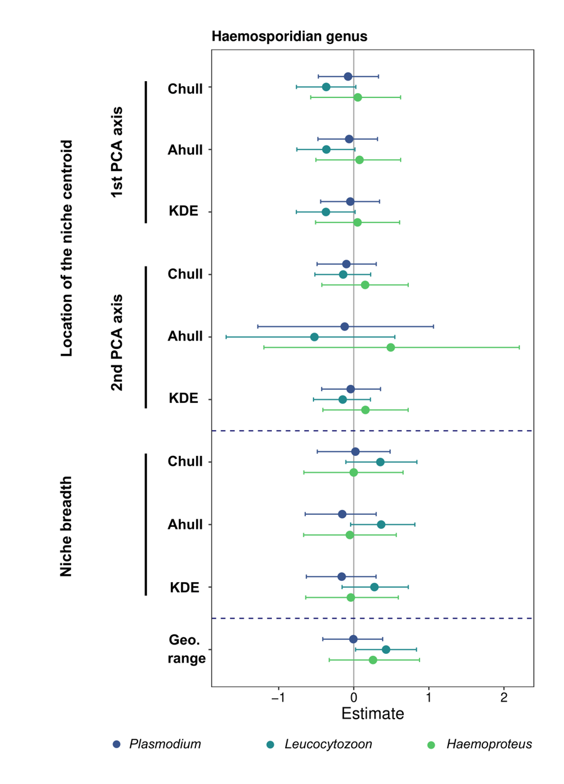
Supplementary Fig. S5. Sensitivity analyses of the effect of niche breadth and niche position on infection risk for each parasite genus according to the use of three different algorithms to quantify climatic niches. For further details see Fig. 4 in the main text and Supplementary Fig. S4.

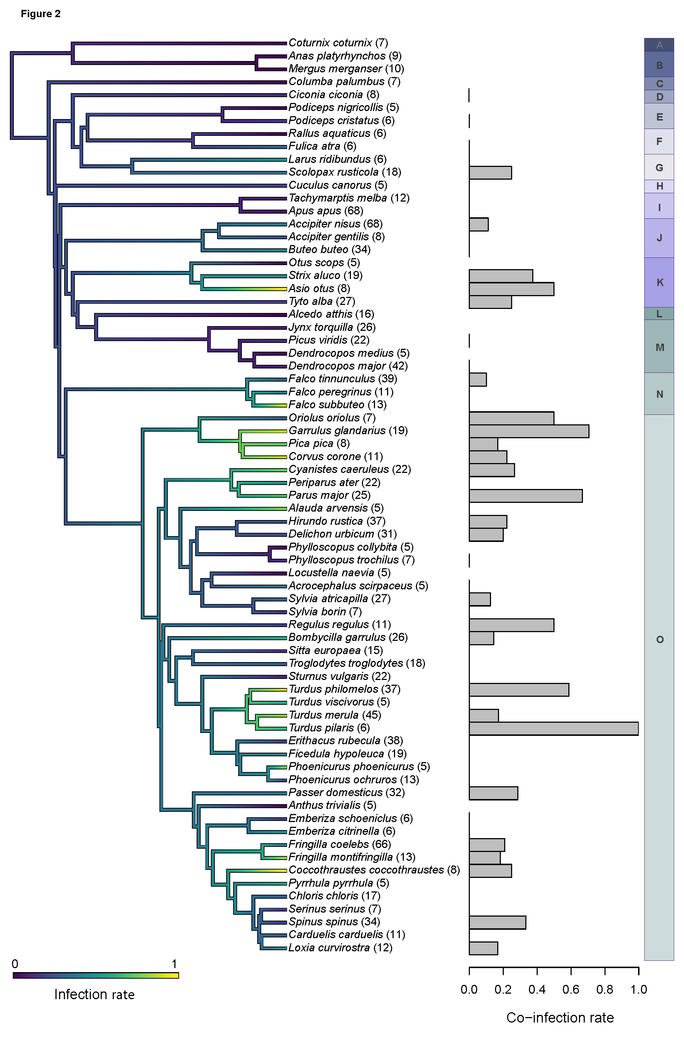
Supplementary Fig. S6. Haemosporidian infection and co-infection rates across the avian phylogeny. The overall proportion of infected individuals (single and co-infected), for each bird species for which at least five individuals were sampled, was mapped as a continuous trait. The consensus tree was generated from 1000 phylogenies obtained from BirdTree.org. The bar plot represents the proportion of co-infected individuals among infected individuals. The numbers in parentheses correspond to the sample sizes per species. Letters (from A to O) correspond to bird orders. A: Galliforme, B: Anseriformes, C: Columbiformes, D: Ciconiiformes, E: Podicepediformes, F: Gruiformes, G: Charadriiformes, H: Cuculiformes, I: Apodiformes, J: Accipitriformes, K: Strigiformes, L: Coraciiformes, M: Piciformes, N: Falconiformes, O: Passeriformes

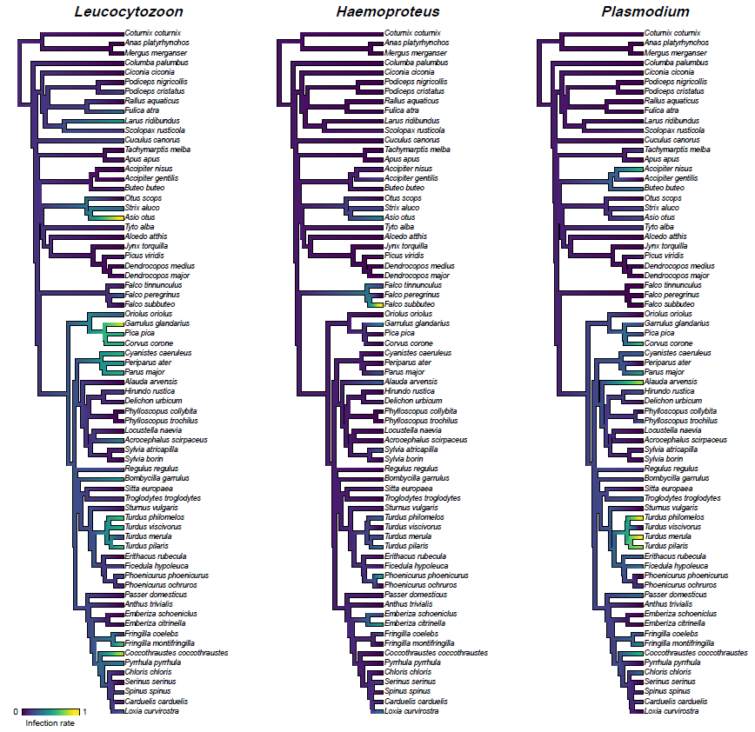
Supplementary Fig. S7. Infection rate by each haemosporidian genus across the avian phylogeny. The proportion of individuals infected by each parasite genera for each well-sampled host species (≥ 5 individuals) was mapped as a continuous trait. The consensus tree was generated from 1000 phylogenies obtained from BirdTree.org (backbone tree from Hackett et al. 2008).

Reference
Hackett, S.J., Kimball, R.T., Reddy, S., Bowie, R.C.K., Braun, E.L., Braun, M.J., Chojnowski, J.L., Cox, W.A., Han, K.-L., Harshman, J., Huddleston, C.J., Marks, B.D., Miglia, K.J., Moore, W.S., Sheldon, F.H., Steadman, D.W., Witt, C.C., Yuri, T., 2008. A Phylogenomic study of birds reveals their evolutionary history. Science 320, 1763–1768. https://doi.org/10.1126/science.1157704

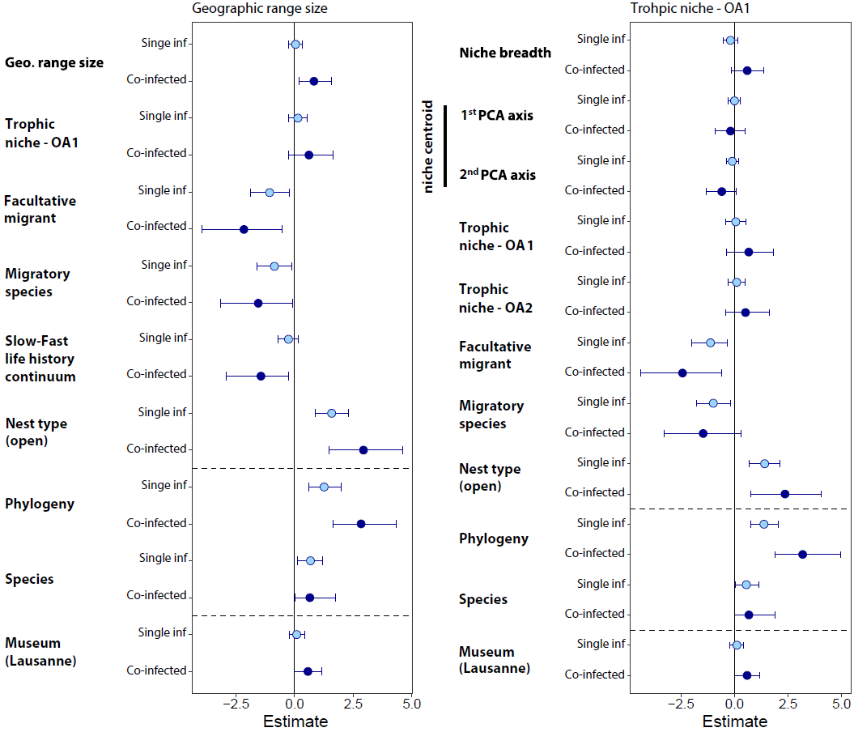
Supplementary Fig. S8. Sensitivity analyses to the inclusion of geographic range size and OA1 (structure of the foraging environment) on single-and co-infection probabilities in replacement of predictors they were correlated with (life-history strategy and climatic niche breadth). For further details see Fig. 3 in the main text.

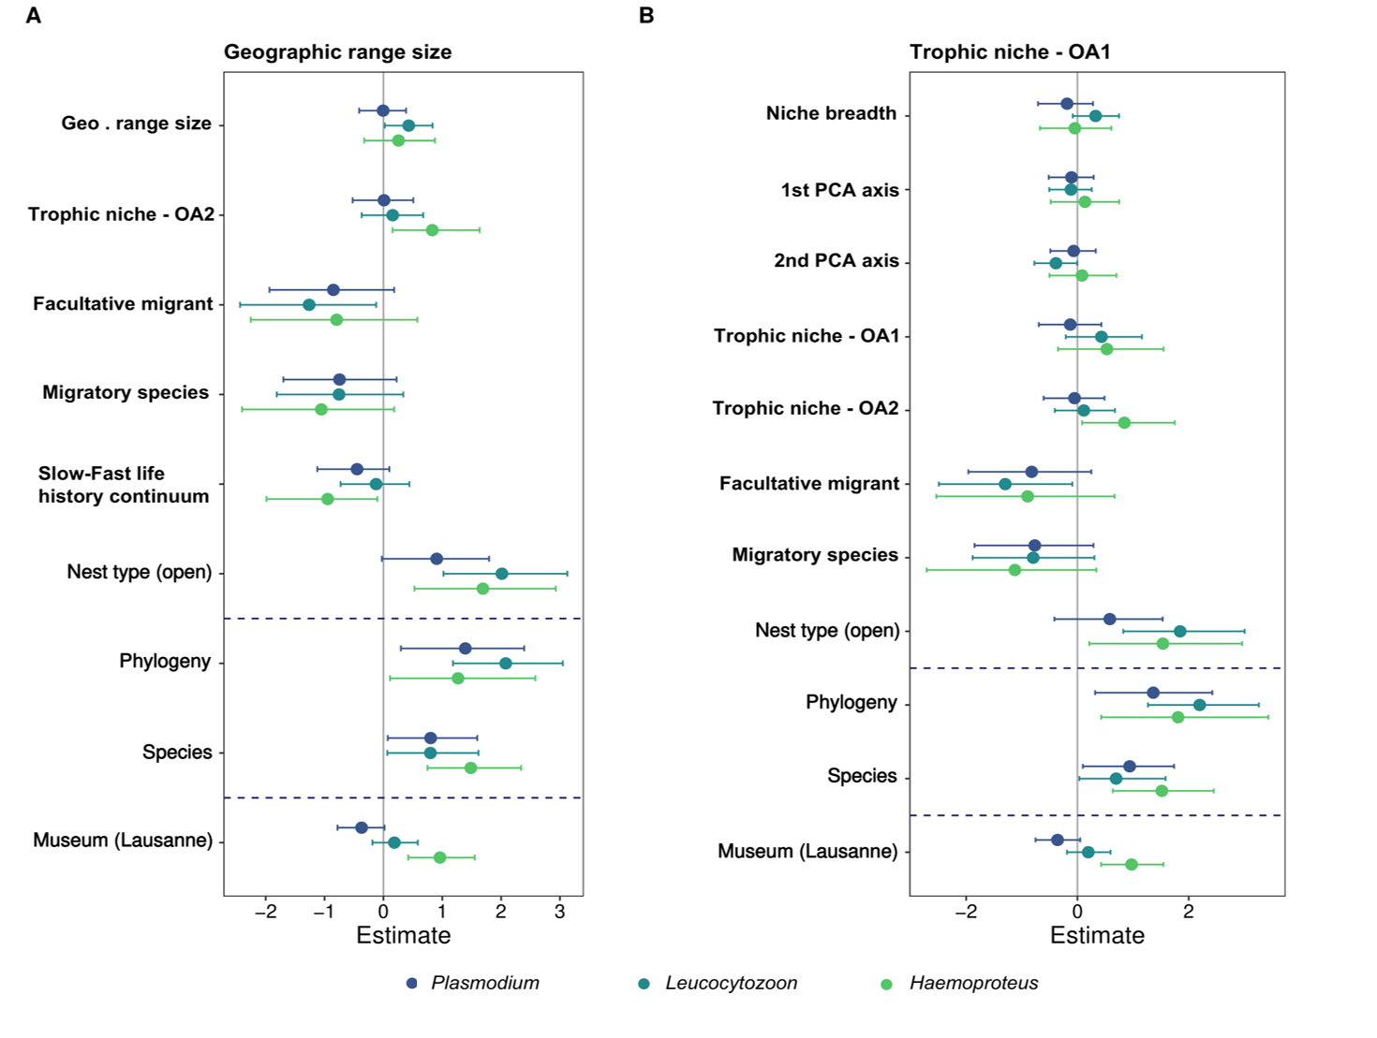
Supplementary Fig. S9. Sensitivity analyses to the inclusion of geographic range size and OA1 (structure of the foraging environment) on the inflection probability by each parasite genus in replacement of predictors they were correlated with (life-history strategy and climatic niche breadth). For further details see Figs. 3 and 4 in the main text.

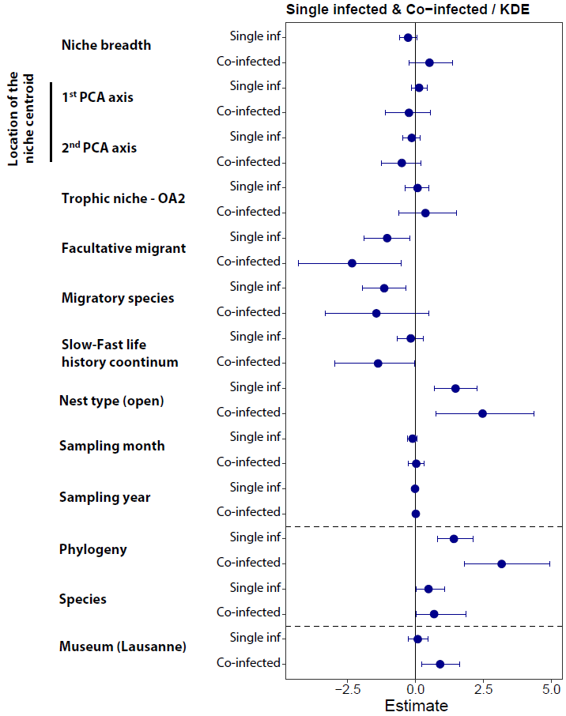
Supplementary Fig. S10. Sensitivity analyses to the inclusion of sampling month and year on single-and co-infection probabilities. The analysis was conducted on 1162 individuals for which the collection date was available. For further details see Fig. 3 in the main text. KDE, kernel density estimation

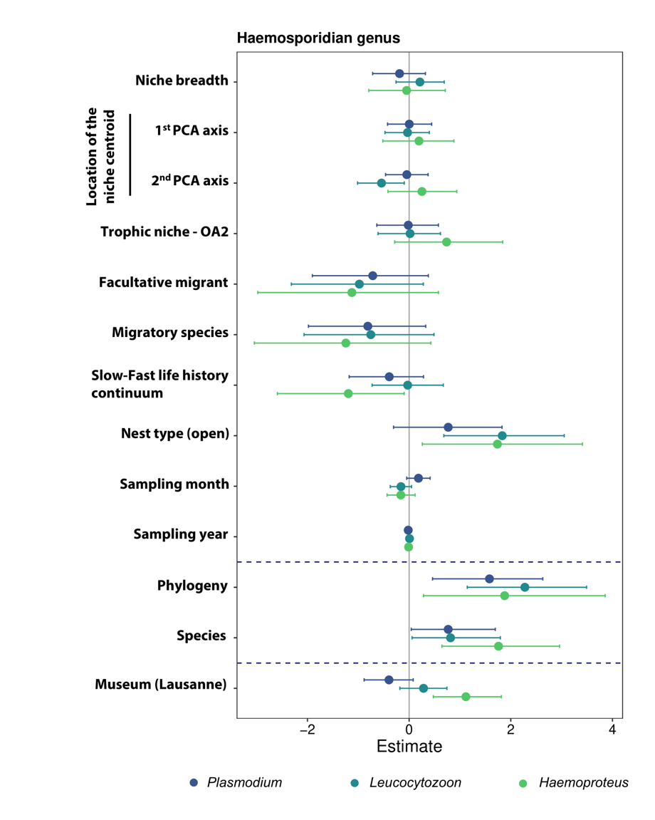
Supplementary Fig. S11. Sensitivity analyses to the inclusion of sampling month and year on the inflection probability by each parasite genus. The analysis was conducted on 1162 individuals for which the collection date was available. For further details see Fig. 3 in the main text.

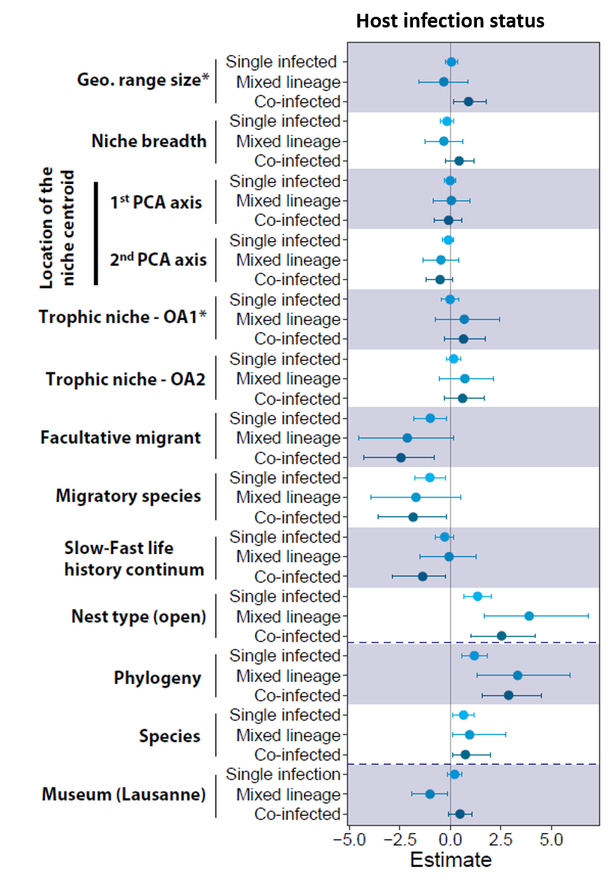
Supplementary Fig. S12. Posterior mean and associated 95% credible intervals of fixed and random effects (i.e. phylogeny and host species) as estimated by a multinomial phylogenetic brms model with four infection statuses (i.e. uninfected, single infected, mixed lineage infected – i.e. birds infected by several lineages of parasite belonging to the same haemosporidian genus, co-infected) as the response variable. *Since OA1 (structure of the foraging environment) and the geographic range size were strongly correlated with bird life-history strategies (ρ = -0.81) and the climatic niche breadth (ρ = 0.76), respectively, the posterior mean of OA1 and geographic range size presented here was estimated from two other brms model where they replaced the variables they were correlated with.

