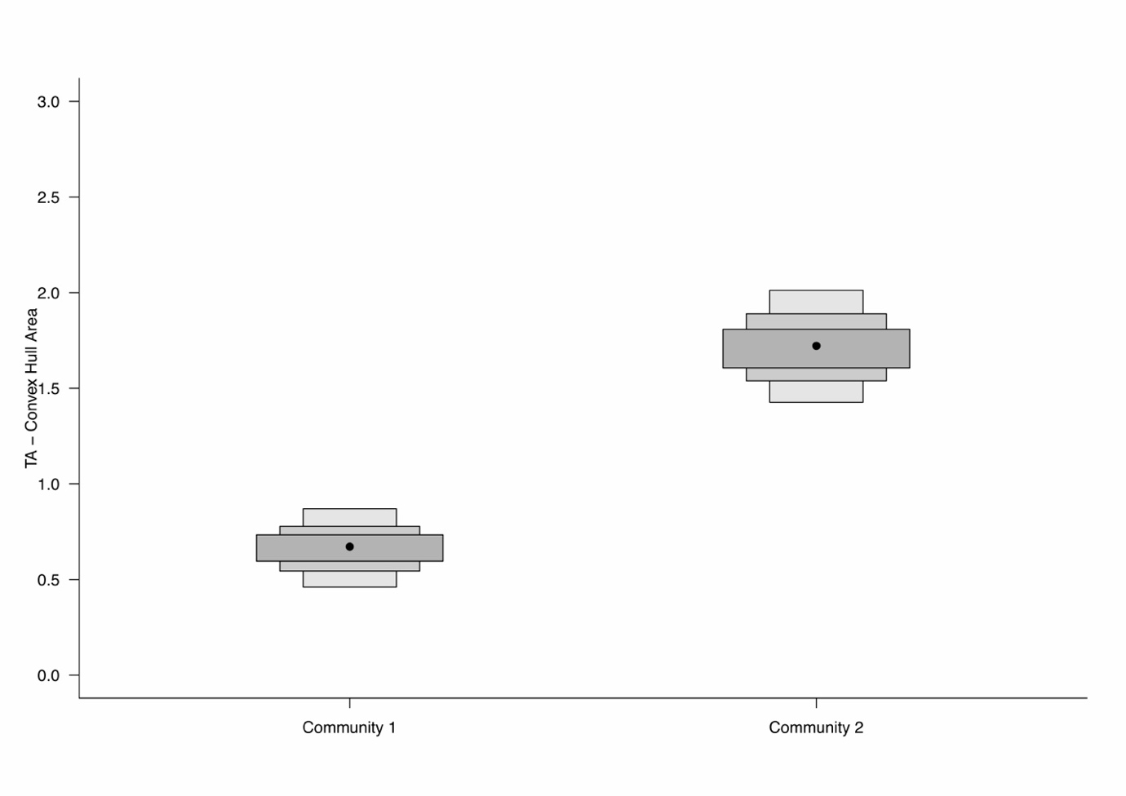

**S1 Fig.** **Total area of convex hull estimated for each community or period.** Community 1 = Period 1, Community 2 = Period 2. The black points correspond to the mean standard ellipse area for each group while the grey and white boxed areas reflect the 95, 75 and 50% confidence intervals.