Supplementary material for:

Spatial and temporal variability of the physical, carbonate and CO₂ properties in the Southern Ocean surface waters during austral summer (2005-2019)
Margaux Brandon^{1,*}, Catherine Goyet², Franck Touratier², Nathalie Lefèvre¹, Elodie Kestenare³, Rosemary Morrow³
¹Institut de Recherche Pour le Développement, Laboratoire d’Océanographie et du Climat Expérimentations et Approches Numériques (LOCEAN), Sorbonne Université, Centre National de la Recherche Scientifique, Muséum National d’Histoire Naturel, 4 Place Jussieu, 75005 Paris, France
²Laboratoire IMAGES-ESPACE-DEV, Univ. Perpignan Via Domitia, Perpignan, France
³LEGOS, CNRS/IRD/CNES/University of Toulouse III, Toulouse, France
*Corresponding author. Email address: margaux.brandon@locean.ipsl.fr
in Deep-Sea Research Part I: Oceanographic Research Papers

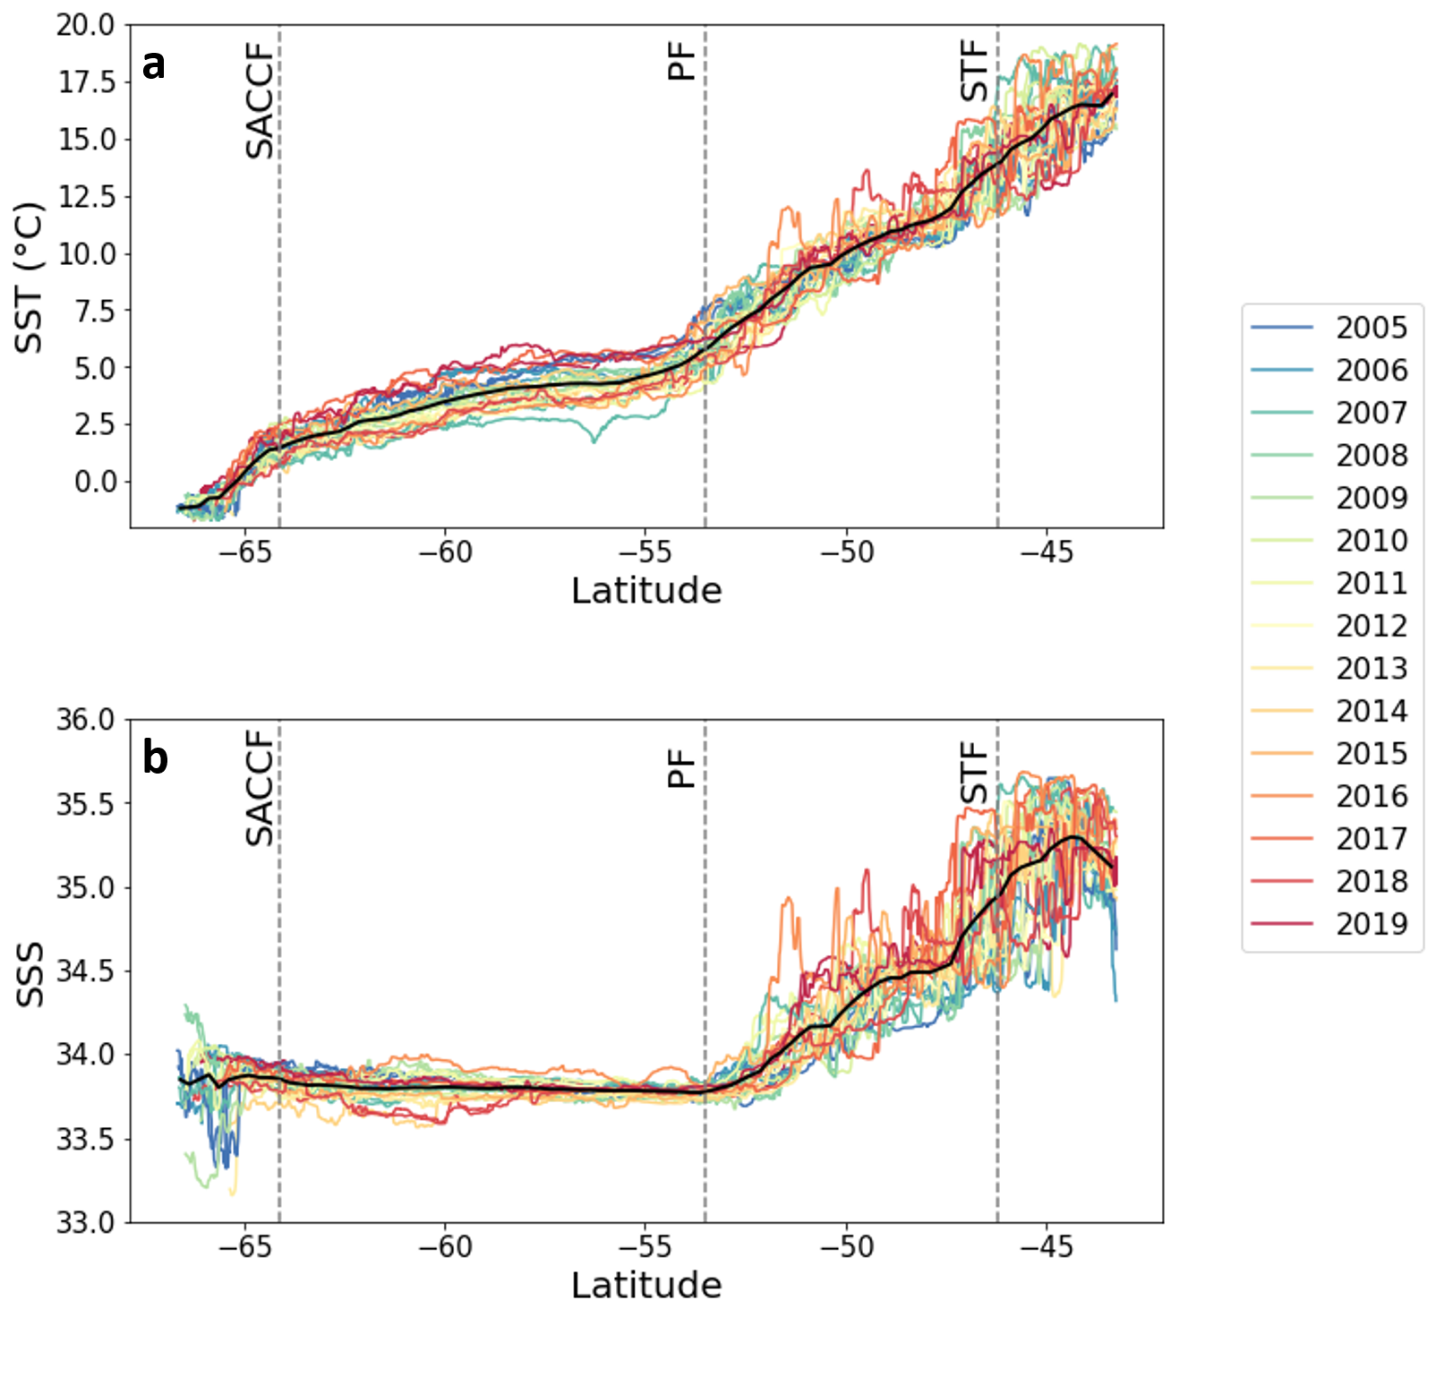
Supplementary Figure 1 Latitudinal variations of a) measured SST, b) SSS from SURVOSTRAL for years 2005 to 2019. Black curve represents the latitudinal mean of all years.

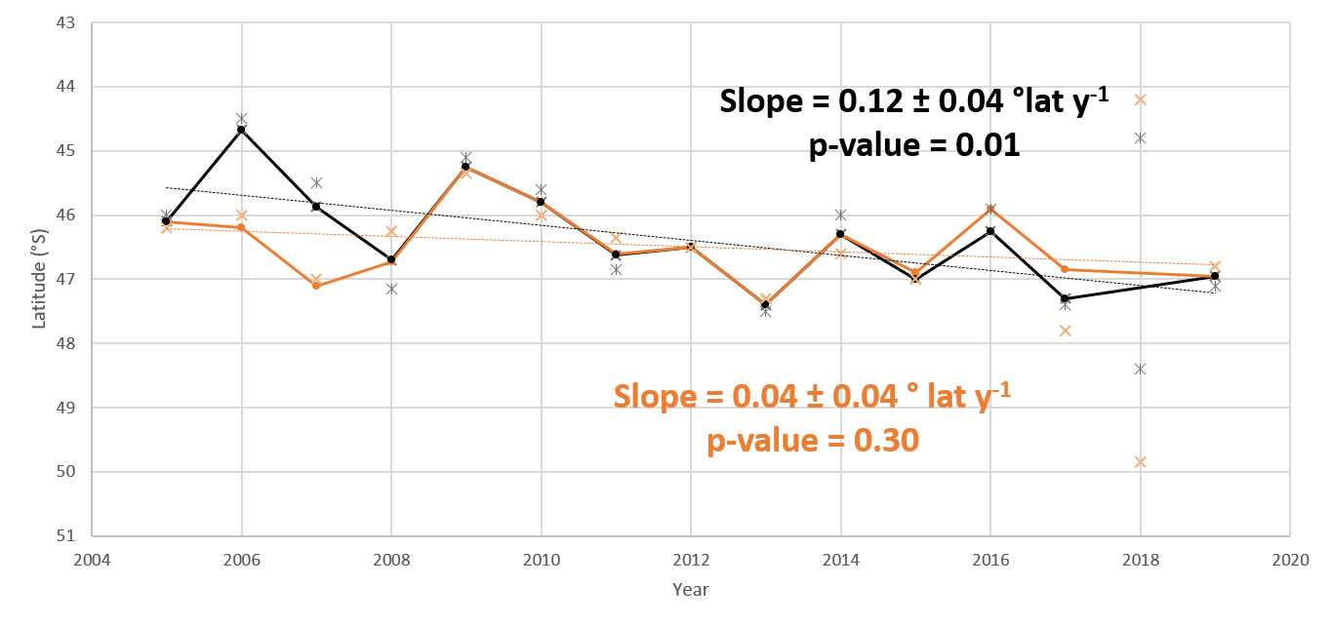
Supplementary Figure 2 Evolution of the STF position through time. The black line (and associated black dots) represents the evolution of the mean STF position for each year during summer, determined by the strong SSS gradient observed in SURVOSTRAL SSS data. Grey crosses are the associated position of the STF for each cruise when two cruises are available the same year. The orange line (and associated orange dots) is the evolution of the mean STF position for each year during summer determined by the 13°C isotherm using SURVOSTRAL SST data. Light orange crosses are the associated position of the STF for each cruise when two cruises are available the same year. Trends of STF migration are presented for each method. The trends do not consider year 2018 because of the high variability of the STF position between the two cruises and the difficulty to assess the exact position of the STF using both methods. While the 13°C isotherm is often used to determine the position of the STF, its signature is lost more rapidly than SSS because of air-sea interactions. Here we determine the position of the STF using both the 13°C isotherm and the SSS gradient from SURVOSTRAL dataset. Both methods show a southward migration of the STF with time, with a stronger signature in SSS (0.12 ± 0.04 °lat y⁻¹) than in SST (0.04 ± 0.04 °lat y⁻¹).

