

Journal of Geophysical Research: Solid Earth

Supporting Information for

**From long- to short-term inter-plate coupling at the subducted Carnegie Ridge crest, offshore Central Ecuador**

J-Y Collot1, J-N. Proust2, J-M Nocquet1,3, C. Martillo4, F. Michaud1,5, J-F. Lebrun6, L. Schenini1, S. Popescu7, M-J. Hernandez8 and G. Ratzov1.

1 Université Côte d’Azur, IRD, CNRS, Observatoire de la Côte d’Azur, Geoazur, F06560 Valbonne, France.

2 Université de Rennes, CNRS, Géosciences-Rennes, F-35000 Rennes, France.

3 Institut de Physique du Globe de Paris, Sorbonne Paris Cité, Université Paris Diderot, UMR 7154 CNRS, Paris, France

4 Escuela Superior Politécnica del Litoral, GEMAC-FIMCM-CADS, P.O. Box 09-01-5863, Guayaquil, Ecuador

5 Sorbonne Université, Institut des Sciences de la Terre, 75252, PARIS cedex 05, France

6Geosciences Montpellier, Université des Antilles, Université de Montpellier, CNRS, Pointe à Pitre, Guadeloupe (FWI)

7 Geobiostratdata.Consulting, 69140, Rillieux la Pape, France

8 Escuela Politécnica Nacional, Departamento de Geológica, Ladrón de Guevara E11-253, Quito, Ecuador

**Contents of this file**

Text S1

Figures S1 to S5

Tables S1 to S2

Text S1. Method and accuracy for dating sediment in the study area

1. **Seismic stratigraphy**

Seismic units 1, 2 and 3 are composed of a stack of 0.01 to 0.1 stwtt–thick elementary seismic sequences bounded by unconformities defined by truncation below and onlap-downlap geometries above (Fig. S1 and 4). The sequences comprise genetically related packages of seismic facies called systems tracts (Vail et al., 1977), which register the changes in shoreline trajectories (transgression, T; normal regression, NR; and forced regression, FR). Following the T-R sequences proposed by Embry (1993), we have grouped the set of regressive systems tracts (Highstand, Falling-Stage, and Lowstand) in a “Regressive Systems Tract”, and the transgressive systems tracts in the “Transgressive Systems Tract”. The limits of T-R sequences are located on maximum regressive surfaces. The interpretation of unit 1 seismic facies and systems tracts can be found in Proust et al. (2016) from two high-resolution seismic lines collected on the Manta-La Plata shelf, ~ 60 km south of our study area.

In the study area, T-R sequences within unit 1, 2 and the upper part of unit 3 were identified on both high-resolution Atacames, and SCAN industrial seismic data, whereas deeper unit 3 elementary sequences could only be picked up on line SCAN 888 (Fig. S1). The elementary sequences in unit 1 correlate around the seismic grid in the SW Bahia-Jama depocenter (SWBJ). These sequences, which are mostly lacunar on the shelf promontory, were interpreted on the northern flank of the shelf promontory from their identification farther north in the Pedernales Basin. Although units 2 and 3 were identified in both the SWBJ depocenter and the Pedernales Basin, their elementary sequences were only picked up in the SWBJ depocenter. In the SWBJ depocenter, the seismic records indicate 10 T-R seismic sequences in Unit 1 named UTR 1 to 10, 5 in Unit 2 named MTR A to E, and 19 in Unit 3 named LTR F to X (Fig. S1). The sequences were numbered assuming a minimum time gap along their unconformities due to potential erosion.

1. **Biostratigraphic and radiocarbon age dating**

2.1. Biostratigraphic results

The seven piston cores available in the study area (see location map Fig. 1c and seismic lines in Fig. 6 and S2) comprise bioclastic silty clays to coarse sands (Table S2). The selected samples are rich in microfossils, and were analysed for their planktonic and benthic foraminifer assemblages in order to provide biostratigraphy and paleoenvironment (Table S2 and Popescu, 2021). Samples collected on the CP shelf promontory (Fig. 3) from interpreted seismic unit L3b (KAT29 and 24) and seismic unit 1 (KAT25 and 30) provide a Piacenzian to Pleistocene or Holocene age range.

Samples from the Manta anticline (Fig. S2) provide a Piacenzian-Gelasian (~3.6-1.8 Ma) age for interpreted seismic unit L3b at site KAT33, and a Zanclean-Holocene age-range at both site KAT31 and KAT32. However, based on specific fauna (Popescu, 2021), the time window for the deposition of sediments from sample KAT32 might be reduced to Piacenzian-Middle Pleistocene. Thus, sediment of core KAT31, which are stratigraphically younger (upper L3b) than those at site KAT33 (Lower L3b) could be Gelasian in age (2.58-1.8Ma) and those of core KAT32 taken in interpreted seismic unit 1 could be younger, potentially Ionian (0,781-0,126 Ma) in age.

2.2. Radiocarbon age dating

Only core KAT25 yielded material datable in absolute age with 14C. The 1.77 m-long core KAT25 was taken on seismic line 46.1 (Fig. 6-I) in the upper part of Unit 1 at the contact between UTR 8 and 9 (Fig. S3). The lower section of the core, from 1.77 m to 1.05 m, presents homogeneous facies with medium sand grains with mm-sized bioclasts. At 1.05 m, an erosional unconformity separates the lower homogeneous facies from the upper facies of fine olive-glauconitic green sand. The latter is highly bioturbated from 1 to 0.50 m with cm-large burrows filled with dark-green sand grains. We interpret this 0.5m-thick, burrowed, olive-green mid-shelf sand overlying the unconformity as the transgressive systems tract of UTR 9. A carbonate shell sample was selected for 14C dating at 1.04 m just above the unconformity. This sample provided a laboratory age of 43400 ± 1300 BP, and an age of 46400 cal yr BP with correction for marine reservoir effects. Core KAT30 (Fig.1c and 6-II) was tentatively dated with 14C and provided an age older than 50 000 yr BP.

**3. Dating of units L3b, 1, 2 and 3**

Biostratigraphic data show that unit L3b is Late Pliocene to Lower Early Pleistocene in age, an equivalent to the onshore Middle Borbon formation (Reyes and Michaud, 2012). The overlying units 1, 2 and 3 are therefore younger and likely Upper Early Pleistocene to Holocene.

On the Manta-La Plata shelf (Fig. 1a), where seismic data are correlated to piston core data and onshore exposures, unit 1 is dated from the Middle (Ionian, 0,781-0,126 Ma) to Upper (Tarantian, 0,126-0,0117 Ma) Pleistocene age (Proust et al., 2016). There, the 10 UTR sequences in Unit 1 are composed of terrestrial and marine sediments whose deposition was controlled by the post-MPT (Mid Pleistocene climatic Transition) eccentricity-driven (100 ka-scale) glacio-eustatic changes in sea level. In our study area, unit 1 comprises the same 10 UTR sequences as in the Manta-La Plata area, and the age of UTR9 is 14C-controlled in both areas, implying that unit 1 sequences occurred synchronously and in in the same environment at both places.

Assuming that climato-eustasy was the main driver of the changes in accommodation space at these short time scales (10’s ka) (e.g. Proust and Chanier (2004), we propose a time frame for the sediment deposition in the study area by tying the seismic sequences unconformities to the well-dated transition between the even (cold climate, low sea level) and odd (warm climate, high sea-level) marine isotopic stages (MIS) (Table S1). Older Units 2 and 3 comprises 24 elementary sequences deposited before the MPT, a time when the accommodation space was controlled by obliquity-driven (40 ka-scale) glacio-eustatic changes in sea level (e. g. in Proust and Chanier (2004)). As their thickness is smaller due to their higher frequency, it is more difficult to assign them a precise age.

The main sources of error in the proposed dates are:

- For unit 1 (i) uncertainties in lateral correlations from one profile to another and (ii) possible confusion with higher frequency variations of the sea level superimposed on the 100 ka sea level variations. These uncertainties may lead to an error of plus or minus one sequence;

- For units 2 and 3, lack of accuracy of the picking due to (i) the progressive decrease in resolution with depth, (ii) the thinness of the 40 ka T-R sequences compared to the 100 ka’ possibly accentuated by unexpected changes in sedimentation rates, and (iv) underestimated erosion beneath major surfaces Ua and Ub in the absence of absolute age control.

- Finally, uncertainties in the age model of global sea level variations LR014 that is estimated at 6 ka from 3 - 1 Ma, and 4 ka from 1 - 0 Ma (Lisiecki and Raymo, 2005).

Considering these sources of error allow estimating the minimum error to be 100 ka for unit 1, 40 ka for unit 2 and 40 ka for unit 3 plus 10 ka for the age model. Thus, the proposed ages for the main discontinuities are as follows: Ua, 790 ka +/-110; Ub, 1031 ka+/-150; Uc, 1832 ka +/-200, and ages for UTR, MTR and LTR sequences within units 1, 2 and 3 are as indicated in Table S1.

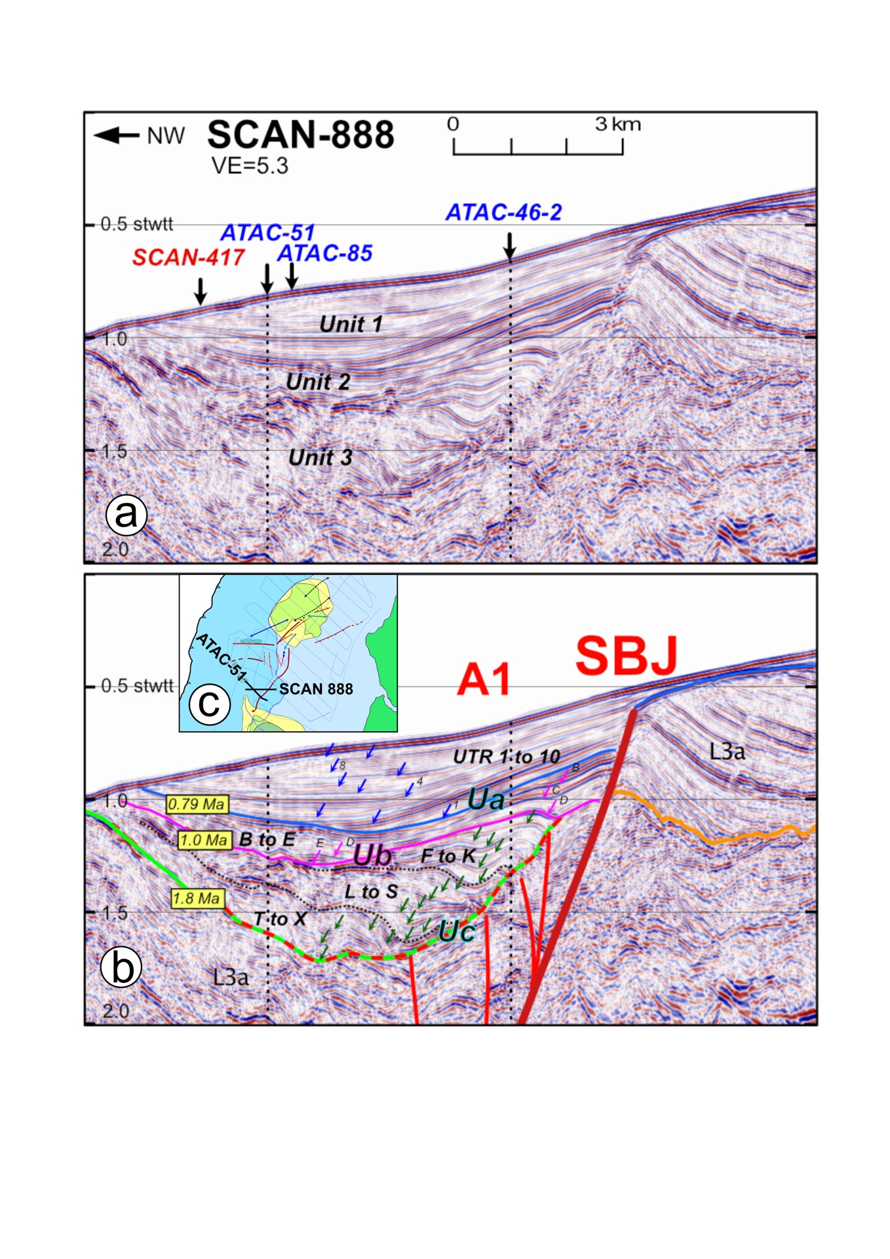

Figure S1. Seismic reflection line SCAN-888 across the SWBJ depocenter and A1-SBJ fault system; (a) un-interpreted section with crossing lines and seismic units 1, 2 and 3. Depth in stwtt (second two-travel time); VE= Vertical exaggeration; (b) interpreted section indicates major unconformities Ua, Ub and Uc and their respective inferred ages. Blue arrows = interpreted elementary seismic sequences UTR 1 to 10 (see Table S1). Purple arrows = interpreted elementary seismic sequences MTR A to E. Note that due to the wedge shape of Unit 3, sequence A is absent in SCAN 888 but present in crossing line ATAC- 51 (Fig. 4). Green arrows = interpreted elementary seismic sequences LTR F to X. Unit L3a is Lower Pliocene after Hernandez et al., (2020). SBJ is South Bahia Jama fault segment; A1 is branching fault; (c) Location map

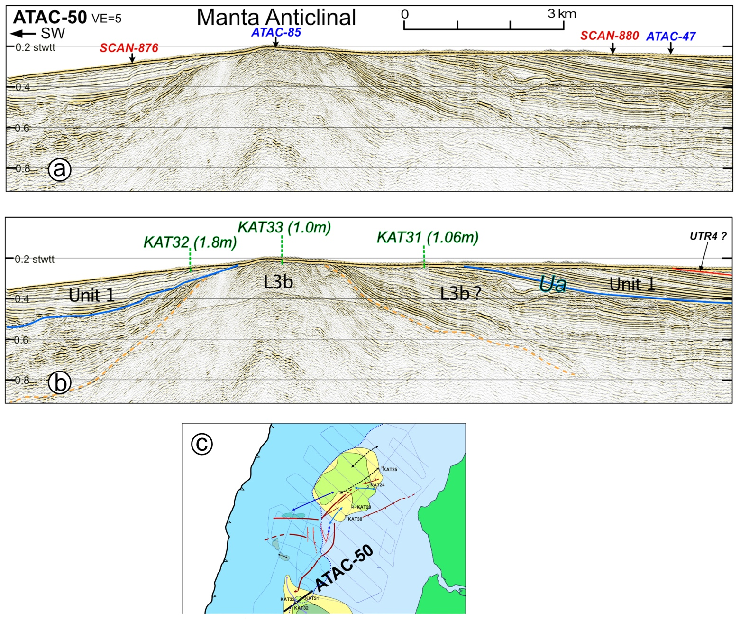

Figure S2. Seismic reflection line ATAC-50 across the Manta anticline with sediment core location; (a) un-interpreted section with crossing lines; (b) interpreted section (see Figure 4 for caption) with sedimentary cores KAT31, 32, 33 and their length; (c) location map.

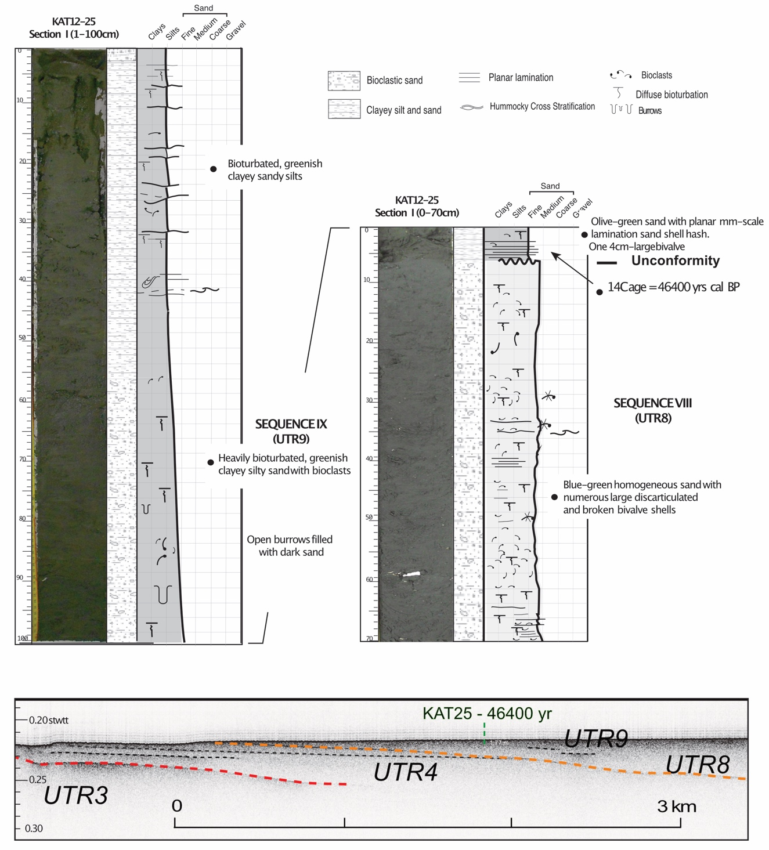

Figure S3. Piston core data collected along line ATAC-46-1 (Fig. 1c and 6-I). top: Core KAT25 is 1.77 m-long; the core shows the sharp contact between bioclastic medium sand below and glauconitic fine sand above interpreted as the unconformity between UTR sequences 8 and 9 of unit 1; a shell collected 3 cm above the unconformity provided a 14C age of 46,400 kyrs BP; bottom: core location on Chirp line 46-1 (Fig; 6-Id).

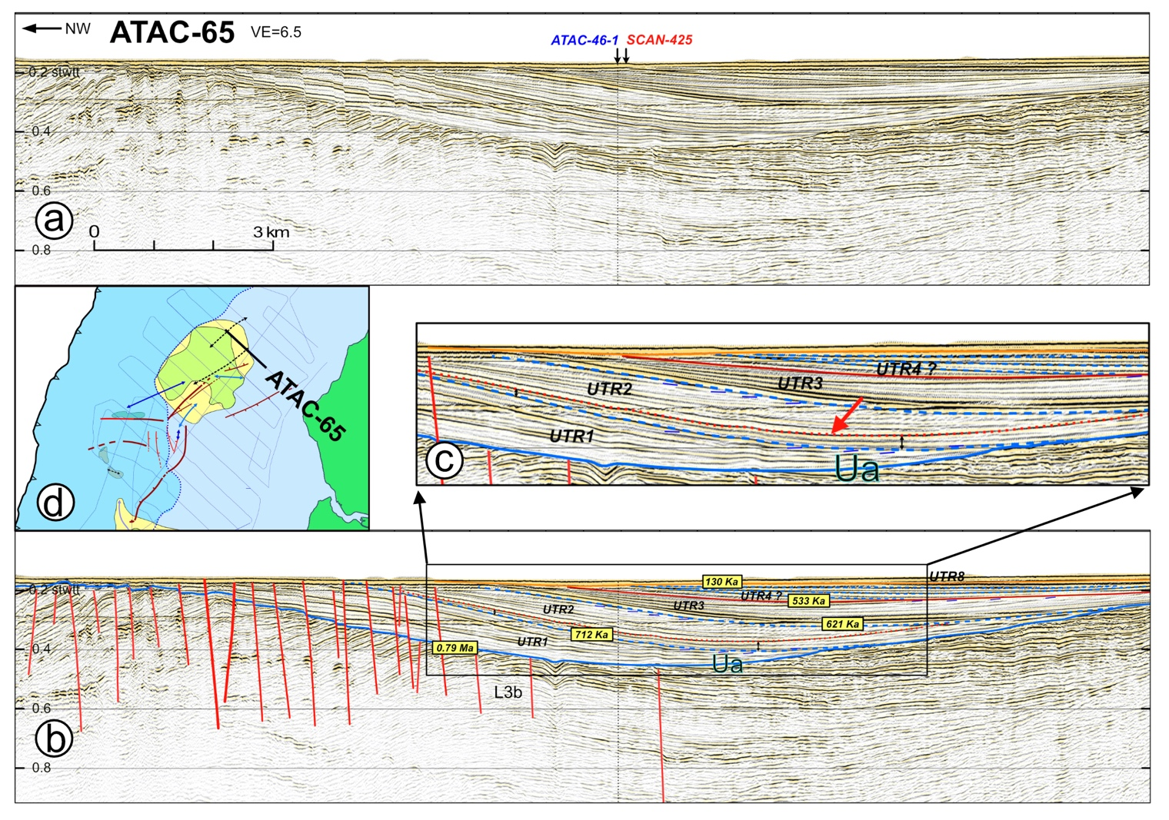

**Figure S4**. Seismic reflection line ATAC-65 across the northern end of the shelf promontory; a) un-interpreted section with crossing lines; b) interpreted section (see Figure 4 for stratigraphy and ages caption). Note the seaward thickening of sequence UTR1 pointing to a period of subsidence of the shelf promontory; c) As identified in line ATAC-61(Fig. 9) the zoom images the landward diverging pattern of lower strata of sequence UTR2 (thin black double arrows beneath the red arrow) that contrasts with the trenchward diverging pattern of sequence UTR1, thus dating the recent uplift and landward tilt of the outer shelf (see text); d) Location map;

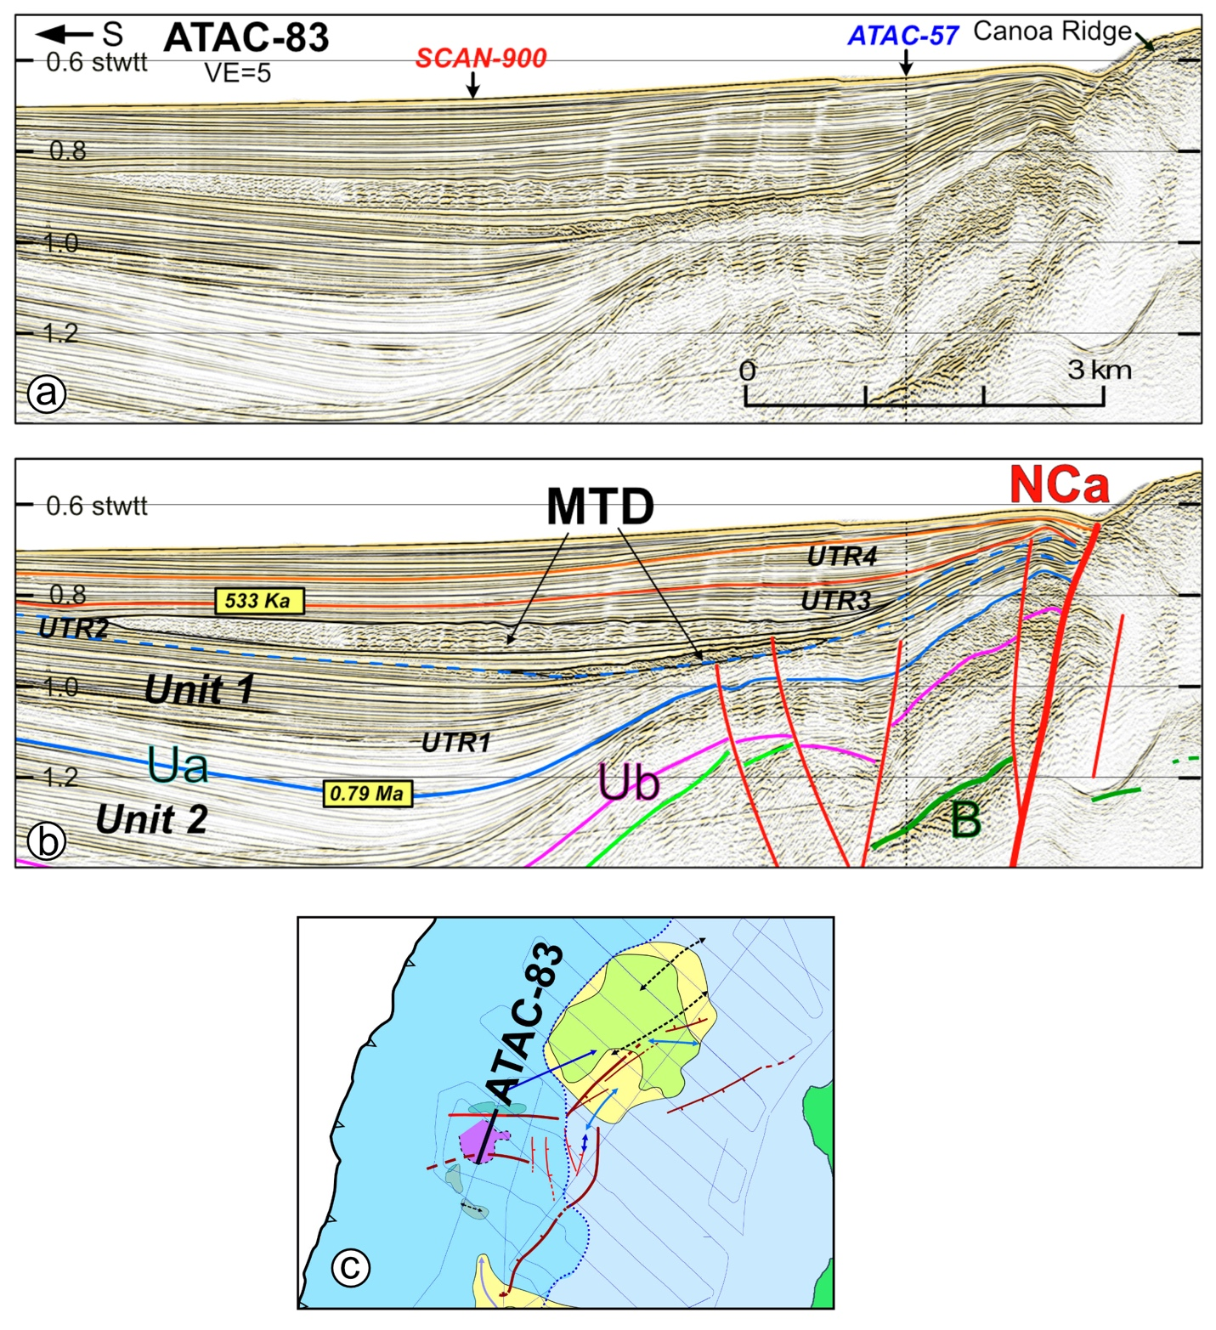

**Figure S5.** Mass Transport Deposits (MTD) in seismic reflection line ATAC-83; a) un-interpreted section with crossing lines; b) interpreted section (see Figure 4 for stratigraphy and ages caption) shows poorly stratified bodies returning incoherent reflections, interpreted as MTD; these sedimentary bodies were emplaced between UTR 2 and 3, immediately south of the Canoa Ridge and North Canoa Fault (NCa); c) Location map; pink patch shows geographic extent of the MTD.



Table S1. T-R sequences from the seismic stratigraphy and the proposed correlation of their boundaries to Marine Isotopic Stages (MIS) and their associated ages (<http://www.lorraine-lisiecki.com/LR04_MISboundaries.txt>)



**Table S2.** Lithology, Depositional environment and Ages of sediment cored at site KAT24 and 25, and KAT29 to 33 offshore Central Ecuador (Location in Fig. 1c); ages and depositional environment were derived from planktonic and benthic foraminifer assemblages (Popescu, 2021).