Supplementary Material
Table 2: Similarity percentages (SIMPER) analysis of the fatty acid profile (%) of aquatic and terrestrial insects for each sampling month (April to October). Fatty acids are listed for each month in descending order of their contribution to the dissimilarity between the groups. P values are calculated from 1,000 permutations. Bold contribution values represent those that were statistically significant (p < 0.05); a “*” mark refers to marginally significant values. The coeluting fatty acids 18:1n-9 and 18:1n-12 are collectively labelled as 18:1.
April |  | May |  | June |  | July |  | August |  | September |  | October
20:5n-3 (EPA) | 13.5 | 20:5n-3 (EPA) | 12.3 | 20:5n-3 (EPA) | 13.8 | 20:5n-3 (EPA) | 13.2 | 20:5n-3 (EPA) | 12.2 | 20:5n-3 (EPA) | 10.3 | 20:5n-3 (EPA) | 12.1
18:1 | 11.1 | 18:1 | 10.4 | 18:1 | 8.3 | 18:1 | 8.9 | 18:1 | 10.0 | 18:3n-3 (ALA) | 9.6* | 18:1 | 10.4
18:1n-7 | 9.4 | 18:1n-7 | 8.5 | 18:2n-6 (LIN) | 7.9 | 18:2n-6 (LIN) | 8.7 | 18:2n-6 (LIN) | 9.6 | 18:1 | 9.0 | 18:3n-3 (ALA) | 9.6
18:2n-6 (LIN) | 7.5 | 18:2n-6 (LIN) | 8.3 | 18:3n-3 (ALA) | 7.8 | 16:1 | 7.7 | 18:4n-3 | 7.5 | 18:2n-6 (LIN) | 8.5 | 16:1 | 8.8
18:3n-3 (ALA) | 7.5 | 18:3n-3 (ALA) | 7.8 | 16:1 | 7.4 | 18:3n-3 (ALA) | 7.3 | 18:3n-3 (ALA) | 7.5 | 18:4n-3 | 6.9 | 18:2n-6 (LIN) | 8.2
16:1n-7 | 7.1 | 16:1 | 6.7 | 18:4n-3 | 7.1 | 18:1n-7 | 6.5 | 20:4n-6 (ARA) | 7.2 | 16:1 | 6.6 | 18:1n-7 | 6.1
18:4n-3 | 5.7 | 18:4n-3 | 6.1 | 18:1n-7 | 6.6 | 18:4n-3 | 6.4 | 16:1 | 6.6 | 20:1n-7 | 6.6 | 18:4n-3 | 5.9
14:0 | 5.0 | 14:0 | 6.0 | 20:4n-6 (ARA) | 5.9 | 20:4n-6 (ARA) | 6.0 | 18:1n-7 | 5.6 | 18:1n-7 | 6.4 | 20:1n-7 | 5.1
20:4n-6 (ARA) | 4.7 | 16:0 | 5.7* | 14:0 | 5.6 | 14:0 | 5.5 | 14:0 | 5.6 | 20:4n-6 (ARA) | 5.4 | 14:0 | 5.1
16:0 | 4.2 | 20:4n-6 (ARA) | 4.9 | 22:6n-3 (DHA) | 4.0 | 16:0 | 4.5 | 22:6n-3 (DHA) | 3.8 | 14:0 | 4.9 | 18:0 | 4.7
18:3n-6 | 4.2 | 18:3n-6 | 3.4 | 16:0 | 3.9 | 22:6n-3 (DHA) | 3.6 | 18:3n-6 | 3.1 | 18:0 | 4.8 | 22:2n-6 | 4.5
18:0 | 2.8 | 18:0 | 3.4 | 18:0 | 3.3 | 18:3n-6 | 3.6 | 18:0 | 2.9 | 16:0 | 4.2 | 20:4n-6 (ARA) | 4.5
15:0 | 2.8 | 20:0 | 2.8 | 18:3n-6 | 3.2 | 18:0 | 3.0 | 16:0 | 2.9 | 20:0 | 3.5 | 16:0 | 4.2
17:1n-7 | 2.6 | 15:0 | 2.6 | 17:1 | 2.9 | 20:0 | 2.6 | 15:0 | 2.7 | 18:3n-6 | 2.9 | 20:0 | 2.3
20:0 | 2.5 | 17:1 | 2.5 | 15:0 | 2.9 | 17:1 | 2.5 | 20:0 | 2.5 | 15:0 | 2.0 | 17:1 | 2.2
20:1n-7 | 2.3 | 20:1n-7 | 2.1 | 20:0 | 2.7 | 15:0 | 2.5 | 22:2n-6 | 2.4 | 17:1 | 1.9 | 18:3n-6 | 1.9
20:3n-3 | 1.5 | 22:6n-3 (DHA) | 1.3 | 20:4n-3 | 1.2 | 20:1n-7 | 1.8 | 17:1 | 2.4 | 22:2n-6 | 1.6 | 15:0 | 1.5
20:3n-6 | 1.0 | 21:0 | 0.9 | 22:5n-3 | 0.8 | 20:4n-3 | 1.2 | 20:1n-7 | 2.0 | 22:6n-3 (DHA) | 0.9 | 14:1 | 1.2
22:0 | 0.8 | 20:4n-3 | 0.8 | 22:0 | 0.8 | 20:3n-3 | 1.1 | 20:4n-3 | 0.7 | 22:0 | 0.8 | 20:4n-3 | 0.8
21:0 | 0.7* | 20:3n-6 | 0.8 | 20:1n-7 | 0.7 | 22:5n-3 | 1.0 | 14:1 | 0.7* | 14:1 | 0.8 | 20:1n-9 | 0.3
20:2n-6 | 0.6 | 14:1 | 0.7 | 20:3n-3 | 0.6 | 22:2n-6 | 0.6 | 22:5n-3 | 0.6 | 20:4n-3 | 0.7 | 20:3n-6 | 0.2
22:6n-3 (DHA) | 0.6 | 20:3n-3 | 0.6 | 22:2n-6 | 0.5 | 21:0 | 0.5 | 22:0 | 0.5 | 20:1n-9 | 0.7 | 21:0 | 0.1
20:1n-9 | 0.5 | 20:1n-9 | 0.6 | 14:1 | 0.5 | 20:3n-6 | 0.4 | 21:0 | 0.3* | 20:3n-3 | 0.4 | 20:3n-3 | 0.1
22:2n-6 | 0.0 | 22:0 | 0.4 | 20:3n-6 | 0.4 | 14:1 | 0.3 | 20:2n-6 | 0.3* | 24:0 | 0.2
22:5n-3 | 0.7 | 20:2n-6 | 0.3 | 21:0 | 0.4 | 22:0 | 0.3 | 20:3n-3 | 0.2 | 20:3n-6 | 0.1
20:4n-3 | 0.3* | 22:2n-6 | 0.2 | 20:1n-9 | 0.4 | 20:1n-9 | 0.2 | 20:1n-9 | 0.2 | 22:5n-3 | 0.1
14:1n-7 | 0.2 | 22:5n-3 | 0.1 | 20:2n-6 | 0.3 | 24:0 | 0.1 | 20:3n-6 | 0.1
24:0 | 0.1 | 24:0 | 0.0 | 24:0 | 0.2 | 20:2n-6 | 0.1 | 24:0 | 0.0

Table 3: PERMANOVA pairwise comparison of within-group similarity in (A) aquatic and (B) terrestrial insects collected from April to October. Bold contribution values represent those that were statistically significant (p < 0.05); a “*” mark refers to marginally significant values. P-values calculated using Bonferroni correction to reduce chances of obtaining false-positive results (type I errors) when multiple pairwise tests were performed.
(A) Aquatic Insects
 | April | May | June | July | August | September | October
April
May | 0.504
June | 0.028 | 0.028
July | 0.020 | 0.084* | 1.000
August | 0.028 | 0.028 | 0.056* | 0.252
September | 0.028 | 0.028 | 0.028 | 0.028 | 0.056*
October | 0.056* | 0.056* | 0.028 | 0.028 | 0.028 | 1.000
(B) Terrestrial Insects
 | April | May | June | July | August | September | October
April
May | 1.000
June | 0.378 | 0.315
July | 1.000 | 1.000 | 1.000
August | 0.105 | 0.546 | 1.000 | 1.000
September | 0.063* | 0.105 | 1.000 | 1.000 | 0.777
October | 1.000 | 1.000 | 1.000 | 1.000 | 1.000 | 0.861

Table 4: Similarity percentages (SIMPER) analysis of the fatty acid profile (%) of (A) aquatic and (B) terrestrial insects for each comparison of sampling season (spring: April, May; summer: June, July, August; autumn: September, October). Fatty acids are listed for each comparison in descending order of their contribution to the dissimilarity between the groups. P values are calculated from 1,000 permutations. Bold contribution values represent those that were statistically significant (p < 0.05); a “*” mark refers to marginally significant values. The coeluting fatty acids 18:1n-9 and 18:1n-12 are collectively labelled as 18:1.

Aquatic |  |  |  |  |  | Terrestrial
Spring:Summer |  | Spring:Autumn |  | Summer:Autum |  | Spring:Summer |  | Spring:Autumn |  | Summer:Autum
16:1 | 8.1 | EPA | 10.4 | EPA | 9.9 | ALA | 11.7 | ALA | 11.5 | ALA | 12.4
EPA | 8.0 | 16:1 | 7.9 | 20:1n-7 | 7.5 | LIN | 11.3 | 18:1n-9/n-12 | 11.4 | LIN | 11.6
18:1n-9/n-12 | 7.0 | ALA | 7.9 | ALA | 7.4* | 18:1n-9/n-12 | 10.7 | LIN | 11.2 | 18:1n-9/n-12 | 11.6
LIN | 6.8 | 18:1n-9/n-12 | 7.6 | 16:1 | 7.1 | 16:1 | 9.9 | 16:1 | 9.3 | 16:1 | 10.4
ALA | 6.8 | 20:1n-7 | 7.6 | ARA | 6.9 | EPA | 7.3 | 18:1n-7 | 6.8* | EPA | 7.1
18:1n-7 | 6.6 | 18:1n-7 | 7.4 | 18:1n-9/n-12 | 6.6 | 18:1n-7 | 6.8 | EPA | 6.6 | 18:0 | 6.3
ARA | 6.5 | LIN | 6.3* | LIN | 6.6* | ARA | 6.0 | ARA | 5.6 | 14:0 | 5.7
DHA | 6.2 | ARA | 5.5 | 18:1n-7 | 6.0 | 16:0 | 5.7 | 18:0 | 5.6 | 16:0 | 5.7
16:0 | 5.9 | 16:0 | 5.2 | DHA | 5.6* | 18:0 | 4.6 | 16:0 | 5.5 | ARA | 5.5
18:4n-3 | 5.5 | 14:0 | 5.2* | 18:4n-3 | 5.2 | 14:0 | 4.4 | 14:0 | 5.0 | 18:1n-7 | 5.3
14:0 | 5.0 | 18:4n-3 | 5.1 | 14:0 | 4.9 | 20:0 | 3.1* | 22:2n-6 | 3.4 | 22:2n-6 | 4.2
18:0 | 3.8 | 18:0 | 4.0* | 16:0 | 4.4 | 18:4n-3 | 2.6 | 20:0 | 2.9 | 20:0 | 2.6
20:0 | 3.6 | 18:3n-6 | 3.6 | 18:0 | 3.7 | 18:3n-6 | 2.3 | 18:3n-6 | 2.2 | 17:1 | 1.7
18:3n-6 | 3.5 | 20:0 | 3.4 | 18:3n-6 | 3.3 | 17:1 | 2.2 | 17:1 | 2.1* | 18:4n-3 | 1.6
17:1 | 3.2 | 15:0 | 3.2 | 15:0 | 3.2 | 20:1n-7 | 2.1 | 20:1n-7 | 1.7 | 18:3n-6 | 1.6
15:0 | 3.2 | 17:1 | 3.2 | 20:0 | 3.2 | 20:3n-3 | 1.8 | 20:3n-3 | 1.6 | 14:1 | 1.3
20:1n-7 | 2.9 | DHA | 1.5 | 17:1 | 3.2 | 22:2n-6 | 1.1 | 18:4n-3 | 1.6 | 22:0 | 1.0
20:4n-3 | 1.5 | 20:4n-3 | 1.1 | 20:4n-3 | 1.5 | 21:0 | 1.1 | 14:1 | 1.1 | 20:3n-3 | 0.9
22:5n-3 | 1.1 | 20:1n-9 | 0.8 | 22:5n-3 | 1.0 | 20:4n-3 | 1.0 | 22:0 | 0.8 | 20:4n-3 | 0.9
20:3n-6 | 0.8 | 14:1 | 0.6 | 20:1n-9 | 0.8 | 22:0 | 0.9 | 20:3n-6 | 0.8 | 20:1n-7 | 0.8
20:1n-9 | 0.7 | 20:3n-6 | 0.6 | 14:1 | 0.5 | 20:3n-6 | 0.9 | 21:0 | 0.8 | 20:3n-6 | 0.5
14:1 | 0.6 | 22:0 | 0.4 | 20:3n-3 | 0.3 | 14:1 | 0.6 | 20:4n-3 | 0.7 | 21:0 | 0.5
22:0 | 0.6 | 21:0 | 0.4 | 22:0 | 0.3 | 20:2n-6 | 0.5 | 20:1n-9 | 0.5* | 15:0 | 0.4
21:0 | 0.6 | 22:2n-6 | 0.3 | 22:2n-6 | 0.3 | DHA | 0.5 | DHA | 0.4 | 20:1n-9 | 0.2
20:3n-3 | 0.5 | 22:5n-3 | 0.2 | 20:3n-6 | 0.2 | 20:1n-9 | 0.4 | 20:2n-6 | 0.4 | 22:5n-3 | 0.2
22:2n-6 | 0.4 | 15:1 | 0.2 | 21:0 | 0.2 | 22:5n-3 | 0.3 | 15:0 | 0.4 | 20:2n-6 | 0.1
20:2n-6 | 0.2 | 20:3n-3 | 0.2 | 20:2n-6 | 0.2 | 15:0 | 0.3 | 22:5n-3 | 0.2 | DHA | 0.1
15:1 | 0.2 | 20:2n-6 | 0.1 | 15:1 | 0.1 | ALA | 11.7 | ALA | 11.5 | ALA | 12.4

Table 5: General linear model of α-linolenic acid (ALA; 18:3n-3) content by arthropod taxa. Values were compared to semi-aquatic insect order Psychodidae. Bold values represent coefficient variables that were statistically significant at the α = 0.05 level; a “*” mark refers to marginally significant values.
 | Estimate | Std. Error |  | t value | p
(Intercept) | 0.000 | 3.393 |  | 0.000 | 1.000
Coleoptera | 3.508 | 3.479 |  | 1.008 | 0.314
Collembola | 3.354 | 3.793 |  | 0.884 | 0.377
Dermaptera | 8.337 | 3.918 |  | 2.128 | 0.034
Diplopoda | 1.158 | 5.364 |  | 0.216 | 0.829
Diptera | 1.924 | 3.435 |  | 0.560 | 0.576
Diptera (Chaoborus) | 2.863 | 3.448 |  | 0.831 | 0.406
Diptera (Chironomidae) | 3.458 | 3.418 |  | 1.012 | 0.312
Diptera (Culicidae) | 1.116 | 4.291 |  | 0.260 | 0.795
Diptera (Simuliidae) | 10.970 | 3.627 |  | 3.023 | 0.003
Ephemeroptera | 3.003 | 3.524 |  | 0.852 | 0.394
Hemiptera* | 6.327 | 3.470 |  | 1.823 | 0.069
Hymenoptera | 7.930 | 3.459 |  | 2.293 | 0.022
Isopoda | 1.661 | 4.488 |  | 0.370 | 0.711
Ixodida | 0.000 | 6.785 |  | 0.000 | 1.000
Lepidoptera | 11.040 | 3.607 |  | 3.061 | 0.002
Mecoptera | 2.821 | 4.155 |  | 0.679 | 0.497
Megaloptera | 1.501 | 3.918 |  | 0.383 | 0.702
Neuroptera | 1.049 | 4.155 |  | 0.252 | 0.801
Opiliones | 1.882 | 4.155 |  | 0.453 | 0.651
Orthoptera | 4.601 | 4.155 |  | 1.107 | 0.268
Plecoptera | 4.777 | 4.291 |  | 1.113 | 0.266
Pseudoscorpionida | 0.000 | 6.785 |  | 0.000 | 1.000
Psocoptera | 2.415 | 4.291 |  | 0.563 | 0.574
Psychodidae | 2.937 | 3.548 |  | 0.828 | 0.408
Raphidioptera | 0.527 | 6.785 |  | 0.078 | 0.938
Thysanoptera | 16.630 | 4.798 |  | 3.466 | 0.001
Trichoptera* | 5.691 | 3.450 |  | 1.650 | 0.099
Trombidiformes | 1.932 | 4.798 |  | 0.403 | 0.687
Null deviance: 35633 on 897 df |  |  | Residual deviance: 30008 on 869 df
AIC: 5759.5

Table 6: General linear model of linoleic acid (LIN; 18:2n-6) content by arthropod taxa. Values were compared to semi-aquatic insect order Psychodidae. Bold values represent coefficient variables that were statistically significant at the α = 0.05 level; a “*” mark refers to marginally significant values.
 | Estimate | Std. Error |  | t value | p
(Intercept) | 2.630 | 5.342 |  | 0.492 | 0.623
Coleoptera | 8.352 | 5.478 |  | 1.525 | 0.128
Collembola | 8.315 | 5.972 |  | 1.392 | 0.164
Dermaptera | 14.890 | 6.168 |  | 2.414 | 0.016
Diplopoda | 0.615 | 8.446 |  | 0.073 | 0.942
Diptera | 6.421 | 5.408 |  | 1.187 | 0.235
Diptera (Chaoborus) | 1.453 | 5.428 |  | 0.268 | 0.789
Diptera (Chironomidae) | 4.571 | 5.382 |  | 0.849 | 0.396
Diptera (Culicidae) | -0.758 | 6.757 |  | -0.112 | 0.911
Diptera (Simuliidae) | 3.079 | 5.711 |  | 0.539 | 0.590
Ephemeroptera | 0.421 | 5.549 |  | 0.076 | 0.940
Hemiptera* | 9.671 | 5.464 |  | 1.770 | 0.077
Hymenoptera | 13.241 | 5.446 |  | 2.431 | 0.015
Isopoda | 0.395 | 7.067 |  | 0.056 | 0.956
Ixodida | -1.795 | 10.684 |  | -0.168 | 0.867
Lepidoptera | 2.249 | 5.679 |  | 0.396 | 0.692
Mecoptera | 7.441 | 6.542 |  | 1.137 | 0.256
Megaloptera | 1.591 | 6.168 |  | 0.258 | 0.797
Neuroptera* | 12.547 | 6.542 |  | 1.918 | 0.056
Opiliones | 3.772 | 6.542 |  | 0.577 | 0.564
Orthoptera | 14.037 | 6.542 |  | 2.146 | 0.032
Plecoptera | 6.482 | 6.757 |  | 0.959 | 0.338
Pseudoscorpionida | 0.977 | 10.684 |  | 0.091 | 0.927
Psocoptera | 6.531 | 6.757 |  | 0.967 | 0.334
Psychodidae | 3.228 | 5.587 |  | 0.578 | 0.564
Raphidioptera | 9.434 | 10.684 |  | 0.883 | 0.378
Thysanoptera | 2.270 | 7.554 |  | 0.300 | 0.764
Trichoptera | 2.239 | 5.432 |  | 0.412 | 0.680
Trombidiformes | 11.025 | 7.554 |  | 1.459 | 0.145
Null deviance: 87234 on 897 df |  |  | Residual deviance: 74388 on 869 df
AIC: 6574.8

Table 7: General linear model of eicosapentaenoic acid (EPA; 20:5n-3) content by arthropod taxa. Values were compared to semi-aquatic insect order Psychodidae. Bold values represent coefficient variables that were statistically significant at the α = 0.05 level; a “*” mark refers to marginally significant values.
 | Estimate | Std. Error |  | t value | p
(Intercept) | 0.000 | 4.899 |  | 0.000 | 1.000
Coleoptera | 0.810 | 5.024 |  | 0.161 | 0.872
Collembola | 5.677 | 5.477 |  | 1.036 | 0.300
Dermaptera | 1.083 | 5.657 |  | 0.191 | 0.848
Diplopoda | 0.186 | 7.746 |  | 0.024 | 0.981
Diptera | 2.007 | 4.959 |  | 0.405 | 0.686
Diptera (Chaoborus) | 10.830 | 4.978 |  | 2.176 | 0.030
Diptera (Chironomidae)* | 8.380 | 4.936 |  | 1.698 | 0.090
Diptera (Culicidae) | 1.942 | 6.197 |  | 0.313 | 0.754
Diptera (Simuliidae) | 5.969 | 5.237 |  | 1.140 | 0.255
Ephemeroptera | 15.030 | 5.089 |  | 2.953 | 0.003
Hemiptera | 0.132 | 5.011 |  | 0.026 | 0.979
Hymenoptera | 5.149 | 4.995 |  | 1.031 | 0.303
Isopoda | 0.800 | 6.481 |  | 0.124 | 0.902
Ixodida | 0.000 | 9.798 |  | 0.000 | 1.000
Lepidoptera | 0.801 | 5.209 |  | 0.154 | 0.878
Mecoptera | 1.893 | 6.000 |  | 0.316 | 0.752
Megaloptera | 4.756 | 5.657 |  | 0.841 | 0.401
Neuroptera | 0.000 | 6.000 |  | 0.000 | 1.000
Opiliones | 1.808 | 6.000 |  | 0.301 | 0.763
Orthoptera | 0.154 | 6.000 |  | 0.026 | 0.980
Plecoptera | 4.525 | 6.197 |  | 0.730 | 0.465
Pseudoscorpionida | 3.795 | 9.798 |  | 0.387 | 0.699
Psocoptera | 0.000 | 6.197 |  | 0.000 | 1.000
Psychodidae | 2.442 | 5.123 |  | 0.477 | 0.634
Raphidioptera | 0.908 | 9.798 |  | 0.093 | 0.926
Thysanoptera | 0.652 | 6.928 |  | 0.094 | 0.925
Trichoptera* | 9.473 | 4.982 |  | 1.902 | 0.058
Trombidiformes | 0.593 | 6.928 |  | 0.086 | 0.932
Null deviance: 78392 on 897 df |  |  | Residual deviance: 62564 on 869 df
AIC: 6419.3

Table 8: General linear model of arachidonic acid (ARA; 20:4n-6) content by arthropod taxa. Values were compared to semi-aquatic insect order Psychodidae. Bold values represent coefficient variables that were statistically significant at the α = 0.05 level; a “*” mark refers to marginally significant values.
 | Estimate | Std. Error |  | t value | p
(Intercept) | 0.000 | 1.555 |  | 0.000 | 1.000
Coleoptera | 0.516 | 1.595 |  | 0.324 | 0.746
Collembola | 3.742 | 1.739 |  | 2.152 | 0.032
Dermaptera | 0.507 | 1.796 |  | 0.283 | 0.778
Diplopoda | 0.680 | 2.459 |  | 0.277 | 0.782
Diptera | 1.287 | 1.574 |  | 0.817 | 0.414
Diptera (Chaoborus) | 3.275 | 1.580 |  | 2.072 | 0.039
Diptera (Chironomidae) | 1.305 | 1.567 |  | 0.833 | 0.405
Diptera (Culicidae) | 0.998 | 1.967 |  | 0.507 | 0.612
Diptera (Simuliidae) | 1.379 | 1.663 |  | 0.830 | 0.407
Ephemeroptera | 0.894 | 1.615 |  | 0.554 | 0.580
Hemiptera | 0.062 | 1.591 |  | 0.039 | 0.969
Hymenoptera | 1.365 | 1.586 |  | 0.861 | 0.390
Isopoda | 1.312 | 2.057 |  | 0.638 | 0.524
Ixodida | 0.848 | 3.110 |  | 0.273 | 0.785
Lepidoptera | 0.046 | 1.653 |  | 0.028 | 0.978
Mecoptera | 1.182 | 1.905 |  | 0.620 | 0.535
Megaloptera | 2.231 | 1.796 |  | 1.242 | 0.215
Neuroptera | 0.000 | 1.905 |  | 0.000 | 1.000
Opiliones | 0.961 | 1.905 |  | 0.505 | 0.614
Orthoptera | 0.259 | 1.905 |  | 0.136 | 0.892
Plecoptera | 0.917 | 1.967 |  | 0.466 | 0.641
Pseudoscorpionida | 2.284 | 3.110 |  | 0.734 | 0.463
Psocoptera | 0.106 | 1.967 |  | 0.054 | 0.957
Psychodidae | 1.059 | 1.626 |  | 0.651 | 0.515
Raphidioptera | 1.258 | 3.110 |  | 0.404 | 0.686
Thysanoptera | 0.000 | 2.199 |  | 0.000 | 1.000
Trichoptera | 2.046 | 1.581 |  | 1.294 | 0.196
Trombidiformes | 0.206 | 2.199 |  | 0.094 | 0.926
Null deviance: 7014.0 on 897 df |  |  | Residual deviance: 6305.1 on 869 df
AIC: 4358.6

Table 9: General linear model of docosahexaenoic acid (DHA; 22:6n-3) content by arthropod taxa. Values were compared to semi-aquatic insect order Psychodidae. Bold values represent coefficient variables that were statistically significant at the α = 0.05 level; a “*” mark refers to marginally significant values.
 | Estimate | Std. Error |  | t value | p
(Intercept) | 0.000 | 1.175 |  | 0.000 | 1.000
Coleoptera | 0.000 | 1.205 |  | 0.000 | 1.000
Collembola | 0.000 | 1.313 |  | 0.000 | 1.000
Dermaptera | 0.000 | 1.356 |  | 0.000 | 1.000
Diplopoda | 0.000 | 1.857 |  | 0.000 | 1.000
Diptera | 0.039 | 1.189 |  | 0.033 | 0.974
Diptera (Chaoborus) | 3.189 | 1.194 |  | 2.672 | 0.008
Diptera (Chironomidae) | 0.019 | 1.184 |  | 0.016 | 0.987
Diptera (Culicidae) | 0.000 | 1.486 |  | 0.000 | 1.000
Diptera (Simuliidae) | 0.162 | 1.256 |  | 0.129 | 0.897
Ephemeroptera | 0.002 | 1.220 |  | 0.002 | 0.999
Hemiptera | 0.053 | 1.201 |  | 0.044 | 0.965
Hymenoptera | 0.791 | 1.198 |  | 0.661 | 0.509
Isopoda | 0.000 | 1.554 |  | 0.000 | 1.000
Ixodida | 0.000 | 2.349 |  | 0.000 | 1.000
Lepidoptera | 0.000 | 1.249 |  | 0.000 | 1.000
Mecoptera | 0.072 | 1.439 |  | 0.050 | 0.960
Megaloptera | 0.000 | 1.356 |  | 0.000 | 1.000
Neuroptera | 0.000 | 1.439 |  | 0.000 | 1.000
Opiliones | 0.000 | 1.439 |  | 0.000 | 1.000
Orthoptera | 0.000 | 1.439 |  | 0.000 | 1.000
Plecoptera | 0.000 | 1.486 |  | 0.000 | 1.000
Pseudoscorpionida | 0.000 | 2.349 |  | 0.000 | 1.000
Psocoptera | 0.000 | 1.486 |  | 0.000 | 1.000
Psychodidae | 0.000 | 1.228 |  | 0.000 | 1.000
Raphidioptera | 0.000 | 2.349 |  | 0.000 | 1.000
Thysanoptera | 0.000 | 1.661 |  | 0.000 | 1.000
Trichoptera | 0.024 | 1.194 |  | 0.020 | 0.984
Trombidiformes | 0.000 | 1.661 |  | 0.000 | 1.000
Null deviance: 4427.6 on 897 df |  |  | Residual deviance: 3596.9 on 869 df
AIC: 3854.5

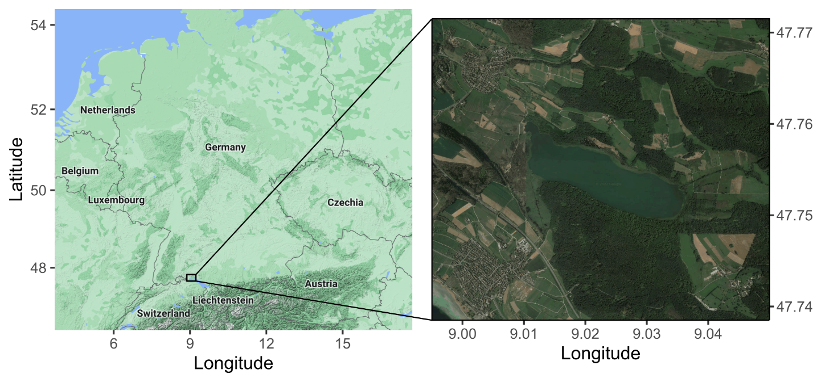Fig. 1: Map of Germany (left) with study area located within the square box. Zoomed in satellite image of Lake Mindelsee (left). Both images were obtained from Google Maps and illustrated using R packages ggplot2 and ggmap (Kahle and Wickham, 2013).
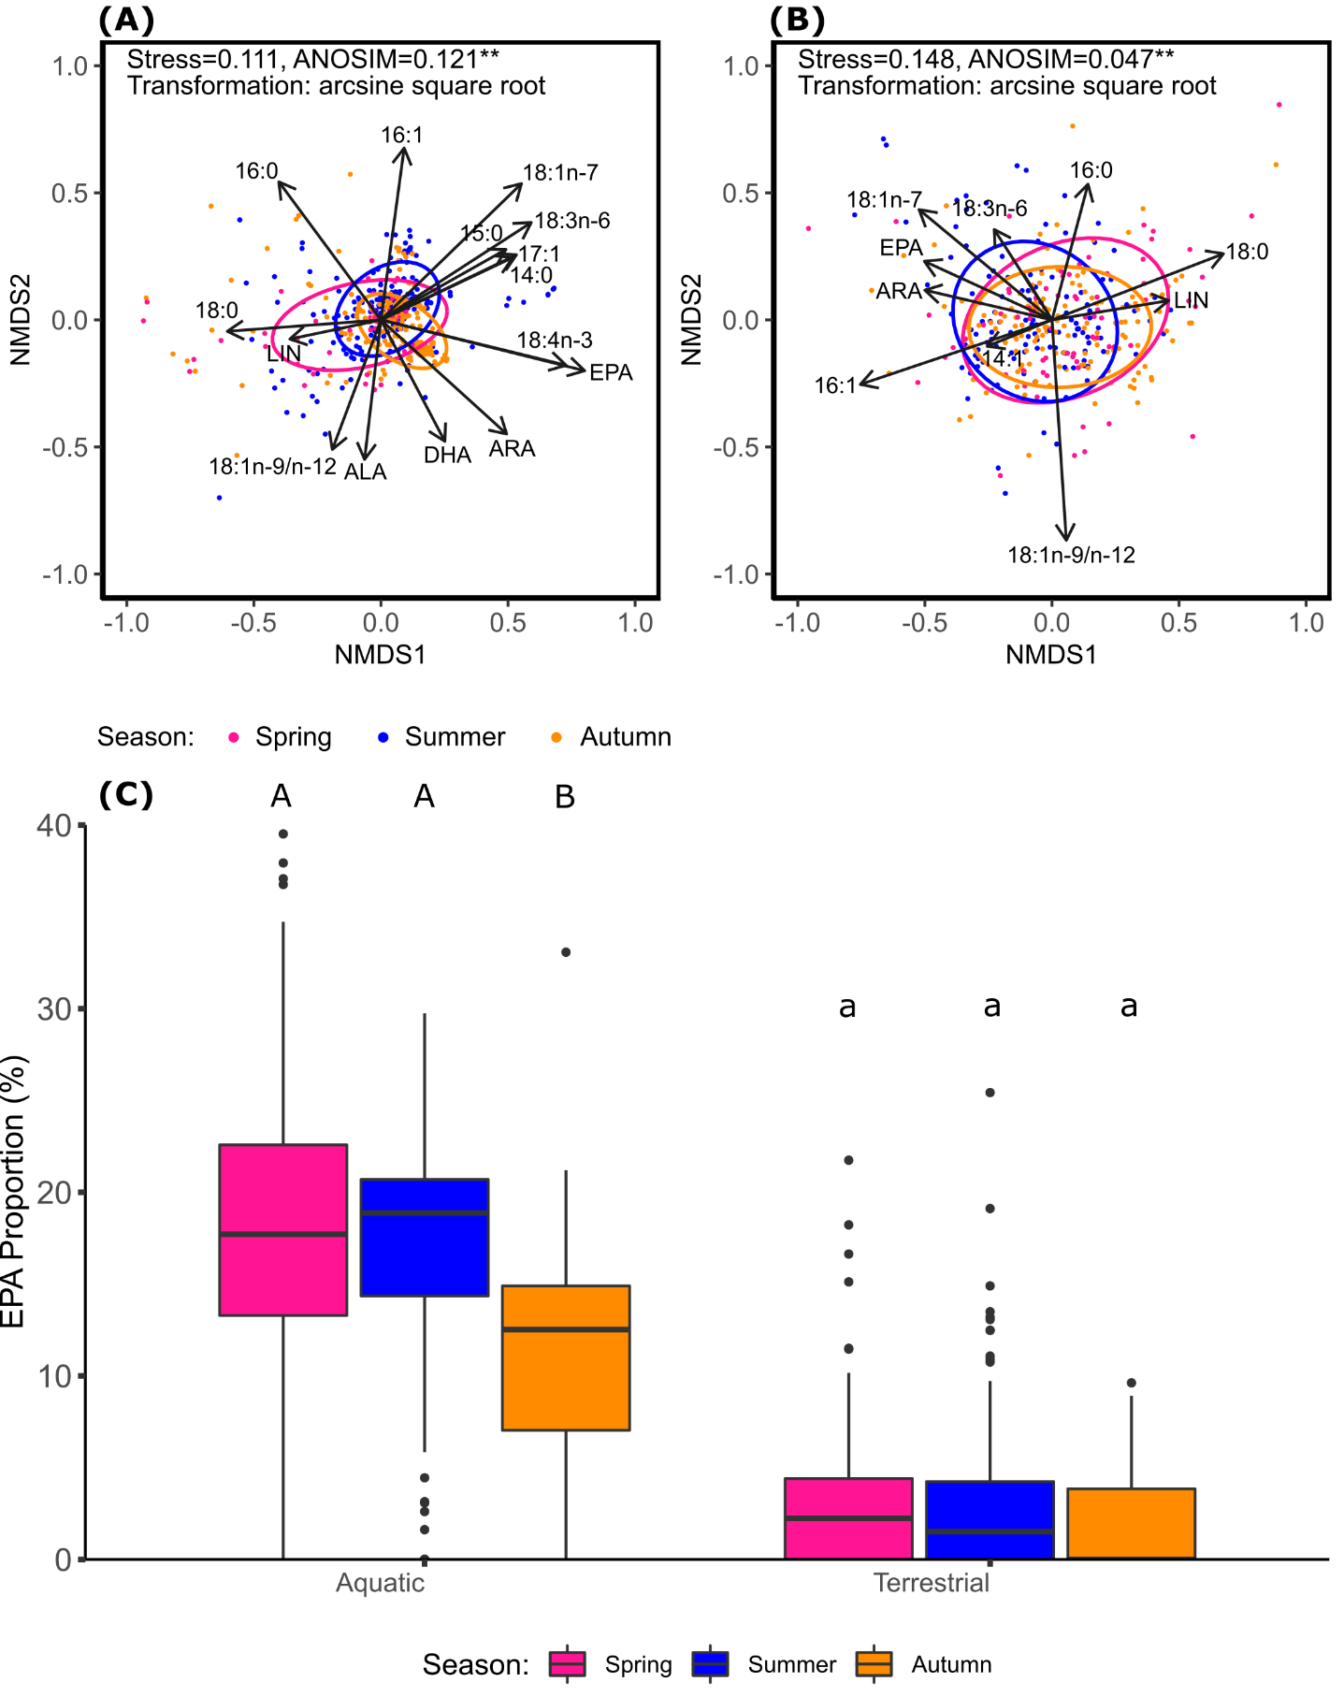
Fig. 2: Non-metric multidimensional scaling (NMDS) of arcsine-square-root-transformed fatty acid fractions (% of total fatty acids) of (A) aquatic and (B) terrestrial insects for each sampling season: spring (April, May), summer (June, July, August) and autumn (September and October). Vectors represent fatty acids that had a significant regression value (p < 0.001) and a vector length of 0.33 or greater. Ellipses represent 75 % confidence intervals. Stars represent significant p values for ANOSIM analysis: p > 0.01 (“*”), p > 0.001 (“**”), p > 0.0001 (“***”). Multivariate comparisons of within-group FA profile similarity revealed, less pronounced, but significant separation between aquatic (ANOSIM: R = 0.097, p < 0.001) and terrestrial insects (ANOSIM: R = 0.029, p < 0.01) sampled in different months. (C) Mean EPA proportions of aquatic and terrestrial insects collected in spring (April, May), summer (June, July, August), and autumn (September and October). The box represents the first quartile to the third quartile with a line representing the median value, and the whiskers represent the minimum and maximum value. Different letters above boxes represent statistically significant groups as determined by Pairwise Wilcoxon Rank Sum comparisons; aquatic and terrestrial insects were analyzed separately (upper case and lowercase letters, respectively).
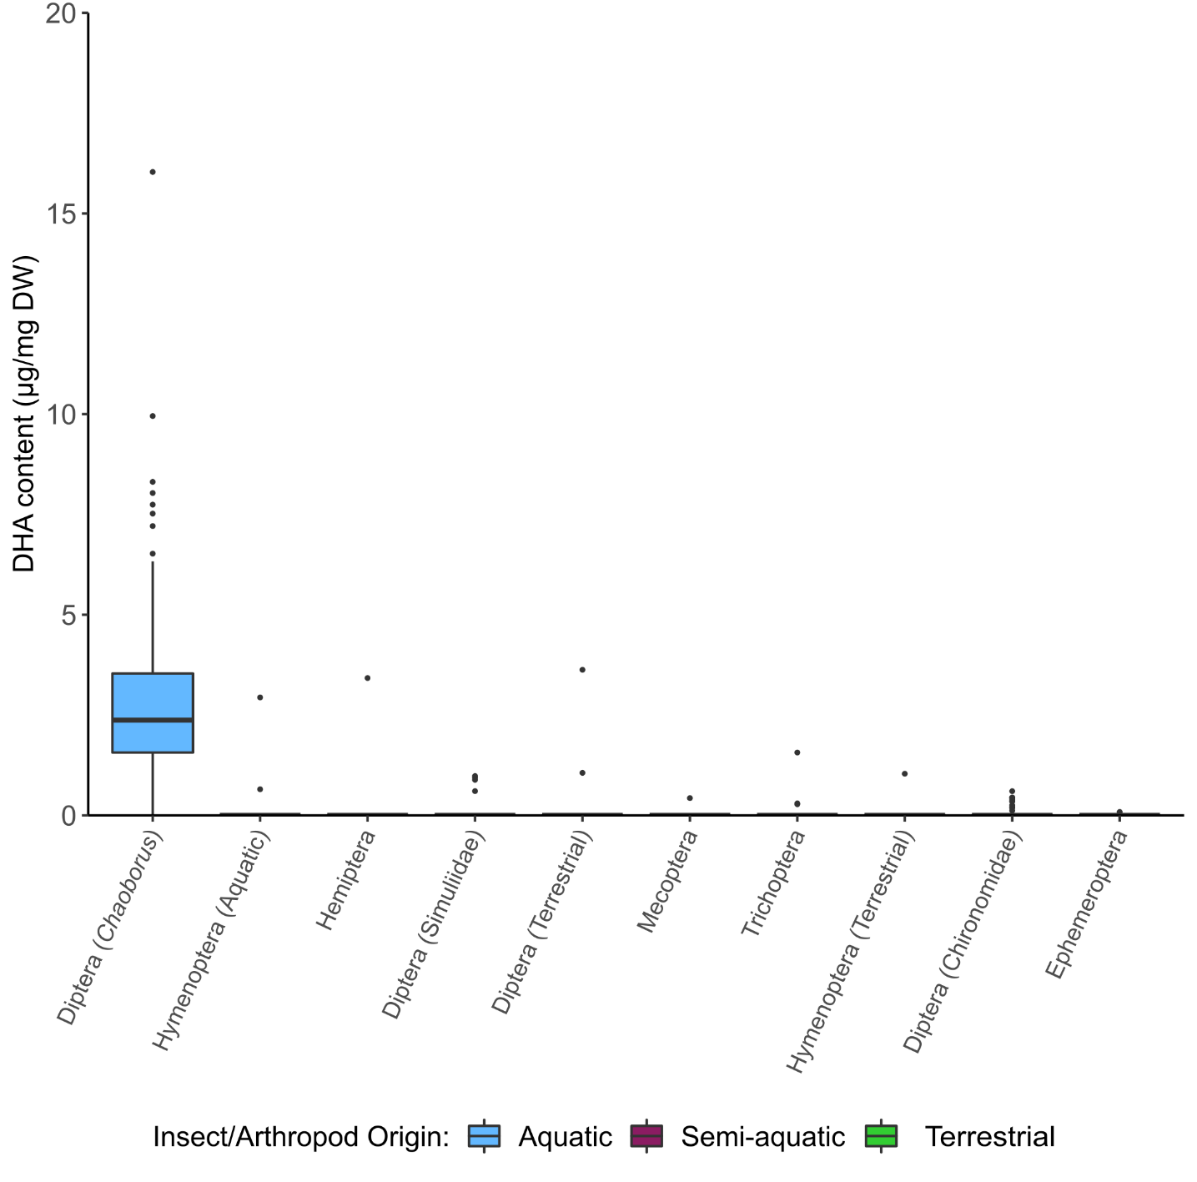
Fig. 3: DHA content of aquatic, semi-aquatic, and terrestrial arthropod orders. The box represents the first quartile to the third quartile with a line representing the median value, and the whiskers represent the minimum and maximum value. Only taxa with DHA content were presented.

References
Kahle, D. J., and Wickham, H. (2013). ggmap: spatial visualization with ggplot2. R J. 5, 144.

