Supplementary Material

Supplementary Figure S1. Meteorological conditions at Bastia Airport weather station over the period 1950-2021: annual cumulative rainfall (histogram, scale on the left, mm) and annual mean air temperature (dark line, scale on the right, °C; with linear trend (dashed dark line)). MK test highlighted a significant increasing trend in annual mean air temperature on the overall period (1950-2021) (p value < 0.001, Sen’s Slope = 0.025), indicating a temperature rise of more than 1.7 °C between 1950 and 2020.

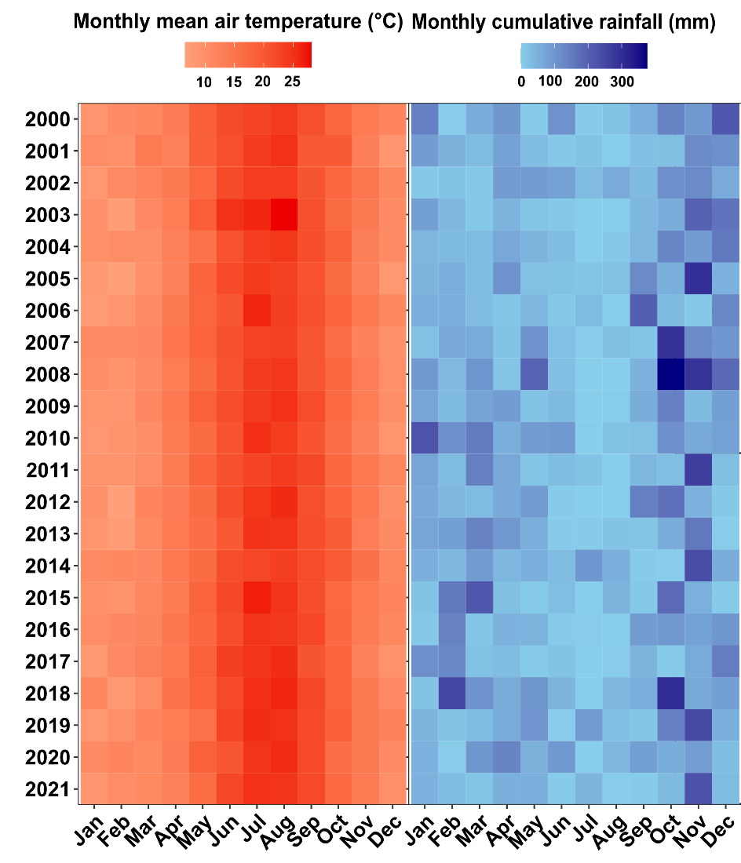

Supplementary Figure S2. Meteorological conditions at Bastia Airport weather station on monthly basis over the period 2000-2021: heat maps of monthly cumulative rainfall (mm) and of monthly mean air temperature (°C).

