*A)* Traditional *(regional) model*

model{

# likelihood

for(i in 1:n.fine){

logit(psi.fine[i]) <- alpha.fine + inprod(beta.1[1:Nvar.fine], X.fine[i,]) +

inprod(beta.1[(Nvar.fine+1):(Nvar.fine*2)], pow(X.fine[i,], 2))

Y.fine[i] ~ dbern(psi.fine[i])

}

# priors

     alpha.fine ~ dnorm(0,0.1)

for(j in 1:(Nvar.fine*2)) {

beta.1[j] ~ dnorm(0, prec.beta[j])

prec.beta[j] <- (lambda2/var.beta)*(tau.beta[j]/(tau.beta[j]-1))

tau.beta[j] ~ dgamma(gam.alpha, gam.beta)T(1,)

    }

lambda1 ~ dt(0,1,1)T(0,)

lambda2 ~ dt(0,1,1)T(0,)

sd.beta ~ dunif(0,10)

var.beta <- pow(sd.beta, 2)

gam.alpha <- 2

gam.beta <- pow((8 * lambda2 * var.beta)*pow(lambda1, 2), -1)

}

*B) Data-pooling model*

model{

### Likelihood

     for(i in 1:n.coarse){

Y.coarse[i] ~ dbern(psi.coarse[i])

logit(psi.coarse[i]) <- alpha.coarse + inprod(beta.1[1:(Nvar.fine-delta.var)], X.coarse[i,]) +

inprod(beta.1[(Nvar.fine+1):((Nvar.fine*2)-delta.var)], pow(X.coarse[i,], 2))

     }

for(i in 1:n.fine){

Y.fine[i] ~ dbern(psi.fine[i])

         logit(psi.fine[i]) <- alpha.fine +  inprod(beta.1[1:Nvar.fine], X.fine[i,]) +

inprod(beta.1[(Nvar.fine+1):(Nvar.fine*2)], pow(X.fine[i,], 2))

     }

     ### Priors

alpha.fine ~ dnorm(0,0.1)

alpha.coarse ~ dnorm(0,0.1)

for(j in 1:(Nvar.fine*2)) {

beta.1[j] ~ dnorm(0, prec.beta[j])

prec.beta[j] <- (lambda2/var.beta)*(tau.beta[j]/(tau.beta[j]-1))

tau.beta[j] ~ dgamma(gam.alpha, gam.beta)T(1,)

     }

lambda1 ~ dt(0,1,1)T(0,)

lambda2 ~ dt(0,1,1)T(0,)

sd.beta ~ dunif(0,10)

var.beta <- pow(sd.beta, 2)

gam.alpha <- 2

gam.beta <- pow((8 * lambda2 * var.beta)*pow(lambda1, 2), -1)

}

*C) Downscaling model*

model{

### likelihood

# absences:

for(i in 1:N0.coarse){Y.coarse[id0.coarse[i]] ~ dbern(psi.coarse0[id0.coarse[i]])}

# presences:

for(i in 1:N1.coarse){Y.coarse[id1.coarse[i]] ~ dbern(psi.coarse1[id1.coarse[i]])}

for(i in 1:n.coarse){

logit(psi.fine1[i]) <- alpha.fine + inprod(beta.1[1:(Nvar.fine-delta.var)], X.coarse[i,]) +

inprod(beta.1[(Nvar.fine+1):((Nvar.fine*2)-delta.var)], pow(X.coarse[i,], 2))

p.abs.fine[i] <- 1 - psi.fine1[i]

psi.coarse0[i] <- pow(psi.fine1[i] , (1-prev.coarse))

psi.coarse1[i] <- 1 - pow(p.abs.fine[i], prev.coarse)

     }

for(i in 1:n.fine){

logit(psi.fine[i]) <- alpha.fine + inprod(beta.1[1:Nvar.fine], X.fine[i,]) +

inprod(beta.1[(Nvar.fine+1):(Nvar.fine*2)], pow(X.fine[i,], 2))

Y.fine[i] ~ dbern(psi.fine[i])

}

    ### priors

     alpha.fine ~ dnorm(0,0.1)

for(j in 1:(Nvar.fine*2)) {

beta.1[j] ~ dnorm(0, prec.beta[j])

prec.beta[j] <- (lambda2/var.beta)*(tau.beta[j]/(tau.beta[j]-1))

tau.beta[j] ~ dgamma(gam.alpha, gam.beta)T(1,)

     }

lambda1 ~ dt(0,1,1)T(0,)

lambda2 ~ dt(0,1,1)T(0,)

sd.beta ~ dunif(0,10)

var.beta <- pow(sd.beta, 2)

gam.alpha <- 2

gam.beta <- pow((8 * lambda2 * var.beta)*pow(lambda1, 2), -1)

}

**Figure S1.** JAGS model codes.

**Supplementary results**



**Table S1.** Average predicted range changes (± SD) for each individual species under the three different models. Blue colors indicate a future increase in the species’ range whereas red colors indicate a future decline.

**(A)**

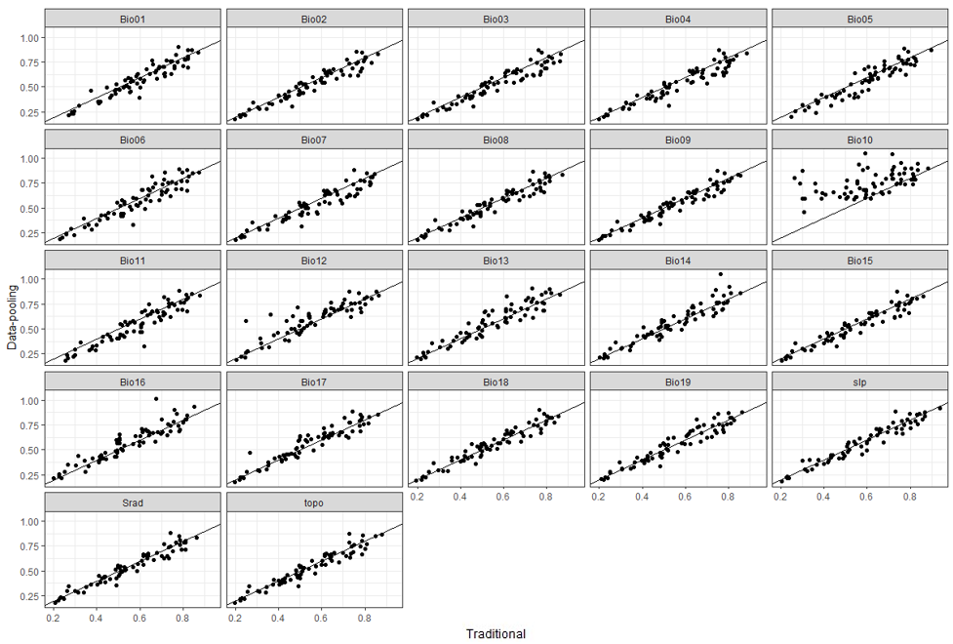

**(B)**

**(C)**

**Figure S2.** Comparison of the estimated variable contribution between (A) the traditional model and the data-pooling model, (B) the traditional model and the downscaling model and (C) the data-pooling model and the downscaling model.

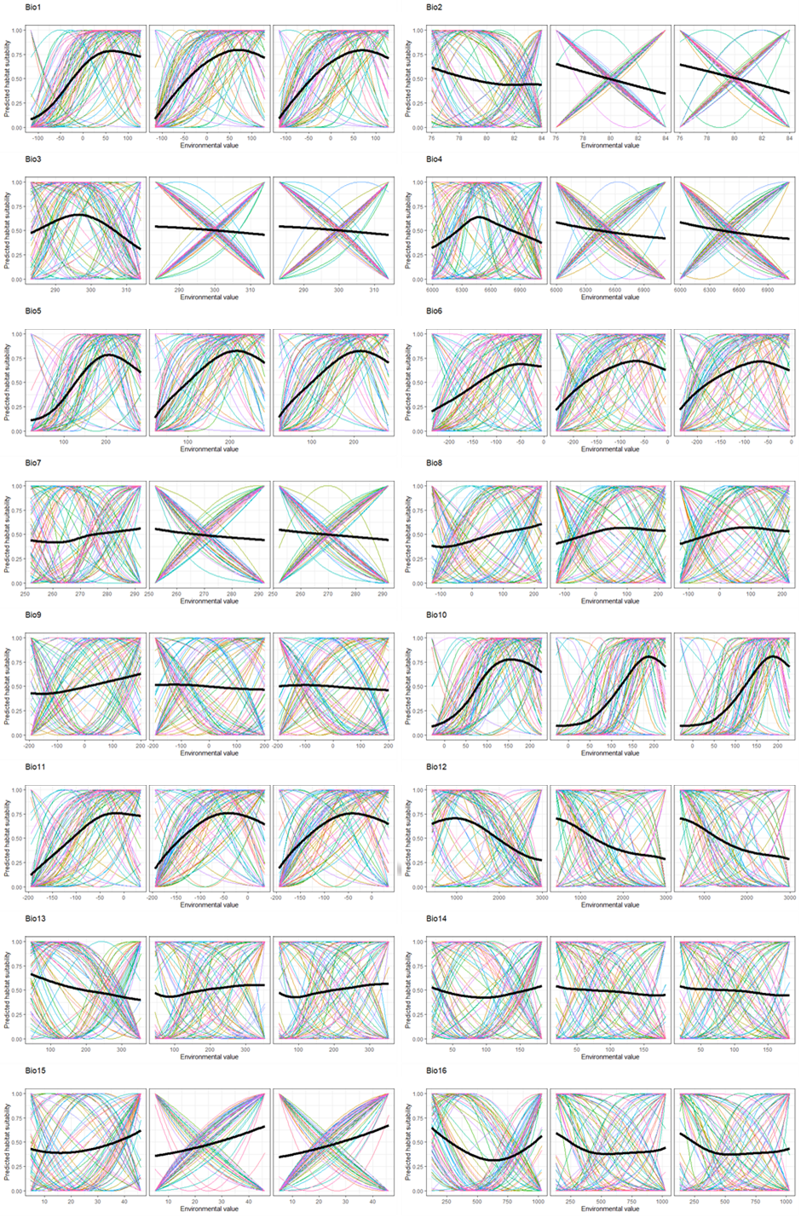



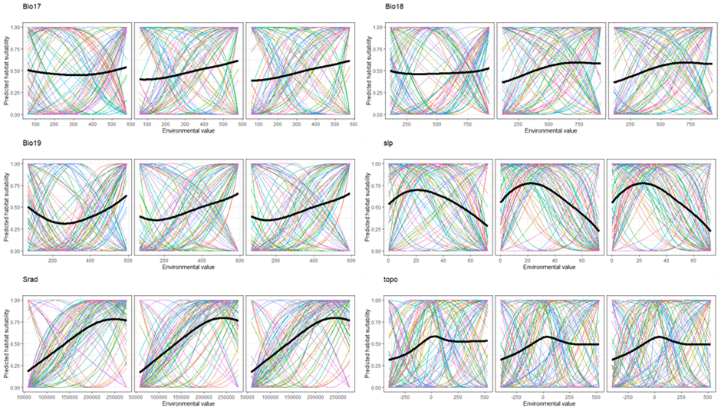

**Figure S3.** Estimated response curves for all climatic (19 bioclimatic variables) and topographic variables (slp, srad, topo) by the traditional (first column), the data-pooling (second column) and downscaling (third column) models. Colors show the response curve for each individual species while the black line represents the average response curve across all species.

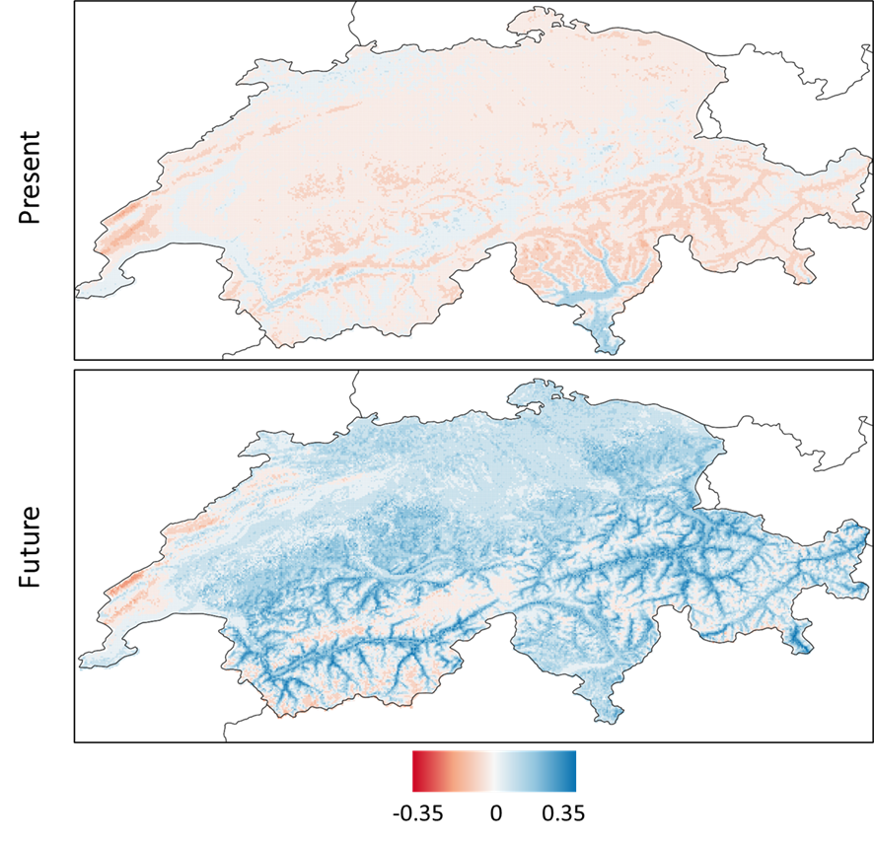

**Figure S4.** Difference between the data-pooling and the traditional models regarding the predicted suitability (averaged across species) under current and future environmental conditions. Negative values (red areas) refer to higher suitability predicted by the traditional model compared to the data-pooling model (similar results were obtained with the downscaling model), while positive values (blue areas) mean the opposite, and values close to 0 (white areas) imply similar predictions by both models.

Determinants of differences between models based on predicted suitability changes

In the main document, we present the effect of several factors on differences between models regarding the predicted range changes. Here, we present similar results regarding predicted changes in suitability values.

Similar to what is shown in the main text, differences between models were not related to the degree of niche overlap (rho=-0.13; p>0.24), the difference in niche size (rho=0.16; p=0.15), the difference in the range of conditions occupied by species either globally (rho=0.11; p=0.30) or regarding minimum (rho=0.8; p=0.44) and maximum (rho=0.04; p=0.44) values, the difference between the number of presences (rho=0.21; p=0.06) or absences (rho=-0.09; p=0.40). Similar to the main text, we still found a marginal significant effect the degree of global extrapolation (rho=-0.28; p=0.05) as well as a negative effect of the proportion of the species range covered by the regional dataset (rho=-0.28; p=0.01) and a positive effect of the difference in species prevalence (rho=0.28; p=0.01). In contrast to results in the main text, we no longer found an effect of MESSw when values are averaged over absences (rho=-0.04; p=0.84).

These reported effects also varied depending on whether the difference between models was negative (more pessimistic predictions of the traditional model) or positive (more optimistic predictions of the traditional model). Specifically, none of the factors had an effect on differences between models when it was negative whereas when differences are positive, the degree of global extrapolation (rho=0.37; p=0.03) and to a lower extent the difference in species prevalence (rho=0.3; p=0.08) and the proportion of geographic range covered (rho=-0.29; p=0.09) still had an effect.

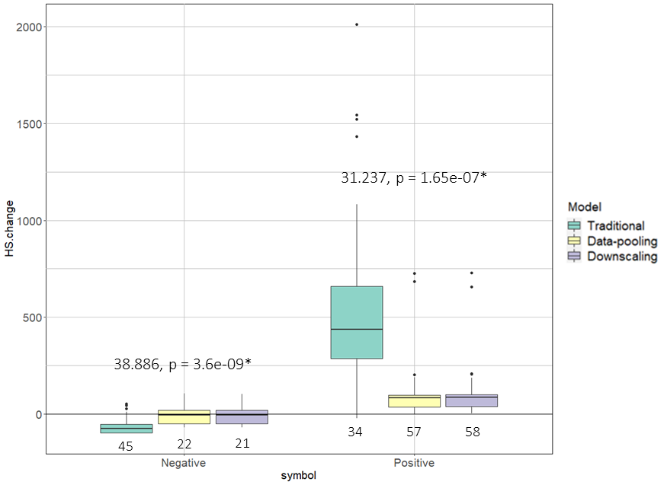

**Figure S5.** Boxplots representing the distribution of the predicted suitability changes (median of posterior distribution) under climate change for all bird species under the three models (traditional, data-pooling, downscaling). To better reflect differences between models, we considered separately losses (negative values) and gains (positive values). For each group the Kruskall-Wallis statistic and its associated p-value are shown, with “*” marking significant differences between models. Below each box we also show the number of species (sample size) predicted to reduce (negative) or increase (positive) their suitability range.

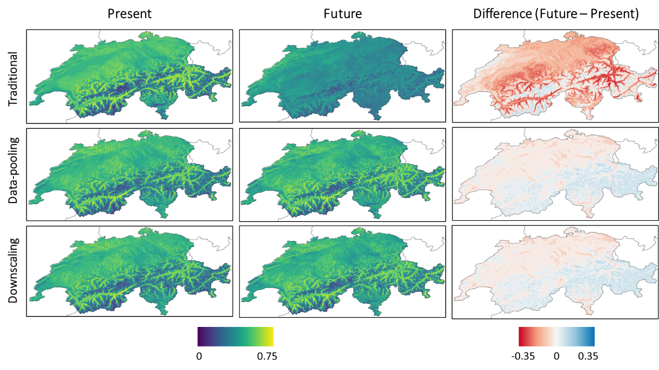

**Figure S6.** Spatial representation of average suitability values predicted under current and future environmental conditions for all 1-km pixels over Switzerland or all bird species, along with the difference between them for the three considered models.