Global Biogeochemical Cycles
Supporting Information for
The Deep Ocean’s Carbon Exhaust
Haidi Chen¹, F. Alexander Haumann^{1*}, Lynne D. Talley², Kenneth S. Johnson³, and Jorge L. Sarmiento¹
¹Atmospheric and Oceanic Sciences Program, Princeton University, Princeton, NJ, USA.
²Scripps Institution of Oceanography, University of California, San Diego, La Jolla, California, USA.
³Monterey Bay Aquarium Research Institute, Moss Landing, California, USA
*Corresponding author: F. Alexander Haumann (alexander.haumann@gmail.com)

Contents of this file

Figures S1

Introduction
This Supporting Information includes Figure S1. It shows a sensitivity test of the estimated soft-tissue pump potential partial pressure of carbon-dioxide (∆PCO₂^{soft}) and residual ∆PCO₂ (∆PCO₂^{res}) in the Pacific basin to different phosphate (PO₄) reference values used in the calculation.

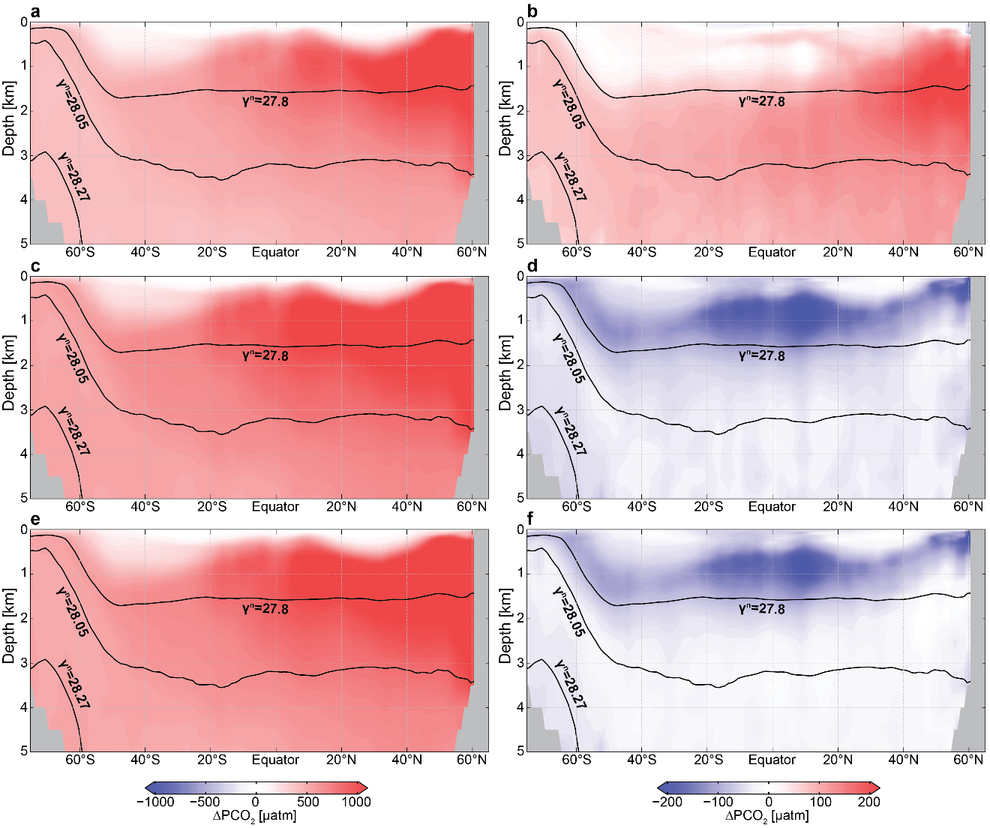

Figure S1. Sensitivity of the calculated zonal mean ∆PCO₂^{soft} (a, c, e) and ∆PCO₂^{res} (b,d,f) in the Pacific basin to different PO₄ reference values. a,b, ∆PCO₂ using the mean present day surface PO₄ reference value of 0.47 µmol kg⁻¹. c,d, ∆PCO₂ using the PO₄ reference value of 0.07 µmol kg⁻¹ used by Gruber & Sarmiento (2002). e,f, ∆PCO₂ using the PO₄ reference value of 0.1 µmol kg⁻¹ used in this study.

References
Gruber, N., & Sarmiento, J. L. (2002). Large-scale biogeochemical–physical interactions in elemental cycles. Biological–Physical Interactions in the Sea, A. R. Robinson, J. J. McCarthy, and B. J. Rothschild, Eds., The Sea: Ideas and Observations on Progress in the Study of the Seas, Vol. 12, John Wiley & Sons, 337–399.

