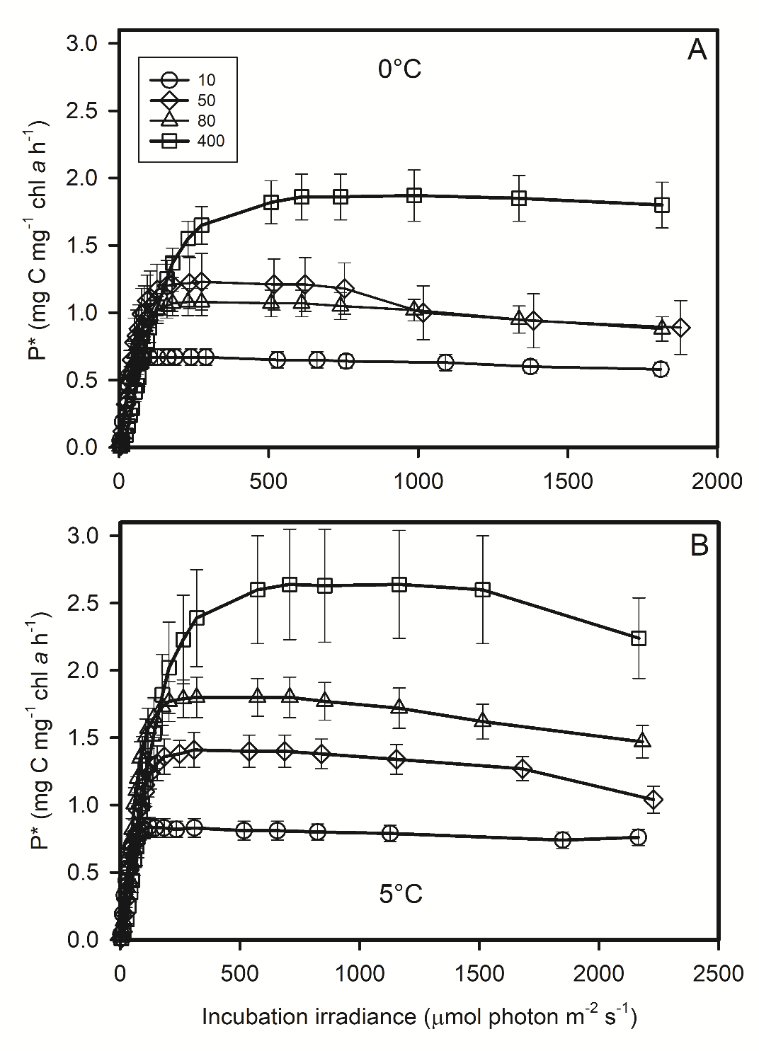
Figure S4: Photoacclimation of carbon fixation. Carbon fixation rate in cell acclimated to 10, 50, 80 and 400 µmol photon m⁻² s⁻¹ versus incubation irradiance at 0°C (A) and 5°C (B). Each data point is the mean of 3 cultures measured each day during 3 consecutive days (50, 80, 400 µmol quanta m⁻² s⁻¹) or 2 days (10 µmol quanta m⁻² s⁻¹). Error bars represent standard deviations.

