**SUPPLEMENTARY MATERIALS**

**Towards a better future for biodiversity and people: modelling Nature Futures**

**Appendix A. Participants’ perspectives on the application of Nature Futures Framework in scenarios and modelling** (Source: 2019 Vancouver Stakeholder Workshop (PBL, 2019a))

This Appendix presents the responses to the two questions asked to the participants[1] of the Stakeholder Workshop “From visions to scenarios for nature and nature’s contributions to people for the 21st century” on the new scenarios needed and important dynamics, variables, processes, feedbacks, or drivers that should be represented in them.

***Question 1.*** *Based on your understanding of the Nature Future Framework, what new Nature Futures scenarios are needed (thinking especially of the ecosystem or area where you work, if applicable)?*

***Question 2.*** *What are the most important dynamics, variables, processes, feedbacks or drivers that should be included in the next generation of scenarios, but are not well represented in existing scenarios?*

***Responses***

* + Scenarios that explicitly consider indigenous and other ways of knowing
  + How to overcome structural inequalities and power differentials to accommodate diversity and difference. Different ways of thinking about people, nature, and how they fit together (e.g. "Walking backwards into the future").
  + Scenarios that allow for positive biodiversity options beyond ‘protected areas’, i.e., non-binary - e.g., better sustainable management
  + Non-quantitative social and cultural ecosystem services (and societal and cultural values) - how do we model the things that we cannot quantify
  + Scenarios that engage with business and industry interests and rights in ways that promote different ways of doing economy. Grounding work in practice and economy crucial for sustainability but usually not very well represented in scenarios
  + Reconcile scale mismatches – especially across governance and biophysical regimes
  + Shared Socio-economic Pathways (SSPs) and marine environment - how different ocean management can help us achieve different dimensions of ocean sustainability
  + People interactions with oceans at regional and global scales besides fishing (e.g., pollution, recreational activities); Interaction of climate change and oceans dynamics beyond fishing (also marina pollution, deep sea fishing, recreation); Differences among regions, ways of living; Inclusion of idiosyncratic ways of living among regions
  + How changes in people's behaviour could change ocean dynamics (further research) and how changes in people’s experience of nature change nature (next few years).
  + Scenarios that incorporate the impact of knowledge/ignorance of nature, including e.g. loss/revival of traditional knowledge; scenarios that incorporate impact of knowledge, biodiversity literacy as educational priority, feedbacks for health and nutrition, public engagement through citizen science, conservation volunteering > awareness/consciousness > mainstreaming as a political issue, culture of data/information sharing > improved science to inform nature-friendly policies. How culture of data sharing can improve production of science itself.
  + Species-focused scenarios that include dynamics of ecosystems and human interactions, evolving conservation strategy, proxies to human wellbeing.
  + Complex scenarios that address impact of invasive species on ecosystems and integrated to broader social-ecological scenarios.
  + Scenarios that incorporate nature conservation goals and sectoral development (especially, agriculture).
  + Interaction with human impact and desired transformation of human relations with nature. *(How human can transform relations with nature in order to significantly reduce negative impact)*
  + "Nature for nature": Rewilding and novel Anthropocene ecosystems: need to incorporate what nature could be (not just humans doing things with/to nature or not).
  + What kind of nature do we want? - learning from the past and bringing back wildness for the animals and for people in the context of the Anthropocene
  + Pluralism context - Different phases in “Policy Cycle” require different types of models & scenarios but tool development heavily biased towards ‘decisions’; let people who think differently about the world engage in the process, not simply focused on "decisions" (e.g., including co-management).
  + Types of motivations (individual and institutional) to pursue specific types of behaviour, policies, etc. related to nature, ecosystems and biodiversity; Values underpinning decision-making processes; Link to value considerations in other IPBES processes
  + Formation of the prevailing nature-related discourses due to the changes in business strategies, public opinion and the influence of opinion-makers. Influence of these discourses on indirect drivers of nature and NCP/ES change (culture, policy, diets, ...)
  + Blue justice (and critical engagement with the sea as a humankind common heritage); range shifts of species, communities, fleets;
  + Inclusion of fishing communities’ ways of resilience, adaptation, nature conservation x industrial use of coastal and riverine zones in scenarios; different types of dependency on the natural resources; application of different governance strategies for BBNJ (and deep seabed); Incorporation of good fisheries management within EEZ (economic exclusive zones)
  + Climate change; Gender, inequality
  + Scenarios that explicitly address degrowth paradigm which can be defined as “‘an equitable downscaling of production and consumption that increases human well-being and enhances ecological conditions at the local and global level, in the short and long term’’ (Schneider et al. 2010:512).
  + Scenarios that explicitly address depopulation and shrinking (compacting) cities and their impacts on NCP and human wellbeing (Aging and depopulation in rural areas; Feedback between land and ocean through nutrient and material flow incl. Pollution; Mental health and greenspace; cross cutting points: multiple-feedbacks (incl. combined feedback)).
  + Scenarios explicitly addressing the linkages between peoples’ relationship with nature and how they value nature - and nature outcomes such as how changes in land-use and migration reshape peoples’ interactions with nature (e.g. urbanisation, intensification of land (water) use, migration to new landscapes)
  + Scenarios exploring peoples’ emotional relation to the ‘products’ of nature; the degree of materialism/consumerism across generations, socio-economic classes and value traditions and what dynamics this creates over space and time.
  + Direct experiences with nature on human well-being and their feedback on value frameworks for nature; Investment in and access to education in general and environmental education in particular. Rise of populist parties, xenophobia, nationalism, lack of trust in science, human rights violations such as civic freedoms related to likelihood for pro-nature policies
  + In my country the vision of “Vivir bien” has been emphasised, but this concept has not been made concrete in models or scenarios. The scenarios needed are those that measure the resilient capacity of cultures, integrate indigenous and local knowledge with scientific knowledge, address the effect of change of indigenous and local knowledge, and those that can be applied to policies affecting biodiversity and ecosystem functions in real and inclusive terms.
  + These new scenarios should cover how inequality in land ownership shapes land use dynamics, including the opportunities generated for good use. They should illustrate how public policy generation and economic interests affect the resilience of local communities and society at large. They should cover transitions of realities without generalizing them and incorporate changes especially in socioeconomic terms.
  + New scenarios should explicitly address revenue/earning models reshaping how chain parties interact with nature. They should address pollution by agrochemicals (pesticides, fertilizers) and show how this affects biodiversity. They should also address improvements/investments in (nature) education and technological development, as well as the role of nature education in people's experience of nature and how these change over time. We also need scenarios that address the extent to which all parties (government, chain-parties, financers, landlords etc.) facilitate, stimulate, value, and reward land-users to stimulate nature/biodiversity.
  + The new scenarios should cover how pollution/agrochemicals impact biodiversity (i.e. life in soil, water natural pest control, and pollination) in terms of volume of pesticides and level of hazard. They should also indicate how changes in nature education impact people’s experience of nature change, as well as how activities in the open space outside the city (infrastructure, inland waterways, energy projects, recreation, industrial) shapes biodiversity.
  + It is tricky to answer the question of how to incorporate different regional and temporal scales, so this requires discussions. We need scenarios that incorporate cross-domain (land / sea) impacts and threats – including those that address some scale mismatches across those two spheres of work. We would also need new scenarios that explicitly address socio-ecological responses to cumulative impacts (different scales, over time, and multiple stressors) - e.g., sedimentation.
  + We need scenarios that include land-sea interactions, such as demand for food production. For example, with a future decline in agricultural production, can the demand be covered by food production in oceans and coastal areas?
  + New scenarios should measure how activities on land impact the sea life (i.e. sediment, plastic, and nutrients), and how ocean governance and international trade impact fishing patterns.
  + We need scenarios that look at the interactive impact of climate change and biodiversity either of biophysical and atmospheric effect on societies, or the impact of climate mitigation and adaptation on biodiversity – as an attempt to link two systems of models to better inform policy decisions. We also need scenarios that look at the impact of large scale collective actions (e.g. diet/consumption change), and national decisions (e.g. large scale restoration) on what is perceived to have the potential to bend the curve on biodiversity and climate change (e.g. scaling up positive seeds of Anthropocene) – scenarios and models that decision makers can understand and take to their world in governments, businesses, etc.
  + New scenarios should cover the impact of collective human actions on biodiversity change, identify specific targets on indirect drivers that countries can act upon, and show the cost of implementing policy decisions or conservation interventions.
  + We need scenarios incorporating as indirect drivers the key global economic trends and implications for nature at regional / local scales. This would cover trade, financing, foreign direct investments, equity considerations, and linkages between nature and cultural / language diversity.
  + Examples of variables related to global economic trends are: Macroeconomic trends (GDP growth and structure), international Trade (Commodity prices / terms of trade / export value & volume), Financing (Total debt / % of GDP / % of exports), and Foreign Direct Investments (Total FDI / Structure).
  + Nature as Culture would show a strengthening of cultural traditions, with people going back to traditional land management and agricultural practices. In Nature for Society/People, people move to multi-functional ways of managing the landscape, with a lot of emphasis on regulating services, but also other ecosystem services. In Nature for Nature, there will be rewilding, with forest and wildlife coming back. We need to imagine these nature futures for different landscapes and what they would mean at global level, national level and for different sectors, and link them to local biodiversity models as models used for different scales are not the same. At the global level Integrated Assessment Models, but at local level, we would need local ecosystem models and knowledge.
  + There seems to be a tension between diverse values and how the scenarios are discussed, caused by wanting to quantify everything. We need to focus on scenarios that have nature as a being with which we interact, rather than nature as an object being used. Difficulty identifying places where humans have positive influence on nature, so need to uplift examples of that (People’s contributions to nature rather than just nature’s contributions to people). Focus on food in cities is great as it is often underrepresented, but we should also address overall consumption of materials.
  + New scenarios would need to respect and illustrate diverse ways of relating to nature, rather than having a quantitative and report-based focus. Ecological Footprinting could be replaced with Eco shed. It would also need to cover co-nurturing and interdependence, and positive impacts from humans to nature, including areas of stewardship rather than “protection” or “preservation”.
  + We need new scenarios that address how people’s specific daily actions can directly improve the outcome for biodiversity and nature, and overcome the current disconnect between people’s daily actions and the environment. Scenarios should also address how Indigenous knowledge can be included in a meaningful way and highlight how leaving nature (habitat) intact can have co-benefits for climate change reduction.
  + The new scenarios should measure how activities by urbanites can impact biodiversity and identify what are the main drivers/ motivation for taking action. They should also cover the feedback of how changes in environmental health affect human health, including psychological wellbeing, as well as how people value certain species or issues, and influence their outcome.
  + The new scenarios need to address freshwater biodiversity, as it is not well addressed, particularly in global scenarios. They should also cover invasive species, trade and trade agreements, and the interactions between biodiversity, ecosystem function and service. This is needed in order to move beyond ecosystem structure and function, and to show the role of biodiversity itself in maintaining ecosystem function in the face of uncertainty (e.g., resilience - option and insurance value).
  + I would like to know how these new nature future scenarios will align with the new generation of scenarios representing integrated pathways to the SDGs and beyond (in the TWI2050 and other contexts). I see these nature futures perspectives as kind of “archetypes” beyond Global and Regional Sustainability, beyond the SSP1 single narrative. We would need new scenarios that explicitly deal with how these three perspectives on nature affect human wellbeing. For instance: rural-urban interactions and inequality (half earth, urbanization, actors, jobs) under different perspectives of nature in considering different contexts.
  + The new scenarios should cover how inequality in land ownership (concentration) shapes land use dynamics and its impacts (on health, pesticides, etc), local/global interaction and feedbacks (market certifications affecting different actors, local policies, trade, agreements, land tenure regimes, etc.) in global models and in multi-scale scenarios.
  + How biodiversity is the base for ecosystem function and how it can be integrated over the long term & how it can be used to influence social policies; how to integrate BES in socio economic benefits in a way that we can use the function to influence social policies
  + We need scenarios that further explore how biodiversity is the base for ecosystem functioning, and how these processes and feedback can be integrated over the Long-term.
  + I consider important also to continue exploring how Biodiversity and Ecosystem Services have an underpinning role in socioeconomic development and human well-being, to Influence short and long-term policies aiming to the protection of nature.
  + 1) Transformative change (not only within the system, but also to alternative systems); 2) other big societal transitions (etc. populism / nationalism / politics; and digital transformations (AI, machine learning etc) influencing energy demands, employment etc.; 3) Cross cutting issues: gender, intersectionality.
  + Relationship of humans with technology
  + Cross-scale dynamics
  + Hybrid natures, technology that nature has, what does this look like in the future; complex dynamics, global narratives, post 2020 agenda.
  + We need scenarios that explicitly address how urbanism is reshaping how people interact with nature and shape regional and global dynamics.
  + We need conservative (cultural-historic identity, heritage, value - native biodiversity) AND progressive (dynamism, emergence, reorganization) nature futures scenarios.
  + Integrated, spatial heterogeneous, cross-scale scenarios
  + 1. Spread of invasive species - people's perceptions of "wild" versus biodiversity. 2. Assessing biocultural diversity (land as culture, culture as land). 3. Inequality and land ownership - look at failures of conservation and what can we learn from them (look beyond poverty as causes)
  + Relationship B and rewilding is important to understand; tolerance from behavioural point of view is great, attractive in large parks; commonality theories of nature than recognized, land is culture, culture is land; inequality and land ownership: need to look at failures of nature conservations (poverty), big losses have to do with conservation failure to deliver on promises to people, moving people out of parks etc. (3 challenges)
  + Rewilding in contrast with urbanisation
  + Rural areas with high cultural and natural heritages
  + Social, technical, economic innovations
  + Business strategies
  + Social inclusiveness
  + Methodological challenges arising from discussions with modellers
  + From SSPs, businesses as partners (not just ‘enemies’ of nature), role that oceans play, how indigenous knowledge is critical

**Appendix B. Identifying indicators for the three Nature Futures value perspectives**

This Appendix documents the tables of indicators drafted by the participants of the Stakeholder Workshop “From visions to scenarios for nature and nature’s contributions to people for the 21st century” and of the Modellers[2] Workshop ‘Global Modelling of Biodiversity and Ecosystem Services”, followed by additional tables conceptualized by the authors intersecting the NFF with the IPBES Conceptual Framework. The numbers in the table are the ranks or priorities of importance.

Source: 2019 Vancouver Stakeholder Workshop (PBL, 2019a)

|  |  |  |  |  |
| --- | --- | --- | --- | --- |
|  |  | **Nature for Nature** | **Nature for Society** | **Nature as Culture** |
| OCEAN | | | | |
| Management | Total sustainable catch |  | ↗ (1) |  |
|  | % fish from aquaculture |  |  |  |
|  | Level of management decision | Global |  | Local |
|  | Area with no-take marine protected area | ↗ (2) 30% |  |  |
|  | Area under community-based management |  |  | ↗ (3) |
| State | % fish stocks depleted | ↘(All stocks) | ↘(Commercial stocks) | ↘(Culturally important stocks) |
|  | % species endangered | ↘ (1) |  |  |
|  | Status of culturally important species | ↗ |  | ↗ (2) |
|  | Area of wetland & mangroves | ↗ (3) | ↗ |  |
| Benefit | Carbon sequestration |  | ↗ (2) |  |
|  | Dietary needs met |  |  |  |
|  | Number of jobs |  | ↗ (3) |  |
|  | Recreation in nature |  |  |  |
|  | Livelihoods |  |  | ↗ (1) |
|  | Social cohesion |  |  | ↗ |
| LAND | | | | |
| Management | Level of management decision | Global |  | Local |
|  | Area under community-based management |  |  | ↗ (1) |
|  | Area under rewilding | ↗ (2) |  |  |
|  | Wilderness protected area | ↗ (3) |  |  |
|  | Invasive species | ↘(4) |  |  |
| State | % endangered species | ↘ (1) | ↘ | ↘ |
|  | Status of culturally important species |  |  | ↗ (2) |
| Impact | Clean water |  | ↗ (1) |  |
|  | Carbon sequestration |  | ↗ |  |
|  | Soil protection |  | ↗ |  |
|  | Pollination |  | ↗ |  |
|  | Timber provision |  | ↗ |  |
|  | Local crops and breeds |  |  | ↗ (3) |
|  | Sustainable bushmeat |  |  | ↗ (4) |
|  | Dietary needs met | ↗ | ↗ | ↗ |
|  | Number of jobs (ecotourism, agriculture, recreation) |  | ↗ (2) |  |
|  | Recreation in nature |  | ↗ (3) |  |
| URBAN | | | | |
| Drivers | Density of city | High (1) |  | Low |
|  | % of people in cities | High (2) | Medium – High | Low |
|  | Distribution of city SAD? | Medium | Medium | Small |
|  | Remote responsibility | ↗ ↗ ↗ |  |  |
|  | Green spaces that are self-sustained | ↗ |  |  |
| Pressure | Air quality regulation | ↗ | ↗ (1) |  |
|  | Water quality regulation (waste water management) | ↗ | ↗ (2) |  |
|  | Community gardening |  |  | ↗ (2) |
|  | Urban gardening |  | ↗ |  |
|  | Green roofs / nature-based solution |  | ↗ |  |
|  | Level of management decision | Global |  | Local |
| State | Species richness (no-take species) | ↗ |  |  |
|  | Status of culturally important species |  |  | ↗ |
|  | Area of green spaces | ↗ Natural green spaces | ↗ Functioning green spaces (3) | ↗ Cultural green spaces |
| Impact | Number hours commute | ↘ | ↘ | ↘↘↘ |
|  | Mode of commute | Mass transportation, biking | | |
|  | Equity | ↗ | ↗ | ↗ |
|  | Mode of entry supply | Central | Renewable | Local |
|  | Accessibility to green areas | Good for large | Depends on function | Small green and close (1) |
|  | Hours of nature education | ↗ Biodiversity | ↗ ES | ↗ Bioculture |

Source: 2019 The Hague Modellers Workshop (PBL, 2019b)

|  |  |  |  |
| --- | --- | --- | --- |
|  | **Management** | **State** | **Benefit** |
| *Nature for Nature* | *Indicator: Protected areas*  Marine: WDPA - No take  Terrestrial: WDPA 1-3 | *Endangered sp. and habitat*  M: Endangered species, Coral reef cover  T: endangered sp., pristine forest, wetland extent  apex predators; megaherbivores; "trophic rewilding" | M: diving sites  T: wildlife watching |
| *Nature for Society* | *Sustainable use areas*  M: Mgmt effectiveness (country level)  T: WDPA 4-6 | M: % depleted stocks  T: CO2 sequestration, water purification, soil retention  nature-based solution | M: Sustainable fish catch  T: Ag production w/o erosion or water pollution, storm protection |
| *Nature as Culture* | *Comm-based mgmt*  M: Comm. Based mgmt (country reports)  T: WDPA Comm. Based Mgmt.  Do changes relate to the perceptions/values of the governing legal/government systems rather than of the people living in a particular location?  sacred forests?  indigenous land | *Cultural keystones*  M: status of culturally important species  T: status of culturally important species, cultural landscapes  social indicators; cultural support; such as cultural festivals  cultural landscape  certified food production - appellation  UNESCO world heritage sites*, maybe MABs and indigenous reserves, certain certifications* | *# Jobs (livelihoods?)*  M: number of jobs  T: local livelihoods  books; cultural roles; shaman; cultural activities  co-management; local control over nature; social-ecological feedbacks |

Source: Illustrative examples during the follow-on consultation post-workshops in drafting this paper





**Appendix C. Assessing a single policy using the Nature Futures Framework and indicators**

(Source: 2019 Vancouver Stakeholder Workshop (PBL, 2019a))

This Appendix documents the figures drafted by the participants of the Stakeholder Workshop “From visions to scenarios for nature and nature’s contributions to people for the 21st century” in assessing a single policy using the Nature Futures Framework with indicators on three themes “Species”, “Habitat/Landscape” and “Livelihood.

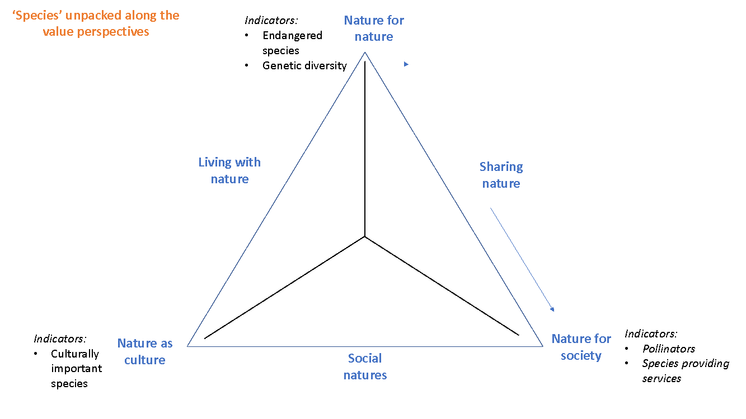

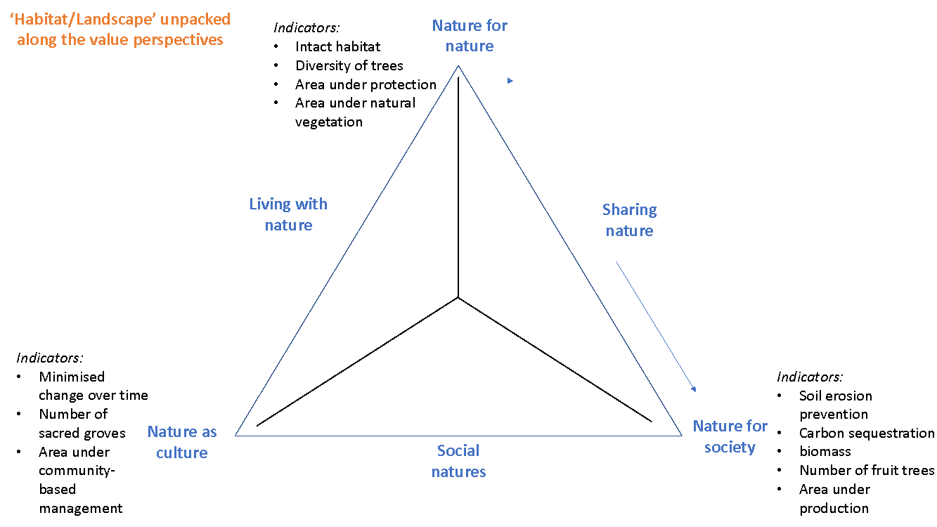

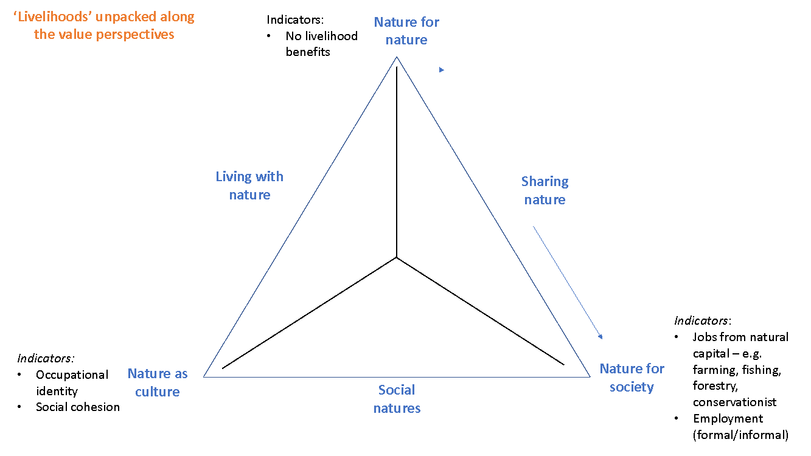

**Appendix D. Assessing a suite of policies using the Nature Futures Framework and models**

(Source: 2019 Vancouver Stakeholder Workshop (PBL, 2019a))

This Appendix presents the figures drafted by the participants of the Stakeholder Workshop “From visions to scenarios for nature and nature’s contributions to people for the 21st century” in illustrating the systems dynamic modelling for Nature Futures scenarios (first three) and additional draft figures conceptualized by the authors through iteration, intersecting the NFF with DPSIR and the IPBES Conceptual Framework.

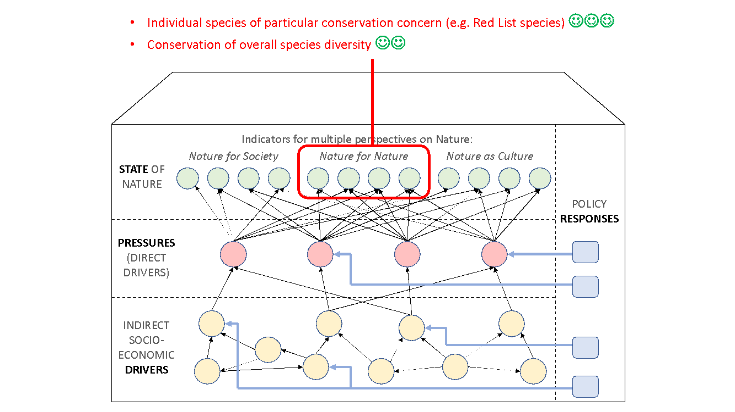

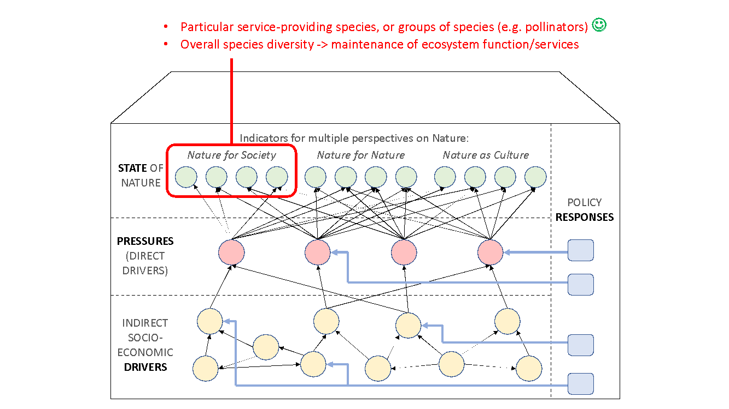

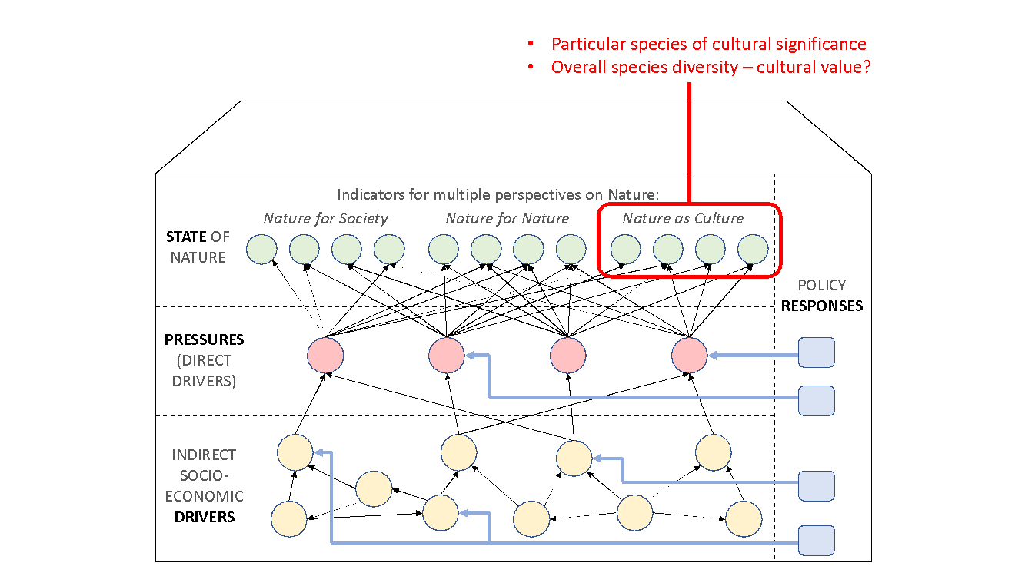

Source: Illustrative examples during the follow-on consultation post-workshops in drafting this paper







**Appendix E. Modellable questions for Nature Futures scenarios and their assessment on relevance, novelty and feasibility** (Source: 2019 The Hague Modellers Workshop (PBL, 2019b))

This Appendix presents key questions for the Nature Futures scenarios modelling conceptualized by the experts of the Modellers Workshop ‘Global Modelling of Biodiversity and Ecosystem Services” with an assessment on their relevance, novelty and feasibility with a view on the scale, models, and policy impact.

***Nature for Nature***

1. Under what social-economic context/governance/climate change mitigation would protected area and other area-based conservation measures improve biodiversity and impacts/trade-offs to society in the future?

* Under what conditions (consistent with SSPs, including transboundary cooperation) would ambitious area-based conservation targets be possible?
* How protecting 50% of biomes affects biodiversity and ecosystem services?
* What has been the impact of protected areas on larger landscape biodiversity and people?
* What are the non-terrestrial tools for future conservation?

Scale: Limit to global scale

Model: Available to address this question (model intercomparison using a suite of models looking at multiple dimensions of biodiversity)

Policy impact: CBD discussion of targets and goals

2. How would the restoration of abandoned agricultural landscape increase biodiversity and their implications for sustainable food and timber production elsewhere?

* How ecological corridors around human-managed systems improve biodiversity?

Scale: Global scale and larger regional case studies

Model: In principle, existing models are possible to address this question (vegetation cover/structure linking with species composition and biome shift)

Policy impact: Yes, particularly on restoration vs afforestation and nature-based solutions; also boundary of nature for nature.

3. Would climate change over-ride the positive effects of protected area/other land/ocean policies for biodiversity conservation?

Scale: Local to global

Model: Yes, models are ready to address this question

Policy impact: Relevant to design management of protected areas and informing the level of National-Determined Contributions needed.

4. Restoration of ecosystems and effects on biodiversity

* What kind of long term forest and environment transition (restoration of forest) can reduce biodiversity loss and hasten nature’s recovery?
* What are the optimal restoration mechanisms in different ecosystems? What are the cost implications in implementing them?
* How would reintroduction of species from zoos affect biodiversity?

Scale: Local to global

Model: Models are available to address the first sub-question, maybe for the second, and probably not for the third sub-question

Policy impact: Relevant to restoration-related policies.

5. Can minimizing invasive species, overexploitation and pollution prevent all species in the world from becoming endangered and maintain ecosystem integrity under projected climate change and population growth?

Scale: Global  
Model: Yes, models are available  
Policy impact: Yes, for global conservation policies

6. How/whether interventions related to global trade can minimize extinction risks and maintain/restore biodiversity?

Scale: Global  
Model: Yes, methods/models are available

Policy impact: A range of effective conservation/trade related policies for biodiversity conservation

1. Do environmental/ecological education improve nature protection?

Scale: Local  
Model: Possible qualitative social-ecological model

Policy impact: Relevant to local environmental policy

***Nature for Society***

1. Original: Does this perspective result in perverse biodiversity outcome?

Revised: Does managing the world for ES result in changes (increases or declines) in biodiversity, and how does that vary by types of biodiversity?

Rating: Very important, moderately difficult, dependent on ES

2. How do/can ecosystem services contribute to the regional economy?  
Rating: Very important, relatively easy (if ecosystem services is known)

3. Original: Can you simulate in IAMs which landscape manages biodiversity better?

Revised: Can you incorporate a wide variety of management approaches to enhance ecosystem services (and their ecological implications) into IAMs?

Rating: Very important, difficult

4. Original: What ecosystem services can be minimized/reduced for conservation – identify over consumption areas and ecosystem service types

Revised: Trade-offs between ES and biodiversity. How can you find a combination of provisioning services while having enough regulating services?

5. Original: Can we sustainably harvest fish without any species becoming endangered and maintaining ecosystem integrity?

Revised: Can we sustainably harvest fish without any economically important species becoming endangered and maintaining ecosystem integrity such that ES are not compromised?

Rating: Important, moderately difficult

6. Original: How would improving biodiversity in the agricultural landscape impact the level, resilience, and distribution of ecosystem services?

Revised: How would improving biodiversity (crops, livestock, wild) in agricultural landscapes impact the level, resilience, and distribution of ecosystem services?

Rating: Important, difficult, some aspects (e.g., resilience), geographies, and relationships (wild biodiversity and ag.) very difficult

7. Original: What kind of ecological and economic development pathways can yield human nature outcomes congruent with all nature-based outcomes?

Revised: How do we define win-win scenarios, including more diverse social- ecological interconnections? And then, how do we identify the pathways to those solutions?

Rating: Deep interconnections: Essential, very difficult; Shallow interconnections: Important, relatively easy

8. Original: Can the ecological pressure be kept low enough in intensive systems to prevent severe feedback?

Revised: What level of ecological simplification is sustainable, and avoids undesirable human impacts?

Rating: Important, very difficult

9. Aquaculture vs wild catch  
Rating: Important, not difficult

10. Original: How does/will a transition to responsible consumption affect the economy regionally?

Revised: How do changes in human behaviour (e.g., consumption) affect the regional economy, ecosystems, and land use, and thus ES?

Rating: moderately important, moderately difficult

11. Same as #10 but focusing on health and other socio-economic aspects (How does/will a transition to responsible consumption affect the economy regionally?).

Rating: Less important (for IPBES), difficult

12. Original: How would transformation to largely plant based consumption affect biodiversity and other ecosystem services?

Rating: Not essential, relatively easy

13. How do we incorporate urban areas and infrastructure into models of biodiversity and ecosystem services?

***Nature as Culture***

* How would diverse and locally sourced diets affect biodiversity and ecosystem services?
  + Key indicator: indicators biological/cultural/linguistic/agricultural/diet diversity
  + Diversity in agriculture (crops, livestock). Expand LU to build in diversity in crop type in IAMs as well as effects of crop type on biodiversity. PREDICTS is doing with crop management.
  + Measures of genetic diversity of crops (FAO has some info).
  + Localising diets/food miles/supply chain.
  + Maintenance of cultural/social component of diet
* How will cultural landscapes (including sacred sites) be affected by climate change and other drivers? Traditional agricultural landscapes such as landscaped terraces in Papua New Guinea, Satoyama/Japan, ancient Mediterranean cultural landscapes. Drivers: sea level rise, erosion, abandonment, rewilding
* How do traditional fisheries, maritime cultures, land-based traditional management and livelihoods affect biodiversity and ecosystem integrity? How do we model ‘partial’ protected areas/traditional land/sea management? How do global change impacts alter traditional fisheries without any species becoming extirpated and maintaining ecosystem integrity?
* How can we model cultural change and how do cultural feedbacks shape and are shaped by ecosystems?
* Is land sharing better for biodiversity and human well-being than land sparing - broader version of ‘traditional management?
* How do cultural landscapes affect different aspects of biodiversity and the ecosystem services they provide? Do we need to conserve or restore cultural landscapes?
* Can the idea of low intensity landscapes be combined with sufficient production for 9.5 billion people? [management intensity]
* Can biocultural thinking identify new global strategies or is it all context dependent?
  + Scaling up mosaic landscape on a global scale. Conceptually mosaic of multiple LU types at different scales e.g. could be communities each focussed on particular agricultural practice/strain/species.
  + Linking cultural diversity and biological/genetic diversity.
  + How different cultures react with agriculture/food?
  + More small scale/less intensive agriculture.e.g. French millet
  + Would farm-based selection of crops be an improvement vs single crop?
  + Is it important to maintain a biocultural relationship to improve/maintain biodiversity?
  + Long term resilience through potential reduction in crop yields -- probably larger footprint, less productive, but more resilience.
* What kind of societal change can contribute to sustain cultural (traditional) agricultural landscapes (e.g., ‘Satoyama’)? [Changes in dominant industrial/economic paradigm]
* How does close connection between nature and society affect human well-being? What are the well-being metrics, e.g. mental health benefits of interaction with nature vs sense of place, identity (NS hard to dissociate with NC)?
* How do changes in diversity/ecosystem health feedback on culture - feedback of nature to people, e.g. pastoral plain/organised/managed culture, like or dislike of open landscapes.
* How useful is rewilding in urban landscapes for biodiversity?

|  |  |  |  |
| --- | --- | --- | --- |
| **Scenario** | **Feasible (1 hard, 10 easy)** | **Novelty**  **(1 low, 10 high)** | **Interest/ Importance** |
| *Diet:*  ● Diversity: maintaining genetic diversity of crops/resilience  ● Locally sourced: diets/food miles/supply chain  ● Traditional culture: would maintaining a traditional diet impact biodiversity | Diversity: 4  (FAO cropland genetic diversity)  Local source: 6  (transport across natural boundaries., can do local region, not direct relationship between local supply and GHG footprint)  Traditional culture: 1  (possibly at very local scale) | 10 | 10 |
| *Livelihood:*  ● Cultural identity maintained (species still exist)  ● Influence of change/drivers | Identity: 10  Drivers: 10 | 5 | 8 |
| *Cultural landscapes and biodiversity* ● Provision of BES ● Resilience to drivers/climate change | Local/regional: 10 (has been done)  Global: 2 (how to scale up) | Local/regional: 5  Global: 10 | 10 |
| *Management intensity*  ● Food production efficiency  ● BES contributions  ● Land sharing vs land sparing  ● Different types of PAs  ● Different spatial and temporal management regimes | 10  e.g. PREDICTS differentiate  GLOBIO but many lump LU | Configuration and link to cultural landscape  Local: 10  Global 10 | 10 |
| *Leverage points for restoring and/or maintaining cultural landscapes*   * Agricultural subsidies for diverse agro-cultural landscapes * PAs that include biocultural (Medellin) | Local/regional: 9  Ocean models, econometric models (have subsidies) | 5 | 7 |
| *Ecosystem benefits to people*  ● Mental health (MH) ● Sense of place/identity (SoP) | MH: nature access/distance 10  (lots of data but not in scenarios) SoP: 2 | MH: 8  SoP: 10 | MH: 8  SoP: 10 |
| *Impacts of greening of urban spaces* ● Accounting for green  space on BES page54image59467616 | Local: 10  Global: 8 | Local: 2 Global: 10 |  |

***Cross-cutting***

Ranking of questions

|  |  |  |  |  |  |
| --- | --- | --- | --- | --- | --- |
|  |  | **Novelty** | **Feasibility** | **Global** | **Local** |
| 1 | How would compact cities compare with low density cities on biodiversity and ecosystem services locally and globally? | XX | XXXX | X | XX |
| 2 | How does biodiversity and ecosystem services differ in cultural landscape and sustainably intensified landscape? | XX | XXXX | X | XXX |
| 3 | What are the conditions when economic development is compatible with nature conservation (what are the tools other than protected areas and CBNRM?)? |  | XX | XX |  |
| 4 | How does having more no-take and sustainable-take areas compare with having sustainable harvest everywhere for livelihoods and biodiversity? | X | XX | XX | X |
| 5 | How can we model pathways for nature as support for economies and people (and identify new ways key path)? | XX | X |  |  |
| 6 | How can we model the role of global capital finance in shaping local places? | XX |  |  | XX |
| 7 | What is the role of ownership of land and land tenure/ownership in nature futures? | X |  |  | XX |
| 8 | Are any of these perspectives incompatible with “desired” growth projections (population, GDP, etc.)? | XXX | XX | XXXX |  |
| 9 | How do different perspectives of terrestrial and marine systems impact/feedback on each other? | XXXX | XX | XX | X |
| 10 | What can we learn for “successes” from each perspective? What enhances? What erodes? Trade-offs, synergies. | XXXX | X |  | X |
| 11 | What are the missing drivers of positive ecosystem change for the future (NFF Futures)? | XXXX | X | X | X |
| 12 | What are political economies that support each or erode nature future perspective? | XXXX | X | XXX |  |
| 13 | Are the pathways similar for GDP and Human Development Indices (HDI) within the 3 nature future perspectives? | XXX |  | XX |  |
| 14 | Is it possible to fulfil the needs for 9.5 billion people on half the land? | page57image40882880 | XXXX | XXX | page57image40391168 |

Clustering of questions (possible categories):

|  |  |
| --- | --- |
| **Aerial based measures** | |
| 1 | How would compact cities compare with low density cities on biodiversity locally and globally and ecosystem services? |
| 4 | How does having more no-take and sustainable-take areas compare with having sustainable harvest everywhere for livelihoods and biodiversity? |
| 14 | Is it possible to fulfil the needs for 9.5 billion people on half the land? |
| **Process based solutions** | |
| 2 | How does biodiversity and ecosystem services differ in cultural landscape and sustainable intensified landscape? |
| **Indirect drivers** | |
| 8 | Are any of these perspectives incompatible with “desired” growth projections (population, GDP, etc.)? |
| 11 | What are the missing drivers of positive ecosystem change for the future (NFF Futures)? |
| **Social-ecological feedbacks** | |
| 5  page57image40888640 | How can we model pathways nature as support for economies and people (and identify new ways key path)? |
| 10 | What can we learn for “successes” from each perspective? What enhances? What erodes? Trade-offs, synergies. |
| page57image4088460812 | What are political economies that support or erode each nature future perspective? |
| **Biodiversity and ecosystem services linkages** | |
| 1 | How would compact cities compare with low density cities on biodiversity locally and globally and ecosystem services? |
| 2 | How does biodiversity and ecosystem services differ in cultural landscape and sustainable intensified landscape? |
| 5 | How can we model pathways nature as support for economies and people (and identify new ways key path)? |
| **Management** | |
| 2 | How does biodiversity and ecosystem services differ in cultural landscape and sustainable intensified landscape? |
| 4 | How does having more no-take and sustainable-take areas compare with having sustainable harvest everywhere for livelihoods and biodiversity? |
| 6 | How can we model the role of global capital finance in shaping local places? |
| 12 | What are political economies that support each or erode nature future perspective? |
| **State** | |
| 2 | How does biodiversity and ecosystem services differ in cultural landscape and sustainable intensified landscape? |
| 4 | How does having more no-take and sustainable-take areas compare with having sustainable harvest everywhere for livelihoods and biodiversity? |
| 9 | How do different perspectives of terrestrial and marine systems impact/feed-back on each other? |
| **Benefits** | |
| 2 | How does biodiversity and ecosystem services differ in cultural landscape and sustainable intensified landscape? |
| 4 | How does having more no-take and sustainable-take areas compare with having sustainable harvest everywhere for livelihoods and biodiversity? |
| 12 | What are political economies that support or erode each nature future perspective? |

**Appendix F. Glossary**

**Co-benefits:** It refer to ‘the positive effects that a policy or measure aimed at one objective might have on other objectives, irrespective of the net effect on overall social welfare’ (IPCC, 2015; Mayrhofer and Gupta, 2016).

**Drivers**: the external factors that cause change in nature, anthropogenic assets, nature’s contributions to people and a good quality of life. They include institutions and governance systems and other indirect drivers, and direct drivers (both natural and anthropogenic) (IPBES, 2016).

**Feedback:** The modification or control of a process or system by its results or effects (IPBES online glossary accessed 4 January 2021). A negative feedback is one in which the initial perturbation is weakened by the changes it causes; a positive feedback is one in which the initial perturbation is enhanced (IPCC, 2015)

**Frontiers:** Nature Futures frontiers are where different combinations of interventions achieve substantive co-benefits to reach optimal and efficient states on all three nature value perspectives (Polasky et al., 2008).

**Indicators:** A quantitative or qualitative factor or variable that provides a simple, measurable and quantifiable characteristic or attribute responding in a known and communicable way to a changing environmental condition, to a changing ecological process or function, or to a changing element of biodiversity (IPBES online glossary accessed 13 May 2021).

**Interventions**: A change in policies or management practices that are aimed to protect, enhance or restore biodiversity, ecosystem services and their contributions to people.

**Modelling**: Development and use of models to translate scenarios into expected consequences for biodiversity and ecosystem services (IPBES methodological guide on scenarios and models 2017)

**Models**: Qualitative or quantitative representations of key components of a system and of relationships between the components (IPBES online glossary accessed 28 July 2020)

**Narratives (or scenario narratives)**: Qualitative descriptions which provide the framework from which quantitative exploratory scenarios can be formulated (IPBES glossary10).

**Nature Futures**: Future states of nature that “represent a wide range of human–nature interactions, based on the perspectives of different stakeholders, and include a variety of different types of human-modified ecosystems encompassing different degrees of human intervention” (Rosa et al., 2017).

**Nature Futures Framework (NFF)** (Lundquist et al., In preparation)**:** A heuristic that captures diverse, positive values for human-nature relationships in a triangular space.

**Nature Futures value perspectives** (Pereira et al., 2020): Three types of value perspectives on nature in Nature Futures Framework – intrinsic (also known as Nature for Nature), instrumental (Nature for Society), and relational (Nature as Culture) values. These nature values are not mutually exclusive and intricately intertwined by nature.

**Pathways:** Different strategies for moving from the current situation towards a desired future vision or set of specified targets. They are purposive courses of actions that build on each other, from short-term to long-term actions into broader transformation (Ferguson et al., 2013; Wise et al., 2014). The Three Horizons approach is often used to define such pathways in future visioning processes (Sharpe et al., 2016).

**Policy space**: Nature Futures policy space utilizes interventions and their representative indicators to score and map the system across value perspectives for a point in time or progress over two time points.

**Regime shift**: Substantial reorganization in system structure, functions and feedback that often occurs abruptly and persists over time (IPBES online glossary accessed 4 January 2021).

**Retrospective evaluation** (also known as ‘ex-post assessments’): is carried out to review the outcome of implemented policies and management, and can also be done through comparative scenarios or counterfactual analyses (IPBES 2016). Although valuable in enhancing transparent reporting and performance evaluation, retrospective analyses have been limited due to the challenges including environment-governance complexity, inadequate monitoring or the absence of enforcement systems (Haug et al., 2010). However, to improve the evidence base for policy decisions, retrospective evaluation is critical in informing the design and implementation of policies (Andam et al., 2008; Geldmann et al., 2019; Smismans, 2015).

**Scenarios**: Representations of possible futures for one or more components of a system, particularly for drivers of change in nature and nature’s benefits, including alternative policy or management options (IPBES online glossary accessed 28 July 2020)

**Social-ecological systems:** An ecosystem, the management of this ecosystem by actors and organizations, and the rules, social norms, and conventions underlying this management (IPBES online glossary accessed 4 January 2021).

**State-space:** TheNature Futures state-space is where all three nature value perspectives are enhanced simultaneously from the present-day conditions.

**Synergies**: Synergies arise when the enhancement of one desirable outcome leads to enhancement of another. Also see definition for “Trade-offs” (IPBES online glossary accessed 4 January 2021).

**Tipping points:** A set of conditions of an ecological or social system where further perturbation will cause rapid change and prevent the system from returning to its former state (IPBES online glossary accessed 4 January 2021).

**Trade-offs:** A trade-off is a situation where an improvement in the status of one aspect of the environment or of human well-being is necessarily associated with a decline in or loss of a different aspect. Trade-offs characterize most complex systems, and are important to consider when making decisions that aim to improve environmental and/or socio-economic outcomes. Trade-offs are distinct from synergies (the latter are also referred to as “win-win” scenarios): synergies arise when the enhancement of one desirable outcome leads to enhancement of another (IPBES online glossary accessed 4 January 2021).

**Value:** A principle or core belief underpinning rules and moral judgments. Values as principles vary from one culture to another and also between individuals and groups (IPBES/4/INF/13).  
Value (as preference): A value can be the preference someone has for something or for a particular state of the world. Preference involves the act of making comparisons, either explicitly or implicitly. Preference refers to the importance attributed to one entity relative to another one (IPBES/4/INF/13, IPBES online glossary accessed 28 July 2020).

**Visioning**: “the process of creating a vision, i.e., a representation of a desirable future state, as opposed to scenario building (possible future states), forecasting (likely future states), and backcasting (pathways to desirable future states)” (Wiek and Iwaniec, 2014).

**Visions**: “Visions” are built on the different seed initiatives from which inspirational stories of sustainable, equitable futures can inspire us to move toward the values and ideals of a “good Anthropocene” (Bennett et al., 2016; Preiser et al., 2017). “Seeds” are innovative initiatives, practices and ideas that are present in the world today, but are not currently widespread or dominant (Bennett et al., 2016; Lundquist et al., 2017).

**References**

Andam, K.S., Ferraro, P.J., Pfaff, A., Sanchez-Azofeifa, G.A., Robalino, J.A., 2008. Measuring the effectiveness of protected area networks in reducing deforestation. Proceedings of the National Academy of Sciences 105, 16089–16094. https://doi.org/10.1073/pnas.0800437105

Bennett, E.M., Solan, M., Biggs, R., McPhearson, T., Norström, A.V., Olsson, P., Pereira, L., Peterson, G.D., Raudsepp-Hearne, C., Biermann, F., Carpenter, S.R., Ellis, E.C., Hichert, T., Galaz, V., Lahsen, M., Milkoreit, M., Martin López, B., Nicholas, K.A., Preiser, R., Vince, G., Vervoort, J.M., Xu, J., 2016. Bright spots: seeds of a good Anthropocene. Frontiers in Ecology and the Environment 14, 441–448. https://doi.org/10.1002/fee.1309

Ferguson, S.M., Phillips, P.E.M., Roth, B.L., Wess, J., Neumaier, J.F., 2013. Direct-Pathway Striatal Neurons Regulate the Retention of Decision-Making Strategies. Journal of Neuroscience 33, 11668–11676. https://doi.org/10.1523/JNEUROSCI.4783-12.2013

Geldmann, J., Manica, A., Burgess, N.D., Coad, L., Balmford, A., 2019. A global-level assessment of the effectiveness of protected areas at resisting anthropogenic pressures. Proc Natl Acad Sci USA 116, 23209–23215. https://doi.org/10.1073/pnas.1908221116

Haug, C., Rayner, T., Jordan, A., Hildingsson, R., Stripple, J., Monni, S., Huitema, D., Massey, E., van Asselt, H., Berkhout, F., 2010. Navigating the dilemmas of climate policy in Europe: evidence from policy evaluation studies. Climatic Change 101, 427–445. https://doi.org/10.1007/s10584-009-9682-3

IPBES, 2016. The methodological assessment report on scenarios and models of biodiversity and ecosystem services., IPBES Methodological Assessment Report on Scenarios and Models of Biodiversity and Ecosystem Services. Intergovernmental Platform on Biodiversity and Ecosystem Services.

IPCC, 2015. Climate Change 2014: Impacts, Adaptation and Vulnerability, Volume 1, Global and Sectoral Aspects Working Group II Contribution to the IPCC Fifth Assessment Report. Cambridge University Press, Cambridge.

Lundquist, C.J., Miguel, P., Henrique, D, P., Garry, Sylvia, K.-V., Laura, P., A, A., Lilibeth, Resit, A., H., William, C., K, D., Kathryn, Eefje, den B., Simon, F., Alison, G., Jennifer, H., HyeJin, K., Nicholas, K., Grygoriy, K., J, K., Jan, Paul, M., Jean, N, N., Karachepone, Sana, O., Gabriela, P., Maria, Ramón, P.-M., Federica, R., Carlo, R., Jyothis, S., A, S., Machteld, Rob, A., In preparation. A pluralistic Nature Futures Framework for policy and action.

Lundquist, C.J., Pereira, H.M., Alkemade, R., den Belder, E., Carvalho Ribeiro, S., Davies, K., Greenaway, A., Hauck, J., Karlsson-Vinkhuyzen, S., Kim, H., King, N., Lazarova, T., Pereira, L., Peterson, G., Ravera, F., van den Brink, T., Argumedo, A., Arida, C., Armenteras, D., Ausseil, A.G., Baptiste, B., Belanger, J., Bingham, K., Bowden-Kerby, A., Cao, M., Carino, J., van Damme, P.A., Devivo, R., Dickson, F., Dushimumuremyi, J.P., Ferrier, S., Flores-Díaz, A., Foley, M., Garcia Marquez, J., Giraldo-Perez, P., Greenhaigh, S., Hamilton, D.J., Hardison, P., Hicks, G., Hughey, K., Kahui-McConnell, R., Karuri-Sebina, G., De Kock, M., Leadley, P., Lemaitre, F., Maltseva, E., de Mattos Scaramuzza, C.A., Metwally, M., Nelson, W., Ngo, H., Neumann, C., Norrie, C., Perry, J., Quintana, R., Rodriguez Osuna, V.E., Roehrl, C., Seager, J., Sharpe, H., Shortland, T., Shulbaeva, P., Sumaila, U.R., Takahashi, Y., Titeux, N., Tiwari, S., Trisos, C., Ursache, A., Wheatley, A., Wilson, D., Wood, S., van Wyk, E., Yue, T.X., Zulfikar, D., Brake, M., Leigh, D., Lindgren-Streicher, P., 2017. Visions for nature and nature’ s contributions to people for the 21 st century.

Mayrhofer, J.P., Gupta, J., 2016. The science and politics of co-benefits in climate policy. Environmental Science & Policy 57, 22–30. https://doi.org/10.1016/j.envsci.2015.11.005

PBL, 2019a. From visions to scenarios for nature and nature’s contributions to people for the 21st century (Workshop report No. 3756). PBL Netherlands Environmental Assessment Agency, The Hague.

PBL, 2019b. Global modelling of biodiversity and ecosystem services (Workshop report No. 3798). PBL Netherlands Environmental Assessment Agency, The Hague.

Pereira, L.M., Davies, K.K., Belder, E., Ferrier, S., Karlsson‐Vinkhuyzen, S., Kim, H., Kuiper, J.J., Okayasu, S., Palomo, M.G., Pereira, H.M., Peterson, G., Sathyapalan, J., Schoolenberg, M., Alkemade, R., Carvalho Ribeiro, S., Greenaway, A., Hauck, J., King, N., Lazarova, T., Ravera, F., Chettri, N., Cheung, W.W.L., Hendriks, R.J.J., Kolomytsev, G., Leadley, P., Metzger, J., Ninan, K.N., Pichs, R., Popp, A., Rondinini, C., Rosa, I., Vuuren, D., Lundquist, C.J., 2020. Developing multiscale and integrative nature–people scenarios using the Nature Futures Framework. People and Nature 2, 1172–1195. https://doi.org/10.1002/pan3.10146

Polasky, S., Nelson, E., Camm, J., Csuti, B., Fackler, P., Lonsdorf, E., Montgomery, C., White, D., Arthur, J., Garber-Yonts, B., Haight, R., Kagan, J., Starfield, A., Tobalske, C., 2008. Where to put things? Spatial land management to sustain biodiversity and economic returns. Biological Conservation 141, 1505–1524. https://doi.org/10.1016/j.biocon.2008.03.022

Preiser, R., Pereira, L.M., Biggs, R. (Oonise), 2017. Navigating alternative framings of human-environment interactions: Variations on the theme of ‘Finding Nemo.’ Anthropocene 20, 83–87. https://doi.org/10.1016/j.ancene.2017.10.003

Rosa, I.M.D., Pereira, H.M., Ferrier, S., Alkemade, R., Acosta, L.A., Akcakaya, H.R., den Belder, E., Fazel, A.M., Fujimori, S., Harfoot, M., Harhash, K.A., Harrison, P.A., Hauck, J., Hendriks, R.J.J., Hernández, G., Jetz, W., Karlsson-Vinkhuyzen, S.I., Kim, H., King, N., Kok, M.T.J., Kolomytsev, G.O., Lazarova, T., Leadley, P., Lundquist, C.J., García Márquez, J., Meyer, C., Navarro, L.M., Nesshöver, C., Ngo, H.T., Ninan, K.N., Palomo, M.G., Pereira, L.M., Peterson, G.D., Pichs, R., Popp, A., Purvis, A., Ravera, F., Rondinini, C., Sathyapalan, J., Schipper, A.M., Seppelt, R., Settele, J., Sitas, N., van Vuuren, D., 2017. Multiscale scenarios for nature futures. Nat Ecol Evol 1, 1416–1419. https://doi.org/10.1038/s41559-017-0273-9

Sharpe, B., Hodgson, A., Leicester, G., Lyon, A., Fazey, I., 2016. Three horizons: a pathways practice for transformation. E&S 21, art47. https://doi.org/10.5751/ES-08388-210247

Smismans, S., 2015. Policy Evaluation in the EU: The Challenges of Linking *Ex Ante* and *Ex Post* Appraisal. Eur. j. risk regul. 6, 6–26. https://doi.org/10.1017/S1867299X00004244

Wiek, A., Iwaniec, D., 2014. Quality criteria for visions and visioning in sustainability science. Sustain Sci 9, 497–512. https://doi.org/10.1007/s11625-013-0208-6

Wise, R.M., Fazey, I., Stafford Smith, M., Park, S.E., Eakin, H.C., Archer Van Garderen, E.R.M., Campbell, B., 2014. Reconceptualising adaptation to climate change as part of pathways of change and response. Global Environmental Change 28, 325–336. https://doi.org/10.1016/j.gloenvcha.2013.12.002

1. For the list of participants, please see the Annex 1 of PBL, 2019a. From visions to scenarios for nature and nature’s contributions to people for the 21st century (Workshop report No. 3756). PBL Netherlands Environmental Assessment Agency, The Hague. [URL](https://www.pbl.nl/sites/default/files/downloads/IPBES_Vancouver_workshop_report.pdf)
2. For the list of participants, please see the Annex 1 of PBL, 2019b. Global modelling of biodiversity and ecosystem services (Workshop report No. 3798). PBL Netherlands Environmental Assessment Agency, The Hague. [URL](https://www.pbl.nl/sites/default/files/downloads/workshop_report_global_modelling_of_bes.pdf)