Environmental conditions and male quality traits simultaneously explain variation of multiple colour signals in male lizards

Arnaud Badiane¹, Andréaz Dupoué¹, Pauline Blaimont², Donald B. Miles³, Anthony L. Gilbert³, Mathieu Leroux-Coyau¹, Anna Kawamoto¹, David Rozen-Rechels⁴, Sandrine Meylan¹, Jean Clobert⁵, Jean-François Le Galliard^{1,6}

Supplementary Information

Supp. Info. S1: Localisation, elevation, mean annual temperatures (T), and number of males captured (N) from the 13 natural populations of the common lizard (Z. vivipara) in the Massif Central, France.
Population | Coordinates | Elevation (m) | T (°C) | N
BAR | 44.442234; 3.618474 | 1403 | 16.06 | 13
BEL | 44.672442; 4.024956 | 1416 | 16.52 | 11
BES | 44.587643; 3.508088 | 1227 | 17.81 | 16
BOB | 44.823958; 4.228239 | 1433 | 15.66 | 16
BOU | 44.753746; 3.515384 | 1391 | 16.64 | 15
CARM | 45.158041; 2.838223 | 1211 | 17.32 | 13
COM | 44.667354; 3.531928 | 1410 | 16.10 | 16
LAJ | 44.844330; 3.431061 | 1325 | 16.94 | 12
MON | 44.511183; 4.008156 | 1049 | 17.62 | 15
PAR | 44.601054; 3.559713 | 1396 | 17.63 | 14
PIM | 44.384970; 3.873304 | 1420 | 16.73 | 25
ROB | 44.384091; 3.877833 | 1411 | 16.73 | 29
TIO | 44.588575; 3.107019 | 1275 | 17.55 | 16

Supp. Info. S2
We obtained reflectance spectra from the throat and belly of each male (two replicates per body region) using a JAZ diode-array spectrophotometer with a R400-7-UV/VIS reading-illumination probe (Ocean Optics Inc.) and a notebook computer running OceanView (Ocean Optics Inc.). We took reflectance readings in a darkened room using a PX2 light source (Ocean Optics Inc.) for full spectrum illumination. We recorded reflectance spectra relative to a white diffuse standard (WS1; Ocean Optics Inc.) and a dark reading. We set integration time to 30, scans to average to 10, and boxcar width to 10. For data acquisition, we hand-held the probe over the centre of the targeted colour patch with a 90° angle between the probe and the skin surface (i.e. coincident normal recording geometry, Anderson and Prager 2006). An entomological pin attached to the tip of the probe allowed us to maintain a constant distance of 3 mm between the tip of the probe and the skin surface. We always aimed the probe at a skin area larger than 1.5 mm in diameter that did not contain any black spot to avoid spectral contamination (Badiane, Pérez i de Lanuza, García‐Custodio, Carazo, & Font, 2017). We later processed spectral data in R v.3.3.2 (R Development Core Team 2017) using the package pavo 2.0 (Maia, Gruson, Endler, & White, 2019). We cropped each spectrum between 300-700 nm, smoothed them using a loess smooth span of 0.2, and averaged the two replicates recorded for each body region.

Supp. Info. S3
Model list of the initial piecewise SEM. We indicate the modelling method, response variables, predictors and random intercept used in each model. Variables in bold were added to the models based on the tests of d-separation. We also provide marginal (R²m) and conditional (R²c) R² for each model. This initial model had a Fisher’s C statistic of 28.39 with a p-value of 0.55 and on 30 degrees of freedom, and was thus accepted as it fitted the data. This model had an AIC of 140.39 and a BIC of 300.54. GLMM = generalised linear mixed models; LMM = linear mixed models; YO-chroma = yellow-orange chroma. We used LMMs with the R package nlme (Pinheiro, Bates, DebRoy, Sarkar, & R Core Team, 2019) to analyse normally distributed variables, namely body size, endurance, bite force, and the five colour variables (i.e. UV chroma, yellow-orange chroma, throat and belly luminance, and ventral blackness), and GLMMs with the R package lme4 (Bates, Maechler, Bolker, & Walker, 2015) to analyse variables for which we assumed a Poisson distribution, namely the number of ticks and haemogregarines. We added population as random intercept in all models, and we log-transformed endurance and testosterone to comply with models’ assumptions.
Method | Response | Predictors | Random | R²m | R²c
GLMM | Haemogregarines | ~ logTestosterone | Population | 0.03 | 0.87
GLMM | Ticks | ~ logTestosterone | Population | 0.06 | 0.74
LMM | Body size | ~ logTestosterone | Population | 0.01 | 0.31
LMM | logEndurance | ~ Body size + logTestosterone | Population | 0.02 | 0.27
LMM | Bite force | ~ Body size + logTestosterone + Haemogregarines | Population | 0.59 | 0.61
LMM | Black | ~ logEndurance + BF + Ticks + Haemogregarines + Body size | Population | 0.24 | 0.31
LMM | YO-Chroma | ~ logEndurance + BF + Ticks + Haemogregarines | Population | 0.16 | 0.17
LMM | Belly luminance | ~ logEndurance + BF + Ticks + Haemogregarines | Population | 0.08 | 0.28
LMM | UV chroma | ~ logEndurance + BF + Ticks + Haemogregarines | Population | 0.03 | 0.34
LMM | Throat luminance | ~ logEndurance + BF + Ticks + Haemogregarines | Population | 0.07 | 0.19

Supp. Info. S4
Table summarising the statistics from the LMMs run seprately to test the relationship between the colour variables and sprint speed. These models had the colour variables as response, sprint speed as predictor, and population as random intercept. We provide the estimates (β), standard errors (SE), p-values, and marginal and conditional R² for each model. The level of significance is indicated (* < 0.05). YO chroma = yellow-orange chroma

Response | β ± SE | p-value | R²m | R²c
UV chroma | 0.02 ± 0.01 | 0.040 * | 0.04 | 0.25
YO chroma | 0.01 ± 0.03 | 0.67 | < 0.01 | 0.09
Throat luminance | 0.15 ± 1.54 | 0.925 | 0.00 | 0.19
Belly luminance | -0.63 ± 1.17 | 0.591 | < 0.01 | 0.10
Absolute black | 0.46 ± 11.30 | 0.968 | 0.00 | 0.15
% black | -0.86 ± 2.97 | 0.773 | < 0.01 | 0.16

Supp. Info. S5
False discovery rates (FDR) of 15%, 20%, and 25% were calculated following the Benjamini-Hochberg procedure for the structural equation modelling procedure. We provide three different values of false discovery rate (Q) to explore how they affect our results, and new p-values are calculated for each FDR. New significance thresholds are indicated by p-values highlighted in red for a FDR of 15%, in blue for a FDR of 20%, and in green for a FDR of 25%.
Response | Predictor | P-value | Rank | Q 15% | Q 20% | Q 25%
Haemegregarines | logTestosterone | 0.001 | 1 | 0.003 | 0.005 | 0.006
Ticks | logTestosterone | 0.001 | 2 | 0.007 | 0.009 | 0.011
Bite Force | Body Size | 0.001 | 3 | 0.010 | 0.014 | 0.017
Absolute Black | Body Size | 0.001 | 4 | 0.014 | 0.018 | 0.023
YO Chroma | Ticks | 0.001 | 5 | 0.017 | 0.023 | 0.028
YO Luminance | Absolute Black | 0.003 | 6 | 0.020 | 0.027 | 0.034
UV Luminance | UV Chroma | 0.004 | 7 | 0.024 | 0.032 | 0.040
YO Chroma | Bite Force | 0.010 | 8 | 0.027 | 0.036 | 0.045
UV Luminance | YO Luminance | 0.011 | 9 | 0.031 | 0.041 | 0.051
YO Luminance | logEndurance | 0.018 | 10 | 0.034 | 0.045 | 0.057
YO Luminance | UV Chroma | 0.020 | 11 | 0.038 | 0.050 | 0.063
Bite Force | Haemogregarines | 0.026 | 12 | 0.041 | 0.055 | 0.068
Absolute Black | UV Chroma | 0.026 | 13 | 0.044 | 0.059 | 0.074
Relative Black | UV Chroma | 0.031 | 14 | 0.048 | 0.064 | 0.080
UV Luminance | logEndurance | 0.057 | 15 | 0.051 | 0.068 | 0.085
Haemegregarines | Body Size | 0.068 | 16 | 0.055 | 0.073 | 0.091
UV Luminance | Ticks | 0.085 | 17 | 0.058 | 0.077 | 0.097
YO Luminance | Ticks | 0.086 | 18 | 0.061 | 0.082 | 0.102
Absolute Black | YO Chroma | 0.088 | 19 | 0.065 | 0.086 | 0.108
YO Chroma | logEndurance | 0.089 | 20 | 0.068 | 0.091 | 0.114
Bite Force | logEndurance | 0.095 | 21 | 0.072 | 0.095 | 0.119
Relative Black | YO Chroma | 0.108 | 22 | 0.075 | 0.100 | 0.125
YO Chroma | UV Chroma | 0.112 | 23 | 0.078 | 0.105 | 0.131
logEndurance | Body Size | 0.117 | 24 | 0.082 | 0.109 | 0.136
YO Luminance | Haemogregarines | 0.120 | 25 | 0.085 | 0.114 | 0.142
Bite Force | logTestosterone | 0.122 | 26 | 0.089 | 0.118 | 0.148
UV Luminance | YO Chroma | 0.137 | 27 | 0.092 | 0.123 | 0.153
Absolute Black | logEndurance | 0.145 | 28 | 0.095 | 0.127 | 0.159
UV Chroma | Haemogregarines | 0.190 | 29 | 0.099 | 0.132 | 0.165
UV Luminance | Absolute Black | 0.190 | 30 | 0.102 | 0.136 | 0.170
UV Chroma | Bite Force | 0.206 | 31 | 0.106 | 0.141 | 0.176
Absolute Black | Ticks | 0.209 | 32 | 0.109 | 0.145 | 0.182
UV Luminance | Haemogregarines | 0.214 | 33 | 0.113 | 0.150 | 0.188
UV Luminance | Bite Force | 0.216 | 34 | 0.116 | 0.155 | 0.193
Absolute Black | Bite Force | 0.235 | 35 | 0.119 | 0.159 | 0.199
UV Chroma | Ticks | 0.299 | 36 | 0.123 | 0.164 | 0.205
Body Size | logTestosterone | 0.311 | 37 | 0.126 | 0.168 | 0.210
YO Luminance | YO Chroma | 0.394 | 38 | 0.130 | 0.173 | 0.216
Haemegregarines | Ticks | 0.401 | 39 | 0.133 | 0.177 | 0.222
logEndurance | logTestosterone | 0.709 | 40 | 0136 | 0.182 | 0.227
YO Chroma | Haemogregarines | 0.732 | 41 | 0.140 | 0.186 | 0.233
YO Luminance | Bite Force | 0.914 | 42 | 0.143 | 0.191 | 0.239
UV Chroma | logEndurance | 0.943 | 43 | 0.147 | 0.195 | 0.244
Absolute Black | Haemogregarines | 0.971 | 44 | 0.150 | 0.200 | 0.250

Supp. Info. S6
Best models (ΔAICc < 2) from the model selection procedure regarding the analysis of the relationship between ecogeographical variables and colouration. We provide the predictors, the AIC score, the ΔAICc, the weight, and the adjusted R² of each model.
Response | Predictors | AICc | ΔAICc | Weight | R²
Throat  UV chroma | Elevation + Latitude + Forest Cover | 532.1 | 0.00 | 0.286 | 0.139
 | Latitude + Forest Cover | 533.6 | 1.50 | 0.135 | 0.122
 | Elevation + Latitude + Forest Cover + Tmean | 533.7 | 1.60 | 0.129 | 0.142
 | Elevation + Latitude + Forest Cover + Dryness | 533.9 | 1.86 | 0.113 | 0.141
Throat luminance | Latitude + Tmean | 575.9 | 0.00 | 0.145 | 0.114
 | Latitude + Forest Cover + Tmean | 576.3 | 0.39 | 0.120 | 0.122
 | Elevation + Latitude + Forest Cover + Tmean | 576.4 | 0.51 | 0.113 | 0.131
 | Tmean | 576.5 | 0.60 | 0.108 | 0.102
 | Elevation + Tmean | 577.0 | 1.03 | 0.087 | 0.110
 | Elevation + Latitude + Tmean | 577.4 | 1.44 | 0.071 | 0.117
 | Latitude + Dryness + Tmean | 577.9 | 1.97 | 0.054 | 0.115
Belly  Y-O chroma | Forest Cover + Tmean | 584.5 | 0.00 | 0.185 | 0.100
 | Forest Cover + Dryness + Tmean | 585.5 | 0.96 | 0.114 | 0.105
 | Latitude + Forest Cover + Tmean | 586.4 | 1.83 | 0.074 | 0.101
Belly  Luminance | Elevation + Latitude + Dryness | 572.4 | 0.00 | 0.235 | 0.163
 | Latitude + Dryness + Tmean | 573.9 | 1.46 | 0.113 | 0.157
 | Elevation + Latitude + Forest Cover + Dryness | 574.1 | 1.65 | 0.103 | 0.165
 | Elevation + Latitude + Dryness + Tmean | 574.3 | 1.86 | 0.093 | 0.164
Black  (absolute) | Elevation + Latitude + Dryness | 549.7 | 0.00 | 0.097 | 0.255
 | Latitude + Dryness | 549.9 | 0.16 | 0.090 | 0.246
 | Elevation + Dryness | 550.1 | 0.33 | 0.083 | 0.246
 | Dryness | 550.2 | 0.43 | 0.078 | 0.237
 | Latitude | 550.6 | 0.90 | 0.062 | 0.235
 | Dryness + Tmean | 550.8 | 1.08 | 0.056 | 0.243
 | Elevation + Forest Cover + Dryness | 550.9 | 1.14 | 0.055 | 0.251
 | Latitude + Dryness + Tmean | 551.1 | 1.31 | 0.050 | 0.250
 | Elevation + Latitude + Forest Cover + Dryness | 551.5 | 1.73 | 0.041 | 0.257
Black  (%) | Latitude + Dryness | 544.1 | 0.00 | 0.162 | 0.268
 | Elevation + Latitude + Dryness | 544.7 | 0.58 | 0.121 | 0.274
 | Latitude + Dryness + Tmean | 544.8 | 0.63 | 0.118 | 0.274
 | Latitude | 545.7 | 1.56 | 0.074 | 0.254
Black  (residuals) | Latitude + Dryness + Tmean | 554.8 | 0.00 | 0.198 | 0.235
 | Latitude + Dryness | 555.0 | 0.21 | 0.179 | 0.226
 | Elevation + Latitude + Dryness | 556.1 | 1.29 | 0.104 | 0.230
 | Latitude + Forest Cover + Dryness + Tmean | 556.4 | 1.61 | 0.089 | 0.238
 | Latitude + Forest Cover + Dryness | 556.6 | 1.79 | 0.081 | 0.228

Supp. Info. S7
False discovery rates (FDR) of 15%, 20%, and 25% were calculated following the Benjamini-Hochberg procedure for the model averaging procedure. We provide three different values of false discovery rate (Q) to explore how they affect our results, and new p-values are calculated for each FDR. Significance thresholds are indicated as bold p-values highlighted in red for a FDR of 15%, in blue for a FDR of 20%, and in green for a FDR of 25%.
Response | Predictor | P | Rank | Q 10% | Q 20% | Q 25%
UV Chroma | Forest Cover | 0.000 | 1 | 0.005 | 0.007 | 0.008
UV Luminance | Temperature | 0.001 | 2 | 0.010 | 0.013 | 0.017
YO Luminance | Latitude | 0.014 | 3 | 0.015 | 0.020 | 0.025
YO Chroma | Forest Cover | 0.038 | 4 | 0.020 | 0.027 | 0.033
UV Chroma | Latitude | 0.039 | 5 | 0.025 | 0.033 | 0.042
Relative Black | Latitude | 0.040 | 6 | 0.030 | 0.040 | 0.050
YO Luminance | Dryness | 0.045 | 7 | 0.035 | 0.047 | 0.058
Relative Black | Dryness | 0.047 | 8 | 0.040 | 0.053 | 0.067
Absolute Black | Dryness | 0.050 | 9 | 0.045 | 0.060 | 0.075
YO Chroma | Temperature | 0.061 | 10 | 0.050 | 0.067 | 0.083
YO Luminance | Elevation | 0.099 | 11 | 0.055 | 0.073 | 0.092
UV Chroma | Elevation | 0.140 | 12 | 0.060 | 0.080 | 0.100
UV Luminance | Latitude | 0.146 | 13 | 0.065 | 0.087 | 0.108
Absolute Black | Latitude | 0.161 | 14 | 0.070 | 0.093 | 0.117
Absolute Black | Elevation | 0.289 | 15 | 0.075 | 0.100 | 0.125
UV Luminance | Elevation | 0.312 | 16 | 0.080 | 0.107 | 0.133
UV Luminance | Forest Cover | 0.332 | 17 | 0.085 | 0.113 | 0.142
YO Luminance | Temperature | 0.360 | 18 | 0.090 | 0.120 | 0.150
YO Chroma | Elevation | 0.377 | 19 | 0.095 | 0.127 | 0.158
YO Chroma | Latitude | 0.449 | 20 | 0.100 | 0.133 | 0.167
Relative Black | Temperature | 0.453 | 21 | 0.105 | 0.140 | 0.175
Relative Black | Elevation | 0.483 | 22 | 0.110 | 0.147 | 0.183
Absolute Black | Forest Cover | 0.488 | 23 | 0.115 | 0.153 | 0.192
YO Chroma | Dryness | 0.490 | 24 | 0.120 | 0.160 | 0.200
Absolute Black | Temperature | 0.665 | 25 | 0.125 | 0.167 | 0.208
Relative Black | Forest Cover | 0.669 | 26 | 0.130 | 0.173 | 0.217
YO Luminance | Forest Cover | 0.712 | 27 | 0.135 | 0.180 | 0.225
UV Chroma | Temperature | 0.803 | 28 | 0.140 | 0.187 | 0.233
UV Chroma | Dryness | 0.891 | 29 | 0.145 | 0.193 | 0.242
UV Luminance | Dryness | 0.965 | 30 | 0.150 | 0.200 | 0.250

Supp. Info. S8
Best selected path diagram representing the relationships between colour signals (bottom line, 5 colour components including the proportion of black colouration instead of the absolute amount of black), body size (measured by snout-vent length), physiological performance (bite force and endurance), parasitism (number of ticks and blood haemogregarines) and plasma testosterone levels. Each single-headed arrow represents a statistically significant direct causal path and arrow thickness is proportional to their effect size. Significant correlations are indicated by doubleheader arrows.
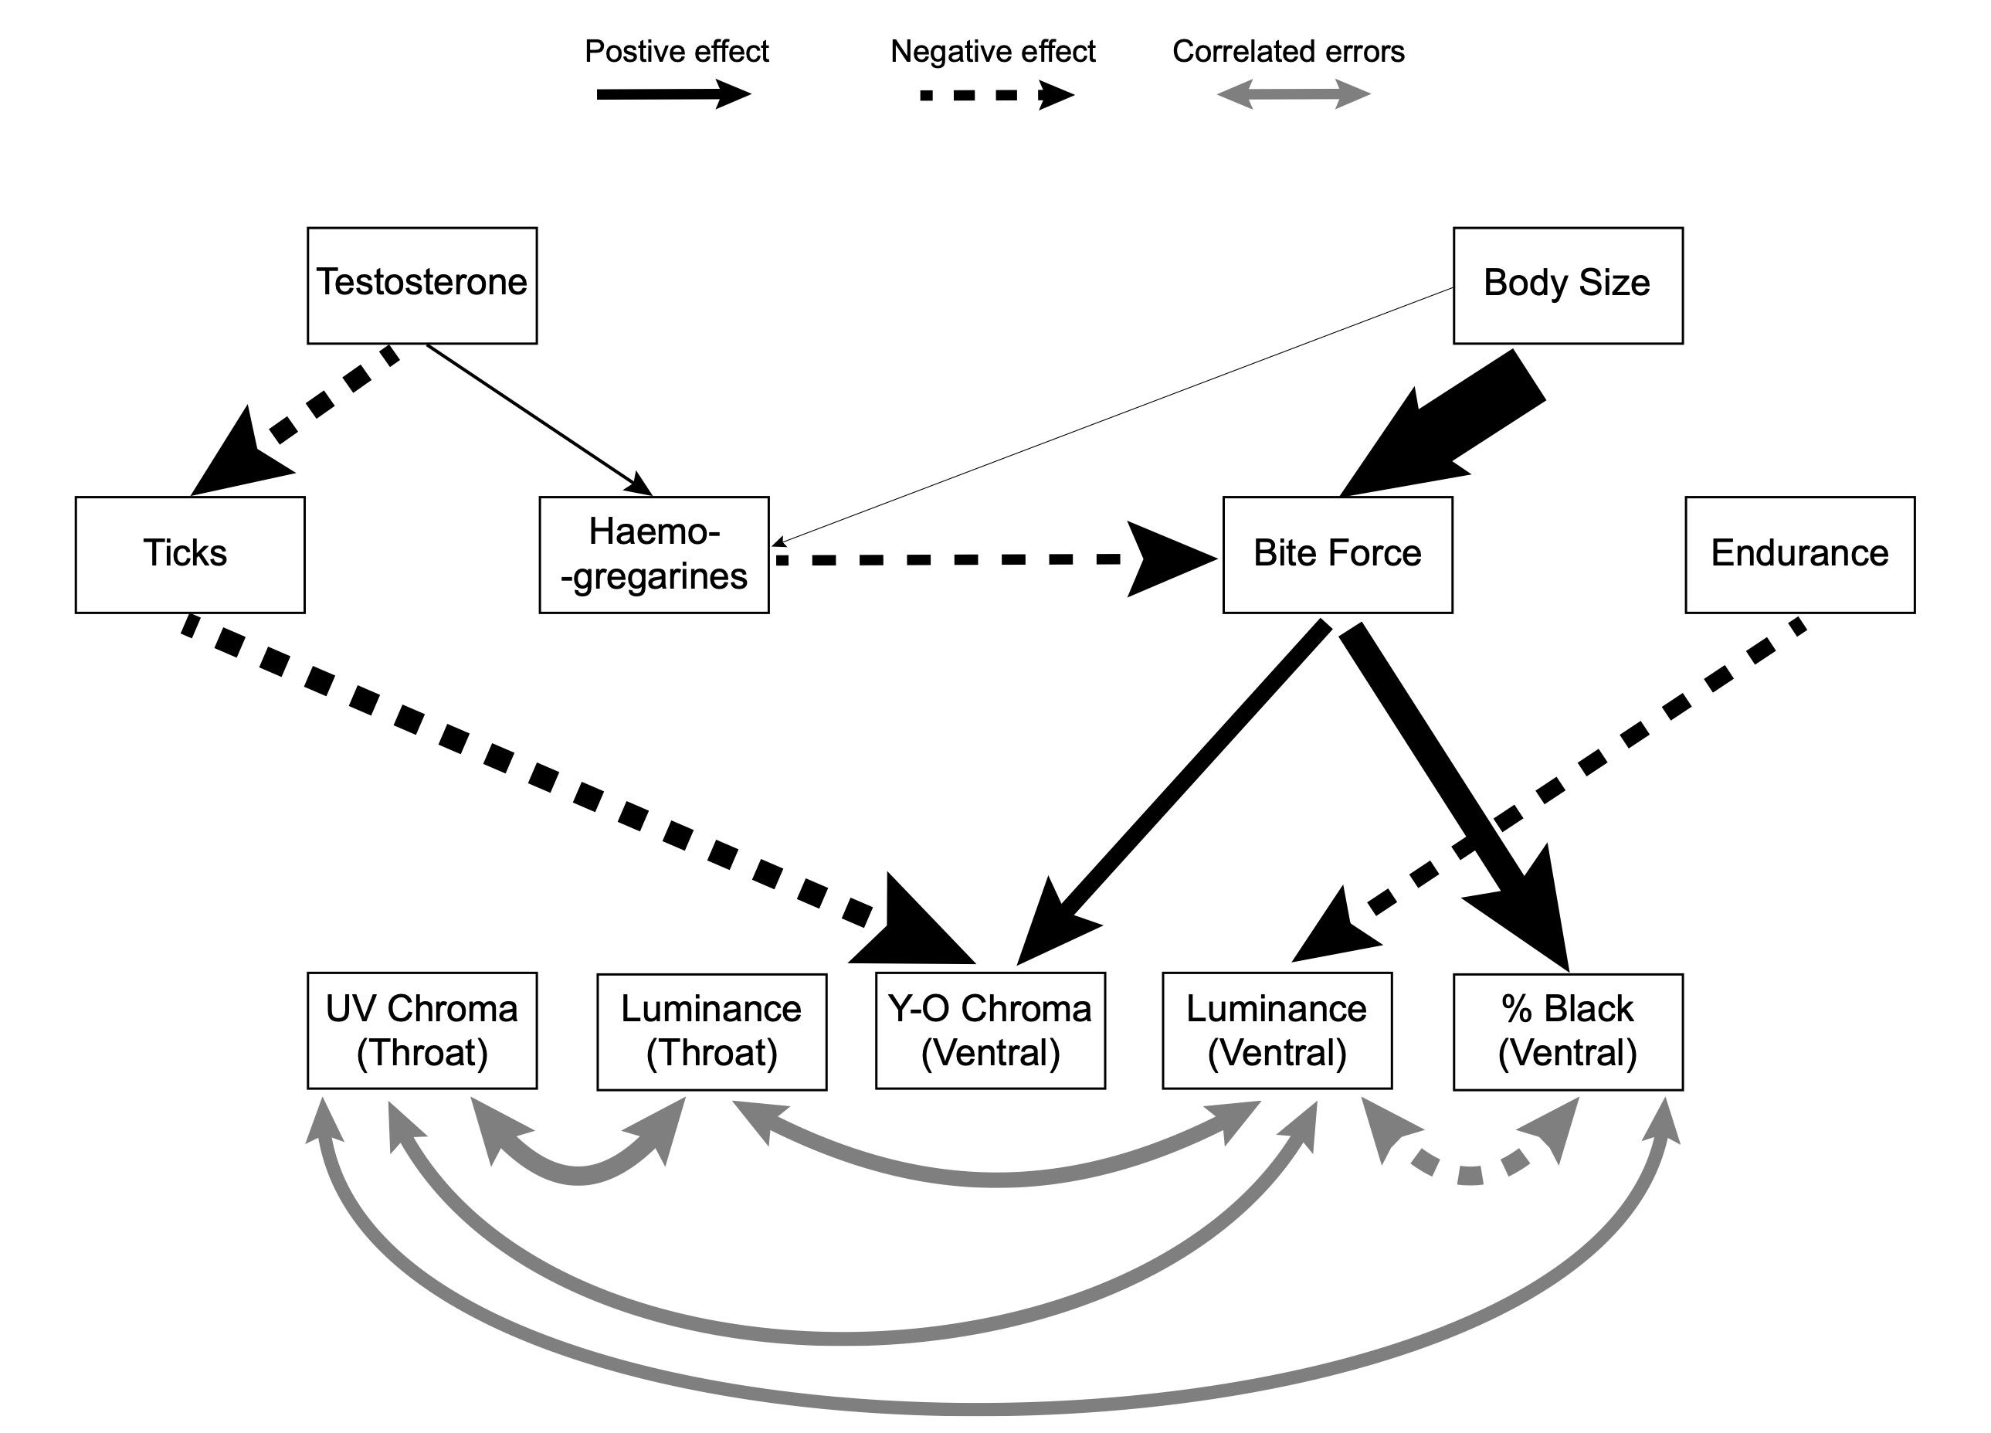

References
Anderson, S., & Prager, M. (2006). Quantifying colors. In G. E. Hill & K. J. Mcgraw (Eds.), Bird coloration: Volume 1, mechanisms and measurements (pp. 41–89).
Badiane, A., Pérez i de Lanuza, G., García‐Custodio, M. del C., Carazo, P., & Font, E. (2017). Colour patch size and measurement error using reflectance spectrophotometry. Methods in Ecology and Evolution, 8(11), 1585–1593. doi: 10.1111/2041-210X.12801
Bates, D., Maechler, M., Bolker, B., & Walker, S. (2015). Fitting linear mixed-effects models using lme4. Journal of Statistical Software, 67(1), 1–48.
Maia, R., Gruson, H., Endler, J. A., & White, T. E. (2019). pavo 2: New tools for the spectral and spatial analysis of colour in r. Methods in Ecology and Evolution, 10(7), 1097–1107. doi: 10.1111/2041-210X.13174
Pinheiro, J., Bates, D., DebRoy, S., Sarkar, D., & R Core Team. (2019). nlme: Linear and nonlinear mixed effects models. R package version 3.1-141.
RDevelopmentCoreTeam. (2017). R: A language and environment for statistical computing. Vienna, Austria: R Foundation for Statistical Computing.

