Supplementary Information

Metalloenzyme signatures in authigenic carbonates from the Chukchi Borderlands in the western Arctic Ocean

Dong-Hun Lee^{1,†}, Jung-Hyun Kim^{2,*}, Yung Mi Lee², Germain Bayon³, Dahae Kim², Young Jin Joe², Xudong Wang⁴, Kyung-Hoon Shin¹, Young Keun Jin²

¹Department of Marine Sciences and Convergent Technology, Hanyang University ERICA Campus, Ansan, 15588, Republic of Korea
²Korea Polar Research Institute, Incheon, 21990, Republic of Korea
³University Brest, CNRS, Ifremer, Geo-Ocean, F-29280 Plouzané, France
⁴Shanghai Engineering Research Center of Hadal Science and Technology, College of Marine Sciences, Shanghai Ocean University, Shanghai 201306, China

*Correspondence:
Jung-Hyun Kim
jhkim123@kopri.re.kr

†Present address:
Marine Environment Research, Division, National Institute of Fisheries Science, Busan, South Korea

Table S1. Elemental concentrations for carbonate fractions (1M AA leachates) of authigenic carbonates (mg/kg) from the Chukchi Borderlands.
Sites | Sample ID | Carbonate fraction (1M AA leachates) (ppm) |  |  |  |  |  |  |  |  |  |  |  |  |  |  |  |  |  |  |  |  |  |  |  |  |  |  |  |  |  |  |  |  |  |  |  |  |  |  |  |  |  |  |  |  |  |  |  |  |  |  |  |  | Reference
 |  | Li | Ti | V | Mn | Co | Ni | Cu | Zn |  | Rb |  | Sr |  | Zr |  | Mo |  |  | Ba |  | La |  | Ce |  | Pr |  | Nd |  | Sm |  | Tb |  | Dy |  |  | Y |  | Ho |  | Er |  | Yb |  | Lu |  |  | W |  | Pb |  | Th |  | U
Chukchi borderland  (CB) | CB-1 | 11.66 | 0.53 | 8.07 | 118 | 2.03 | 3.18 | 0.09 | 6.72 |  | 5.91 |  | 3156 |  | 0.34 |  | 0.25 |  |  | 516 |  | 2.84 |  | 6.26 |  | 0.79 |  | 3.98 |  | 1.04 |  | 0.17 |  | 0.93 |  |  | 6.26 |  | 0.19 |  | 0.49 |  | 0.38 |  | 0.06 |  |  | 0.01 |  | 0.24 |  | 0.04 |  | 1.54 | This study
 | CB-2 | 4.26 | 3.77 | 14.12 | 1268 | 0.91 | 2.83 | 0.18 | 9.52 |  | 1.78 |  | 1722 |  | 0.70 |  | 10.56 |  |  | 32 |  | 4.94 |  | 11.40 |  | 1.26 |  | 5.85 |  | 1.51 |  | 0.30 |  | 1.92 |  |  | 23.57 |  | 0.46 |  | 1.40 |  | 1.38 |  | 0.24 |  |  | 0.01 |  | 0.41 |  | 0.61 |  | 83.62 | This study
 | CB-3 | 4.52 | 3.23 | 6.13 | 1641 | 1.21 | n.d. | 0.49 | 5.52 |  | 1.93 |  | 1177 |  | 0.69 |  | 1.06 |  |  | 30 |  | 2.57 |  | 6.80 |  | 0.81 |  | 3.66 |  | 0.92 |  | 0.13 |  | 0.69 |  |  | 4.26 |  | 0.13 |  | 0.33 |  | 0.27 |  | 0.04 |  |  | 0.01 |  | 0.65 |  | 0.32 |  | 1.06 | This study
 | CB-4 | 6.14 | 0.40 | 5.26 | 62 | 1.41 | 1.69 | 0.21 | 6.35 |  | 1.91 |  | 1692 |  | 0.67 |  | 0.10 |  |  | 272 |  | 1.21 |  | 3.04 |  | 0.38 |  | 1.80 |  | 0.48 |  | 0.08 |  | 0.45 |  |  | 2.88 |  | 0.09 |  | 0.24 |  | 0.20 |  | 0.03 |  |  | 0.01 |  | 0.28 |  | 0.20 |  | 0.34 | This study
 | CB-5 | 8.32 | 0.63 | 4.53 | 670 | 3.17 | 3.96 | 0.07 | 5.58 |  | 3.72 |  | 1912 |  | 0.13 |  | 4.85 |  |  | 60 |  | 5.00 |  | 11.65 |  | 1.31 |  | 6.21 |  | 1.59 |  | 0.30 |  | 1.83 |  |  | 15.06 |  | 0.40 |  | 1.16 |  | 1.05 |  | 0.18 |  |  | 0.01 |  | 0.32 |  | 0.05 |  | 4.79 | This study
 | CB-6 | 7.33 | 0.63 | 8.10 | 77 | 1.50 | 2.71 | 0.24 | 13.02 |  | 2.46 |  | 2392 |  | 0.32 |  | 0.23 |  |  | 476 |  | 1.87 |  | 4.54 |  | 0.58 |  | 2.72 |  | 0.71 |  | 0.13 |  | 0.74 |  |  | 5.33 |  | 0.15 |  | 0.43 |  | 0.37 |  | 0.06 |  |  | 0.01 |  | 0.51 |  | 0.03 |  | 1.42 | This study
 | CB-7 | 15.05 | 0.80 | 11.87 | 213 | 2.57 | 3.78 | 0.16 | 13.86 |  | 5.73 |  | 3659 |  | 0.14 |  | 0.33 |  |  | 788 |  | 4.24 |  | 9.66 |  | 1.22 |  | 6.65 |  | 1.85 |  | 0.39 |  | 2.36 |  |  | 16.84 |  | 0.51 |  | 1.41 |  | 1.12 |  | 0.19 |  |  | 0.01 |  | 0.39 |  | 0.02 |  | 9.95 | This study
Congo Fan  (CF) | CF-1 | 4.16 | 0.64 | 3.16 | 413 | 0.19 | 1.14 | 0.12 | 4.42 |  | 0.64 |  | 1535 |  | 0.10 |  | 0.71 |  |  | 798 |  | 2.23 |  | 8.21 |  | 0.70 |  | 2.92 |  | 0.64 |  | 0.10 |  | 0.59 |  |  | 4.28 |  | 0.13 |  | 0.40 |  | 0.38 |  | 0.06 |  |  | 0.02 |  | 0.50 |  | 0.37 |  | 8.07 | Wang et al., 2019
 | CF-2 | 2.86 | 0.60 | 7.48 | 76 | 0.19 | 0.75 | 0.04 | 1.83 |  | 0.34 |  | 1121 |  | 0.11 |  | 0.41 |  |  | 330 |  | 3.24 |  | 8.50 |  | 0.89 |  | 3.80 |  | 0.82 |  | 0.14 |  | 0.87 |  |  | 6.43 |  | 0.20 |  | 0.59 |  | 0.52 |  | 0.08 |  |  | 0.01 |  | 0.11 |  | 0.42 |  | 7.50 | Wang et al., 2019
 | CF-3 | 3.22 | 0.56 | 1.63 | 70 | 0.75 | 3.00 | 0.19 | 2.86 |  | 0.32 |  | 10409 |  | 0.13 |  | 0.07 |  |  | 10 |  | 5.65 |  | 11.69 |  | 1.37 |  | 5.53 |  | 0.93 |  | 0.10 |  | 0.53 |  |  | 3.51 |  | 0.11 |  | 0.28 |  | 0.22 |  | 0.03 |  |  | 0.02 |  | 0.08 |  | 0.47 |  | 6.23 | Wang et al., 2019
Nile Deep-Sea Fan  (NDSF) | NDSF-1 | 1.29 | 0.31 | 8.79 | 266 | 0.54 | 1.90 | 0.24 | 3.87 |  | 0.76 |  | 9753 |  | 0.77 |  | 0.18 |  |  | 18 |  | 3.10 |  | 6.80 |  | 0.77 |  | 3.29 |  | 0.69 |  | 0.11 |  | 0.64 |  |  | 4.06 |  | 0.13 |  | 0.36 |  | 0.31 |  | 0.05 |  |  | 0.01 |  | 0.11 |  | 0.31 |  | 7.02 | Wang et al., 2019
 | NDSF-2 | 3.31 | 1.27 | 1.77 | 117 | 2.42 | 3.82 | 1.92 | 3.94 |  | 0.57 |  | 1281 |  | 0.41 |  | 0.06 |  |  | 30 |  | 8.41 |  | 16.56 |  | 2.06 |  | 8.91 |  | 2.00 |  | 0.33 |  | 1.98 |  |  | 13.18 |  | 0.41 |  | 1.12 |  | 0.92 |  | 0.14 |  |  | 0.01 |  | 0.81 |  | 0.40 |  | 7.50 | Wang et al., 2019
 | NDSF-3 | 2.10 | 0.97 | 3.68 | 64 | 0.29 | 1.59 | 3.34 | 5.07 |  | 0.50 |  | 7619 |  | 0.41 |  | 0.05 |  |  | 152 |  | 4.44 |  | 6.85 |  | 1.07 |  | 4.59 |  | 0.99 |  | 0.17 |  | 1.06 |  |  | 9.06 |  | 0.23 |  | 0.65 |  | 0.53 |  | 0.08 |  |  | 0.01 |  | 1.01 |  | 0.36 |  | 3.93 | Wang et al., 2019
 | NDSF-4 | 1.39 | 0.92 | 3.30 | 115 | 0.38 | 0.93 | 1.96 | 2.84 |  | 0.37 |  | 9657 |  | 0.58 |  | 0.06 |  |  | 444 |  | 2.63 |  | 4.38 |  | 0.66 |  | 2.94 |  | 0.65 |  | 0.11 |  | 0.67 |  |  | 5.58 |  | 0.15 |  | 0.41 |  | 0.33 |  | 0.05 |  |  | 0.01 |  | 0.49 |  | 0.20 |  | 4.58 | Wang et al., 2019
Niger Fan  (NF) | NF-1 | 0.62 | 0.30 | 4.67 | 4 | 0.03 | 0.72 | 0.21 | 1.53 |  | 0.12 |  | 10563 |  | 0.02 |  | 5.13 |  |  | 32 |  | 0.10 |  | 0.24 |  | 0.02 |  | 0.10 |  | 0.02 |  | 0.00 |  | 0.02 |  |  | 0.20 |  | 0.00 |  | 0.01 |  | 0.01 |  | 0.00 |  |  | 0.02 |  | 0.13 |  | 0.01 |  | 3.95 | Wang et al., 2019
 | NF-2 | 1.12 | 0.36 | 6.25 | 20 | 0.22 | 0.63 | 0.13 | 1.50 |  | 0.30 |  | 10327 |  | 0.08 |  | 0.71 |  |  | 17 |  | 4.36 |  | 9.48 |  | 0.91 |  | 3.73 |  | 0.55 |  | 0.04 |  | 0.21 |  |  | 1.25 |  | 0.04 |  | 0.09 |  | 0.07 |  | 0.01 |  |  | 0.01 |  | 0.40 |  | 0.19 |  | 6.88 | Wang et al., 2019
 | NF-3 | 3.01 | 0.53 | 14.46 | 419 | 0.33 | 1.05 | 0.03 | 6.12 |  | 1.11 |  | 395 |  | 0.47 |  | 0.19 |  |  | 65 |  | 7.70 |  | 24.62 |  | 2.33 |  | 10.30 |  | 2.32 |  | 0.41 |  | 2.61 |  |  | 18.20 |  | 0.59 |  | 1.78 |  | 1.67 |  | 0.25 |  |  | 0.01 |  | 0.32 |  | 1.20 |  | 7.77 | Wang et al., 2019
 | NF-4 | 4.90 | 0.13 | 0.69 | 880 | 1.14 | 6.28 | 0.80 | 11.76 |  | 1.71 |  | 485 |  | 0.14 |  | 0.07 |  |  | 100 |  | 15.97 |  | 39.61 |  | 4.25 |  | 18.13 |  | 3.73 |  | 0.53 |  | 3.07 |  |  | 21.00 |  | 0.65 |  | 1.86 |  | 1.64 |  | 0.25 |  |  | 0.01 |  | 0.18 |  | 2.31 |  | 1.36 | Wang et al., 2019
Gulf of Mexico  (GoM) | GoM-1 | 0.84 | 0.21 | 1.20 | 167 | 0.54 | 1.60 | 0.90 | 2.07 |  | 0.92 |  | 15455 |  | 0.45 |  | 0.07 |  |  | 92 |  | 3.31 |  | 4.88 |  | 0.73 |  | 3.06 |  | 0.62 |  | 0.08 |  | 0.47 |  |  | 3.12 |  | 0.10 |  | 0.25 |  | 0.20 |  | 0.03 |  |  | 0.01 |  | 0.11 |  | 0.21 |  | 8.21 | Wang et al., 2019
 | GoM-2 | 2.12 | 0.14 | 1.64 | 295 | 0.52 | 1.25 | 0.46 | 3.68 |  | 0.71 |  | 1074 |  | 0.44 |  | 0.12 |  |  | 162 |  | 1.84 |  | 3.17 |  | 0.41 |  | 1.74 |  | 0.38 |  | 0.06 |  | 0.37 |  |  | 3.00 |  | 0.08 |  | 0.23 |  | 0.21 |  | 0.03 |  |  | 0.01 |  | 0.03 |  | 0.07 |  | 1.19 | Wang et al., 2019
 | GoM-3 | 0.83 | 0.06 | 0.83 | 91 | 0.08 | 4.32 | 1.68 | 2.64 |  | 0.47 |  | 12430 |  | 0.34 |  | 0.13 |  |  | 31 |  | 3.83 |  | 2.43 |  | 0.85 |  | 3.73 |  | 0.66 |  | 0.07 |  | 0.38 |  |  | 2.32 |  | 0.07 |  | 0.19 |  | 0.14 |  | 0.02 |  |  | 0.01 |  | 0.29 |  | 0.08 |  | 9.30 | Wang et al., 2019
 | GoM-4 | 3.88 | 0.09 | 1.39 | 564 | 0.60 | 4.73 | 1.23 | 5.44 |  | 0.74 |  | 3051 |  | 0.12 |  | 0.09 |  |  | 652 |  | 2.90 |  | 3.60 |  | 0.70 |  | 3.20 |  | 0.75 |  | 0.12 |  | 0.69 |  |  | 5.49 |  | 0.15 |  | 0.39 |  | 0.31 |  | 0.05 |  |  | 0.01 |  | 0.06 |  | 0.07 |  | 9.13 | Wang et al., 2019
 | GoM-5 | 2.27 | 0.26 | 2.21 | 160 | 0.51 | 1.67 | 0.85 | 3.35 |  | 0.59 |  | 1141 |  | 0.34 |  | 0.06 |  |  | 295 |  | 3.33 |  | 4.54 |  | 0.77 |  | 3.39 |  | 0.75 |  | 0.12 |  | 0.73 |  |  | 5.62 |  | 0.16 |  | 0.43 |  | 0.35 |  | 0.05 |  |  | 0.01 |  | 0.13 |  | 0.09 |  | 0.50 | Wang et al., 2019
 | GoM-6 | 2.77 | 0.09 | 1.95 | 182 | 0.53 | 3.19 | 1.19 | 3.52 |  | 0.71 |  | 1445 |  | 0.20 |  | 0.06 |  |  | 318 |  | 5.99 |  | 5.92 |  | 1.39 |  | 6.26 |  | 1.42 |  | 0.24 |  | 1.42 |  |  | 11.07 |  | 0.31 |  | 0.83 |  | 0.64 |  | 0.10 |  |  | 0.01 |  | 0.22 |  | 0.09 |  | 0.50 | Wang et al., 2019
 | GoM-7 | 2.14 | 0.94 | 6.90 | 167 | 0.42 | 1.18 | 0.85 | 3.86 |  | 0.64 |  | 1228 |  | 1.08 |  | 0.07 |  |  | 657 |  | 4.94 |  | 9.38 |  | 1.11 |  | 4.53 |  | 0.95 |  | 0.15 |  | 0.88 |  |  | 6.20 |  | 0.19 |  | 0.52 |  | 0.46 |  | 0.07 |  |  | 0.01 |  | 0.14 |  | 0.44 |  | 5.17 | Wang et al., 2019
n.d. indicates ‘not determined’.

Table S2. Elemental concentrations for sulfide fractions (3M HNO₃ leachates) of authigenic carbonates (mg/kg) from the Chukchi Borderlands.
Sites | Sample ID | Sulfide fraction (3M HNO₃ leachates) (ppm) |  |  |  |  |  |  |  |  |  |  |  |  |  |  |  |  |  |  |  |  |  |  |  |  |  |  |  |  |  |  |  |  |  |  |  |  |  |  |  |  |  |  |  |  |  |  |  |  |  |  |  | Reference
 |  | Li | Ti | V | Mn | Co | Ni | Cu | Zn |  | Rb |  | Sr |  | Zr |  | Mo |  | Ba |  | La |  | Ce |  | Pr |  | Nd |  | Sm |  | Tb |  | Dy |  | Y |  | Ho |  | Er |  | Yb |  |  | Lu |  | W |  | Pb |  | Th |  |  | U
Chukchi borderland  (CB) | CB-1 | 2.79 | 13.12 | 4.32 | 52 | 1.59 | 2.80 | 2.54 | 11.03 |  | 2.28 |  | 212 |  | 1.83 |  | 0.17 |  | 66 |  | 1.33 |  | 3.00 |  | 0.40 |  | 1.71 |  | 0.42 |  | 0.06 |  | 0.34 |  | 1.83 |  | 0.06 |  | 0.16 |  | 0.13 |  |  | 0.02 |  | 0.00 |  | 1.93 |  | 0.76 |  |  | 0.16 | This study
 | CB-2 | 2.55 | 12.66 | 5.90 | 267 | 1.28 | 2.16 | 2.81 | 8.41 |  | 2.54 |  | 509 |  | 1.61 |  | 2.81 |  | 7 |  | 1.82 |  | 3.77 |  | 0.48 |  | 2.05 |  | 0.50 |  | 0.08 |  | 0.52 |  | 4.53 |  | 0.11 |  | 0.33 |  | 0.32 |  |  | 0.05 |  | 0.01 |  | 2.03 |  | 0.79 |  |  | 10.23 | This study
 | CB-3 | 2.53 | 15.88 | 4.00 | 352 | 1.79 | 2.69 | 3.83 | 9.67 |  | 2.64 |  | 206 |  | 2.34 |  | 0.28 |  | 11 |  | 2.17 |  | 4.93 |  | 0.61 |  | 2.57 |  | 0.60 |  | 0.09 |  | 0.50 |  | 2.97 |  | 0.10 |  | 0.26 |  | 0.22 |  |  | 0.03 |  | 0.01 |  | 2.41 |  | 1.02 |  |  | 0.52 | This study
 | CB-4 | 2.34 | 10.43 | 3.95 | 80 | 1.60 | 2.83 | 4.30 | 11.31 |  | 2.28 |  | 217 |  | 2.13 |  | 0.08 |  | 55 |  | 1.41 |  | 3.39 |  | 0.47 |  | 2.05 |  | 0.52 |  | 0.08 |  | 0.42 |  | 2.26 |  | 0.08 |  | 0.19 |  | 0.14 |  |  | 0.02 |  | 0.00 |  | 2.38 |  | 0.92 |  |  | 0.14 | This study
 | CB-5 | 2.50 | 13.79 | 5.37 | 397 | 2.19 | 2.91 | 2.27 | 8.68 |  | 2.31 |  | 210 |  | 1.69 |  | 0.62 |  | 13 |  | 2.01 |  | 4.37 |  | 0.54 |  | 2.29 |  | 0.55 |  | 0.10 |  | 0.58 |  | 3.84 |  | 0.12 |  | 0.34 |  | 0.33 |  |  | 0.05 |  | 0.01 |  | 1.79 |  | 0.84 |  |  | 0.68 | This study
 | CB-6 | 3.29 | 14.01 | 6.14 | 48 | 1.36 | 2.64 | 3.78 | 11.86 |  | 2.20 |  | 257 |  | 3.27 |  | 0.14 |  | 80 |  | 2.22 |  | 5.15 |  | 0.65 |  | 2.67 |  | 0.61 |  | 0.09 |  | 0.49 |  | 2.92 |  | 0.09 |  | 0.24 |  | 0.19 |  |  | 0.03 |  | 0.01 |  | 2.48 |  | 1.03 |  |  | 0.33 | This study
 | CB-7 | 2.37 | 16.30 | 3.94 | 100 | 1.72 | 3.05 | 3.52 | 10.32 |  | 2.61 |  | 271 |  | 2.11 |  | 0.16 |  | 234 |  | 2.03 |  | 4.52 |  | 0.59 |  | 2.57 |  | 0.65 |  | 0.12 |  | 0.69 |  | 4.17 |  | 0.14 |  | 0.39 |  | 0.36 |  |  | 0.05 |  | 0.01 |  | 2.19 |  | 1.00 |  |  | 1.12 | This study
Congo Fan  (CF) | CF-1 | 1.28 | 9.51 | 1.85 | 95 | 0.37 | 1.94 | 2.05 | 3.81 |  | 1.32 |  | 276 |  | 0.48 |  | 0.36 |  | 862 |  | 1.00 |  | 3.46 |  | 0.30 |  | 1.20 |  | 0.25 |  | 0.03 |  | 0.20 |  | 1.52 |  | 0.04 |  | 0.13 |  | 0.13 |  |  | 0.02 |  | 0.00 |  | 0.56 |  | 0.47 |  |  | 1.52 | Wang et al., 2019
 | CF-2 | 1.18 | 11.78 | 4.18 | 38 | 0.47 | 1.61 | 2.06 | 3.51 |  | 1.27 |  | 276 |  | 0.56 |  | 0.44 |  | 110 |  | 1.70 |  | 4.54 |  | 0.46 |  | 1.88 |  | 0.39 |  | 0.06 |  | 0.39 |  | 3.09 |  | 0.09 |  | 0.25 |  | 0.24 |  |  | 0.03 |  | 0.00 |  | 0.58 |  | 0.54 |  |  | 1.99 | Wang et al., 2019
 | CF-3 | 1.72 | 19.23 | 9.27 | 20 | 0.58 | 2.16 | 1.13 | 5.13 |  | 1.01 |  | 1757 |  | 0.66 |  | 0.36 |  | 4 |  | 2.25 |  | 5.21 |  | 0.54 |  | 2.06 |  | 0.35 |  | 0.04 |  | 0.21 |  | 1.48 |  | 0.04 |  | 0.11 |  | 0.09 |  |  | 0.01 |  | 0.01 |  | 0.80 |  | 0.71 |  |  | 1.55 | Wang et al., 2019
Nile Deep-Sea Fan  (NDSF) | NDSF-1 | 0.70 | 15.11 | 10.92 | 108 | 1.87 | 3.38 | 5.07 | 4.98 |  | 1.53 |  | 1967 |  | 4.01 |  | 2.16 |  | 5 |  | 2.83 |  | 6.67 |  | 0.79 |  | 3.21 |  | 0.65 |  | 0.09 |  | 0.51 |  | 3.13 |  | 0.10 |  | 0.26 |  | 0.21 |  |  | 0.03 |  | 0.00 |  | 0.81 |  | 0.51 |  |  | 1.73 | Wang et al., 2019
 | NDSF-2 | 1.39 | 33.08 | 11.93 | 100 | 3.84 | 4.44 | 4.11 | 3.34 |  | 1.21 |  | 229 |  | 3.72 |  | 0.21 |  | 10 |  | 3.60 |  | 8.80 |  | 0.87 |  | 3.58 |  | 0.75 |  | 0.12 |  | 0.67 |  | 5.09 |  | 0.14 |  | 0.38 |  | 0.32 |  |  | 0.05 |  | 0.01 |  | 1.91 |  | 0.44 |  |  | 1.90 | Wang et al., 2019
 | NDSF-3 | 0.82 | 20.93 | 5.83 | 20 | 0.32 | 1.53 | 2.59 | 2.85 |  | 0.85 |  | 1534 |  | 1.23 |  | 0.05 |  | 42 |  | 1.57 |  | 2.55 |  | 0.38 |  | 1.56 |  | 0.32 |  | 0.05 |  | 0.30 |  | 2.90 |  | 0.06 |  | 0.17 |  | 0.15 |  |  | 0.02 |  | 0.01 |  | 0.54 |  | 0.18 |  |  | 0.93 | Wang et al., 2019
 | NDSF-4 | 0.79 | 14.75 | 4.31 | 39 | 0.39 | 1.54 | 2.40 | 2.57 |  | 0.78 |  | 1958 |  | 1.63 |  | 0.27 |  | 1110 |  | 1.43 |  | 2.51 |  | 0.35 |  | 1.45 |  | 0.30 |  | 0.04 |  | 0.26 |  | 2.30 |  | 0.05 |  | 0.14 |  | 0.12 |  |  | 0.02 |  | 0.01 |  | 0.57 |  | 0.23 |  |  | 1.21 | Wang et al., 2019
Niger Fan  (NF) | NF-1 | 0.23 | 2.01 | 1.15 | 1 | 0.03 | 0.29 | 0.32 | 0.41 |  | 0.10 |  | 2660 |  | 0.02 |  | 0.49 |  | 5 |  | 0.08 |  | 0.16 |  | 0.02 |  | 0.06 |  | 0.01 |  | 0.00 |  | 0.01 |  | 0.10 |  | 0.00 |  | 0.01 |  | 0.00 |  |  | 0.00 |  | 0.01 |  | 0.04 |  | 0.01 |  |  | 1.54 | Wang et al., 2019
 | NF-2 | 0.34 | 4.27 | 2.31 | 4 | 0.30 | 0.66 | 0.68 | 0.69 |  | 0.25 |  | 2302 |  | 0.13 |  | 0.31 |  | 4 |  | 1.31 |  | 2.75 |  | 0.26 |  | 1.04 |  | 0.16 |  | 0.01 |  | 0.06 |  | 0.45 |  | 0.01 |  | 0.03 |  | 0.02 |  |  | 0.00 |  | 0.00 |  | 0.15 |  | 0.07 |  |  | 1.74 | Wang et al., 2019
 | NF-3 | 0.98 | 11.50 | 9.29 | 138 | 0.83 | 1.89 | 1.81 | 2.93 |  | 1.83 |  | 74 |  | 1.43 |  | 1.41 |  | 19 |  | 3.65 |  | 11.76 |  | 1.10 |  | 4.73 |  | 1.04 |  | 0.18 |  | 1.17 |  | 9.18 |  | 0.26 |  | 0.79 |  | 0.76 |  |  | 0.11 |  | 0.01 |  | 0.64 |  | 0.63 |  |  | 2.58 | Wang et al., 2019
 | NF-4 | 1.96 | 10.86 | 37.56 | 445 | 2.30 | 7.34 | 2.91 | 12.32 |  | 4.34 |  | 54 |  | 1.73 |  | 0.12 |  | 40 |  | 7.73 |  | 20.59 |  | 2.06 |  | 8.37 |  | 1.69 |  | 0.23 |  | 1.34 |  | 9.51 |  | 0.28 |  | 0.79 |  | 0.74 |  |  | 0.11 |  | 0.01 |  | 1.96 |  | 1.90 |  |  | 0.39 | Wang et al., 2019
Gulf of Mexico  (GoM) | GoM-1 | 1.58 | 18.57 | 10.78 | 92 | 1.26 | 2.44 | 3.13 | 5.24 |  | 2.14 |  | 2193 |  | 2.23 |  | 0.34 |  | 20 |  | 2.14 |  | 3.96 |  | 0.51 |  | 2.02 |  | 0.41 |  | 0.06 |  | 0.29 |  | 2.03 |  | 0.06 |  | 0.15 |  | 0.12 |  |  | 0.02 |  | 0.02 |  | 1.39 |  | 0.65 |  |  | 1.48 | Wang et al., 2019
 | GoM-2 | 3.18 | 29.58 | 11.11 | 221 | 2.47 | 4.98 | 4.13 | 9.57 |  | 3.58 |  | 280 |  | 6.51 |  | 0.78 |  | 57 |  | 2.27 |  | 4.69 |  | 0.59 |  | 2.39 |  | 0.52 |  | 0.07 |  | 0.38 |  | 2.89 |  | 0.08 |  | 0.20 |  | 0.18 |  |  | 0.03 |  | 0.02 |  | 1.79 |  | 0.82 |  |  | 0.48 | Wang et al., 2019
 | GoM-3 | 0.80 | 11.98 | 4.68 | 128 | 0.76 | 3.39 | 2.67 | 3.45 |  | 1.08 |  | 2325 |  | 0.76 |  | 0.26 |  | 8 |  | 1.57 |  | 2.17 |  | 0.36 |  | 1.45 |  | 0.26 |  | 0.03 |  | 0.16 |  | 1.20 |  | 0.03 |  | 0.08 |  | 0.07 |  |  | 0.01 |  | 0.02 |  | 0.93 |  | 0.23 |  |  | 1.80 | Wang et al., 2019
 | GoM-4 | 1.43 | 13.71 | 26.48 | 199 | 1.30 | 3.89 | 2.97 | 6.77 |  | 1.51 |  | 270 |  | 2.22 |  | 1.48 |  | 100 |  | 1.79 |  | 3.32 |  | 0.46 |  | 1.87 |  | 0.39 |  | 0.06 |  | 0.31 |  | 2.40 |  | 0.06 |  | 0.17 |  | 0.15 |  |  | 0.02 |  | 0.02 |  | 1.43 |  | 0.52 |  |  | 1.28 | Wang et al., 2019
 | GoM-5 | 1.95 | 19.85 | 10.82 | 112 | 1.43 | 3.38 | 2.26 | 6.11 |  | 1.94 |  | 179 |  | 2.87 |  | 0.09 |  | 57 |  | 1.96 |  | 3.70 |  | 0.49 |  | 1.98 |  | 0.42 |  | 0.06 |  | 0.33 |  | 2.65 |  | 0.07 |  | 0.18 |  | 0.15 |  |  | 0.02 |  | 0.01 |  | 1.47 |  | 0.51 |  |  | 0.12 | Wang et al., 2019
 | GoM-6 | 2.20 | 24.58 | 16.41 | 219 | 2.91 | 5.73 | 3.26 | 7.76 |  | 2.30 |  | 184 |  | 3.41 |  | 0.13 |  | 60 |  | 3.06 |  | 5.35 |  | 0.74 |  | 3.06 |  | 0.66 |  | 0.10 |  | 0.56 |  | 4.61 |  | 0.12 |  | 0.31 |  | 0.26 |  |  | 0.04 |  | 0.01 |  | 2.53 |  | 0.67 |  |  | 0.54 | Wang et al., 2019
 | GoM-7 | 2.21 | 36.44 | 6.36 | 60 | 0.98 | 2.63 | 2.96 | 6.17 |  | 2.72 |  | 191 |  | 3.67 |  | 0.46 |  | 126 |  | 3.30 |  | 6.68 |  | 0.79 |  | 3.10 |  | 0.62 |  | 0.08 |  | 0.45 |  | 3.23 |  | 0.09 |  | 0.24 |  | 0.21 |  |  | 0.03 |  | 0.01 |  | 1.42 |  | 0.83 |  |  | 1.22 | Wang et al., 2019

Table S3. Elemental concentrations for detrital silicate fractions (concentrated HF + HCl leachates) of authigenic carbonates (mg/kg) from the Chukchi Borderlands.
Sites | Sample ID | Detrital silicate fractions (conc. HF+HCl) (ppm) |  |  |  |  |  |  |  |  |  |  |  |  |  |  |  |  |  |  |  |  |  |  |  |  |  |  |  |  |  |  |  |  |  |  |  |  |  |  |  |  |  |  |  |  |  |  |  |  |  | Reference
 |  | Li | Ti | V | Mn | Co | Ni | Cu | Zn | Rb |  | Sr |  | Zr | Mo | Ba |  | La |  | Ce |  | Pr |  | Nd |  | Sm |  | Tb |  |  | Dy |  | Y |  | Ho |  |  | Er |  | Yb |  | Lu |  |  | W |  | Pb |  | Th |  | U
Chukchi borderland  (CB) | CB-1 | 57.02 | 4652.94 | 142.26 | 157 | 7.19 | 23.46 | 4.81 | 90.02 | 107.61 |  | 142.87 |  | 114.21 | 0.86 | 458 |  | 21.14 |  | 43.76 |  | 4.90 |  | 17.45 |  | 2.81 |  | 0.34 |  |  | 2.32 |  | 18.91 |  | 0.53 |  |  | 1.66 |  | 1.85 |  | 0.27 |  |  | 1.50 |  | 4.80 |  | 5.39 |  | 2.00 | This study
 | CB-2 | 59.00 | 4967.64 | 154.12 | 212 | 7.07 | 24.03 | 4.70 | 85.95 | 123.49 |  | 155.10 |  | 126.87 | 9.20 | 502 |  | 19.88 |  | 41.80 |  | 4.76 |  | 16.84 |  | 2.82 |  | 0.36 |  |  | 2.48 |  | 20.69 |  | 0.56 |  |  | 1.75 |  | 1.97 |  | 0.30 |  |  | 1.62 |  | 3.64 |  | 5.73 |  | 3.10 | This study
 | CB-3 | 55.70 | 4817.46 | 116.62 | 182 | 6.35 | 20.03 | 4.74 | 75.07 | 99.88 |  | 111.20 |  | 134.34 | 1.13 | 410 |  | 20.69 |  | 44.14 |  | 5.15 |  | 18.07 |  | 3.02 |  | 0.38 |  |  | 2.45 |  | 17.53 |  | 0.55 |  |  | 1.71 |  | 1.81 |  | 0.28 |  |  | 1.64 |  | 4.53 |  | 6.15 |  | 2.05 | This study
 | CB-4 | 68.78 | 4384.58 | 160.75 | 120 | 6.18 | 25.84 | 5.94 | 115.34 | 107.11 |  | 108.64 |  | 112.09 | 0.71 | 488 |  | 22.65 |  | 46.31 |  | 5.08 |  | 17.46 |  | 2.68 |  | 0.31 |  |  | 2.10 |  | 17.33 |  | 0.49 |  |  | 1.55 |  | 1.75 |  | 0.27 |  |  | 1.52 |  | 4.99 |  | 5.12 |  | 2.13 | This study
 | CB-5 | 39.99 | 3764.94 | 89.69 | 240 | 6.01 | 18.51 | 4.65 | 91.18 | 77.98 |  | 136.00 |  | 125.14 | 1.91 | 329 |  | 19.70 |  | 36.57 |  | 4.13 |  | 14.80 |  | 2.56 |  | 0.34 |  |  | 2.30 |  | 18.57 |  | 0.52 |  |  | 1.60 |  | 1.74 |  | 0.26 |  |  | 1.24 |  | 4.25 |  | 4.87 |  | 1.75 | This study
 | CB-6 | 59.56 | 4614.30 | 121.88 | 115 | 5.25 | 20.94 | 5.98 | 115.95 | 95.24 |  | 106.86 |  | 142.17 | 0.72 | 431 |  | 20.92 |  | 43.80 |  | 4.97 |  | 17.46 |  | 2.83 |  | 0.36 |  |  | 2.43 |  | 20.12 |  | 0.55 |  |  | 1.72 |  | 1.89 |  | 0.28 |  |  | 1.57 |  | 5.00 |  | 5.59 |  | 2.11 | This study
 | CB-7 | 62.14 | 4769.26 | 145.82 | 141 | 6.65 | 22.55 | 11.98 | 130.72 | 112.85 |  | 438.29 |  | 127.76 | 0.89 | 3846 |  | 22.52 |  | 47.07 |  | 5.40 |  | 18.84 |  | 3.00 |  | 0.36 |  |  | 2.49 |  | 20.82 |  | 0.58 |  |  | 1.82 |  | 2.04 |  | 0.31 |  |  | 1.57 |  | 5.26 |  | 5.80 |  | 2.31 | This study
Congo Fan  (CF) | CF-1 | 93.60 | 3453.00 | 65.00 | 70 | 6.08 | 24.00 | 12.60 | 45.40 | 70.00 |  | 931.00 |  | 98.00 | 1.67 | 22659 |  | 24.40 |  | 35.50 |  | 4.20 |  | 13.89 |  | 2.41 |  | 0.30 |  |  | 1.81 |  | 10.94 |  | 0.37 |  |  | 1.09 |  | 1.14 |  | 0.17 |  |  | 1.44 |  | 9.80 |  | 5.41 |  | 4.23 | Wang et al., 2019
 | CF-2 | 101.30 | 4052.00 | 74.40 | 64 | 6.50 | 25.80 | 11.50 | 43.80 | 72.00 |  | 35.00 |  | 125.00 | 1.56 | 257 |  | 24.10 |  | 34.92 |  | 4.16 |  | 13.72 |  | 2.34 |  | 0.33 |  |  | 1.98 |  | 12.89 |  | 0.41 |  |  | 1.23 |  | 1.30 |  | 0.19 |  |  | 1.59 |  | 10.18 |  | 5.59 |  | 1.95 | Wang et al., 2019
 | CF-3 | 107.50 | 4421.00 | 80.50 | 68 | 5.83 | 44.40 | 15.30 | 59.00 | 64.00 |  | 63.00 |  | 135.00 | 4.31 | 396 |  | 38.62 |  | 55.56 |  | 6.56 |  | 21.53 |  | 3.47 |  | 0.39 |  |  | 2.16 |  | 12.10 |  | 0.41 |  |  | 1.16 |  | 1.13 |  | 0.16 |  |  | 1.79 |  | 17.14 |  | 8.52 |  | 2.53 | Wang et al., 2019
Nile Deep-Sea Fan  (NDSF) | NDSF-1 | 52.00 | 7421.00 | 109.00 | 103 | 7.75 | 33.90 | 8.10 | 52.70 | 46.00 |  | 163.00 |  | 261.00 | 5.69 | 204 |  | 28.31 |  | 43.31 |  | 4.96 |  | 16.96 |  | 2.91 |  | 0.42 |  |  | 2.76 |  | 20.34 |  | 0.61 |  |  | 1.89 |  | 2.05 |  | 0.30 |  |  | 1.58 |  | 5.86 |  | 3.60 |  | 1.60 | Wang et al., 2019
 | NDSF-2 | 57.70 | 6905.00 | 123.60 | 228 | 15.93 | 52.20 | 37.20 | 59.20 | 61.00 |  | 91.00 |  | 213.00 | 24.75 | 209 |  | 16.20 |  | 25.97 |  | 3.05 |  | 10.83 |  | 2.02 |  | 0.35 |  |  | 2.29 |  | 15.97 |  | 0.50 |  |  | 1.54 |  | 1.65 |  | 0.24 |  |  | 1.56 |  | 8.44 |  | 3.94 |  | 1.71 | Wang et al., 2019
 | NDSF-3 | 57.60 | 5832.00 | 119.90 | 129 | 7.82 | 34.70 | 15.70 | 47.70 | 62.00 |  | 113.00 |  | 217.00 | 1.86 | 231 |  | 26.90 |  | 45.32 |  | 5.10 |  | 17.82 |  | 3.07 |  | 0.43 |  |  | 2.73 |  | 18.90 |  | 0.59 |  |  | 1.77 |  | 1.91 |  | 0.28 |  |  | 1.21 |  | 7.60 |  | 6.77 |  | 2.14 | Wang et al., 2019
 | NDSF-4 | 41.20 | 4062.00 | 65.00 | 106 | 6.13 | 27.20 | 11.40 | 44.00 | 59.00 |  | 1091.00 |  | 144.00 | 3.96 | 13128 |  | 19.67 |  | 32.94 |  | 3.73 |  | 13.11 |  | 2.31 |  | 0.33 |  |  | 2.11 |  | 14.54 |  | 0.46 |  |  | 1.39 |  | 1.50 |  | 0.22 |  |  | 0.97 |  | 7.12 |  | 3.61 |  | 1.57 | Wang et al., 2019
Niger Fan  (NF) | NF-1 | n.d. | n.d. | n.d. | n.d. | n.d. | n.d. | n.d. | n.d. | n.d. |  | n.d. |  | n.d. | n.d. | n.d. |  | n.d. |  | n.d. |  | n.d. |  | n.d. |  | n.d. |  | n.d. |  |  | n.d. |  | n.d. |  | n.d. |  |  | n.d. |  | n.d. |  | n.d. |  |  | n.d. |  | n.d. |  | n.d. |  | n.d. | Wang et al., 2019
 | NF-2 | n.d. | n.d. | n.d. | n.d. | n.d. | n.d. | n.d. | n.d. | n.d. |  | n.d. |  | n.d. | n.d. | n.d. |  | n.d. |  | n.d. |  | n.d. |  | n.d. |  | n.d. |  | n.d. |  |  | n.d. |  | n.d. |  | n.d. |  |  | n.d. |  | n.d. |  | n.d. |  |  | n.d. |  | n.d. |  | n.d. |  | n.d. | Wang et al., 2019
 | NF-3 | 109.40 | 5623.00 | 109.00 | 77 | 6.73 | 30.30 | 5.90 | 45.70 | 78.00 |  | 92.00 |  | 183.00 | 5.19 | 239 |  | 51.02 |  | 89.50 |  | 8.98 |  | 29.57 |  | 4.63 |  | 0.52 |  |  | 2.98 |  | 18.01 |  | 0.61 |  |  | 1.77 |  | 1.82 |  | 0.27 |  |  | 1.33 |  | 16.61 |  | 7.38 |  | 1.89 | Wang et al., 2019
 | NF-4 | 68.40 | 3291.00 | 176.80 | 211 | 9.58 | 31.90 | 5.60 | 66.70 | 68.00 |  | 52.00 |  | 118.00 | 3.31 | 144 |  | 35.20 |  | 57.90 |  | 6.27 |  | 20.56 |  | 3.26 |  | 0.37 |  |  | 2.09 |  | 12.20 |  | 0.42 |  |  | 1.21 |  | 1.25 |  | 0.19 |  |  | 2.16 |  | 14.64 |  | 5.45 |  | 1.14 | Wang et al., 2019
Gulf of Mexico  (GoM) | GoM-1 | 46.50 | 3588.00 | 154.70 | 91 | 4.45 | 16.00 | 5.70 | 42.00 | 102.00 |  | 143.00 |  | 116.00 | 1.22 | 511 |  | 19.11 |  | 33.25 |  | 3.66 |  | 12.65 |  | 2.02 |  | 0.27 |  |  | 1.78 |  | 12.93 |  | 0.41 |  |  | 1.32 |  | 1.48 |  | 0.22 |  |  | 1.01 |  | 4.42 |  | 4.28 |  | 1.95 | Wang et al., 2019
 | GoM-2 | 54.90 | 3065.00 | 120.70 | 98 | 4.37 | 16.80 | 3.50 | 34.70 | 111.00 |  | 80.00 |  | 109.00 | 1.69 | 497 |  | 24.67 |  | 45.29 |  | 4.92 |  | 16.95 |  | 2.64 |  | 0.34 |  |  | 2.24 |  | 15.39 |  | 0.51 |  |  | 1.59 |  | 1.74 |  | 0.26 |  |  | 0.87 |  | 4.77 |  | 5.37 |  | 2.74 | Wang et al., 2019
 | GoM-3 | 49.90 | 3711.00 | 132.90 | 100 | 4.80 | 28.60 | 21.70 | 47.60 | 102.00 |  | 125.00 |  | 123.00 | 3.12 | 478 |  | 24.25 |  | 41.85 |  | 4.65 |  | 16.02 |  | 2.56 |  | 0.34 |  |  | 2.23 |  | 15.63 |  | 0.50 |  |  | 1.56 |  | 1.72 |  | 0.25 |  |  | 1.36 |  | 7.65 |  | 7.34 |  | 2.65 | Wang et al., 2019
 | GoM-4 | 59.50 | 3911.00 | 133.80 | 178 | 6.83 | 29.80 | 12.10 | 58.20 | 120.00 |  | 93.00 |  | 125.00 | 12.18 | 441 |  | 25.05 |  | 44.53 |  | 4.82 |  | 16.55 |  | 2.64 |  | 0.36 |  |  | 2.36 |  | 16.39 |  | 0.53 |  |  | 1.65 |  | 1.79 |  | 0.26 |  |  | 1.39 |  | 6.16 |  | 5.57 |  | 2.24 | Wang et al., 2019
 | GoM-5 | 51.40 | 3360.00 | 110.50 | 117 | 6.03 | 18.50 | 10.30 | 41.30 | 107.00 |  | 90.00 |  | 129.00 | 1.21 | 547 |  | 24.19 |  | 45.22 |  | 4.87 |  | 16.96 |  | 2.74 |  | 0.38 |  |  | 2.53 |  | 17.14 |  | 0.56 |  |  | 1.73 |  | 1.84 |  | 0.27 |  |  | 1.16 |  | 6.87 |  | 6.35 |  | 2.48 | Wang et al., 2019
 | GoM-6 | 53.20 | 4096.00 | 130.60 | 145 | 7.87 | 23.20 | 15.30 | 49.10 | 123.00 |  | 97.00 |  | 131.00 | 1.81 | 500 |  | 24.85 |  | 45.51 |  | 4.95 |  | 17.25 |  | 2.80 |  | 0.39 |  |  | 2.57 |  | 17.79 |  | 0.57 |  |  | 1.77 |  | 1.88 |  | 0.28 |  |  | 1.39 |  | 7.03 |  | 5.75 |  | 2.53 | Wang et al., 2019
 | GoM-7 | 34.00 | 3164.00 | 71.50 | 133 | 4.63 | 15.70 | 6.80 | 30.30 | 76.00 |  | 134.00 |  | 168.00 | 1.68 | 510 |  | 18.61 |  | 34.02 |  | 3.78 |  | 13.44 |  | 2.34 |  | 0.34 |  |  | 2.23 |  | 15.51 |  | 0.50 |  |  | 1.54 |  | 1.65 |  | 0.24 |  |  | 0.80 |  | 6.16 |  | 4.25 |  | 1.67 | Wang et al., 2019
n.d. indicates ‘not determined’.

Table S4. Elemental concentrations for total lipids of authigenic carbonates (mg/kg) from the Chukchi Borderlands.
Sites | Sample  ID | Total lipid fractions (ppm) |  |  |  |  |  |  |  |  |  |  |  |  |  |  |  |  |  |  |  |  |  |  |  |  |  |  |  |  |  |  |  |  |  |  |  |  |  |  |  |  |  |  |  |  |  |  |  |  |  |  |  |  | Reference
 |  | Li | Ti | V | Mn | Co | Ni |  | Cu |  | Zn |  | Rb |  | Sr |  | Zr |  | Mo |  | Ba |  | La |  | Ce |  | Pr |  | Nd |  |  | Sm |  | Tb |  | Dy |  | Y |  | Ho |  | Er |  | Yb |  |  | Lu |  | W |  | Pb |  | Th | U
Chukchi  Borderland  (CB) | CB-1 | 29.94 | 27.34 | 6.70 | 8.54 | 0.55 | 19.70 |  | 6.44 |  | 103.98 |  | 3.13 |  | 25.67 |  | n.d. |  | 0.84 |  | 17.50 |  | 0.32 |  | 0.61 |  | 0.07 |  | 0.29 |  |  | 0.03 |  | 0.00 |  | 0.04 |  | 0.27 |  | 0.01 |  | 0.01 |  | 0.03 |  |  | 0.01 |  | n.d. |  | 2.06 |  | 0.09 | 0.04 | This study
 | CB-2 | 26.81 | 13.55 | 2.68 | 27.17 | 0.22 | 4.26 |  | 3.02 |  | 45.30 |  | 2.19 |  | 21.03 |  | n.d. |  | 2.93 |  | 13.02 |  | 0.24 |  | 0.48 |  | 0.06 |  | 0.19 |  |  | 0.04 |  | 0.00 |  | 0.06 |  | 0.35 |  | 0.02 |  | 0.03 |  | 0.02 |  |  | 0.01 |  | n.d. |  | 1.15 |  | 0.09 | 0.77 | This study
 | CB-3 | 13.31 | 28.94 | 3.41 | 40.18 | 0.94 | 8.55 |  | 9.38 |  | 54.86 |  | 2.30 |  | 11.61 |  | n.d. |  | 1.08 |  | 16.39 |  | 0.42 |  | 0.96 |  | 0.13 |  | 0.45 |  |  | 0.09 |  | 0.01 |  | 0.07 |  | 0.33 |  | 0.01 |  | 0.01 |  | 0.03 |  |  | 0.01 |  | n.d. |  | 1.07 |  | 0.15 | 0.03 | This study
 | CB-4 | 2.80 | 222.31 | 15.41 | 17.81 | 1.93 | 18.35 |  | 5.44 |  | 64.80 |  | 3.03 |  | 36.47 |  | n.d. |  | 0.45 |  | 22.34 |  | 0.64 |  | 1.34 |  | 0.18 |  | 0.67 |  |  | 0.14 |  | 0.01 |  | 0.11 |  | 0.49 |  | 0.02 |  | 0.06 |  | 0.03 |  |  | 0.00 |  | n.d. |  | 1.56 |  | 0.21 | 0.02 | This study
 | CB-5 | 6.59 | 110.71 | 5.02 | 59.34 | 8.61 | 26.88 |  | 4.48 |  | 60.40 |  | 4.13 |  | 45.05 |  | n.d. |  | 1.94 |  | 20.60 |  | 0.55 |  | 0.95 |  | 0.11 |  | 0.69 |  |  | 0.11 |  | 0.02 |  | 0.11 |  | 0.87 |  | 0.03 |  | 0.12 |  | 0.04 |  |  | 0.00 |  | n.d. |  | 4.83 |  | 0.21 | 0.15 | This study
 | CB-6 | n.d. | n.d. | n.d. | n.d. | n.d. | n.d. |  | n.d. |  | n.d. |  | n.d. |  | n.d. |  | n.d. |  | n.d. |  | n.d. |  | n.d. |  | n.d. |  | n.d. |  | n.d. |  |  | n.d. |  | n.d. |  | n.d. |  | n.d. |  | n.d. |  | n.d. |  | n.d. |  |  | n.d. |  | n.d. |  | n.d. |  | n.d. | n.d. | This study
 | CB-7 | 21.88 | 33.39 | 5.64 | 30.60 | 0.99 | 18.06 |  | 225.07 |  | 300.38 |  | 3.90 |  | 34.27 |  | n.d. |  | 1.81 |  | 51.97 |  | 0.29 |  | 0.75 |  | 0.10 |  | 0.52 |  |  | 0.09 |  | 0.01 |  | 0.11 |  | 0.47 |  | 0.01 |  | 0.05 |  | 0.05 |  |  | 0.01 |  | n.d. |  | 4.17 |  | 0.13 | 0.16 | This study
Congo Fan  CF) | CF-1 | 27.90 | 13.04 | 1.41 | 25.00 | 0.22 | 2.18 |  | 2.74 |  | 13.50 |  | 1.40 |  | 77.20 |  | 0.46 |  | 0.42 |  | 634.00 |  | 0.38 |  | 1.00 |  | 0.10 |  | 0.36 |  |  | 0.07 |  | 0.01 |  | 0.05 |  | 0.35 |  | 0.01 |  | 0.03 |  | 0.03 |  |  | n.d. |  | 0.04 |  | 0.47 |  | 0.13 | 0.47 | Wang et al., 2019
 | CF-2 | 21.70 | 16.99 | 2.61 | 8.30 | 0.29 | 2.60 |  | 2.38 |  | 10.10 |  | 1.01 |  | 51.90 |  | 1.04 |  | 0.52 |  | 38.00 |  | 0.38 |  | 0.97 |  | 0.09 |  | 0.34 |  |  | 0.07 |  | 0.01 |  | 0.06 |  | 0.43 |  | 0.01 |  | 0.04 |  | 0.04 |  |  | 0.01 |  | 0.04 |  | 0.66 |  | 0.14 | 0.44 | Wang et al., 2019
 | CF-3 | 10.10 | 17.58 | 1.96 | 5.90 | 0.15 | 1.17 |  | 0.94 |  | 6.50 |  | 0.68 |  | 183.00 |  | 0.27 |  | 0.14 |  | 8.70 |  | 0.44 |  | 0.88 |  | 0.09 |  | 0.36 |  |  | 0.06 |  | 0.01 |  | 0.03 |  | 0.20 |  | 0.01 |  | 0.02 |  | 0.01 |  |  | n.d. |  | 0.01 |  | 0.51 |  | 0.13 | 0.19 | Wang et al., 2019
Nile Deep-Sea  Fan  (NDSF) | NDSF-1 | 17.10 | 26.06 | 1.91 | 15.40 | 0.36 | 1.56 |  | 4.48 |  | 10.20 |  | 0.71 |  | 208.00 |  | 0.92 |  | 0.67 |  | 5.40 |  | 0.37 |  | 0.82 |  | 0.09 |  | 0.37 |  |  | 0.07 |  | 0.01 |  | 0.06 |  | 0.32 |  | 0.01 |  | 0.03 |  | 0.02 |  |  | n.d. |  | 0.01 |  | 0.27 |  | 0.06 | 0.24 | Wang et al., 2019
 | NDSF-2 | 12.90 | 10.14 | 1.10 | 10.00 | 0.38 | 1.65 |  | 2.86 |  | 11.20 |  | 0.57 |  | 19.80 |  | 0.34 |  | 0.20 |  | 8.20 |  | 0.21 |  | 0.57 |  | 0.05 |  | 0.22 |  |  | 0.05 |  | 0.01 |  | 0.04 |  | 0.26 |  | 0.01 |  | 0.02 |  | 0.02 |  |  | n.d. |  | 0.02 |  | 0.59 |  | 0.04 | 0.12 | Wang et al., 2019
 | NDSF-3 | 24.40 | 11.98 | 1.27 | 4.80 | 0.27 | 9.84 |  | 37.90 |  | 6.80 |  | 0.68 |  | 153.00 |  | 0.24 |  | 0.55 |  | 8.90 |  | 0.19 |  | 0.36 |  | 0.05 |  | 0.20 |  |  | 0.04 |  | 0.01 |  | 0.04 |  | 0.32 |  | 0.01 |  | 0.02 |  | 0.02 |  |  | n.d. |  | 0.05 |  | 0.39 |  | 0.03 | 0.11 | Wang et al., 2019
 | NDSF-4 | 16.40 | 3.01 | 0.41 | 3.00 | 0.07 | 1.54 |  | 20.50 |  | 12.70 |  | 0.48 |  | 87.60 |  | 0.14 |  | 0.17 |  | 163.00 |  | 0.08 |  | 0.16 |  | 0.02 |  | 0.09 |  |  | 0.02 |  | n.d. |  | 0.01 |  | 0.10 |  | n.d. |  | 0.01 |  | 0.01 |  |  | n.d. |  | 0.01 |  | 0.24 |  | 0.01 | 0.05 | Wang et al., 2019
Niger Fan  (NF) | NF-1 | 9.79 | 2.58 | 1.66 | 2.10 | 0.09 | 1.87 |  | 3.21 |  | 9.30 |  | 0.84 |  | 507.00 |  | 0.14 |  | 2.98 |  | 13.50 |  | 0.06 |  | 0.18 |  | 0.01 |  | 0.07 |  |  | 0.01 |  | 0.00 |  | 0.01 |  | 0.05 |  | n.d. |  | n.d. |  | n.d. |  |  | n.d. |  | 0.02 |  | 0.39 |  | 0.01 | 0.30 | Wang et al., 2019
 | NF-2 | 32.60 | 8.23 | 2.08 | 7.00 | 0.33 | 2.73 |  | 3.41 |  | 23.10 |  | 1.01 |  | 1106.00 |  | 0.26 |  | 0.76 |  | 28.80 |  | 0.66 |  | 1.41 |  | 0.14 |  | 0.59 |  |  | 0.09 |  | 0.01 |  | 0.04 |  | 0.23 |  | 0.01 |  | 0.02 |  | 0.01 |  |  | n.d. |  | 0.03 |  | 0.86 |  | 0.06 | 0.99 | Wang et al., 2019
 | NF-3 | 31.30 | 1.14 | 0.72 | 5.90 | 0.40 | 3.10 |  | 2.80 |  | 7.70 |  | 0.80 |  | 3.84 |  | 0.12 |  | 0.16 |  | 2.80 |  | 0.14 |  | 0.38 |  | 0.04 |  | 0.16 |  |  | 0.04 |  | 0.00 |  | 0.03 |  | 0.20 |  | 0.01 |  | 0.02 |  | 0.02 |  |  | n.d. |  | 0.02 |  | 0.29 |  | 0.02 | 0.08 | Wang et al., 2019
 | NF-4 | n.d. | n.d. | n.d. | n.d. | n.d. | n.d. |  | n.d. |  | n.d. |  | n.d. |  | n.d. |  | n.d. |  | n.d. |  | n.d. |  | n.d. |  | n.d. |  | n.d. |  | n.d. |  |  | n.d. |  | n.d. |  | n.d. |  | n.d. |  | n.d. |  | n.d. |  | n.d. |  |  | n.d. |  | n.d. |  | n.d. |  | n.d. | n.d. | Wang et al., 2019
Gulf of Mexico  (GoM) | GoM-1 | 6.76 | 4.78 | 2.13 | 11.80 | 0.17 | 1.48 |  | 3.79 |  | 6.30 |  | 0.82 |  | 221.00 |  | 0.26 |  | 0.12 |  | 8.70 |  | 0.20 |  | 0.42 |  | 0.05 |  | 0.19 |  |  | 0.04 |  | n.d. |  | 0.03 |  | 0.17 |  | 0.01 |  | 0.01 |  | 0.01 |  |  | n.d. |  | 0.02 |  | 0.30 |  | 0.07 | 0.15 | Wang et al., 2019
 | GoM-2 | 9.03 | 4.61 | 9.30 | 10.50 | 0.22 | 5.39 |  | 3.49 |  | 46.50 |  | 0.83 |  | 28.00 |  | 0.34 |  | 0.14 |  | 7.90 |  | 0.15 |  | 0.35 |  | 0.04 |  | 0.14 |  |  | 0.03 |  | n.d. |  | 0.02 |  | 0.12 |  | n.d. |  | 0.01 |  | 0.01 |  |  | n.d. |  | 0.03 |  | 0.21 |  | 0.04 | 0.03 | Wang et al., 2019
 | GoM-3 | 6.94 | 8.38 | 1.79 | 25.60 | 0.24 | 1.81 |  | 3.59 |  | 4.00 |  | 0.89 |  | 410.00 |  | 0.32 |  | 0.20 |  | 12.70 |  | 0.35 |  | 0.59 |  | 0.08 |  | 0.33 |  |  | 0.06 |  | 0.01 |  | 0.04 |  | 0.23 |  | 0.01 |  | 0.02 |  | 0.02 |  |  | n.d. |  | 0.04 |  | 0.38 |  | 0.08 | 0.39 | Wang et al., 2019
 | GoM-4 | 8.19 | 24.43 | 8.62 | 58.60 | 0.46 | 2.20 |  | 2.55 |  | 8.10 |  | 2.20 |  | 104.00 |  | 0.99 |  | 0.63 |  | 34.40 |  | 0.65 |  | 1.24 |  | 0.16 |  | 0.60 |  |  | 0.12 |  | 0.01 |  | 0.09 |  | 0.62 |  | 0.02 |  | 0.05 |  | 0.05 |  |  | 0.01 |  | 0.08 |  | 0.62 |  | 0.18 | 0.42 | Wang et al., 2019
 | GoM-5 | 6.60 | 29.35 | 6.39 | 33.50 | 0.57 | 3.75 |  | 3.35 |  | 6.30 |  | 2.62 |  | 82.00 |  | 1.33 |  | 0.21 |  | 33.70 |  | 0.88 |  | 1.69 |  | 0.21 |  | 0.81 |  |  | 0.16 |  | 0.02 |  | 0.12 |  | 0.81 |  | 0.03 |  | 0.07 |  | 0.06 |  |  | 0.01 |  | 0.02 |  | 0.89 |  | 0.22 | 0.08 | Wang et al., 2019
 | GoM-6 | 6.94 | 27.91 | 6.12 | 49.60 | 0.72 | 2.65 |  | 2.10 |  | 4.80 |  | 2.43 |  | 72.00 |  | 1.40 |  | 0.19 |  | 29.90 |  | 1.00 |  | 1.86 |  | 0.24 |  | 0.95 |  |  | 0.19 |  | 0.02 |  | 0.17 |  | 1.10 |  | 0.03 |  | 0.09 |  | 0.08 |  |  | 0.01 |  | 0.01 |  | 0.95 |  | 0.24 | 0.21 | Wang et al., 2019
 | GoM-7 | 8.25 | 29.55 | 5.25 | 8.50 | 0.19 | 1.73 |  | 7.49 |  | 22.20 |  | 1.00 |  | 33.00 |  | 0.44 |  | 0.13 |  | 19.50 |  | 0.40 |  | 0.80 |  | 0.09 |  | 0.34 |  |  | 0.07 |  | 0.01 |  | 0.05 |  | 0.30 |  | 0.01 |  | 0.03 |  | 0.02 |  |  | n.d. |  | 0.01 |  | 0.37 |  | 0.08 | 0.09 | Wang et al., 2019
n.d. indicates ‘not determined’.

Table S5. Lipid biomarker data for authigenic carbonates from the Chukchi Borderlands.
Sites | Sample  ID | Irregular hydrocarbons |  |  |  |  |  | isoprenoid dialkyl glycerol diethers |  |  |  |  |  | non-isoprenoid dialkyl glycerol diethers |  |  |  |  |  | fatty acids |  |  |  |  |  |  |  |  |  | Reference
 |  | Crocetane |  | PMI |  | PMI:3 |  | archaeol |  | sn-2-hydroxyarchaeol |  | sn-3-hydroxyarchaeol |  | DGD_If |  | DGD_IIa |  | DGD_IId |  | i-C15:0 | ai-C15:0 | C16:1ω7 | C16:0 | C17:0 | C18:1ω9 | C18:1ω7 | C18:0 | C20:0 | C22:0
 |  | μg g⁻¹dw | ‰ VPDB | μg g⁻¹dw | ‰ VPDB | μg g⁻¹dw | ‰ VPDB | μg g⁻¹dw | ‰ VPDB | μg g⁻¹dw | ‰ VPDB | μg g⁻¹dw | ‰ VPDB | μg g⁻¹dw | ‰ VPDB | μg g⁻¹dw | ‰ VPDB | μg g⁻¹dw | ‰ VPDB | μg g⁻¹dw
Chukch  borderland  (CB) | CB-1 | 0.01* | n.d. | 0.02 | -65.2 | n.d. | n.d. | 0.02 | -87.6 | 0.02 | -90.6 | n.d. | n.d. | 0.03 | -66.5 | 0.01 | n.d. | 0.01 | n.d. | 0.02 | 0.05 | 0.23 | 0.62 | 0.04 | 0.09 | 0.15 | 0.47 | 0.07 | 0.13 | This study
 | CB-2 | 0.03* | -28.5 | 0.03 | -68.4 | n.d. | n.d. | 0.04 | -94.1 | 0.05 | -94.7 | n.d. | n.d. | 0.05 | -54.9 | 0.04 | -77.7 | 0.02 | -80.6 | 0.01 | 0.01 | 0.01 | 0.28 | 0.02 | 0.01 | 0.03 | 0.24 | 0.02 | 0.02 | This study
 | CB-3 | 0.02* | -28.5 | 0.02 | -79.2 | n.d. | n.d. | 0.05 | -92.1 | 0.05 | -99.4 | n.d. | n.d. | 0.02 | -56.5 | 0.01 | n.d. | 0.01 | n.d. | 0.01 | 0.02 | 0.08 | 0.22 | 0.01 | 0.04 | 0.06 | 0.12 | 0.09 | 0.01 | This study
 | CB-4 | 0.02* | -27.9 | 0.02 | -83.9 | n.d. | n.d. | 0.09 | -85.6 | 0.1 | -87.5 | n.d. | n.d. | 0.06 | -53.7 | 0.04 | -50.3 | 0.03 | -50.6 | n.d. | 0.02 | 0.34 | 0.28 | 0.02 | 0.17 | 0.08 | 0.08 | 0.09 | 0.01 | This study
 | CB-5 | 0.01* | n.d. | 0.02 | -60.9 | n.d. | n.d. | 0.03 | -97.4 | 0.03 | -94.1 | n.d. | n.d. | 0.02 | -58.5 | 0.01 | n.d. | 0.01 | n.d. | 0 | 0.01 | 0.04 | 0.21 | 0.01 | 0.07 | 0.05 | 0.11 | 0.05 | 0.02 | This study
 | CB-6 | 0.01* | n.d. | 0.02 | -88.2 | n.d. | n.d. | 0.18 | -102.9 | 0.32 | -108.0 | n.d. | n.d. | 0.11 | -78.0 | 0.1 | -84.9 | 0.08 | -88.6 | 0.01 | 0.01 | 0.06 | 0.26 | 0.02 | 0.07 | 0.11 | 0.16 | 0.07 | 0.08 | This study
 | CB-7 | 0.05* | -25.4 | 0.04 | -61.5 | n.d. | n.d. | 0.03 | -82.9 | 0.02 | -96.9 | n.d. | n.d. | 0.05 | -60.3 | 0.02 | -60.8 | 0.02 | -65.5 | n.d. | n.d. | 0.03 | 0.09 | 0.01 | 0.04 | 0.06 | 0.04 | 0.07 | n.d. | This study
Congo Fan  (CF) | CF-1 | n.d. | n.d. | n.d. | n.d. | n.d. | n.d. | 0.01 | n.d. | 0.03 | -112.5 | n.d. | n.d. | n.d. | n.d. | n.d. | n.d. | n.d. | n.d. | n.d. | n.d. | n.d. | 0.16 | n.d. | n.d. | n.d. | 0.21 | n.d. | 0.04 | Wang et al., 2019
 | CF-2 | n.d. | n.d. | n.d. | n.d. | n.d. | n.d. | 0.03 | -97.6 | 0.04 | -97.4 | n.d. | n.d. | n.d. | n.d. | n.d. | n.d. | n.d. | n.d. | n.d. | n.d. | n.d. | 0.14 | n.d. | n.d. | 0.02 | 0.2 | 0.02 | 0.02 | Wang et al., 2019
 | CF-3 | 0.03 | -87.8 | 0.25 | -122.1 | n.d. | n.d. | 0.83 | -116.2 | 0.6 | -117.3 | 0.22 | -118.6 | 0.43 | -104.7 | 0.07 | -87.1 | 0.11 | -68.8 | 0.01 | n.d. | 0.01 | 0.64 | 0.05 | 0.01 | 0.01 | 0.88 | 0.02 | 0.03 | Wang et al., 2019
Nile Deep-Sea  Fan  (NDSF) | NDSF-1 | 0.21 | -57.9 | 0.42 | -123.6 | 0.49 | -109.9 | 0.92 | -109.3 | 1.28 | -108.9 | 0.1 | -103.4 | 0.17 | -87.5 | 0.16 | -83.7 | 0.22 | -75.1 | 0.05 | 0.02 | 0.05 | 0.23 | 0.03 | 0.07 | 0.14 | 0.39 | 0.04 | 0.02 | Wang et al., 2019
 | NDSF-2 | 0.08 | -45.9 | 0.1 | -112.5 | n.d. | n.d. | n.d. | n.d. | n.d. | n.d. | n.d. | n.d. | n.d. | n.d. | n.d. | n.d. | n.d. | n.d. | n.d. | n.d. | n.d. | 0.06 | n.d. | 0.01 | n.d. | 0.15 | 0.01 | 0.02 | Wang et al., 2019
 | NDSF-3 | 0.05 | -67.9 | 0.02 | -134.4 | n.d. | n.d. | 0.21 | -122.2 | 0.48 | -116.5 | 0.03 | -118.5 | n.d. | n.d. | n.d. | n.d. | n.d. | n.d. | n.d. | n.d. | 0.01 | 0.22 | n.d. | n.d. | 0.02 | 0.18 | 0.01 | 0.02 | Wang et al., 2019
 | NDSF-4 | 0.02 | -52.1 | 0.03 | -107.7 | n.d. | n.d. | 0.36 | -117.4 | 0.46 | -111.0 | 0.21 | -115.9 | 0.06 | -109.9 | 0.12 | -85.5 | 0.22 | -80.3 | n.d. | 0.01 | n.d. | 0.24 | 0.02 | 0.03 | 0.02 | 0.19 | 0.01 | 0.02 | Wang et al., 2019
Niger Fan  (NF) | NF-1 | 0.25 | -119.7 | 0.25 | -127.5 | 0.01 | n.d. | 6.97 | -125.3 | 22.13 | -120.1 | n.d. | n.d. | 0.41 | -84.0 | 1.07 | -108.6 | 0.55 | -116.3 | 0.02 | 0.02 | n.d. | 0.14 | n.d. | 0.04 | 0.02 | 0.08 | n.d. | 0.01 | Wang et al., 2019
 | NF-2 | 0.07 | -67.4 | 0.05 | -105.3 | n.d. | n.d. | 0.73 | -104.9 | 1.34 | -103.0 | 0.2 | -105.9 | 0.04 | -92.0 | n.d. | n.d. | n.d. | n.d. | n.d. | 0.01 | n.d. | 0.35 | n.d. | 0.01 | 0.01 | 0.3 | 0.01 | 0.02 | Wang et al., 2019
 | NF-3 | 0.09 | -57.0 | n.d. | n.d. | n.d. | n.d. | 0.09 | -123.8 | 0.23 | -115.7 | 0.02 | -112.4 | n.d. | n.d. | n.d. | n.d. | n.d. | n.d. | n.d. | 0.02 | 0.06 | 0.22 | 0.02 | 0.02 | 0.08 | 0.19 | n.d. | 0.06 | Wang et al., 2019
 | NF-4 | 0.13 | -49.6 | n.d. | n.d. | n.d. | n.d. | n.d. | n.d. | n.d. | n.d. | n.d. | n.d. | n.d. | n.d. | n.d. | n.d. | n.d. | n.d. | n.d. | 0.05 | 0.12 | 0.87 | 0.05 | 0.16 | n.d. | 0.78 | 0.02 | 0.02 | Wang et al., 2019
Gulf of Mexico  (GoM) | GoM-1 | 0.17 | -50.1 | 0.09 | -102.2 | n.d. | n.d. | 0.31 | -124.6 | 0.68 | -99.8 | 0.04 | -100.4 | 0.12 | -32.5 | n.d. | n.d. | n.d. | n.d. | 0.05 | 0.06 | 0.09 | 1.99 | 0.14 | 0.09 | 0.14 | 1.61 | 0.05 | 0.07 | Wang et al., 2019
 | GoM-2 | 0.25 | -32.3 | n.d. | n.d. | n.d. | n.d. | 0.02 | -87.7 | n.d. | n.d. | n.d. | n.d. | 0.04 | -36.3 | n.d. | n.d. | n.d. | n.d. | 0.03 | 0.03 | 0.06 | 0.89 | 0.12 | 0.1 | n.d. | 0.63 | 0.03 | 0.06 | Wang et al., 2019
 | GoM-3 | 0.13 | -93.9 | 0.11 | -119.8 | n.d. | n.d. | 1.76 | -111.8 | 3.2 | -107.3 | 0.29 | -105.4 | 0.21 | -30.2 | n.d. | n.d. | n.d. | n.d. | 0.05 | 0.03 | n.d. | 0.62 | 0.05 | 0.02 | 0.05 | 0.46 | 0.02 | 0.01 | Wang et al., 2019
 | GoM-4 | 0.15 | -95.5 | 0.14 | -111.8 | n.d. | n.d. | 1.48 | -116.5 | 3.08 | -110.7 | 0.09 | -111.4 | 0.29 | -37.6 | 0.25 | -99.8 | 0.39 | -94.0 | 0.01 | 0.02 | n.d. | 0.78 | 0.05 | 0.03 | 0.06 | 0.63 | 0.03 | 0.02 | Wang et al., 2019
 | GoM-5 | 0.07 | -45.4 | 0.03 | -109.4 | n.d. | n.d. | 0.04 | -121.1 | 0.03 | -122.7 | n.d. | n.d. | n.d. | n.d. | n.d. | n.d. | n.d. | n.d. | 0.02 | 0.02 | n.d. | 0.76 | 0.02 | 0.03 | 0.05 | 0.61 | 0.02 | 0.02 | Wang et al., 2019
 | GoM-6 | 0.06 | -57.0 | 0.04 | -132.9 | n.d. | n.d. | 0.06 | -121.7 | 0.04 | -120.6 | n.d. | n.d. | n.d. | n.d. | n.d. | n.d. | n.d. | n.d. | n.d. | 0.02 | n.d. | 0.55 | 0.03 | n.d. | 0.08 | 0.39 | 0.01 | 0.06 | Wang et al., 2019
 | GoM-7 | 0.06 | -55.3 | 0.03 | -109.6 | n.d. | n.d. | n.d. | n.d. | n.d. | n.d. | n.d. | n.d. | n.d. | n.d. | n.d. | n.d. | n.d. | n.d. | n.d. | 0.02 | n.d. | 0.45 | 0.05 | 0.02 | 0.04 | 0.36 | 0.02 | 0.07 | Wang et al., 2019
n.d. indicates ‘not determined’.
* indicates not crocetane but phytane.

Table S6. Microbial diversity in authigenic carbonates from the Chukchi Borderlands.
Taxanomy· |  | Study sites
Domain | Phylum | Chukchi borderland (Western Arctic) |  |  |  |  |  |  | Gulf of Mexico |  |  |  |  |  | Nile Deep-Sea Fan |  |  | Niger Fan |  |  | Congo Fan
 |  | CB-1 | CB-2 | CB-3 | CB-4 | CB-5 | CB-6 | CB-7 | GoM-1 | GoM-2 | GoM-3 | GoM-4 | GoM-5 | GoM-6 | NDSF-1 | NDSF-2 | NDSF-3 | NF-1 | NF-2 | NF-3 | CF-1 | CF-2 | CF-3
Archaea | Euryarchaeota | 85.00 | n.d. | 98.94 | 99.98 | 92.38 | 99.41 | 96.67 | n.d. | n.d. | n.d. | n.d. | n.d. | n.d. | 90.78 | n.d. | n.d. | 97.45 | n.d. | n.d. | n.d. | n.d. | n.d.
 | Lokiarchaeota | 14.37 | n.d. | 0.00 | 0.00 | 6.12 | 0.45 | 1.48 | n.d. | n.d. | n.d. | n.d. | n.d. | n.d. | 8.69 | n.d. | n.d. | 2.55 | n.d. | n.d. | n.d. | n.d. | n.d.
 | Bathyarchaeota | 0.48 | n.d. | 1.06 | 0.00 | 1.05 | 0.05 | 0.67 | n.d. | n.d. | n.d. | n.d. | n.d. | n.d. | 0.15 | n.d. | n.d. | 0.00 | n.d. | n.d. | n.d. | n.d. | n.d.
 | Thaumarchaeota | 0.15 | n.d. | 0.00 | 0.00 | 0.46 | 0.04 | 1.17 | n.d. | n.d. | n.d. | n.d. | n.d. | n.d. | 0.00 | n.d. | n.d. | 0.00 | n.d. | n.d. | n.d. | n.d. | n.d.
 | Unclassified archaea | n.d. | n.d. | n.d. | 0.02 | n.d. | 0.04 | n.d. | n.d. | n.d. | n.d. | n.d. | n.d. | n.d. | 0.38 | n.d. | n.d. | 0.00 | n.d. | n.d. | n.d. | n.d. | n.d.
Bacteria | Firmicutes | n.d. | n.d. | n.d. | n.d. | n.d. | 0.66 | n.d. | 98.28 | 20.17 | 87.13 | 88.21 | 49.17 | 64.60 | 1.77 | 88.53 | 62.94 | 4.27 | 19.17 | n.d. | 1.44 | 9.31 | 5.46
 | Proteobacteria | n.d. | n.d. | n.d. | n.d. | n.d. | 7.58 | 11.49 | 1.21 | 19.19 | 10.37 | 10.00 | 36.71 | 30.20 | 30.15 | 9.68 | 26.25 | 20.40 | 35.79 | n.d. | 74.52 | 65.20 | 56.11
 | Atribacteria | n.d. | n.d. | n.d. | n.d. | n.d. | 61.38 | 77.85 | 0.00 | 0.15 | 0.03 | 0.00 | 0.00 | 0.00 | 2.07 | 0.00 | 1.32 | 0.71 | 0.00 | n.d. | 5.77 | 1.47 | 2.18
 | Actinobacteria | n.d. | n.d. | n.d. | n.d. | n.d. | 7.04 | 2.73 | 0.26 | 25.30 | 0.11 | 0.59 | 7.80 | 3.06 | 3.94 | 1.33 | 2.54 | 2.70 | 24.10 | n.d. | 0.00 | 4.90 | 3.06
 | Bacteroidetes | n.d. | n.d. | n.d. | n.d. | n.d. | 2.18 | 0.46 | 0.15 | 10.68 | 1.45 | 0.74 | 2.60 | 1.37 | 2.39 | 0.22 | 1.69 | 31.54 | 6.78 | n.d. | 8.65 | 15.93 | 6.77
 | Planctomycetes | n.d. | n.d. | n.d. | n.d. | n.d. | 4.80 | 5.56 | 0.04 | 3.85 | 0.33 | 0.00 | 1.20 | 0.00 | 12.53 | 0.08 | 0.75 | 4.02 | 0.06 | n.d. | 2.88 | 0.98 | 6.77
 | WM88 | n.d. | n.d. | n.d. | n.d. | n.d. | 0.12 | 0.00 | 0.00 | 0.20 | 0.03 | 0.00 | 0.00 | 0.00 | 11.19 | 0.02 | 1.03 | 21.06 | 0.00 | n.d. | 0.00 | 0.00 | 3.28
 | Others | n.d. | n.d. | n.d. | n.d. | n.d. | 16.23 | 1.91 | 0.06 | 20.46 | 0.56 | 0.45 | 2.51 | 0.77 | 35.97 | 0.13 | 3.48 | 15.29 | 14.10 | n.d. | 6.73 | 2.21 | 16.38
n.d. indicates ‘not determined’.

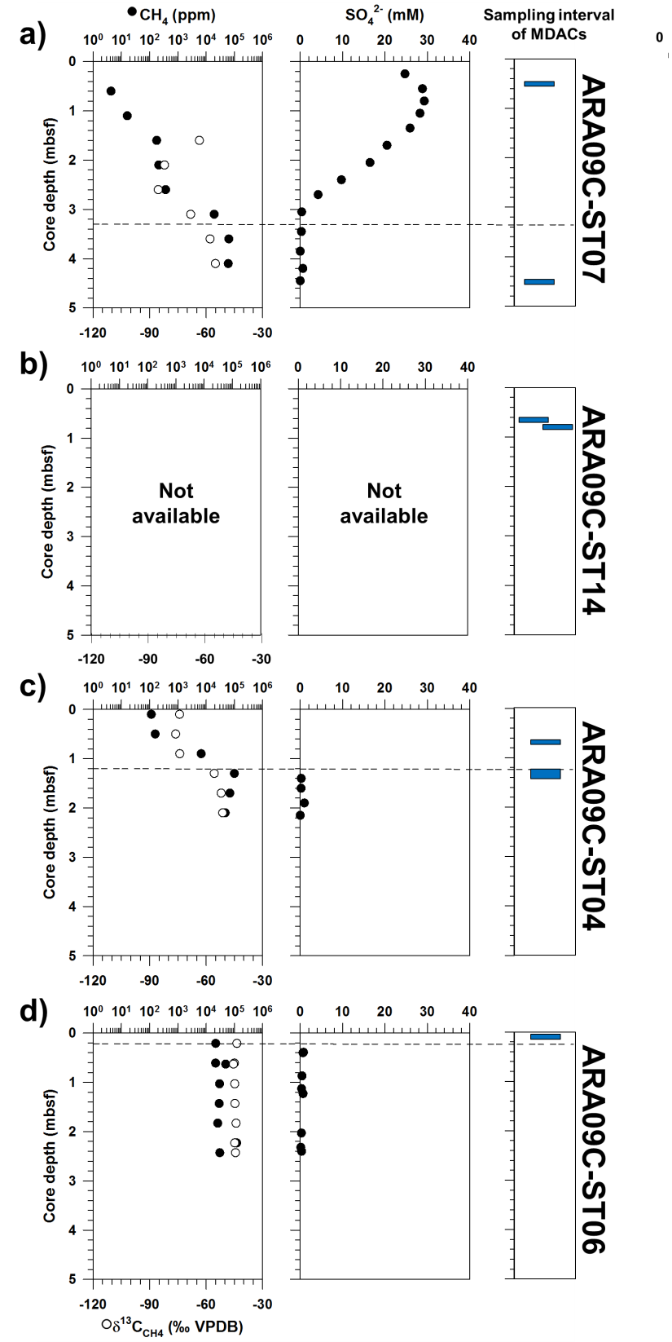
Figure S1. Downcore profiles of CH₄ concentrations (ppm) and δ¹³C_{CH4} values (‰ VPDB) of headspace gases and dissolved sulfate (mM) in porewater with the indication of the MDAC sampling interval at sites a) ARA09C-ST07, b) ARA09C-ST014, c) ARA09C-ST04, and d) ARA09-ST06 (Kim et al., 2020 and 2022). Note that the data for ARA09C-ST014 are not available. Black dash lines indicate the depths of sulfate-methane transition zone (SMTZ).
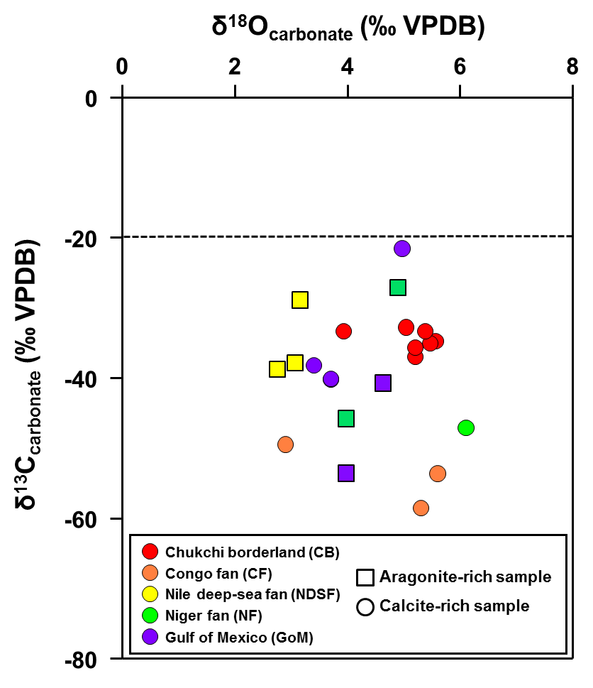
Figure S2. Scatter plot of δ¹⁸O_{carbonate} and δ¹³C_{carbonate} of authigenic carbonate samples considered in this study. The dashed line indicates the δ¹³C baseline between marine- and methane-derived carbonates.

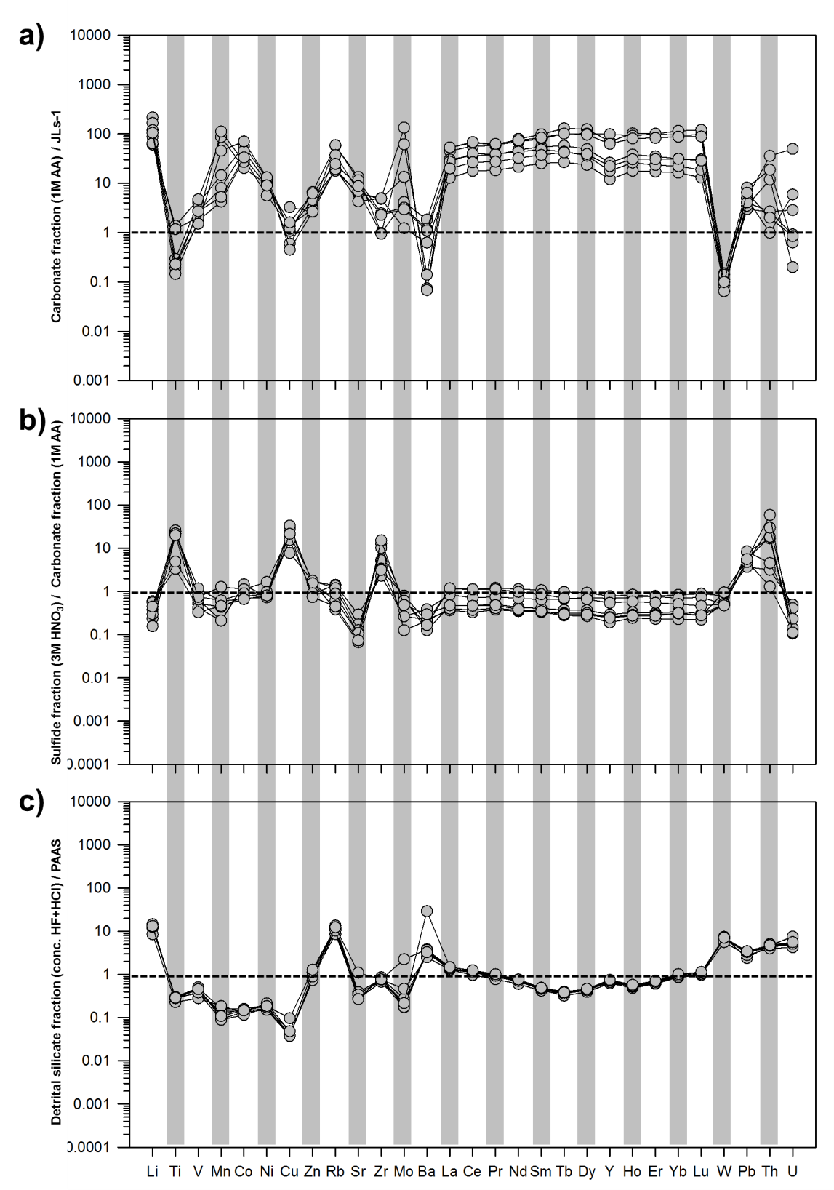
Figure S3. Enrichment factors of a) carbonate fraction (1M AA leachates) data normalized to values for the JLs-1 carbonate reference material, b) sulfide fraction (3M HNO₃ leachates) data normalized to values for corresponding carbonate fractions (1M AA leachates), and c) detrital silicate fraction (concentrated HF + HCl leachates) data normalized to values for the PAAS reference material.
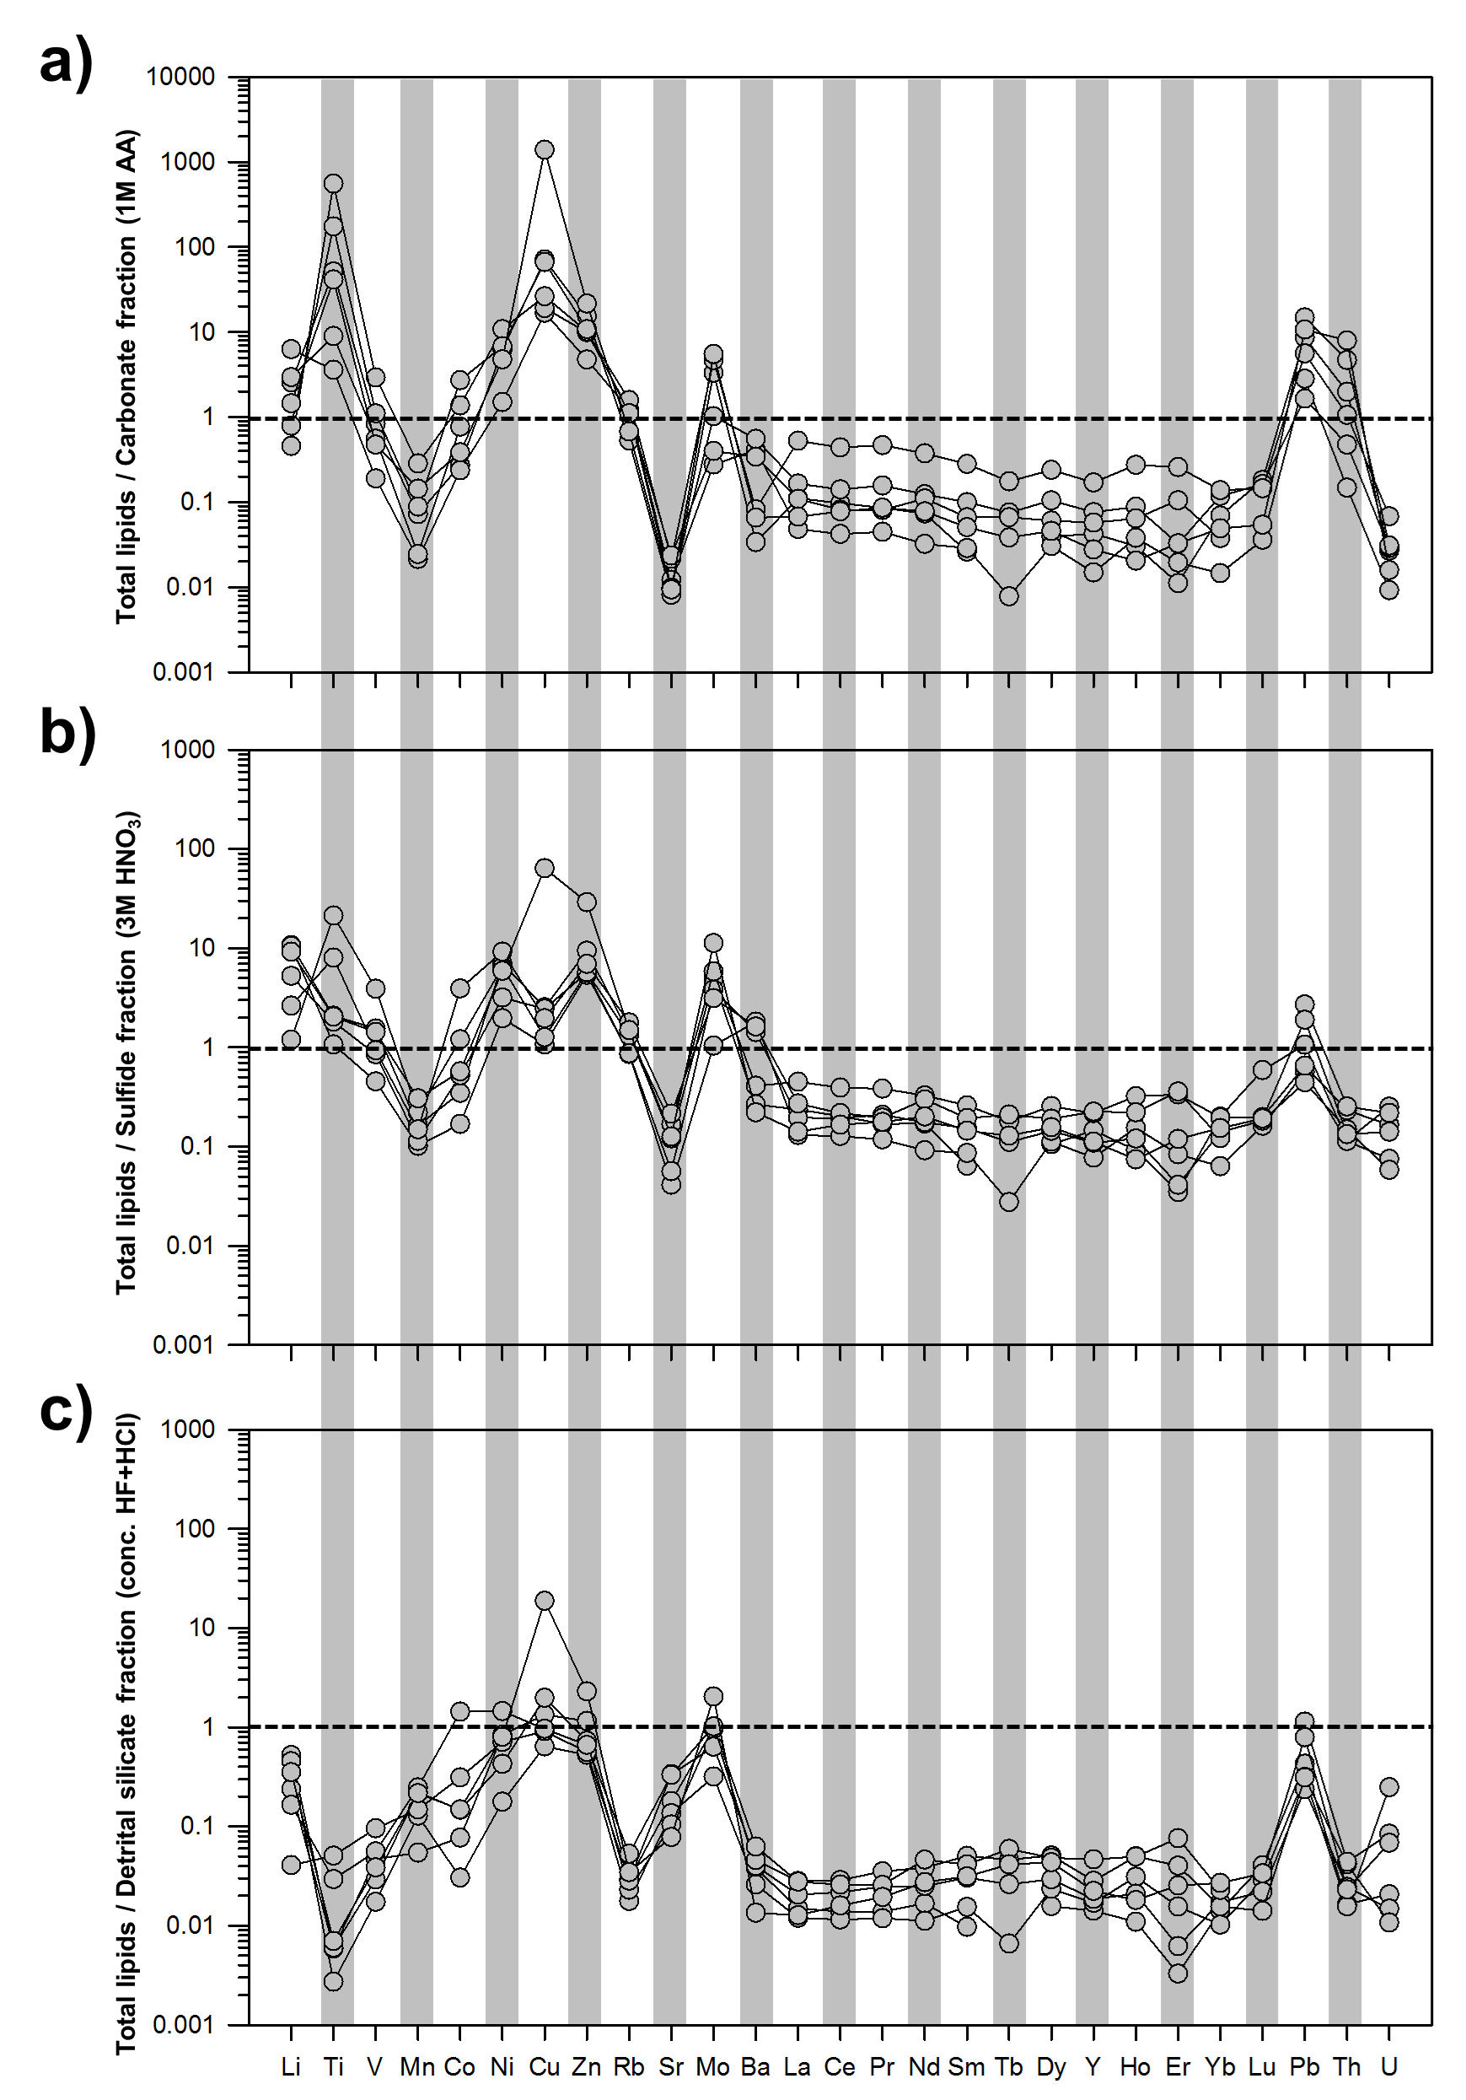
Figure S4. Enrichment factors of total lipids normalized to values for a) carbonate fractions (1M AA leachates), b) sulfide fractions (3M HNO₃ leachates), and c) detrital silicate fractions (concentrated HF + HCl leachates).
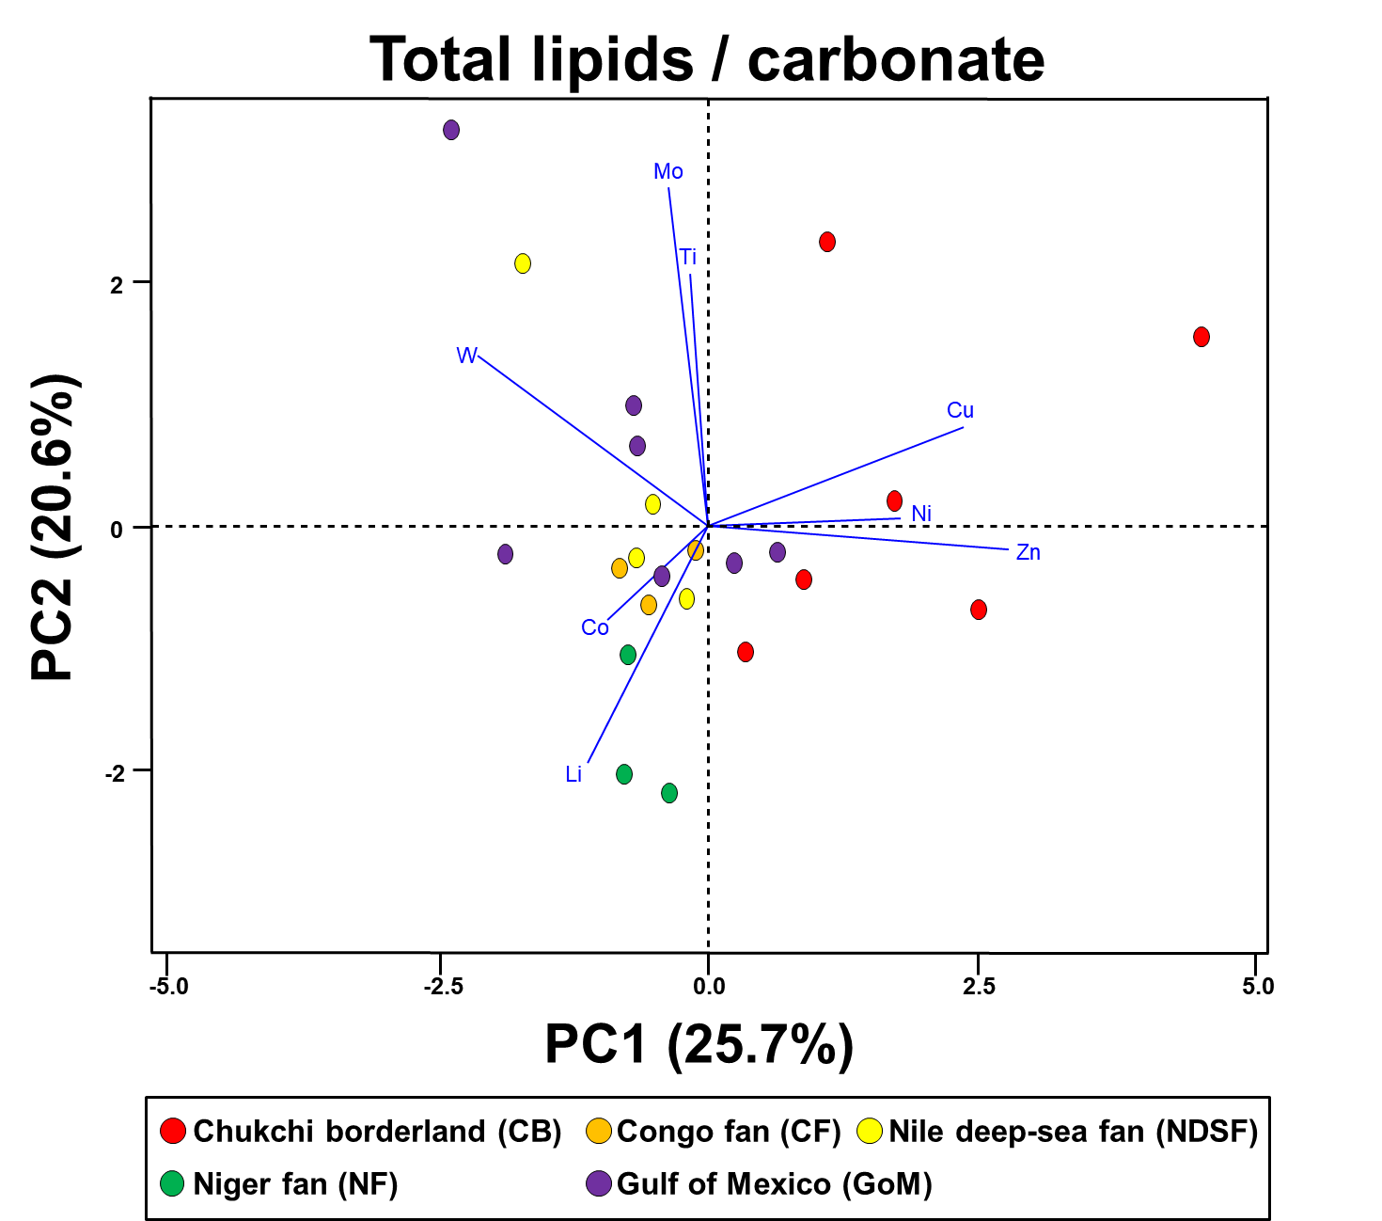
Figure S5. PCA results for the trace metal data for the total lipids normalized to the values of the carbonate fraction.

