Supplementary material
Supplementary Table S1. Available/in development monitoring technologies to cover the needs of N. norvegicus stock-assessment. Sensors and vessel-assisted or autonomous platforms with different levels of monitoring footprint are presented, according to the population and individual level of analysis. Their Technology Readiness Level (TRL; assigned by the authors for levels below marketization; i.e., TRL 9) is provided as a metric of how advanced a specific technology is (Héder, 2017). Blue, green, yellow and red dots correspond to TRL3 (i.e., “experimental proof of concept”), TRL7 (i.e., “system prototype demonstration in operational environment”), TRL8 (i.e., “system complete and qualified”) and TRL9 (i.e., “actual system proven in operational environment”), respectively.
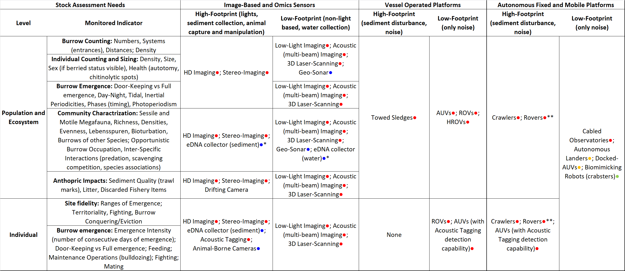
*not yet a sensor, but on the pathway to becoming a central element for augmented monitoring.
**Deployed by boats through garages, but only with a few days of full autonomy.
Supplementary Table S2. Environmental variables affecting N. norvegicus physiology, behavior, and overall ecology. Examples of sensors able to measure these variables are provided, alongside the rationale for their measurement in the context of monitoring of stocks (i.e., experimentally observed or simulated effects of different climate or stressor scenarios).
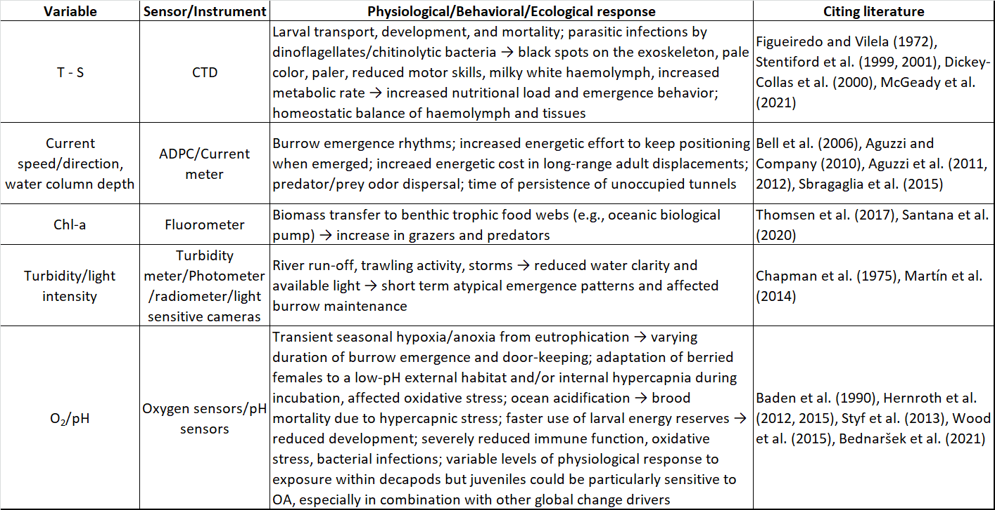

References
Aguzzi, J., and Company, J.B. (2010). Chronobiology of deep-water decapod crustaceans on continental margins. Adv. Mar. Biol. 58, 155–225. doi: 10.1016/B978-0-12-381015-1.00003-4
Aguzzi, J., Company, J.B., Costa, C., Menesatti, P., Garcia, J.A., Bahamon, N., et al. (2011). Activity rhythms in the deep-sea: a chronobiological approach. Front. Biosci. Landmark Ed. 16, 131–150. doi: 10.2741/3680.
Aguzzi, J., Jamieson, A.J., Fujii, T., Sbragaglia, V., Costa, C., Menesatti, P., et al. (2012). Shifting feeding behaviour of deep-sea buccinid gastropods at natural and simulated food falls. Mar. Ecol. Prog. Ser. 458, 247–253. doi: 10.3354/meps09758
Baden, S., Pihl, L., Rosenberg, R. (1990). Effects of oxygen depletion on the ecology, blood physiology and fishery of the Norway lobster Nephrops norvegicus. Mar. Ecol. Prog. Ser. 67, 141–155. doi: 10.3354/meps067141
Bednaršek, N., Ambrose, R., Calosi, P., Childers, R.K., Feely, R.A., Litvin, S.Y., et al. (2021). Synthesis of thresholds of ocean acidification impacts on decapods. Front. Mar. Sci. 8:651102. doi: 10.3389/fmars.2021.651102
Bell, M.C., Redant, F., Tuck, I. (2006). “Nephrops species” in Lobsters: biology, management, aquaculture and fisheries, ed. B.F. Phillips (Oxford, UK: Blackwell Publishing), 412–461. doi: 10.1002/9780470995969.ch13
Chapman, C.J., Johnstone, A.D.F., Rice, A.L. (1975). “The behaviour and ecology of the Norway lobster Nephrops norvegicus (L)” in Proceedings of the 9th European Marine Biology Symposium, ed. H.B. Barnes (Aberdeen, UK: Aberdeen University Press), 59-74
Dickey-Collas, M., McQuaid, N., Armstrong, M.J., Allen, M., Briggs, R.P. (2000). Temperature-dependent stage duration of Irish sea Nephrops larvae. J. Plankton Res. 22, 749–760. doi: 10.1093/plankt/22.4.749
Figueiredo, M.J., and Vilela, M.H. (1972). On the artificial culture of Nephrops norvegicus reared from the egg. Aquaculture 1, 173–180. doi: 10.1016/0044-8486(72)90017-8
Héder, M. (2017). From NASA to EU: the evolution of the TRL scale in Public Sector Innovation. Innov. J. 22:3
Hernroth, B., Krång, A.S., Baden, S. (2015). Bacteriostatic suppression in Norway lobster (Nephrops norvegicus) exposed to manganese or hypoxia under pressure of ocean acidification. Aquat. Toxicol. 159, 217-224. doi: 10.1016/j.aquatox.2014.11.025
Hernroth, B., Sköld, H. N., Wiklander, K., Jutfelt, F., & Baden, S. (2012). Simulated climate change causes immune suppression and protein damage in the crustacean Nephrops norvegicus. Fish & shellfish immunology, 33(5), 1095-1101.Martín, M., Puig, P., Palanques, A., Giamportone, A. (2014). Commercial bottom trawling as a driver of sediment dynamics and deep seascape evolution in the Anthropocene. Anthropocene 7, 1–15. doi: 10.1016/j.ancene.2015.01.002
McGeady, R., Lordan, C., Power, A.M. (2021). Shift in the larval phenology of a marine ectotherm due to ocean warming with consequences for larval transport. Limnol. Oceanogr. 66, 543–557. doi: 10.1002/lno.11622
Santana, C.A.d.S., Wieczorek, A.M., Browne, P., Graham, C.T., Power, A.M. (2020). Importance of suspended particulate organic matter in the diet of Nephrops norvegicus (Linnaeus, 1758). Sci. Rep. 10:3387. doi: 10.1038/s41598-020-60367-x
Sbragaglia, V., García, J.A., Chiesa, J.J., Aguzzi, J. (2015). Effect of simulated tidal currents on the burrow emergence rhythms of the Norway lobster (Nephrops norvegicus). Mar. Biol. 162, 2007–2016. doi: 10.1007/s00227-015-2726-5
Stentiford G.D., Douglas N., Atkinson R.J.A. (2001). Alteration of burrow-related behaviour of the Norway Lobster Nephrops norvegicus during infection by the parasitic dinoflagellate Hematodinium. Mar. Fresh. Behav. Physiol. 34, 139–156. doi: 10.1080/10236240109379068
Stentiford, G.D., Neil, D.M., Atkinson R.J.A. (1999). Infection by the dinoflagellate Hematodinium in the Norway lobster (Nephrops norvegicus L.) on the west coast of Scotland, United Kingdom. J. Shellfish Res. 18, 334. Abstract from the 1999 Annual Meeting of the National Shellfisheries Association (Halifax, NS, Canada)
Styf, H.K., Nilsson Sköld, H., Eriksson, S.P. (2013). Embryonic response to long‐term exposure of the marine crustacean Nephrops norvegicus to ocean acidification and elevated temperature. Ecol. Evol. 3, 5055–5065. doi: 10.1002/ece3.860
Thomsen, L., Aguzzi, J., Costa, C., De Leo, F., Ogston, A., Purser, A. (2017). The oceanic biological pump: rapid carbon transfer to depth at continental margins during winter. Sci. Rep. 7:10763. doi: 10.1038/s41598-017-11075-6
Van Raan, A.F. (2014). “Advances in bibliometric analysis: research performance assessment and science mapping” in Bibliometrics. Use and Abuse in the Review of Research Performance, eds. W. Blockmans, L. Engwall, D. Weaire (London, UK: Portland Press), 17–28.
Wood, H.L., Eriksson, S.P., Nordborg, M., Styf, H.K. (2015). The effect of environmental stressors on the early development of the Norway lobster Nephrops norvegicus (L.). J. Exp. Mar. Biol. Ecol. 473, 35–42. doi: 10.1016/j.jembe.2015.08.009

