Supplementary materials

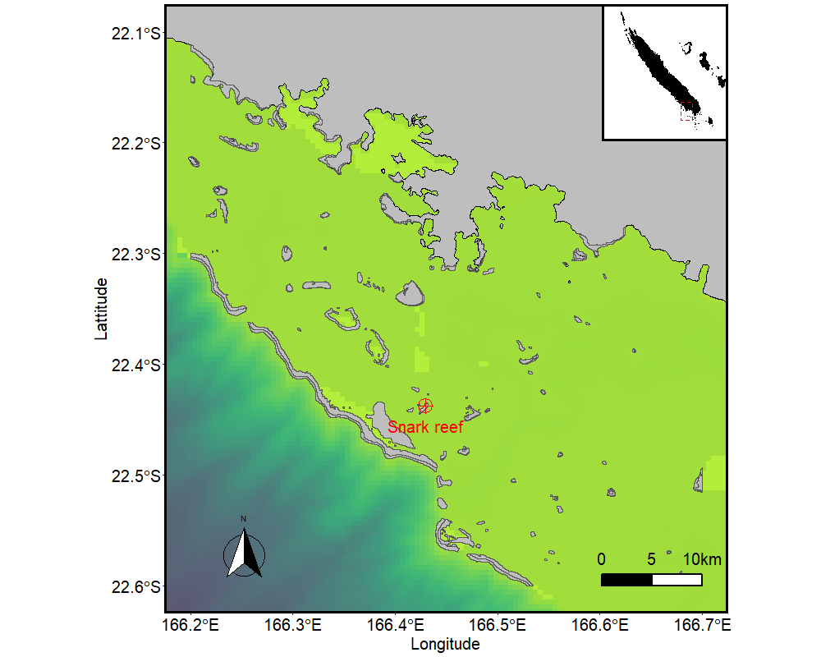
Supplementary Figure 1 : Location of the sampling site (Snark reef) of the 7 Acropora millepora colonies subjected to a long-term heat stress assay . The reef is ~1.3 km x 0.3 km wide and located in the New Caledonian lagoon ~5.5 km from the barrier. Isobaths obtained from the SHOM are represented in shades of cyan. Reefs coordinates were recorded from UNEP database(UNEP‐WCMC 2010).
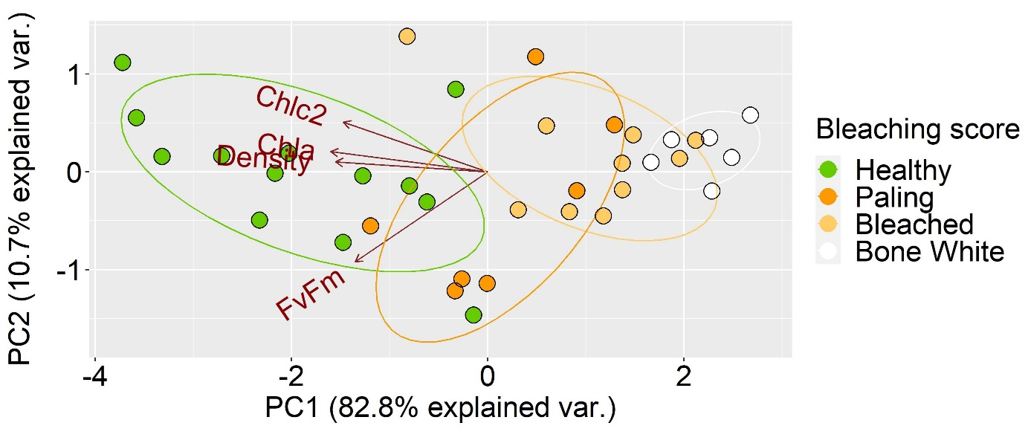
Supplementary Figure 2 : PCA components 1 and 2 of physiological parameters for the 36 nubbins sampled at the end of the experiment (3/colony/treatment). Numbers in parentheses represent the proportion of variance explained by that principal component. Samples are colored according to the bleaching score assigned visually.

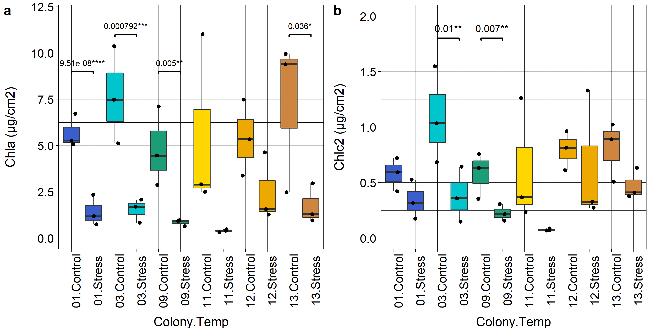

Supplementary Figure 3 : Chlorophyll content at the end of the experiment. (a) Chlorophyll a, (b) Chlorophyll c2. Horizontal bars show significant differences between groups, multiple comparisons adjusted with Games-Howell post-hoc tests. Pvalues and significance are indicated above.

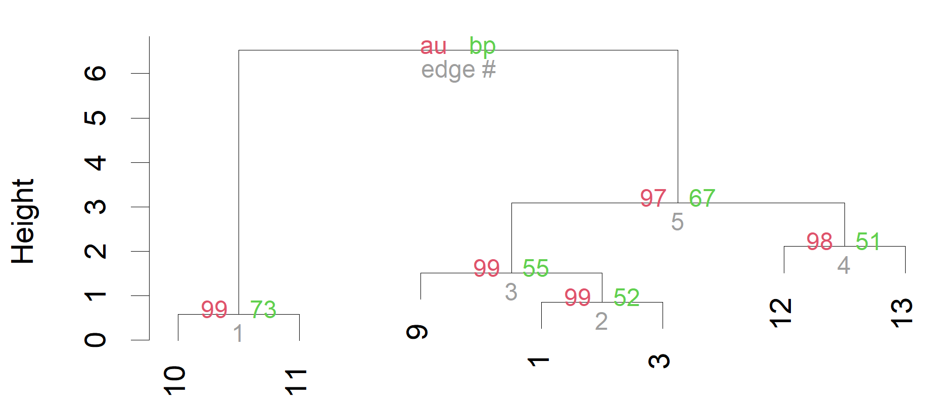
Supplementary Figure 4 : Hierarchical clustering of the 7 colonies phenotypes (Ward.D2, Euclidean distance) with 1000 bootstrap replications. Values in red represent AU (Approximately Unbiased) pvalues (%) and values in green represent BP (Bootstrap Probabilities ) pvalues (%).

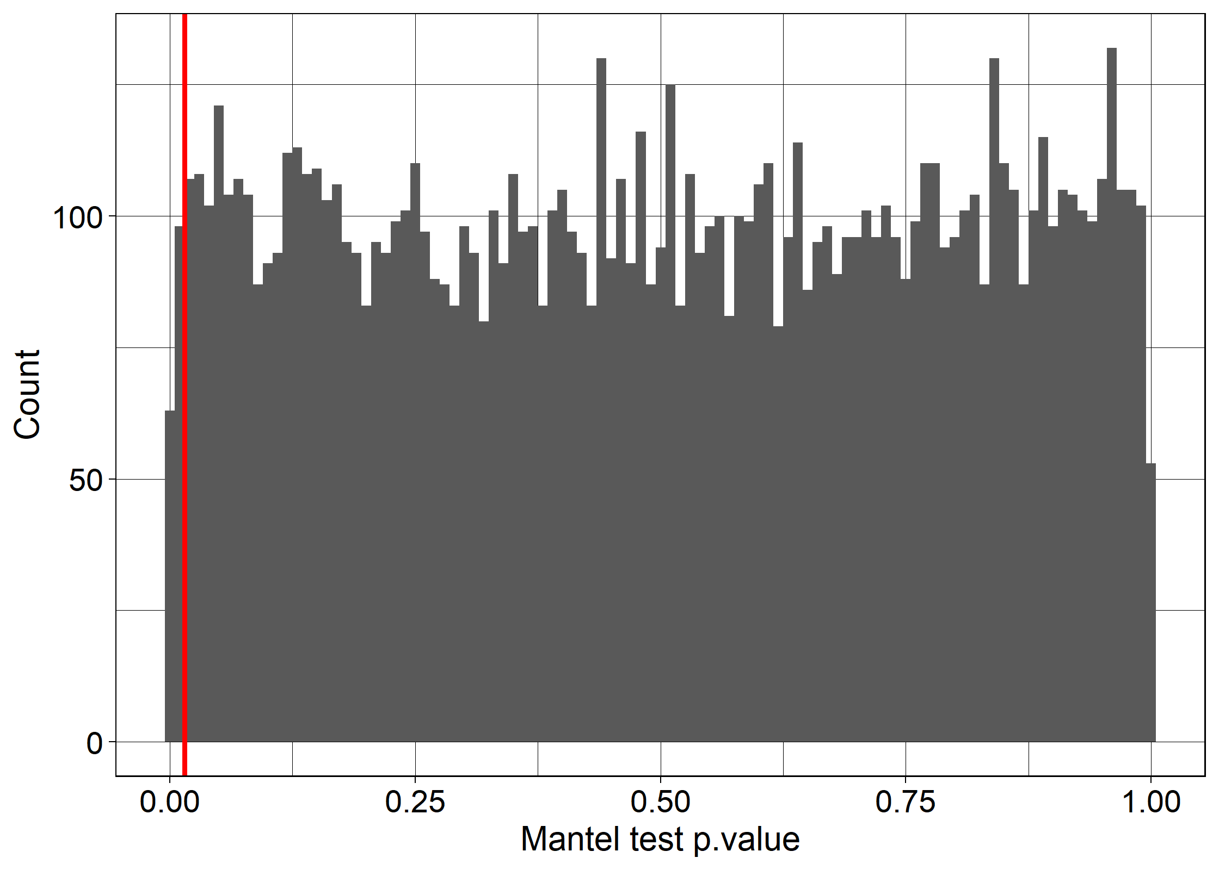
Supplementary Figure 5 : Distribution of Mantel test p-values between the phenotype dissimilarity matrix and genotype dissimilarity matrix computed from 22 random SNPs (10 000 replications). The red line indicates the p-value obtained for the genotype dissimilarity matrix computed from the restricted set of 22 SNPs with an association q-value<0.02 with one the BA variables.

UNEP‐WCMC, W.-C. (2010). "WRI, & TNC.(2010)." Global distribution of warm‐water coral reefs, compiled from multiple sources including the Millennium Coral Reef Mapping Project. Version 1.

