The Physical Oceanography of Fortune Bay, an overview
Supplementary Material
Sebastien Donnet¹, Pascal Lazure², Andry Ratsimandresy¹ and Guoqi Han³
¹Fisheries and Oceans Canada, Northwest Atlantic Fisheries Centre, 80 East White Hills Rd, St. John’s NL, A1C 5X1
² Ifremer, Laboratoire d’Océanographie Physique et Spatiale, Centre Bretagne, ZI de la Pointe du Diable, CS 10070, 29280 Plouzané, FRANCE
³ Fisheries and Oceans Canada, Institute of Ocean Sciences, 9860 West Saanich Road,Sidney, BC, V8L 4B2
Correspondence to: Sebastien Donnet (sebastien.donnet@dfo-mpo.gc.ca)

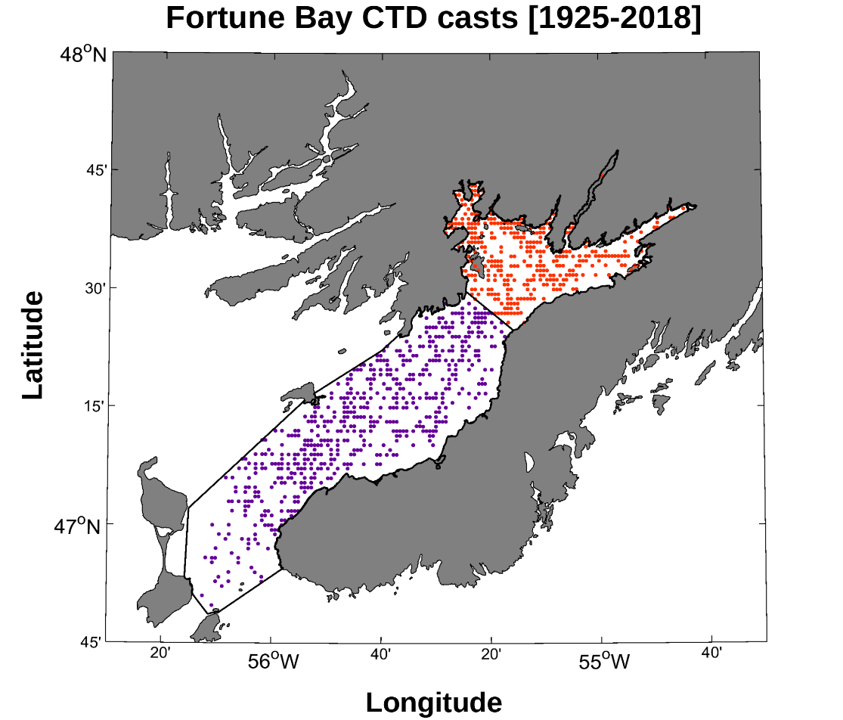
Figure S1: available hydrographic profiles in Fortune Bay. The region is separated in two areas, BB (red dots) and FB (purple dots).
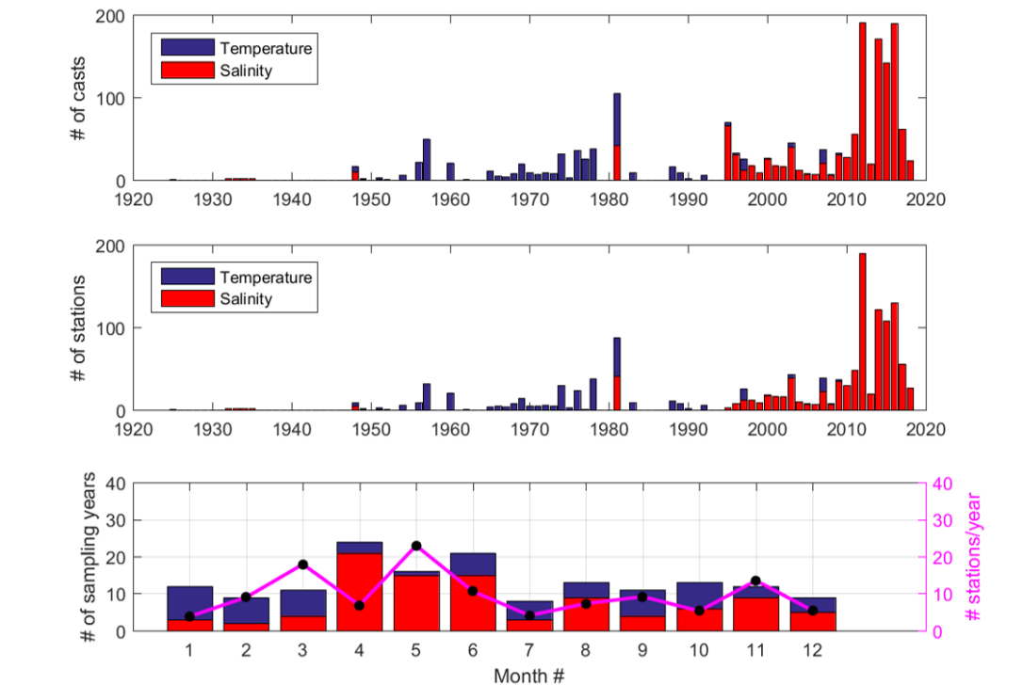
Figure S2: available hydrographic profiles in Fortune Bay (as a whole). # of sampling years correspond to the number of years with at least 1 cast within the area of interest while (i.e. a measure of temporal coverage) # stations/year is average number of stations used per year for any given calendar month (i.e. a measure of spatial coverage).

Linear T-S relationships
A linear regression analysis was performed on monthly Temperature-Salinity (T-S) diagrams to both derive T-S relationships allowing the determination of salinity from temperature data and study water masses. Illustrations of T-S relationship are given in Figure S3-S6 and a summary of the regression analysis is provided in Table S1 and Table S2. Up to 3 regressions were needed to fit the T-S scatters, varying from month to month and corresponding to the water masses observed for each month. The number of regressions, and depth ranges chosen to make them, were determined by visual inspection of inflection points; corresponding to changes in the seasonal stratification and deep water characteristics.
Overall, good fits (R² > 0.7) are found with the largest part of the water column for most months with enough data. Near-surface and near-bottom regions, however, have much more scattered values resulting in much lower correlations (e.g. Mar, Sep and Oct in both FB and BB). Poorly sampled months of Dec-Feb are either unknown (in FB) or not well resolved (in BB). July is also a month that has not been well sampled both with respect to time (Figure S2) and to space (no data in FB and limited range in BB).
The robustness of the regression analysis results was tested using data collected recently in the area during which CTD profiles were taken nearby oceanographic moorings equipped with thermistor lines (Donnet et al., 2020). Generally, while we found that the salinity profiles derived from thermistor lines compared reasonably well with the profiles taken by the CTD, the ‘model’ appears sensitive to the depth chosen for the ‘inflection’ points, i.e. the depths ranges, or layers, used to make the linear fits. This results in steps in the profiles derived from the regression (Figure S7). Overall, a mean difference of 0.15 g/kg with a mean standard deviation of 0.08 g/kg and RMS value of 0.17 g/kg was found between the 62 CTD and thermistors derived salinity profiles taken between May 2015 and May 2017.
The regression analysis also allows the examination of the seasonality of the surface layer and deep water mass and to infer on the latter’s renewal processes described earlier. The presence of a well-defined intermediate layer between these two seasonally variable regions appears from June to September and is characterized by a T-S slope of about -0.1 g/kg/ºC (note that a surface layer is not defined for the month of August in FB). Warmer and saltier conditions are found from March to June below 120 m in both FB and BB as illustrated in Figures S3&S5 and indicated by the positive T-S relationship slope in Tables S1&S2. Omitting the poorly sampled month of July (short profiles and discontinuity in the data at depth) these warm conditions seem to last until August in BB while a reversing (i.e. cooling) trend occur in FB that month (negative slope; Figures S4&S6). Colder (but still salty) conditions are thus found from August to October in FB before reversing back to a positive (warmer) trend again by November. In BB, no reversal is found before the end of the year though data are too poorly sampled in December to determine whether or not it would occur that month. This seasonal bottom water cycle is consistent with the previous studies (see Hay and de Young, 1989 in particular) that described inflow (bottom water renewal) of warm MSW during the winter (December to June) and inflow of cold LCW during the summer (May to December). The time-lag seen between FB and BB areas, BB lagging by about a month in T-S characteristics, may reflect the effect of the inner sills present between FB and BB (see Figure 1 and introduction of the main text); limiting the exchange of deep water below 210 m (depth of the deepest inner sill between the main deep basin of each area).

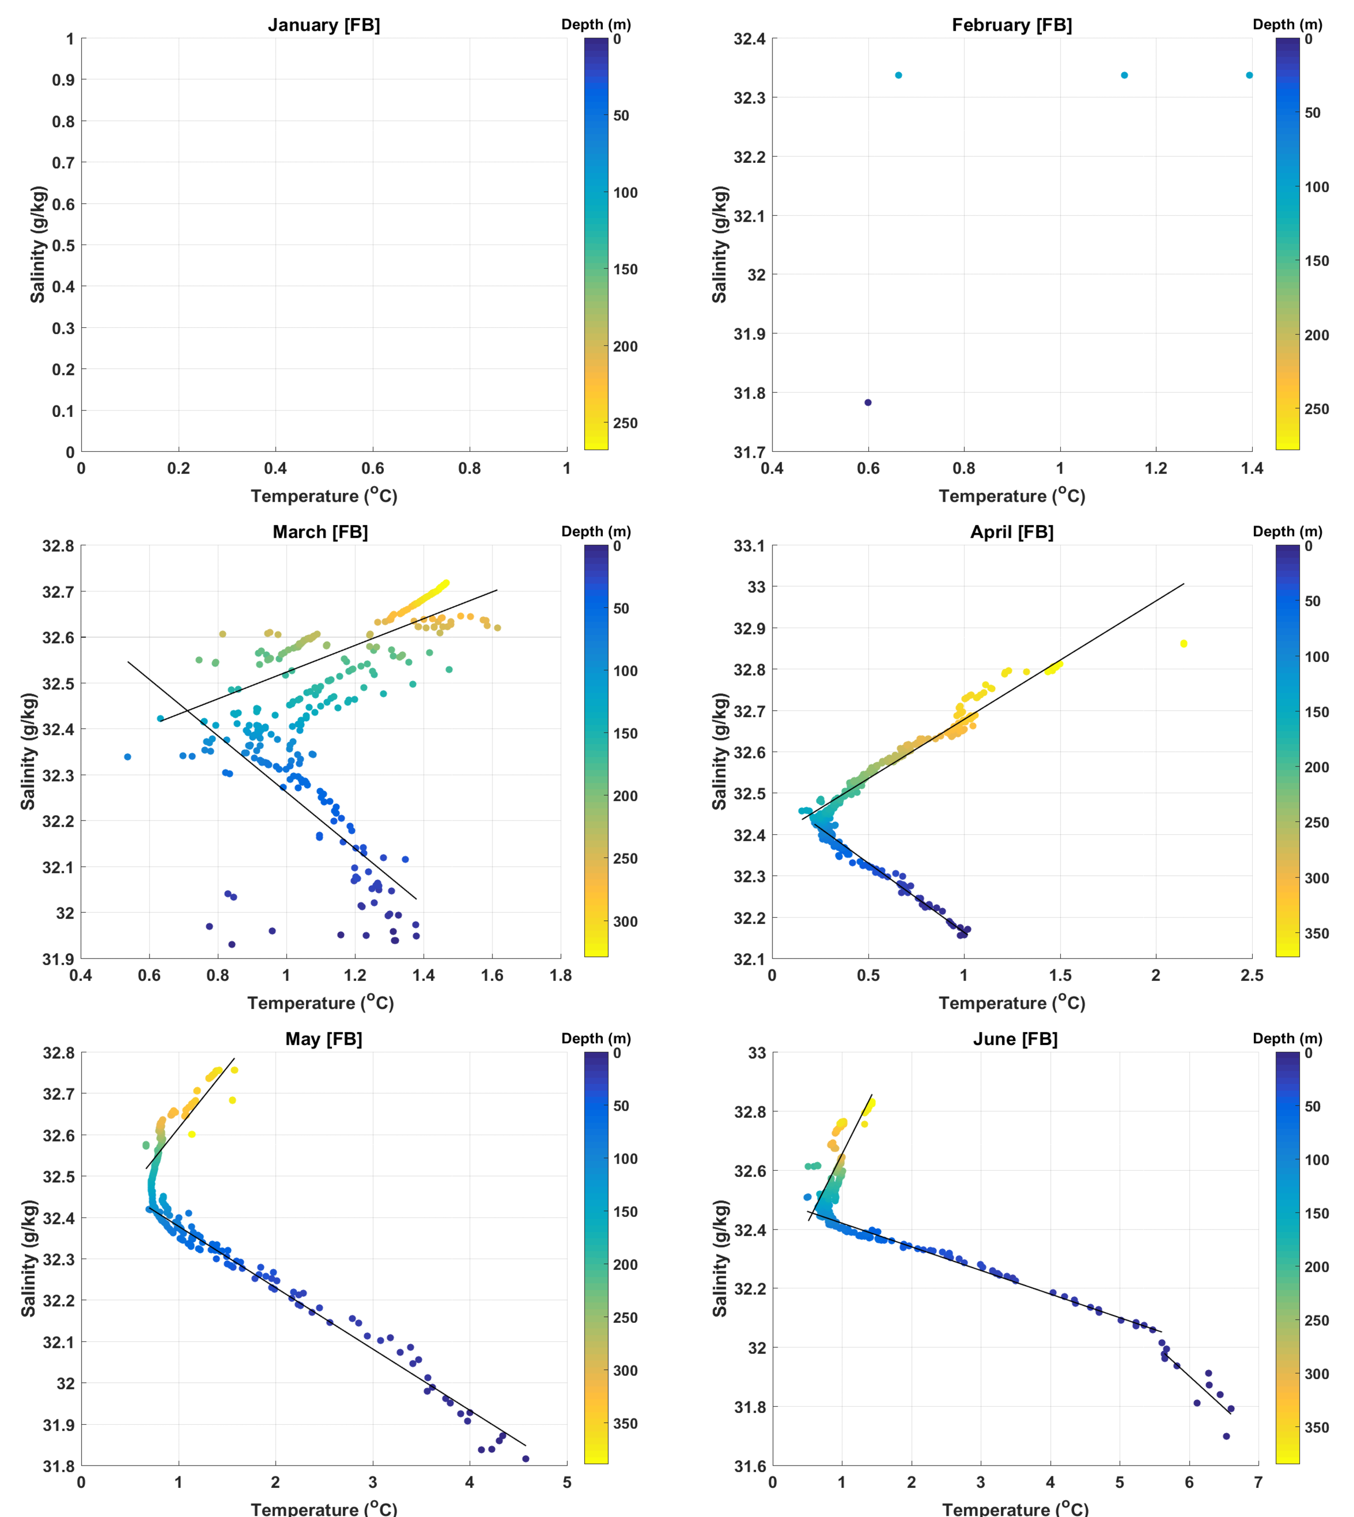Figure S3: Fortune Bay area (FB) T-S regressions (January to June). Linear regression lines are illustrated in black.

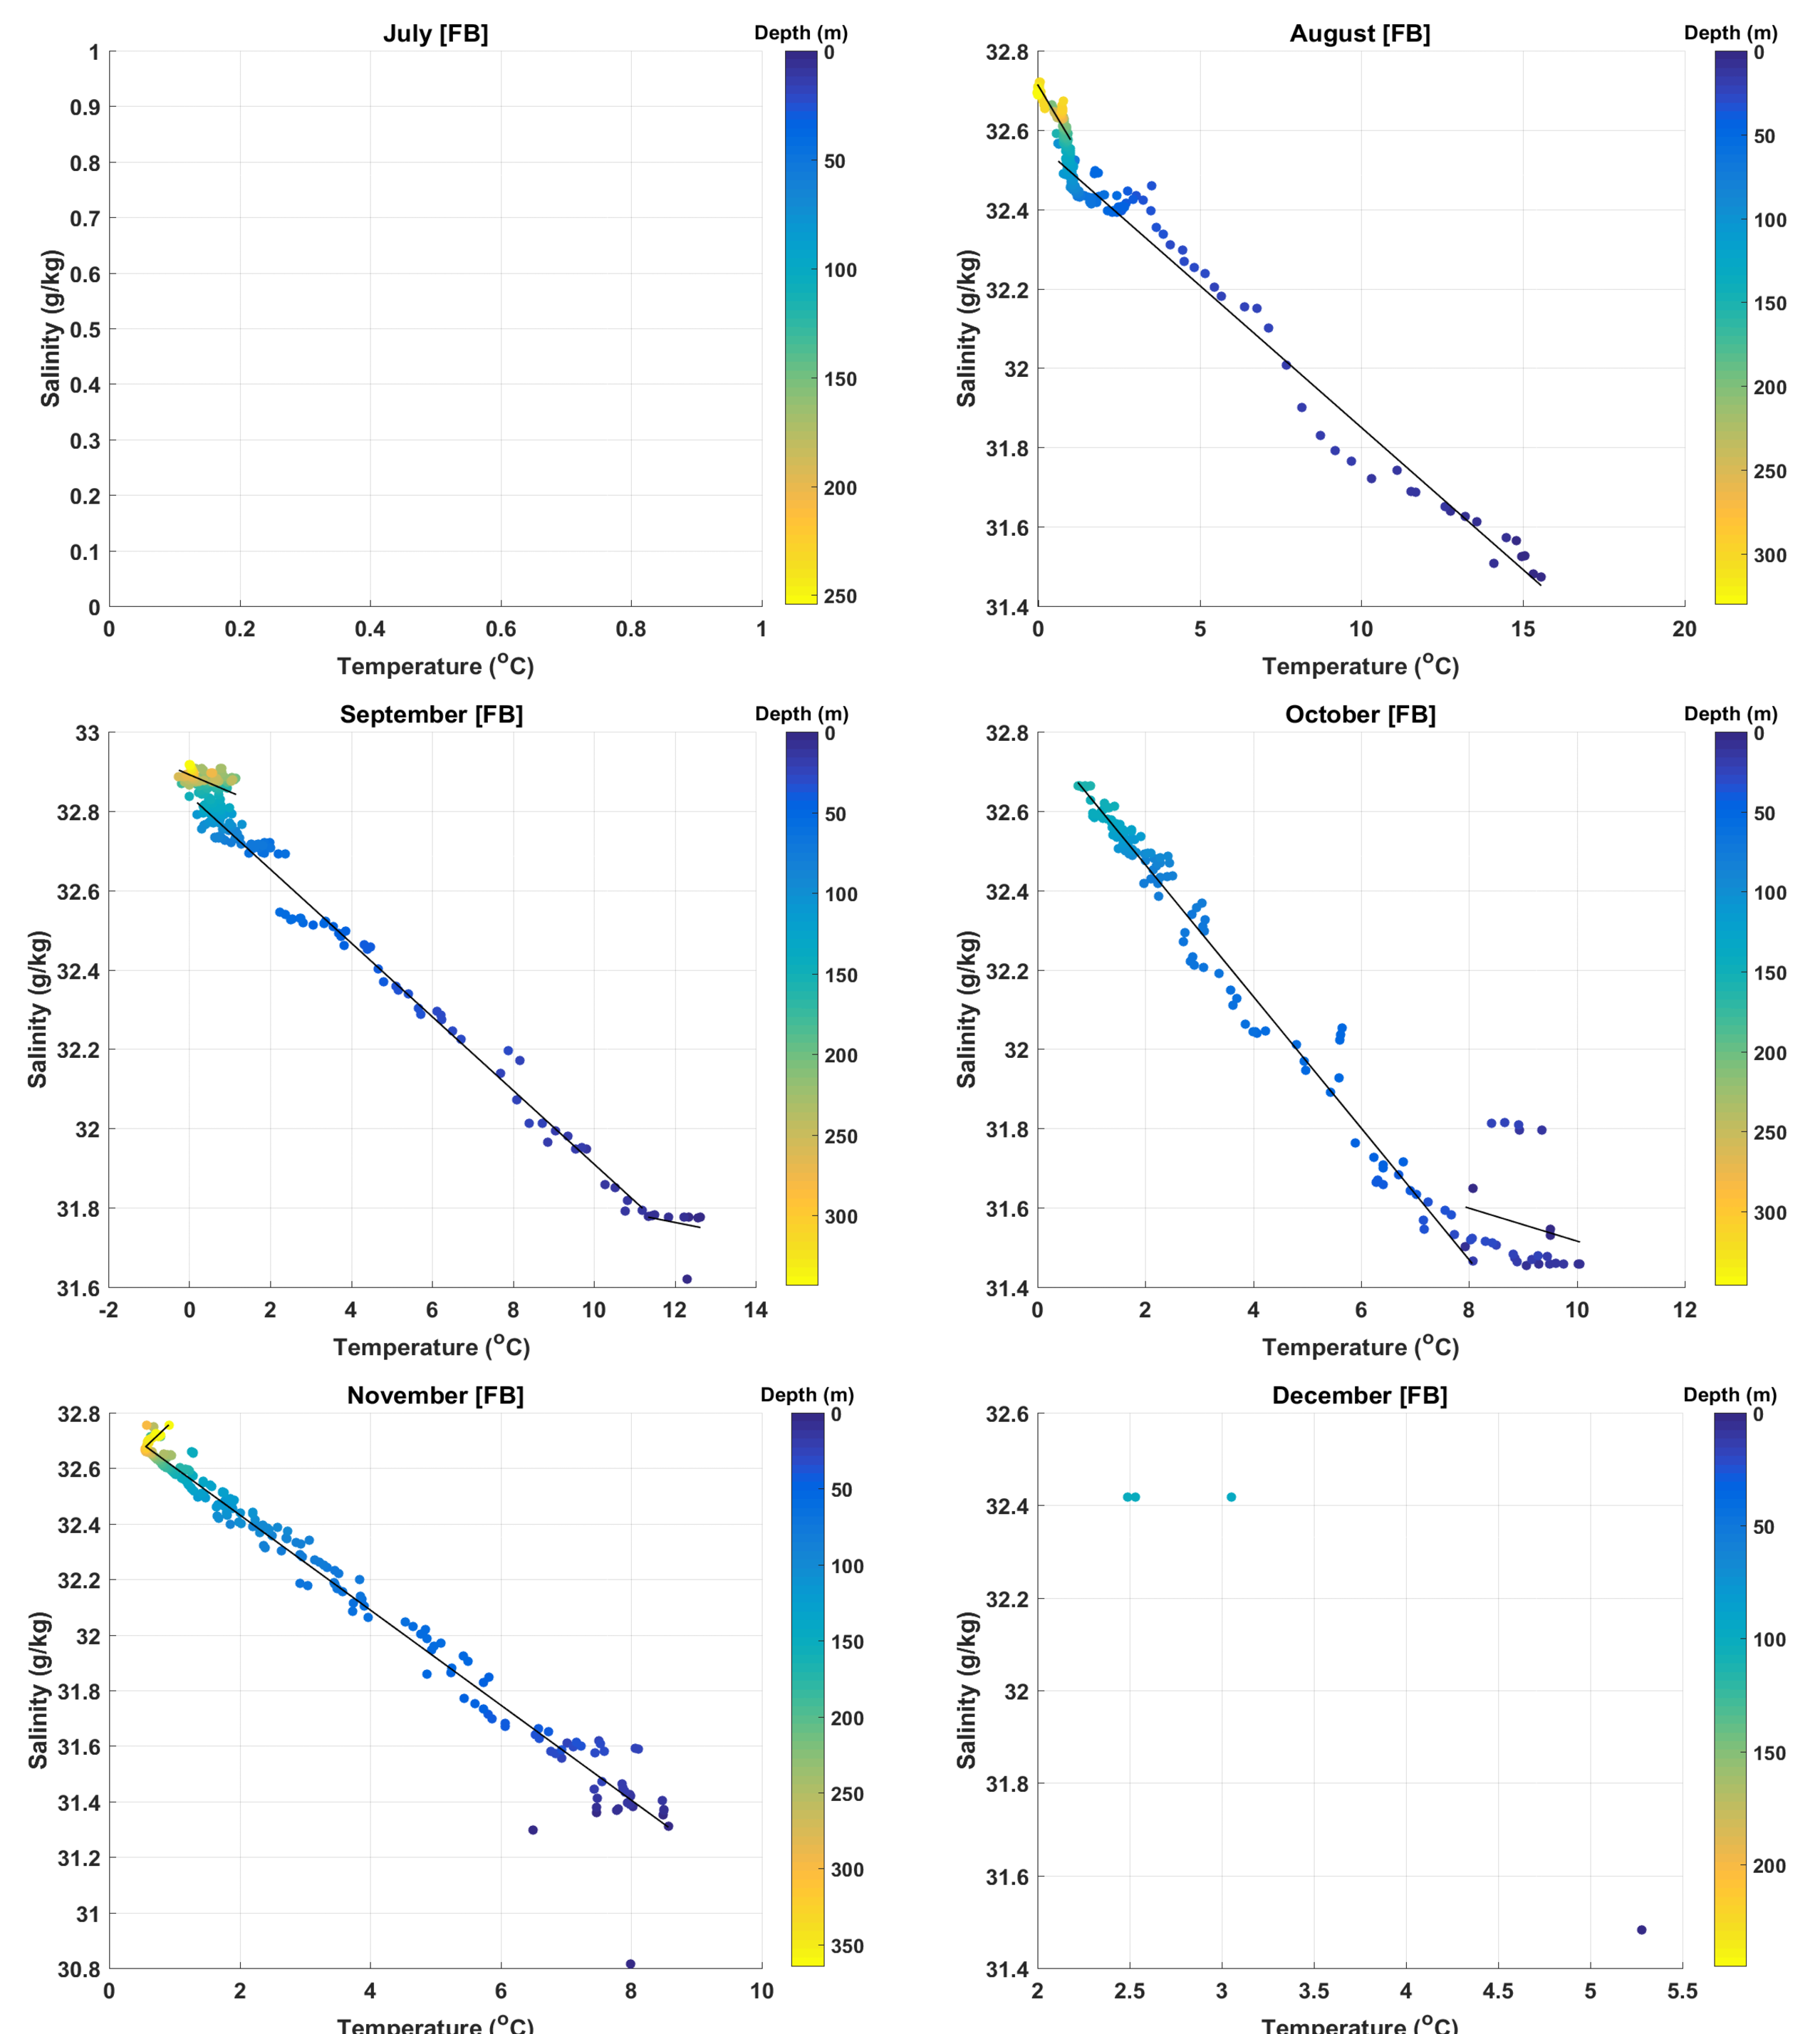Figure S4: Fortune Bay area (FB) T-S regressions (July to December). Linear regression lines are illustrated in black.

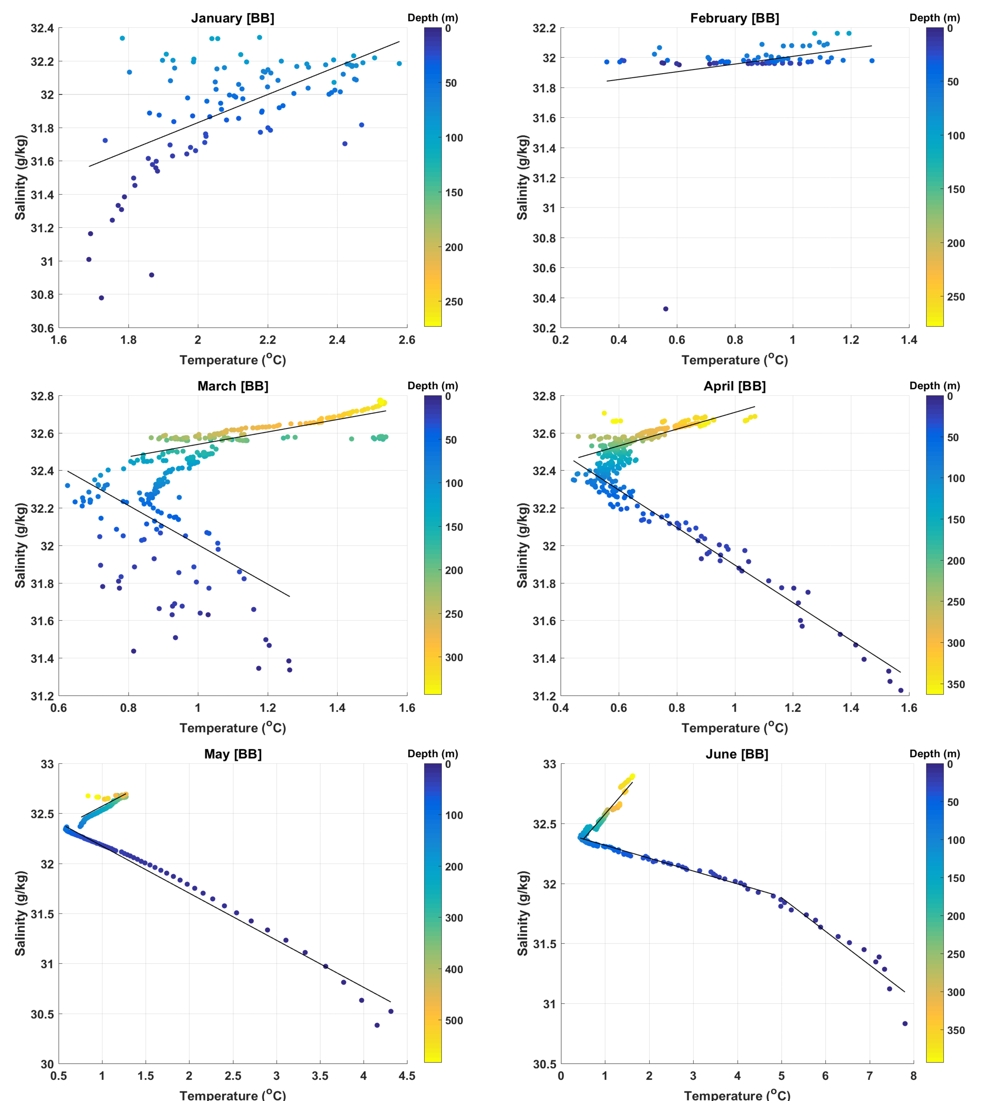Figure S5: Belle Bay area (BB) T-S regressions (January to Jun). Linear regression lines are illustrated in black.

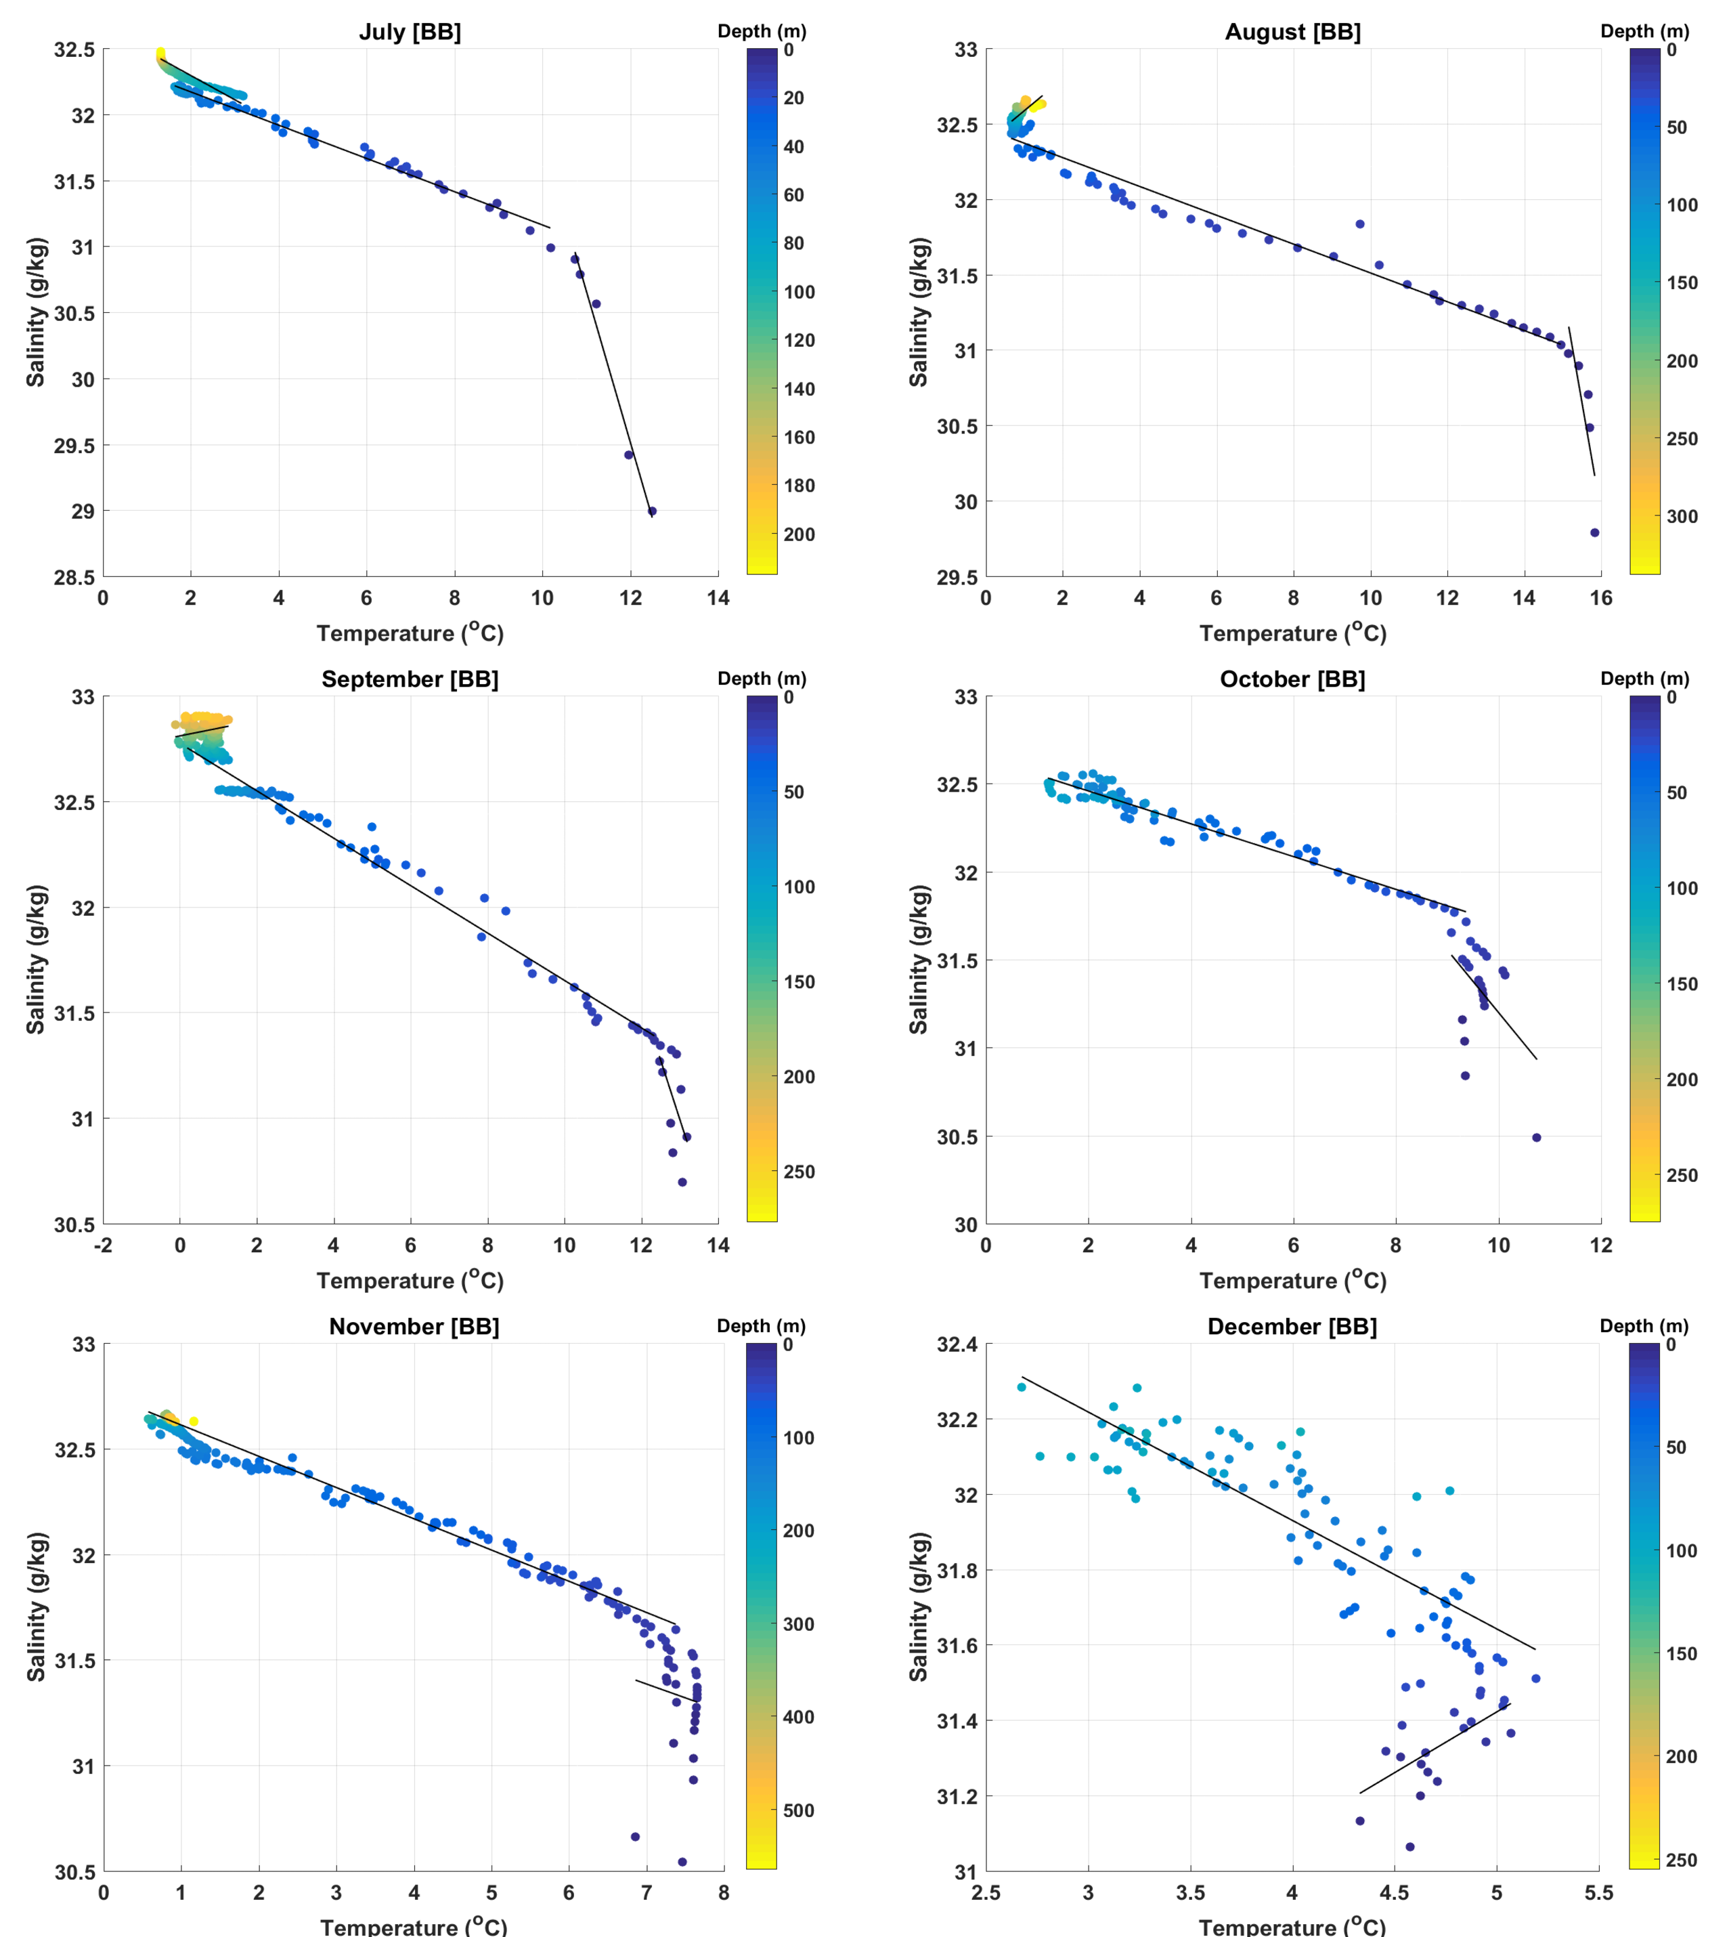Figure S6: Belle Bay area (BB) T-S regressions (July to December). Linear regression lines are illustrated in black.

Table S1: FB monthly climate T-S regressions summary. Highlighted in yellow are the regressions that should be used with caution and in red the ones that should not be used (no correlation). Salinity S = Slope x T + Intersect
FB | Jan | Feb | Mar | Apr | May | Jun | Jul | Aug | Sep | Oct | Nov | Dec
Surface Layer depth (m) | N/A | N/A | 0-120 | 0-120 | 0-120 | 0-10 | N/A | 0-120 | 0-10 | 0-30 | 0-300 | N/A
Slope | N/A | N/A | -0.61 | -0.34 | -0.15 | -0.21 | N/A | -0.07 | -0.02 | -0.04 | -0.17 | N/A
Intersect | N/A | N/A | 32.88 | 32.5 | 32.53 | 33.19 | N/A | 32.57 | 32.1 | 31.93 | 32.77 | N/A
R² | N/A | N/A | 0.50 | 0.97 | 0.98 | 0.75 | N/A | 0.98 | 0.04 | 0.03 | 0.98 | N/A
Mid-Layer depth (m) | N/A | N/A | N/A | N/A | N/A | 10-120 | N/A | N/A | 10-120 | N/A | N/A | N/A
Slope | N/A | N/A | N/A | N/A | N/A | -0.08 | N/A | N/A | -0.09 | N/A | N/A | N/A
Intersect | N/A | N/A | N/A | N/A | N/A | 32.5 | N/A | N/A | 32.84 | N/A | N/A | N/A
R² | N/A | N/A | N/A | N/A | N/A | 0.98 | N/A | N/A | 0.99 | N/A | N/A | N/A
Deep Layer depth (m) | N/A | N/A | 120-max | 120-max | 120-max | 120-max | N/A | 120-max | 120-max | 30-max (160) | 300-max | N/A
Slope | N/A | N/A | 0.29 | 0.29 | 0.29 | 0.47 | N/A | -0.14 | -0.04 | -0.17 | 0.22 | N/A
Intersect | N/A | N/A | 32.23 | 32.39 | 32.32 | 32.19 | N/A | 32.71 | 32.89 | 32.8 | 32.55 | N/A
R² | N/A | N/A | 0.50 | 0.96 | 0.62 | 0.55 | N/A | 0.69 | 0.21 | 0.98 | 0.81 | N/A
Table S2: BB monthly climate T-S regressions summary. Highlighted in yellow are the regressions that should be used with caution and in red the ones that should not be used (no correlation). Salinity S = Slope x T + Intersect
BB | Jan | Feb | Mar | Apr | May | Jun | Jul | Aug | Sep | Oct | Nov | Dec
Surface Layer depth (m) | 0-max (100) | 0-max (100) | 0-120 | 0-120 | 0-120 | 0-15 | 0-5 | 0-5 | 0-10 | 0-20 | 0-30 | 0-20
Slope | 0.84 | 0.26 | -1.05 | -1.00 | -0.47 | -0.28 | -1.14 | -1.46 | -0.56 | -0.36 | -0.13 | 0.32
Intersect | 30.15 | 31.75 | 33.05 | 32.9 | 32.64 | 33.29 | 43.25 | 53.32 | 38.31 | 34.75 | 32.30 | 29.81
R² | 0.36 | 0.07 | 0.23 | 0.96 | 0.98 | 0.90 | 0.98 | 0.68 | 0.37 | 0.22 | 0.01 | 0.35
Mid-Layer depth (m) | N/A | N/A | N/A | N/A | N/A | 15-120 | 5-70 | 5-70 | 10-130 | N/A | N/A | N/A
Slope | N/A | N/A | N/A | N/A | N/A | -0.11 | -0.13 | -0.10 | -0.11 | N/A | N/A | N/A
Intersect | N/A | N/A | N/A | N/A | N/A | 32.42 | 32.42 | 32.47 | 32.77 | N/A | N/A | N/A
R² | N/A | N/A | N/A | N/A | N/A | 0.97 | 0.99 | 0.97 | 0.98 | N/A | N/A | N/A
Deep Layer depth (m) | N/A | N/A | 120-max | 120-max | 120-max | 120-max | 70-max (210) | 70-max | 130-max (240) | 20-max (100) | 30-max | 20-max (110)
Slope | N/A | N/A | 0.33 | 0.45 | 0.46 | 0.43 | -0.18 | 0.21 | 0.04 | -0.09 | -0.15 | -0.29
Intersect | N/A | N/A | 32.21 | 32.26 | 32.12 | 32.15 | 32.66 | 32.37 | 32.81 | 32.64 | 32.76 | 33.08
R² | N/A | N/A | 0.66 | 0.56 | 0.66 | 0.92 | 0.87 | 0.51 | 0.08 | 0.95 | 0.97 | 0.76
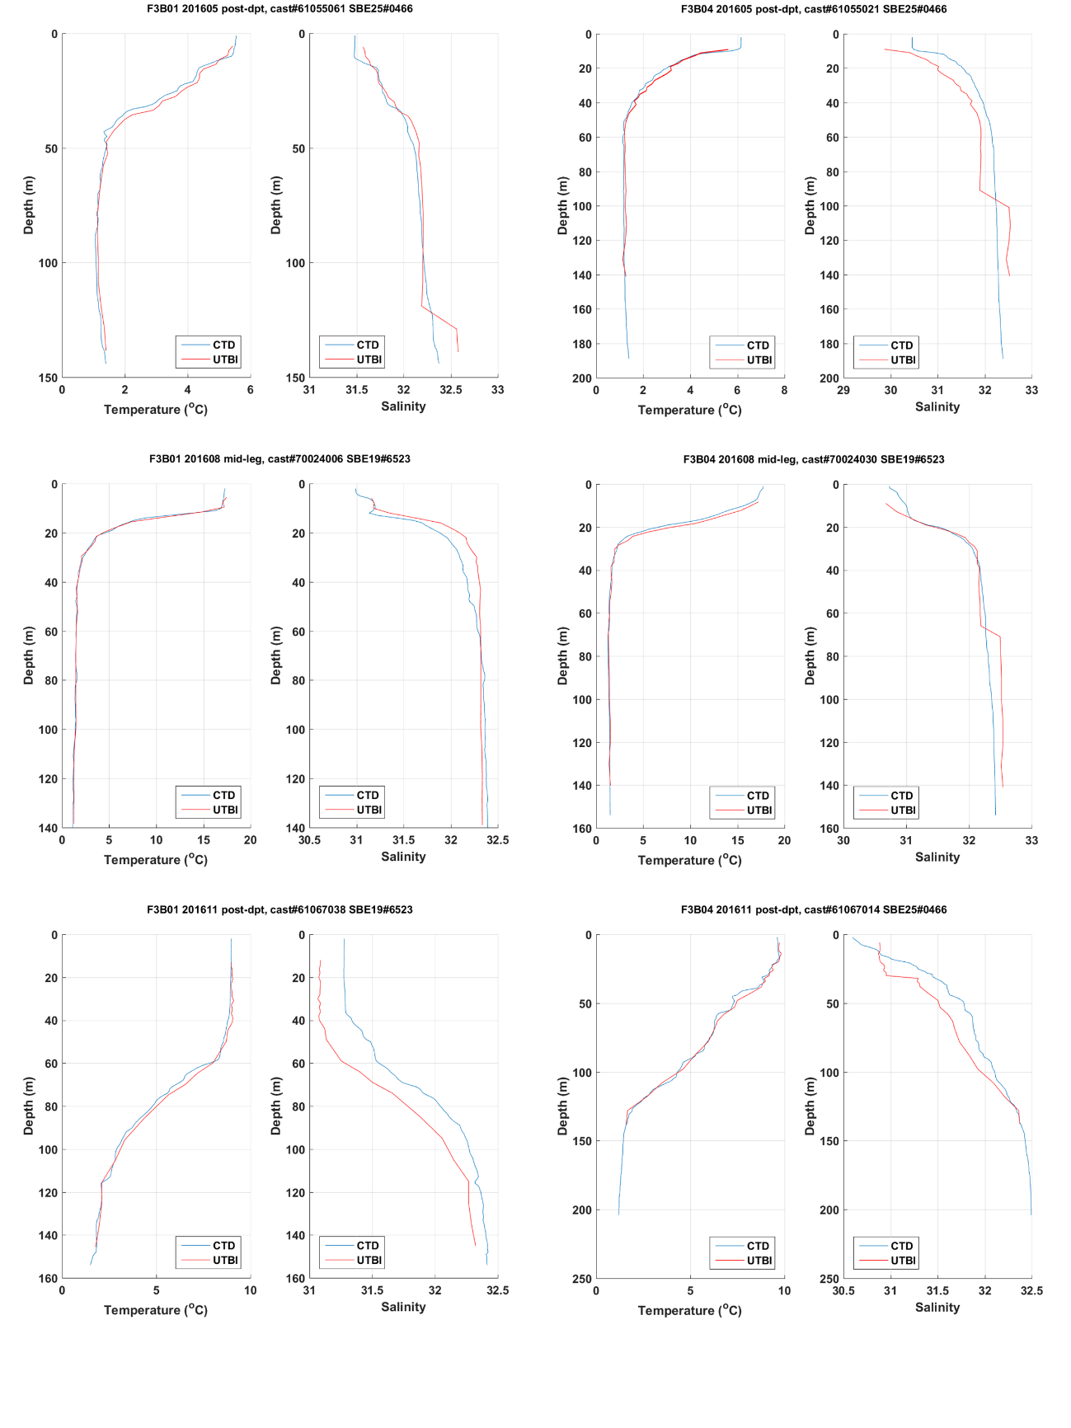Figure S7: CTD profiles (CTD) vs. moored thermistors (UTBI); UTBI salinity were calculated using the regression analysis results presented in Table S1&S2
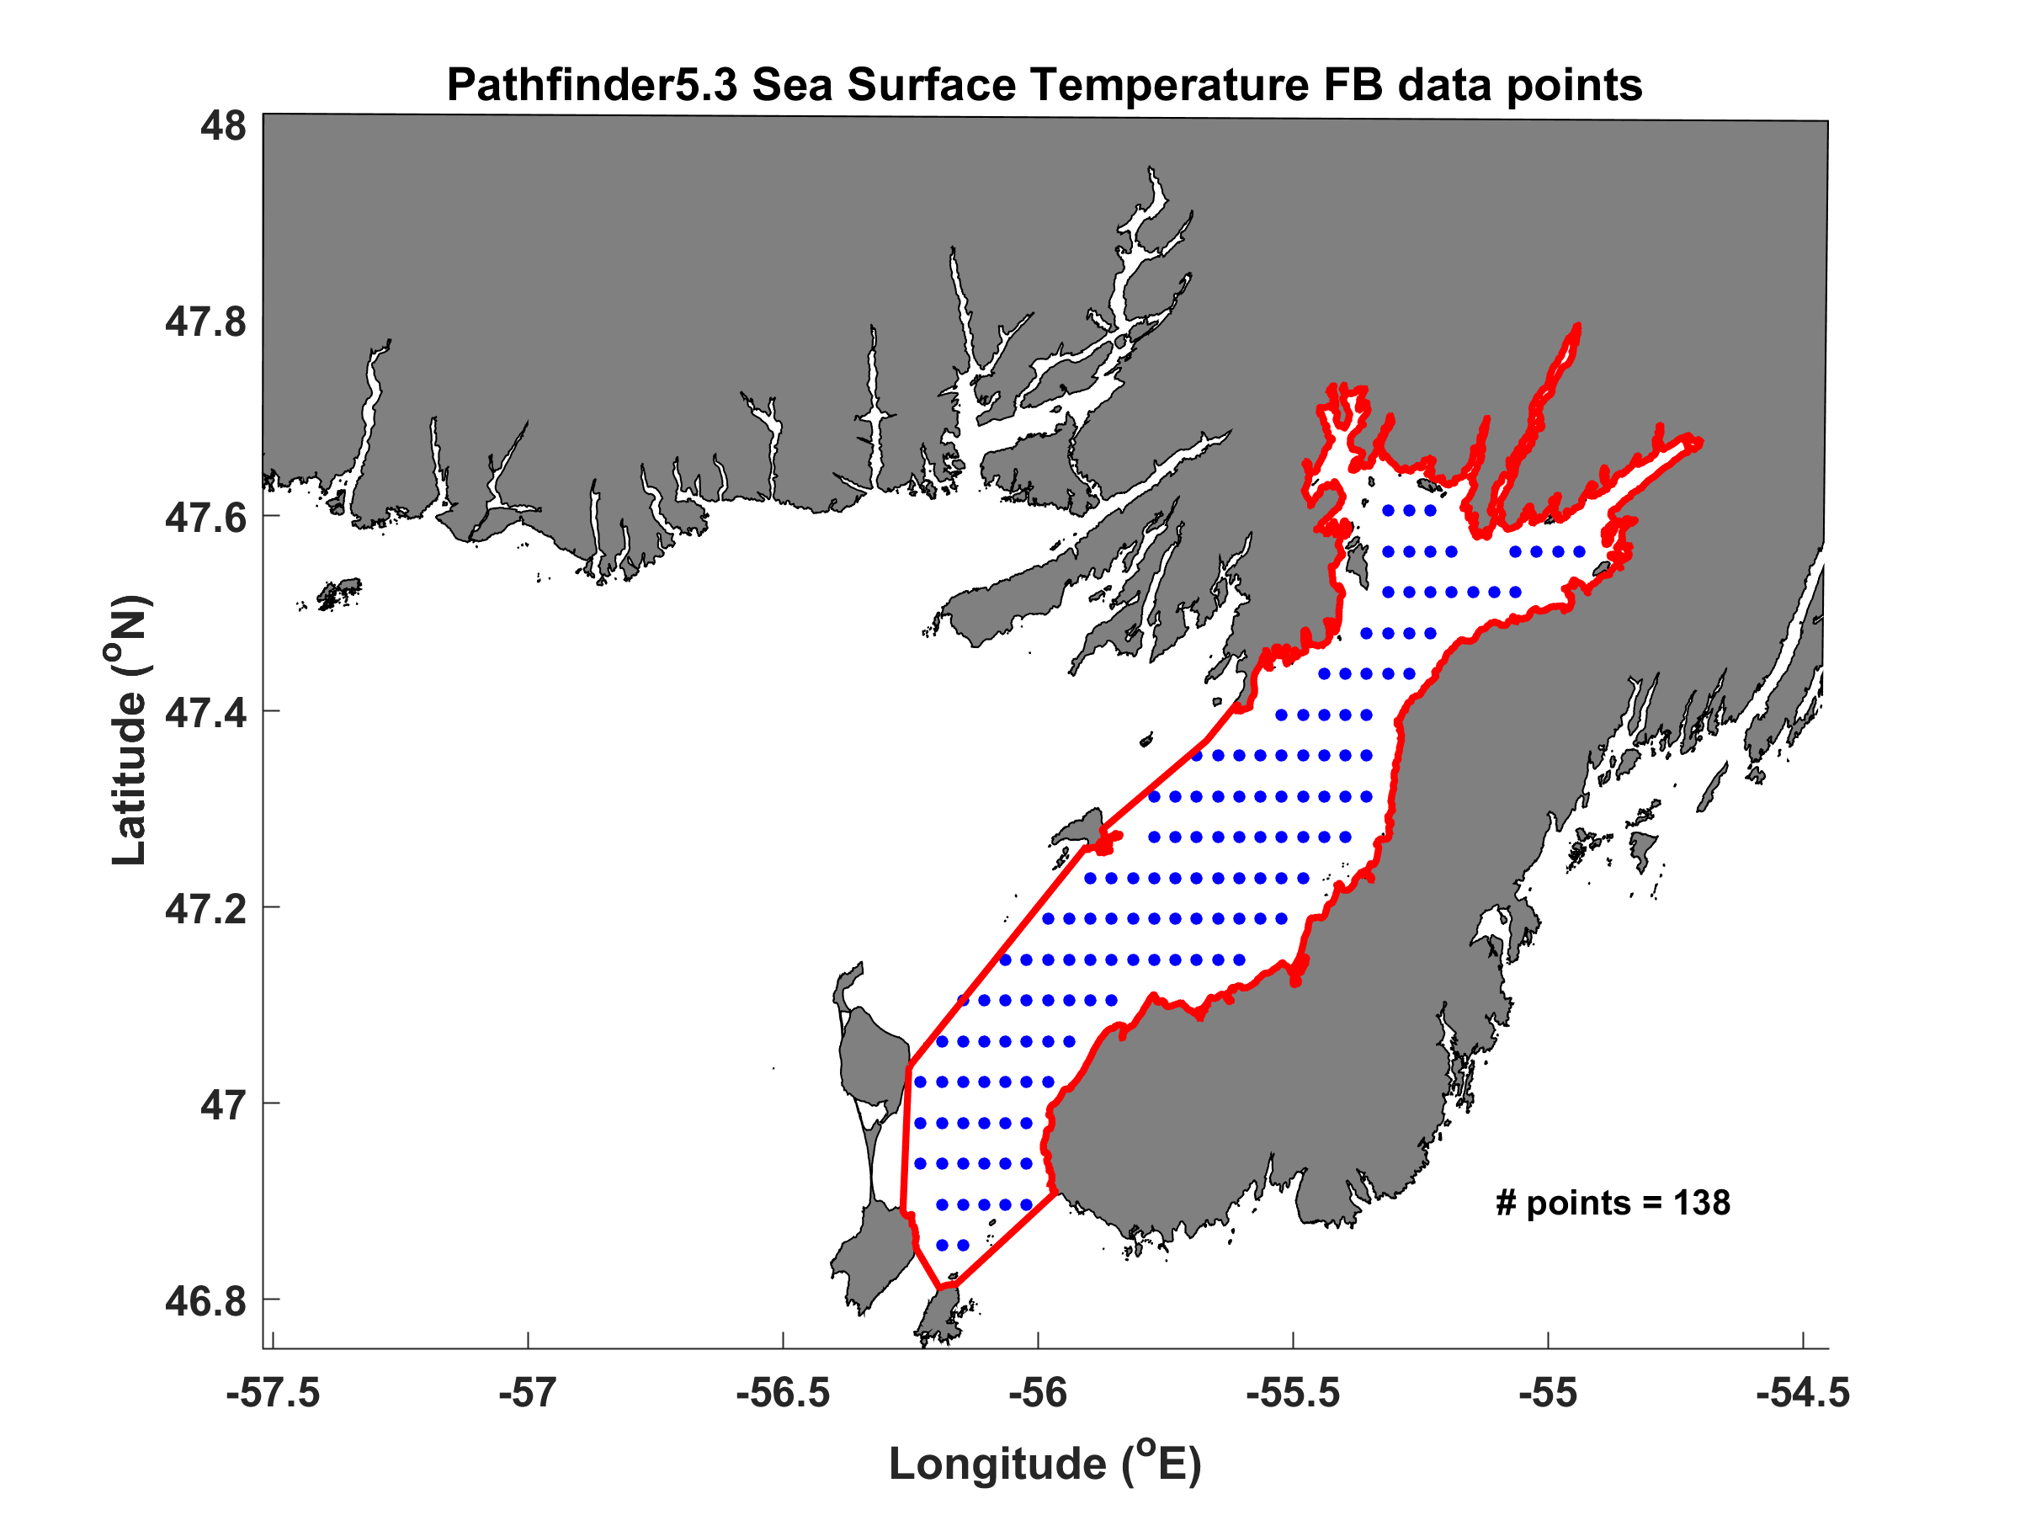Figure S8: Pathfinder v5.3 Sea Surface Temperature spatial coverage in Fortune Bay (FB)
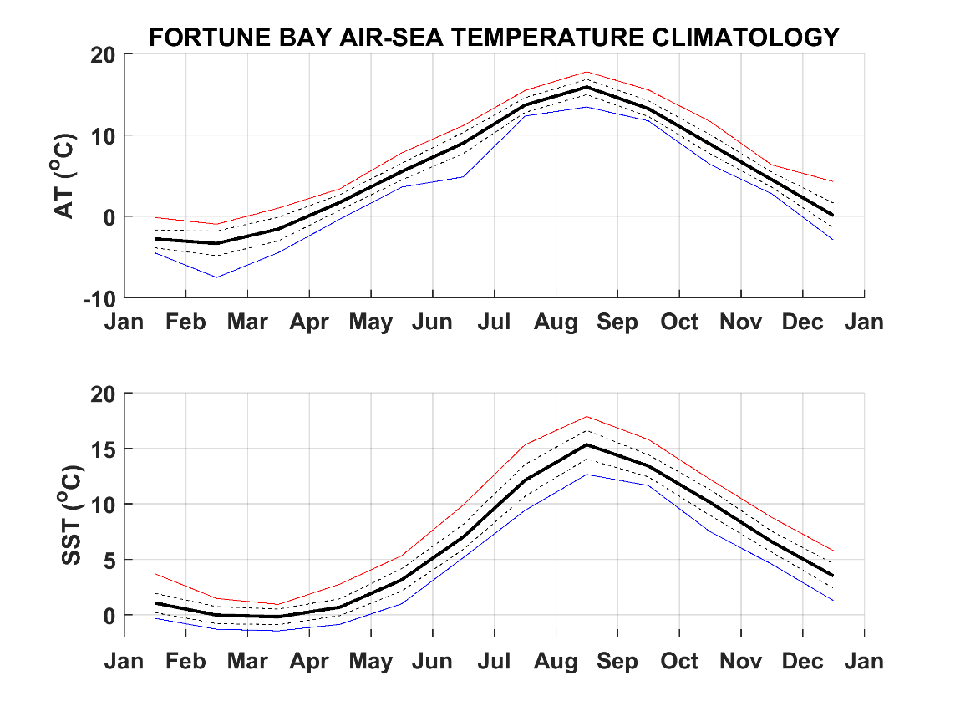
Figure S9: air-sea temperature climate (AT and SST, respectively)
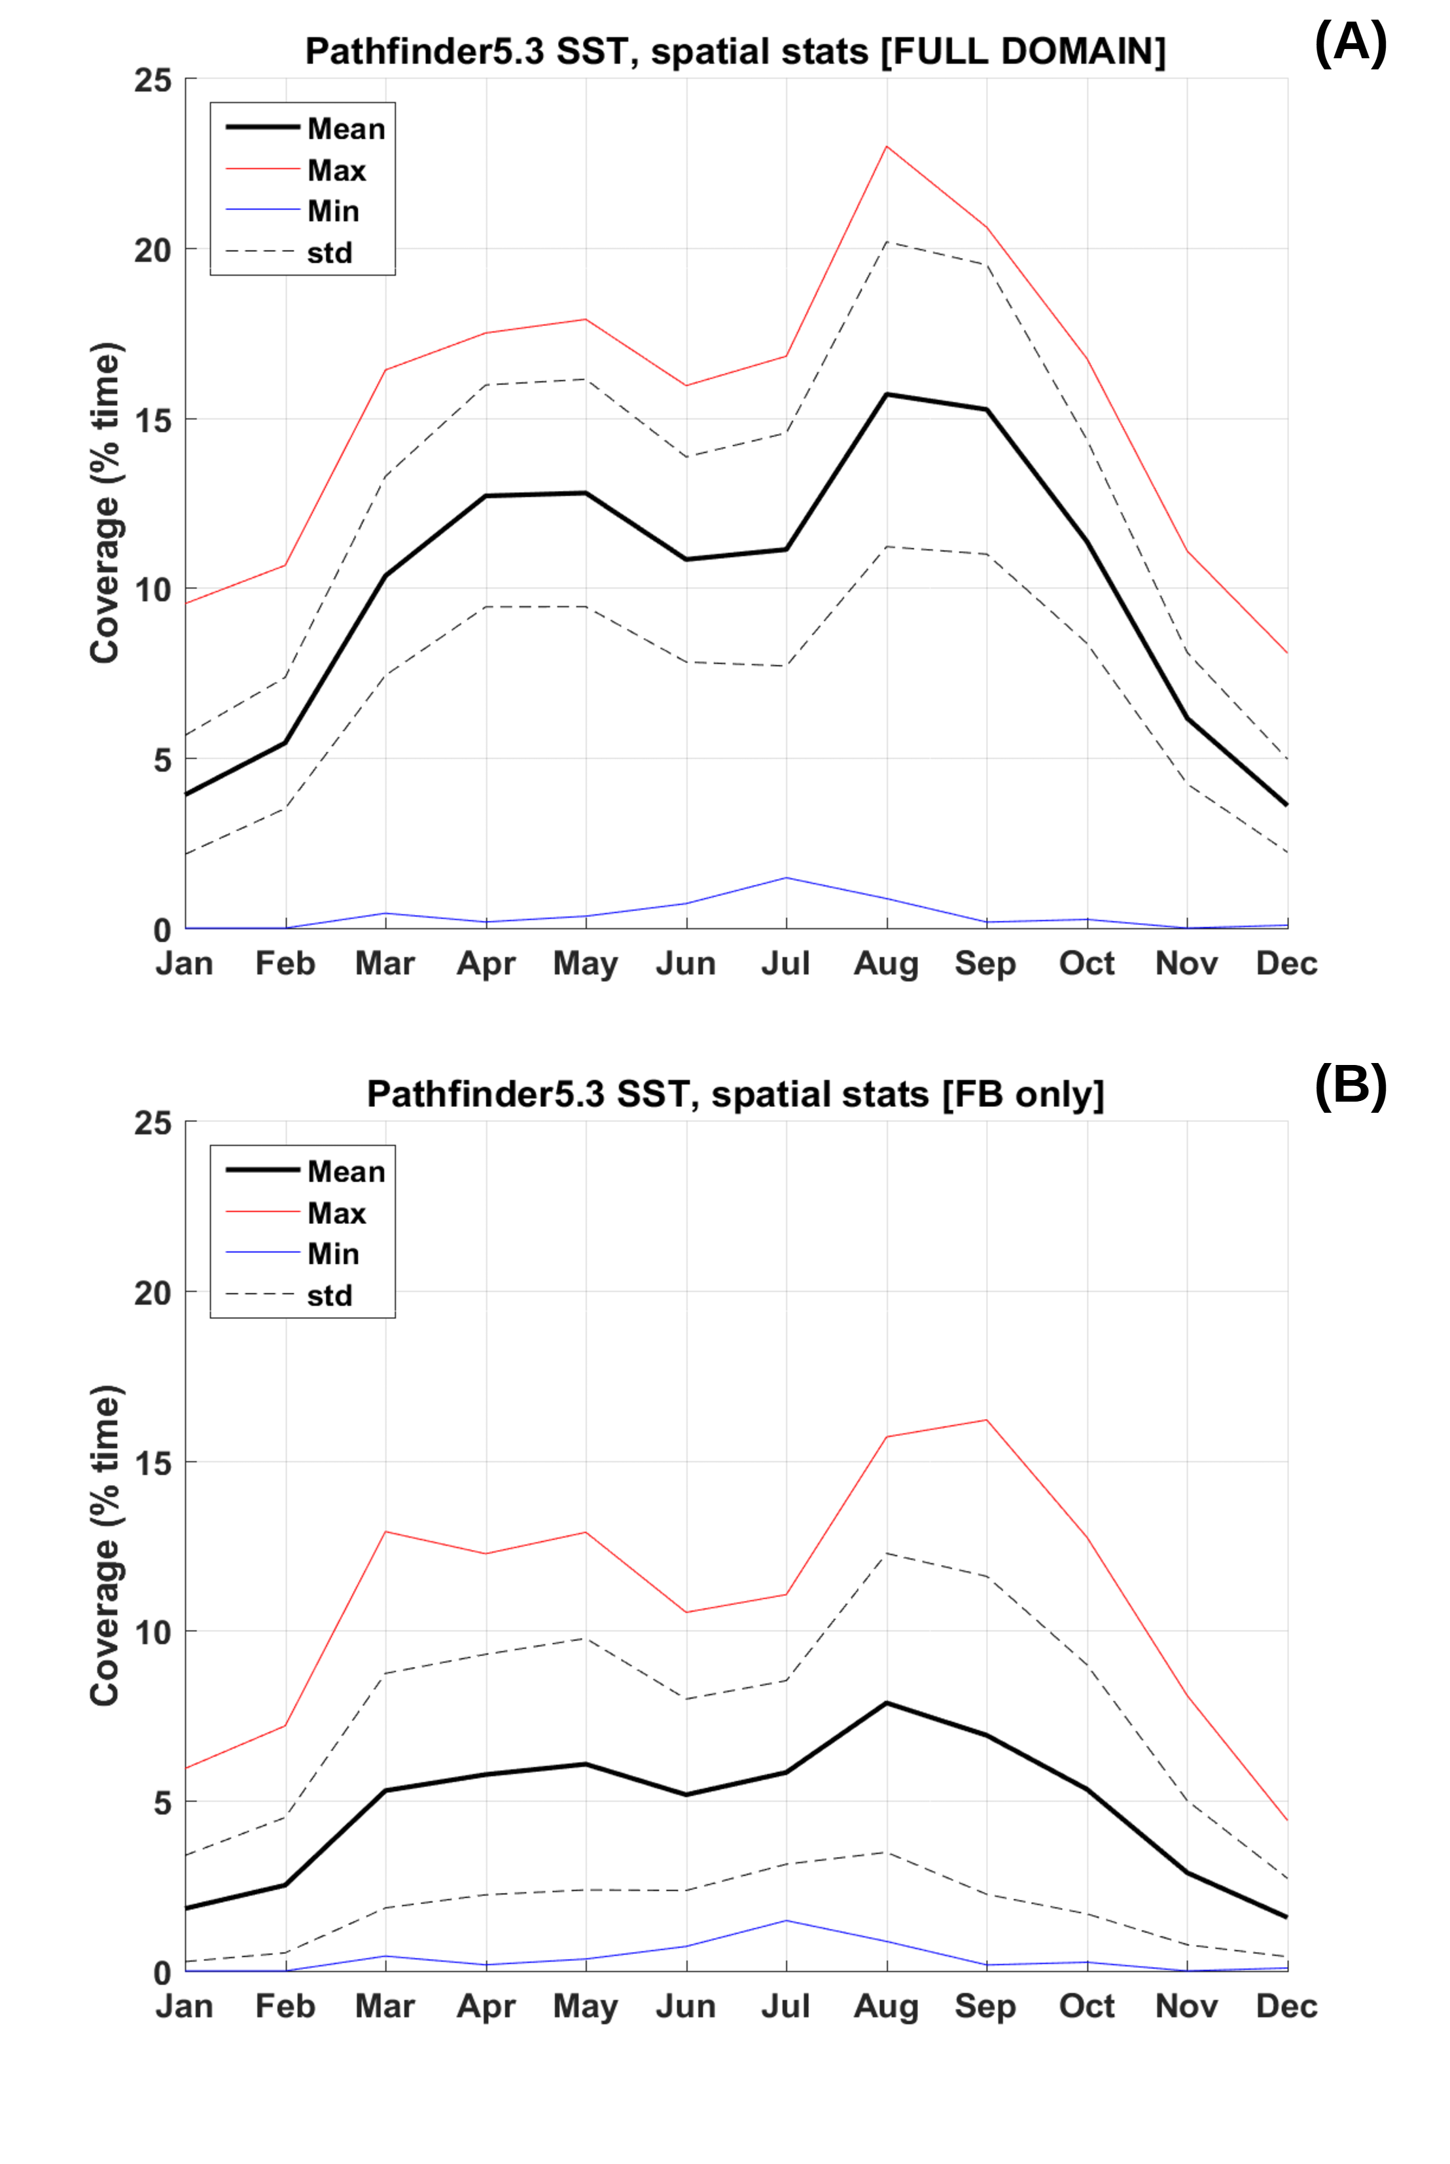Figure S10: Pathfinder v5.3 Sea Surface Temperature (SST) temporal coverage over the full domain considered in Figure 3 (main text) (A), i.e. 46.5 to 48oN and 57.5 to 54.5oW, and over Fortune Bay (FB) only (B). Statistics are calculated for the whole area considered, e.g. the mean is an average of the coverage over the area while the maximum is the maximum coverage found at one given point. The percentages are calculated as 100 x number of good SST values / number of samples (including bad or missing) for each point (or pixel).

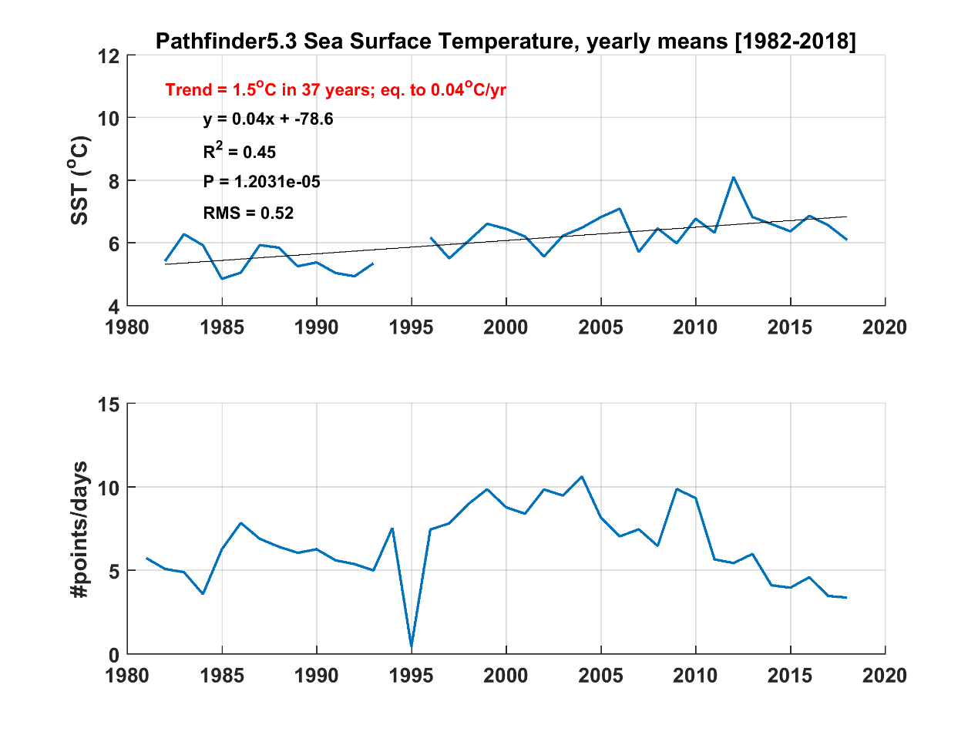
Figure S11: Pathfinder 5.3 Sea Surface Temperature (SST) long term (1982-2018) trend and data coverage in Fortune Bay
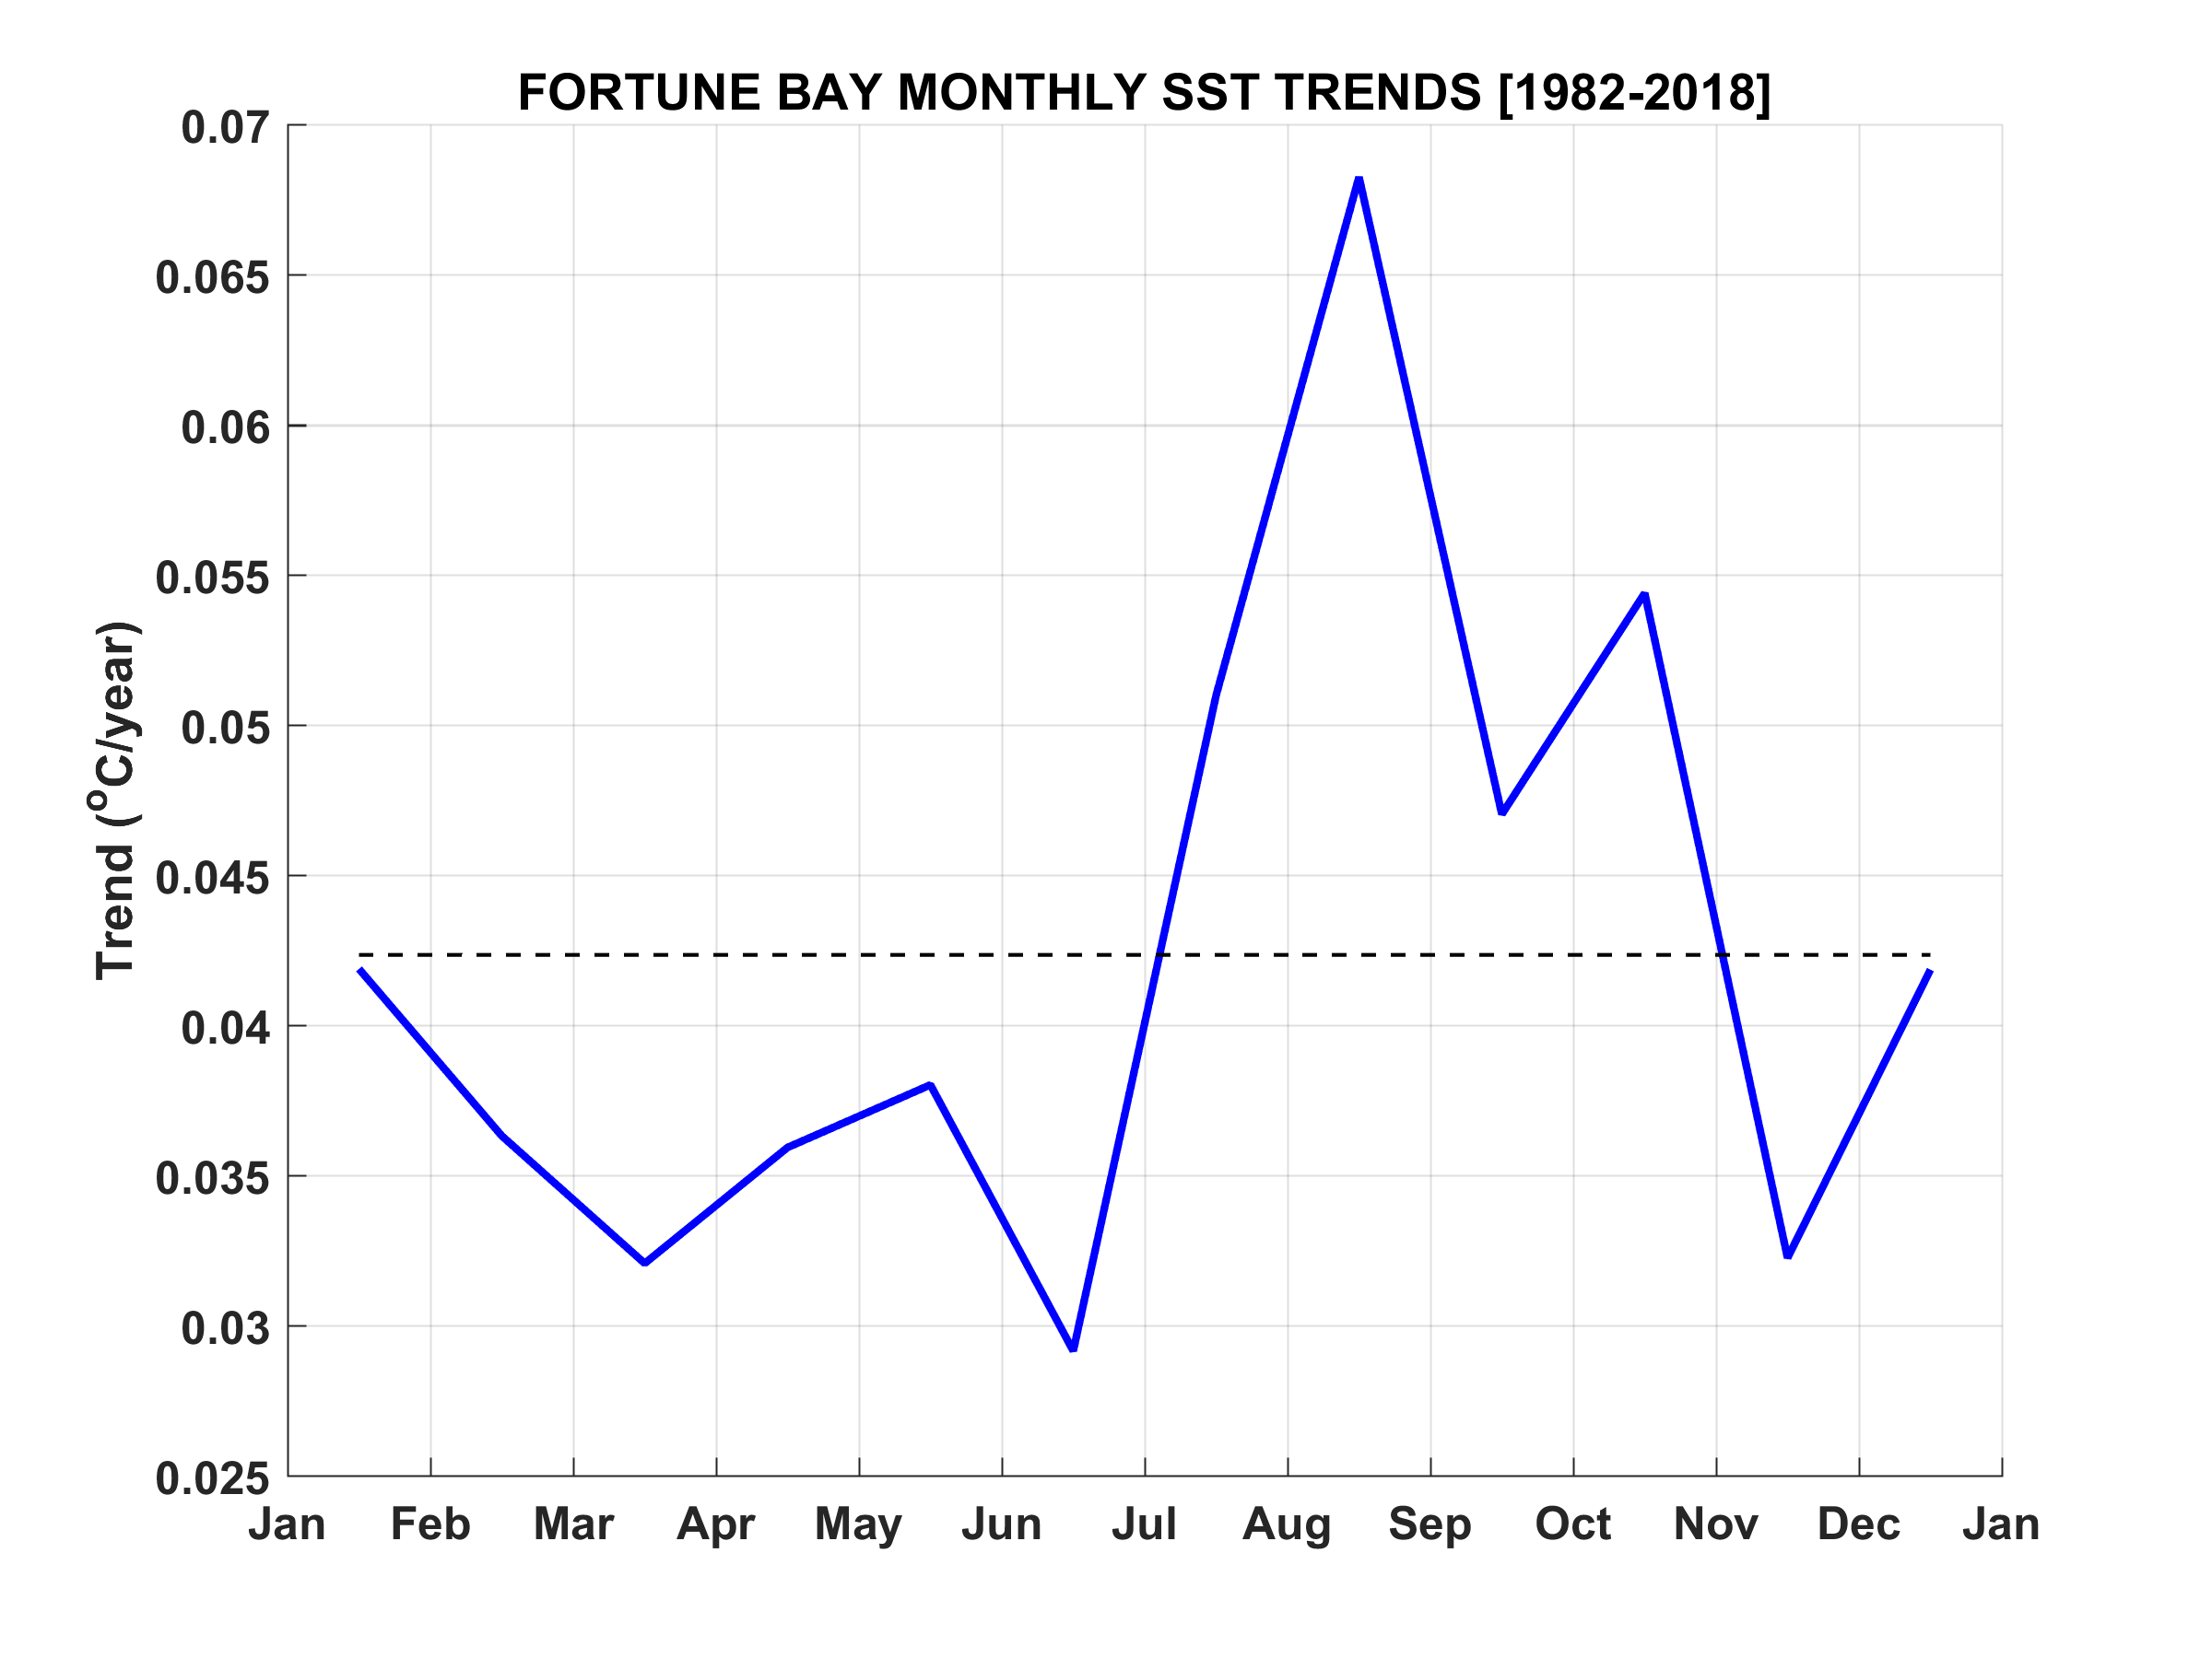Figure S12: Fortune Bay long-term Sea Surface Temperature monthly trends calculated over the period 1982-2018 from Pathfinder 5.3 data. The horizontal dash line represent the annual mean trend as represented in Figure S8.
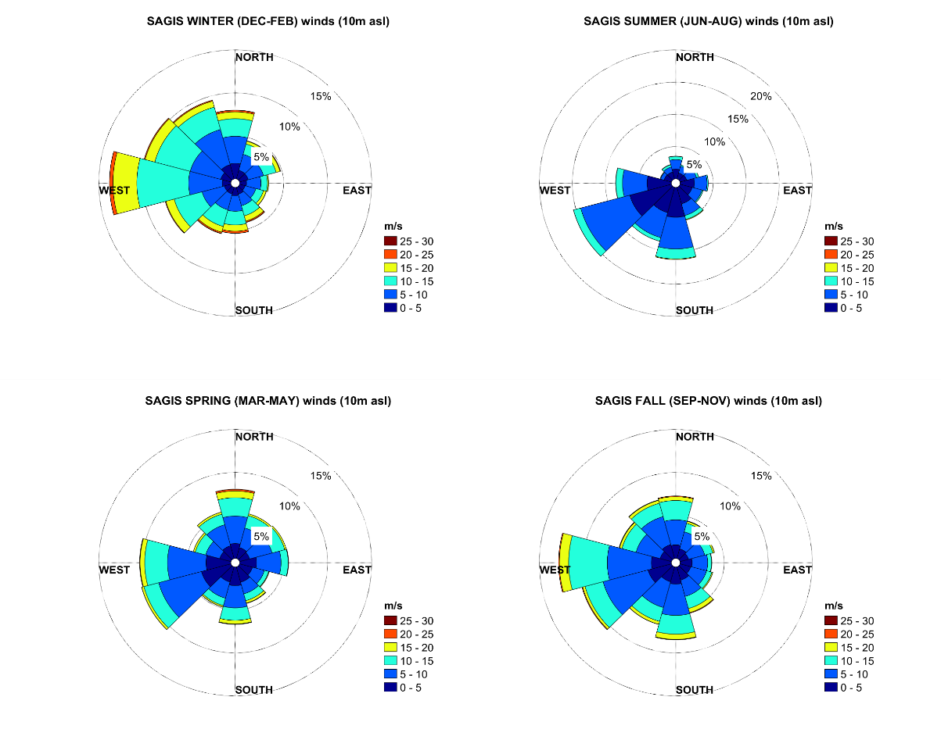
Figure S13: seasonal wind climate from Sagona Island (SAGIS) at 10 m above sea level (asl)
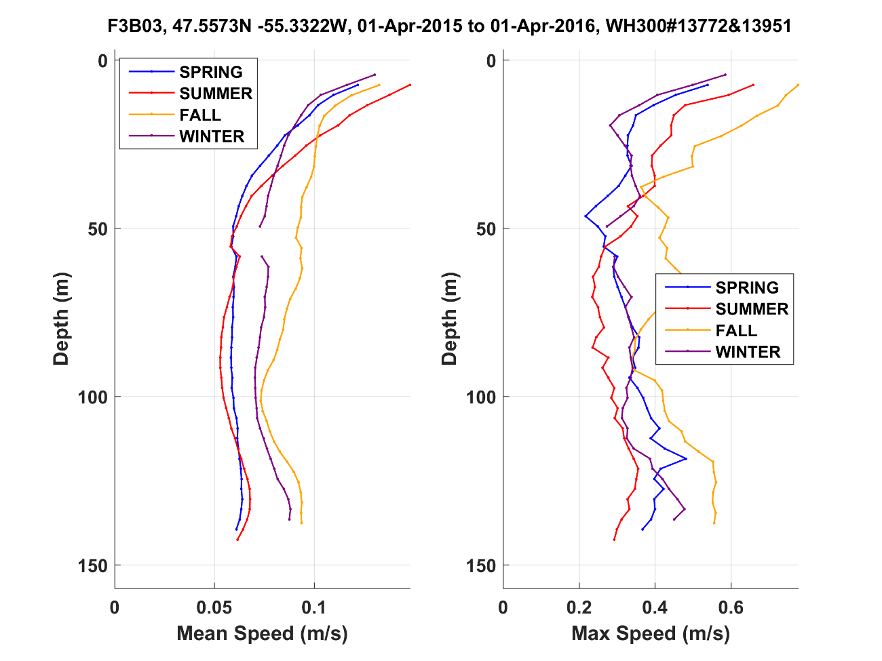
Figure S14: time-averaged and maximum current speed profile as observed at F3B03 (west of Belle Bay mouth)
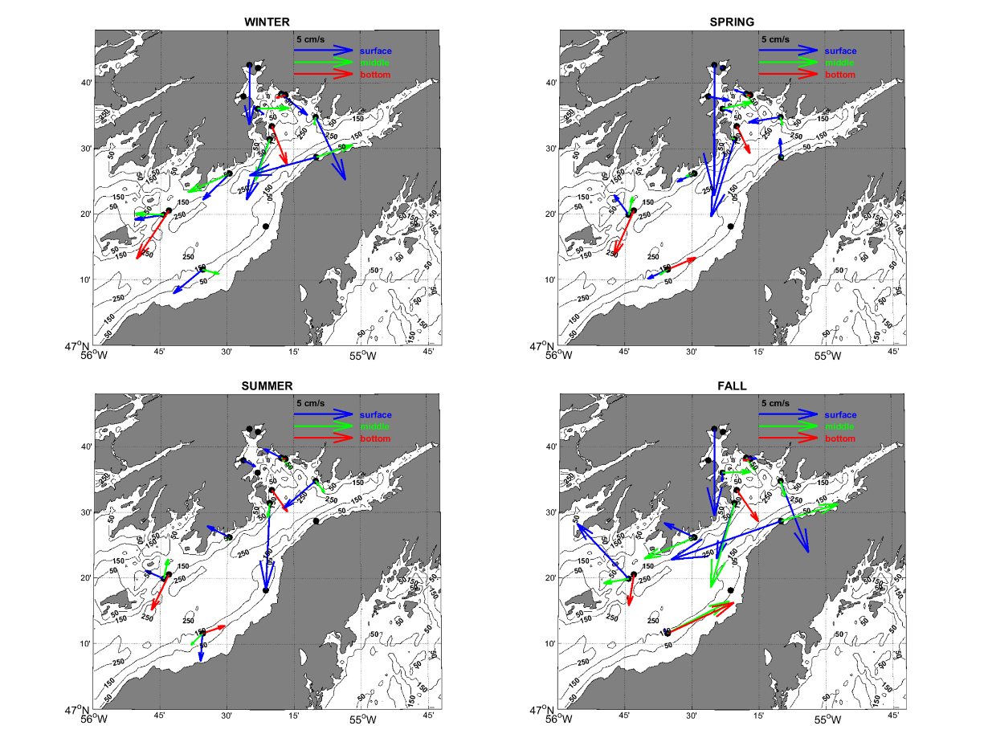
Figure S15: mean, seasonal, circulation near-surface (10 m), middle (70 m) and near-bottom (125 m) layer. Scaling by a factor of 3 was applied to near-surface currents at F3B12 (winter) due to their much larger magnitude. All data available were used; resulting in shorter coverage at F3B08, 11 and 12 (see main text for details).

Pulses cross-correlations
To quantify the relationship of the signals, lagged cross-correlation was performed amongst all sites. The 5ºC isotherm depth was selected to make the analyses as well as the currents’ along-shore component at 3 depths (10, 70 and 135 m with year 1 data, 10, 40 and 70 m with year 2 data). Along-shore currents were band-pass filtered prior to analysis to use the dominant low-frequency 2-20 d band. 10, 20 and 30 d non-overlapping windows were used for all the runs set to look at maximum lags of 5-10 d (5 d with 10 d windows, 10 d with 20 d and 30 d windows). 816 runs were performed in total (including runs done on isotherms 2ºC, 4ºC, 6ºC and 8ºC before a final selection of the 5ºC isotherm) from which an example using year 1 data with 10 d windows and 5 d lags is presented in Figure S16. Isotherms correlations equal to or greater than 0.7, i.e. almost 50% variance explained, are found during the stratified period amongst most sites (Jun-Dec) while equivalent along-shore currents correlation levels are found amongst most sites and depths throughout the year. Correlations are markedly stronger and more consistent, however, amongst mooring pairs from F3B08 to F3B06 (from Belle Bay to the northern shore of FB) and are usually the lowest with F3B02; particularly with the isotherms. Near surface currents (10 m) tend to be more correlated during the stratified period while sub-surface currents (40, 70 and 135 m) can be correlated throughout the year. Window’s size has a significant effect, generally decreasing the correlation levels (except for the most strongly and frequently correlated sites such as F3B04-03) and enhancing the seasonal pattern. Strongest correlations generally occur at 0-4 d lags, giving phase speeds of the order of 0.5-2 m/s (when using along-slope distance between mooring pairs). Phase speeds tend to increase from spring to fall (as shown by the isotherms) before tapering off in winter (along-shore currents results, not shown).
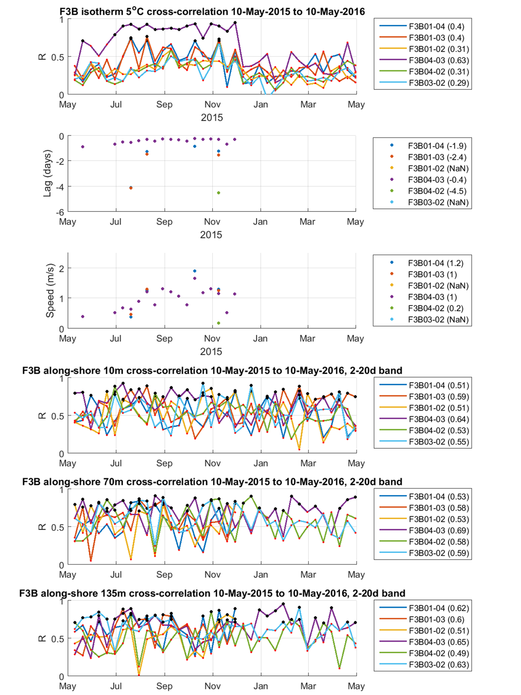
Figure S16: lagged cross-correlation results. Correlations (R) correspond to the maximum positive correlation found within a given window (10 d length) and (associated) negative lags are shown; only lags and phase speed for correlation (R) >= 0.7 are shown in the isotherm plot. Black dots are values corresponding to correlations (R)>=0.7 and phase speeds >2 m/s are not shown. Mean correlations are indicated in bracket in the legends.

Pulses frequency of occurrence, duration and excursion
To get a sense of the frequency of occurrence, duration and excursion associated with those pulses, extraction and persistence analyses were carried out on the along-shore currents, bandpass filtered for a 2-20 d period range as for previous analyses. Pulses were defined as periods of current speed larger than its mean + 1 std (calculated on the whole series length). Standard deviations were found to be about twice as large or more near-surface than near bottom for mean speeds of about the same magnitude (i.e. 1-8 cm/s). Extraction was done on both positive and negative components, representing ingoing flow at F3B01, 05, 11, 08 and 04 and outgoing flow at F3B07, 03, 06 and 02, respectively. For each pulse identified, its duration and associated excursion were extracted and persistence was calculated for durations of 6, 12, 24, 36 and 48 hr. Excursion (given in km) was calculated by integrating the speed over the duration of a pulse, in each direction (separately). Persistence analysis was run monthly and a maximum pulse duration was also calculated for each month. The analyses were conducted on all available series and depths observed. Overall, an average of 28±3 pulses per year were extracted at each monitored site and depth. Each pulse flows during 23±12 hr on average in either direction (ingoing or outgoing) and has an associated excursion of 10±7 km. A maximum pulse duration of 111 hr and a maximum excursion of 63 km were observed although maximums, at any given site, are on the order of 79±14 hr and 40±15 km on average. Seasonally, a peak of activity from September to December is revealed by the persistence analysis at most sites (see a representative example using a threshold of 24 hr on year 1 dataset in Figure S10). During the peak activity period, 3-6 pulses of 24 hr duration or more (in either direction) can occur at any given site (and depth) per month (i.e. about 1 event of 48 hr duration every 5-10 d). It should be noted that while pulses occurrence, duration and excursion are statistically equivalent in either direction, i.e. in terms of annual means, standard deviations and maximums, they are not necessarily symmetrical on a case by case basis. Taking the examples shown in Figure 12 for instance, representative of strong events, a net transport of more than 15 km can occur at any given depth after a few pulses (see Figure S15 for an illustration). This asymmetry can be ‘balanced’ when integrating over depth (e.g. F3B03 & 04 in October 2015) but can also result in a net transport in either direction when integrating all (e.g. F3B01 in October 2015) or a portion of the water column only (e.g. F3B03 in July 2016; which is a site of 160 m depth).
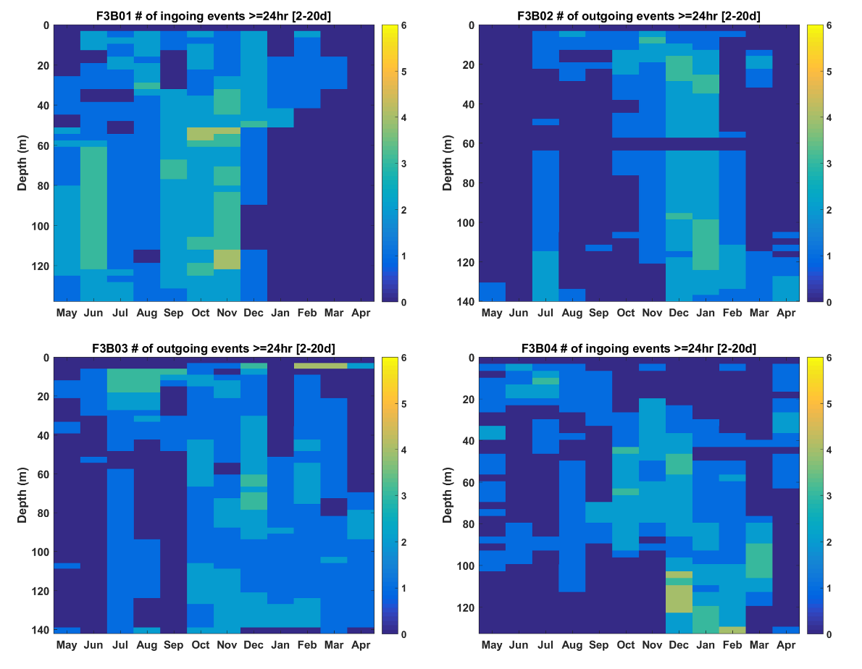
Figure S17: frequency of occurrence of along-shore current pulses of 24 hr duration or more (in one direction) within the bay in 2015-16
Figure S18: net excursion of water induced by the events represented in FIG. The distances are calculated over a period of 7 days (3 pulses) in October 2015 (left) and 4 days (1 pulse) in July 2016 (right), shifting the start of the integration for each site to account for the phase delay (e.g. 1 d between F3B01 and F3B04 in October 2015; see the main text for more details). The depth-averaged value of each profile is indicated in the legend.

