[Journal of Geophysical Research - Oceans]
Supporting Information for
[Meltwater lenses over the Chukchi and the Beaufort seas during summer 2019: from in-situ to synoptic view]
[Alexandre Supply^{1,2}, Jacqueline Boutin³, Nicolas Kolodziejczyk¹, Gilles Reverdin³, Camille Lique¹, Jean-Luc Vergely⁴ and Xavier Perrot⁵]
[1 Univ. Brest, CNRS, IRD, Ifremer, Laboratoire d’Océanographie Physique et Spatiale (LOPS), IUEM, Brest 29280, France
2 CNES, Paris, France
3 Sorbonne University, LOCEAN Laboratory - IPSL, CNRS–IRD–MNHM, Paris, France
4 ACRI-ST, Guyancourt, France
5 LMD / IPSL, CNRS, ENS, PSL, Paris, France]

Contents of this file

Figures S1 to S6
Introduction
[Supporting information contains in figure S1 comparisons between SMOS SSS product used in this study, SMOS SSS v3.1 from BEC and saildrones, filtering, debiasing and validation in figure S2 and S3 and finally comparisons between SMOS, SMAP and SMOS+SMAP SSS in figures S4, S5 and S6.]

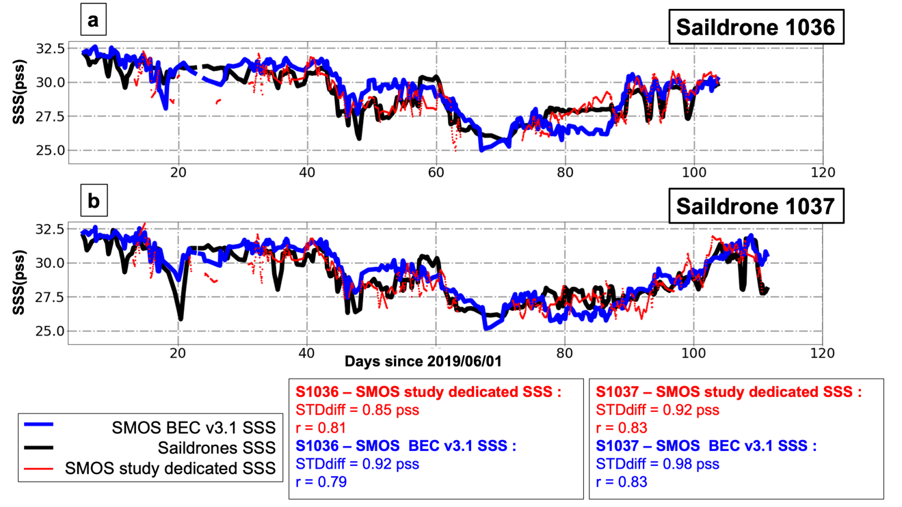

Figure S1. a) S1036 SSS measurement time series (black), SMOS study dedicated SSS collocated SSS (red) and SMOS BEC v3.1 collocated SSS (green); b) S1037 SSS measurement time series (black), SMOS study dedicated SSS collocated SSS (red) and SMOS BEC v3.1 collocated SSS (green). Table is for statistical indicators (STDdiff = STandard Deviation of Difference and r = correlation coefficient).

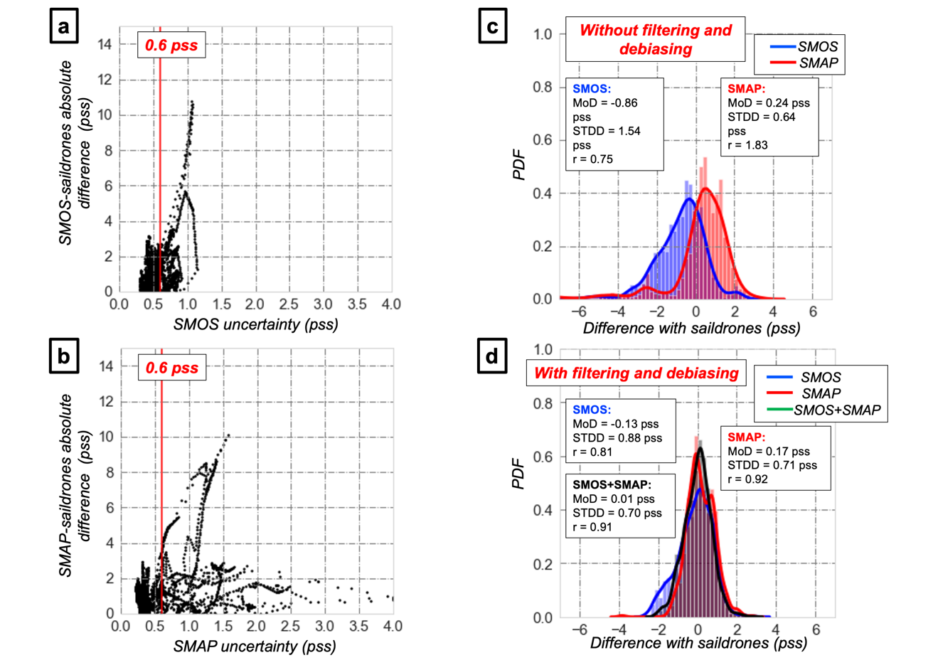

Figure S2. a) Scatterplot of absolute difference between SMOS SSS and saildrones SSS versus SMOS SSS uncertainty (uncertainty threshold indicated in red); b) Scatterplot of absolute difference between SMAP SSS and saildrones SSS versus SMAP SSS uncertainty (uncertainty threshold indicated in red); c) Distributions of differences between SMOS and SMAP SSS, and saildrones SSS without filtering and debiasing; d) Distributions of differences between SMOS, SMAP and SMOS+SMAP SSS, and saildrones SSS with filtering and debiasing.

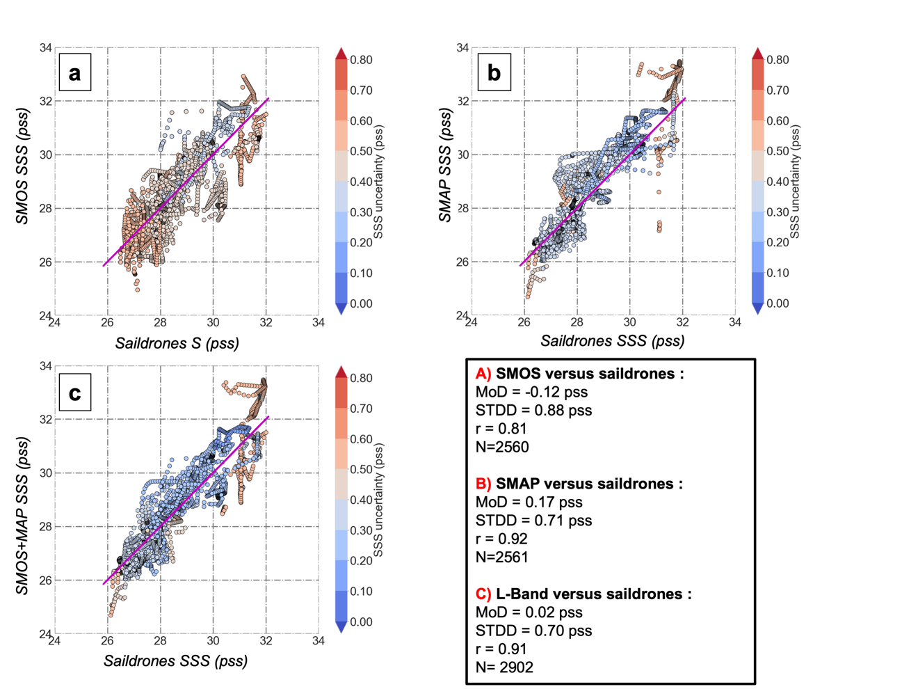

Figure S3. SMOS, SMAP and SMOS+SMAP SSS validation performances after debiasing and filtering. Scatterplot of SSS, with satellite SSS retrieved uncertainties in colour: a) SMOS SSS versus Saildrones SSS; b) SMAP SSS versus Saildrones SSS; c) SMOS+SMAP SSS versus Saildrones SSS. Table is for statistical indicators (MoD = Mean of Difference, STDD = STandard Deviation of Difference, r = correlation coefficient and N = Number of collocations between satellite SSS and saildrone salinity).

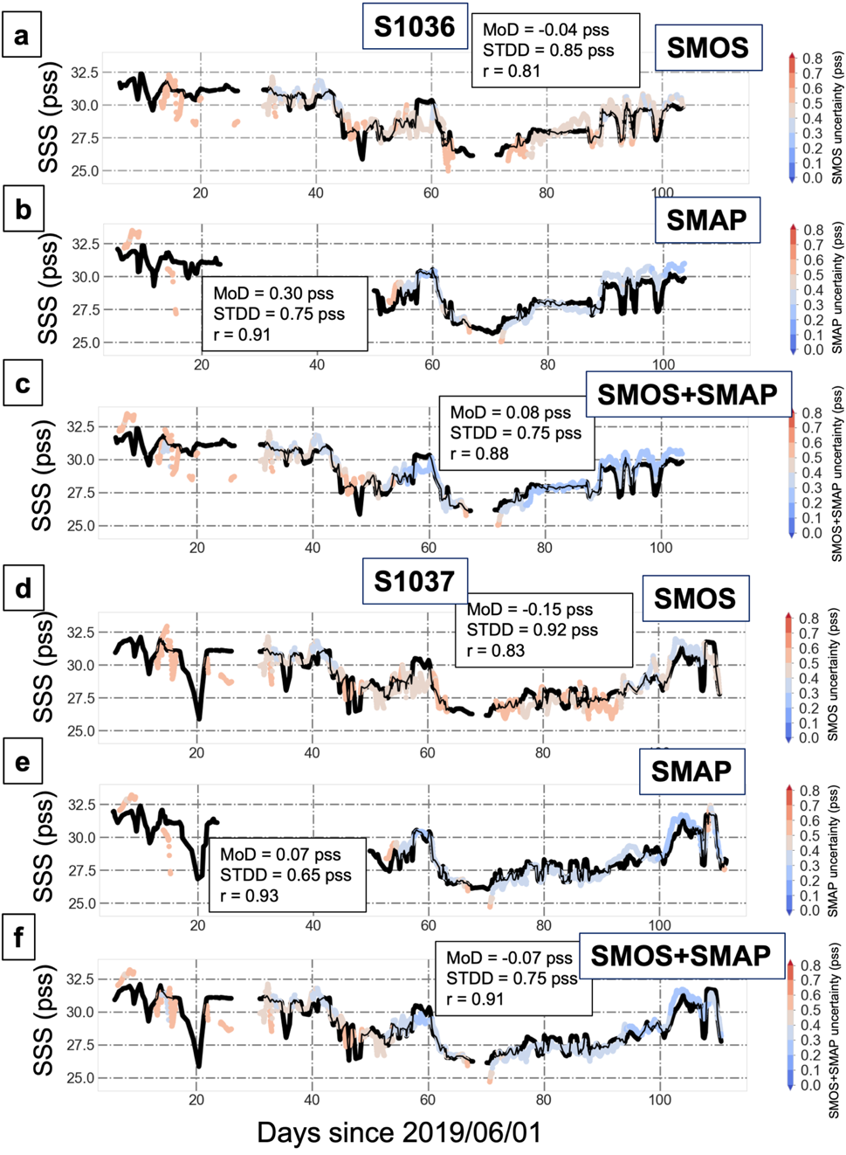

Figure S4. a) Saildrone 1036 SSS measurement (black) and SMOS collocated SSS in colour (colour for SSS uncertainty) timeseries; b) Saildrone 1036 SSS measurement (black) and SMAP collocated SSS in colour (colon for SSS uncertainty) timeseries; c) Saildrone 1036 SSS measurement (black) and SMOS+SMAP collocated SSS in colour (colour for SSS uncertainty) timeseries; d) Saildrone 1037 SSS measurement (black) and SMOS collocated SSS in colour (colour for SSS uncertainty) timeseries; e) Saildrone 1037 SSS measurement (black) and SMAP collocated SSS in colour (colour for SSS uncertainty) timeseries; f) Saildrone 1037 SSS measurement (black) and SMOS+SMAP collocated SSS in colour (colour for SSS uncertainty) timeseries.

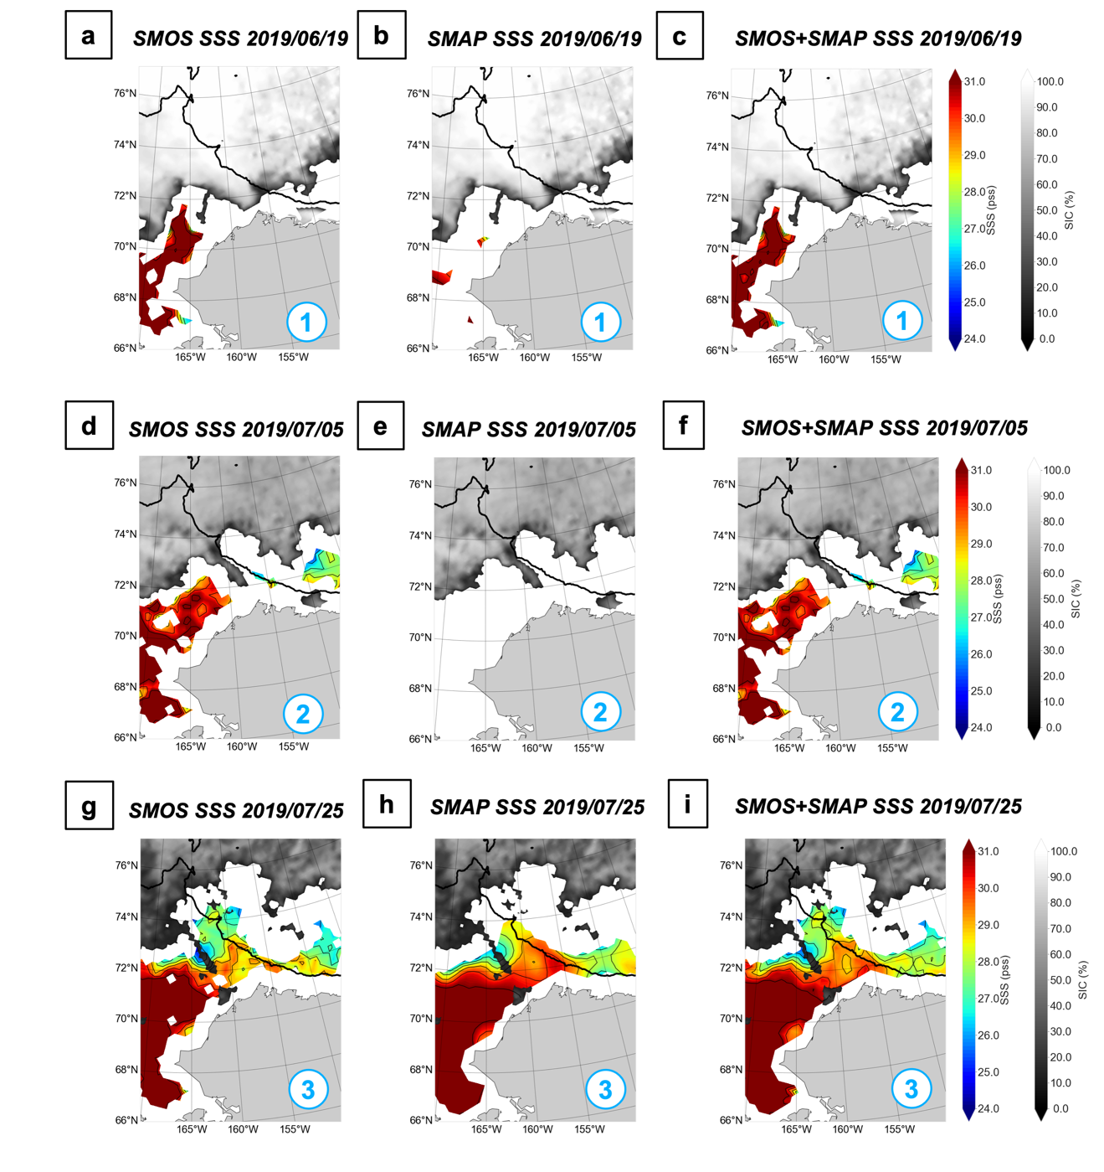

Figure S5. a) SMOS SSS and OSI-SAF SIC for 2019/06/19; b) SMAP SSS and OSI-SAF SIC for 2019/06/19; c) L-Band SSS and OSI-SAF SIC for 2019/06/19; d) SMOS SSS and OSI-SAF SIC for 2019/07/05; e) SMAP SSS and OSI-SAF SIC for 2019/07/05; f) SMOS+SMAP SSS and OSI-SAF SIC for 2019/07/05; g) SMOS SSS and OSI-SAF SIC for 2019/07/25; h) SMAP SSS and OSI-SAF SIC for 2019/07/25; i) SMOS+SMAP SSS and OSI-SAF SIC for 2019/07/25.

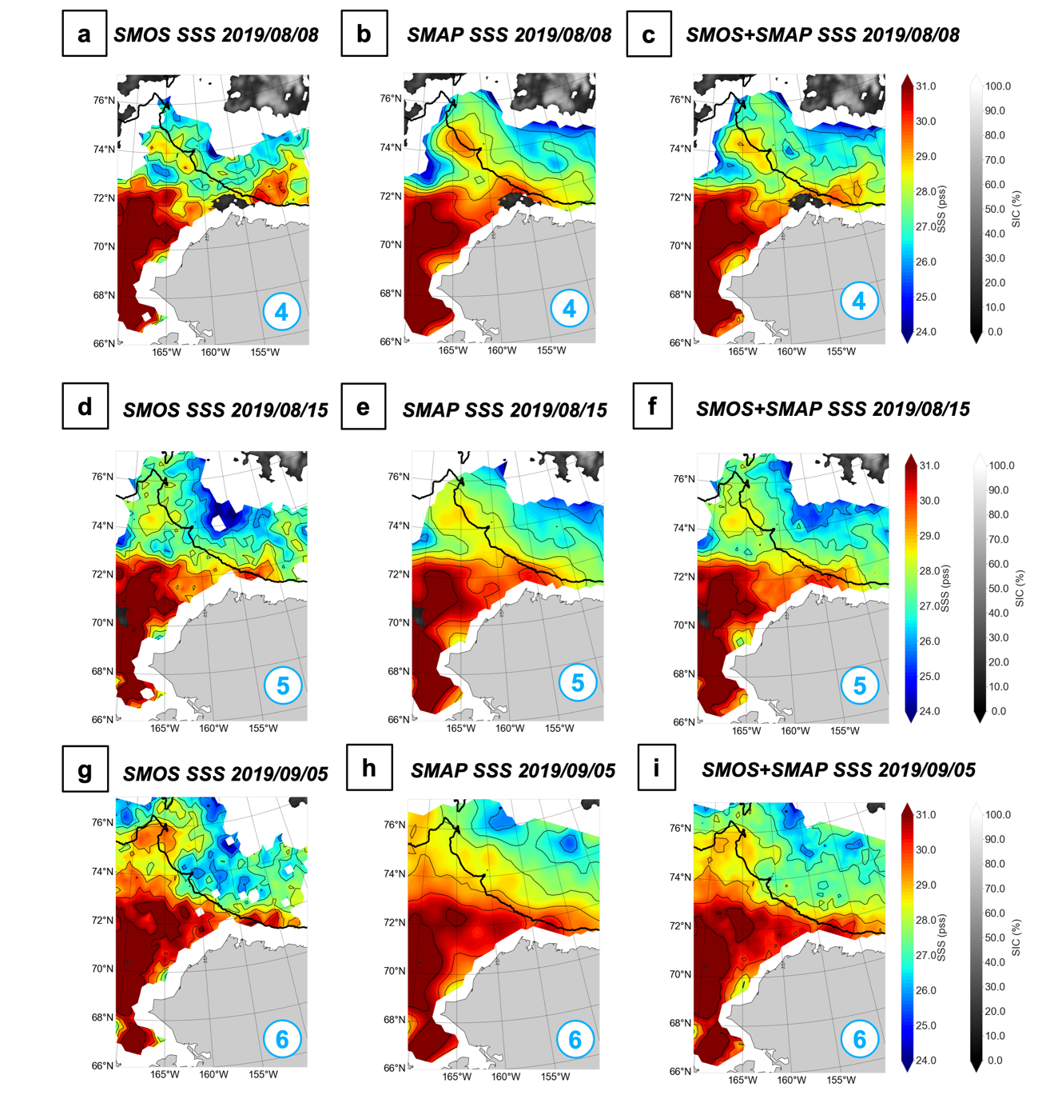

Figure S6. a) SMOS SSS and OSI-SAF SIC for 2019/08/08; b) SMAP SSS and OSI-SAF SIC for 2019/08/08; d) L-Band SSS and OSI-SAF SIC for 2019/08/08; d) SMOS SSS and OSI-SAF SIC for 2019/08/15; e) SMAP SSS and OSI-SAF SIC for 2019/08/15; f) SMOS+SMAP SSS and OSI-SAF SIC for 2019/08/15; g) SMOS SSS and OSI-SAF SIC for 2019/09/05; h) SMAP SSS and OSI-SAF SIC for 2019/09/05; i) SMOS+SMAP SSS and OSI-SAF SIC for 2019/09/05.

