Supplementary Material
Supplementary Figure 1: Map of the sediment classification of the northeastern Brazil coast and zone A (dominated by sand) and zone B (where complex substrates such as calcareous algae and reefs occur more). AL: Alagoas; PB: Paraiba; PE: Pernambuco; RN: Rio Grande do Norte. The sedimentological data were compiled from the Brazilian National Oceanographic Data Bank (BNDO) and literature(Amaral and Santos, 2015; Assiset al., 2016; Assis et al., 2015; Vital et al., 2005) (Assis et al., 2015, 2016, Amaral et al., 2015, Vital et al., 2005) with information about the sediment composition (i.e., percent of mud, sand, and gravel). The sediment data were categorized attributing distinct numbers 1 to 9 to each sediment class and then interpolated, with the same spatial resolution of 100 m, using the natural neighbor technique, to generate a textural classification map according to (Lucatelli et al. (2020).
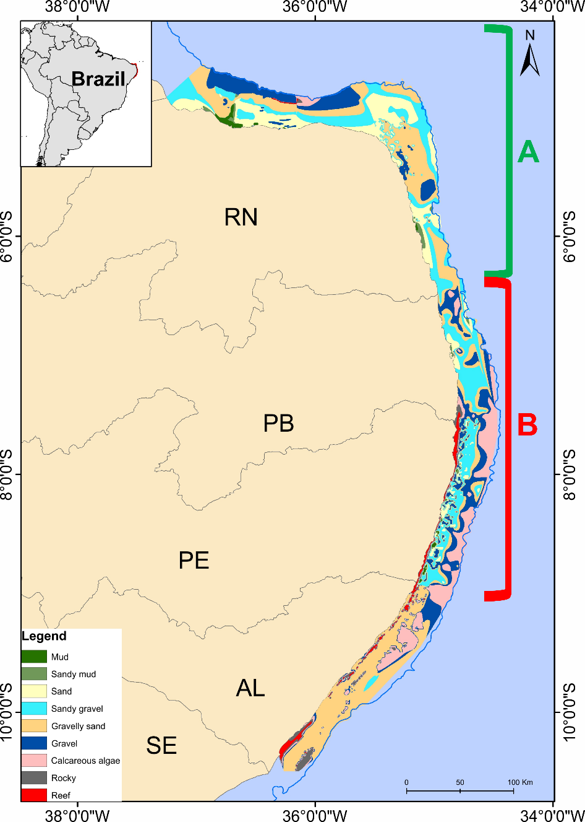

Supplementary Figure 2: Resultant uncertainty in the TA (total isotopic área), dC (carbon range and dN (nitrogen range) arising from the simulations. Black dots represent the mode of the values, and the shaded boxes represent the 50%, 75%and 95% credible intervals from dark to light grey.

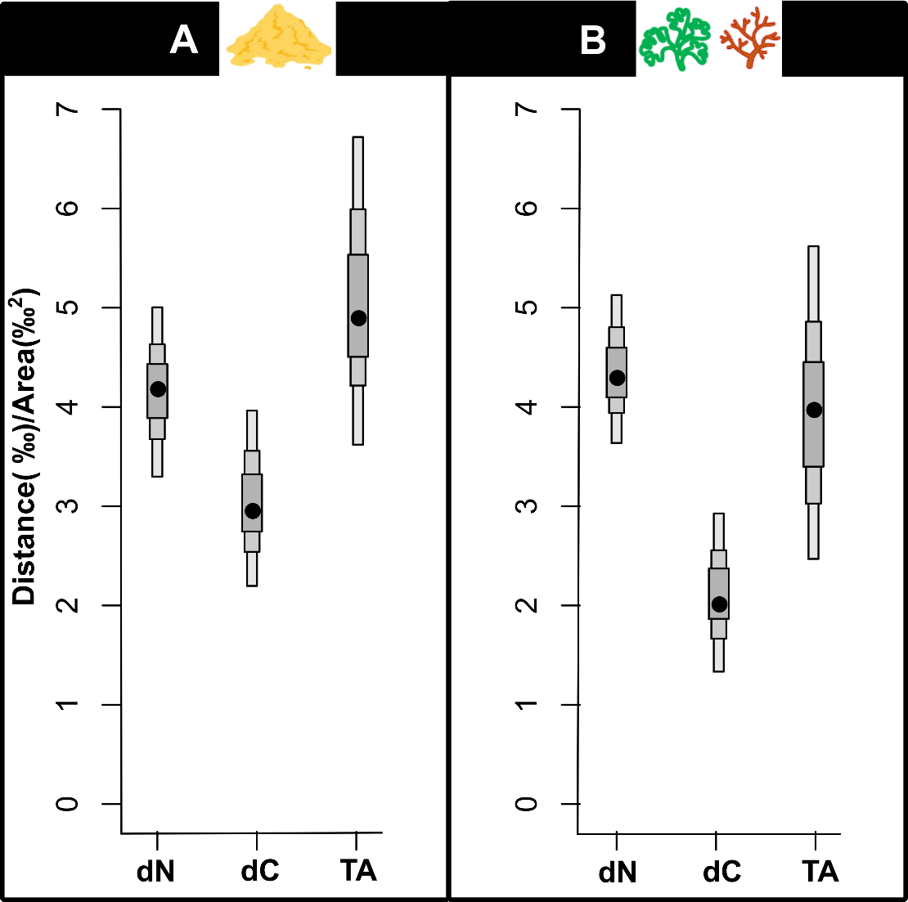
Supplementary Table 1: Trophic guild (from Ferreira et al. 2019), trophic levels (from Fishbase).
Species | Acronym | Trophic Guild
Acanthurus chirurgus  (Bloch, 1787) | aca.chi | Herbivorous
Haemulon aurolineatum Cuvier, 1830 | hae.aur | Zoobenthivorous
Haemulon plumierii (Lacepède, 1801) | hae.plu | Zoobenthivorous
Holocentrus adscensionis (Osbeck, 1765) | hol.ads | Zoobenthivorous
Hypanus marianae (Gomes, Rosa & Gadig, 2000) | hyp.mar | Zoobenthivorous
Lutjanus synagris (Linnaeus, 1758) | lut.syn | Zoobenthivorous
Pseudupeneus maculatus (Bloch, 1793) | pse.mac | Zoobenthivorous
Sparisoma axillare (Steindachner, 1878) | spa.axi | Herbivorous

  - Supplementary Table 2: Importance of each compartment in the diet of the selected species.
 | Algae | Animal | Crustacea | Detritus | Echinodermata | Mollusca | Polychaeta | Seagrass | Teleostei | Reference
aca.chi | 61% | 2% |  | 44% |  |  |  | 3% |  | (Ferreira and Gonçalves, 2006)
hae.aur |  |  | 72% |  | 5% | 3% | 20% |  | 0,1% | Cruise data  Submitted in Limeira et al.
hae.plu |  |  | 42% |  | 23% | 4% | 19% |  | 12% | Cruise data  Submitted in Limeira et al.
hol.ads |  |  | 95% |  |  | 1% | 4% |  |  | (Randall, 1967)
hyp.mar |  |  | 54% |  |  |  | 41% |  | 1% | (Queiroz et al., 2019)
lut.syn | 0,12% |  | 75% |  |  | 2% | 0,36% |  | 22,5% | (Duarte and Garcia, 1999)
pse.mac |  |  | 95% |  |  | 2% |  |  | 3% | Cruise data  Published in (Soares et al., 2020)
spa.axi | 39% | 1% |  | 58% |  |  |  | 2% |  | (Ferreira and Gonçalves, 2006)

  - Supplementary Table 3: Number of individuals analysed (n), mean values (±SD) of stable isotope ratios of carbon (𝛿¹³C) and nitrogen (𝛿¹⁵N), size range (Total length cm), SEAc (corrected Standard ellipse area) and ITP (intraspecific trophic pressure) values for each selected species in zones A and B.
 | zone A |  |  |  |  |  | zone B
Species | n | δ¹³C (‰) | δ¹⁵N (‰) | Size (cm) | SEAc | ITP | n | δ¹³C (‰) | δ¹⁵N (‰) | Size (cm) | SEAc | ITP
aca.chi | 18 | -16.4 ±2.9 | 7.3 ±1.9 | 14.8-27.0 | 98.9 | 0.03 | 8 | -15.8 ±0.2 | 7.7 ±2.1 | 13.8-25.0 | 12.9 | 0.22
hae.aur | 32 | -15.1±0.6 | 8.8 ±1.4 | 11.7-25.0 | 13.5 | 0.31 | 35 | -15.3 ±0.7 | 9.7 ±1.3 | 11.5-21.0 | 15.7 | 0.18
hae.plu | 27 | -14.7 ±0.4 | 9.0 ±0.8 | 18.6-28.8 | 6.6 | 0.48 | 41 | -15.1 ±0.5 | 10.1 ±1.2 | 12.7-28.7 | 11.4 | 0.25
hol.ads | 17 | -15.3 ±0.8 | 9.0 ±0.7 | 19.4-27.4 | 10.3 | 0.34 | 31 | -15.1 ±0.6 | 8.6 ±0.7 | 13.3-25.4 | 5.8 | 0.54
hyp.mar | 20 | -14.1±0.9 | 7.7 ±1.0 | 44.0-55.0 | 17.4 | 0.16 | 14 | -14.7 ±0.6 | 7.2 ±0.7 | 29.0-65.0 | 7.4 | 0.32
lut.syn | 37 | -15.4±0.8 | 9.9 ±1.3 | 12.6-26.8 | 18.2 | 0.16 | 23 | -15.0 ±0.6 | 10.1 ±1.1 | 16.6-26.8 | 8.4 | 0.32
pse.mac | 43 | -16.1±0.8 | 8.2 ±0.6 | 13.4-28.3 | 9.3 | 0.35 | 57 | -15.7 ±0.6 | 8.2 ±0.9 | 9.2-26.0 | 10.2 | 0.33
spa.axi | 8 | -17.2±0.5 | 5.8 ±0.2 | 16.7-21.4 | 2.6 | 0.87 | 10 | -16.8 ±0.5 | 5.8±1.1 | 24.0-30.0 | 9.8 | 0.21

Supplementary Material References:
Amaral, R.F. do, Santos, J.R. dos, 2015. Carta textural da plataforma continental rasa do estado de Rio Grande do Norte-setor Touro. Recife:CPRM. Mapa color.,73,25 x71,99cm,Escala:1:100.000 (Programa Mar, Zona Costeira e Antártica. Folha de referência:SC-25-V -C-II).
Assis, H.M.B. De, Lopes, H., Gomes, R.B., Salviano, K. Dos S., Valle, M.M., Oliveira, P.R.A., Moura, L.P., 2016. Carta textural e geomorfológica da Plataforma Rasa de Alagoas, setor Maceió Oeste. Recife:CPRM. Mapa color.96,55x 82,86cm ,Escala:1:100.000(Prog ram a M ar,Zona Costeira e Antártica.F olhasde referência:S C-25-V-A-V,S C-25-V-C-IIe S C-25-V-C-I)
Assis, H.M.B. de, Valle, M.M., Gomes, R.B., Salviano, K. dos S., Pereira, L.B.F., 2015. Carta de caracterização dos agregados marinhos da plataforma continental rasa do estado de Pernambuco. Recife:CPRM. F olh as de referência:S B.25-Y-C e S C.25-V-A.R ecife:CPR M ,2015.1mapa color.,83,71cm x 79,70cm,Escala:1:250.000(Programa M ar,Zona Costeira e Antártica.
Duarte, L.O., Garcia, C.B., 1999. Diet of the lane snapper, Lutjanus synagris (Lutjanidae), in the Gulf of Salamanca, Colombia. Caribbean Journal of Science 35, 54–63.
Ferreira, C.E.L., Gonçalves, J.E.A., 2006. Community structure and diet of roving herbivorous reef fishes in the Abrolhos Archipelago, south-western Atlantic. Journal of Fish Biology 69, 1533–1551.
Limeira, A.G.C., Frédou, T., Soares, A.P.C .,Lira, A.S., Le Loc´h, F., Viana, G.F.S., Filho, J.S.R., Munaron, J., Lucena-Frédou, F., (Submitted) Trophic ecology and resource partitioning of Haemulidae species along the Northeastern Brazilian continental shelf.
Queiroz, A.P., Araújo, M.L., Lessa, R., 2019. Dietary composition and trophic level of Hypanus marianae (Myliobatiformes: Dasyatidae), captured off Pernambuco coast, Brazil. Latin american journal of aquatic research 47, 808–817.
Randall, J.E., 1967. Food habits of reef fishes of the West Indies. Institute of Marine Sciences, University of Miami Coral Gables.
Soares, A., Lira, A.S., Gonzalez, J.G., Eduardo, L.N., Lucena-Frédou, F., Le Loc’h, F., Ferreira, B.P., Frédou, T., 2020. Feeding habits and population aspects of the spotted goatfish, Pseudupeneus maculatus (Perciformes: Mullidae), on the continental shelf of northeast Brazil. Scientia Marina 84, 119–131.
Vital, H., Silveira, I.M. da, Amaro, V.E., 2005. Carta sedimentólogica da plataforma continental brasileira: área Guamaré a Macau (NE Brasil), utilizando integração de dados geológicos e sensoriamento remoto. Revista Brasileira de Geofísica 23, 233–241.

