Supplementary information
for
revealing environmental synchronicity that enhances anchovy recruitment in the mediterranean sea
F. Quattrocchi¹, G. Garofalo¹
¹National Research Council - Institute for Marine Biological Resources and Biotechnology (CNR IRBIM), SS Mazara del Vallo, Via L. Vaccara 61, 91026, Mazara del Vallo (TP), Italy
Corresponding author:
Federico Quattrocchi, federico.quattrocchi@irbim.cnr.it

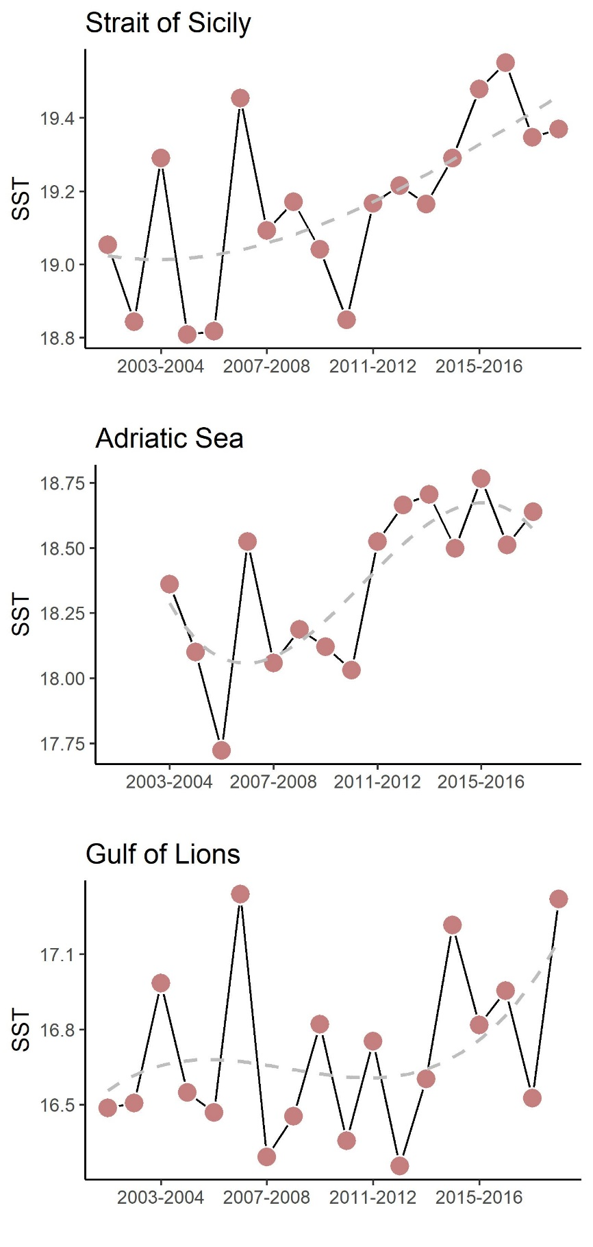
Figure S1. Fluctuation in sea surface temperature (SST) in the three ecosystems (Gulf of Lions, Adriatic Sea, and Strait of Sicily).

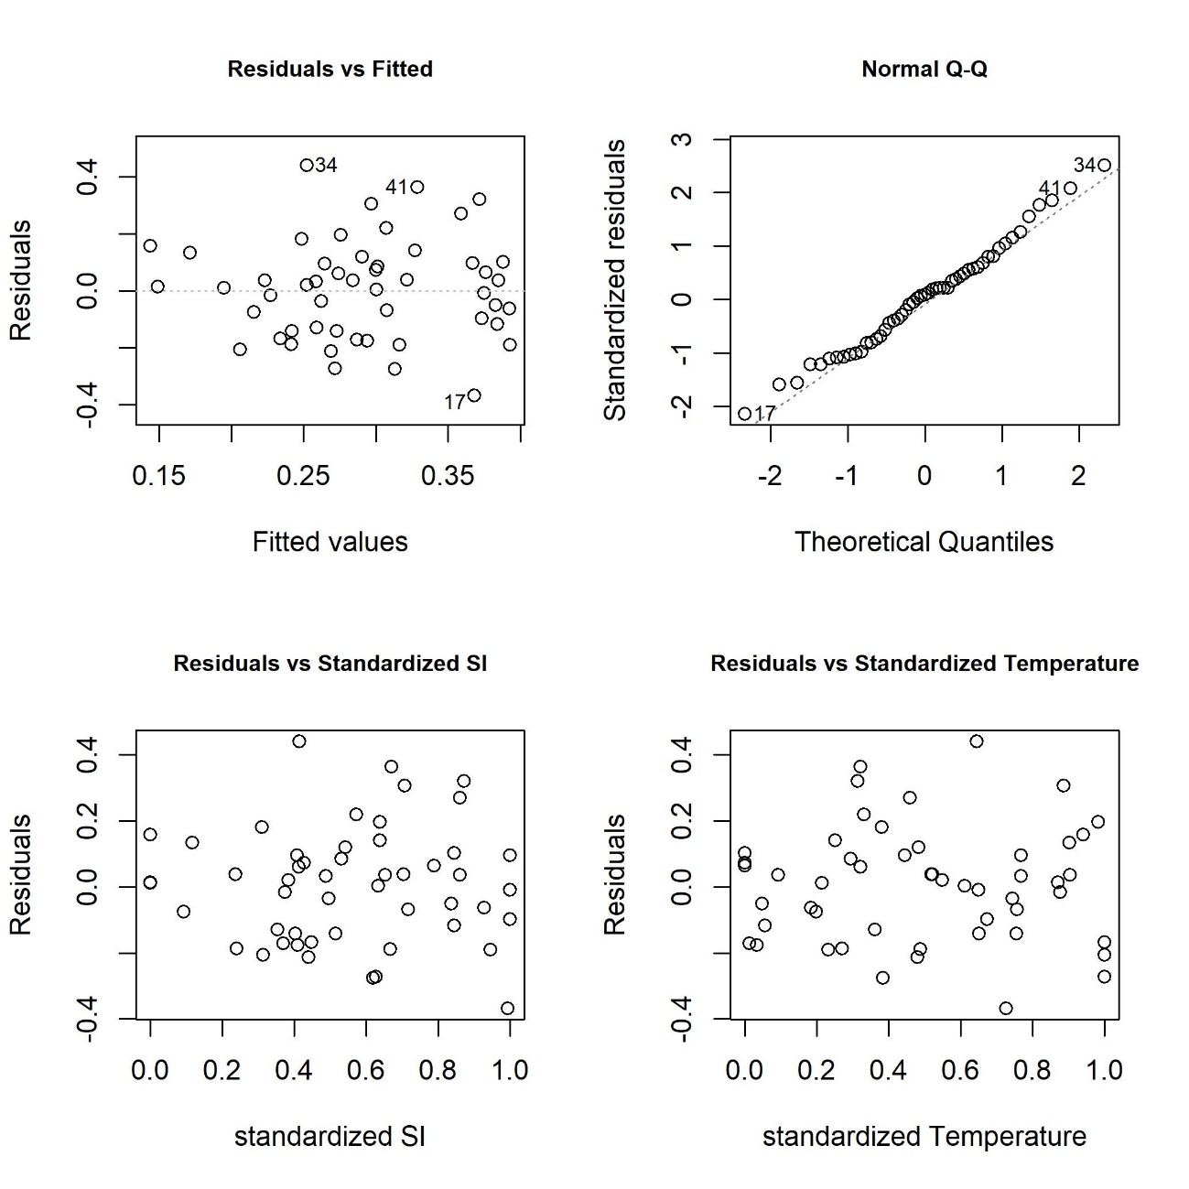
Figure S2. Model validation graphs. Top left: Fitted values versus residuals (homogeneity). top right: QQ-plot for (normality). Bottom left: Residuals versus Standardized SI (independence assumption). Bottom right: Residuals versus Standardized SI (independence assumption).

