Supplementary Material

Supplementary Figures

Supplementary Figure 1. Luminophores of different colors were spread onto the sediment surface at the start of each heatwave to study differences in the effects of repeated heatwaves on sediment mixing rates. The picture presents one side of the box in treatment Heat2, replicate 3 at the start of the first heatwave (upper picture) and on third day of the second heatwave (lower picture).

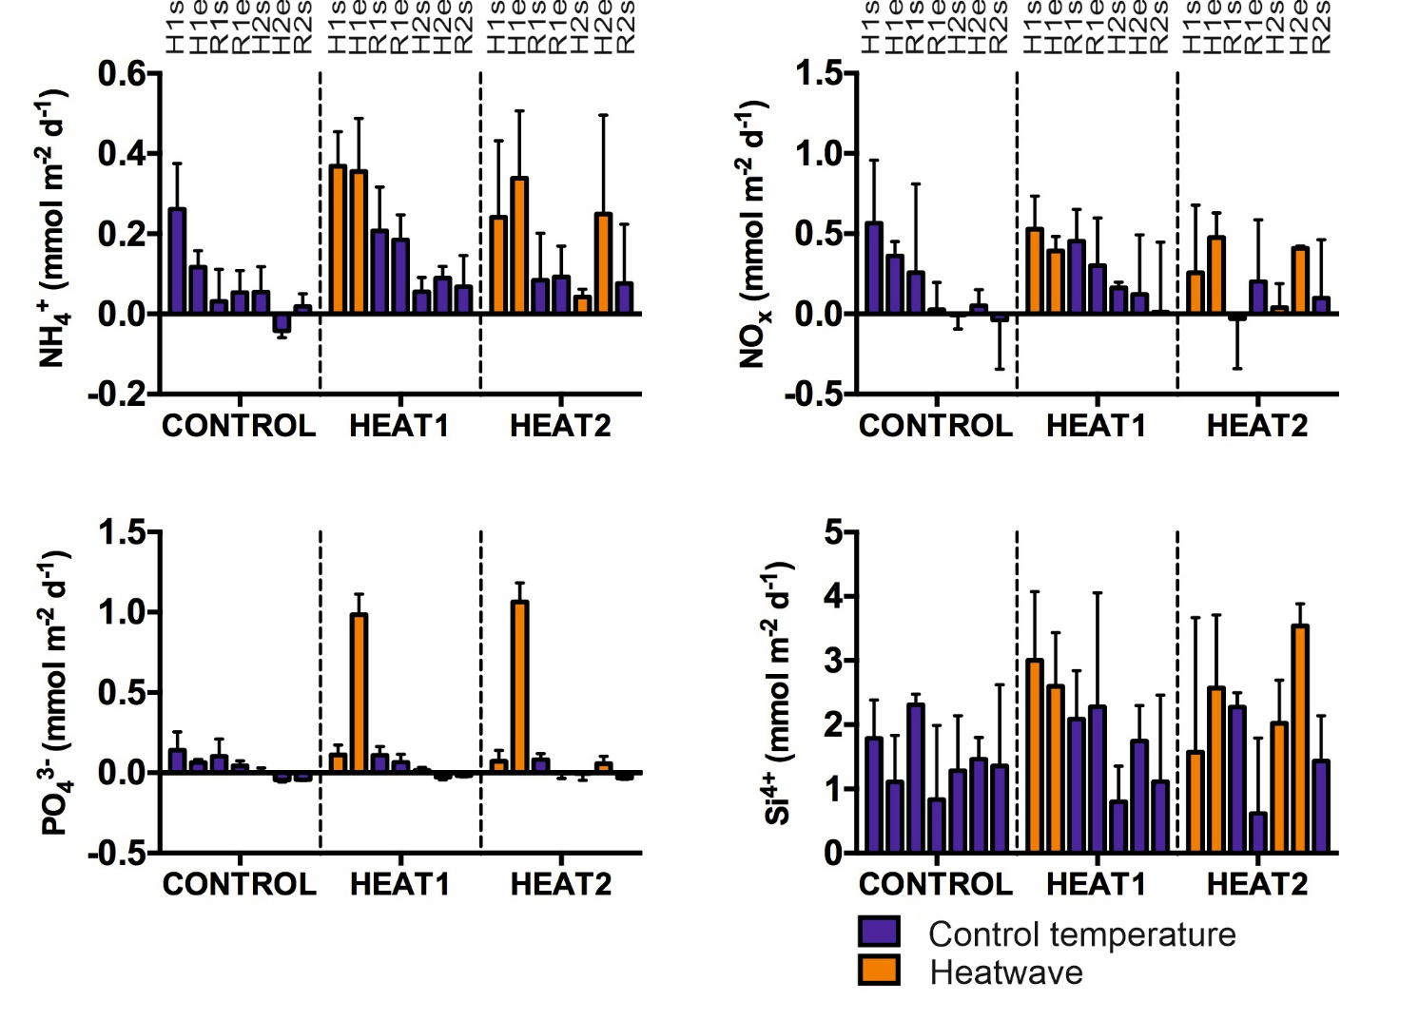
Supplementary Figure 2. Fluxes of solutes (NH4-N, NOx-N, PO4-P and Si) in the three different treatments sampled at the start and end of every experimental phase (first heatwave, first recovery, second heatwave, second recovery). Due to replicates being lost at the end of the second heatwave, results are omitted from the analysis and from the figure. The blue/dark color refers to control conditions (the climatological mean temperature for the reference period 1931-2020) and the light color refers to heatwave. H1s=start of first heatwave, H1e=end of first heatwave, R1s=start of first recovery, R1e=end of first recovery, H2s=start of second heatwave, H2e=end of second heatwave, R2s=start of second recovery.

