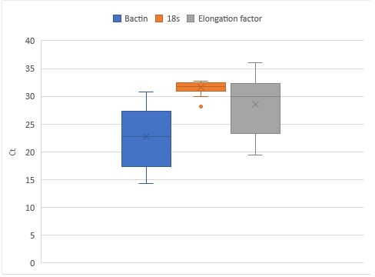
Supplementary Figure 1: Variance of Ct value between candidate reference genes used in this study for normalization gene expression.

