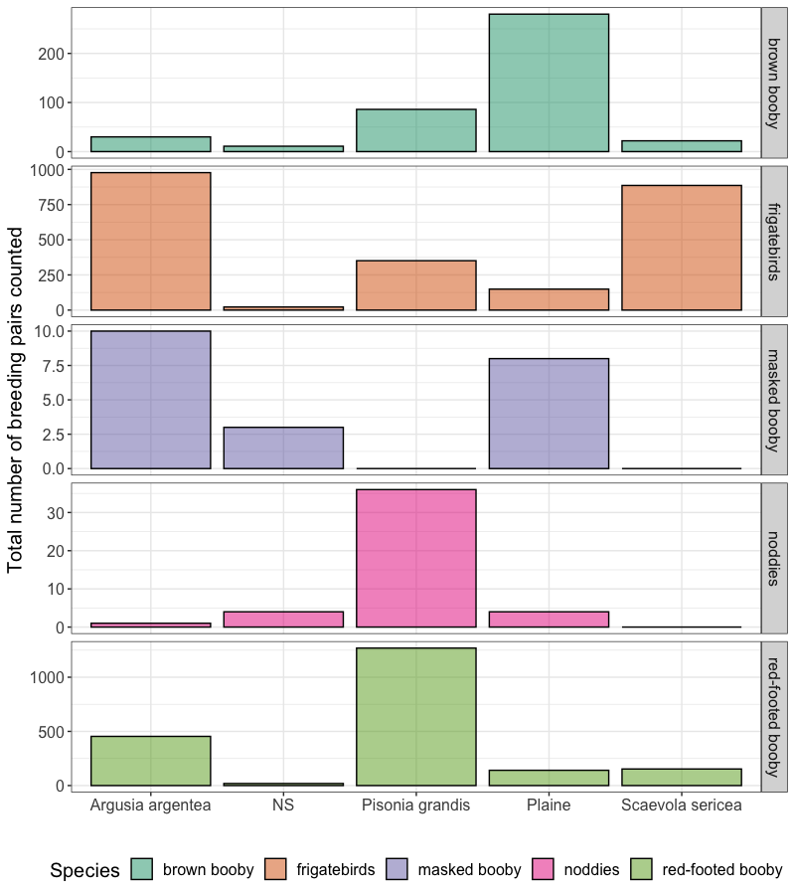

**Supplementary Figure 1.** Totalannual number of seabird breeding pairs counted considering vegetation type on Surprise Island from 2002 to 2009. NS is not specified vegetation corresponding to the areas near the beaches.

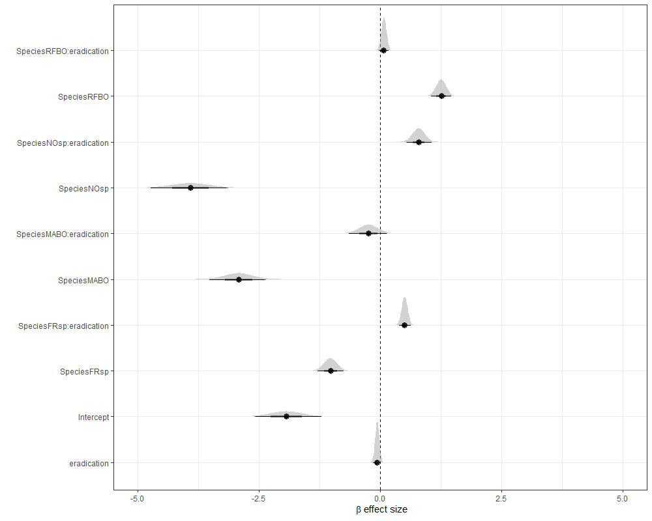

**Supplementary Figure 2.** Bayesian forest plot of the GLMM with eradication effect. RFBO: red-footed booby, NOsp: noddies, MABO: masked booby and FRsp: frigatebirds.

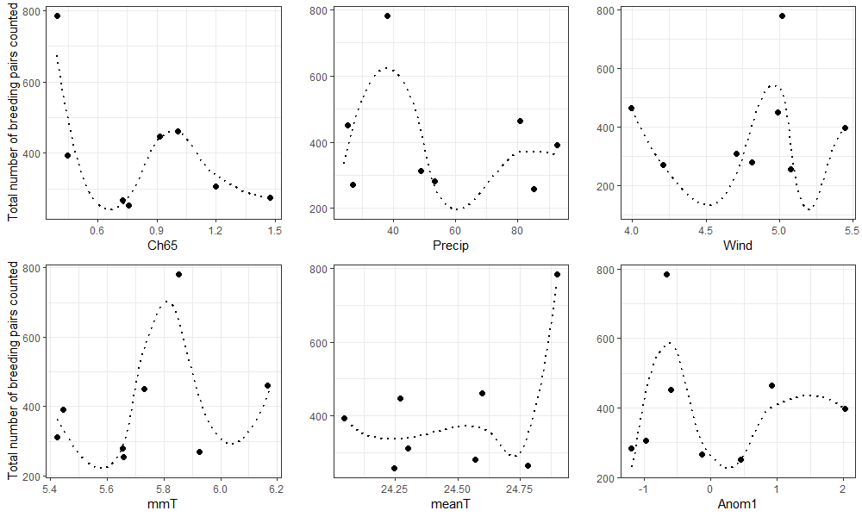

**Supplementary Figure 3.** Effects of fluctuations in climate, inshore and offshore primary productivity on the total number of breeding pairs counted during the transect survey from 2002 to 2009. Ch65 (Chlorophyll concentration in mg/m3 within a range of 65km) ; Precip (rainfall in mm/m²) Wind (m/s): ; mmT (monthly temperature variation between maximum and minimum in C°: ; meant (monthly average temperature in C°): ; Anom1 (Temperature anomaly in °C for Nino 4 region).

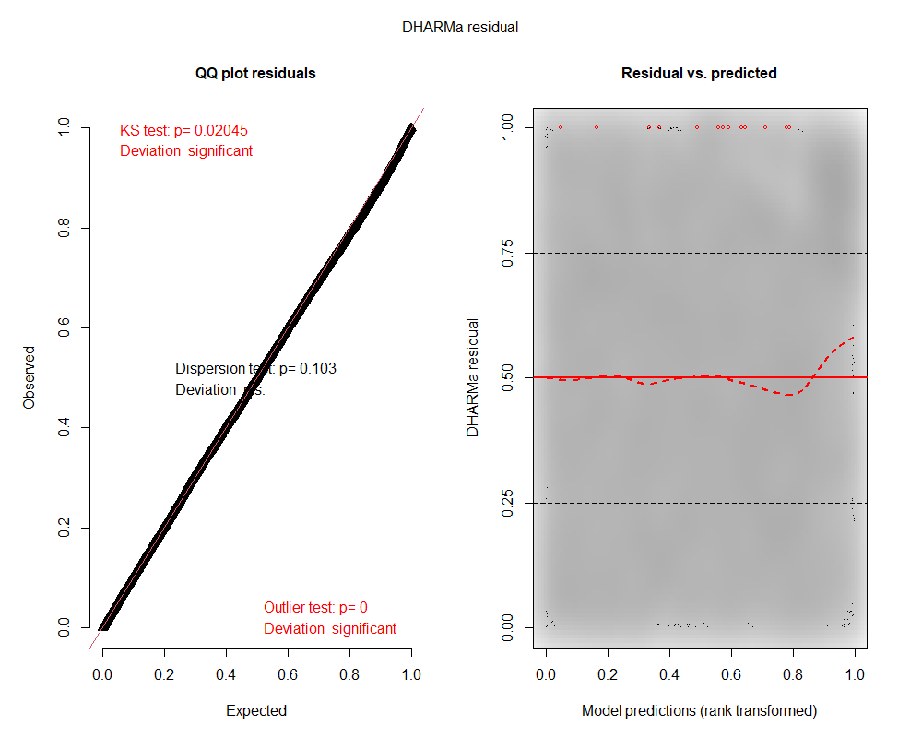

**Supplementary Figure 4.** DHARMa residual diagnostic of the model.

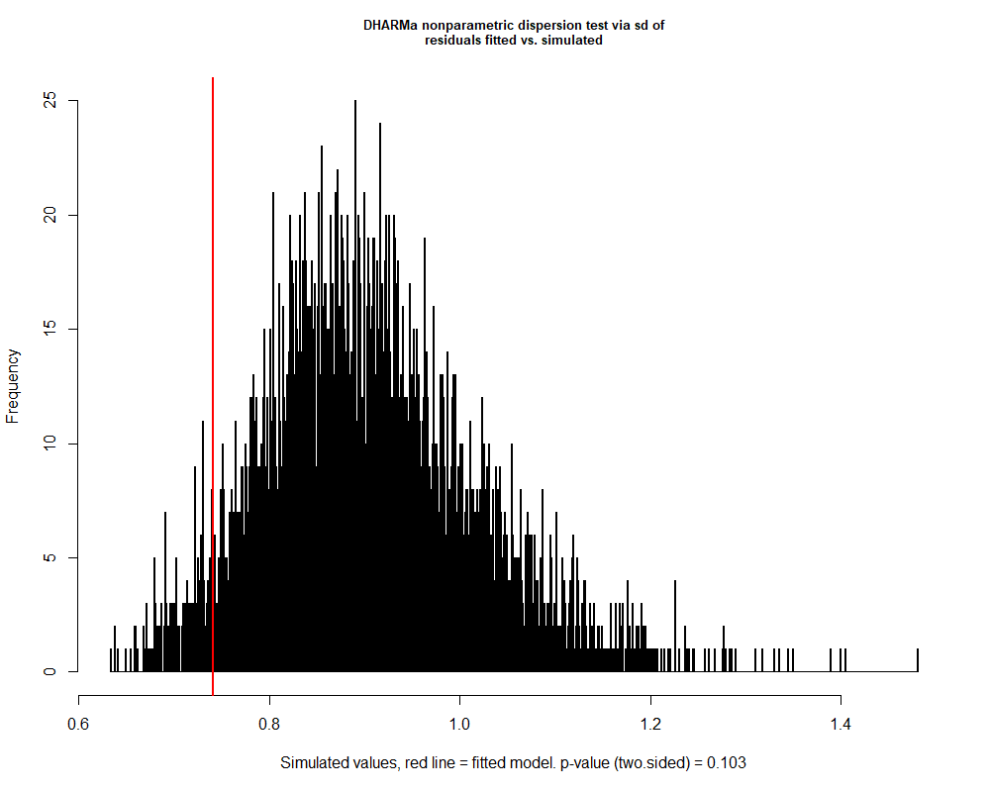

**Supplementary Figure 5.** DHARMa dispersion diagnostic of the model.

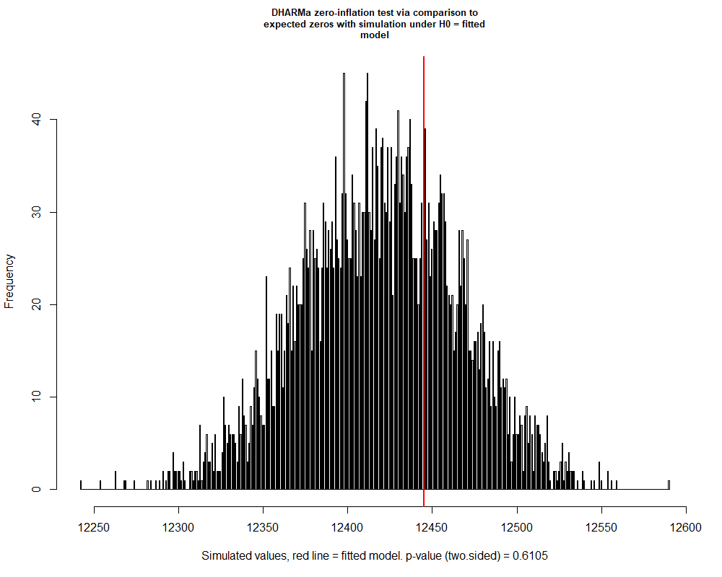

**Supplementary Figure 6.** DHARMa zero-inflation diagnostic of the model.

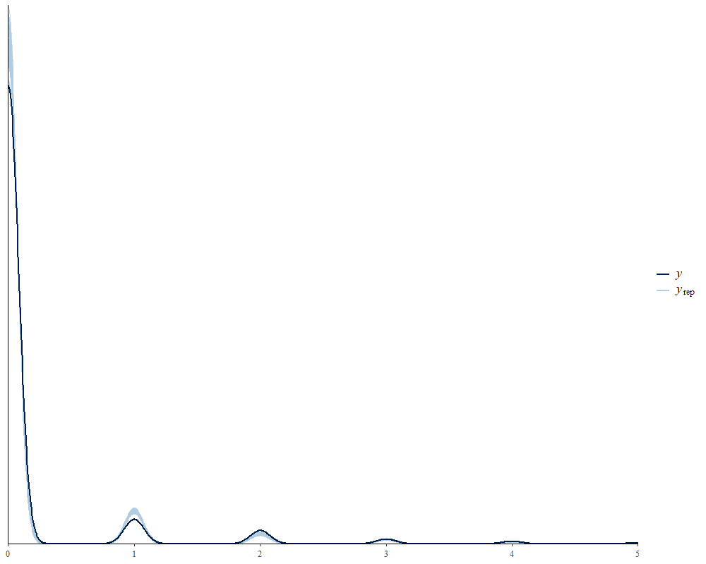

**Supplementary Figure 7.** Posterior predictions of the model.

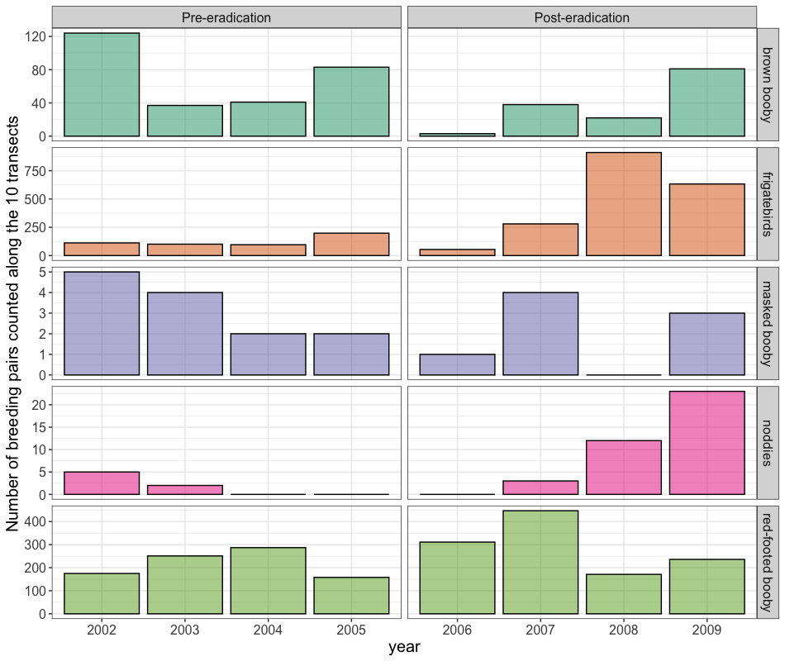

**Supplementary Figure 8.** Annual ‘potential’ number of seabird breeding pairs counted on Surprise Island from 2002 to 2009 along ten transects.The left box represents the four surveys carried out before the rodent eradication from 2002 to 2005 and the right box the four surveys carried out after the rodent eradication between 2006 and 2009.

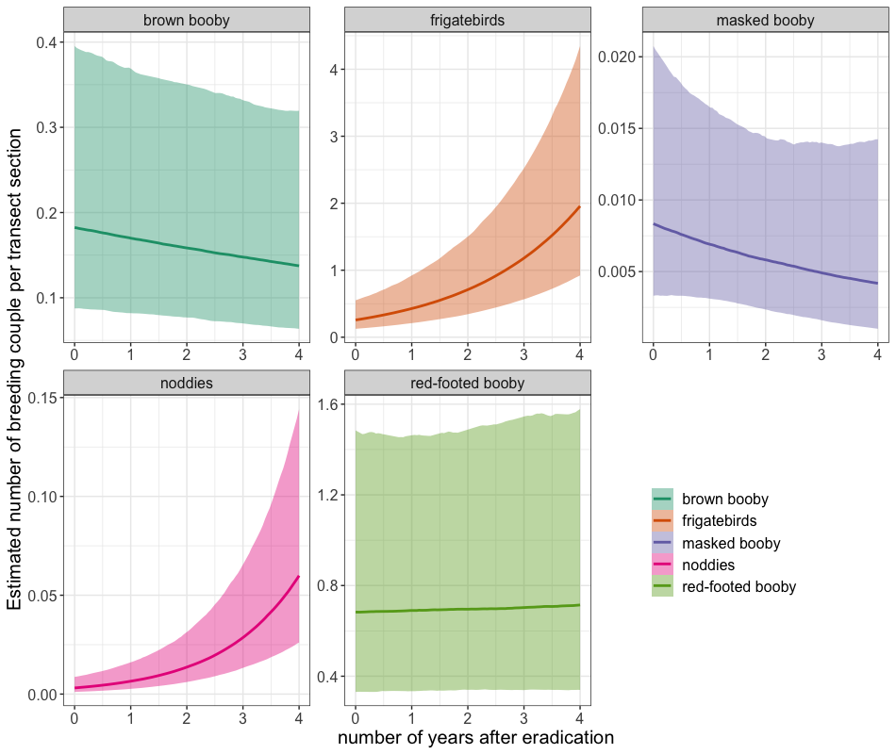

**Supplementary Figure 9.** Effect of eradication on the ‘potential’ number of seabird breeding pairs per 100m2 section on Surprise Island during transect sampling from 2002 to 2009. Dotted lines represent the estimated marginal means, and the colored zones the associated 95% CI from the generalized linear mixed model. The y-axis is different for each species.

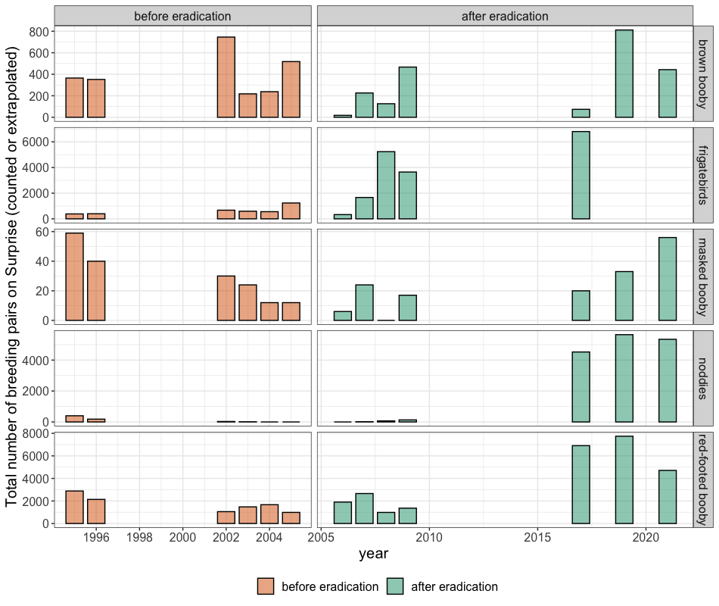

**Supplementary Figure 10.** Dynamics of ‘potential’ seabird breeding pair populations from 1995 to 2021 on Surprise Island. Three data sources were combined: the transect surveys performed by Robinet et al. between 1995 and 1996, our core surveys from 2002 to 2009, and our recent surveys between 2017 and 2021. We kept the maximum number of pairs observed per year for each species except frigatebirds. Due to their synchronous phenology, only the October 2017 survey was retained for frigatebirds. The samples are divided into two stages: “pre-eradication” in orange and “post-eradication” in blue. The total number of breeding pairs was extrapolated for all the survey before 2017 and counted after.