Supplementary material 1: atmospheric correction of harmful algal blooms (ACHABs)
Field data of remote-sensing reflectance, R_{rs}(λ), was acquired during 3 massive blooms (Fig. S1) respectively dominated by the dinoflagellate Lepidodinium chlorophorum (16 July 2019, Vilaine estuary, French Atlantic coast), the ciliate Mesodinium rubrum (29 March 2021, Vie estuary, French Atlantic coast), and an unknown assemblage of cyanobacteria (2 September 2021, Bolmon lagoon, Mediterranean Sea). The analysis of water samples revealed that the chlorophyll a concentration ranged from 4.8 – 24.8 μg l⁻¹ during the ciliate red tide, and was around 116.2 μg l⁻¹ during the cyanobloom. During the L. chlorophorum green seawater discoloration, cell abundance was as high as 33 10⁶ cells l⁻¹.
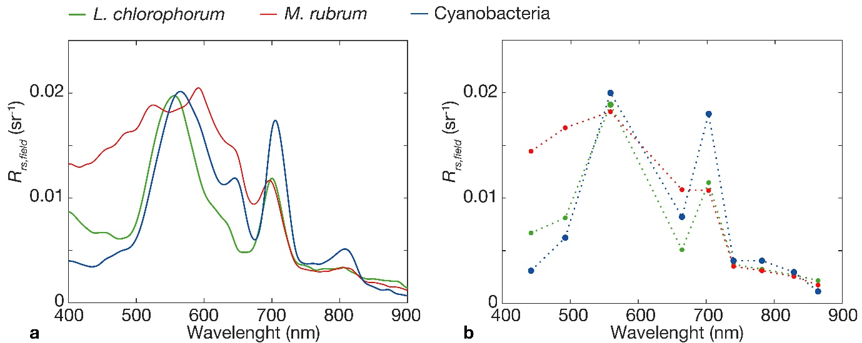

Figure S1-1. Examples of field R_{rs}(λ) measurements acquired during a bloom of L. chlorophorum (in green), M. rubrum (in red), or cyanobacteria (in blue), at native hyperspectral resolution (a), and downgraded at MSI spectral resolution (b).

During these 3 blooms, above-water hyperspectral radiometric measurements were performed with an ASD field spectro-radiometer from 350 – 1075 nm at the time of S2 acquisition. The upwelling radiance, L_{u}(λ), downwelling radiance, L_{d}(λ), and sky radiance, L_{sky}(λ), were sequentially measured following a standard protocol (Muller et al., 2000). Following Burggraaff et al. (2020), hyperspectral radiances were then resampled to S2 spectral resolution using MSI spectral response function prior to compute R_{rs}(λ). The air-water interface reflection coefficient of the sky radiance was calculated as a function of wind speed at the time of field measurements (Ruddick et al., 2006).
Concomitant top-of-atmosphere Sentinel-2 images were processed using four different atmospheric correction (AC) methods: GRS (Harmel et al., 2018), ACOLITE (Vanhellemont and Ruddick, 2018), POLYMER (Steinmetz, et al., 2011), and the Case 2 Regional CoastColour (C2RCC) algorithms. For each image, the pixels corresponding to the in situ stations were extracted. The performance of the four ACs was evaluated by comparing the satellite-derived vs. in situ R_{rs}(λ) using standard statistical metrics such as the coefficient of determination (R²), root mean square difference (RMSD), bias, and mean absolute difference (MAD). Ten field stations were available for match-up. The nine S2 spectral bands from 443 – 865 nm were pooled together, yielding a total of 90 match-up points. Overall, the performance of the four AC methods was satisfactory (R² > 0.8) and the degree of AC uncertainty was generally low in terms RMSD, bias, and MAD (Table S1). The GRS and ACOLITE algorithms performed best, followed by POLYMER, and C2RCC.

Table S1. Performance of the GRS, ACOLITE, POLYMER, and C2RCC AC algorithms. N corresponds to the total number of match-up points.

 | N | R² | RMSD | bias | MAD
GRS | 90 | 0.92 | 0.0016 | -0.0007 | 0.0013
ACOLITE | 86 | 0.93 | 0.0017 | 0.0002 | 0.0013
POLYMER | 85 | 0.88 | 0.0018 | -0.0014 | 0.0019
C2RCC | 80 | 0.84 | 0.0026 | -0.0012 | 0.0020

The number of points available for match-up varied between the different ACs (Table S1) because some AC occasionally failed or retrieved negative R_{rs}(λ) in the near-infrared spectral spectral bands. Among the four ACs tested here, only the GRS algorithm was able to retrieve consistent R_{rs}(λ) for all stations and all spectral bands (Fig. S2). The GRS algorithm was therefore selected because it performed well in the case of massive blooms, and contains a robust deglinting algorithm (Harmel et al., 2018).

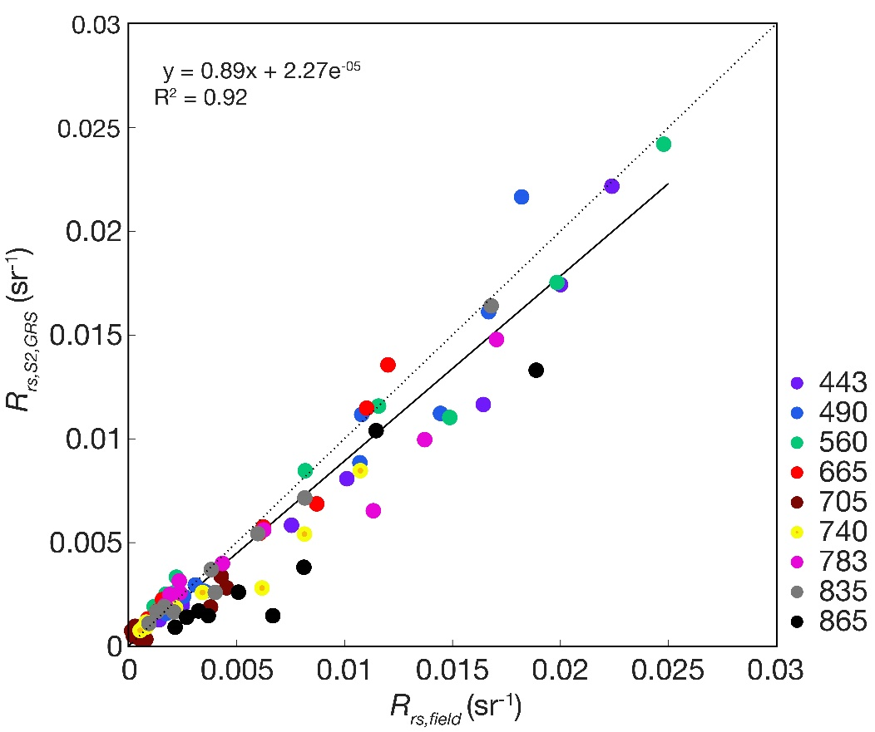

Figure S1-2. Match-up between S2-derived and concomitant field R_{rs}(λ) measurements, using the GRS AC. Each color represents a single S2 spectral band. The solid black line shows the linear fit for all bands; the 1:1 line is in dashed.

References
Harmel, T., Chami, M., Tormos, T., Reynaud, N., and Danis, P.A. 2018. Sunglint correction of the Multi-Spectral Instrument (MSI)-Sentinel-2 imagery over inland and sea waters from SWIR bands. Remote Sens. Environ. 204, 308-321.
Mueller, J.L., Davis, C., Arnone, R., Frouin, R., Carder, K.L., Lee, Z.P., … and McLean, S. 2002. Above- water radiance and remote sensing reflectance measurement and analysis protocols, NASA Tech. Mem., TM-2002-210004, 171–182.
Ruddick, K., De Cauwer, V., Park, Y.-J., Moore, G., 2006. Seaborne measurements of near infrared water-leaving reflectance: The similarity spectrum for turbid waters. Limnol. Oceanogr. 51, 1167-1179.
Steinmetz, F., Deschamps, P.-Y., and Ramon, D. 2011. Atmospheric correction in presence of sun glint: application to MERIS. Opt. Express 19, 9783-9800.
Vanhellemont, Q., Ruddick, K., 2018. Atmospheric correction of metre-scale optical satellite data for inland and coastal water applications. Remote Sens. Environ. 216, 586-597.

