Supplementary material 3: reflectance spectra of 108 red tide events
The following figures show the R_{rs}(λ) and standardized R_{rs}(λ) spectra of the 108 red tides analysed in the present study. The blooms are grouped at genus and/or species level, and an example of a Sentinel-2 image is shown in each case. The 21 figures are shown in the same order than in Table 1, and correspond to red tides dominated by 13 dinoflagellate genera (Fig. S3-1-13), 5 cyanobacteria genera (Fig. S3-14-18), 1 ciliate (Fig. S3-19), 1 prymnesiophyte (Fig. S3-20), and 1 pelagophyte (Fig. S21).

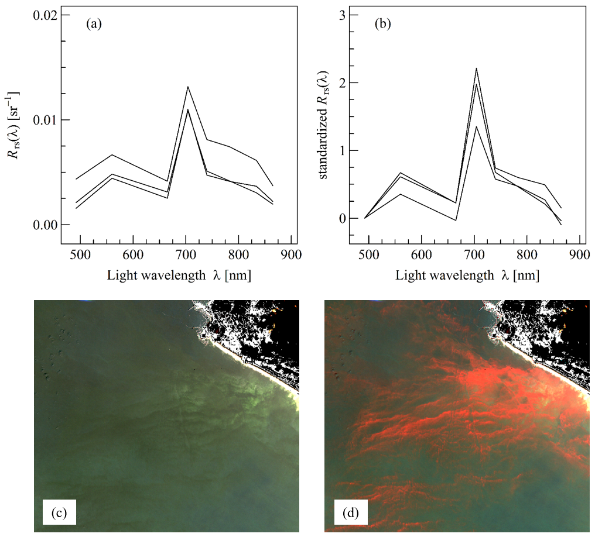
Figure S3-1. (a, b) R_{rs}(λ) and standardized R_{rs}(λ) spectra, respectively, of red tides dominated by the dinoflagellate Alexandrium sp., corresponding to a bloom of A. monilatum in Chesapeake Bay, US, the 29 August 2016 (Wolny et al., 2020), and two blooms of A. ostenfeldii in Paracas Bay, Peru, the 2 and 12 March 2017 (HAEDAT PE-17-001). (c, d) Example of Sentinel-2 image of a bloom dominated by Alexandrium (2 March 2017, Paracas Bay, Peru) displayed using a RGB and REGB colour composite, respectively. The colour histogram was adjusted as follow: 0.01, 0.02, and 0.02 sr⁻¹ for the red, green, and blue band, respectively.

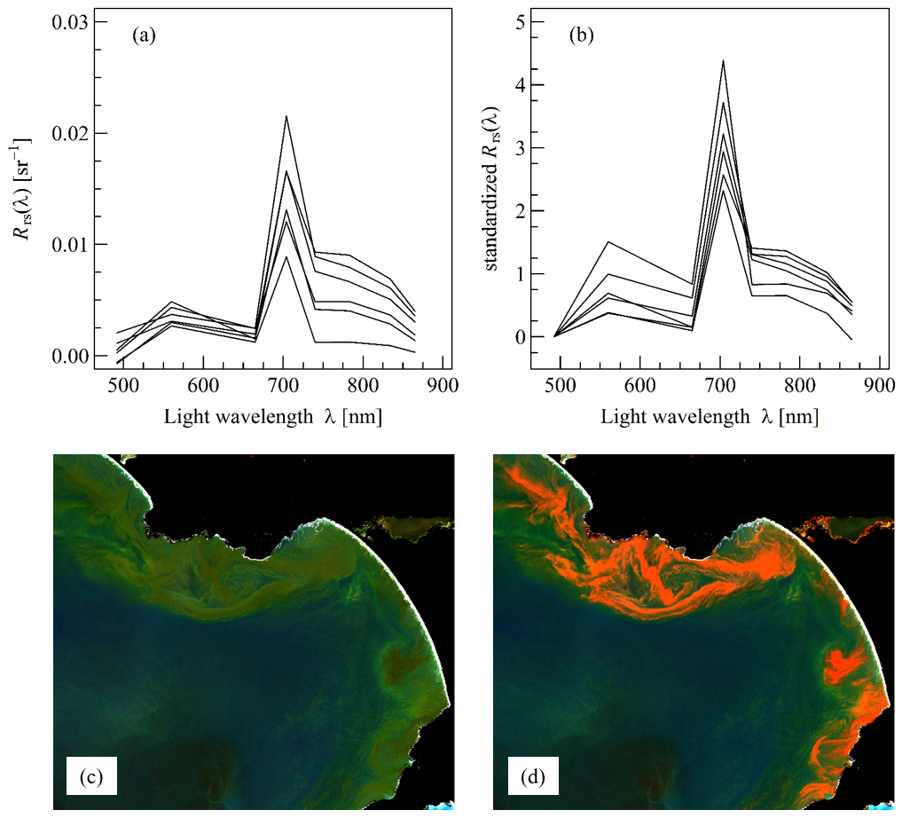
Figure S3-2. (a, b) R_{rs}(λ) and standardized R_{rs}(λ) spectra, respectively, of red tides dominated by the dinoflagellate Gonyaulax sp., corresponding to a bloom of G. polygramma in Chabahar Bay, Iran, the 25 October 2017 (Dolatabadi et al. 2021), two blooms of G. digitale in Puget Sound, US, the 20 and 25 July 2020 (State of Washington department of Ecology), and three blooms of G. spinifera in Walker Bay, South Africa, the 31 January 2017 (HAEDAT ZAF-17-001; Pitcher et al. 2019) and 25 February 2019 (Smith and Bernard, 2020). (c, d) Example of Sentinel-2 image of a bloom dominated by Gonyaulax (25 February 2019, Walker Bay, South Africa) displayed using a RGB and REGB colour composite, respectively. The colour histogram was adjusted as follow: 0.01, 0.015, and 0.01 sr⁻¹ for the red, green, and blue band, respectively.

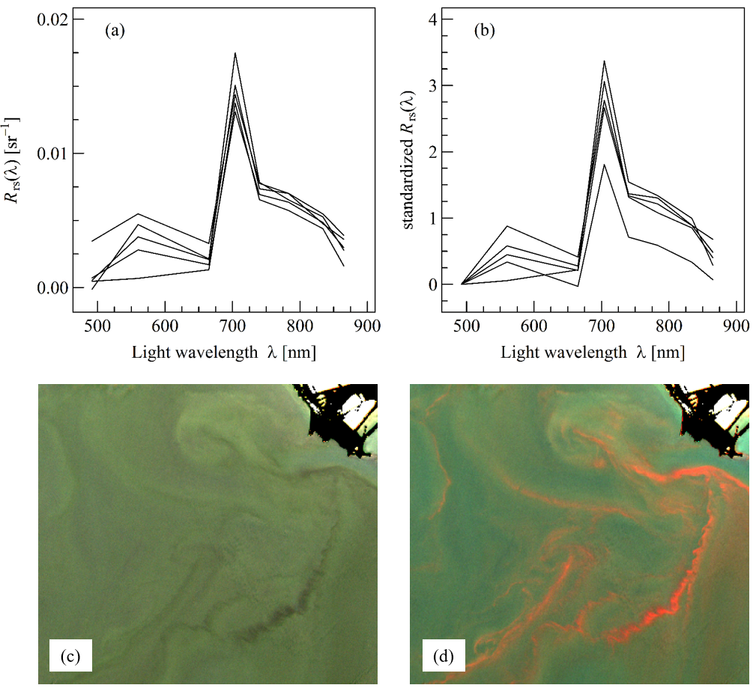
Figure S3-3. (a, b) R_{rs}(λ) and standardized R_{rs}(λ) spectra, respectively, of red tides dominated by the dinoflagellate Gymnodinium sp., corresponding to three blooms of G. impudicum in Berre Lagoon, France, the 6, 16 August and 5 September 2018 (REPHY), a bloom of G. aureolum in Caraguatatuba Bay, Brazil, the 4 September 2017, and a bloom of G. catenatum in the Gulf of California, Mexico, the 18 April 2018 (HAEDAT MX-17-014). (c, d) Example of Sentinel-2 image of a bloom dominated by Gymnodinium (5 September 2018, Berre lagoon, France) displayed using a RGB and REGB colour composite, respectively. The colour histogram was adjusted as follow: 0.015 sr⁻¹ for the three bands.

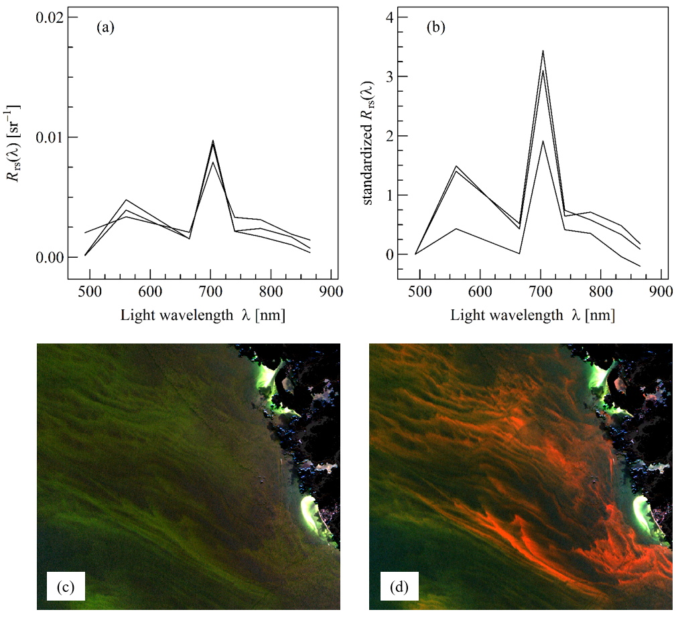
Figure S3-4. (a, b) R_{rs}(λ) and standardized R_{rs}(λ) spectra, respectively, of red tides dominated by the dinoflagellate Karenia sp., corresponding to two blooms of K. brevis off Florida, US, the 28 July and 7 August 2018 (Weisberg et al., 2019), and a bloom of K. mikimotoi in Saga Bay, Japan, the 31 July 2019 (HAEDAT JP-19-007). (c, d) Example of Sentinel-2 image of a bloom dominated by Karenia (7 August 2018, Florida, US) displayed using a RGB and REGB colour composite, respectively. The colour histogram was adjusted as follow: 0.01, 0.02, and 0.015 sr⁻¹ for the red, green, and blue band, respectively.

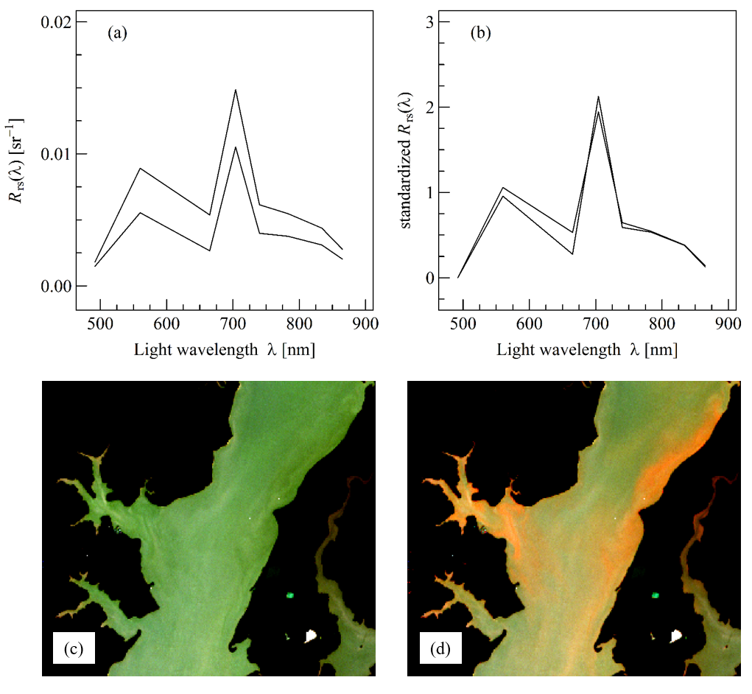
Figure S3-5. (a, b) R_{rs}(λ) and standardized R_{rs}(λ) spectra, respectively, of red tides dominated by the dinoflagellate Karlodinium veneficum, corresponding to two blooms in Chesapeake Bay, US, the 16 May and 17 November 2017 (Wolny et al., 2020). (c, d) Example of Sentinel-2 image of a bloom dominated by K. veneficum (17 November 2017, Chesapeake Bay, US) displayed using a RGB and REGB colour composite, respectively. The colour histogram was adjusted as follow: 0.015, 0.015, and 0.01 sr⁻¹ for the red, green, and blue band, respectively.

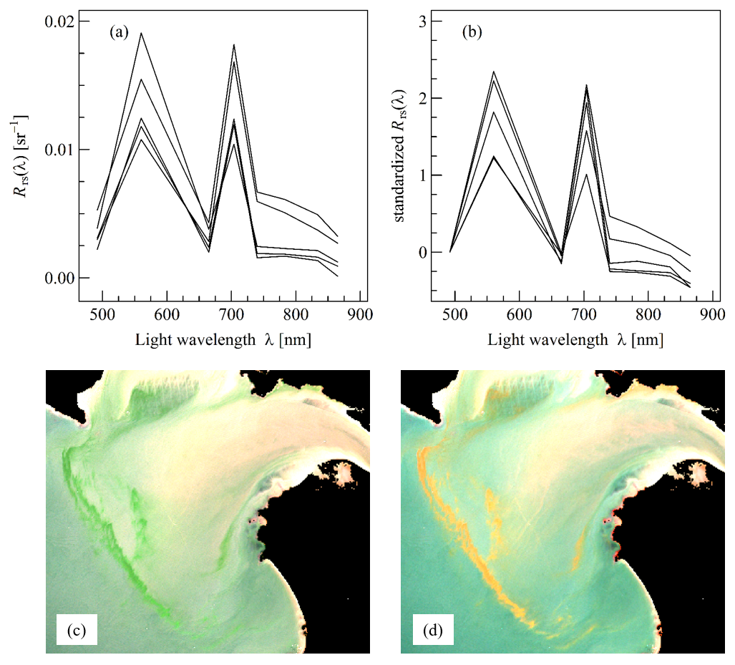
Figure S3-6. (a, b) R_{rs}(λ) and standardized R_{rs}(λ) spectra, respectively, of red tides dominated by the dinoflagellate Lepidodinium chlorophorum, corresponding to five blooms in the Vilaine and Loire estuaries, France, the 6, 11, 16 and 21 July 2019 (Roux et al., 2022). (c, d) Example of Sentinel-2 image of a bloom dominated by L. chlorophorum (21 July 2019, Vilaine estuary, France) displayed using a RGB and REGB colour composite, respectively. The colour histogram was adjusted as follow: 0.01, 0.02, and 0.015 sr⁻¹ for the red, green, and blue band, respectively.

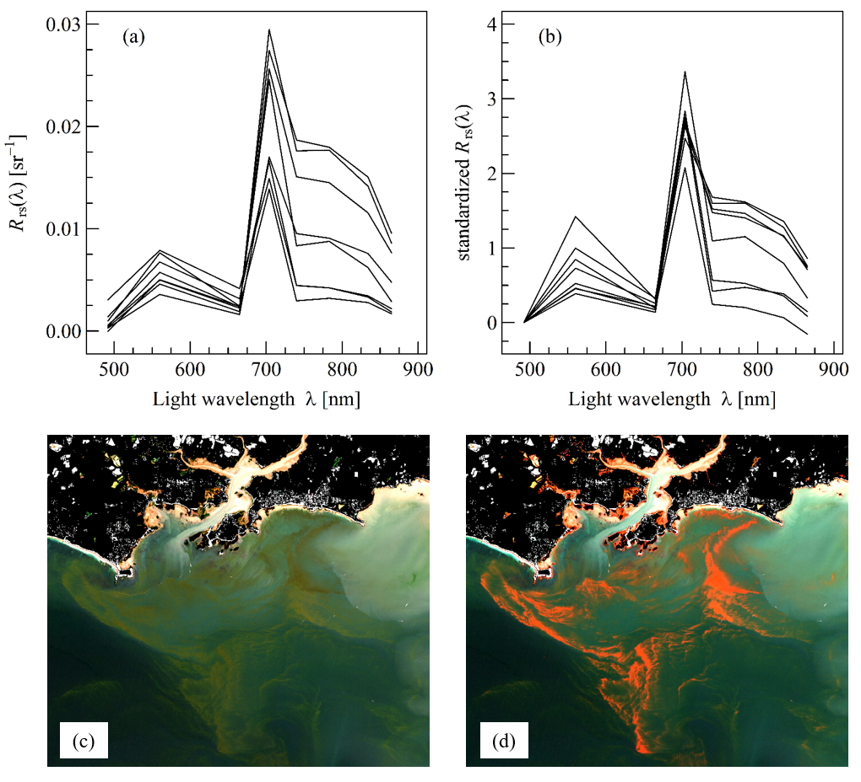
Figure S3-7. (a, b) R_{rs}(λ) and standardized R_{rs}(λ) spectra, respectively, of red tides dominated by the dinoflagellate Lingulodinium polyedra, corresponding to five blooms off San Diego, US, the 15, 23, and 25 April 2020 (Kahru et al., 2021), a bloom off the Guadiana estuary, Spain, the 16 July 2019 (Caballero et al., 2020), and two blooms in the Vilaine estuary, France, the 14 August and 6 September 2021 (REPHY). (c, d) Example of Sentinel-2 image of a bloom dominated by L. polyedra (14 August 2021, Vilaine estuary, France) displayed using a RGB and REGB colour composite, respectively. The colour histogram was adjusted as follow: 0.01, 0.02, and 0.015 sr⁻¹ for the red, green, and blue band, respectively.

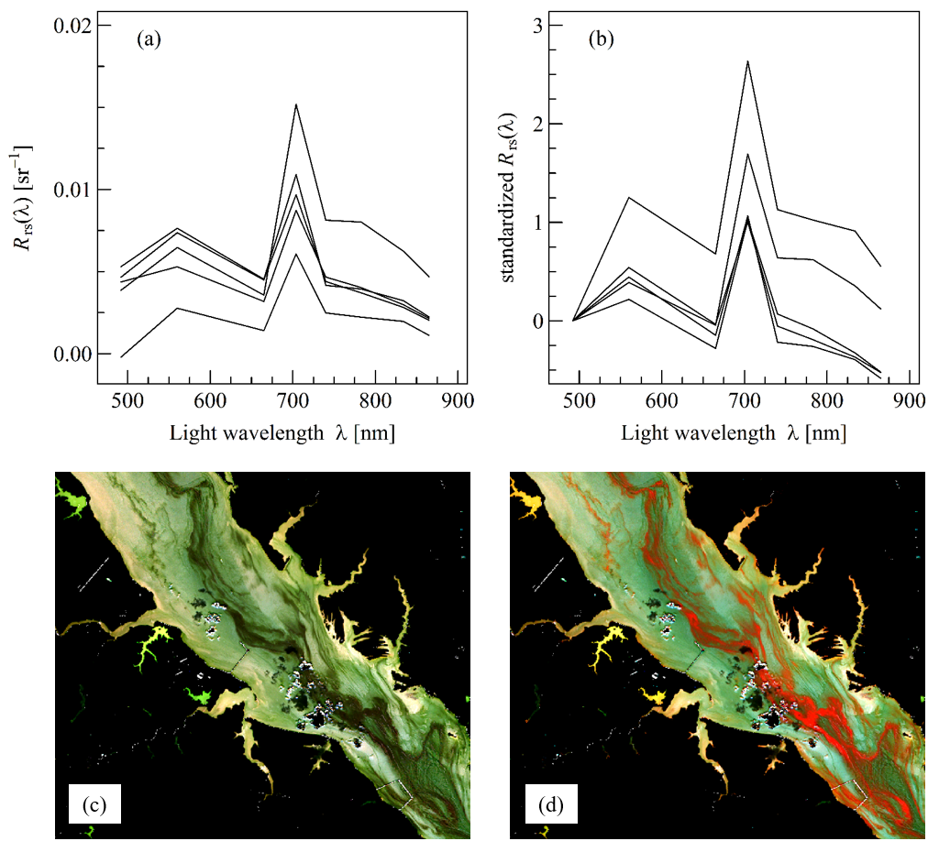
Figure S3-8. (a, b) R_{rs}(λ) and standardized R_{rs}(λ) spectra, respectively, of red tides dominated by the dinoflagellate Margalefidinium polykrikoides, corresponding to two blooms off Binhai, China, the 3 September 2015 (HAEDAT CN-15-003), and three blooms in Chesapeake Bay, US, the 4 August 2017 (HAEDAT US-17-020), 8 August 2020 (HAEDAT US-20-015), and 7 September 2020 (HAEDAT US-20-016). (c, d) Example of Sentinel-2 image of a bloom dominated by M. polykrikoides (4 April 2017, Chesapeake Bay, US) displayed using a RGB and REGB colour composite, respectively. The colour histogram was adjusted as follow: 0.01, 0.015, and 0.01 sr⁻¹ for the red, green, and blue band, respectively.

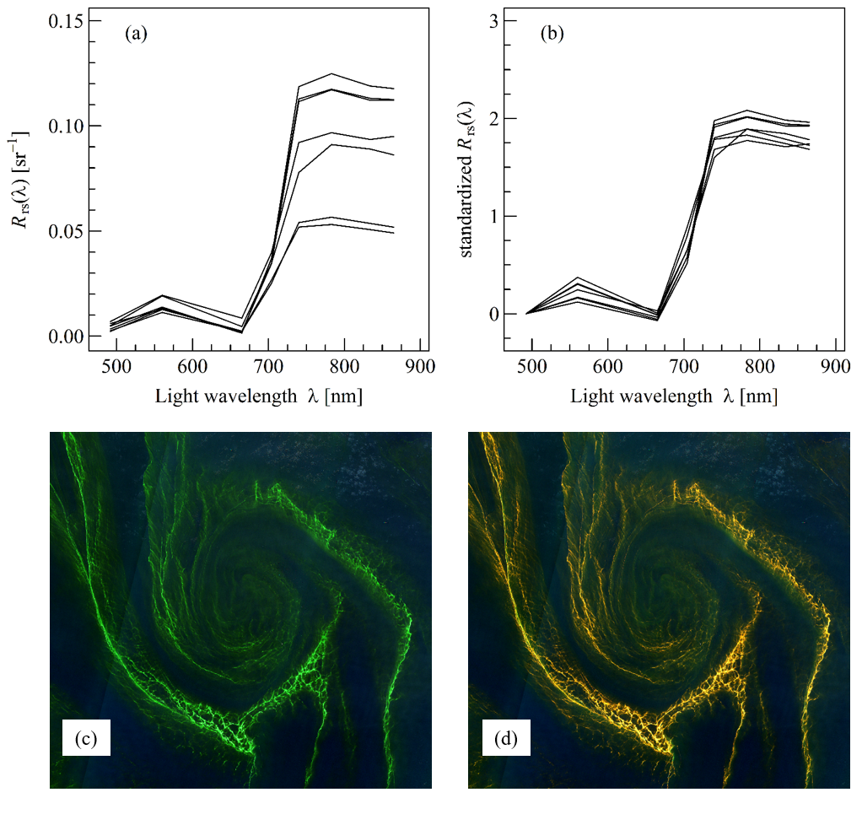
Figure S3-9. (a, b) R_{rs}(λ) and standardized R_{rs}(λ) spectra, respectively, of red tides dominated by the dinoflagellate Noctiluca scintillans (green form), corresponding to four blooms in the Eastern China Sea, the 8 June 2019 (Qi et al., 2020), and three blooms in the Arabian Sea, Oman, the 14 March 2019 (Qi et al., 2020). (c, d) Example of Sentinel-2 image of a bloom dominated by the green N. scintillans (14 March 2019, Arabian Sea, Oman) displayed using a RGB and REGB colour composite, respectively. The colour histogram was adjusted as follow: 0.01 sr⁻¹ for the three bands.

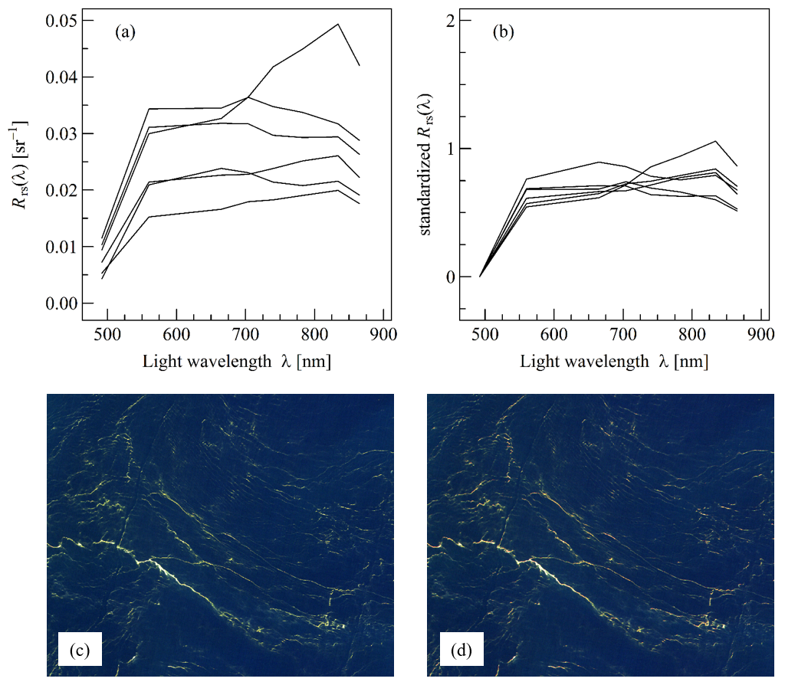
Figure S3-10. (a, b) R_{rs}(λ) and standardized R_{rs}(λ) spectra, respectively, of red tides dominated by the dinoflagellate Noctiluca scintillans (red form), corresponding to a bloom in the North-western Aegean Sea, Greece, the 25 March 2019 (HAEDAT GR-19-002), a bloom off the Sables d’Olonne, France, the 11 April 2020 (Phenomer), two blooms in the Ria de Vigo, Spain, the 25 September 2017 and 4 September 2021 (blog fitopasion), and a bloom off Gran Canaria, Spain, the 13 April 2016 (blog fitopasion). (c, d) Example of Sentinel-2 image of a bloom dominated by the red N. scintillans (13 April 2016, Gran Canaria, Spain) displayed using a RGB and REGB colour composite, respectively. The colour histogram was adjusted as follow: 0.01 sr⁻¹ for the three bands.

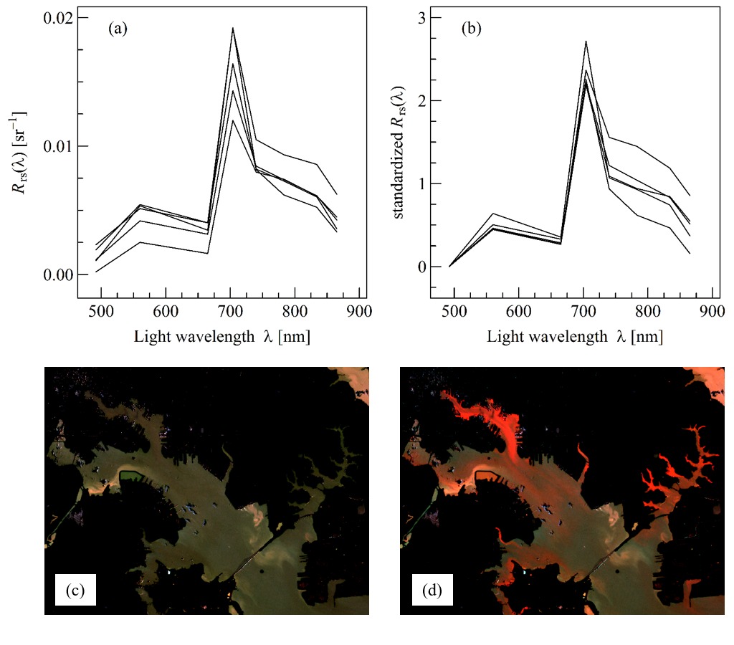
Figure S3-11. (a, b) R_{rs}(λ) and standardized R_{rs}(λ) spectra, respectively, of red tides dominated by the dinoflagellate Prorocentrum sp., corresponding to four blooms in Chesapeake Bay, US, the 7 and 29 November and 17 December 2018 (Maryland State Monitoring), and 16 January 2020 (Wolny et al., 2020), and a bloom in Berre lagoon, France, the 25 October 2018 (GIPREB). (c, d) Example of Sentinel-2 image of a bloom dominated by P. minimum (16 January 2020, Chesapeake Bay, US) displayed using a RGB and REGB colour composite, respectively. The colour histogram was adjusted as follow: 0.01, 0.02, and 0.015 sr⁻¹ for the red, green, and blue band, respectively.

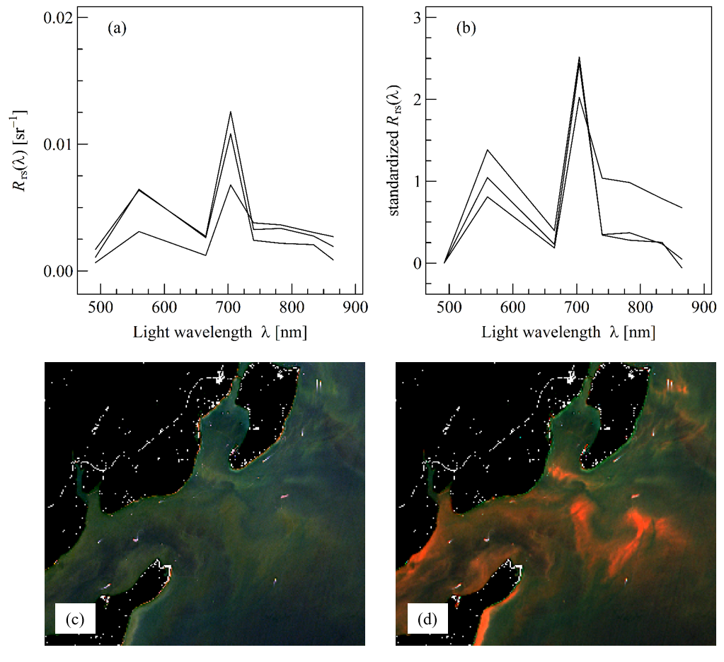
Figure S3-12. (a, b) R_{rs}(λ) and standardized R_{rs}(λ) spectra, respectively, of red tides dominated by the dinoflagellate Protoceratium reticulatum, corresponding to three blooms in Puget Sound, US, the 26 and 29 July and 5 August 2020 (State of Washington department of Ecology). (c, d) Example of Sentinel-2 image of a bloom dominated by P. reticulatum (27 July 2020, Puget Sound, US) displayed using a RGB and REGB colour composite, respectively. The colour histogram was adjusted as follow: 0.01, 0.02, and 0.01 sr⁻¹ for the red, green, and blue band, respectively.

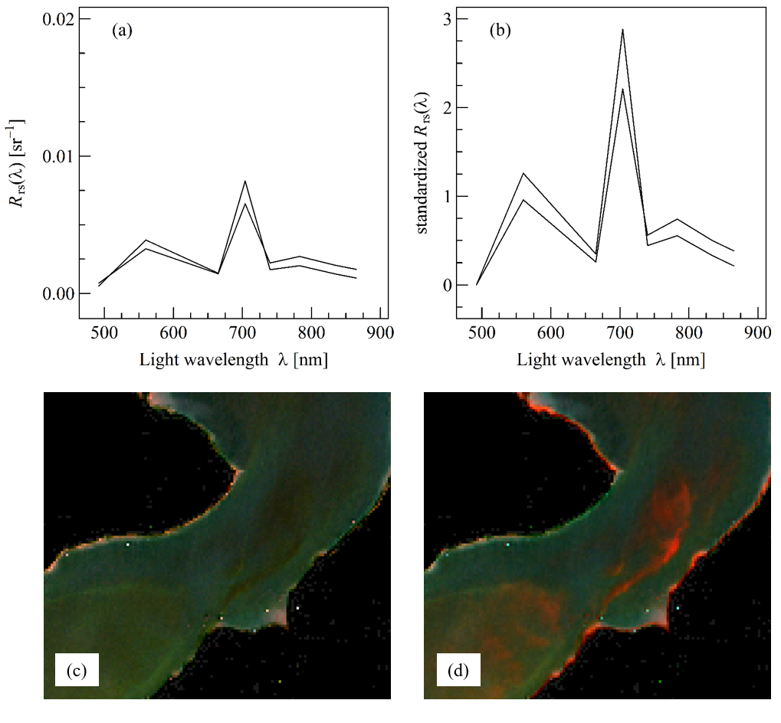
Figure S3-13. (a, b) R_{rs}(λ) and standardized R_{rs}(λ) spectra, respectively, of red tides dominated by the dinoflagellate Tripos fusus, corresponding to two blooms in Puget Sound, US, the 30 July 2017, and 15 July 2018 (State of Washington department of Ecology). (c, d) Example of Sentinel-2 image of a bloom dominated by T. fusus (15 July 2018, Puget Sound, US) displayed using a RGB and REGB colour composite, respectively. The colour histogram was adjusted as follow: 0.01, 0.02, and 0.015 sr⁻¹ for the red, green, and blue band, respectively.

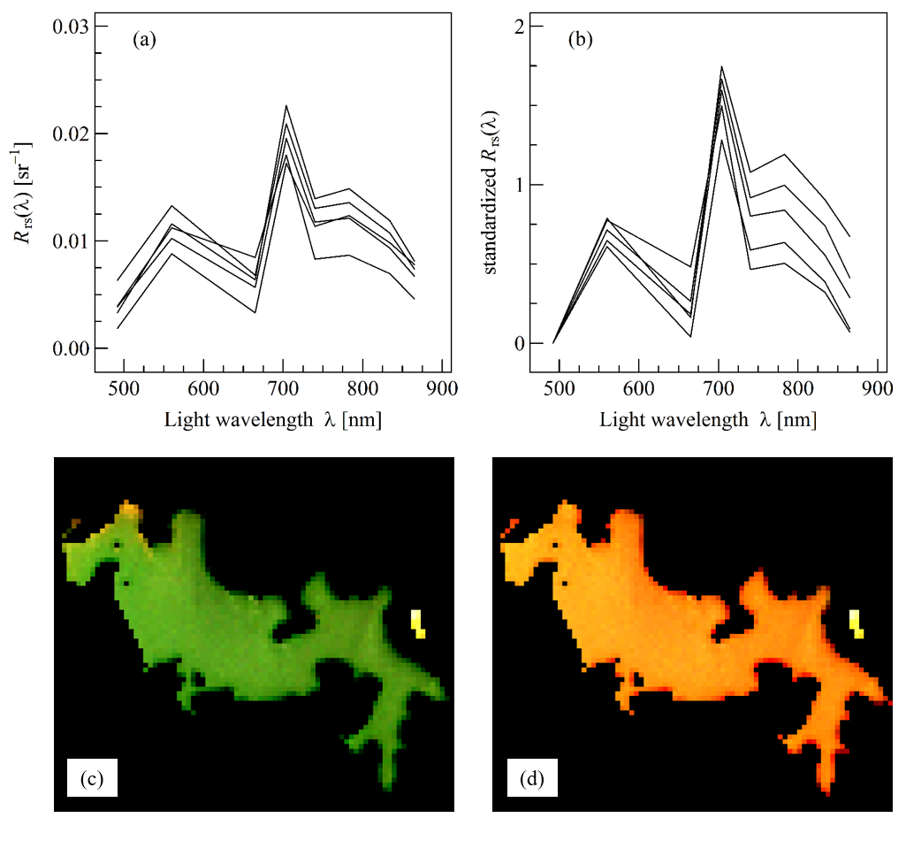
Figure S3-14. (a, b) R_{rs}(λ) and standardized R_{rs}(λ) spectra, respectively, of red tides dominated by the cyanobacteria Anabaenopsis sp., corresponding to five blooms in Albufera lagoon, Menorca, Spain, the 9, 14, 19, 24, and 29 July 2018 (HAEDAT ES-18-014). (c, d) Example of Sentinel-2 image of a bloom dominated by Anabaenopsis (14 July 2019, Albufera lagoon, Spain) displayed using a RGB and REGB colour composite, respectively. The colour histogram was adjusted as follow: 0.01, 0.015, and 0.02 sr⁻¹ for the red, green, and blue band, respectively.

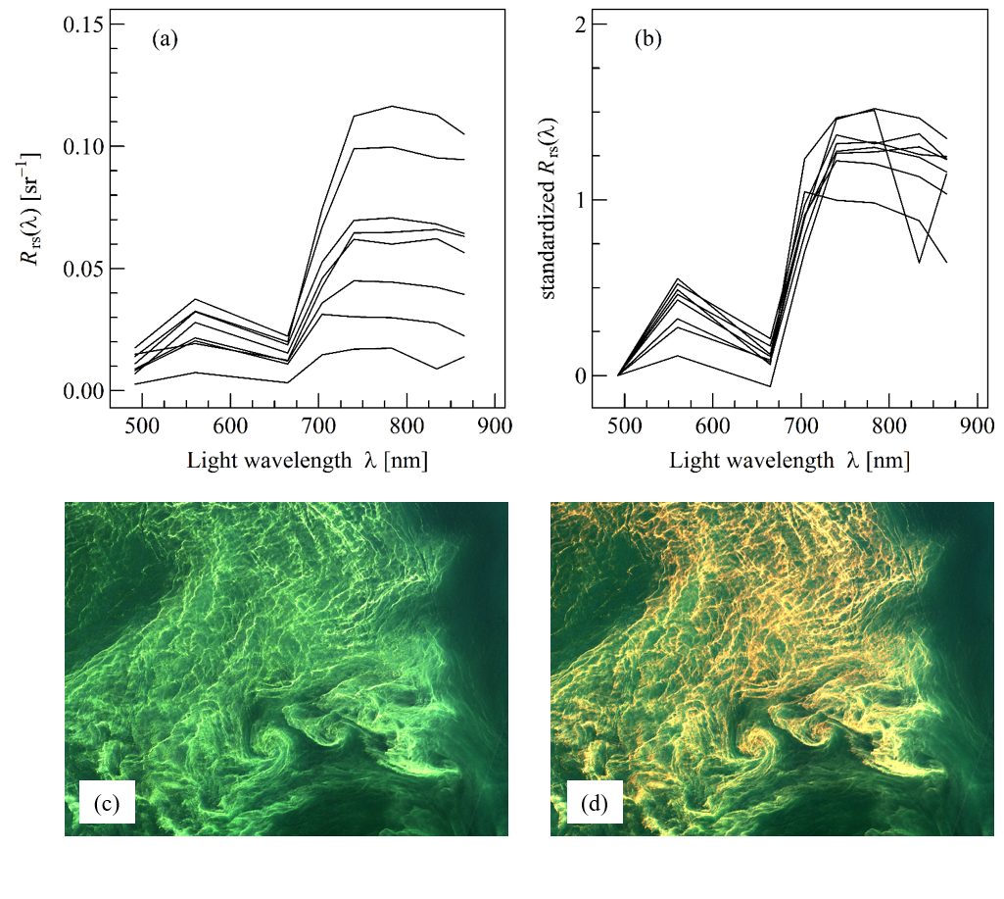
Figure S3-15. (a, b) R_{rs}(λ) and standardized R_{rs}(λ) spectra, respectively, of red tides dominated by the cyanobacteria Aphanizomenon sp., corresponding to six blooms in the Baltic Sea, Latvia, and Sweden, the 13 August 2015 (HAEDAT SE-15-012), 25 July 2016 (HAEDAT SE-16-006), 20 July 2019 (Zettler et al., 2020), and 26 July 2020 (HAEDAT SE-19-007, Karlson et al., 2021). (c, d) Example of Sentinel-2 image of a bloom dominated by Aphanizomenon (20 July 2019, Baltic Sea, Sweden) displayed using a RGB and REGB colour composite, respectively. The colour histogram was adjusted as follow: 0.01 sr⁻¹ for the three bands, respectively.

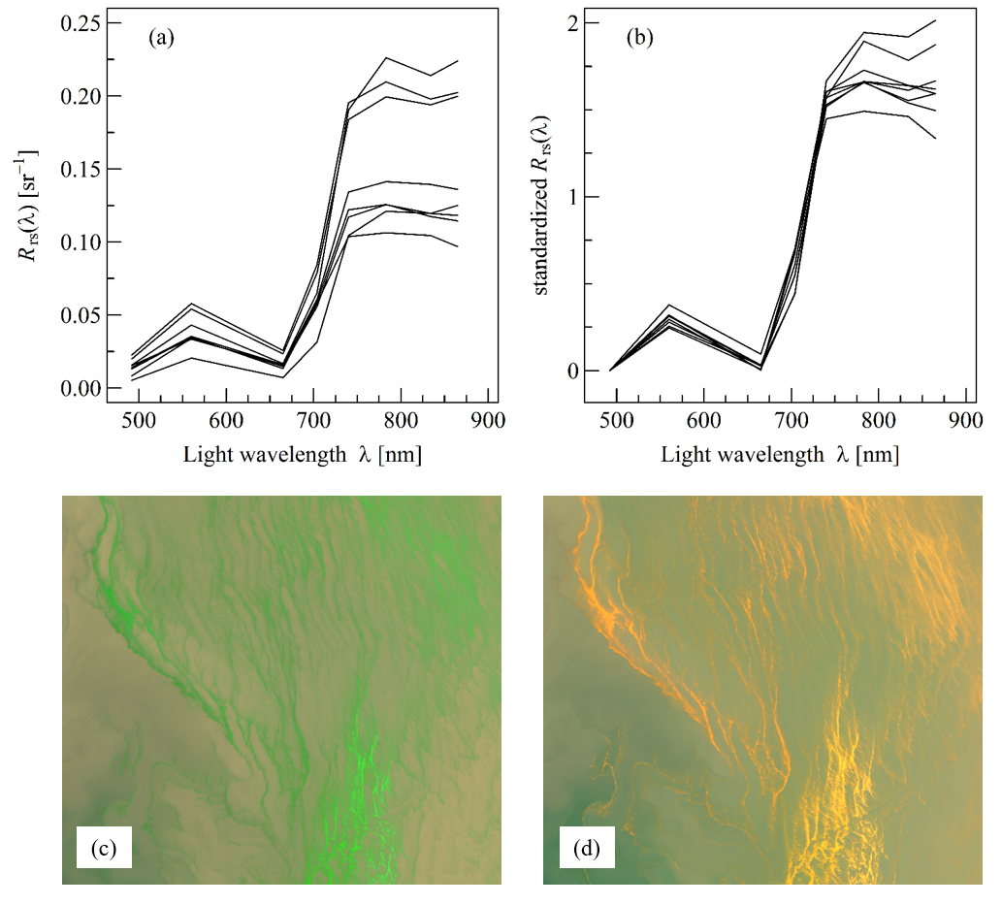
Figure S3-16. (a, b) R_{rs}(λ) and standardized R_{rs}(λ) spectra, respectively, of red tides dominated by the cyanobacteria Microcystis sp., corresponding to three blooms in Laguna Lake, Philippines, the 4, 14 and 19 September 2020 (Caballero and Navarro 2021), two blooms in Lagoa dos Patos, Brazil, the 27 February and 1 March 2019 (Qi et al., 2020), and three blooms in Lake Taihu, China, the 14, 19 and 29 May 2019 (Qi et al., 2020). (c, d) Example of Sentinel-2 image of a bloom dominated by Microcystis (1 March 2019, Lagoa dos Patos, Brazil) displayed using a RGB and REGB colour composite, respectively. The colour histogram was adjusted as follow: 0.04 sr⁻¹ for the three bands, respectively.

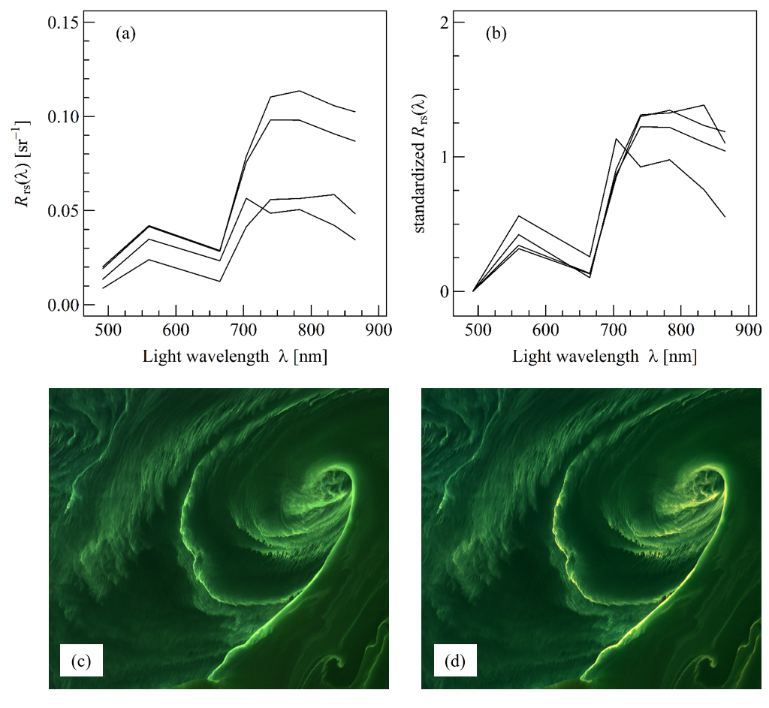
Figure S3-17. (a, b) R_{rs}(λ) and standardized R_{rs}(λ) spectra, respectively, of red tides dominated by the cyanobacteria Nodularia spumigena, corresponding to two blooms in the Baltic Sea, Sweden, the 31 July 2018 (HAEDAT SE-18-005), and two blooms in the Gulf of Gdańsk, Poland, the 25 July 2018 (HAEDAT PL-18-002) and 26 June 2020 (HAEDAT PL-20-001). (c, d) Example of Sentinel-2 image of a bloom dominated by Nodularia (25 July 2018, Gulf of Gdańsk, Poland) displayed using a RGB and REGB colour composite, respectively. The colour histogram was adjusted as follow: 0.03 sr⁻¹ for the three bands, respectively.

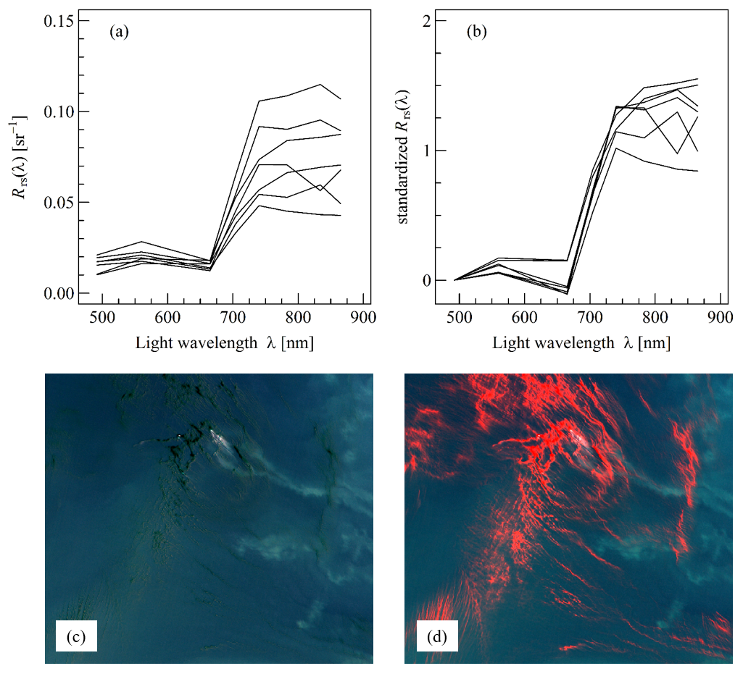
Figure S3-18. (a, b) R_{rs}(λ) and standardized R_{rs}(λ) spectra, respectively, of red tides dominated by the cyanobacteria Trichodesmium sp., corresponding to three blooms in Australia, the 11 March 2018 (Qi et al., 2020) and 3 June 2018, a bloom off Fiji Island, the 25 November 2018 (Qi et al., 2020), a bloom off Brazil, the 1 February 2019 (Qi et al., 2020), and two blooms off Guadeloupe, France, the 18 and 28 March 2018 (REPHY). (c, d) Example of Sentinel-2 image of a bloom dominated by Trichodesmium (3 June 2018, Australia) displayed using a RGB and REGB colour composite, respectively. The colour histogram was adjusted as follow: 0.01, 0.03, and 0.03 sr⁻¹ for the red, green, and blue band, respectively.

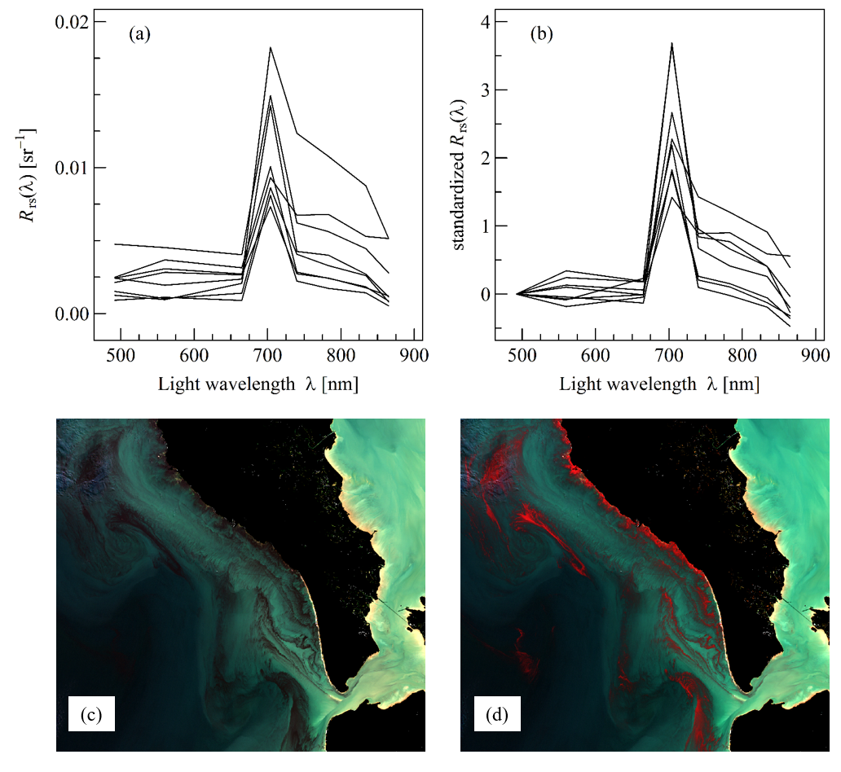
Figure S3-19. (a, b) R_{rs}(λ) and standardized R_{rs}(λ) spectra, respectively, of red tides dominated by the ciliate Mesodinium rubrum, corresponding to four blooms in France, off the Loire estuary, the 12 April 2017 (Souchu et al., 2017), off the Sables d’Olonne, the 11 April 2020 (Phenomer), off Oléron Island, the 18 April 2020 (Phenomer), and off the Vie estuary, the 27 March 2021 (Phenomer), a bloom in Chabahar Bay, Iran, the 8 April 2017 (Ershadifar et al., 2020), a bloom in the Gulf of California, Mexico, the 13 March 2017 (HAEDAT MX-17-005), and a bloom in Grays Harbor, US, the 31 May 2019 (State of Washington department of Ecology). (c, d) Example of Sentinel-2 image of a bloom dominated by Mesodinium rubrum (18 April 2020, Oléron Island, France) displayed using a RGB and REGB colour composite, respectively. The colour histogram was adjusted as follow: 0.02, 0.03, and 0.03 sr⁻¹ for the red, green, and blue band, respectively.
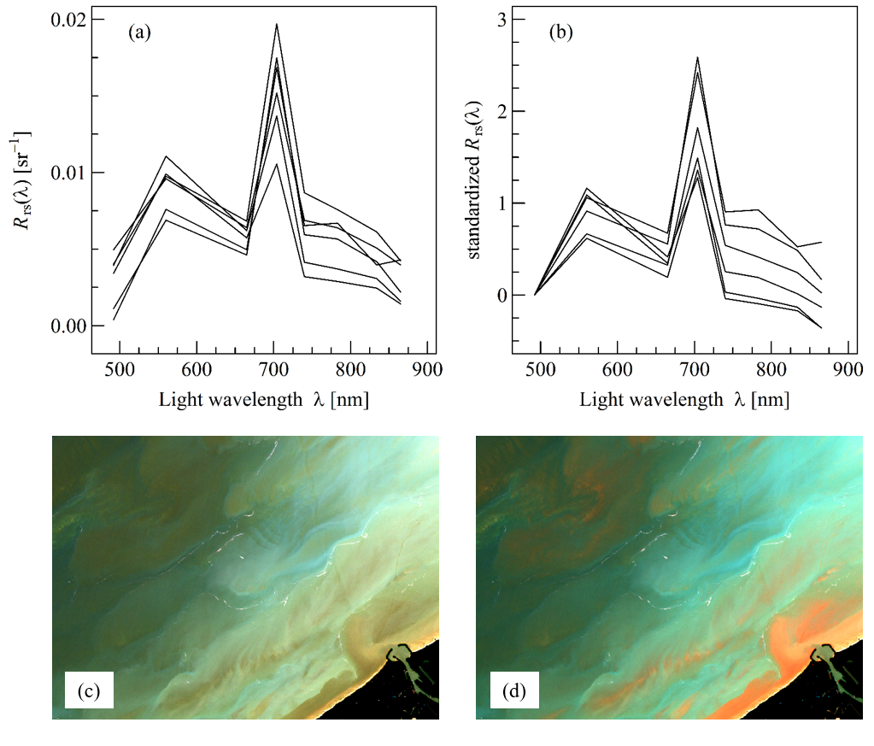
Figure S3-20. (a, b) R_{rs}(λ) and standardized R_{rs}(λ) spectra, respectively, of red tides dominated by the prymnesiophyte Phaeocystis sp., corresponding to three bloom in the North Sea, the 1 May 2016, 16 May 2019, and 20 April 2020 (Karlson et al., 2021). (c, d) Example of Sentinel-2 image of a bloom dominated by Phaeocystis (1 May 2016, North Sea, Belgium) displayed using a RGB and REGB colour composite, respectively. The colour histogram was adjusted as follow: 0.01, 0.02, and 0.015 sr⁻¹ for the red, green, and blue band, respectively.

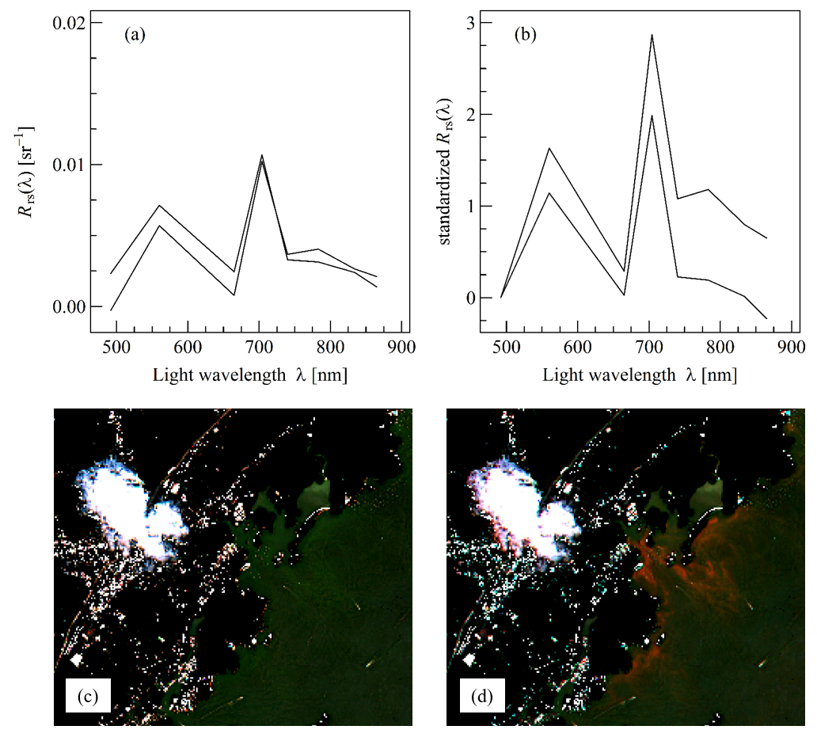
Figure S3-21. (a, b) R_{rs}(λ) and standardized R_{rs}(λ) spectra, respectively, of red tides dominated by the pelagophyte Aureococcus anophagefferens, corresponding to two blooms in Long Island Sound, US, the 17 and 27 July 2016 (HAEDAT US-16-009). (c, d) Example of Sentinel-2 image of a bloom dominated by Aureococcus (17 July 2016, Long Island Sound, US) displayed using a RGB and REGB colour composite, respectively. The colour histogram was adjusted as follow: 0.02, 0.03, and 0.03 sr⁻¹ for the red, green, and blue band, respectively.

