**Supplementary Material B.**

**Bay of Biscay Anchovy HCRs and allowable harvest rates versus deterministic MSY values**

In this supplementary material we compare the actual harvest rates (Hr = catches / SSB) of the selected harvest control rules (HCRs) for the Bay of Biscay (BoB) anchovy versus the Hr corresponding with a deterministic analysis of the maximum sustainable yield (MSY) for anchovy fishery.

The design of the anchovy HCRs were not based on the framework of MSY, but they were rather based on the framework of the precautionary approach by finding out maximum harvest rate strategies which would still keep the spawning stock biomass (SSB) above Blim (at 21,000 t) with a certainty of 0.95 in the simulations (the precautionary principle). As such given TACmin, TAC max and the lowest Biomass threshold where the fishery was allowed to resume at the TACmin level, for every rule the election was made on the maximum rate of increase of catches (the slope as a function of SSB) that would comply with the precautionary principle. In this way, the HCRs for anchovy does not define necessarily a single fishing mortality or harvest rates over a range of biomasses. For the purposes of this discussion for each selected HCR a mean harvest rate (allowable Catches over SSB in the management year) over the most common range of biomass in the past (between Bclose 24,000 t and 80,000 t) is calculated and compared with the Harvest rate over SSB (Hr(SSB)) at MSY.

A deterministic seasonal (on half year basis) MSY analysis was run based on the population modelling available for the revision of the LTMP in 2014, i.e. using the CBBM assessment (Ibaibarriaga et al., 2011) adjusted to the assessment of the period 1987-2013 and a SRR ricker model fitted to the series of SSB and recruitment from such assessment (STECF, 2014). Results are summarised in Table B.1 below.

***Table B.1*** *The deterministic MSY analysis results, with Fbar(1-3) mean fishing mortality from ages 1 to 3; HR(B1+) harvest rate on the biomass of anchovies of ages 1 and older (B1+) at the beginning of the year; HR(SSB) harvest rate on the spawning stock biomass (SSB) at spawning time; %SBR spawning biomass per recruit relative to the one expected without fishing. These estimates are reported at fishing mortality at MSY (FMSY), at F(0.1) of MSY, at F leading 20%SBR (F20%B0), at 40%SBR (F40%B0), at 50%SBR (F50%B0) and for the F resulting in catches 90% MSY (F90%MSY).*



The HCRs retained for the management of the BoB anchovy **are plot in figure 6 of the paper and in Figure B.1** in terms of the allowable harvest rates on SSB as a function of the expected SSB in the management year.

***Figure B.1*** *implicit Harvest rates resulting from the application of the selected HCRs for the BoB anchovy over a range of spawning biomasses, measured as allowable catches over SSB. Rule B(0.3) and G0(0.3) are the two rules selected after the 2008 STECF works and G4(0.45) and G3 G3(0.4) were the two rules selected after the 2014 STECF work.*

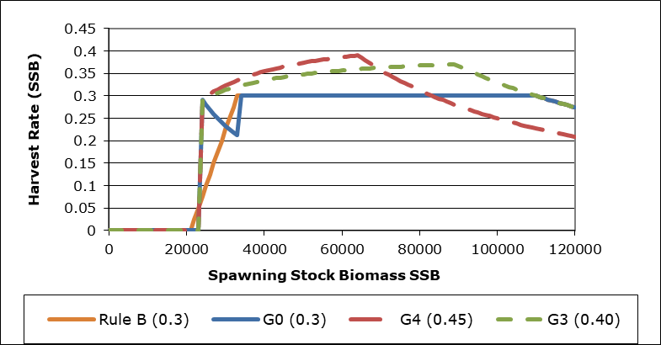

The original HCRs selected in the 2008 formulation of the LTMP (STECF2008) the RuleB(0.3) and the G0(0.3), which were almost identical, had mean Hr value between Bclose (24000 t) and 80000 t of 0.28 and 0.29 respectively.

The HCR selected after the 2014 review of the LTMP (STECF2014) G4 (with a slope 0.45 and TACmax= 25,000 t) had mean Hr value of 0.37. And the final rule adopted by managers in 2016 (G3 0.4) with TACmax at 33,000 t, to account for the stake holders preference of a larger TACmax than 25,000 t, implied lowering the mean Hr to about 0.34.

The mean Hr(SSB) values between Bclose (24,000 t) and 80,000 t of the different harvest control rules selected for the BoB anchovy are all smaller than the Hr(SSB) value at MSY resulting from the deterministic MSY analysis above. This means that in order to be precautionary (i.e., of keeping the probability of falling below the Blim in the long term equal or below 0.05), the selected rules implied fishing well below the deterministic MSY levels.

**REFERENCES**

**Ibaibarriaga, L., Fernandez, C., and Uriarte, A. 2011. Gaining information from commercial catch for a Bayesian two-stage biomass dynamic model: application to Bay of Biscay anchovy. ICES Journal of Marine Science, 68: 1435-1446.**

**STECF. 2014. Evaluation/scoping of Management plans - Data analysis for support of the impact assessment for the management plan of Bay of Biscay anchovy (COM(2009)399 final). (STECF-14-05). Luxembourg. EUR 26611 EN, JRC 89792. 128 pp.**