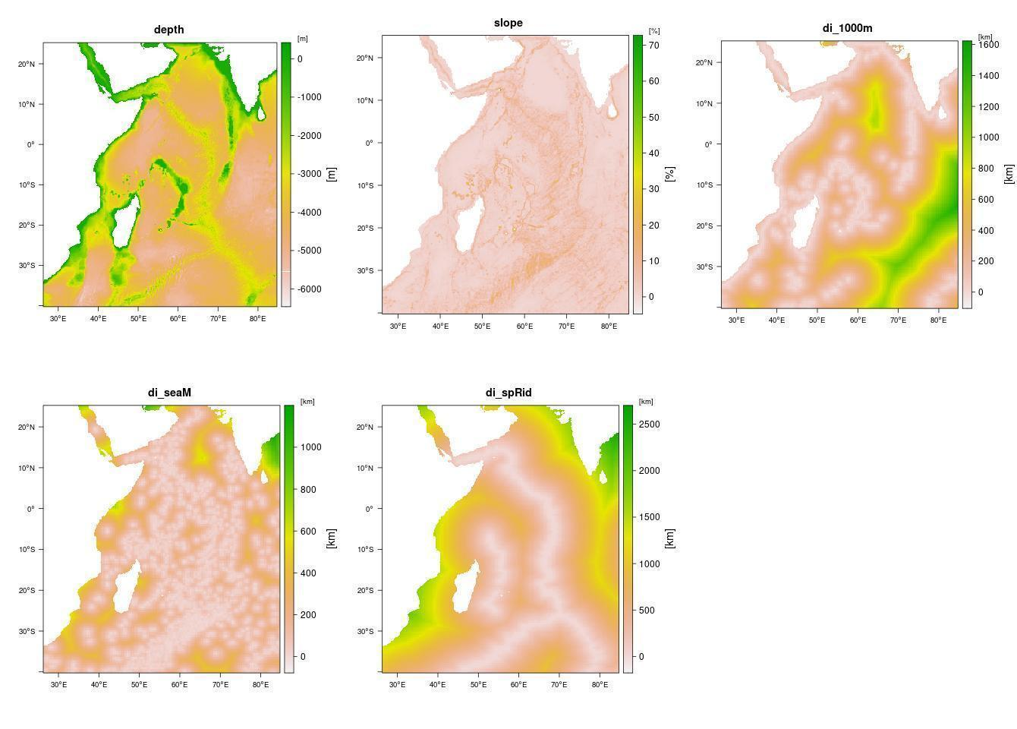
APPENDIX S2. Environmental variables used for Maxent habitat suitability modelling. Abbreviation and units – depth: seabed depth (m), slope: seabed slope (%), di_1000m: distance to 1000 meter isobath (km), di_seaM: distance to seamount (km), di_spRid: distance to spreading ridge (km).

