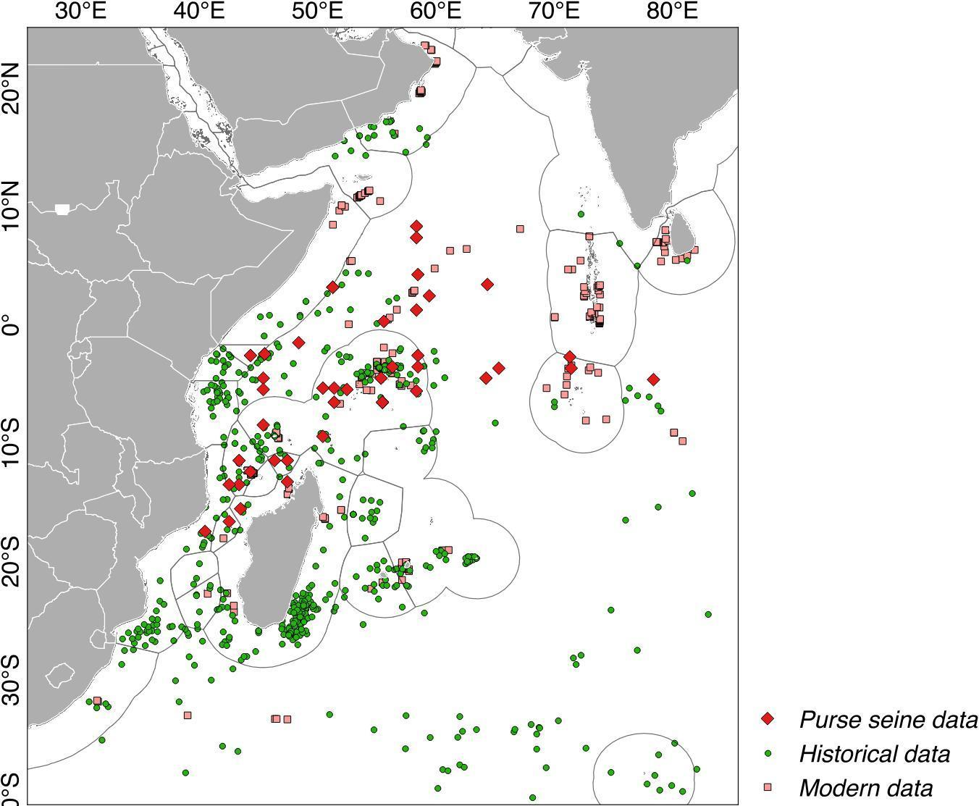
APPENDIX S4. Sperm whale records from historical whaling logs (green, Smith et al. 2012), modern scientific surveys (see Appendix S3 for sources), and observations from commercial purse seine activities [2002-2011, adapted from Figure 4c in Escalle et al. (2015)]. The purse seine records were only available on a 1° by 1° grid and were therefore not further analysed for habitat suitability modelling, but were digitised and included here for visualisation purposes and for comparison with the other datasets.

