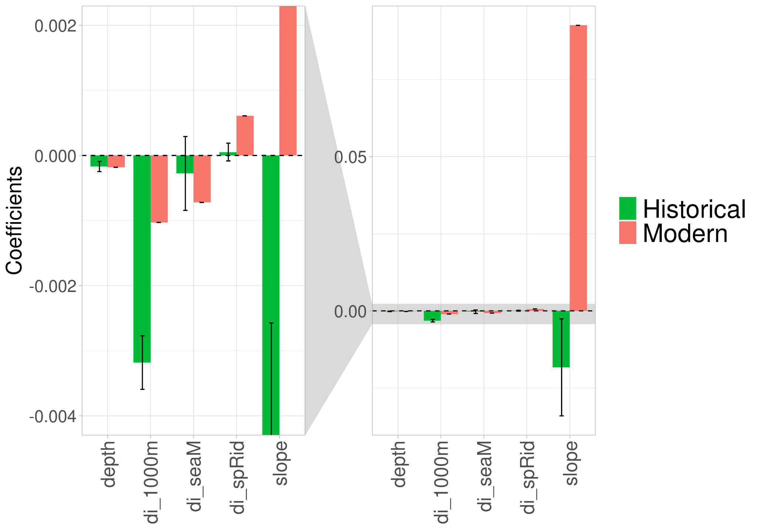
APPENDIX S5. Sensitivity analysis showing historical and modern habitat suitability model coefficients and variability of prediction repetitions (error bars) around the historical model coefficient. (a) Depth: seabed depth (m); slope: seabed slope (%); di_1000m: distance to 1000m isobath (km); di_seaM: distance to seamount (km); di_spRid: distance to spreading ridge (km).

