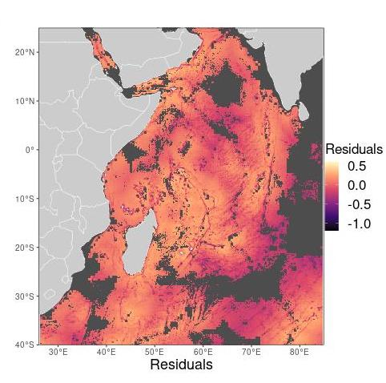
APPENDIX S7. Residuals from linear regression between historical and modern predictions, where positive residuals reflect higher relative historical predictions, showing extrapolation zones for both models combined.

