Detection of fishing pressure using ecological network indicators derived from ecosystem models
Maysa Ito^{1,2*}, Ghassen Halouani¹, Pierre Cresson¹, Carolina Giraldo¹, Raphaël Girardin¹
Affiliation:
¹ Ifremer, Channel and North Sea Fisheries Research Unit, HMMN, F‐62200 Boulogne-sur- mer, France
² Division of Marine Ecology, Marine Evolutionary Ecology, GEOMAR Helmholtz Centre for Ocean Research Kiel, Düsternbrooker Weg 20, 24105 Kiel, Germany
*Corresponding author: mito@geomar.de
Supplementary Material

Appendix A
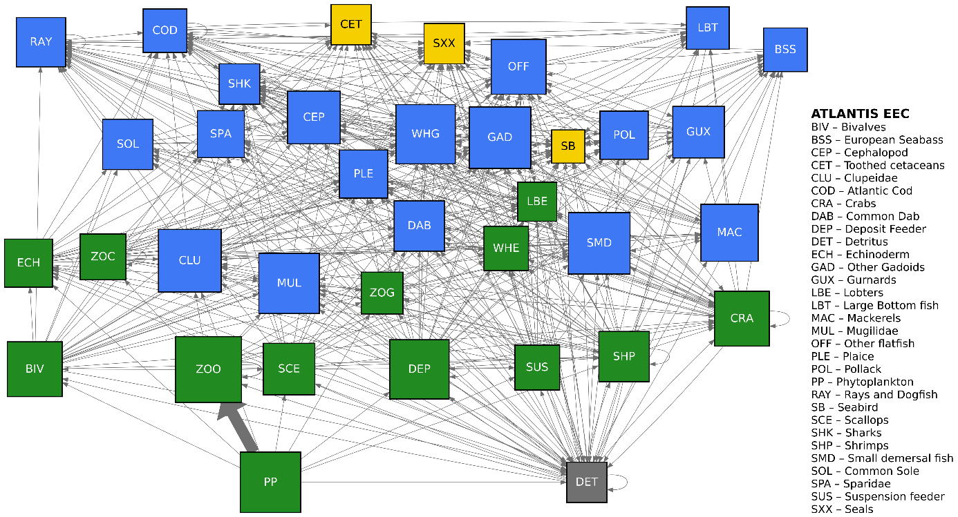
(a)
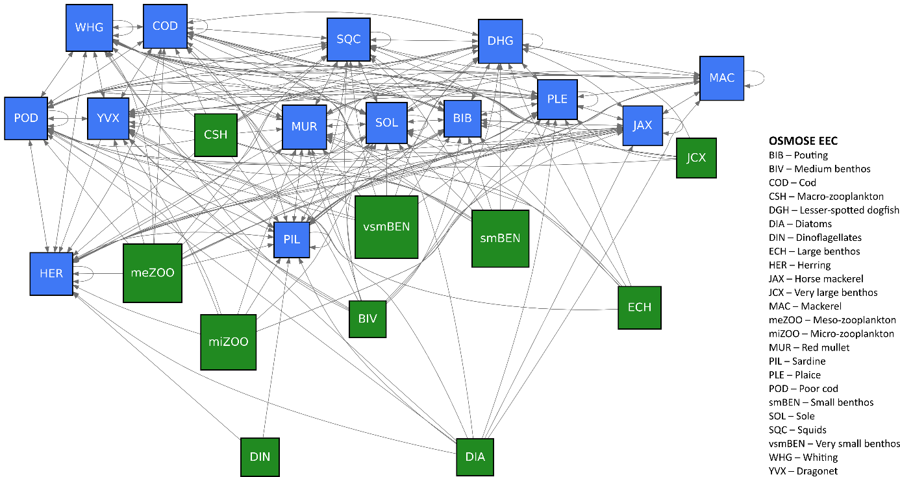
(b)
Figure A.1 Trophic network structure of Atlantis-EEC and list of groups embedded in the model (a) and network structure of OSMOSE-EEC and list of groups considered by the model (b). Note that only intercompartmental exchange is represented, while imports and exports (including fishing mortality) are not depicted.
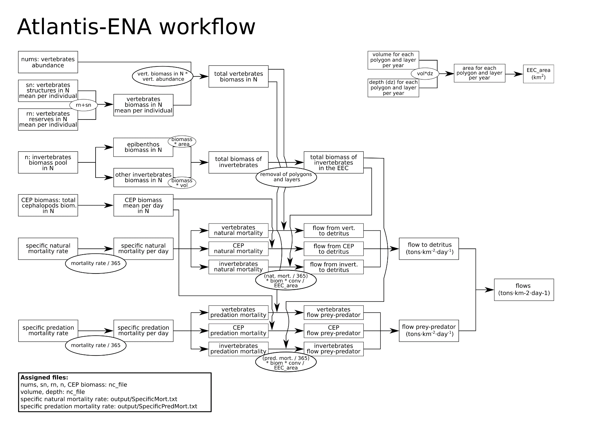
Figure A.2 Schematic representation of the workflow to use the output of Atlantis as input for Ecological Network Analysis. This figure shows the computation of intercompartmental exchange, the imports and exports (respiration and fishing mortality) were computed from the excess in- and outflows from each compartment.

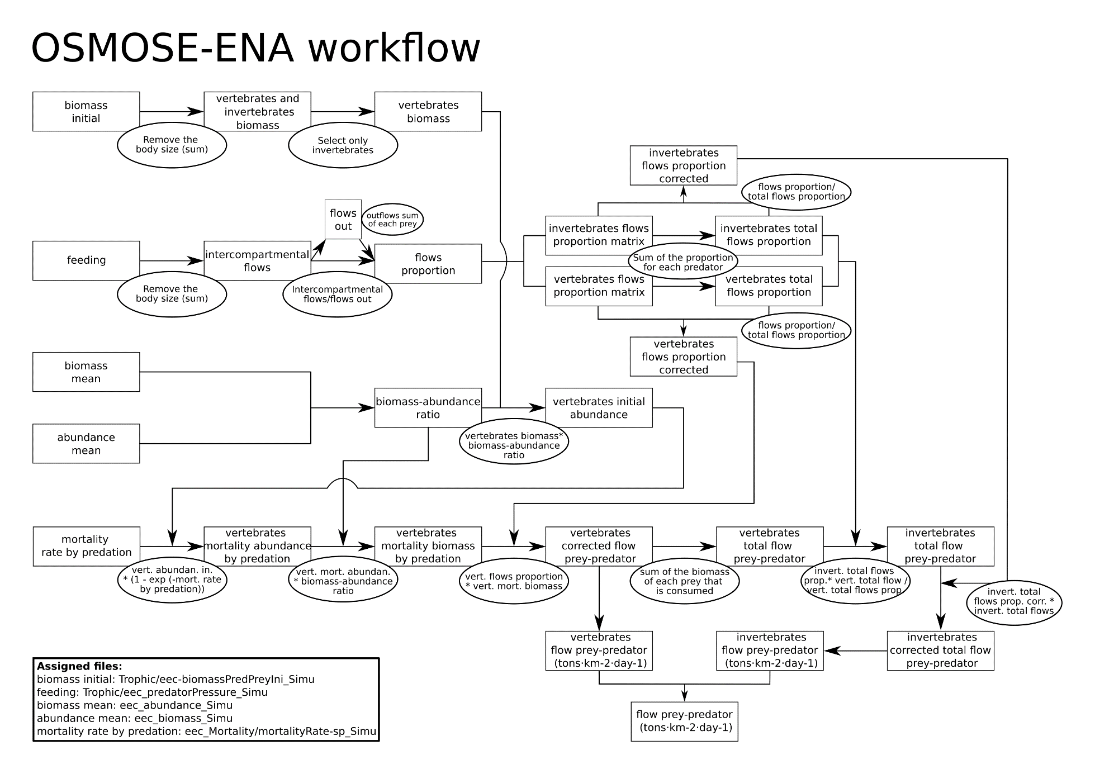
Figure A.3 Schematic representation of the workflow to use the output of OSMOSE as input for Ecological Network Analysis. This figure shows the computation of intercompartmental exchange, the imports and exports (respiration and fishing mortality) were computed from the excess in- and outflows from each compartment.
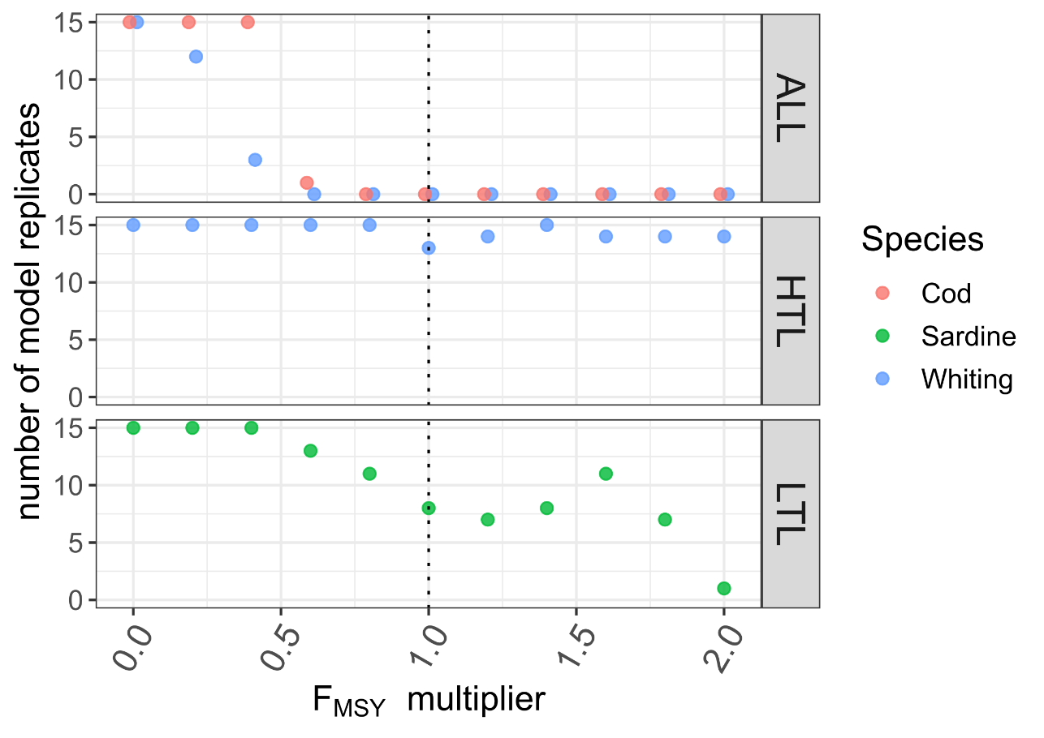
Figure A.4 Groups that collapsed along the fishing mortality scenario simulated in OSMOSE-EEC, cod (red circles), sardine (green circles) and whiting (blue circles). The y-axis represents the number of replicates of scenarios simulation in which the group did not collapse. The F_{MSY} multiplier in x-axis represents the fishing mortality gradient applied to the scenarios. The rows represent the fishing mortality scenarios. The scenario in which all the target species are exposed to the fishing mortality gradient (ALL), the scenario that high trophic level target fish species (i.e. higher than trophic level 4) are exposed to the fishing mortality gradient (HTL) and the scenario that low trophic level target species (i.e. forage fish species) are exposed to the fishing mortality gradient (LTL).
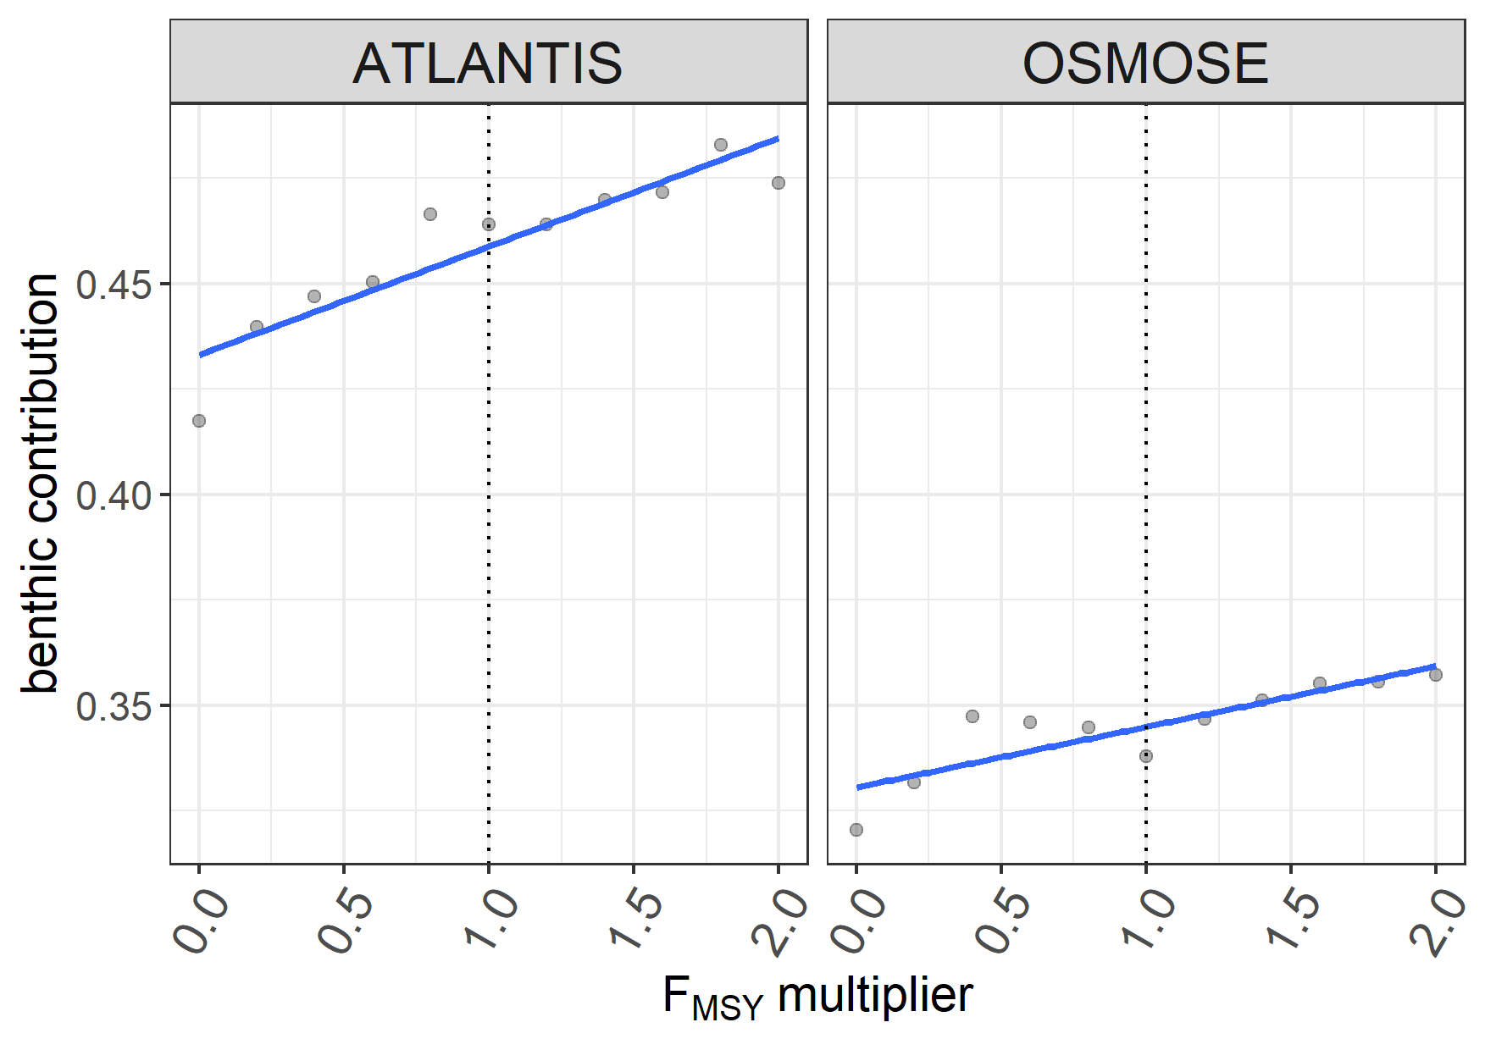
Figure A.5 Benthic relative contribution for the EEC ecosystem in the LTL fishing mortality scenario along the fishing mortality gradient for Atlantis and OSMOSE models.

Table A1. Significance of the smooth terms of the GAM fitted to the indicators computed from the outputs of OSMOSE and modified Atlantis after the simulation of fishing scenarios represented in the columns. The scenario (ALL) in which all exploited species are exposed to the fishing mortality gradient, the scenario (HTL) which target only high trophic level species, and the scenario (LTL) which target only low trophic level species. The indicators represented are total system throughput (TSTp), average mutual information (AMI), flow diversity (H), overhead (OH), relative ascendency (A/DC), relative redundancy (R/DC), average path length (APL) and connectance (C).
 | scenario ALL |  |  |  | scenario HTL |  |  |  | scenario LTL
TSTp
 | edf | Ref.edf | F | p-value | edf | Ref.edf | F | p-value | edf | Ref.edf | F | p-value
s(F_{MSY}) | 1.67 | 1.67 | 671.30 | <0.01* | 1.00 | 1.00 | 19.33 | <0.01* | 1.57 | 1.81 | 19.34 | <0.01*
s(F_{MSY}):ATLANTIS_mod | 6.71 | 7.71 | 185.90 | <0.01* | 2.35 | 3.16 | 11.90 | <0.01* | 3.02 | 3.97 | 16.46 | <0.01*
s(F_{MSY}):OSMOSE | 7.87 | 7.97 | 710.10 | <0.01* | 1.00 | 1.00 | 1.30 | 0.27 | 1.00 | 1.00 | 5.89 | 0.02*
R-sq.(adj) | 0.99 |  |  |  | 0.97 |  |  |  | 0.99
Dev. explained | 100% |  |  |  | 98% |  |  |  | 99%
AMI
 | edf | Ref.edf | F | p-value | edf | Ref.edf | F | p-value | edf | Ref.edf | F | p-value
s(F_{MSY}) | 1.56 | 1.81 | 111.90 | <0.01* | 1.00 | 1.00 | 31.84 | <0.01* | 1.00 | 1.00 | 0.27 | 0.61
s(F_{MSY}):ATLANTIS_mod | 9.2E-05 | 1.5E-04 | 0.02 | 1.00 | 3.42 | 4.23 | 10.06 | <0.01* | 3.45 | 4.27 | 2.89 | 0.06
s(F_{MSY}):OSMOSE | 7.49 | 8.44 | 23.23 | <0.01* | 1.68 | 2.33 | 3.97 | 0.03* | 3.01 | 3.95 | 3.00 | 0.08
R-sq.(adj) | 0.95 |  |  |  | 0.99 |  |  |  | 0.95
Dev. explained | 97.30% |  |  |  | 99.10% |  |  |  | 97.20%
H
 | edf | Ref.edf | F | p-value | edf | Ref.edf | F | p-value | edf | Ref.edf | F | p-value
s(F_{MSY}) | 1.98 | 2.00 | 216.82 | <0.01* | 1.99 | 2.00 | 54.82 | <0.01* | 1.40 | 1.60 | 36.46 | <0.01*
s(F_{MSY}):ATLANTIS_mod | 1.0E-05 | 2.0E-05 | 0.03 | 1.00 | 1.00 | 1.00 | 9.91 | <0.01* | 1.51 | 1.82 | 98.64 | <0.01*
s(F_{MSY}):OSMOSE | 6.37 | 7.53 | 40.19 | <0.01* | 4.18 | 5.31 | 3.85 | 0.01* | 7.0E-06 | 1.3E-05 | 0.01 | 1.00
R-sq.(adj) | 0.98 |  |  |  | 0.95 |  |  |  | 0.90
Dev. explained | 98.70% |  |  |  | 97.10% |  |  |  | 92%
OH
 | edf | Ref.edf | F | p-value | edf | Ref.edf | F | p-value | edf | Ref.edf | F | p-value
s(F_{MSY}) | 1.67 | 1.67 | 868.00 | <0.01* | 1.00 | 1.00 | 20.65 | <0.01* | 1.00 | 1.00 | 468.17 | <0.01*
s(F_{MSY}):ATLANTIS_mod | 6.93 | 7.86 | 234.20 | <0.01* | 2.14 | 2.90 | 10.33 | <0.01* | 3.85 | 4.76 | 28.59 | <0.01*
s(F_{MSY}):OSMOSE | 7.89 | 7.97 | 925.00 | <0.01* | 1.00 | 1.00 | 0.89 | 0.36 | 1.1E-05 | 2.2E-05 | 0.07 | 1.00
R-sq.(adj) | 1.00 |  |  |  | 0.97 |  |  |  | 0.99
Dev. explained | 100% |  |  |  | 98% |  |  |  | 99%
A/DC
 | edf | Ref.edf | F | p-value | edf | Ref.edf | F | p-value | edf | Ref.edf | F | p-value
s(F_{MSY}) | 1.00 | 1.00 | 14.46 | <0.01* | 1.99 | 2.00 | 157.91 | <0.01* | 1.00 | 1.00 | 33.80 | <0.01*
s(F_{MSY}):ATLANTIS_mod | 3.91 | 4.82 | 14.15 | <0.01* | 9.95E-06 | 1.87E-05 | 0.13 | 1.00 | 4.17 | 5.14 | 18.05 | <0.01*
s(F_{MSY}):OSMOSE | 4.49 | 5.64 | 18.41 | <0.01* | 4.23 | 5.23 | 61.62 | <0.01* | 1.9E-05 | 3.8E-05 | 0.005 | 1.00
R-sq.(adj) | 0.94 |  |  |  | 0.96 |  |  |  | 0.81
Dev. explained | 96.70% |  |  |  | 97.30% |  |  |  | 86.70%
R/DC
 | edf | Ref.edf | F | p-value | edf | Ref.edf | F | p-value | edf | Ref.edf | F | p-value
s(F_{MSY}) | 1 | 1 | 4.07 | 0.06 | 1.99 | 2.00 | 72.06 | <0.01* | 1.00 | 1.00 | 10.54 | <0.01*
s(F_{MSY}):ATLANTIS_mod | 2.50 | 3.108 | 2.491 | 0.10 | 3.1E-05 | 6.0E-05 | 0.09 | 1.00 | 3.01 | 3.74 | 20.18 | <0.01*
s(F_{MSY}):OSMOSE | 2.89 | 3.808 | 11.946 | <0.01* | 5.42 | 6.57 | 12.68 | <0.01* | 1.2E-05 | 2.4E-05 | 0.07 | 1.00
R-sq.(adj) | 0.94 |  |  |  | 0.89 |  |  |  | 0.91
Dev. explained | 95.90% |  |  |  | 93.30% |  |  |  | 93.20%
APL
 | edf | Ref.edf | F | p-value | edf | Ref.edf | F | p-value | edf | Ref.edf | F | p-value
s(F_{MSY}) | 1.96 | 2.00 | 28.74 | <0.01* | 1.00 | 1.00 | 369.04 | <0.01* | 1.00 | 1.00 | 3.91 | 0.07
s(F_{MSY}):ATLANTIS_mod | 1.00 | 1.00 | 4.43 | 0.06 | 2.3E-05 | 4.6E-05 | 1.0E-03 | 1.00 | 3.50 | 4.33 | 5.10 | <0.01*
s(F_{MSY}):OSMOSE | 4.86 | 6.03 | 31.64 | <0.01* | 6.50 | 7.65 | 45.45 | <0.01* | 2.14 | 2.89 | 7.23 | <0.01*
R-sq.(adj) | 0.99 |  |  |  | 0.96 |  |  |  | 0.95
Dev. explained | 99.50% |  |  |  | 97.30% |  |  |  | 96.70%
C
 | edf | Ref.edf | F | p-value | edf | Ref.edf | F | p-value | edf | Ref.edf | F | p-value
s(F_{MSY}) | 1.00 | 1.00 | 3.50 | 0.09 | 1.13 | 1.25 | 111.30 | <0.01* | 1.56 | 1.79 | 2.39 | 0.08
s(F_{MSY}):ATLANTIS_mod | 5.10 | 6.22 | 12.45 | <0.01* | 7.41 | 8.40 | 119.10 | <0.01* | 2.06 | 2.82 | 2.03 | 0.12
s(F_{MSY}):OSMOSE | 2.18 | 2.94 | 8.86 | <0.01* | 3.5E-05 | 6.7E-05 | 0.00 | 1.00 | 1.00 | 1.00 | 2.08 | 0.17
R-sq.(adj) | 0.91 |  |  |  | 0.98 |  |  |  | 0.64
Dev. explained | 94.70% |  |  |  | 99% |  |  |  | 73.80%

