Supplementary Information for
“Non-linear response of glacier melting to Holocene warming in Svalbard recorded by sedimentary iron (oxyhydr)oxides”

Kwangchul Jangª, Germain Bayon^{b}, Christoph Vogt^{c}, Matthias Forwick^{d}, Youngkyu Ahnª, Jung-Hyun Kimª and Seung-Il Nam^{a,}*

This file includes:
Supplementary Figure S1 to S3
Supplementary Table S1 to S10
References
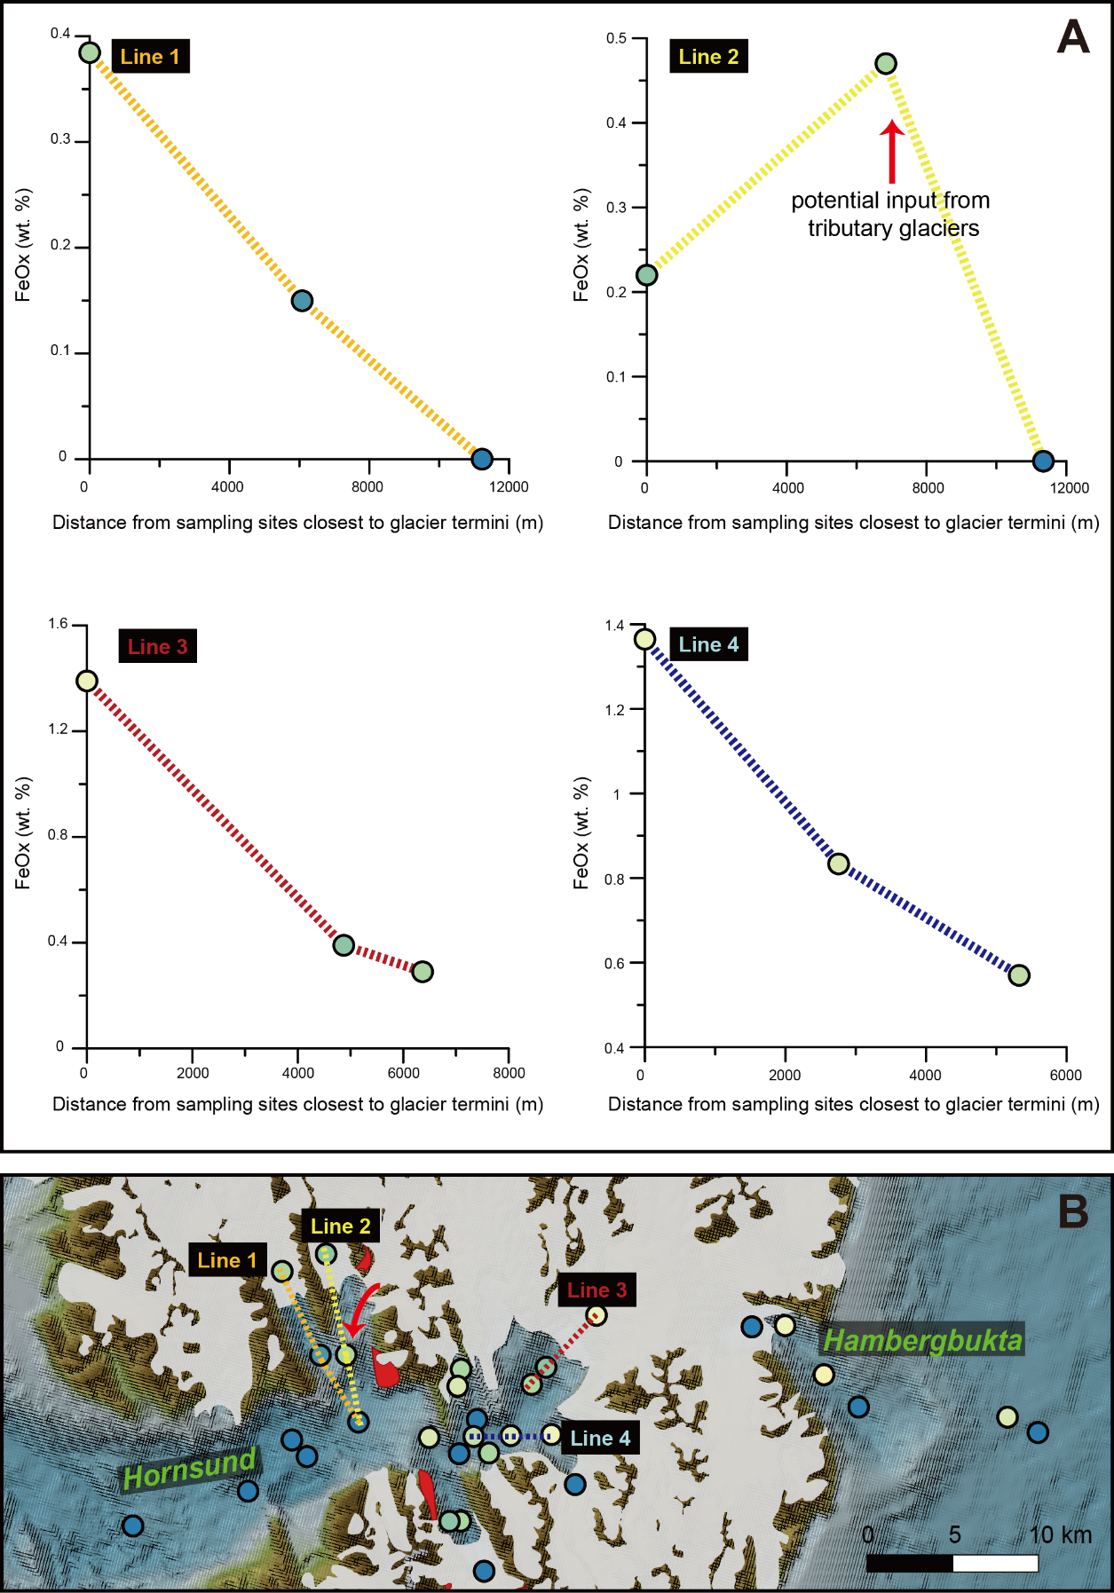
Supplementary Fig. S1. (A) Plots of Fe-(oxyhydr)oxide minerals (FeOx; weight percentage) versus distances from sampling sites closest to glacier termini (B) in four transect lines of Hornsund. The FeOx contents generally decrease with increasing distance from glacier termini.

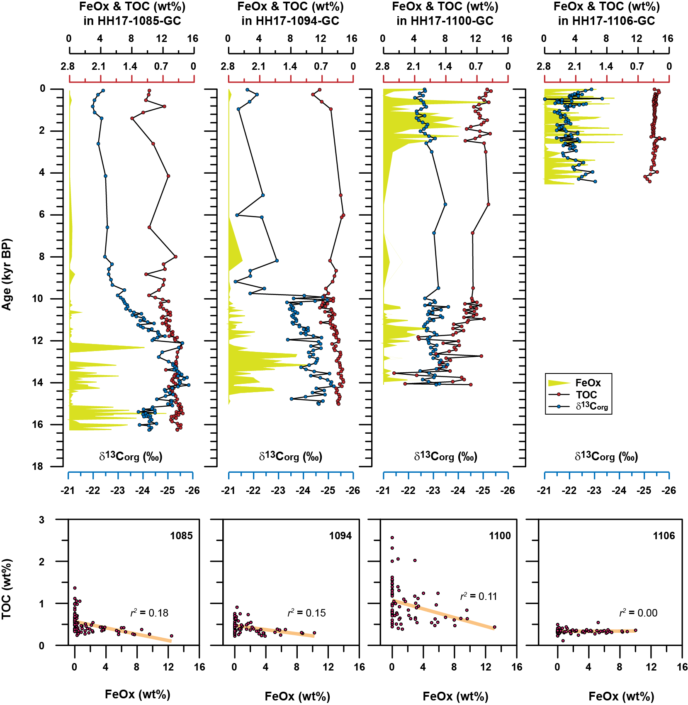
Supplementary Fig. S2. Comparison of Fe-(oxyhydr)oxides (FeOx) with total organic carbon (TOC) and its isotopes (δ¹³C_{org}) in cores HH17-1085-GC, HH17-1094-GC, HH17-1100-GC and HH17-1106-GC in Wijdefjorden. There is no significant relationship between FeOx and TOC in all core sediments, implying a minor diagenetic influence on FeOx contents. The TOC and δ¹³C_{org} data in core HH17-1085-GC are from Jang et al. (2021).

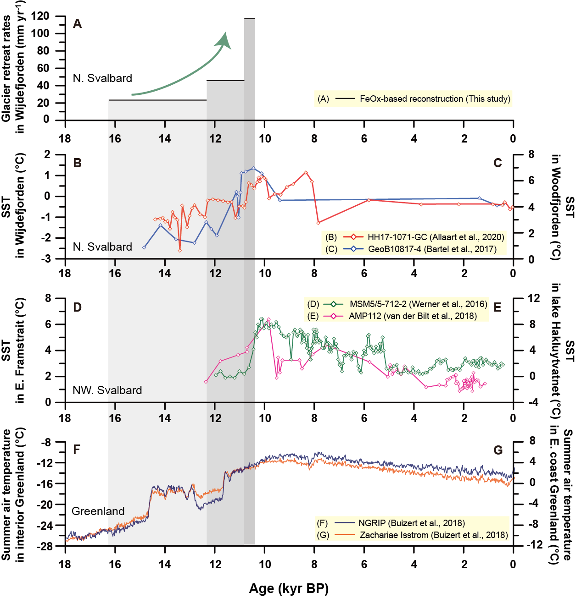
Supplementary Fig. S3. Comparison of glacier retreat rates in Wijdefjorden (A) with the various temperature records: GDGTs-based seawater (sub)surface temperatures (SST) in Wijdefjorden (B), alkenone-based SST in Woodfjorden (C), SST derived from foraminiferal transfer function in eastern Framstrait (D), alkenone-based SST in lake Hakluytvatnet (E), and summer air surface temperatures in the interior (F) and eastern coast Greenland (G). All data are from the references in Figure (Allaart et al., 2020; Bartels et al., 2017; Buizert et al., 2018; van der Bilt et al., 2018; Werner et al., 2016).

Supplementary Table S1. Core information
Station | Latitude (°N) | Longitude (°E) | Water depth (m) | Location | Recovery (cm)
HH17-1085-GC∗ | 80.27 | 16.21 | 322 | Continental shelf off northern Svalbard | 465
HH17-1094-GC | 79.74 | 15.42 | 148 | Wijdefjorden mouth | 377.6
HH17-1100-GC | 79.30 | 15.78 | 112 | Inner fjord | 380.2
HH17-1106-GC | 79.00 | 16.21 | 160 | Fjord head | 434
∗information from Jang et al. (2021)

Supplementary Table S2. AMS ¹⁴C ages and converted calendar ages of cores HH17-1094-GC, HH17-1100-GC and HH17-1106-GC
GC station | Core depth (cm) | AMS ¹⁴C age (yr BP, 2σ) | Calendar Age (yr BP, 2σ)∗ | Material dated | Reference
HH17-1094-GC | 14.5 | 1488 ± 64 | 927±164 | Mollusc | This study
HH17-1094-GC | 24.5 | 6441 ±75 | 6808 ±197 | Mollusc | This study
HH17-1094-GC | 30 | 5740 ±30 | 6042 ±116 | Mollusc | This study
HH17-1094-GC | 35 | 8020 ±40 | 8390 ±105 | Mollusc | This study
HH17-1094-GC | 54.5 | 8620 ±30 | 9138 ±120 | Mollusc | This study
HH17-1094-GC | 55 | 9310 ±30 | 10015 ±138 | Mollusc | This study
HH17-1094-GC | 65 | 9220 ±30 | 9865 ±180 | Mollusc | This study
HH17-1094-GC | 215 | 10550 ±30 | 11563 ±244 | Mollusc | This study
HH17-1100-GC | 94 | 2470 ±30 | 1994 ±111 | Mollusc | This study
HH17-1100-GC | 120 | 2960 ±30 | 2604 ±121 | Mollusc | Braun (2019)
HH17-1100-GC | 150 | 9080 ±30 | 9644 ±124 | Mollusc | Braun (2019)
HH17-1100-GC | 154.5 | 9391 ±38 | 10110 ±118 | Mollusc | Braun (2019)
HH17-1100-GC | 225 | 10070 ±30 | 10935 ±164 | Mollusc | Braun (2019)
HH17-1106-GC | 14.5 | 820 ±30 | 363 ±83 | Mollusc | This study
HH17-1106-GC | 134.5 | 1290 ±30 | 737 ±84 | Mollusc | This study
HH17-1106-GC | 329.5 | 3140 ±30 | 2814 ±87 | Mollusc | This study
HH17-1106-GC | 424.5 | 4840 ±30 | 4983 ±143 | Mollusc | This study
∗applying the Marine13 dataset of the Calib Rev. 7.0.4 program with △R = 105 ± 24 yr

Supplementary Table S3. (dataset.xlsx)
The contents of Fe-(oxyhydr)oxides (FeOx) in Svalbard bedrock.
Supplementary Table S4. (dataset.xlsx)
Spatial variability of Fe-(oxyhydr)oxides (FeOx) in Svalbard fjords.

Supplementary Table S5. (dataset.xlsx)
Temporal Fe-(oxyhydr)oxides (FeOx) variability in core HH17-1085-GC.

Supplementary Table S6. (dataset.xlsx)
Temporal Fe-(oxyhydr)oxides (FeOx) variability in core HH17-1094-GC.

Supplementary Table S7. (dataset.xlsx)
Temporal Fe-(oxyhydr)oxides (FeOx) variability in core HH17-1100-GC.

Supplementary Table S8. (dataset.xlsx)
Temporal Fe-(oxyhydr)oxides (FeOx) variability in core HH17-1106-GC.

Supplementary Table S9. (dataset.xlsx)
Total organic carbon (TOC) contents and its isotopes (δ¹³C_{org}) in bulk sediments from cores HH17-1094-GC, HH17-1100-GC and HH17-1106-GC
Supplementary Table S10. Calculated glacier advance/retreat rates
Observation | Age  (yr BP) | Age intervals  (yr) | Distance between∗  (m) | Advance/retreat rate†  (m/yr)
Re-occurrence of FeOx at core HH17-1100-GC | 2,578 | 1,940 | 34,970 | <18.0
First FeOx at core HH17-1106-GC | 4,519 | 5,864
Last FeOx at HH17-core-1100 | 10,383 | 426  (24~825) | -49,600 | -116  (-60~-2060)
Last FeOx at core HH17-1094-GC | 10,809 | 1,514  (1055~1985) | -61,400 | -40.5  (-30.9~-58.2)
Last FeOx at core HH17-1085-GC | 12,324 | 3,929  (3341~4513) | -70,000 | -17.8  (-15.5~-21.0)
First FeOx at core HH17-1085-GC | 16,252
Average glacier retreat rate |  | 5,846  (5336-6408) | -181,000 | -30.8  (-28.2~-33.9)
∗assumed distance for the iron delivery to be 70,000 m
†95% confidential intervals within the parentheses

References
Allaart, L., Müller, J., Schomacker, A., Rydningen, T.A., Håkansson, L., Kjellman, S.E., Mollenhauer, G., Forwick, M., 2020. Late Quaternary glacier and sea-ice history of northern Wijdefjorden, Svalbard. Boreas, doi:10.1111/bor.12435.
Bartels, M., Titschack, J., Fahl, K., Stein, R., Seidenkrantz, M.-S., Hillaire-Marcel, C., Hebbeln, D., 2017. Atlantic Water advection vs. glacier dynamics in northern Spitsbergen since early deglaciation. Clim. Past 13, 1717-1749.
Braun, C., 2019. Late Weichselian and Holocene glacier dynamics and sedimentary processes in and north of the Wijdefjorden-Austfjorden fjord system, north Spitsbergen. The Arctic University of Norway.
Buizert, C., Keisling, B., Box, J., He, F., Carlson, A., Sinclair, G., DeConto, R., 2018. Greenland‐wide seasonal temperatures during the last deglaciation. Geophys. Res. Lett. 45, 1905-1914.
Jang, K., Ahn, Y., Joe, Y.J., Braun, C.A., Joo, Y.J., Kim, J.-H., Bayon, G., Forwick, M., Vogt, C., Nam, S.-I., 2021. Glacial and environmental changes in northern Svalbard over the last 16.3 ka inferred from neodymium isotopes. Glob. Planet. Chang. 201, 103483.
van der Bilt, W.G.M., D'Andrea, W.J., Bakke, J., Balascio, N.L., Werner, J.P., Gjerde, M., Bradley, R.S., 2018. Alkenone-based reconstructions reveal four-phase Holocene temperature evolution for High Arctic Svalbard. Quat. Sci. Rev. 183, 204-213.
Werner, K., Müller, J., Husum, K., Spielhagen, R.F., Kandiano, E.S., Polyak, L., 2016. Holocene sea subsurface and surface water masses in the Fram Strait – Comparisons of temperature and sea-ice reconstructions. Quat. Sci. Rev. 147, 194-209.

