Supplementary Results
3.1 Undamaged fish
Egg incubation temperature did not significantly affect fish weight, standard length, condition factor (Table 1) or cortisol (Supp. Fig. 1) in unmanipulated fish. Gene expression was not significantly modified in the skin of unmanipulated fish from different thermal backgrounds (Supp. Fig. 2). The exception was krt2, which was significantly up-regulated (p < 0.05) in the undamaged skin of fish from eggs incubated at 11 ºC, compared to fish from the other thermal backgrounds. Glucose was also significantly modified between the fish from different thermal backgrounds, with a mean rank of glucose levels of 5 mM for 11-Und, 13 mM for 13.5-Und and 16.5 mM for 16-Und (Supp. Fig. 1).

Biometric parameters
Two-way ANOVA revealed no significant interaction between time of wound and egg incubation temperature, nor an individual effect of time and temperature on juvenile fish weight, length or condition factor (p > 0.05, Table 1). Simple main effects detected a significant increase (p < 0.05) in fish weight and length at 3 days relative to 1-day post-damage, in fish incubated as eggs at 16 ºC.
Histological modifications in intact and wounded skin after superficial damage
The AB-PAS-stained control skin was characterised by a visible external mucous layer and three main skin layers, an external protective epidermis of stratified squamous epithelium (purple blue), the connective tissue rich dermis (pale pink) and a loosely packed hypodermis containing few cells (Fig. 3A). The calcified scales were covered by the epidermis and emerged from individual scale pockets that were located between the two strata of the dermis. The stratum spongiosum was evident on the upper side of the scale pocket and was comprised of a thin layer of loose connective tissue with infrequent small blood vessels. Iridophores and occasional melanophores were confined between the epidermis and the stratum spongiosum and are responsible for the metallic silver-grey sheen of skin (Fig. 3C). The stratum compactum of the dermis was characterized by dense connective tissue and was anchored to the hypodermis by collagen fibres (thick pink fibres), crossing another iridescent layer.
The hypodermis infiltrated the skeletal muscle and contained white adipose tissue composed of cells of highly variable size and occasional blood vessels and nerves. Presumptive sensory organs, resembling cutaneous taste buds previously described in other fish [1-3], were identified in the epidermis and had a well-defined dermal papilla (Fig. 3B). These structures had a two-layered bud shape and the apical and major portion of the mound consisted of elongated, vertically oriented cells.
Superficial cutaneous damage inflicted by scale removal resulted in the loss of the epidermis and left the scale pocket and stratum spongiosum exposed to the external environment (Fig. 3D and E). One day after the superficial wound the disrupted stratum spongiosum sealed the scale pocket in one of two ways, a) by contacting and spreading forward along the stratum compactum (and closing the scale pocket, Fig. 3F and H) or folding inside out over the disrupted stratum (closing the anterior scale pocket, Fig. 3G and I). In the AB-PAS stain a thin layer of epidermis with rare goblet cells (blue/purple) was observed 1 day after recovery above the stratum spongiosum. From 0 to 3 days after damage the epidermal layer thickened and by day 3 many basophilic cells invaded the scale pocket and formed a two-layered sheet of scleroblasts surrounding a very thin regenerating scale (Fig. 3H and I). During scale regeneration, the number and size of blood vessels in the loose connective tissue of the stratum spongiosum increased and the tissue became infiltrated with blood cells (Fig. 4A and B). The blood vessels in this area of dermis originated from the adipose tissue, which had increased vascularization (Fig. 4C). In general, both the stratum spongiosum and compactum of the dermis thickened during cutaneous repair.
In both the epidermis and loose connective tissue of the dermis numerous small and darkly pigmented melanomacrophage centers formed (enclosed by dashed line in Fig. 3H and I, and Fig. 4D).
The AB-PAS positive goblet cells were mostly stained blue although a few were magenta or purple and these appeared in the regenerated skin. Both cell types were observed in the epidermis underneath the protruding part of the uppermost scale (Fig. 3A), and AB-PAS positive goblet cells were at the surface of the epithelium and AB-PAS negative cells were in intermediate layers of the epidermis. Scattered AB-PAS negative goblet cells could also be observed at the surface of the epidermis directly exposed to the environment.
Hypodermis thickness
Three-way mixed ANOVA showed that the hypodermis thickness was significantly affected by the interaction of skin condition with thermal background (p = 0.04, Fig. 5). However, simple main effects using Bonferroni adjustment did not detect any significant differences in the hypodermis between fish from eggs hatched under different thermal backgrounds at any time point, in both intact and wounded skin (Supp. Fig. 3 and Supp. Table S2).
Expression of mcl2a and mcl2b
Three-way mixed ANOVA revealed that the expression of mcl2a (p < 0.01) and mcl2b (p < 0.001) was significantly influenced by time and skin condition (Supp. Fig. S4 and Supp. Table S3). The expression of mcl2a was also significantly modified (p = 0.003) by the interaction between time and skin condition. The ratio of expression between the two isoforms was calculated and only the significant effect (p = 0.005) of thermal background was detected by three-way mixed ANOVA (Supp. Fig. S4) and the ratio was significantly lower in intact skin at 1d (p = 0.008) and in wounded skin at 3d (p < 0.05) in fish from eggs hatched at 16 ºC compared to others.

References
[1] A. Hansen, K. Reutter, E. Zeiske, Taste bud development in the zebrafish, Danio rerio, Dev. Dyn. 223(4) (2002) 483-96. https://doi.org/10.1002/dvdy.10074.
[2] R. Harvey, R.S. Batty, Cutaneous taste buds in cod, J. Fish Biol. 53(1) (1998) 138-149. https://doi.org/10.1111/j.1095-8649.1998.tb00116.x.
[3] M. Jakubowski, M. Whitear, Comparative morphology and cytology of taste buds in teleosts, Zeitschrift fx r mikroskopisch-anatomische Forschung. 104 (1990) 529-560.

Supplementary Tables
Supplementary Table S1: Comparison made between time points after skin damage (Immediately after skin damage 0h, 1 day and 3 days) for each thermal background group (11 ºC, 13.5 ºC and 16 ºC), for each of the plasma parameters evaluated. Significant differences across time for each thermal background group are identified with different lowercase letters. Plasma cortisol levels were Log10 transformed for statistical analysis. Two-way ANOVA using a Bonferroni adjustment (n = 8/ thermal background/ timepoint) was performed.
Parameter | 11 ºC |  |  | 13.5 ºC |  |  | 16 ºC
 | 0h | 1d | 3d | 0h | 1d | 3d | 0h | 1d | 3d
Cortisol | a | ab | b | a | a | b | a | a | b
Glucose |  |  |  | a | ab | b | a | a | b

Supplementary Table S2: Comparison made between time points after skin damage (Immediately after skin damage 0h, 1 day and 3 days) for each thermal background group (11 ºC, 13.5 ºC and 16 ºC), for each of the histomorphometric parameters evaluated. Significant differences across time within wounded skin of fish from each thermal backgrounds are identified with different capital letters, while for intact skin significant differences are identified by different lowercase letters. Three-way mixed ANOVA using a Bonferroni adjustment (n = 8/ thermal background/ skin condition/ timepoint) was performed.
Parameter | Skin condition | 11 ºC |  |  | 13.5 ºC |  |  | 16 ºC
 |  | 0h | 1d | 3d | 0h | 1d | 3d | 0h | 1d | 3d
AB-PAS positive goblet cells | Intact
 | Wounded |  |  |  | A | A | B | A | AB | B
AB-PAS negative goblet cells | Intact
 | Wounded | A | A | B | A | A | B | A | A | B
Epidermis thickness | Intact | a | ab | b |  |  |  | a | ab | b
 | Wounded | A | B | C | A | B | C | A | B | C
Basal cell layer thickness | Intact | a | b | a
 | Wounded | A | B | C | A | B | C | A | B | C
Basement membrane thickness | Intact |  |  |  | a | b | ab
 | Wounded | A | B | B | A | B | B | A | B | B
Dermis thickness | Intact
 | Wounded | A | AB | B |  |  |  | A | B | AB
Hypodermis thickness | Intact
 | Wounded

Supplementary Table S3: Comparison made between time points after skin damage (Immediately after skin damage 0h, 1 day and 3 days) for each thermal background group (11 ºC, 13.5 ºC and 16 ºC), for each of the transcript evaluated (qPCR). Significant differences across time within wounded skin of fish from each thermal backgrounds are identified with different capital letters, while for intact skin significant differences are identified by different lowercase letters. Three-way mixed ANOVA using a Bonferroni adjustment (n = 8/ thermal background/ skin condition/ timepoint) was performed.
Gene | Skin condition | 11 ºC |  |  | 13.5 ºC |  |  | 16 ºC
 |  | 0h | 1d | 3d | 0h | 1d | 3d | 0h | 1d | 3d
angptl2b | Intact | a | b | b | a | b | b | a | b | b
 | Wounded |  |  |  | A | B | A | A | B | B
cat | Intact | a | b | c | a | b | ab | a | b | b
 | Wounded | A | B | B | A | B | B | A | B | B
col1α1 | Intact | a | a | b | a | ab | b | a | b | b
 | Wounded | A | B | C | A | B | C | A | B | C
colXα | Intact |  |  |  | a | b | a | ab | a | b
 | Wounded | A | A | B | A | B | C | A | B | C
csf-1r | Intact
 | Wounded | A | AB | B | A | AB | B | A | A | B
krt2 | Intact | a | b | ab
 | Wounded | A | B | C | A | B | B | A | A | B
lyg1 | Intact | a | b | ab
 | Wounded | A | B | B
lalba | Intact
 | Wounded |  |  |  |  |  |  | A | B | A
mcl2a | Intact | a | ab | b
 | Wounded | A | AB | B | A | B | B | A | B | C
mcl2b | Intact |  |  |  | a | ab | b
 | Wounded |  |  |  | A | B | AB | A | A | B
mmp9 | Intact
 | Wounded | A | B | C | A | B | C | A | B | C
sparc | Intact | a | b | b | a | b | b | a | b | b
 | Wounded | A | B | C | A | B | B | A | B | B
pck1 | Intact
 | Wounded | A | B | AB | A | B | B | A | B | B
pcna | Intact | a | b | a | a | b | a
 | Wounded | A | B | B | A | A | B | A | AB | B
pparγ | Intact | a | ab | b | a | a | b | a | b | b
 | Wounded | A | A | B | A | A | B | A | B | C
sod1 | Intact |  |  |  |  |  |  | a | ab | b
 | Wounded | A | B | A | A | B | C | A | B | C

Supplementary Figures
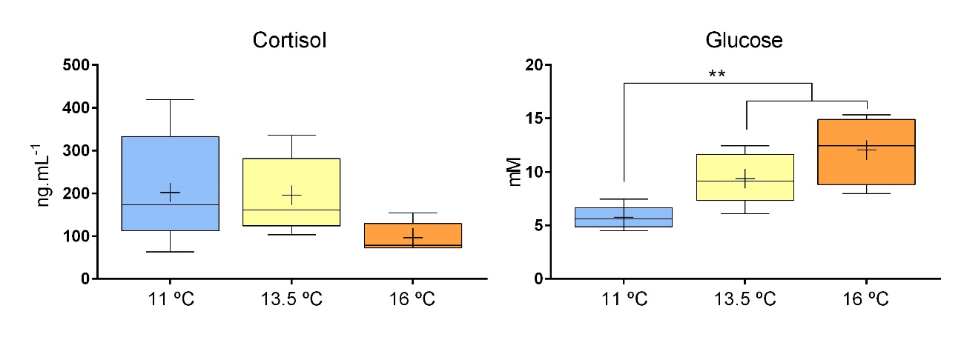
Supplementary Figure S1: Plasma levels of cortisol (ng.mL⁻¹) and glucose (mM) of juvenile undamaged fish incubated as eggs at different temperatures (11, 13.5 and 16 ºC). Results (n = 8/ thermal background) are plotted in Tukey box and whiskers graphs and ‘+’ represents the mean. Given the high degree of lipemia in some plasma samples from the 16-Und group, which prevented the accurate measurement of glucose levels by spectrophotometry, those lipemic samples were removed from the statistical analysis. Consequently, the number of samples in 16-Und group was highly unbalanced (n = 4) compared to sample size in other thermal background groups (n = 8). Kruskal-Wallis H Test was used for glucose analysis and one-way ANOVA for cortisol (p set at 0.05, ** p < 0.01;).
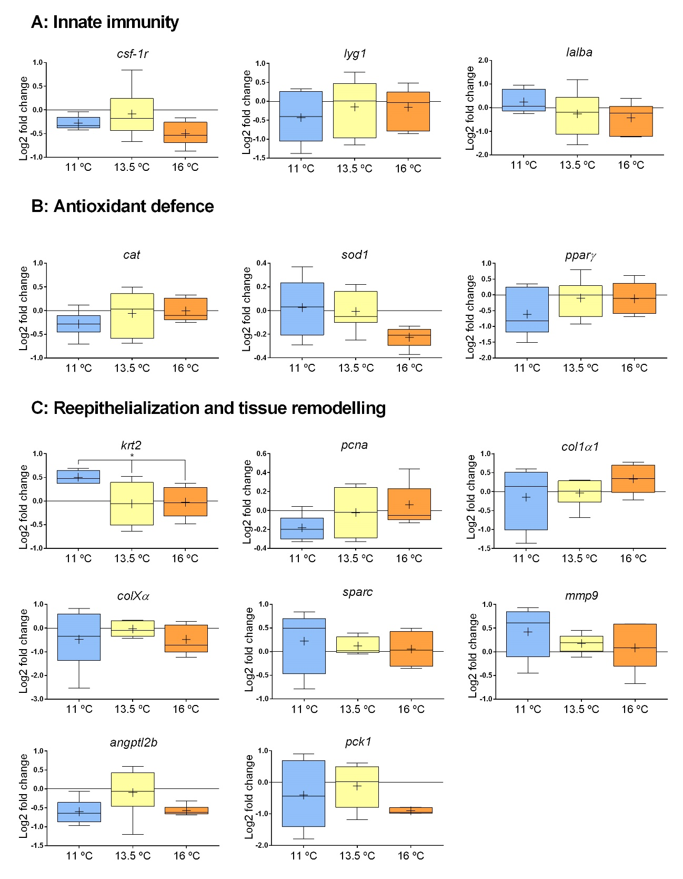
Supplementary Figure S2: Relative abundance of transcripts associated with A) innate immunity (csf-1r, lyg1 and lalba), B) antioxidant defence (cat, sod1 and pparγ) and reepithelialization and tissue remodelling (krt2, pcna, col1a1, colxα, sparc, mmp9, angptl2b and pck1) in the undamaged skin of juvenile sea bass incubated as eggs at different temperatures (11, 13.5 and 16 ºC). Results were normalised using the geometric mean of hsp70, ef1α and 18s and then expressed as Log2 fold change, calculated relative to undamaged skin from the 13.5 ºC group (considered the control temperature for European sea bass egg incubation). Results (n = 8/ thermal background) are plotted in Tukey box and whiskers graphs and ‘+’ represents the mean. One-way ANOVA, * p < 0.05.
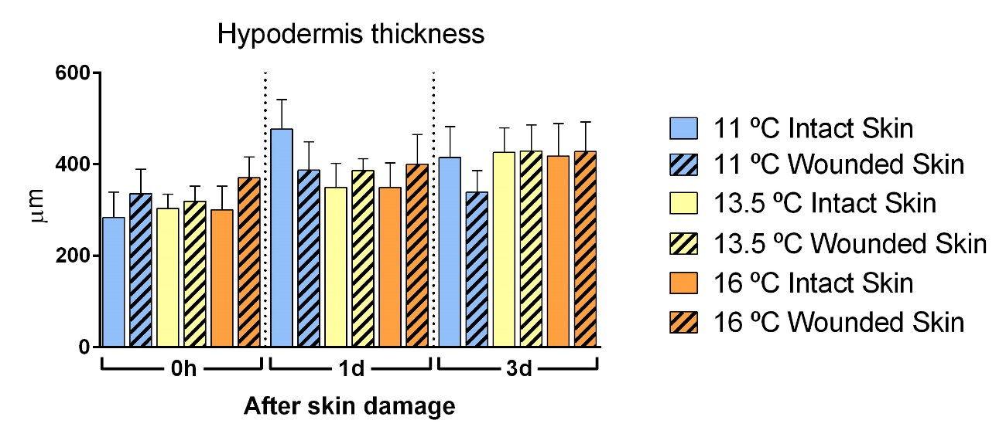
Supplementary Figure S3: Histomorphometric analysis of hypodermis thickness (µm) of European sea bass skin. Results for each thermal background group (11 ºC, 13.5 ºC and 16 ºC), for both wounded and intact skin and at each time point after superficial skin damage (0h, 1d and 3d; n = 8/ thermal background/ skin condition/ timepoint) were plotted as the mean + s.e.m; Three-way mixed ANOVA.
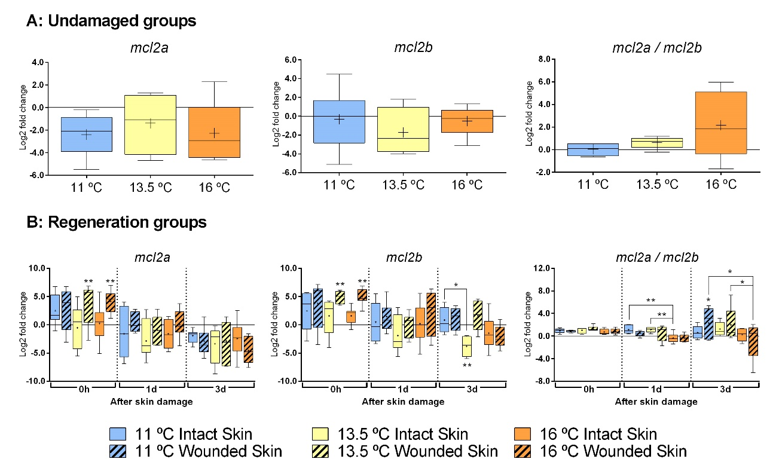
Supplementary Figure S4: Expression of markers of skeletal muscle (mcl2a and mcl2b) across time: A) undamaged groups, and B) at 0h, 1d and 3d after scale removal (regeneration groups), for each thermal background (11 ºC, 13.5 ºC and 16 ºC) and skin condition (intact and wounded). Results were normalised using the geometric mean of hsp70, ef1α and 18s and then expressed as Log2 fold change, calculated relative to undamaged skin from the 13.5 ºC group (considered the control temperature for European sea bass egg incubation). The ratio of expression between the two isoforms (mcl2a/mcl2b) was calculated. Results (n = 8/ thermal background/ skin condition/ time point) are plotted in Tukey box and whiskers graphs and ‘+’ represents the mean. Significant differences between wounded and intact skin are indicated: * p < 0.05, ** p < 0.01; Three-Way mixed ANOVA.

