Supplementary Materials

Foraging strategies under extreme events: Contrasting adaptations by benthic macrofauna to drastic biogeochemical disturbance
Yiming V. Wang^{1*}, Thomas Larsen¹, Mario Lebrato², Li-Chun Tseng³, Pei-Wen Lee³, Nicolás Sánchez⁴, Juan-Carlos Molinero⁵, Jiang-Shiou Hwang^{3,6,7}, Tin-Yam Chan^{3,6}, Dieter Garbe-Schönberg²

Affiliation:
- Max Planck Institute for the Geoanthropology, Kahlaische Str. 10, 07745, Jena, Germany.
- Institute of Geosciences, Kiel University, Ludewig-Meyn-Str. 10, 24118, Kiel, Germany.
- Institute of Marine Biology, National Taiwan Ocean University, No. 2, Beining Road, 20224, Keelung, Taiwan.
- GEOMAR Helmholtz Centre for Ocean Research Kiel, Düsternbrooker 20, 24105 Kiel, Germany.
- MARBEC - Marine Biodiversity, Exploitation and Conservation, (IRD/CNRS/IFREMER/Univ Montpellier), Avenue Jean Monnet, BP 171, 34203, Sète Cedex, France.
- Center of Excellence for the Oceans, National Taiwan Ocean University, No. 2, Beining Road, 20224 Keelung, Taiwan.
- Center of Excellence for Ocean Engineering, No. 2, Beining Road, National Taiwan Ocean University, Keelung 20224, Taiwan
Supplementary Text I | Background of the study region.
Supplementary Text II | Extreme impact of Earthquake and Typhoon in KST vents in 2016.
Supplementary Video S1 | Turtle Island live earthquake video recorded by Taiwan TV
Supplementary Video S2 | KST ocean conditions during and after C5 typhoon Nepartak in 2016.
Supplementary Video S3 | Turtle Island shallow vents changes from 2001 to 2017.
Supplementary Text III | Will Oven-dry and freeze-dry procedures affect the stable isotope values of our macroinvertebrate samples?
Supplementary Table S1 | Individual δ¹³C, δ¹⁵N and δ³⁴S values and shell width of individual organisms from the KST vent.
Supplementary Table S2 | Individual δ¹³C, δ¹⁵N and δ³⁴S values of several potential food sources at the KST region.
Supplementary Table S3 | MANOVA and ANOVA results comparing δ¹³C, δ¹⁵N, δ³⁴S values between 2015 and 2018 for vent crab (Xenograpsus testudinatus).
Supplementary Table S4 | MANOVA and ANOVA results comparing δ¹³C, δ¹⁵N, δ³⁴S values between the vent crab (Xenograpsus testudinatus) and pooled Mollusca group (Ergalatax contracta, Thylacodes adamsii, Bostrycapulus gravispinosus) in 2015.
Supplementary Table S5 | MANOVA and ANOVA results comparing δ¹³C, δ³⁴S values between the vent crab (Xenograpsus testudinatus) and pooled Mollusca group (Ergalatax contracta, Thylacodes adamsii, Bostrycapulus gravispinosus) in 2018.
Supplementary Table S6 | Summary of Welch Two Sample t-test comparing δ¹³C, δ¹⁵N, δ³⁴S values between the vent crab (Xenograpsus testudinatus) and pooled Mollusca group (Ergalatax contracta, Thylacodes adamsii, Bostrycapulus gravispinosus) in 2017. Lower and upper limits of 95% Confidence Intervals (CI) are also presented.
Supplementary Table S7 | MANOVA and ANOVA results comparing δ¹³C, δ¹⁵N, δ³⁴S values between the Xenograpsus testudinatus collected in the Yellow and White Vents in 2018.
Supplementary Table S8 | MANOVA and ANOVA results comparing δ¹³C, δ¹⁵N, δ³⁴S values between the male and female Xenograpsus testudinatus in 2018.
Supplementary Table S9. | The δ¹³C, δ¹⁵N, and δ³⁴S niche space for all organisms. TA stands for total community area, SEA stands for Standard Ellipse Area, and SEAc stands for Standard Ellipse Area corrected for small sample size.
Supplementary Fig. S1. | Underwater image next to the new Yellow Vent mouths (121.962°E, 24.834° N) to monitor the vent crab (Xenograpsus testudinatus) population change.
Supplementary Fig. S2 | Inter-annual δ³⁴S, δ¹³C and δ¹⁵N variability of benthic organism tissues in the Kuishantao Island in 2015 and 2018
Supplementary Discussion I: | Why Bayesian mixing model is an inappropriate approach in our study
Supplementary Fig. S3 | The isotope mixing space defined by the sampled food sources.

Supplementary Text I: Background of the study region
Kueishantao Island (KST, 24.843°N, 121.951°E), also known as Turtle Island, is situated at a tectonic junction off the coast of northeastern Taiwan and the southern end of the Okinawa Trough. KST is a Holocene stratovolcano and volcanic activity beneath the KST area is still vigorous, even though the last eruption occurred ~7000 years ago (Chen et al. 2005). In the last two decades, KST shallow vents are among the most intensively studied shallow vent systems in the world due to their extreme geochemical properties and their easy accessibility. The active YV vents are typically within the temperature range of >70 °C and fluid fluxes are up to 150 m³/h, whereas the temperature range of the semi-inactive WV fluctuates between 30–65 °C, with frequent degassing activity (Chen et al. 2005; Chen et al. 2018). The low pH values (down to 1.75 at certain locations) were recorded as the lowest in the world two decades ago (Chen et al. 2005). Before May 2016, more than 30 hydrothermal vents located at a water depth between 6 to 30 m were still active (Chen et al. 2005; Chen et al. 2018), making them easily accessible for scientists to study the geochemical and biological processes of these vent systems. However, in 2016, KST was hit by a M5.8 earthquake and a subsequent C5 typhoon within a few weeks (12th May and 2nd-10th July, respectively), disrupting normal conditions, and providing a unique opportunity to study food web changes induced by the extreme events.

Supplementary Text II: Extreme impact of Earthquake and Typhoon in 2016.
To demonstrate how M5.8 earthquake (12th May, 2016) and a subsequent C5 typhoon Nepartak (2nd-10th July, 2016) could have impacted our study area, we present three videos online (links below):

Video S1. Turtle Island live earthquake video recorded and reported by the Taiwan National TV channel. The Earthquake caused a tremor and subsequently triggered landslides on the cliff face in the KST vent region. Watch here: https://www.youtube.com/watch?v=DI-1-t7peBI.

Video S2. KST ocean conditions during and after typhoon Nepartak in 2016.
Using snapshot footages captured by NTU2 buoy camera during and after typhoon at the KST, we show the real-time offshore rough ocean conditions during the typhoon condition in July, 2016. In comparison, we show the calm ocean conditions side by side after the typhoon in August, 2016. These images are courtesy of the Institute of Oceanography at the National Taiwan University (https://po.oc.ntu.edu.tw/buoy/buoy2017/index.php). Watch here: https://www.youtube.com/watch?v=bBKEqbTMPcA

Video S3. Turtle Island shallow vents changes from 2001 to 2017. We made a video documenting a time-series of the KST vent activity change. These footages include helicopter and drone aerial video/photo from 2001 to 2017 as well as underwater filming around Turtle Island shallow vents from 1960 to 2017. In these images, we use arrows to demonstrate changes in the landscape and vent activities through time. Our video shows that although there were already gradual decreases in vent activities from 2001, the 2016 M5.8 earthquake and C5 typhoon have changed venting activity drastically. The major changes after the extreme events include: 1) a significant decrease in the intensity of conspicuous white color produced by the dominant chemoautotrophic sulfur bacteria (e.g. epsilonproteobacteria and gammaproteobacteria) in the WV seawater after the extreme events; 2) disappearance of abundant native sulfur accretions near the active Yellow Vent. Watch here: https://www.youtube.com/watch?v=us6hIY5MqGU

Supplementary Text III. Will Oven-drying and freeze-drying method affect the stable isotope values for different batch of samples?

We do not believe that there would be a significant difference of the freeze-drying vs oven-drying preparation method on the stable isotope values of our benthic macroinvertebrates. Both methods are commonly used. Oven-drying can cause isotopic fractionation due to the loss of lighter isotopes relative to the heavier isotopes during evaporation, potentially leading to slightly higher δ¹³C and δ¹⁵N values (de Lecea, Smit & Fennessy 2011). However, this effect is more pronounced in samples with high lipid content, such as fatty fish (e.g. salmon, sardines, tuna, and mackerel) with up to 20% lipid content and is not expected to significantly impact our results. A comparative study of freeze-drying and oven-drying preparation methods shows that these methods do not affect the isotope values of freshly caught benthic macroinvertebrates samples (Akamatsu et al. 2016). Even if had the oven-drying procedure caused lipid loss and led to ¹³C and ¹⁵N enrichment in our sampels, the δ¹³C and δ¹⁵N values of consumers in 2015 are actually lower than those in 2018. Therefore, our interpretation based on these data are not be affected. In addition, for organisms with C:N > 3.5, we applied lipid correction to δ¹³C values for muscle tissue samples (n=49) following Logan et al. (2008). This will allow us to account for effect of the lipid content on isotope values. We did not perform lipid extraction prior to stable isotope analyses of muscle tissues, because lipid extraction is known to affect δ¹⁵N values (Svensson et al. 2016).

Supplementary Table S1. Individual δ¹³C, δ¹⁵N and δ³⁴S values of individual organisms and the shell width from the Kueishantao (KST) shallow hydrothermal vent.
Species | Body size(mm) | Year | δ¹³C | δ¹⁵N | δ³⁴S
Bostrycapulus gravispinosus | 14.24 | 2015 | -20.2 | 6.9 | 10.3
Bostrycapulus gravispinosus | 13.92 | 2015 | -20.4 | 6.8 | 8.2
Bostrycapulus gravispinosus | 13.77 | 2015 | -20.4 | 6.4 | 8.7
Ergalatax contracta | 24.12 | 2015 | -19.2 | 8.2 | 7.3
Ergalatax contracta | 22.62 | 2015 | -19.7 | 8.6 | 6.4
Ergalatax contracta | 20.20 | 2015 | -20.3 | 7.8 | 6.7
Thylacodes adamsii | N.D | 2015 | -21.4 | 7.4 | 4.8
Thylacodes adamsii | N.D | 2015 | -21.6 | 7.1 | 7.5
Thylacodes adamsii | N.D | 2015 | -21.1 | 6.6 | 9.4
Xenograpsus testudinatus | 23.58 | 2015 | -13.1 | 5.0 | 4.3
Xenograpsus testudinatus | 22.89 | 2015 | -11.1 | 5.2 | 6.9
Xenograpsus testudinatus | 21.12 | 2015 | -13.6 | 5.3 | 6.3
Xenograpsus testudinatus | 18.36 | 2015 | -16.8 | 6.1 | 10.0
Xenograpsus testudinatus | 21.91 | 2015 | -16.9 | 6.7 | 10.3
Xenograpsus testudinatus | 22.99 | 2015 | -15.6 | 5.2 | 9.4
Xenograpsus testudinatus | 23.18 | 2015 | -15.5 | 4.0 | 7.7
Xenograpsus testudinatus | 19.46 | 2015 | -15.7 | 5.7 | 10.3
Xenograpsus testudinatus | 26.86 | 2015 | -18.1 | 5.3 | 9.1
Xenograpsus testudinatus | 19.54 | 2015 | -18.0 | 6.7 | 7.9
Xenograpsus testudinatus | 20.89 | 2015 | -16.1 | 4.3 | 3.9
Xenograpsus testudinatus | 16.36 | 2015 | -13.2 | 5.2 | 7.6
Xenograpsus testudinatus (male) | 22.83 | 2018 | -15.7 | 8.6 | 5.8
Xenograpsus testudinatus (female) | 18.84 | 2018 | -16.9 | 7.8 | 6.7
Xenograpsus testudinatus (male) | 23.84 | 2018 | -18.2 | 8.6 | 5.8
Xenograpsus testudinatus (male) | 22.46 | 2018 | -15.3 | 8.2 | 5.3
Xenograpsus testudinatus (female) | 18.69 | 2018 | -17.6 | 7.5 | 4.7
Xenograpsus testudinatus (female) | 15.96 | 2018 | -16.3 | 6.0 | 1.2
Xenograpsus testudinatus (male) | 24.31 | 2018 | -17.2 | 8.2 | 4.0
Xenograpsus testudinatus (female) | 18.09 | 2018 | -16.5 | 7.8 | 8.0
Xenograpsus testudinatus (male) | 22.18 | 2018 | -15.6 | 6.4 | 4.8
Xenograpsus testudinatus (female) | 18.17 | 2018 | -17.8 | 8.1 | 5.7
Xenograpsus testudinatus (male) | 27.14 | 2018 | -13.8 | 6.7 | 5.3
Xenograpsus testudinatus (male) | 18.73 | 2018 | -15.7 | 7.1 | 5.9
Xenograpsus testudinatus (male) | 19.16 | 2018 | -15.2 | 7.1 | 7.0
Xenograpsus testudinatus (female) | 17.32 | 2018 | -15.5 | 6.9 | 5.7
Xenograpsus testudinatus (female) | 19.53 | 2018 | -15.9 | 7.4 | 5.4
Xenograpsus testudinatus (female) | 18.85 | 2018 | -15.5 | 7.4 | 5.8
Ergalatax contracta | 20.85 | 2018 | -15.3 | 9.1 | 7.9
Ergalatax contracta | 22.8 | 2018 | -15.2 | 10.5 | 9.5
Ergalatax contracta | 18.0 | 2018 | -15.5 | 9.6 | 9.0
Ergalatax contracta | 21.47 | 2018 | -16.2 | 10.2 | 12.6
Ergalatax contracta | 20.44 | 2018 | -16.0 | 9.8
Ergalatax contracta | 20.0 | 2018 | -15.2 | 10.2 | 10.7
Thylacodes adamsii | N.D | 2018 | -18.7 | 5.9 | 11.0
Thylacodes adamsii | N.D | 2018 | -18.2 | 0.7 | 13.8
Thylacodes adamsii | N.D | 2018 | -18.6 | 5.7 | 13.8
Bostrycapulus gravispinosus | 12.98 | 2018 | -18.2 | 4.6 | 11.7
Bostrycapulus gravispinosus | 13.34 | 2018 | -16.6 | 0.3 | 12.4
Bostrycapulus gravispinosus | 13.35 | 2018 | -17.6 | 1.2 | 11.5

Supplementary Table S2. Individual δ¹³C, δ¹⁵N and δ³⁴S values of potential food sources the from the Kueishantao (KST) shallow hydrothermal vent collected in 2018.
Year | Sample description | Nitrogen Content (%) | δ¹⁵N_{AIR} (‰) | Carbon Content (%) | δ¹³C_{V-PDB} (‰) | Sulphur Content (%) | δ³⁴S_{V-CDT} (‰)
2018 | green algae | 1.34 | 6.47 | 6.56 | -21.92 | 2.58 | 16.89
2018 | green algae | 1.98 | 7.19 | 13.74 | -17.99 | 2.54 | 16.33
2018 | green algae | 2.44 | 5.28 | 19.02 | -17.08 | 2.37 | 11.92
2018 | green algae | 3.94 | 5.07 | 30.47 | -20.37 | 2.30 | 11.79
2018 | green algae | 3.36 | 5.22 | 26.33 | -20.60 | 3.41 | 18.99
2018 | bacteria | 0.23 | 5.24 | 1.07 | -19.86 | 3.74 | 5.48
2018 | bacteria | 0.41 | 5.37 | 1.83 | -20.16 | 4.36 | 4.12
2018 | zooplankton | 0.59 | 4.24 | 3.85 | -21.89 | 1.68 | 19.86
2018 | zooplankton | 2.14 | 8.01 | 9.48 | -19.75 | 1.64 | 19.92
2018 | zooplankton | 1.93 | 7.94 | 8.88 | -19.78 | 2.02 | 20.11
2018 | zooplankton | 1.34 | 5.32 | 6.33 | -20.12 | 1.93 | 20.16
2018 | zooplankton | 5.72 | 8.95 | 22.68 | -19.48 | 1.63 | 19.22
2018 | zooplankton | 2.20 | 6.19 | 11.53 | -21.59 | 2.42 | 16.19
2018 | zooplankton | 4.64 | 8.82 | 17.92 | -19.59 | 1.84 | 17.58
2018 | zooplankton | 4.61 | 8.85 | 18.47 | -19.51 | 2.00 | 19.29
2018 | zooplankton | 0.92 | 5.17 | 4.61 | -20.40 | 2.00 | 19.25
2018 | zooplankton | 3.05 | 7.74 | 13.08 | -19.11 | 1.75 | 18.54
2018 | zooplankton | 2.00 | 6.05 | 10.91 | -20.94 | 2.17 | 16.70
2018 | zooplankton | 5.23 | 7.94 | 23.72 | -20.15 | 1.74 | 17.12
2018 | zooplankton | 1.22 | 5.20 | 5.67 | -20.11 | 1.63 | 20.94
2018 | zooplankton | 4.27 | 8.40 | 17.48 | -19.70 | 1.60 | 20.64
2018 | zooplankton | 4.05 | 8.22 | 16.31 | -19.73 | 1.67 | 18.77
2018 | zooplankton | 0.89 | 5.08 | 4.77 | -20.77 | 2.38 | 15.14
2018 | zooplankton | 3.70 | 7.05 | 17.39 | -20.15 | 1.83 | 13.60
2018 | zooplankton | 2.29 | 5.36 | 11.62 | -20.48 | 3.18 | 11.44
2018 | zooplankton | 3.36 | 7.90 | 13.74 | -19.44 | 3.15 | 11.72
2018 | zooplankton | 1.69 | 4.90 | 8.83 | -20.53 | 1.96 | 14.49
2018 | zooplankton | 1.75 | 5.09 | 9.27 | -20.43 | 3.31 | 11.69
2018 | zooplankton | 2.16 | 8.10 | 9.75 | -20.52 | 2.53 | 14.02
2018 | Vent POM | 0.26 | 3.79 | 1.59 | -22.21 | 19.53 | 3.49
2018 | Vent POM | 0.44 | 6.06 | 2.23 | -21.48 | 9.56 | 6.02
2018 | Vent POM | 0.56 | 5.83 | 2.78 | -21.57
2018 | Vent POM | 0.39 | 4.22 | 1.99 | -21.51 | 10.91 | 6.50
2018 | Vent POM | 0.26 | 4.64 | 1.66 | -22.45 | 36.02 | 3.26
2018 | Vent POM | 0.21 | 3.37 | 1.67 | -23.28 | 1.21 | 11.37
2018 | Vent POM | 0.20 | 3.84 | 1.68 | -23.43 | 28.71 | 2.34
2018 | Vent POM | 0.29 | 4.02 | 2.48 | -23.54 | 17.05 | 2.51
2018 | Vent POM | 0.26 | 2.71 | 1.23 | -21.13 | 24.49 | 3.00
2018 | Vent POM | 0.30 | 4.32 | 1.45 | -21.58 | 26.43 | 5.12
2018 | Vent POM | 0.23 | 3.29 | 1.15 | -21.68 | 12.70 | 6.02
2018 | POM_Seawater | 0.70 | 5.47 | 3.51 | -20.71 | 0.77 | 14.70
2018 | POM_Seawater | 0.41 | 2.85 | 2.27 | -21.05 | 0.64 | 17.02
2018 | POM_Seawater | 0.42 | 3.32 | 2.34 | -20.60 | 0.75 | 16.36
Supplementary Table S3. MANOVA and ANOVA results comparing δ¹³C, δ¹⁵N, and δ³⁴S values between the Xenograpsus testudinatus collected in the Yellow and White Vents in 2018 (N=16). This result shows that there are no significant differences in δ¹³C, δ¹⁵N, and δ³⁴S for vent crabs in different habitats.

Manova summary
Df Pillai approx F num Df den Df P-adj
Regression 1 0.48737 3.803 3 12 0.0796
Residuals 14

ANOVA summary
Response δ³⁴S:
Df Sum Sq Mean Sq F value P-adj

Location 1 1.5844 1.584 0.7208 0.4102
Residuals 14 30.775 2.198

Response δ¹³C:

Df Sum Sq Mean Sq F value P-adj

Location 1 7.812 7.812 9.282 0.0348
Residuals 14 11.782 0.8416

Response δ¹⁵N:
Df Sum Sq Mean Sq F value P-adj

Location 1 1.442 1.442 2.766 0.1580
Residuals 14 7.296 0.521

Supplementary Table S4. MANOVA and ANOVA results comparing δ¹³C, δ¹⁵N, and δ³⁴S values between the male and female Xenograpsus testudinatus in 2018 (N=16). The results show that there is no significant difference in δ¹³C, δ¹⁵N, and δ³⁴S values between sexes.

Manova summary
Df Pillai approx F num Df den Df P-adj
Regression 1 0.2716 1.4915 3 12 0.2667
Residuals 14

ANOVA summary
Response δ³⁴S:
Df Sum Sq Mean Sq F value P-adj

Sex 1 0.031 0.0306 0.0133 0.91
Residuals 14 32.329 2.3092

Response δ¹³C:
Df Sum Sq Mean Sq F value P-adj
Sex 1 1.756 1.756 1.378 0.2601
Residuals 14 17.839 1.274

Response δ¹⁵N:

Df Sum Sq Mean Sq F value P-adj
Sex 1 0.250 0.250 0.412 0.5311
Residuals 14 8.488 0.606

Supplementary Table S5. MANOVA and ANOVA results comparing δ¹³C, δ¹⁵N, δ³⁴S values between 2015 and 2018 for vent crab (Xenograpsus testudinatus) pooled from both yellow and white vent.

Manova summary

Df Pillai approx. F num Df den Df P-adj

Regression 1 0.889 50.8 3 19 6.397e-09 ***
Residuals 21

ANOVA summary
Response δ³⁴S:

Df Sum Sq Mean Sq F value P-adj

Sampling_year 1 70.283 70.283 37.464 0.003 **
Residuals 21 39.397 1.876

Response δ¹³C:
Df Sum Sq Mean Sq F value P-adj

Sampling_year 1 1.1615 1.1615 0.906 0.1822
Residuals 21 26.9315 1.2825

Response δ¹⁵N:
Df Sum Sq Mean Sq F value P-adj

Sampling_year 1 16.060 16.0604 23.765 6.51e-07 ***
Residuals 21 14.192 0.6758

Supplementary Table S6. Summary of Welch Two Sample t-test comparing δ¹³C, δ¹⁵N, and δ³⁴S values for Ergalatax contracta before and after disturbance. Lower and upper limits of 95% Confidence Intervals (CI) are also presented. The isotope value unit is per mil (‰).

 | Mean of 2018 | Mean of 2015 | CI.lower | CI.upper | p-adj value
δ³⁴S | 9.94 | 6.8 | 0.94 | 5.34 | 0.015
δ¹³C | -19.73 | -15.57 | 3.07 | 5.27 | 0.003
δ¹⁵N | 9.90 | 8.20 | 0.91 | 2.49 | 0.004

Supplementary Table S7. MANOVA and ANOVA results comparing δ¹³C, δ¹⁵N, δ³⁴S values between the pooled vent crab (Xenograpsus testudinatus) from the yellow and white vent and pooled Gastropod group (Ergalatax contracta, Thylacodes adamsii, Bostrycapulus gravispinosus) in 2015.

Manova summary

Df Pillai approx F num Df den Df P-adj

Regression 1 0.84509 21.822 3 12 3.77e-05 ***
Residuals 14

ANOVA summary
Response δ³⁴S:
Df Sum Sq Mean Sq F-value P-adj

Regression 1 9.3729 9.3729 4.4881 0.9025
Residuals 14 29.2371 2.0884

Response δ¹³C:
Df Sum Sq Mean Sq F-value P-adj

Regression 1 57.477 57.477 65.996 4.563e-06***
Residuals 14 12.193 0.871

Response δ¹⁵N:
Df Sum Sq Mean Sq F-value P-adj

Regression 1 10.5862 10.5862 14.876 4.028e-05***
Residuals 14 9.9632 0.7117

Supplementary Table S8. MANOVA and ANOVA results comparing δ¹³C, δ³⁴S values between the pooled vent crab (Xenograpsus testudinatus) from the yellow and white vent and pooled Gastropod group (Ergalatax contracta, Thylacodes adamsii, Bostrycapulus gravispinosus) in 2018.
Manova summary
Df Pillai approx F num Df den Df P-adj
Regression 1 0.76966 40.096 2 24 2.231e-08 ***
Residuals 25

ANOVA summary
Response δ³⁴S:
Df Sum Sq Mean Sq F-value P-adj

Regression 1 220.789 220.789 80.598 5.396e-09***
Residuals 25 68.485 2.739

Response δ¹³C:
Df Sum Sq Mean Sq F-value P-adj

Regression 1 2.985 2.9850 1.8453 0.1865
Residuals 25 40.442 1.6177

Supplementary Table S9. The δ¹³C, δ¹⁵N, and δ³⁴S niche space for all organisms calculated from R package SIBER (Jackson et al. 2011). TA stands for the total community area, SEA stands for the Standard Ellipse Area, and SEAc stands for Standard Ellipse Area corrected for small sample size (n<50). Although we reported the niche space for filter feeder B. gravispinousus and T. adamsii, we did not discuss these values. This is because a minimum of data points of five for each group is required to calculate the covariance matrix and ensure sufficient degrees of freedom (Jackson et al. 2011). Our sample sizes for these two organisms were small (n=3) to draw any meaningful inference. The SEAc of E. contracta and pooled X. testudinatus were denoted in bold.

δ¹³C & δ¹⁵N |  | B. gravispinosus |  |  |  |  |  |  |  |  | T. adamsii |  |  |  |  |  |  | E. contractaa |  |  |  | X. testudinatus
 |  |  |  |  | 2015 |  | 2018 |  |  | 2015 |  |  | 2018 |  |  | 2015 |  |  |  | 2018 |  |  |  | 2015 |  |  |  | 2018
 | TA |  |  | 0.04 |  | 1.43 |  |  | 0.125 |  |  | 0.21 |  |  | 0.32 |  |  |  | 0.77 |  |  |  | 10.15 |  |  |  | 6.56
 | SEA |  |  | 0.07 |  | 2.59 |  |  | 0.226 |  |  | 0.38 |  |  | 0.58 |  |  |  | 0.68 |  |  |  | 5.10 |  |  |  | 2.38
 | SEAc |  |  | 0.15 |  | 5.19 |  |  | 0.45 |  |  | 0.76 |  |  | 1.16 |  |  |  | 0.86 |  |  |  | 5.61 |  |  |  | 2.55
δ¹³C & δ³⁴S |  |  | 2015 |  |  |  |  | 2018 |  |  | 2015 |  |  | 2018 |  |  | 2015 |  |  |  | 2018 |  |  |  | 2015 | 2018
 | TA |  |  | 0.05 |  | 0.37 |  |  | 0.87 |  |  | 1.56 |  |  | 0.35 |  |  |  | 1.555 |  |  |  | 28.00 |  |  |  | 15.32
 | SEA |  |  | 0.09 |  | 0.67 |  |  | 1.57 |  |  | 1.65 |  |  | 0.63 |  |  |  | 1.65 |  |  |  | 12.98 |  |  |  | 5.26
 | SEAc |  |  | 0.18 |  | 1.34 |  |  | 3.14 |  |  | 2.20 |  |  | 1.25 |  |  |  | 2.20 |  |  |  | 14.28 |  |  |  | 5.64

Supplementary Fig. S1. Underwater image next to the new Yellow Vent mouths (121.962°E, 24.834° N) to monitor the vent crab (Xenograpsus testudinatus) population change in
2018.

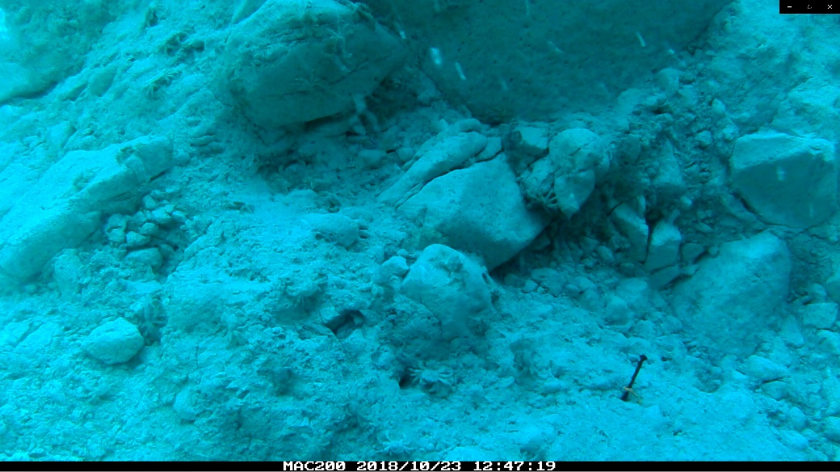

Supplementary Fig. S2. Inter-annual δ³⁴S, δ¹³C and δ¹⁵N variability of benthic organism tissues in the Kuishantao Island in 2015 and 2018: vent crabs (Xenograpsus testudinatus); a sessile suspension feeder limpet (Bostrycapulus gravispinosus); a mobile suspension feeder snail (Thylacodes adamsii); and carnivorous scavenger snail (Ergalatax contracta) before and after the 2016 catastrophic events (Richter M5.8 earthquake and C5 Typhoon). *** denotes for P-adj <0.001 and ** denotes for P-adj <0.05. The boxplot was not plotted for the gastropods due to their small sample sizes (n<6) for each year.

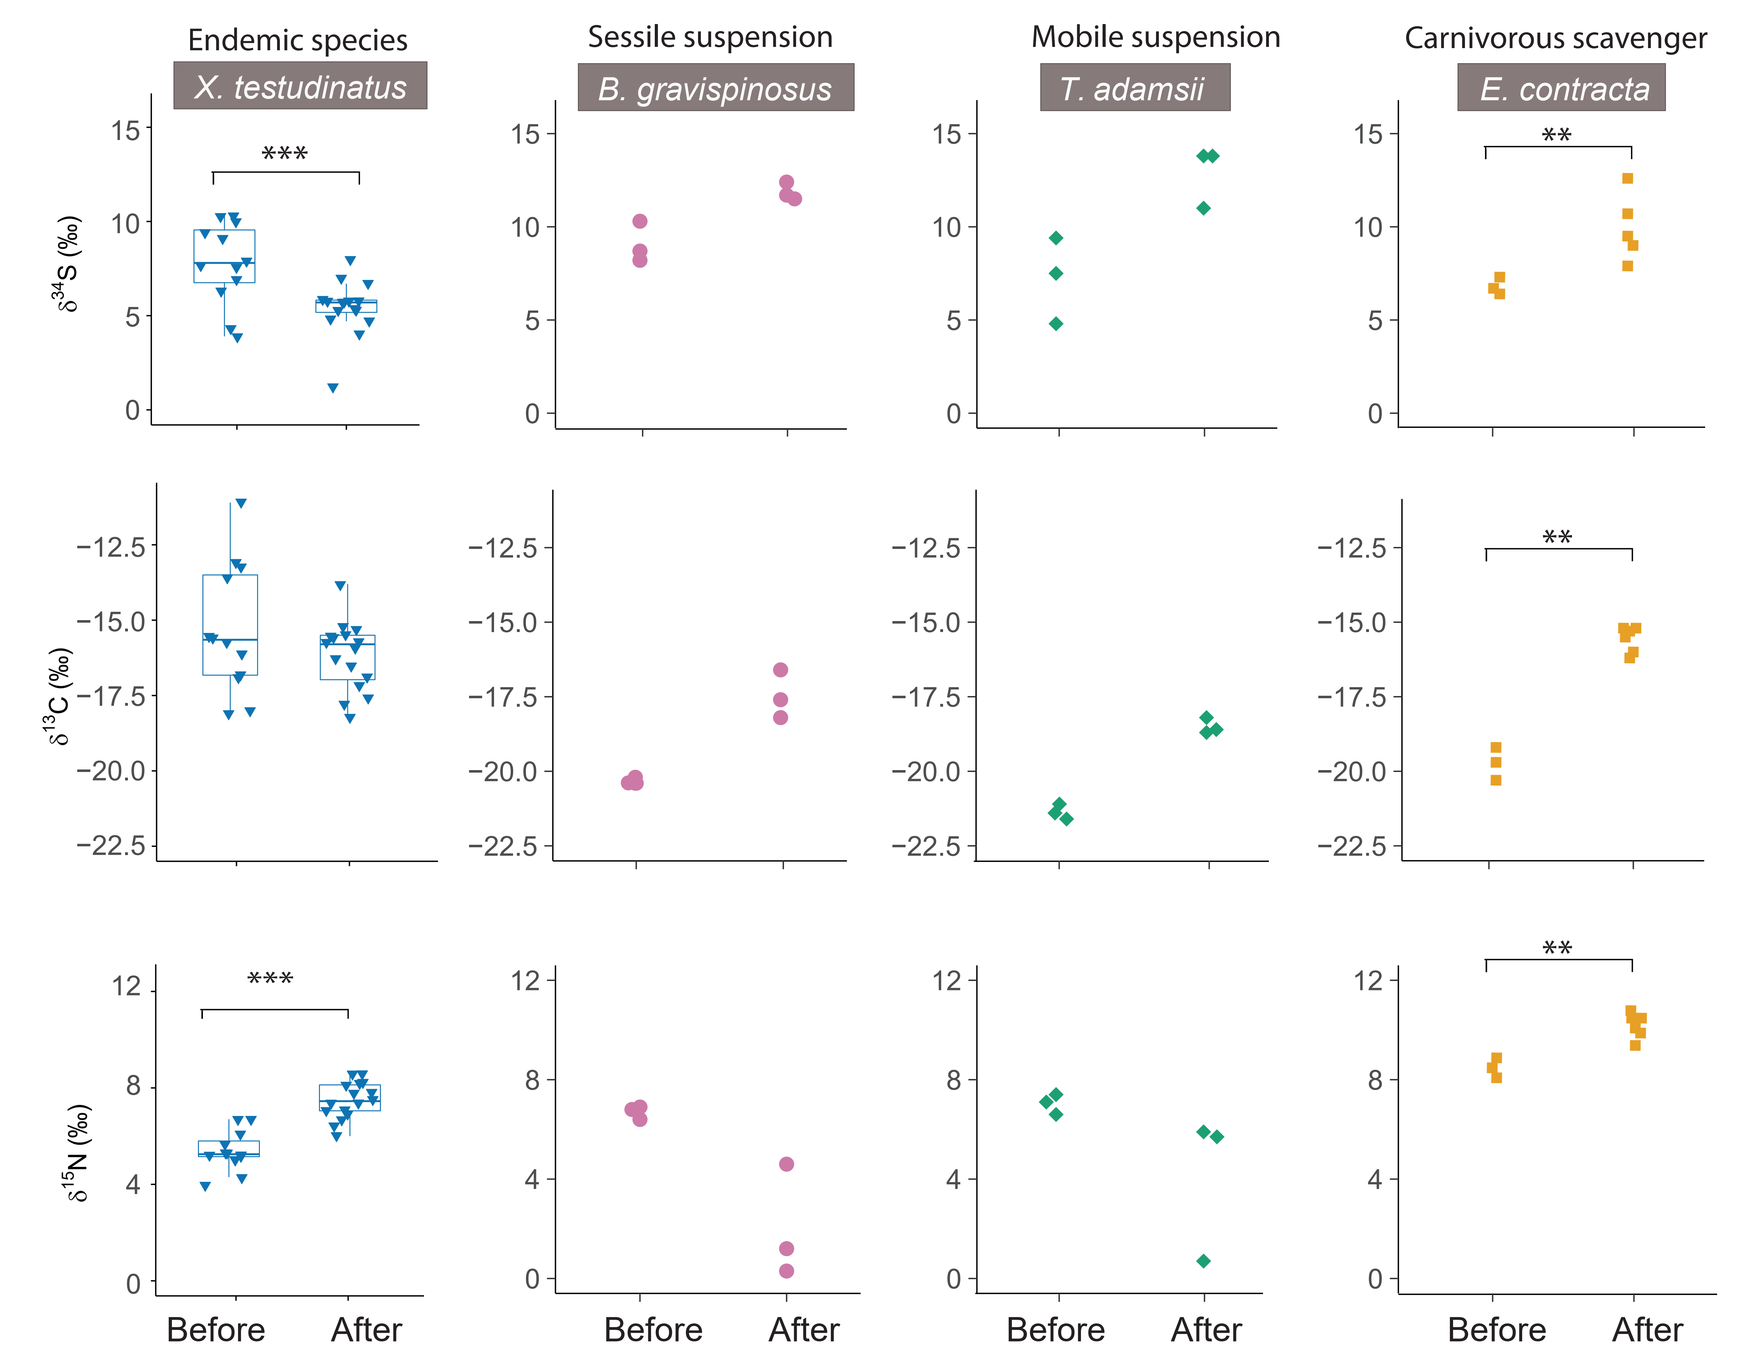

Supplementary Discussion I: Why Bayesian mixing model is an inappropriate approach
To visualize the isotope mixing space defined by the sampled food sources, we added dietary fractionation factors of 3.4‰, 1‰ and 0‰ for δ¹⁵N, δ¹³C, δ³⁴S, respectively, to the potential food sources based on values from Fig. 3 and Table 1. The boundaries of these mixing spaces are shown as the convex hulls in Supplementary Fig. S3.

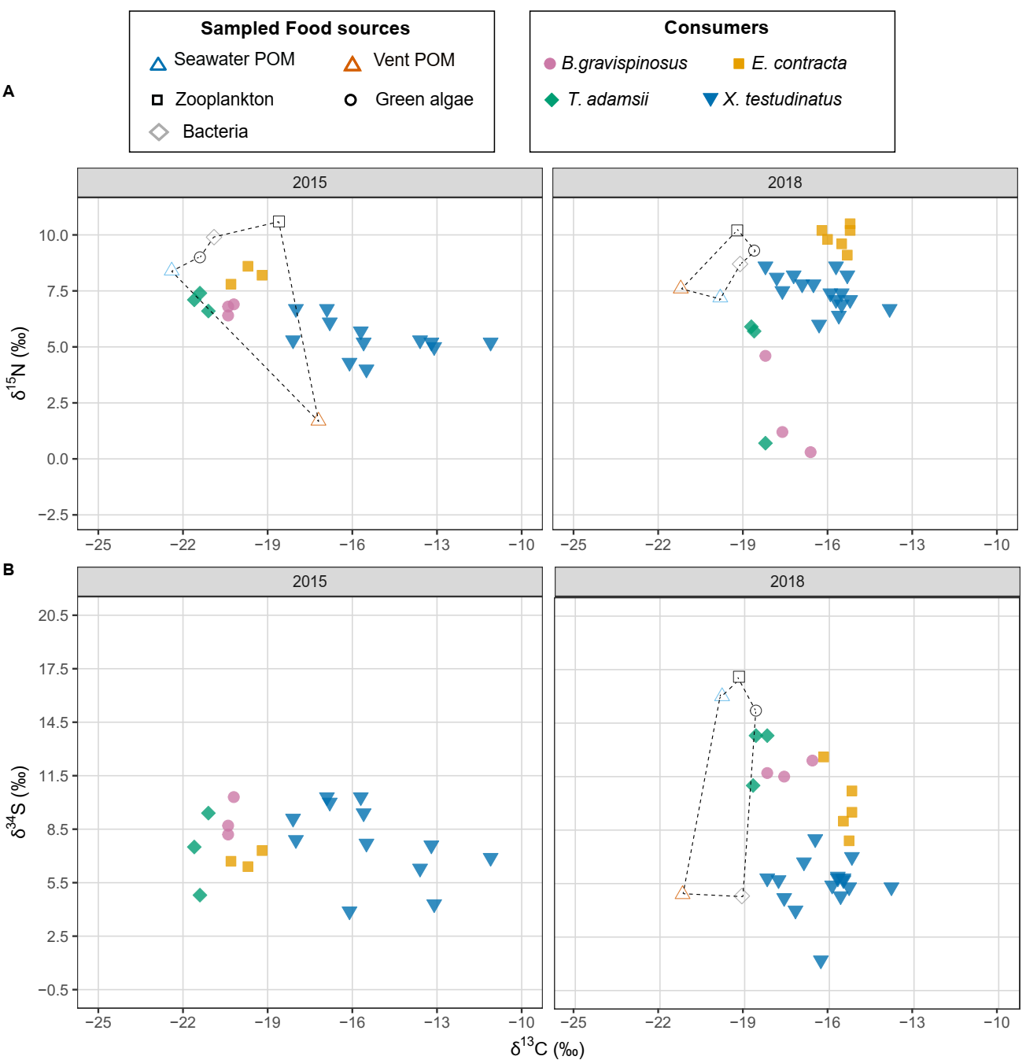
Supplementary Fig.S3. The isotope mixing space defined by the sampled food sources. We added dietary fractionation factors of 3.4‰, 1‰ and 0‰ for δ¹⁵N, δ¹³C, δ³⁴S, respectively, to the potential food sources based on values from Fig. 3 and Table 1. The boundaries of these mixing spaces are shown as dotted convex hulls.
In subplot A2015, X. testudinatus specimens except one lay outside the source mixing space, suggesting an incomplete sampling of potential source endmembers. To properly apply a Bayesian mixing model, all potential dietary resources that can contribute to isotope values in consumer should be characterized, otherwise information regarding the endmembers that constitute the mixture is incomplete. Therefore, any attempt to reconstruct dietary contribution to vent crab would be misleading and overestimate the dietary contributions from the sampled endmembers (Weltje 1997). There has been a report of one algae film sample, which could be an additional potential dietary source for vent crabs. However, this is only based on one measurement (Wang et al., 2022), which makes it anecdotal until confirmed with more measurements. Although the gastropods lay inside the endmember mixing space (the convex hull region), we cannot exclude that they fed on the missing source endmembers in the vent area. Hence, the mixing model would lead to overestimate the dietary contribution from the isotopically characterized sources.

In subplot A-2018, all consumers also lay outside the ¹³C and ¹⁵N mixing space (the dotted convex hull area). The two filter feeders’ δ¹⁵N values are lower than the sampled food sources, suggesting we do not have all dietary nitrogen source endmembers, which could be the nitrogen fixing cyanobacteria (see Discussion). Therefore, if we apply the mixing model for 2018 for carbon and nitrogen sources, our interpretation would be erroneous. Future studies should aim to characterize the δ¹⁵N and δ¹³C compositions of cyanobacteria in the KST region.

As we argued in the main text, S is not a good tracer for dietary change for the KST region before the disturbance because the vent δ³⁴S signature masks the entire KST region. After the disturbance, two processes affect basal sulfur dietary sources: 1) the vent flux decreases and seawater sulfate’s influence became stronger and moved towards to the vent areas (Fig. 2); 2) the shifts in sulfur speciation and the overall sulfur species in the KST region became more ³⁴S depleted. For the ¹³C and ³⁴S space (subplot B-2018), the δ¹³C values of all consumers lay outside the sampled endmember mixing space in 2018, suggesting we do not have all potential carbon sources to apply a Bayesian mixing model. Future isotope study should aim to expand sampling of potential dietary sources, including biofilm, isolated sulfur bacteria as well as nanobacteria from the KST region.

Reference:
Chen, C.-T.A., Zeng, Z., Kuo, F.-W., Yang, T.F., Wang, B.-J. & Tu, Y.-Y. (2005) Tide-influenced acidic hydrothermal system offshore NE Taiwan. Chemical Geology, 224, 69-81.
Chen, X.-G., Lyu, S.-S., Zhang, P.-P., Yu, M.-Z., Chen, C.-T.A., Chen, Y.-J., Li, X., Jin, A., Zhang, H.-Y., Duan, W. & Ye, Y. (2018) Gas discharges from the Kueishantao hydrothermal vents, offshore northeast Taiwan: Implications for drastic variations of magmatic/hydrothermal activities. Journal of Volcanology and Geothermal Research, 353, 1-10.
de Lecea, A.M., Smit, A.J. & Fennessy, S.T. (2011) The effects of freeze/thaw periods and drying methods on isotopic and elemental carbon and nitrogen in marine organisms, raising questions on sample preparation. Rapid Communications in Mass Spectrometry, 25, 3640-3649.
Jackson, A.L., Inger, R., Parnell, A.C. & Bearhop, S. (2011) Comparing isotopic niche widths among and within communities: SIBER – Stable Isotope Bayesian Ellipses in R. Journal of Animal Ecology, 80, 595-602.
Svensson, E., Schouten, S., Hopmans, E.C., Middelburg, J.J. & Damste, J.S.S. (2016) Factors controlling the stable nitrogen isotopic composition (δ¹⁵N) of lipids in marine animals. PLoS ONE, 11.
Weltje, G.J. (1997) End-member modeling of compositional data: Numerical-statistical algorithms for solving the explicit mixing problem. Mathematical Geology, 29, 503-549.

