Supplementary Material

Supplementary Figures and Tables

Supplementary Figures
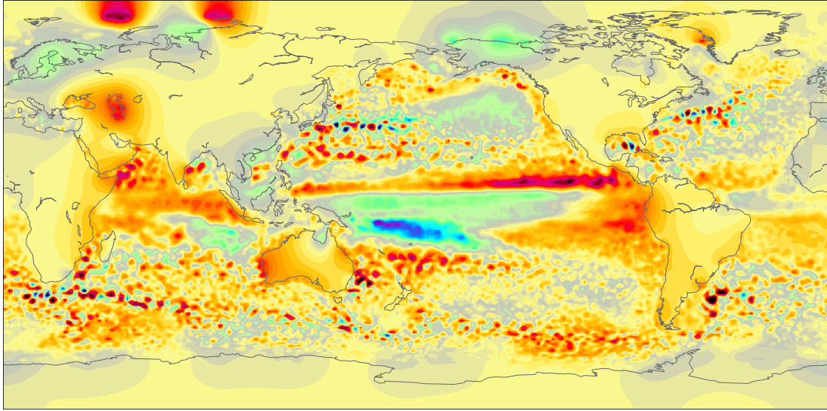
Supplementary Figure 1. SLA after Gap-filling using the heat diffusion equation on land.

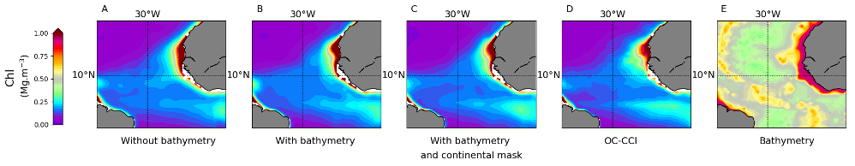
Supplementary Figure 2. Reconstructed Chl averaged over [2012-2015] A) without bathymetry, B) with bathymetry, C) with both bathymetry and binary continental mask, D) satellite Chl_{OC-CCI} averaged over the same time-period, E) bathymetry.

Supplementary Figure 3. Learning curves of left) CNN₁ and right) CNN_{MM8}.

Supplementary Figure 4. a) correlation and b) NRMSE between Chl_{OC-CCI} and reconstructed Chl from CNN₁ over [2012-2015]

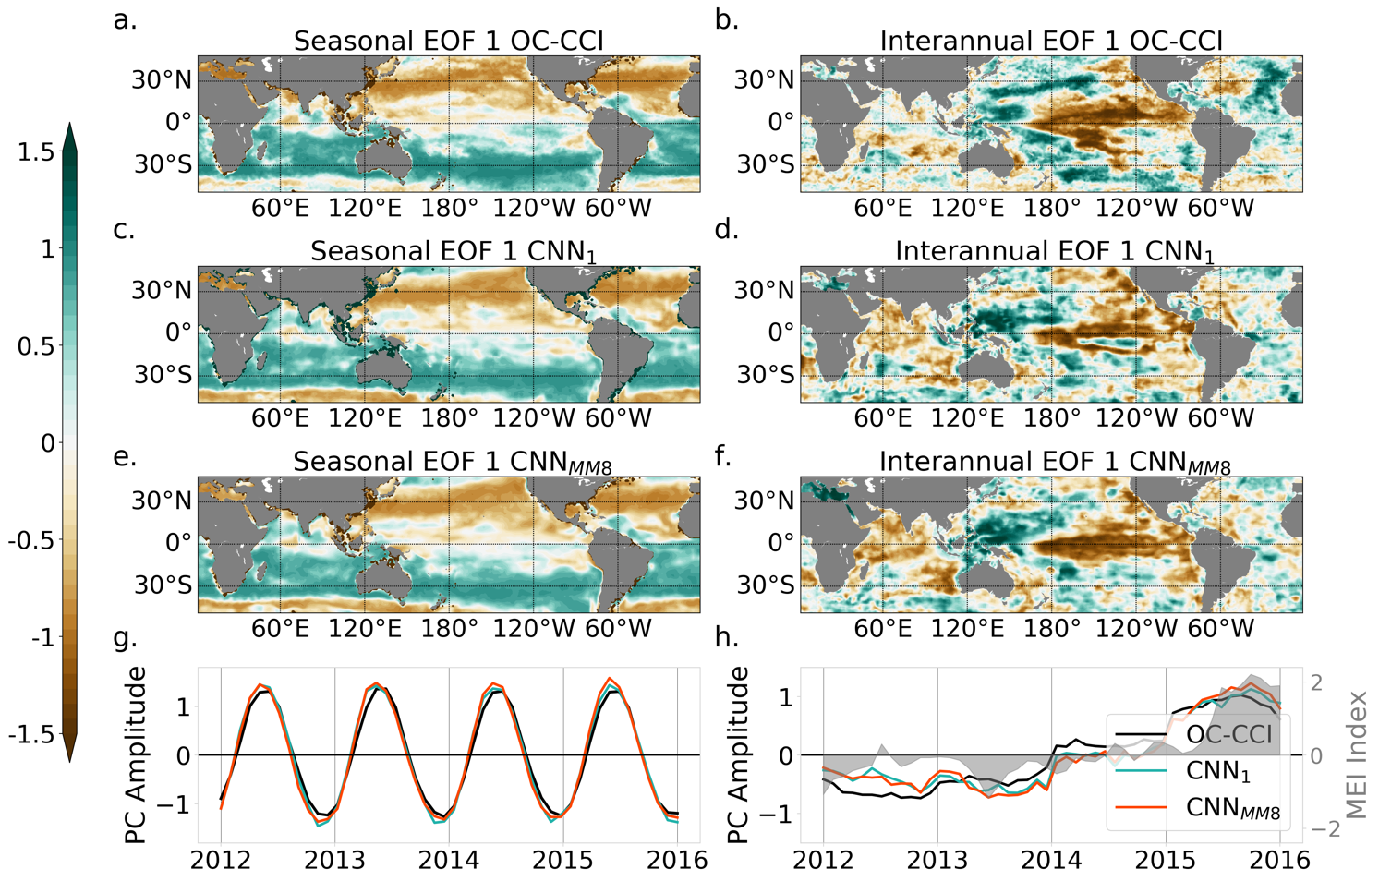
Supplementary Figure 5. EOFs first modes of seasonal (a) Chl_{OC-CCI} (33.2% of the total variance), (c) Chl_{CNN1} (39.6% of the total variance), (e) Chl_{CNN-MM8} (40.29% of the total variance), and (g) their associated PCs over [2012-2015]. In the same manner, EOFs first modes of interannual (b) Chl_{OC-CCI} (13.21% of the total variance), (d) Chl_{CNN1} (12.04% of the total variance), (f) Chl_{CNN-MM8} (13.75% of the total variance), and (h) their associated PCs over [2012-2015]. In (h), the MEI is reported as the grey shaded area.

Supplementary Tables
 |  |  | Global Scatterplot
Layers of CNN | Tested hyperparameter |  | R² | RMSE | Slope
Convolutional layers 3x3: 12*16*32
 | Batch_Size  (without Batch Norm) | 2 | 0.81 | 0.33 | 0.87
 |  | 20 | 0.81 | 0.33 | 0.87
 | Batch Norm | Yes, Batch_size = 20 | 0.79 | 0.34 | 0.87
 |  | No | 0.81 | 0.33 | 0.87
 | Kernel Size | 1x1 | 0.71 | 0.40 | 0.68
 |  | 3x3 | 0.81 | 0.33 | 0.87
 |  | 5x5 | 0.82 | 0.31 | 0.88
 | Number of conv 3x3 layers | 12*16*32 | 0.81 | 0.33 | 0.87
 |  | 12*16*32*64 | 0.84 | 0.30 | 0.90
 |  | 12*16*32*64*128 | 0.86 | 0.28 | 0.91
Convolutional layers 3x3: 12*16*32*64*128 (CNN₁)
 | Learning rate | 0.1 | 0 | 0 | 0
 |  | 0.01 | 0.76 | 0.37 | 0.81
 |  | 0.001 | 0.83 | 0.32 | 0.93
 |  | 0.0001 | 0.83 | 0.33 | 0.96
 |  | 0.00001 | 0.77 | 0.37 | 0.90
 |  | 0.001 -> 0.0001 | 0.83 | 0.31 | 0.89
 | Dropout | 0.15 | 0.83 | 0.33 | 0.96
 |  | 0.35 | 0.82 | 0.33 | 0.93
 |  | 0.50 | 0.81 | 0.34 | 0.91
Supplementary Table 1. Global performance metrics obtained over [1998-2001] with the CNN₁ according to different hyperparameters

 | Global Scatterplot |  |  | Corr. Seas. PC | Corr. Inter. PC | N param
Model | R² | RMSE | Slope
CNN_{MM1} | 0.81 | 0.32 | 0.84 | 0.99 | 0.84 | 25 025
CNN_{MM2} | 0.84 | 0.30 | 0.89 | 0.99 | 0.87 | 58 134
CNN_{MM3} | 0.85 | 0.29 | 0.92 | 0.99 | 0.89 | 83 339
CNN_{MM4} | 0.87 | 0.27 | 0.91 | 0.99 | 0.94 | 108 364
CNN_{MM6} | 0.87 | 0.27 | 0.89 | 0.99 | 0.92 | 157 836
CNN_{MM8} | 0.87 | 0.26 | 0.89 | 0.99 | 0.92 | 208 464
CNN_{MM10} | 0.87 | 0.26 | 0.91 | 0.99 | 0.93 | 259 092
CNN_{MM15} | 0.87 | 0.27 | 0.93 | 1.00 | 0.92 | 383 639

Supplementary Table 2. Global performance metrics obtained over [1998-2001] with the CNN_{MMi} according to the number of modes

